Multimodal Emotion Recognition (MER2025)

**Project Overview**

This project implements a Multimodal Emotion Recognition system using the MER2025 Track 1 dataset. The system integrates video, audio, and text modalities, with features extracted using ViT (video), HuBERT (audio), and RoBERTa (text). A LLaMA 2 model performs fusion and reasoning, combining the modalities into a unified representation for emotion classification.

For more details about the data set you can see in the link :

**Dataset:**

* Name: MER2025 Track 1
* Type: Self-Supervised dataset – feature extraction models were pretrained in a self-supervised manner before fine-tuning

**Modalities:**

* Video (frames from clips)
* Audio (speech and environmental sounds)
* Text (transcripts of speech)

**Preprocessing & Feature Extraction:**

* Video: Vision Transformer (ViT) – pretrained with self-supervised learning for spatial-temporal visual features
* Audio: HuBERT – self-supervised speech/audio representation learning
* Text: RoBERTa – pretrained language model for contextual embeddings

**Unimodal Baseline Testing:**

* Before multimodal fusion, each modality was tested individually (Unimodal setting)
* An Attention-based model was applied to each modality separately to evaluate its standalone performance and identify the most informative modalities

**Multimodal Runing:**

**Architecture:**

**Fusion :**

**Top-N Fusion in LLaMA 2:**

* LLaMA 2 receives embeddings from all three modalities and applies cross-modal attention
* Each modality embedding is assigned an attention weight based on its relevance for the current sample
* The **Top N** highest-weighted embeddings are selected
* LLaMA 2 performs reasoning over these selected embeddings to produce a fused representation

**Classifier:**

* Fully connected layers for final emotion prediction

**Model Output:**

* Classes: Six discrete emotion categories (as defined by the dataset, without explicit explanations)

**Loss Functions:**

Two loss functions were used:

1. Cross-Entropy Loss – primary classification loss
2. Mean Squared Error (MSE) – secondary loss to align predicted emotion score distributions with ground truth

**Implementation Steps:**

1. Feature Extraction – Obtained embeddings from ViT, HuBERT, and RoBERTa (all pretrained with self-supervised learning)
2. Fusion in LLaMA 2 – Combined modality embeddings for reasoning
3. Training – Used AdamW optimizer, early stopping on validation accuracy
4. Evaluation – Measured Accuracy, F1-score, confusion matrix

**Results:**

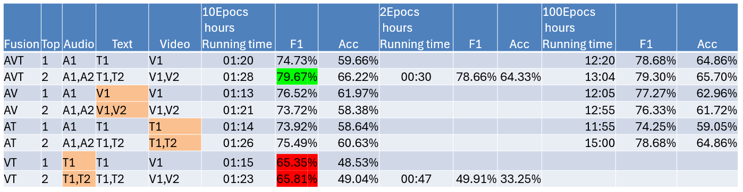

**Observations:**

* Audio & video features were strong indicators for expressive emotions

**Requirements:**

**Usage:**