UK Mortgage Stress in the Post-2010 Period
An exploratory analysis of arrears, possessions and mortgage-market conditions using official quarterly data
Sample: 2011 Q1 to 2024 Q4 | 56 quarterly observations
July 2026

Abstract
This paper examines UK mortgage stress as a sequence linking mortgage-market conditions to serious arrears and, subsequently, possession activity. It uses an aggregate quarterly time series covering 2011 Q1 to 2024 Q4, assembled from official mortgage-lending and house-price series. The analytical dataset contains 56 observations and no missing values. The analysis combines descriptive statistics, Pearson correlations and two exploratory ordinary least squares models estimated with Newey-West heteroskedasticity and autocorrelation consistent standard errors. Mortgage stress declined markedly after the early 2010s, while the fixed-rate share of lending rose. In the first model, lagged average mortgage interest rates are positively associated with serious arrears, whereas fixed-rate share and gross advances are negatively associated. In the second model, lagged serious arrears are strongly associated with later possessions and the share of lending above 90% loan-to-value enters positively. These estimates are associational, not causal, and may partly reflect common trends, structural breaks and institutional interventions. The paper therefore presents the regressions as exploratory evidence rather than definitive risk estimates.
Keywords: UK mortgage market; arrears; possessions; housing finance; credit risk; time series; Newey-West HAC

Key findings
- The analytical sample contains 56 continuous quarters from 2011 Q1 to 2024 Q4 and 23 substantive variables, with no missing observations in the analysis window.
- Serious arrears averaged 1.031% and total arrears averaged 1.435% across the sample.
- New possessions averaged 3,451.9 per quarter, with substantial variation across time.
- The lagged regressions show strong sample associations, but residual persistence and common trends mean the coefficients must be interpreted cautiously.

1. Introduction
Mortgage arrears and possession activity are direct indicators of stress in a housing-finance system. Arrears identify repayment difficulty, while possessions represent a later enforcement-stage outcome. The UK mortgage market is economically important because housing debt is a major component of household balance sheets and because changes in mortgage pricing, lending standards and house prices can affect borrower vulnerability.
The study treats mortgage stress as a staged process. The first question is whether broad mortgage-market conditions are associated with serious arrears in the following quarter. The second is whether serious arrears are associated with possession activity in the following quarter after accounting for selected market indicators. This ordering is analytically useful, but it does not establish causality or prove that one quarter is the economically correct transmission lag.
This study contributes a clean official-data time series, documents the main descriptive patterns and applies an exploratory lagged-regression framework to the relationship between mortgage-market conditions, arrears and possessions. The data are correctly treated as one national time series rather than as a panel of regions, lenders or households.

2. Data and research design
The final analysis uses quarterly UK-level observations from 2011 Q1 to 2024 Q4. Mortgage lending, product composition, leverage, arrears and possessions variables are drawn from official mortgage lending and administration statistics. UK house-price growth is drawn from the Office for National Statistics UK House Price Index. The merged analysis file has 56 observations and no missing values over the study window.
The dataset contains both outcome measures and market-condition indicators. The serious arrears rate is the principal repayment-stress outcome. New possessions represent the enforcement-stage outcome. Explanatory variables include the average mortgage interest rate, the fixed-rate share of lending, the share of gross advances above 90% loan-to-value, impaired-credit-history share, gross advances and annual house-price growth.

Table 1. Core variables used in the analysis
Repository variable | Interpretation | Analytical role
serious_arrears_rate_pct | Serious arrears rate (%) | Primary repayment-stress outcome
new_possessions_units | New possessions (units) | Enforcement-stage outcome
avg_interest_rate_all_loans_pct | Average mortgage interest rate (%) | Mortgage pricing conditions
fixed_rate_share_pct | Fixed-rate share (%) | Product-composition indicator
ltv_gt_90_pct | Share of gross advances above 90% LTV | High-leverage lending indicator
impaired_credit_history_pct | Impaired-credit-history share (%) | Borrower risk proxy
gross_advances_gbp_m | Gross mortgage advances (£m) | Aggregate lending activity
uk_hpi_annual_change_pct | UK HPI annual change (%) | Housing-market momentum

Figure 1. Serious and total mortgage arrears rates, 2011 Q1 to 2024 Q4. 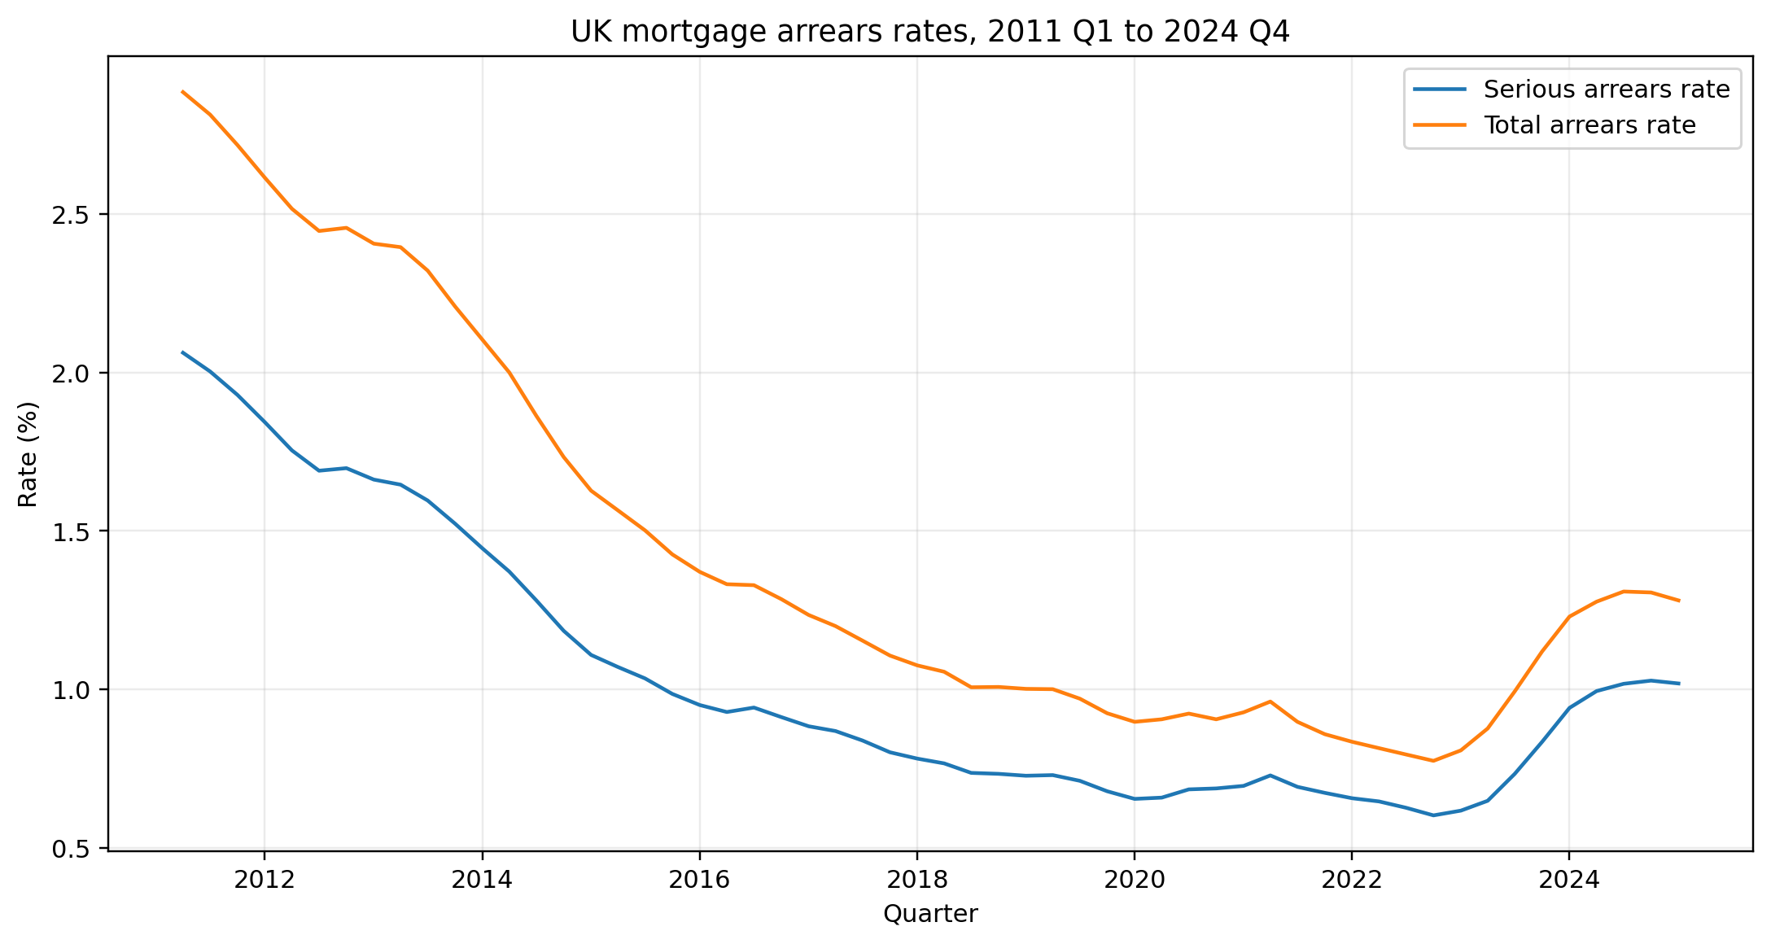
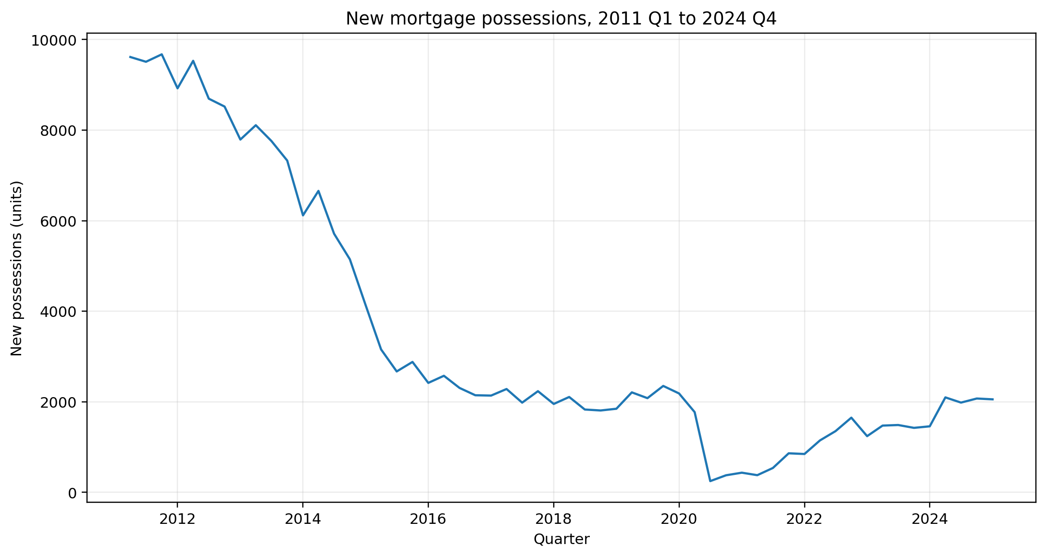
Figure 2. New mortgage possessions, 2011 Q1 to 2024 Q4.

3. Methodology
The empirical workflow has three stages. First, descriptive statistics summarise the distribution of the main variables. Second, Pearson correlations describe selected pairwise relationships. Third, two lagged ordinary least squares models are estimated using Newey-West heteroskedasticity and autocorrelation consistent standard errors with four lags.
Model 1 uses the serious arrears rate in quarter t as the dependent variable. The regressors are the one-quarter lagged average mortgage interest rate, UK HPI annual growth, fixed-rate share, share of lending above 90% LTV, impaired-credit-history share and gross advances. Model 2 uses the natural logarithm of new possessions in quarter t and includes one-quarter-lagged serious arrears plus the lagged interest-rate, HPI, fixed-rate, high-LTV and gross-advances variables.
Newey-West standard errors make the reported inference more robust to heteroskedasticity and limited serial correlation in the regression residuals. They do not solve non-stationarity, common-trend bias, endogeneity or structural breaks. The coefficients are therefore interpreted only as conditional associations in this sample.

4. Descriptive profile
Mortgage stress was substantially higher at the beginning of the sample than in later years. Serious arrears averaged 1.031% and ranged from 0.603% to 2.062%. New possessions averaged 3,451.9 per quarter and ranged from 249 to 9,674. The fixed-rate share rose markedly over the period, while mortgage pricing and lending volumes also changed substantially.
Table 2. Descriptive statistics
Variable | N | Mean | Median | Min | Max | Std. dev.
Serious arrears rate (%) | 56 | 1.031 | 0.899 | 0.603 | 2.062 | 0.416
Total arrears rate (%) | 56 | 1.435 | 1.232 | 0.775 | 2.884 | 0.623
New possessions (units) | 56 | 3,451.911 | 2,141.500 | 249.000 | 9,674.000 | 2,919.587
Stock of possessions (units) | 56 | 6,501.071 | 4,358.000 | 1,583.000 | 16,262.000 | 4,463.220
Average mortgage interest rate (%) | 56 | 3.034 | 2.727 | 1.901 | 5.341 | 0.954
UK HPI annual change (%) | 56 | 3.749 | 3.567 | -2.467 | 11.033 | 3.541
Fixed-rate share (%) | 56 | 82.908 | 87.104 | 51.218 | 95.455 | 12.771
LTV above 90% share (%) | 56 | 2.758 | 3.038 | 0.821 | 4.763 | 1.117
Gross advances (£m) | 56 | 59,535.659 | 62,266.235 | 32,984.725 | 89,117.086 | 14,138.347

5. Correlation evidence
The stress measures are strongly correlated with one another. Serious arrears are also strongly negatively correlated with the fixed-rate share and gross advances. These pairwise coefficients are descriptive and are particularly vulnerable to common trends across the sample; they should not be read as independent causal effects.
Table 3. Selected Pearson correlations
Target variable | Correlated variable | Pearson r
Serious arrears | Total arrears | 0.996751
Serious arrears | New possessions | 0.969003
Serious arrears | Fixed-rate share | -0.925592
Serious arrears | Gross advances | -0.842382
New possessions | LTV above 90% share | -0.663058

6. Exploratory econometric results
Model 1 has an R-squared of 0.9283 and an adjusted R-squared of 0.9193 (N = 55). The lagged average interest rate is positively associated with serious arrears. The lagged fixed-rate share and gross advances enter negatively. The negative coefficient on the high-LTV share is not interpreted as a protective effect because it conflicts with conventional risk expectations and may reflect common trends, model instability or omitted factors.
Table 4. Model 1: serious arrears rate (OLS with Newey-West HAC standard errors)
Predictor | Coefficient | HAC SE | p-value
Constant | 2.779600 | 0.199566 | 0.000000
Lagged average interest rate | 0.077141 | 0.031162 | 0.013305
Lagged UK HPI annual change | 0.002861 | 0.005368 | 0.594021
Lagged fixed-rate share | -0.018548 | 0.004054 | 0.000005
Lagged LTV above 90% share | -0.063975 | 0.023332 | 0.006108
Lagged impaired-credit-history share | 0.114484 | 0.176785 | 0.517252
Lagged gross advances (£m) | -0.000006 | 0.000003 | 0.025479
Model fit: R² = 0.9283; adjusted R² = 0.9193; AIC = -77.8521; BIC = -63.8008; observations = 55.
Model 2 has an R-squared of 0.7900 and an adjusted R-squared of 0.7637 (N = 55). Lagged serious arrears are strongly and positively associated with the logarithm of new possessions. The lagged share of lending above 90% LTV also enters positively. The other included market indicators are not statistically distinguishable from zero in this specification.
Table 5. Model 2: log new possessions (OLS with Newey-West HAC standard errors)
Predictor | Coefficient | HAC SE | p-value
Constant | 5.012831 | 1.652338 | 0.002415
Lagged serious arrears rate | 2.273772 | 0.509588 | 0.000008
Lagged average interest rate | 0.024978 | 0.118575 | 0.833162
Lagged UK HPI annual change | 0.037368 | 0.028160 | 0.184522
Lagged fixed-rate share | -0.010421 | 0.013918 | 0.454008
Lagged LTV above 90% share | 0.250698 | 0.119917 | 0.036563
Lagged gross advances (£m) | 0.000006 | 0.000013 | 0.639250
Model fit: R² = 0.7900; adjusted R² = 0.7637; AIC = 69.5675; BIC = 83.6189; observations = 55.

7. Interpretation and diagnostic cautions
Taken at face value, the two models are consistent with a staged description of mortgage stress: market conditions are associated with serious arrears, and serious arrears are associated with later possession activity. However, the statistical diagnostics require restraint. The Durbin-Watson statistics are approximately 0.72 for Model 1 and 0.63 for Model 2, indicating substantial residual persistence. The design matrices also have large condition numbers, partly because variables are on very different scales and partly because several series move together over time.
The sample also contains major institutional disruptions. Possessions were affected by lender forbearance, court processes and pandemic-era interventions. Fixed-rate penetration, mortgage pricing and lending volumes followed strong long-run movements. Newey-West errors improve the reported uncertainty estimates but do not eliminate bias from these features. For this reason, the high R-squared values should not be presented as proof that the included variables explain mortgage stress structurally.

8. Limitations
- The dataset is an aggregate national time series, so it cannot identify household-level or regional heterogeneity.
- The sample is small for a multivariable time-series model: only 56 quarters are available before lagging.
- Several variables trend strongly, raising the possibility of spurious regression or unstable coefficients.
- The analysis uses a single one-quarter lag even though mortgage resets, arrears and possession processes may operate over longer and variable lags.
- Pandemic-era forbearance, possession restrictions, court delays and other policy interventions are not explicitly modelled in the current specification.
- Important macroeconomic factors such as unemployment, real income, inflation and debt-service burden are not included.
- The current study does not provide a causal design, cointegration analysis, structural-break model or validated forecasting exercise.

9. Conclusion
This study provides an exploratory account of UK mortgage stress between 2011 and 2024. The descriptive evidence documents a large decline in arrears and possessions after the early 2010s, followed by some later movement in stress indicators. The regression results show that lagged mortgage pricing, product composition and lending activity are associated with serious arrears, while lagged serious arrears are strongly associated with later possessions. These results support a staged analytical narrative, but they do not establish causal mechanisms.
The study demonstrates the value of a documented official-data pipeline, clear outcome definitions and a transparent statistical workflow. Further research should add formal stationarity testing, structural-break treatment, intervention controls, distributed lags and additional macroeconomic covariates before making stronger policy claims.

10. Data and code availability
The data, Python analysis workflow, tables and figures used in this study are publicly available at https://github.com/Linpaws7/UK-mortgage-risk-research. The reported results use the 2011 Q1 to 2024 Q4 analysis window.

Sources and references
Financial Conduct Authority. Mortgage lending statistics and related MLAR-based quarterly data. https://www.fca.org.uk/data/mortgage-lending-statistics
Office for National Statistics. UK House Price Index. https://www.ons.gov.uk/economy/inflationandpriceindices/bulletins/housepriceindex/latest
Newey, W. K., and West, K. D. (1987). A simple, positive semi-definite, heteroskedasticity and autocorrelation consistent covariance matrix. Econometrica, 55(3), 703-708.
Project repository: Linpaws7/UK-mortgage-risk-research. https://github.com/Linpaws7/UK-mortgage-risk-research

