Fuel Poverty Risk in County Durham
Analytical report with tables, Word equation formatting, and colour graphs
Item | Value
Local authority | County Durham
Code | E06000047
Report basis | Outputs produced from the Python workflow completed in this conversation
Scope | EPC-led postcode screening; local-authority fuel poverty, energy, gas, and IMD context

1. Purpose and scope
This document summarises the County Durham postcode screening model built from EPC data. The final ranking is not a direct postcode-level measure of observed fuel poverty; it is an EPC-led risk proxy designed to highlight areas where low EPC ratings, weak current efficiency, and remaining upgrade potential are concentrated.
2. Workflow and retained dataset
Workflow checkpoint | Result
Full EPC rows pulled | 299,445
Unique latest property records retained | 233,972
Low-rating properties (bands E, F, or G) | 28,921
Low-efficiency properties (current efficiency < 55) | 28,921
Implausible improvement-gap rows isolated | 30
Filtered postcodes in final ranking (minimum 20 properties) | 4,429

The county field in the cleaned EPC extract was entirely missing and was dropped. Postcodes with fewer than 20 retained properties were excluded to reduce instability in very small groups.
3. County Durham summary results
Indicator | Value
Mean postcode risk score | 0.128685
Median postcode risk score | 0.096423
Highest-risk postcode | DH1 5HG
Lowest-risk postcode | DL14 8FT
Mean postcode current efficiency | 67.561627
Mean postcode potential efficiency | 82.523686
Mean postcode improvement gap | 14.890493
Property-level low-rating share | 0.123609
Property-level low-efficiency share | 0.123609
Latest-property average current efficiency | 66.644915
Latest-property average potential efficiency | 82.178684
Latest-property average cleaned improvement gap | 15.494665

Risk band | Postcode count
Very Low | 886
Low | 886
Medium | 885
High | 886
Very High | 886

The near-equal band counts are expected because risk bands were produced with five-quantile splitting. They are therefore relative within County Durham rather than absolute national thresholds.
4. Highest-risk postcode examples
Postcode | Props | Risk score | Low-rating share | Avg current eff. | Avg gap
DH1 5HG | 45 | 0.815462 | 0.955556 | 37.756 | 15.178
DL13 5AA | 22 | 0.746677 | 0.772727 | 39.136 | 38.227
DL15 8AT | 40 | 0.744958 | 0.800000 | 42.700 | 31.225
DL15 8AS | 22 | 0.733995 | 0.772727 | 46.500 | 34.455
TS27 4SL | 29 | 0.733584 | 0.793103 | 46.690 | 29.483
DH7 9QR | 22 | 0.731398 | 0.772727 | 43.000 | 33.682
DL13 5LR | 25 | 0.694588 | 0.720000 | 41.920 | 35.280
DL13 1QJ | 33 | 0.694169 | 0.727273 | 43.788 | 33.424
DL12 0QW | 37 | 0.688531 | 0.702703 | 40.649 | 37.595
DH7 9DF | 24 | 0.688515 | 0.750000 | 46.125 | 26.333

5. Lowest-risk postcode examples
Postcode | Props | Risk score | Avg current eff. | Avg gap
DL14 8FT | 49 | 0.000000 | 95.224 | 0.000
DH1 2FL | 20 | 0.000000 | 90.400 | 0.000
DL5 5DE | 23 | 0.000000 | 94.043 | 0.000
SR7 9AU | 49 | 0.000000 | 94.531 | 0.000
DH7 8EJ | 32 | 0.000000 | 83.938 | 0.000
DH1 5TN | 36 | 0.000000 | 84.028 | 0.000
TS21 1GS | 23 | 0.000000 | 90.826 | 0.000
TS21 1GN | 31 | 0.000000 | 90.419 | 0.000
DH2 2AA | 36 | 0.000000 | 90.972 | 0.000
SR8 5AS | 71 | 0.000000 | 85.155 | 0.000

6. Contextual local-authority indicators joined to the master table
Context variable | Value
Fuel poverty proportion, County Durham (2023) | 11.4%
Fuel-poor households / total households | 27,698 / 242,909
Electricity domestic standard meters (thousands) | 241.822
Electricity domestic E7 meters (thousands) | 6.735
Electricity all domestic meters (thousands) | 248.557
Electricity all non-domestic meters (thousands) | 15.990
Gas domestic meters (thousands) | 234.967
Gas non-domestic meters (thousands) | 1.839
Gas all meters (thousands) | 236.806
Gas domestic consumption (GWh) | 2,745.080
IMD average rank | 21,488.54
IMD average score | 28.808
Share of LSOAs in most deprived 10% nationally | 0.1697
IMD25 extent | 0.3602
IMD25 rank of extent | 46
IMD25 local concentration | 32,636.06

These joined variables do not differentiate postcodes inside County Durham in the current workflow because they are constant at local-authority level. They provide context for interpretation rather than direct postcode variation.
7. Statistical notation
Symbol | Meaning
i | Property index
j | Postcode index
n_j | Number of retained properties in postcode j
L_i | Low-rating indicator for property i
E_i | Low-efficiency indicator for property i
CE_i | Current energy efficiency for property i
PE_i | Potential energy efficiency for property i
G_clean,i | Cleaned improvement gap for property i
SLR_j | Share of low-rated properties in postcode j
SLE_j | Share of low-efficiency properties in postcode j
ACE_j | Average current efficiency in postcode j
APE_j | Average potential efficiency in postcode j
AIG_j | Average cleaned improvement gap in postcode j
RS_j | Final postcode risk score

8. Statistical formulas used
The formulas below are shown in Word equation format and match the variables used in the County Durham pipeline.
Low-rating indicator
$$Lᵢ = \{ 1, if EPC bandᵢ ∈ \{E, F, G\}; 0, otherwise \}$$
Low-efficiency indicator
$$Eᵢ = \{ 1, if CEᵢ < 55; 0, otherwise \}$$
Raw improvement gap
$$Gᵢ = PEᵢ − CEᵢ$$
Cleaned improvement gap
$$Gᶜˡᵉᵃⁿᵢ = \{ Gᵢ, if 0 ≤ Gᵢ ≤ 100; missing, otherwise \}$$
Property count per postcode
$$nⱼ = ∑ᵢ∈ⱼ 1$$
Share of low-rated properties
$$SLRⱼ = (1 / nⱼ) ∑ᵢ∈ⱼ Lᵢ$$
Share of low-efficiency properties
$$SLEⱼ = (1 / nⱼ) ∑ᵢ∈ⱼ Eᵢ$$
Average current efficiency
$$ACEⱼ = (1 / nⱼ) ∑ᵢ∈ⱼ CEᵢ$$
Average potential efficiency
$$APEⱼ = (1 / nⱼ) ∑ᵢ∈ⱼ PEᵢ$$
Average cleaned improvement gap
$$AIGⱼ = mean(Gᶜˡᵉᵃⁿᵢ)$$
Final postcode risk score
$$RSⱼ = 0.4·SLRⱼ + 0.4·SLEⱼ + 0.2·(AIGⱼ / max(AIG))$$
Arithmetic mean
$$x̄ = (1 / n) ∑ xᵢ$$
Median for odd n
$$median(x) = x₍₍ₙ ₊ ₁₎ / ₂₎$$
Median for even n
$$median(x) = (xₙ/₂ + x₍ₙ/₂ ₊ ₁₎) / 2$$
Sample standard deviation
$$s = √[(1 / (n − 1)) ∑ (xᵢ − x̄)²]$$
Proportion
$$p = k / n$$
9. Descriptive statistics for the final postcode table
Metric | Count | Mean | Std | Min | Median | 75% | Max
properties | 4429 | 35.550237 | 15.441428 | 20.000000 | 31.000000 | 42.000000 | 145.000000
share_low_rating | 4429 | 0.098291 | 0.120228 | 0.000000 | 0.054545 | 0.150000 | 0.955556
share_low_efficiency | 4429 | 0.098291 | 0.120228 | 0.000000 | 0.054545 | 0.150000 | 0.955556
avg_current_efficiency | 4429 | 67.561627 | 7.382067 | 37.755556 | 66.366667 | 70.193548 | 102.086957
avg_potential_efficiency | 4429 | 82.523686 | 6.634291 | 52.933333 | 81.838710 | 83.981818 | 392.961538
avg_improvement_gap | 4429 | 14.890493 | 5.378499 | 0.000000 | 15.432432 | 18.071429 | 59.500000
risk_score | 4429 | 0.128685 | 0.108697 | 0.000000 | 0.096423 | 0.181176 | 0.815462

10. Interpretation and limitations
The strongest screening signal comes from postcodes where EPC bands E, F, and G dominate and where current efficiency averages are materially below the County Durham postcode mean. The model also increases the score where the cleaned improvement gap is large, because those postcodes appear to contain stock with substantial modelled retrofit headroom.
This remains a screening model rather than a causal model of fuel poverty. Fuel poverty, electricity, gas, and IMD indicators were only joined at local-authority level in this workflow, so postcode differentiation comes from the EPC-derived features rather than from those contextual tables. The risk bands are quantile-based and therefore relative within County Durham.
11. Colour graphs
The graphs below use colour for visual separation only. All values come directly from the final County Durham postcode table and the summary tables already reported above.
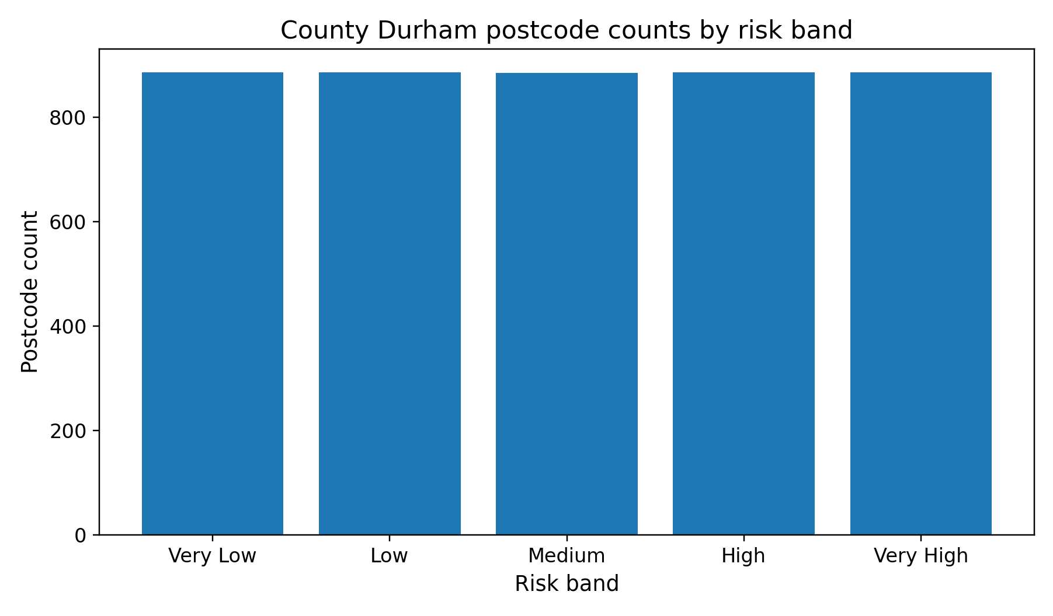
Figure 1. Postcode counts by risk band. The near-equal counts reflect five-quantile banding within County Durham.
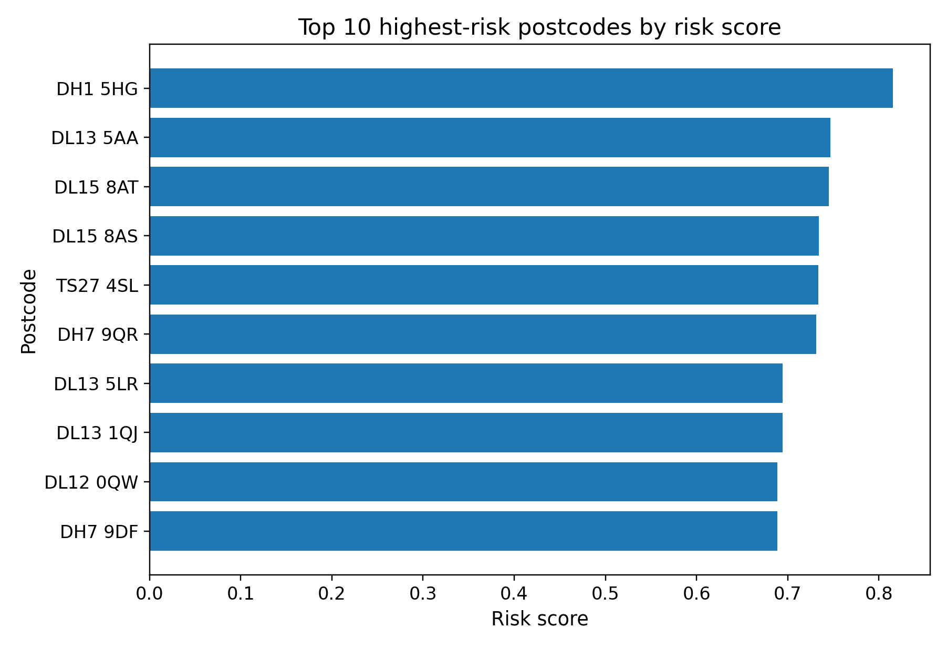
Figure 2. Top 10 highest-risk postcodes by composite risk score. DH1 5HG remains the highest-ranked postcode in the final table.
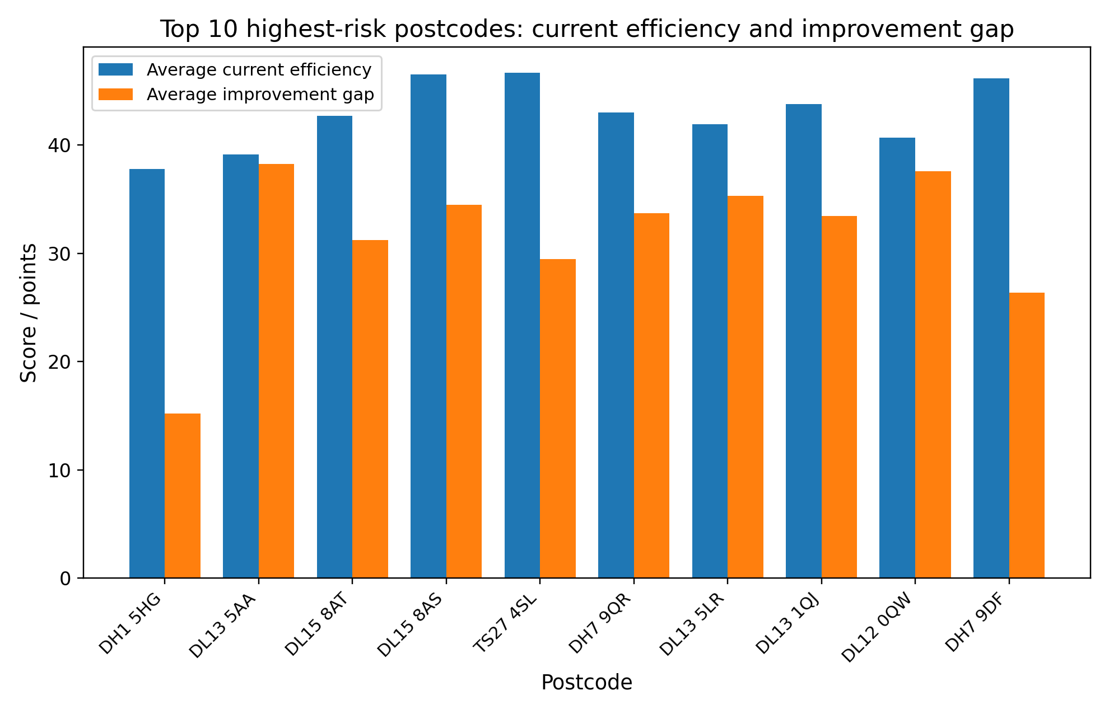
Figure 3. Current efficiency and improvement-gap values for the 10 highest-risk postcodes. Low current efficiency and a large improvement gap often appear together in higher-risk areas.

