Задание крипта

Задание 1

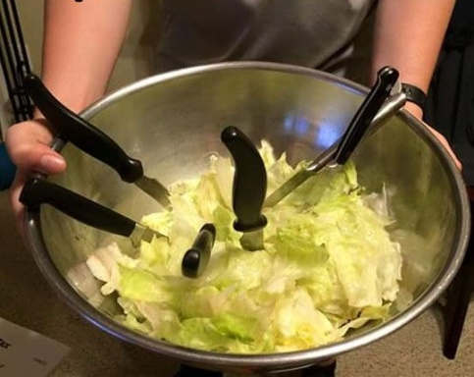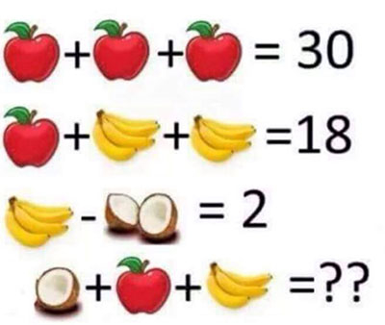

Squiqh mqi rehd ydje q fqjhysyqd vqcybo, jxu wudi Zkbyq, mxysx sbqycut tuisudj vhec Ykbki, ied ev jxu buwudtqho Jhezqd fhydsu Quduqi, ikffeiutbo jxu ied ev jxu wettuii Ludki. Vbqw yi SJV{JxYi_Yi_SuPqH}.Zkbyki Squiqh mqi jxu vyhij xyijehysqb Hecqd je ru evvysyqbbo tuyvyut.