Ur5_Simulation
by NEO 20180331

- Add the obstacles
- Mimic pick_and_place move
- Control the speed of trajectory
- Appendix

Adding Obstacles to the Planning Scene

[Task Summary]

The task below is to illustrate the process of adding obstacles to the planning scene, and the key to view the obstacles in RViz is to select the /move_group/monitored_planning_scene topic for Planning Scene Topic.

[Process]

Step 1: import the classes
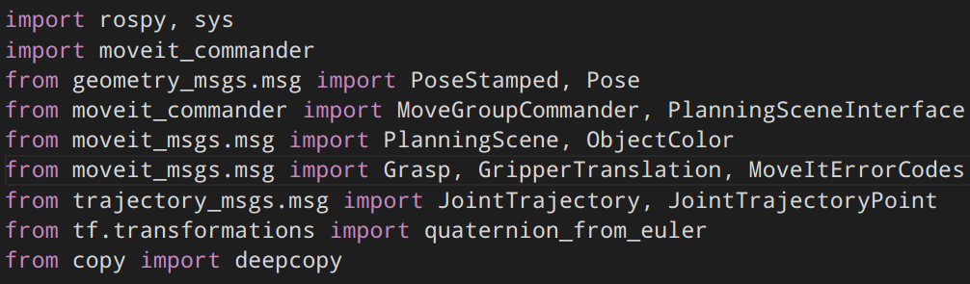
- PlanningSceneInterface enables us to add and remove objects to and from the scene.
- We can change the color of the obstacles using ObjectColor message and update to the topic planning_scene

Step 2: Create an instance and publisher
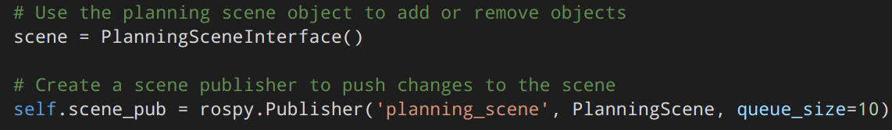

Step 3:Reference frame
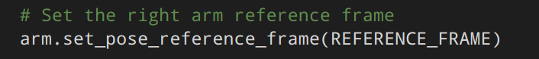

Step 4: Unique name for each object
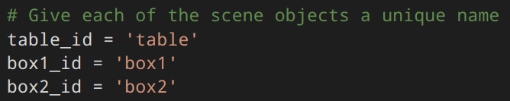

Step 5: Set the size for each object
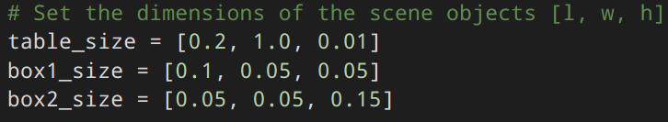
Step 6: Set the pose of each object(take table as an example)
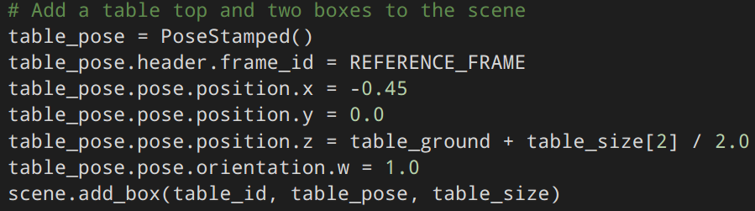
Step 7: More configuration for objects
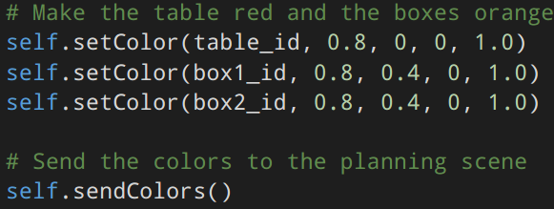

[Problems & Solutions]
- Not sure the where is the reference frame?
Display->Add->rviz->Axes->OK

Adding Obstacles to the Planning Scene

1 [Task Summary]

Build a function used to adjust the speed

2 [Process]

Step 1: Build a function

In the example the file is in the directory:
/home/(user)/catkin_ws/src/rbx2/rbx2_arm_nav/src/rbx2_arm_nav in the py file :
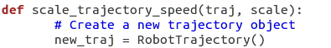

“def” used to state a function , the function has two arguments,and returns a new traj.
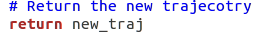

I wont spend too much time on explaining the principle.

What you need is to simply import this function in your own robot py file:

But in obstacle.py file ,the situation is a little different :

1.different ways to new a traj

in obstacle.py:

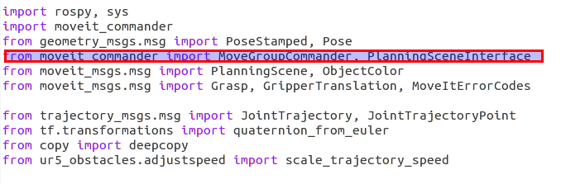
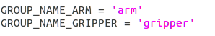

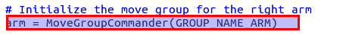

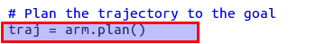

notice traj is created by arm.plan(), so we need to modify the source py file

1. import MoveGroupcommader
2. use 'arm' to create a traj
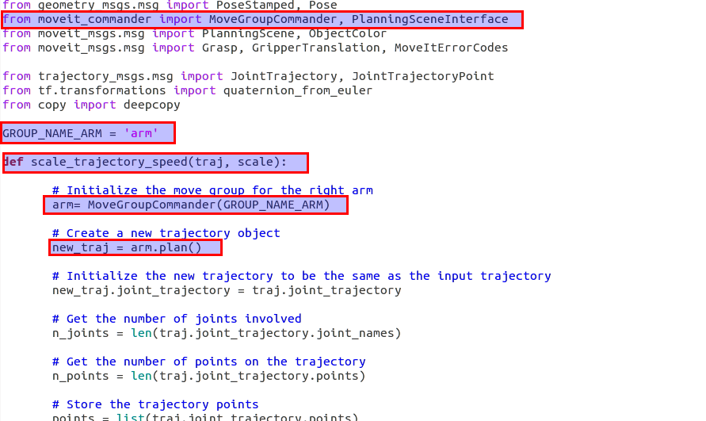

then what we need to do is import the function in obstacle.py
(notice I rename it adjustspeed)

At last, we run the new .py script.

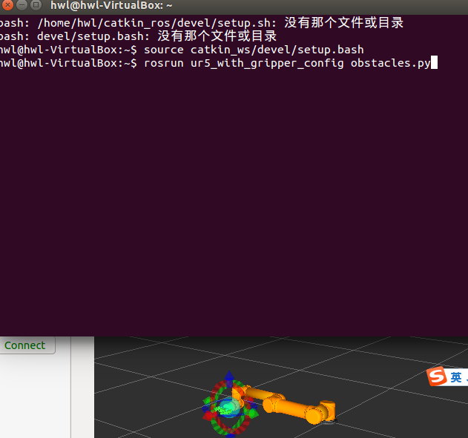

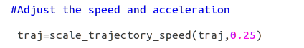

Another way:
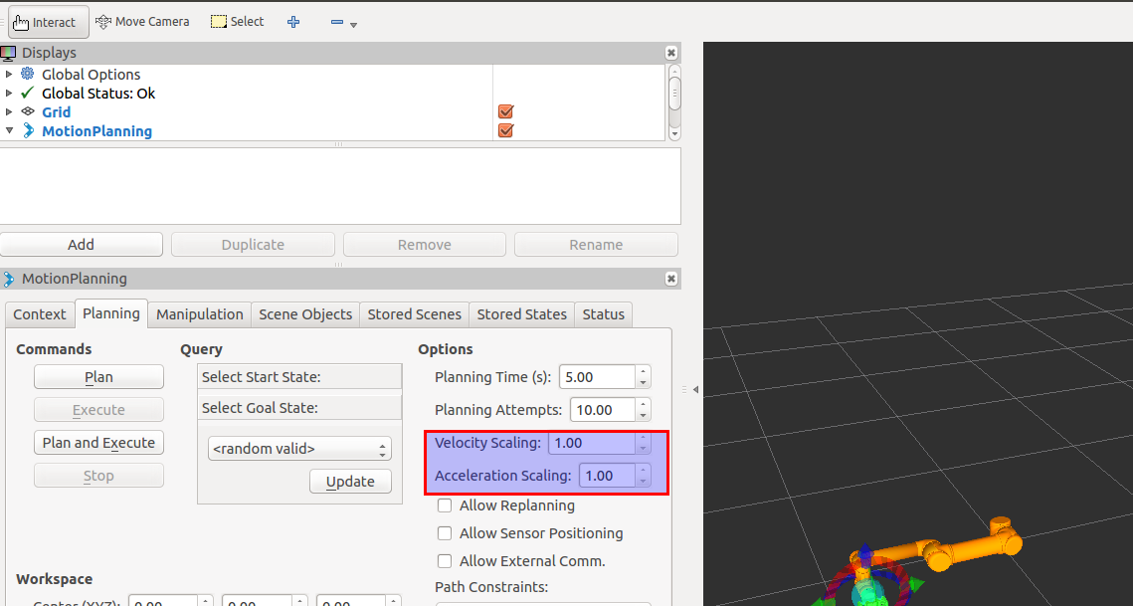

You can change the whole Traj velocity or Acceleration

3 [Problems and solutions]

3.1 “no module named...”
After I import the function,i can't run the obstacle.py file
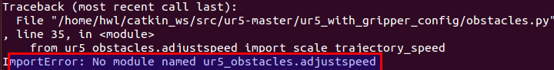
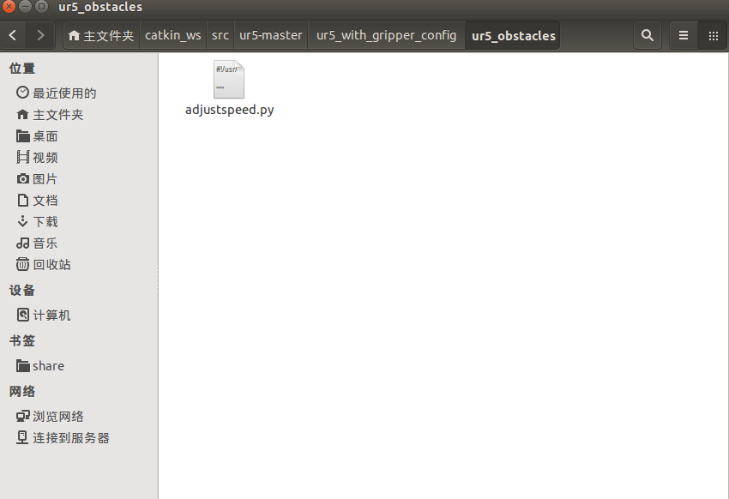
In python,in order to call a package as a module, the package must contain this
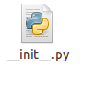

and the adjustspeed.py file is a module.

Simply add a py showed above.(It is an empty file)

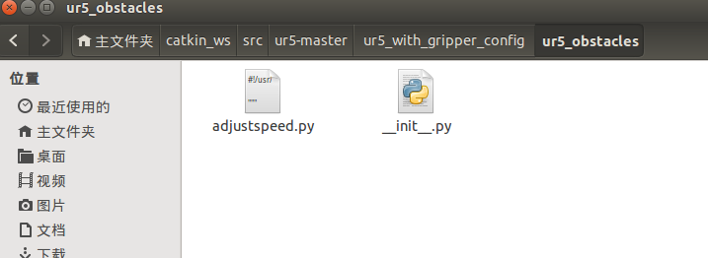

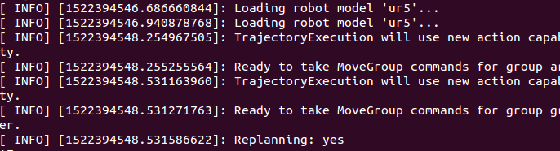
Then the problem is solved.

2.2 .“....is not an executed file”

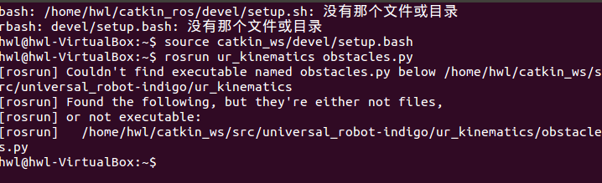
Solution: $ chmod +x obstacles.py

3.3 .“Group armhwl was not found...”

This is because armhwl is what I define on my own. However the arm is the fixed group in the .xacro file ,so we use this

The GROUP_NAME_ARM can only be the fixed one .

3.4. “could not contact ROS master....”

When I try to use .rviz file, it shows this :
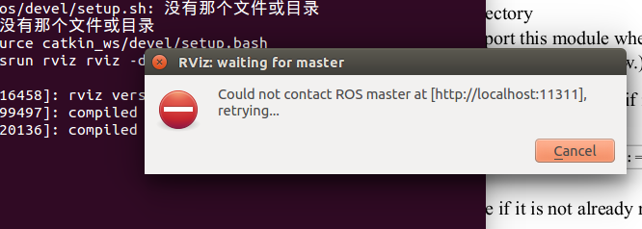

Use $ roscore then the problem is solved.

But we can not see the robot on the screen,because we need to launch a .launch file of the robot,when we invoke the .launch file,we don't need to use the command $ roscore
like this :

Mimic pick_and_place move

1 [Summary]
We will set two targeted poses for the UR5, and we will ask UR5 to reach that two poses without hitting the obstacles. Besides, we will set two poses for robotiq85(end effector) and ask the end effector to be open or closed.

2 [Process]
Step 1: We set joint names of the gripper, according to SRDF file, then we set two states(neutral and closed) to the gripper.
Step 2: According to the configuration file we set earlier by moveit_setup_assistant,
we set the group name, gripper_frame, reference_frame and gripper_effort.
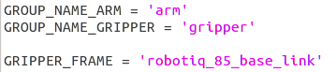

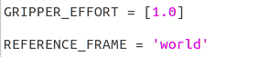

Step 3: We set two poses for the UR5 to reach.
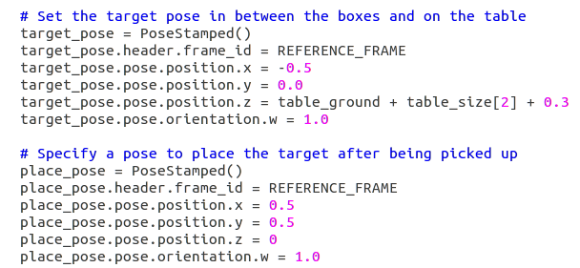
Step 4: We ask UR5 to reach the target_pose first while closing the gripper. Then we ask UR5 to reach the place_pose while opening the gripper. Finally, UR5 will be back to its original place.
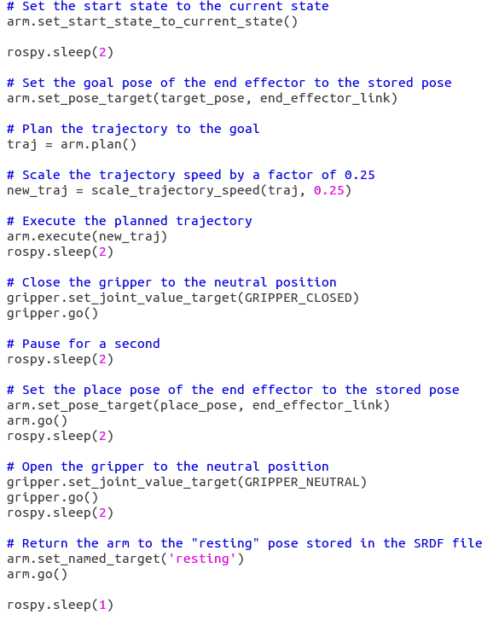

3 [Problems and solutions]

3.1 A bug in ur5 ur5_robotiq85_gripper.urdf.xacro. It doesn't define the pi variable.
Solutions: Add the “Pi” variable in the xacro file.

Appendix

1 [Task List]
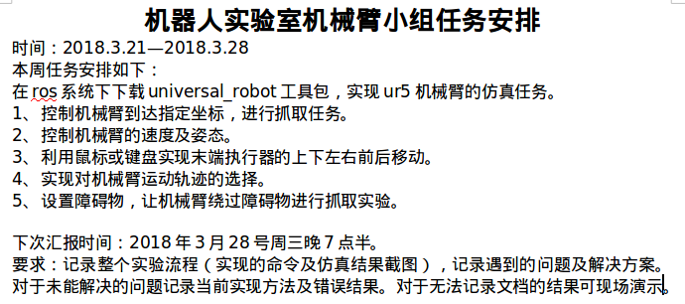

2 [Share]

2.1 代码编辑器-roboware：http://www.roboware.me/#/home

2.2 Bringing The World’s Best Office Experience To Linuxhttps://www.wps.com/linux
2.3图形化显示URDF模型 $ urdf_to_graphiz my_robot.urdf

3 [Problems & Solutions]

3.1 When try to open setup_assistant->Unable to parse XACRO file:
$echo "source /opt/ros/indigo/setup.bash" >> ~/.bashrc
$source ~/.bashrc

3.2 Resource Not Found or rospkg.common.ResourceNotFound ，when you Creat a new Package,follows the steps:
$roscreate-pkg beginner_tutorials std_msgs rospy roscpp
$rospack profile
$rospack find beginner_tutorials //check if you can find the package

3.3 xacro to .urdf file:
$rosrun xacro xacro.py robotiq_85_gripper.xacro > ur5_with_gripper.urdf

3.4 xacro.XacroException: Property wasn't defined: u'pi' [universal_robot]
$Add < xacro:property name="pi" value="3.1415926535897931"/> in the file

3.5 Found the following, but they're either not files,[rosrun] or not executable:
$sudo chmod a+x ur5_obstacles_demo.py

机器人实验室机械臂小组任务安排
时间：2018.3.21—2018.3.28
本周任务安排如下：
在ros系统下下载universal_robot工具包，实现ur5机械臂的仿真任务。
- 控制机械臂到达指定坐标，进行抓取任务。
- 控制机械臂的速度及姿态。
- 利用鼠标或键盘实现末端执行器的上下左右前后移动。
- 实现对机械臂运动轨迹的选择。
- 设置障碍物，让机械臂绕过障碍物进行抓取实验。

下次汇报时间：2018年3月28号周三晚7点半。
要求：记录整个实验流程（实现的命令及仿真结果截图），记录遇到的问题及解决方案。对于未能解决的问题记录当前实现方法及错误结果。对于无法记录文档的结果可现场演示。

