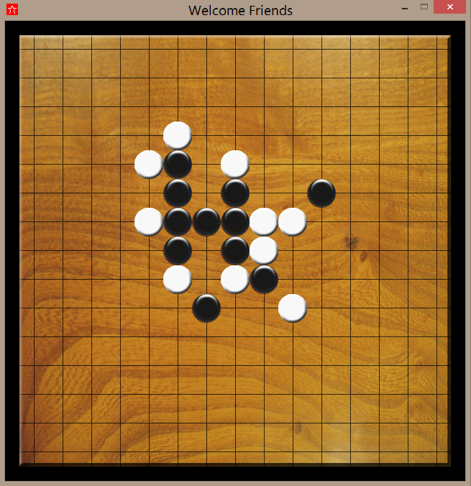

Pranshu Gupta, Rhythm Das & Abhishek Jain  
SUMMER PROJECT 2014  
Programming Club IIT KANPUR

THE RENJUGAME

# WHAT IS RENJU

**RENJU** is the professional variant of GOMOKU, a strategy board game originating in Japan. The game is played on the 225 intersections of 15 horizontal and 15 vertical lines. Two players, Black and White, move in turn by placing a stone of their own color on an empty intersection, henceforth called a square. Black starts the game. The player who first makes a line of five consecutive stones of his color (horizontally, vertically or diagonally) wins the game. The stones once placed on the board during the game never move again nor can they be cap- turned. If the board is completely filled, and no one has five-in-a-row, the game is drawn. Renju eliminates the "Perfect Win" situation in Gomoku by adding special conditions for the first player (Black).

Black can win the game only by placing five black stones in a row (vertically, horizontally or diagonally).

White can win by either:

* Getting five (or more) white stones in a row
* Forcing Black to make a forbidden move, such as six in a row.

# THE PROJECT

* Our objective is to develop the Renju game which is built with the use of ARTIFICIAL INTELLIGENCE and runs in a GRAPHICAL USER INTERFACE.
* We will be using MINIMAX and ALPHA BETA PRUNING for developing the AI part and WXPYTHON along with PYGAME libraries for the gaming and GUI part.
* We will be posting our codes on GITHUB. The link for the same is

<https://github.com/Pranshu258/Renju>

You can learn about GITHUB and how to use it from the book PRO-GIT. Which can be downloaded from

<https://github.s3.amazonaws.com/media/progit.en.pdf>

# THE MAKING OF RENJU GAME

We started out by clearing our concepts of python. The tutorials at thenewboston.org were very useful. Also tutorialspoint.com is also a very good resource.

After that we learned about PYGAME and WXPYTHON from newboston.org. YouTube also has tutorials on PYGAME available at the following link:

<https://www.youtube.com/watch?v=Y7joZ67mC6o&list=PLQVvvaa0QuDcxG_Cajz1JyTH6eAvka93C>

We also came across a book on PYGAME named as “Making games with PYTHON & PYGAME”. It can be downloaded from:

<http://inventwithpython.com/makinggames.pdf>

A good book on WXPYTHON named, “WXPYTHON in action” can be downloaded from: <http://eduunix.ccut.edu.cn/index2/pdf/Manning.Publications.wxPython.in.Action.Mar.2006.pdf>

Then we first tried to make some simple games just to test our understanding. We tried a shooting game (game2.py) and the famous FLAPPY BIRD (game.py). We have uploaded the source code on our GITHUB repository.

<https://github.com/Pranshu258/Renju/blob/master/game.py>

<https://github.com/Pranshu258/Renju/blob/master/game2.py>

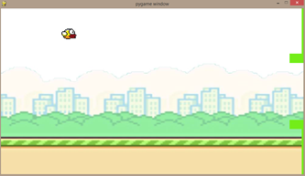

Then we started designing the UI window for our game using the WXPYTHON library of python. It would have buttons to start a new game, to quit the game and it can notify if you made an invalid move, or if either of the players won the game.

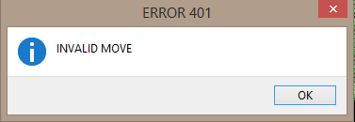

We made our PYGAME code as a method in a WXPYTHON class in order to integrate the two windows. When you click new game button in WXPYTHON window it would invoke the PYGAME method and the game would start.

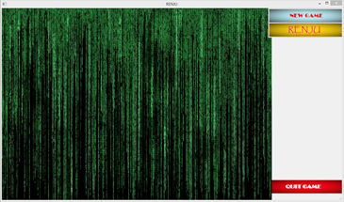

Then we moved towards the implementation of PYGAME for a two player RENJU game. We wrote methods to get the pixel position of the point where the user clicks and to place the black or white stones at the appropriate intersection on the board.

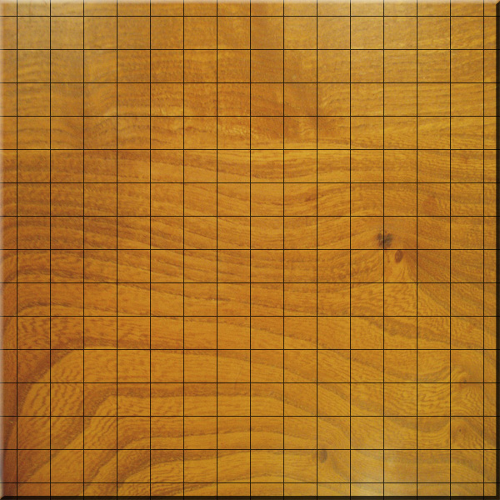

Then we wrote the code of finding the winner and thus completing the two player game experience.

## MAKING OF THE CPU PLAYER

We started searching for material on MINIMAX and ALPHA-BETA PRUNING, and we came across following resources that were useful to us:

* [**http://web.cs.wpi.edu/~rich/courses/imgd4000-d09/lectures/E-iniMax.pdf**](http://web.cs.wpi.edu/~rich/courses/imgd4000-d09/lectures/E-iniMax.pdf)
* <http://www.cs.cornell.edu/courses/cs312/2002sp/lectures/rec21.htm>
* This one has the description of TIC-TAC-TOE using minimax and alpha-beta pruning: <http://www.neverstopbuilding.com/minimax>