集美大学计算机工程学院实验报告

课程名称：软件开发编程基础 | 班级：软件2211 | 实验成绩：
指导教师：李 旺 | 姓名：巩晨阳
实验项目名称：图形程序设计 | 学号：202221332033 | 上机实践日期：2023.3.30
实验项目编号：06 | 组号： | 上机实践时间： 2 学时

一、目的
掌握图形程序设计；掌握Swing组件；掌握事件处理
二、实验内容与设计思想
设计思路
图形程序设计：
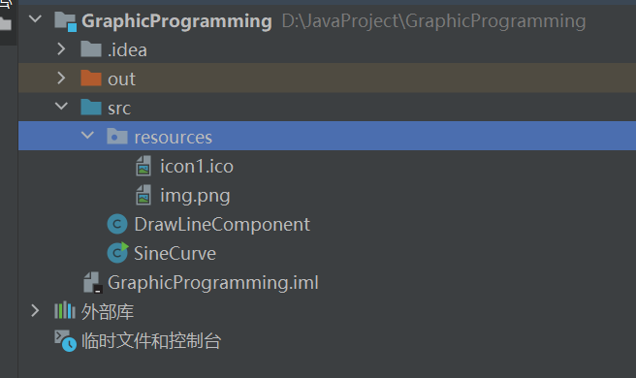
DrawLineComponent负责存储点以及绘制
SineCurve负责展现绘出的界面
resources包负责存储用到的光标指针以及左上角图标资源
Swing用户界面组件：
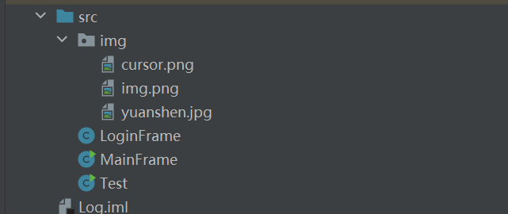
Img负责存储用到的图片文件
LogFrame用来展示登录界面
MainFrame为画图程序的主界面
事件处理:
同第一个
画笔程序:
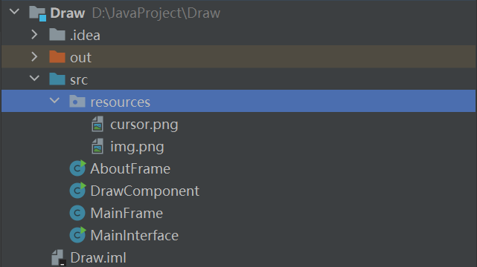
AboutFrame是关于界面
DrawComponent为画图界面
MainFrame为主界面
主要代码结构：
DrawLineComponent：
import java.awt.*;
import java.awt.event.MouseEvent;
import java.awt.event.MouseListener;
import java.awt.event.MouseMotionListener;
import java.awt.geom.Line2D;
import java.awt.geom.Point2D;
import java.util.ArrayList;
import javax.swing.JComponent;
public class DrawLineComponent extends JComponent implements MouseListener, MouseMotionListener {
private ArrayList<Point2D> points;
private Point2D.Double dragOrigin = null; // 拖动起点
private boolean isDragging = false; // 是否正在拖动
private int selectedPointIndex = -1; // 选中的点的索引
private boolean button1_isPressed=false;
private boolean button3_isPressed=false;
public DrawLineComponent(ArrayList<Point2D> points) {
this.points = points;
this.addMouseListener(this);
this.addMouseMotionListener(this);
}
@Override
public void paintComponent(Graphics g) {
Graphics2D g2 = (Graphics2D) g;
for (int i = 0; i < points.size() - 1; i++) {
Point2D p1 = points.get(i);
Point2D p2 = points.get(i + 1);
Line2D line = new Line2D.Double(p1, p2);
g2.draw(line);
}
}
public void paint(Graphics g) {
super.paint(g);
Graphics2D g2d = (Graphics2D) g;
g2d.setStroke(new BasicStroke(2f));
g2d.setColor(Color.RED);
int n = points.size();
if (n > 1) {
for (int i = 0; i < n - 1; i++) {
Point2D p1 = points.get(i);
Point2D p2 = points.get(i + 1);
g2d.drawLine((int) p1.getX(), (int) p1.getY(), (int) p2.getX(), (int) p2.getY());
}
}
}
@Override
public void mousePressed(MouseEvent e) {
if (e.getButton() == MouseEvent.BUTTON1) {
// 判断鼠标是否按下左键
dragOrigin = new Point2D.Double(e.getX(), e.getY()); // 记录起始坐标
isDragging = true;
button1_isPressed=true;
selectedPointIndex = getSelectedIndex(points, e); // 获取被选中的点的索引
} else if (e.getButton() == MouseEvent.BUTTON3) {
// 判断鼠标是否按下右键
dragOrigin = new Point2D.Double(e.getX(), e.getY()); // 记录起始坐标
isDragging = true;
button3_isPressed=true;
}
}
@Override
public void mouseReleased(MouseEvent e) {
if (e.getButton() == MouseEvent.BUTTON1) {
isDragging = false;
button1_isPressed=false;
}
if (e.getButton() == MouseEvent.BUTTON3) {
isDragging = false;
button3_isPressed=false;
}
}
@Override
public void mouseDragged(MouseEvent e) {
if (isDragging&& button1_isPressed) { // 鼠标右键已经按下，正在拖动
double xShift = e.getX() - dragOrigin.getX(); // 计算x轴平移量
double yShift = e.getY() - dragOrigin.getY(); // 计算y轴平移量
for (Point2D point : points) {
double newX = point.getX() + xShift;
double newY = point.getY() + yShift;
point.setLocation(newX, newY); // 将每个点向右平移xShift，向下平移yShift
}
dragOrigin.setLocation(e.getX(), e.getY()); // 更新拖动起点坐标
repaint(); // 重新绘制曲线
}
if (isDragging && button3_isPressed && selectedPointIndex != -1) {
// 鼠标右键已经按下，正在拖动
double xShift = e.getX() - dragOrigin.getX(); // 计算x轴平移量
double yShift = e.getY() - dragOrigin.getY(); // 计算y轴平移量
Point2D point = points.get(selectedPointIndex);
double newX = point.getX() + xShift;
double newY = point.getY() + yShift;
point.setLocation(newX, newY); // 将该点向右平移xShift，向下平移yShift
dragOrigin.setLocation(e.getX(), e.getY()); // 更新拖动起点坐标
repaint(); // 重新绘制曲线
}
}
private double getDistance(Point2D p1, Point2D p2) {
double dx = p1.getX() - p2.getX();
double dy = p1.getY() - p2.getY();
return Math.sqrt(dx * dx + dy * dy);
}
@Override
public void mouseClicked(MouseEvent e) {}
@Override
public void mouseEntered(MouseEvent e) {}
@Override
public void mouseExited(MouseEvent e) {}
@Override
public void mouseMoved(MouseEvent e) {
}
private int getSelectedIndex(ArrayList<Point2D> points, MouseEvent e) {
for (int i = 0; i < points.size(); i++) {
Point2D point = points.get(i);
if (getDistance(point, e.getPoint()) < 5) { // 当鼠标与数据点的距离小于 5 时视为选中
return i;
}
}
return -1; // 没有选中任何点
}
}
加了一个点的索引以及按下判定，可以拖动点了
SineCurve:
import java.awt.*;
import java.awt.event.ActionEvent;
import java.awt.event.ActionListener;
import java.awt.event.MouseListener;
import java.awt.geom.Point2D;
import java.util.ArrayList;
import javax.swing.*;
public class SineCurve {
public static void main(String[] args) {
JFrame frame = new JFrame();
frame.setSize(500, 500);
frame.setDefaultCloseOperation(JFrame.EXIT_ON_CLOSE);
frame.setLocationRelativeTo(null);
frame.setTitle("画图——巩晨阳简洁版");
frame.setIconImage(new ImageIcon("src/resources/img.png").getImage());
ArrayList<Point2D> points = new ArrayList<>();
DrawLineComponent component = new DrawLineComponent(points);
JButton functionbuttonSin = new JButton("正弦函数");
JButton functionbuttonCos = new JButton("余弦函数");
JButton functionbuttonEx = new JButton("ex函数");
functionbuttonSin.addActionListener(new ActionListener() {
@Override
public void actionPerformed(ActionEvent e) {
points.clear(); // 清空旧数据
for (double x = 0; x < 2 * Math.PI; x += 0.001) {
double y = 2 * Math.sin(x);
points.add(new Point2D.Double(x * 80, y * 80 + 250));
}
component.repaint(); // 更新曲线
}
});
functionbuttonCos.addActionListener(new ActionListener() {
@Override
public void actionPerformed(ActionEvent e) {
points.clear(); // 清空旧数据
for (double x = 0; x < 2 * Math.PI; x += 0.001) {
double y = -2 * Math.cos(x);
points.add(new Point2D.Double(x * 80, y * 80 + 250));
}
component.repaint(); // 更新曲线
}
});
functionbuttonEx.addActionListener(new ActionListener() {
@Override
public void actionPerformed(ActionEvent e) {
points.clear(); // 清空旧数据
for (double x = 0; x < 10; x += 0.1) {
double y = -Math.pow(Math.E, x);
points.add((new Point2D.Double(x * 80, y + 400)));
}
component.repaint(); // 更新曲线
}
});
JPanel panel = new JPanel();
panel.add(functionbuttonSin);
panel.add(functionbuttonCos);
panel.add(functionbuttonEx);
frame.add(panel, BorderLayout.NORTH);
frame.add(component);
frame.setVisible(true);
}
}

第二个实验：

LoginFrame
import javax.swing.*;
import java.awt.*;
import java.awt.event.ActionEvent;
import java.awt.event.ActionListener;
import java.awt.image.BufferedImage;
import java.util.HashMap;
import java.util.Map;
import java.util.Random;
public class LoginFrame extends JFrame {
private JPanel panel;
private JLabel userLabel;
private JTextField userText;
private JLabel passwordLabel;
private JPasswordField passwordText;
private JLabel codeLabel;
private JTextField codeText;
private JLabel codeImg;
private JButton loginButton;
private Map<String, String> userMap;
public LoginFrame() {
setTitle("Gong Chenyang Painting Login");
setIconImage(new ImageIcon("src/img/img.png").getImage());
setSize(400, 200);
setDefaultCloseOperation(JFrame.EXIT_ON_CLOSE);
setLocationRelativeTo(null);
panel = new JPanel();
userLabel = new JLabel("用户名：");
userText = new JTextField(20);
passwordLabel = new JLabel("密码：");
passwordText = new JPasswordField(20);
codeLabel = new JLabel("验证码：");
codeText = new JTextField(10);
codeImg = new JLabel();
loginButton = new JButton("登录");
userMap = new HashMap<>();
userMap.put("admin", "123456");
panel.setLayout(new GridLayout(4, 2));
panel.add(userLabel);
panel.add(userText);
panel.add(passwordLabel);
panel.add(passwordText);
panel.add(codeLabel);
panel.add(codeText);
panel.add(codeImg);
panel.add(loginButton);
add(panel);
// 随机生成验证码图片
Random random = new Random(System.currentTimeMillis());
String code1 = "";
for (int i = 0; i < 2; i++) {
int r = random.nextInt(36);
code1 += (char) (r < 10 ? (r + '0') : ((r - 10) + 'A'));
}
String code2="";
for (int i = 0; i < 2; i++) {
int r = random.nextInt(36);
code2 += (char) (r < 10 ? (r + '0') : ((r - 10) + 'A'));
}
BufferedImage img = new BufferedImage(80, 30, BufferedImage.TYPE_INT_RGB);
Graphics2D g = img.createGraphics();
g.setColor(Color.WHITE);
g.fillRect(0, 0, 80, 30);
g.setColor(Color.BLACK);
for (int i = 0; i < 3; i++) {
int x1 = random.nextInt(80);
int y1 = random.nextInt(30);
int x2 = random.nextInt(80);
int y2 = random.nextInt(30);
g.drawLine(x1, y1, x2, y2);
}
g.setColor(Color.BLUE);
g.setFont(new Font("Arial", Font.BOLD, 20));
g.drawString(code1, 20, 20);
g.setColor(Color.red);
g.drawString(code2, 50, 20);
g.dispose();
codeImg.setIcon(new ImageIcon(img));
// 验证码校验
String finalCode = code1+code2;
codeText.addActionListener(new ActionListener() {
@Override
public void actionPerformed(ActionEvent e) {
String input = codeText.getText();
if (!input.equals(finalCode)) {
JOptionPane.showMessageDialog(null, "验证码错误！");
codeText.setText("");
}
}
});
// 登录按钮
loginButton.addActionListener(new ActionListener() {
@Override
public void actionPerformed(ActionEvent e) {
String user = userText.getText();
String password = new String(passwordText.getPassword());
if (userMap.containsKey(user)) {
if (userMap.get(user).equals(password)) {
JOptionPane.showMessageDialog(null, "登陆成功！");
// 转到主界面
dispose();
new MainFrame();
} else {
JOptionPane.showMessageDialog(null, "密码错误！");
}
} else {
JOptionPane.showMessageDialog(null, "用户名不存在！");
}
}
});
setVisible(true);
}
}

MainFrame:
import java.awt.*;
import java.awt.event.ActionEvent;
import java.awt.event.ActionListener;
import java.awt.event.MouseEvent;
import java.awt.event.MouseListener;
import java.awt.geom.Point2D;
import java.awt.image.BufferedImage;
import java.awt.image.ImageObserver;
import java.io.File;
import java.io.IOException;
import java.util.ArrayList;
import javax.imageio.ImageIO;
import javax.swing.*;
import javax.swing.event.MouseInputListener;
public class MainFrame extends JFrame {
private JMenuItem sinItem;
private JMenuItem cosItem;
private JMenuItem otherItem;
private JComponent demoComponent;
public MainFrame() {
Toolkit toolkit = Toolkit.getDefaultToolkit();
Image cursorImg = toolkit.getImage("src/img/cursor.png");
Cursor customCursor = toolkit.createCustomCursor(cursorImg, new Point(0, 0), "YuanShen");
setCursor(customCursor);
setTitle("Gong Chenyang's Painting");
setIconImage(new ImageIcon("src/img/img.png").getImage());
setLocationRelativeTo(null);
setDefaultCloseOperation(JFrame.EXIT_ON_CLOSE);
// 菜单栏
JMenuBar menuBar = new JMenuBar();
setJMenuBar(menuBar);
JMenu projectMenu = new JMenu("曲线演示");
JMenu openMenu = new JMenu("打开文件");
JMenu exitMenu=new JMenu("退出");
JMenu about=new JMenu("关于");
menuBar.add(projectMenu);
menuBar.add(openMenu);
menuBar.add(exitMenu);
menuBar.add(about);
JMenuItem exit=new JMenuItem("退出");
JMenuItem aboutItem=new JMenuItem("关于");
sinItem = new JMenuItem("正弦图像");
cosItem = new JMenuItem("余弦图像");
otherItem = new JMenuItem("其他图像");
exitMenu.add(exit);
about.add(aboutItem);
projectMenu.add(sinItem);
projectMenu.add(cosItem);
projectMenu.add(otherItem);
exit.addActionListener(e->{
System.exit(0);
});
aboutItem.addActionListener(e->{
JOptionPane.showMessageDialog(null, "本软件由JMU巩晨阳制作\n版本1.0\n联系方式：QQ675629384");
});
// 曲线演示面板
demoComponent = new JComponent() {
@Override
protected void paintComponent(Graphics g) {
super.paintComponent(g);
Graphics2D g2d = (Graphics2D) g;
int width = getWidth();
int height = getHeight();
g2d.drawLine(0, height / 2, width, height / 2); //x轴
g2d.drawLine(width / 2, 0, width / 2, height); //y轴
g2d.setColor(Color.BLUE);
double step = Math.PI / 180;
for (int i = -width / 2; i < width / 2; i++) {
double x = (double) i / 20;
double y = 2 * Math.sin(x);
int x1 = i + width / 2;
int y1 = (int) (-y * 20) + height / 2;
g2d.fillOval(x1, y1, 2, 2);
}
g2d.dispose();
}
};
// 菜单项事件处理
sinItem.addActionListener(e -> {
remove(demoComponent);
demoComponent = new JComponent() {
@Override
protected void paintComponent(Graphics g) {
super.paintComponent(g);
Graphics2D g2d = (Graphics2D) g;
int width = getWidth();
int height = getHeight();
g2d.drawLine(0, height / 2, width, height / 2); //x轴
g2d.drawLine(width / 2, 0, width / 2, height); //y轴
g2d.setColor(Color.BLUE);
double step = Math.PI / 180;
for (int i = -width / 2; i < width / 2; i++) {
double x = (double) i / 20;
double y = 2 * Math.sin(x);
int x1 = i + width / 2;
int y1 = (int) (-y * 20) + height / 2;
g2d.fillOval(x1, y1, 2, 2);
}
g2d.dispose();
}
};
add(demoComponent, BorderLayout.CENTER);
revalidate();
});
cosItem.addActionListener(e -> {
remove(demoComponent);
demoComponent = new JComponent() {
@Override
protected void paintComponent(Graphics g) {
super.paintComponent(g);
Graphics2D g2d = (Graphics2D) g;
int width = getWidth();
int height = getHeight();
g2d.drawLine(0, height / 2, width, height / 2); //x轴
g2d.drawLine(width / 2, 0, width / 2, height); //y轴
g2d.setColor(Color.BLUE);
double step = Math.PI / 180;
for (int i = -width / 2; i < width / 2; i++) {
double x = (double) i / 20;
double y = 2 * Math.cos(x);
int x1 = i + width / 2;
int y1 = (int) (-y * 20) + height / 2;
g2d.fillOval(x1, y1, 2, 2);
}
}
};
add(demoComponent, BorderLayout.CENTER);
revalidate();
});
otherItem.addActionListener(e -> {
remove(demoComponent);
demoComponent = new JComponent() {
@Override
protected void paintComponent(Graphics g) {
super.paintComponent(g);
try {
BufferedImage image = ImageIO.read(new File("src/img/yuanshen.jpg"));
g.drawImage(image, 0, 0, getWidth(), getHeight(), this);
} catch (IOException e) {
e.printStackTrace();
}
}
};
add(demoComponent, BorderLayout.CENTER);
revalidate();
});
setSize(552,561);
setLocationRelativeTo(null);
setVisible(true);
}
public static void main(String[] args) {
Toolkit toolkit = Toolkit.getDefaultToolkit();
Image cursorImg = toolkit.getImage("src/img/cursor.png");
Cursor customCursor = toolkit.createCustomCursor(cursorImg, new Point(0, 0), "YuanShen");
new MainFrame().setCursor(customCursor);
}
}

Test:
import java.awt.*;
import java.awt.event.ActionEvent;
import java.awt.event.ActionListener;
import java.awt.event.MouseEvent;
import java.awt.event.MouseListener;
import java.awt.geom.Point2D;
import java.util.ArrayList;
import java.util.Scanner;
import javax.swing.*;
import javax.swing.event.MouseInputListener;
public class Test {
public static void main(String[] args) {
Toolkit toolkit = Toolkit.getDefaultToolkit();
Image cursorImg = toolkit.getImage("src/img/cursor.png");
Cursor customCursor = toolkit.createCustomCursor(cursorImg, new Point(0, 0), "YuanShen");
new LoginFrame().setCursor(customCursor);
}
}

第三个实验：
AboutFrame
import javax.swing.*;
import java.awt.*;
public class AboutFrame extends JFrame {
public AboutFrame() {
setTitle("关于");
setDefaultCloseOperation(JFrame.DISPOSE_ON_CLOSE);
setSize(260, 150);
setLocationRelativeTo(null);
setIconImage(new ImageIcon("src/resources/img.png").getImage());
Toolkit toolkit = Toolkit.getDefaultToolkit();
Image cursorImg = toolkit.getImage("src/resources/cursor.png");
Cursor customCursor = toolkit.createCustomCursor(cursorImg, new Point(0, 0), "YuanShen");
setCursor(customCursor);
JLabel label = new JLabel("<html><body><p><b>巩晨阳画图</b></p><p>版本号：1.0</p>"
+ "<p>开发者：巩晨阳</p><p>联系方式：QQ：675629384</p></body></html>");
label.setHorizontalAlignment(JLabel.CENTER);
label.setVerticalAlignment(JLabel.CENTER);
add(label, BorderLayout.CENTER);
setVisible(true);
}
public static void main(String[] args) {//方便调试
new AboutFrame();
}
}
DrawComponent
import javax.swing.*;
import javax.swing.text.StyleConstants;
import java.awt.*;
import java.awt.event.*;
import java.util.ArrayList;
import java.util.List;
public class DrawComponent extends JComponent implements MouseListener, MouseMotionListener {
private List<List<Point>> lines = new ArrayList<>();
private List<Point> currentLine = null;
public DrawComponent() {
setPreferredSize(new Dimension(400, 400));
addMouseListener(this);
addMouseMotionListener(this);
}
@Override
protected void paintComponent(Graphics g) {
super.paintComponent(g);
Dimension size = getSize();
Graphics2D g2d = (Graphics2D) g;
// 设置线条粗细为3
g2d.setStroke(new BasicStroke(3));
g.drawRect(0, 0, size.width - 1, size.height - 1);
// 绘制所有曲线
for (List<Point> line : lines) {
if (line.size() <= 1) {
continue;
}
Point prev = line.get(0);
for (int i = 1; i < line.size(); i++) {
Point curr = line.get(i);
g.drawLine(prev.x, prev.y, curr.x, curr.y);
prev = curr;
}
}
// 绘制当前曲线
if (currentLine != null && currentLine.size() > 1) {
Point prev = currentLine.get(0);
for (int i = 1; i < currentLine.size(); i++) {
Point curr = currentLine.get(i);
g.drawLine(prev.x, prev.y, curr.x, curr.y);
prev = curr;
}
}
}
@Override
public void mouseClicked(MouseEvent e) {
}
@Override
public void mousePressed(MouseEvent e) {
currentLine = new ArrayList<>();
currentLine.add(e.getPoint());
}
@Override
public void mouseDragged(MouseEvent e) {
currentLine.add(e.getPoint());
repaint();
}
@Override
public void mouseMoved(MouseEvent e) {
}
@Override
public void mouseReleased(MouseEvent e) {
lines.add(currentLine);
currentLine = null;
}
@Override
public void mouseEntered(MouseEvent e) {
}
@Override
public void mouseExited(MouseEvent e) {
}
public static void main(String[] args) {
JFrame frame = new JFrame("画板");
frame.setDefaultCloseOperation(JFrame.EXIT_ON_CLOSE);
JPanel contentPanel = new JPanel(new BorderLayout());
contentPanel.setPreferredSize(new Dimension(500, 500));
contentPanel.add(new DrawComponent());
frame.setContentPane(contentPanel);
frame.pack();
frame.setLocationRelativeTo(null);
frame.setVisible(true);
}
public void clear() {
// 清空线段
lines.clear();
currentLine = null;
// 重绘画板
revalidate();
repaint();
}
}

MainFrame

import javax.imageio.ImageIO;
import javax.swing.*;
import java.awt.*;
import java.awt.event.WindowAdapter;
import java.awt.event.WindowEvent;
import java.awt.image.BufferedImage;
import java.io.File;
import java.io.IOException;
public class MainFrame {
private boolean isMainFrameEnabled = true;
public MainFrame() {
JFrame frame = new JFrame();
frame.setTitle("Gong Chenyang's Painting");
frame.setIconImage(new ImageIcon("src/resources/img.png").getImage());
frame.setDefaultCloseOperation(JFrame.EXIT_ON_CLOSE);
frame.setSize(800, 600);
frame.setLocationRelativeTo(null);
Toolkit toolkit = Toolkit.getDefaultToolkit();
Image cursorImg = toolkit.getImage("src/resources/cursor.png");
Cursor customCursor = toolkit.createCustomCursor(cursorImg, new Point(0, 0), "YuanShen");
frame.setCursor(customCursor);
JMenuBar menuBar = new JMenuBar();
JMenu projectMenu = new JMenu("文件");
frame.setJMenuBar(menuBar);
menuBar.add(projectMenu);
JMenuItem newItem = new JMenuItem("新建");
JMenuItem aboutItem = new JMenuItem("关于");
JMenuItem clear = new JMenuItem("清空");
JMenuItem save = new JMenuItem("保存");
JMenuItem open =new JMenuItem("打开");
projectMenu.add(newItem);
projectMenu.add(clear);
projectMenu.add(open);
projectMenu.add(save);
projectMenu.add(aboutItem);
save.addActionListener(e->{
Container contentPane = frame.getContentPane();
Component[] components = contentPane.getComponents();
// 打印contentPane中包含的组件数量
//System.out.println("contentPane中组件数量：" + components.length);
for (Component c : components) {
// 打印每个组件的类型
//System.out.println("component type: " + c.getClass().getSimpleName());
if (c instanceof DrawComponent) {
BufferedImage image = new BufferedImage(c.getWidth(), c.getHeight(), BufferedImage.TYPE_INT_ARGB);
Graphics2D g2d = image.createGraphics();
c.paint(g2d);
try {
JFileChooser fileChooser = new JFileChooser();
fileChooser.setDialogTitle("保存");
fileChooser.setFileSelectionMode(JFileChooser.FILES_ONLY);
fileChooser.showDialog(frame, "保存");
File selectedFile = fileChooser.getSelectedFile();
if (selectedFile != null) {
if (!selectedFile.getName().endsWith(".png")) {
selectedFile = new File(selectedFile.getAbsolutePath() + ".png");
}
ImageIO.write(image, "png", selectedFile);
}
} catch (IOException ex) {
ex.printStackTrace();
}
}
}
});
aboutItem.addActionListener(e -> {
new AboutFrame();
});
open.addActionListener(e->{
frame.getContentPane().removeAll();
frame.add(new DrawComponent());
frame.revalidate();
JFileChooser fileChooser = new JFileChooser();
fileChooser.setDialogTitle("打开");
fileChooser.setFileSelectionMode(JFileChooser.FILES_ONLY);
int result = fileChooser.showOpenDialog(frame);
if (result == JFileChooser.APPROVE_OPTION) {
File selectedFile = fileChooser.getSelectedFile();
if (selectedFile != null) {
try {
BufferedImage image = ImageIO.read(selectedFile);
JComponent demoComponent = new JComponent() {
@Override
protected void paintComponent(Graphics g) {
super.paintComponent(g);
BufferedImage imageToread = image;
g.drawImage(imageToread, 0, 0, getWidth(), getHeight(), this);
}
};
frame.add(demoComponent);
demoComponent.repaint();
demoComponent.setVisible(true);
frame.revalidate();
} catch (IOException ex) {
ex.printStackTrace();
}
}
}
});
clear.addActionListener(e -> {
// 获取主界面的内容面板
Container contentPane = frame.getContentPane();
Component[] components = contentPane.getComponents();
// 打印contentPane中包含的组件数量
//System.out.println("contentPane中组件数量：" + components.length);
for (Component c : components) {
// 打印每个组件的类型
//System.out.println("component type: " + c.getClass().getSimpleName());
if (c instanceof DrawComponent) {
((DrawComponent) c).clear();
((DrawComponent) c).revalidate();
frame.revalidate();
}
}
});
newItem.addActionListener(e -> {
JFrame eFrame = new JFrame("画板");
eFrame.setIconImage(new ImageIcon("src/resources/img.png").getImage());
eFrame.setDefaultCloseOperation(JFrame.DISPOSE_ON_CLOSE);
// JPanel contentPanel = new JPanel(new BorderLayout());
// contentPanel.setPreferredSize(new Dimension(500, 500));
// contentPanel.add(new DrawComponent(), BorderLayout.CENTER);
//frame.setContentPane(contentPanel);
frame.getContentPane().removeAll();
frame.add(new DrawComponent());
frame.revalidate();
eFrame.pack();
eFrame.setLocationRelativeTo(null);
// 将主界面的所有组件禁用
// frame.setEnabled(false);
// for (Component c : frame.getContentPane().getComponents()) {
// c.setEnabled(false);
// }
// eFrame.addWindowListener(new WindowAdapter() {
// @Override
// public void windowClosing(WindowEvent e) {
// // 将主界面的所有组件启用
// frame.setEnabled(true);
// for (Component c : frame.getContentPane().getComponents()) {
// c.setEnabled(true);
// }
// }
// });
isMainFrameEnabled = false;
//eFrame.setVisible(true);
});
frame.setVisible(true);
}
}

MainInterface
import javax.swing.*;
import java.awt.*;
public class MainInterface {
public static void main(String[] args) {
MainFrame frame=new MainFrame();
}
}

三、实验使用环境
IntelliJ IDEA 2022.3.2
四、实验步骤和调试过程
1．实验步骤
打开软件，进行测试
2．测试数据设计
点击不同按钮，显示不同曲线
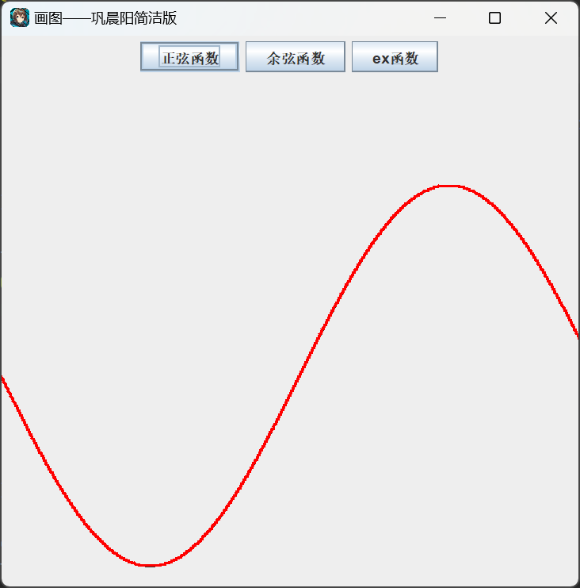
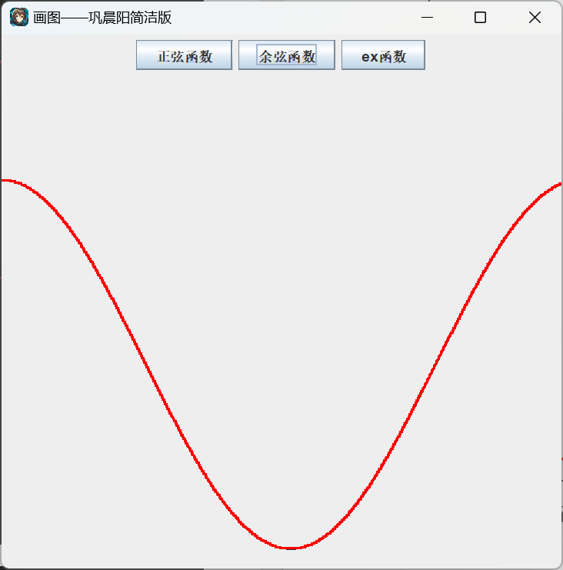
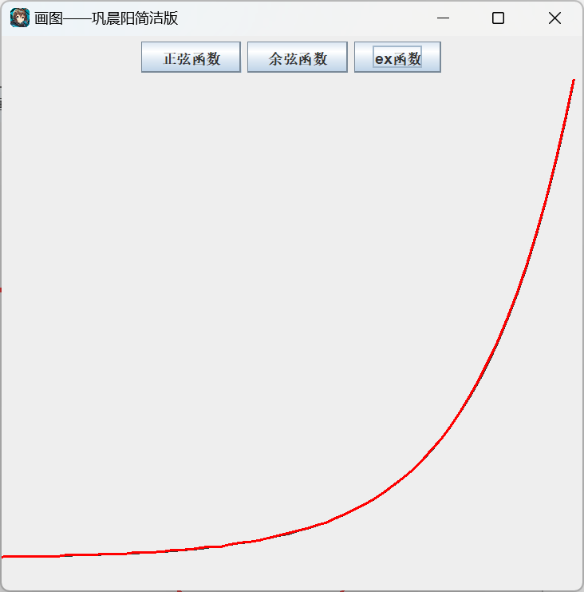
按住左键或者右键对其进行拖动：
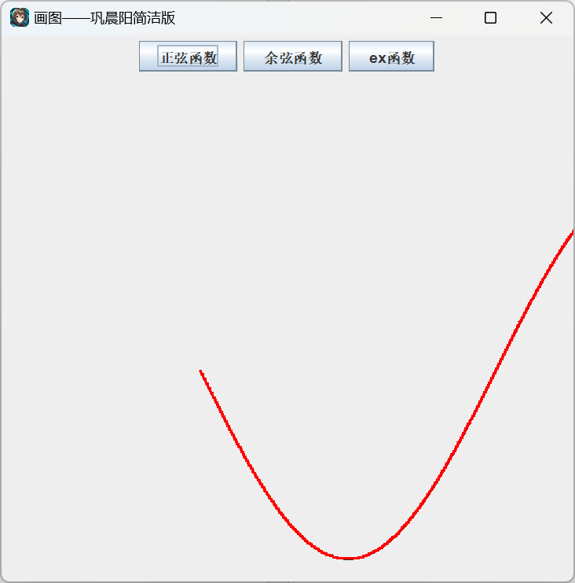
具体拖拽某个点来修改曲线形状：
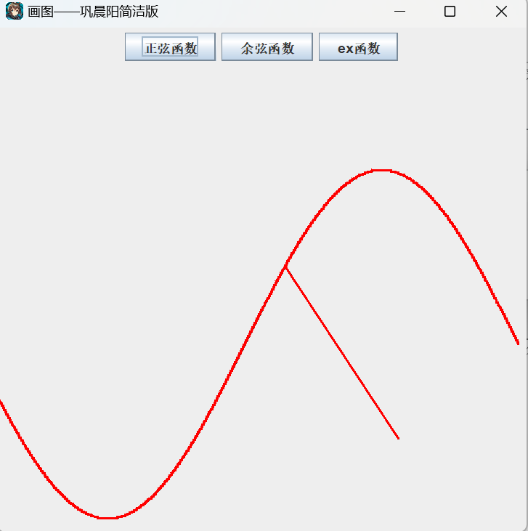
可以看到我拽出来了一个点
第二个实验：
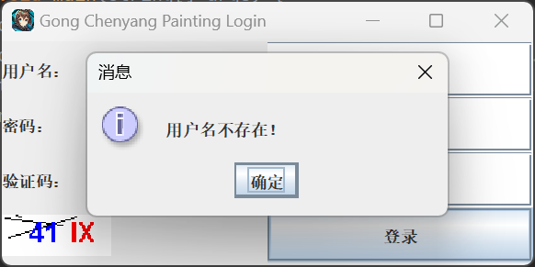
当我未输入用户名时，会弹出一个用户名不存在的按钮
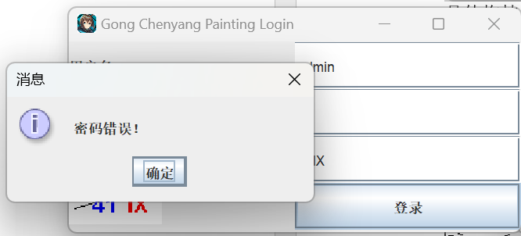
当我输入不正确的密码时，会提示密码错误
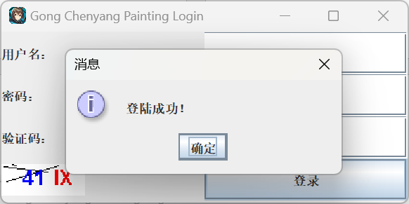
只有当全部输入正确才会弹出登陆成功，届时才会打开画图界面
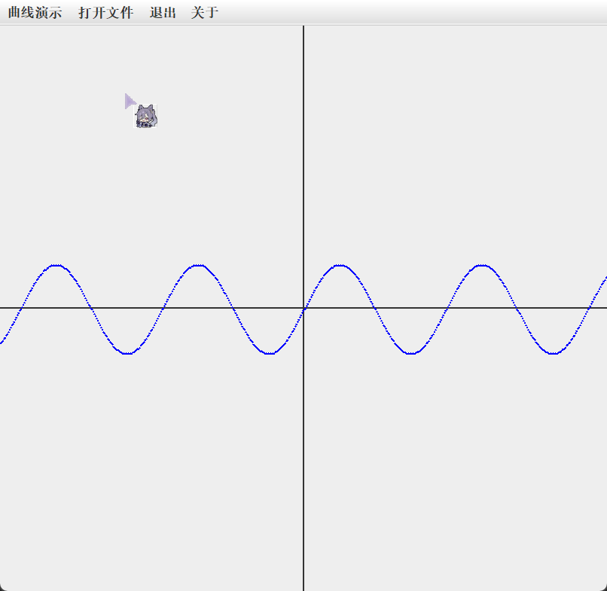
这是选择演示正弦图像
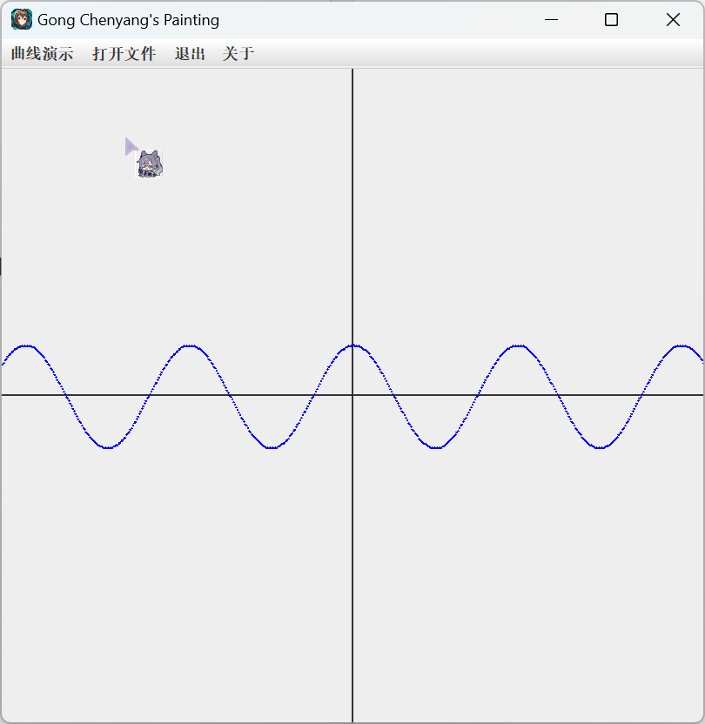
余弦同理
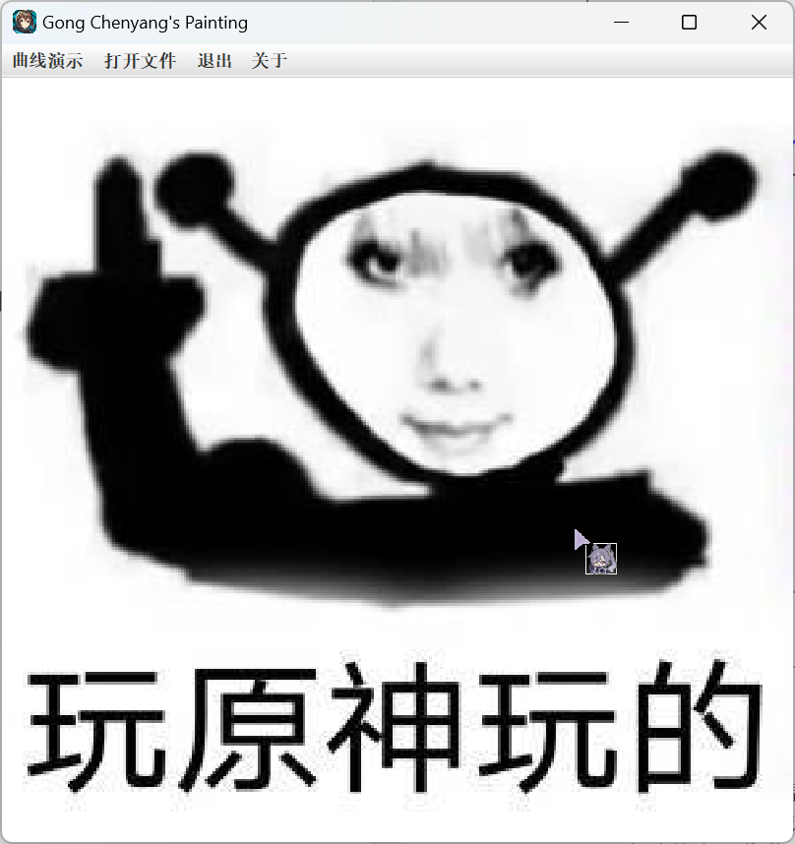
以及其他图像演示
第四个实验：

简单地实现了一些画图功能：
新建：
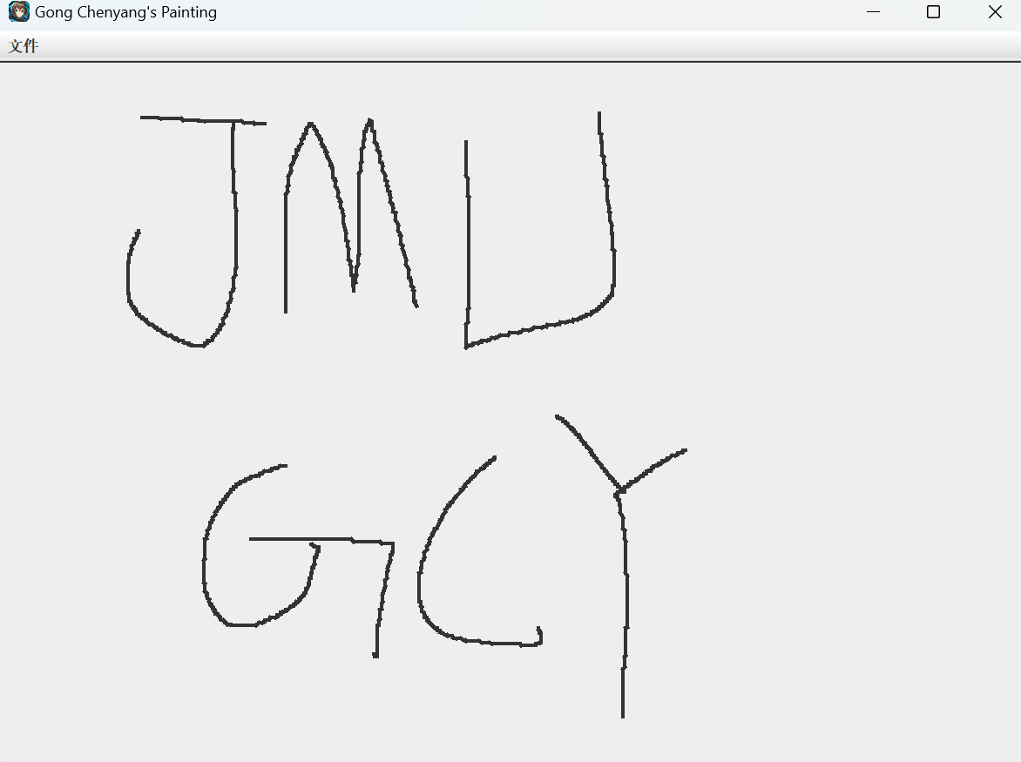
清空：
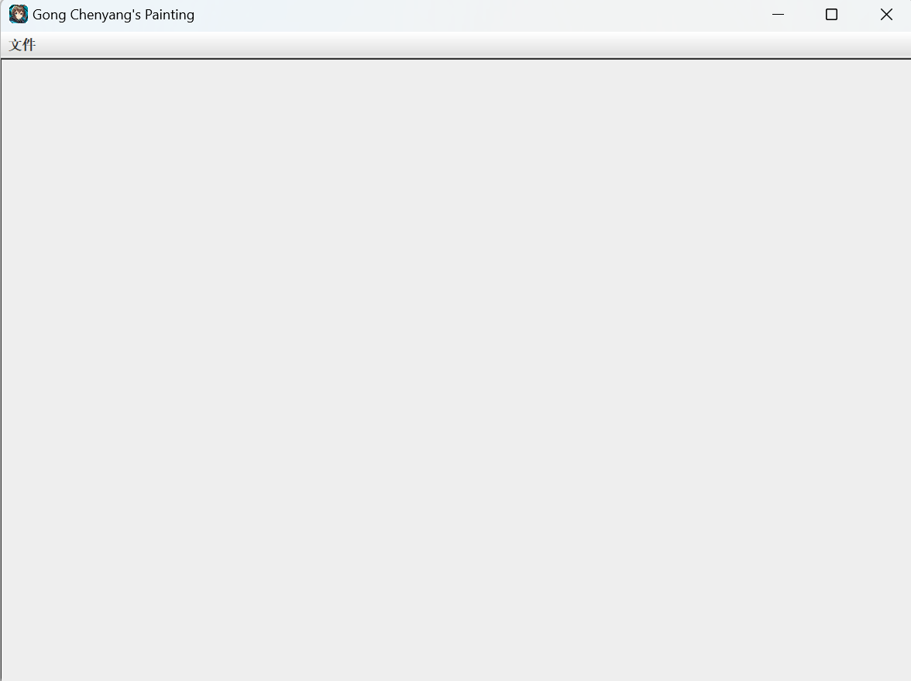
打开
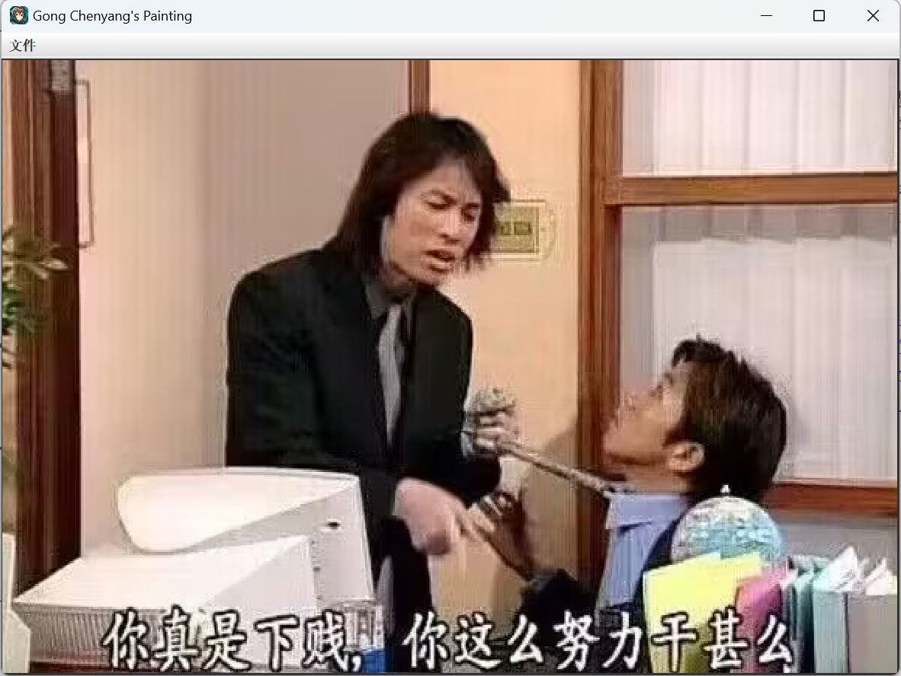
打开并画线：
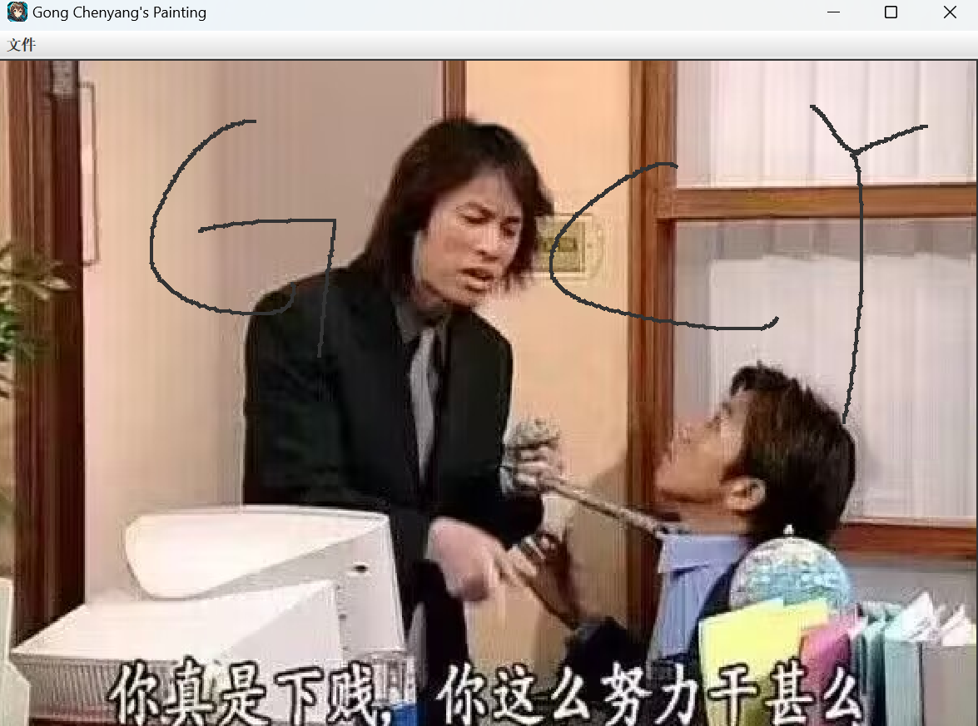
保存：
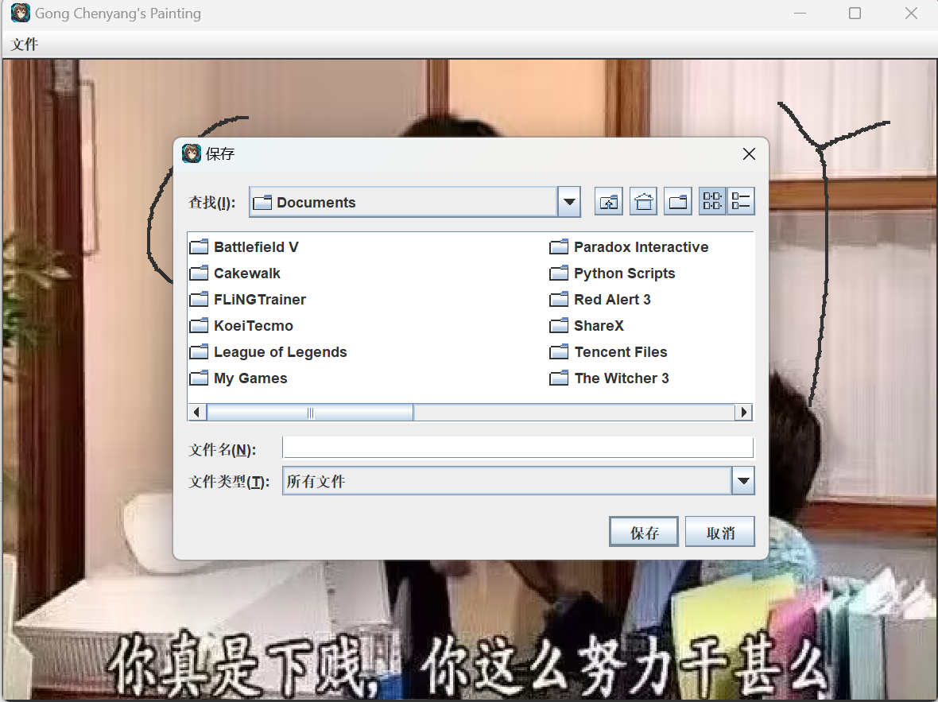
关于：
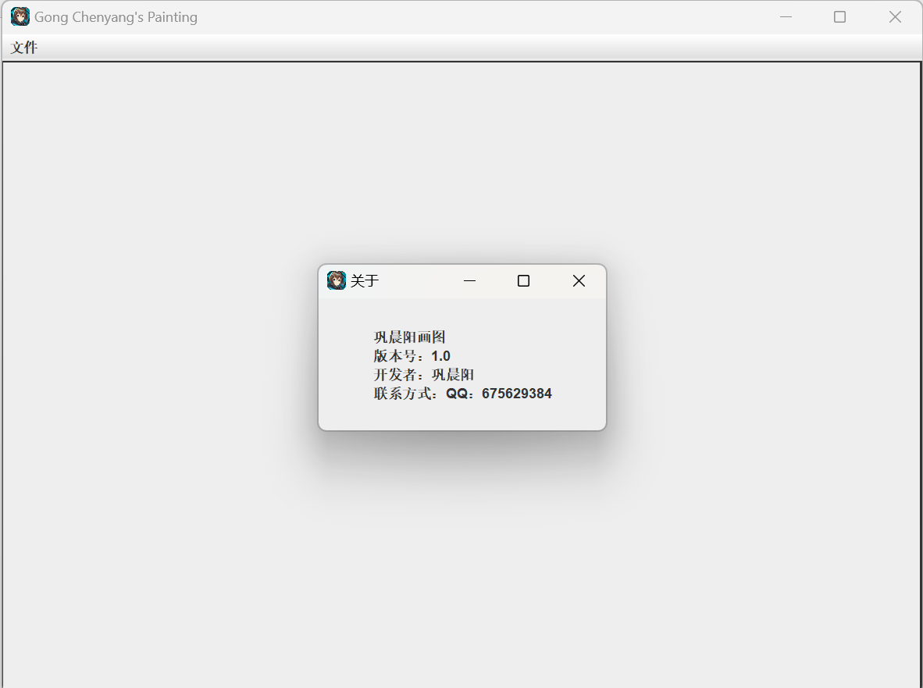
五、实验小结
1．实验中遇到的问题及解决过程
每次选择图像后无法立刻刷新，以及选择图片时无法立刻刷新
使用revalidate();以及JComponent，有效的解决了问题
还有很多，比如没有操控到Component实例，经过检查才有发现，这里就不一一枚举了。
2．实验体会和收获。
通过对于JavaSwing的学习，我进一步了解了Java图形化编程的乐趣，加深了对多态继承封装的理解，可以通过自己的想法来编出一些有趣的程序，学会运用更加高级的组件和方法。

六、附录
Java Swing 介绍 | 菜鸟教程 (runoob.com)
JavaSwing基础_java swing_ShuoHaw的博客-CSDN博客
Java Swing 图形界面开发（目录）_swing图形化目录_xietansheng的博客-CSDN博客
JAVA之Swing组件（常用）_ysysysr_susu的博客-CSDN博客

