集美大学计算机工程学院实验报告

课程名称：软件开发编程基础 | 班级：软件2211 | 实验成绩：
指导教师：李 旺 | 姓名：巩晨阳
实验项目名称： | 学号：202221332033 | 上机实践日期：
实验项目编号： | 组号： | 上机实践时间： 2 学时

一、目的
熟悉类的继承；掌握多态性编程；了解反射机制
二、实验内容与设计思想
1．设计思路
抽象类Geometry与泛型数组列表：
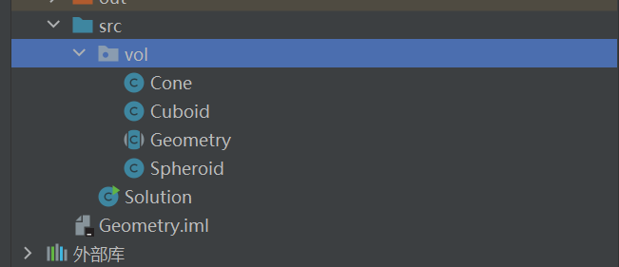
我是将所有的集合体放在一个包里，全部继承自Geometry这个抽象类
Staff, Teacher, SecurityGuard, Dean：
写了两份，第一份不太满意，但是毕竟写了三四百行，还是也放上来吧，总体思路是一样的
旧

新
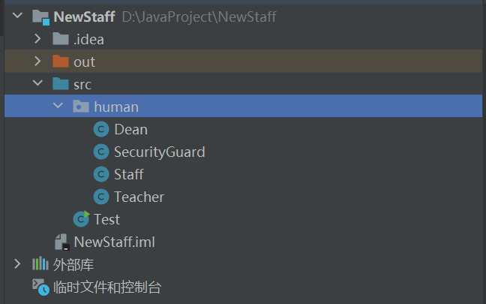
都是把所有的员工类放在一个包里，写好构造函数以及get/set
Account：
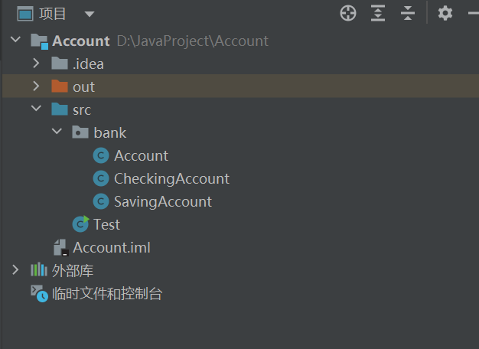
一样的
枚举类型：
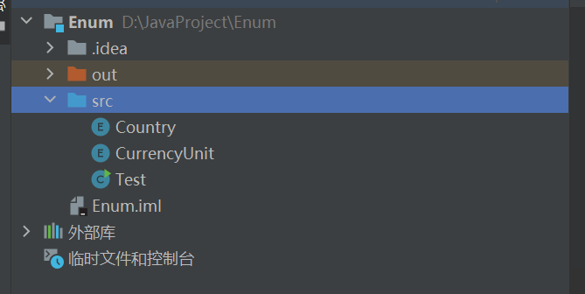
两个枚举类，国家以及货币单位
2. 主要代码结构
抽象类Geometry与泛型数组列表：
Geometry:
package vol;
public abstract class Geometry {
final static double PI=3.1415926535897;
abstract public double getSurfaceArea();
abstract public double getVolume();
}
Cone:
package vol;
import java.util.Objects;
import static java.lang.Math.pow;
public class Cone extends Geometry {
private double r, high;
@Override
public boolean equals(Object o) {
if (this == o) return true;
if (o == null || getClass() != o.getClass()) return false;
Cone cone = (Cone) o;
return Double.compare(cone.r, r) == 0 && Double.compare(cone.high, high) == 0;
}
@Override
public int hashCode() {
return Objects.hash(r, high);
}
@Override
public String toString() {
return "Cone{" +
"r=" + r +
", high=" + high +
'}';
}
public double getR() {
return r;
}
public void setR(double r) {
this.r = r;
}
public double getHigh() {
return high;
}
public void setHigh(double high) {
this.high = high;
}
public Cone(int r, int high) {
this.high = high;
this.r = r;
}
public double getSurfaceArea() {
return PI * r * r + PI * r * pow(r * r + high * high, 0.5);
}
public double getVolume() {
return 1 / 3.0 * PI * PI * r * r * high;
}
}
Cuboid:
package vol;
import java.util.Objects;
public class Cuboid extends Geometry {
private double length;
double wide;
double high;
@Override
public String toString() {
return "Cuboid{" +
"length=" + length +
", wide=" + wide +
", high=" + high +
'}';
}
@Override
public boolean equals(Object o) {
if (this == o) return true;
if (o == null || getClass() != o.getClass()) return false;
Cuboid cuboid = (Cuboid) o;
return Double.compare(cuboid.length, length) == 0 && Double.compare(cuboid.wide, wide) == 0 && Double.compare(cuboid.high, high) == 0;
}
@Override
public int hashCode() {
return Objects.hash(length, wide, high);
}
public double getLength() {
return length;
}
public void setLength(double length) {
this.length = length;
}
public double getWide() {
return wide;
}
public void setWide(double wide) {
this.wide = wide;
}
public double getHigh() {
return high;
}
public void setHigh(double high) {
this.high = high;
}
public Cuboid(double length, double wide, double high) {
this.length = length;
this.wide = wide;
this.high = high;
}
@Override
public double getSurfaceArea() {
return (this.high * this.length + this.wide * this.high + this.length * this.wide) * 2;
}
@Override
public double getVolume() {
return this.high * this.length * this.wide;
}
}
Spheroid:
package vol;
import java.util.Objects;
public class Spheroid extends Geometry {
private double r;
@Override
public String toString() {
return "Spheroid{" +
"r=" + r +
'}';
}
public double getR() {
return r;
}
@Override
public boolean equals(Object o) {
if (this == o) return true;
if (o == null || getClass() != o.getClass()) return false;
Spheroid spheroid = (Spheroid) o;
return Double.compare(spheroid.r, r) == 0;
}
@Override
public int hashCode() {
return Objects.hash(r);
}
public Spheroid(double r) {
this.r = r;
}
public void setR(double r) {
this.r = r;
}
@Override
public double getSurfaceArea() {
return 4 * PI * r * r;
}
@Override
public double getVolume() {
return (4 / 3) * PI * r * r * r;
}
}
Solution:
import vol.*;
import java.util.ArrayList;
public class Solution {
public static void main(String[] args) {
Cuboid cuboid = new Cuboid(10, 10, 10);
Spheroid spheroid = new Spheroid(10);
Cone cone = new Cone(10, 20);
ArrayList<Geometry> vol = new ArrayList<>();
vol.add(cuboid);
vol.add(spheroid);
vol.add(cone);
double SumSurfaceArea = cone.getSurfaceArea() + spheroid.getSurfaceArea() + cuboid.getSurfaceArea();
double SumVolume = cone.getVolume() + spheroid.getVolume() + cuboid.getVolume();
System.out.println("总表面积为：");
System.out.printf("%.2f\n", SumSurfaceArea);
System.out.println("总体积为：");
System.out.printf("%.2f", SumVolume);
}
}
//为什么PI属性要使用final进行修饰？
/*很显然，这是个常量，要是在求值的过程中PI变了那么程序就失去了它的意义*/
Staff, Teacher, SecurityGuard, Dean：
Staff:
package human;
import java.util.Date;
public class Staff {
private String name;
private String address;
private int age;
private String sex;
private double salary;
private Date dateHired;
public Staff(String name, String address, int age, String sex, double salary, Date dateHired) {
this.name = name;
this.address = address;
this.age = age;
this.sex = sex;
this.salary = salary;
this.dateHired = dateHired;
}
public String getName() {
return name;
}
public void setName(String name) {
this.name = name;
}
public String getAddress() {
return address;
}
public void setAddress(String address) {
this.address = address;
}
public int getAge() {
return age;
}
public void setAge(int age) {
this.age = age;
}
public String getSex() {
return sex;
}
public void setSex(String sex) {
this.sex = sex;
}
public double getSalary() {
return salary;
}
public void setSalary(double salary) {
this.salary = salary;
}
public Date getDateHired() {
return dateHired;
}
public void setDateHired(Date dateHired) {
this.dateHired = dateHired;
}
}
Teacher:
package human;
import java.util.Date;
public class Teacher extends Staff {
private String department;
private String speciality;
private double postAllowance;
public Teacher(String name, String address, int age, String sex, double salary, Date dateHired, String department, String speciality, double postAllowance) {
super(name, address, age, sex, salary, dateHired);
this.department = department;
this.speciality = speciality;
this.postAllowance = postAllowance;
}
public String getDepartment() {
return department;
}
public void setDepartment(String department) {
this.department = department;
}
public String getSpeciality() {
return speciality;
}
public void setSpeciality(String speciality) {
this.speciality = speciality;
}
public double getPostAllowance() {
return postAllowance;
}
public void setPostAllowance(double postAllowance) {
this.postAllowance = postAllowance;
}
}
SecurityGuard
package human;
import java.util.Date;
public class SecurityGuard extends Staff {
private String skills;
private double dangerousAllowance;
public SecurityGuard(String name, String address, int age, String sex, double salary, Date dateHired, String skills, double dangerousAllowance) {
super(name, address, age, sex, salary, dateHired);
this.skills = skills;
this.dangerousAllowance = dangerousAllowance;
}
public String getSkills() {
return skills;
}
public void setSkills(String skills) {
this.skills = skills;
}
public double getDangerousAllowance() {
return dangerousAllowance;
}
public void setDangerousAllowance(double dangerousAllowance) {
this.dangerousAllowance = dangerousAllowance;
}
}
Dean:
package human;
import java.util.Date;
public class Dean extends Teacher {
private double adminAward;
public Dean(String name, String address, int age, String sex, double salary, Date dateHired, String department, String speciality, double postAllowance, double adminAward) {
super(name, address, age, sex, salary, dateHired, department, speciality, postAllowance);
this.adminAward = adminAward;
}
public double getAdminAward() {
return adminAward;
}
public void setAdminAward(double adminAward) {
this.adminAward = adminAward;
}
}
Test:
import human.Dean;
import human.SecurityGuard;
import human.Staff;
import human.Teacher;
import java.util.Date;
public class Test {
public static void main(String[] args) {
Staff[] staffs = new Staff[4];
staffs[0] = new Teacher("范乔智", "福建省福州市", 35, "男", 5000, new Date(), "计算机科学与技术", "软件工程", 1000);
staffs[1] = new SecurityGuard("吴才湘", "湖南省怀化市", 28, "男", 3000, new Date(), "防火", 500);
staffs[2] = new Dean("张振宇", "江苏省苏州市", 45, "男", 8000, new Date(), "计算机科学与技术", "网络工程", 2000, 3000);
staffs[3] = new Teacher("陈建兴", "福建省莆田市", 40, "女", 6000, new Date(), "计算机科学与技术", "智能科学与技术", 1500);
printName(staffs);
printSalary(staffs);
sortBySalary(staffs);
sortByAge(staffs);
}
private static void printName(Staff[] persons) {
for (Staff person : persons) {
System.out.println(person.getName());
}
}
private static void printSalary(Staff[] staffs) {
for (Staff staff : staffs) {
if (staff instanceof Teacher) {
Teacher teacher = (Teacher) staff;
System.out.println(teacher.getName() + "的薪水为：" + (teacher.getSalary() + teacher.getPostAllowance()));
} else if (staff instanceof SecurityGuard) {
SecurityGuard securityGuard = (SecurityGuard) staff;
System.out.println(securityGuard.getName() + "的薪水为：" + (securityGuard.getSalary() + securityGuard.getDangerousAllowance()));
} else if (staff instanceof Dean) {
Dean dean = (Dean) staff;
System.out.println(dean.getName() + "的薪水为：" + (dean.getSalary() + dean.getPostAllowance() + dean.getAdminAward()));
} else {
System.out.println(staff.getName() + "的薪水为：" + staff.getSalary());
}
}
}
private static void sortBySalary(Staff[] staffs) {
for (int i = 0; i < staffs.length; i++) {
for (int j = i + 1; j < staffs.length; j++) {
double salary1 = getSalary(staffs[i]);
double salary2 = getSalary(staffs[j]);
if (salary1 < salary2) {
Staff temp = staffs[i];
staffs[i] = staffs[j];
staffs[j] = temp;
}
}
}
System.out.println("按照薪水排序后：");
printSalary(staffs);
}
private static double getSalary(Staff staff) {
if (staff instanceof Teacher) {
Teacher teacher = (Teacher) staff;
return teacher.getSalary() + teacher.getPostAllowance();
} else if (staff instanceof SecurityGuard) {
SecurityGuard securityGuard = (SecurityGuard) staff;
return securityGuard.getSalary() + securityGuard.getDangerousAllowance();
} else if (staff instanceof Dean) {
Dean dean = (Dean) staff;
return dean.getSalary() + dean.getPostAllowance() + dean.getAdminAward();
} else {
return staff.getSalary();
}
}
private static void sortByAge(Staff[] staffs) {
for (int i = 0; i < staffs.length; i++) {
for (int j = i + 1; j < staffs.length; j++) {
if (staffs[i].getAge() > staffs[j].getAge()) {
Staff temp = staffs[i];
staffs[i] = staffs[j];
staffs[j] = temp;
}
}
}
System.out.println("按照年龄升序排序后：");
printName(staffs);
sortBySalary(staffs);
}
}
根据名字排序还没有写
Account：
Account
package bank;
import java.util.Date;
public class Account {
String name;
double balance;
double rate;
Date creat;
public Account(String name, double balance, double rate, Date creat) {
this.name = name;
this.balance = balance;
this.rate = rate;
this.creat = creat;
}
public void setBalance(double balance) {
this.balance = balance;
}
public void WithDraw(double money) {
if(this.balance>money)
{
setBalance(this.balance-money);
System.out.printf("取现成功，本次取现%.2f元，账户余额：%.2f元",money,this.balance);
}
else
System.out.println("余额不足，无法取现");
}
public void Deposit(double money) {
setBalance(this.balance + money);
System.out.printf("存款成功，本次存款%.2f元，账户余额：%.2f元",money,this.balance);
}
public String getName() {
return name;
}
public void setName(String name) {
this.name = name;
}
public double getBalance() {
return balance;
}
public double getRate() {
return rate;
}
public void setRate(double rate) {
this.rate = rate;
}
public Date getCreat() {
return creat;
}
public void setCreat(Date creat) {
this.creat = creat;
}
@Override
public String toString() {
return "Account{" +
"姓名为：'" + name + '\'' +
", 余额=" + balance +
", 年利率=" + rate +
", 账户创建日期=" + creat +
'}';
}
}
SavingAccount：
package bank;
import java.util.Date;
public class SavingAccount extends Account{
public SavingAccount(String name, double balance, double rate, Date creat) {
super(name, balance, rate, creat);
}
double PeriodicBalance;
public void TimeDeposit(int day,double money){
if(money>this.balance){
System.out.println("账户余额无法提供您所存入的金额");
}
else {
this.PeriodicBalance=money;
this.balance-=money;
double temp;
temp=this.PeriodicBalance*(rate)*(day/365.0);
System.out.printf("存%d天之后可获得：%.2f元",day,temp);
}
}
@Override
public String toString() {
return "SavingAccount{" +
"姓名为：" + name + '\'' +
", 余额=" +(balance+PeriodicBalance)+
",年利率=" + rate +
", 账户创建日期=" + creat +
'}';
}
}
CheckAccount：
package bank;
import java.util.Date;
public class CheckingAccount extends Account {//支票帐户
public CheckingAccount(String name, double balance, double rate, Date creat,double overdraw) {
super(name, balance, rate, creat);
this.overdraw=overdraw;
}
//支票帐户有一个透支限定额
double overdraw;
public void setOverdraw(double overdraw) {
this.overdraw = overdraw;
}
@Override
public void WithDraw(double money) {
if(this.balance+this.overdraw>money)
{
setBalance(this.balance-money);
System.out.printf("取现成功，本次取现%.2f元，账户余额：%.2f元",money,this.balance);
}
else
{
System.out.printf("取现失败，可透支余额不足");
}
}
@Override
public String toString() {
return "CheckingAccount{" +
"姓名为：'" + name + '\'' +
", 可透支额=" + overdraw +
", 余额=" + balance +
", 年利率=" + rate +
", 账户创建日期=" + creat +
'}';
}
}
Test：
import bank.*;
import java.util.Date;
public class Test {
public static void main(String[] args) throws ClassNotFoundException, InstantiationException, IllegalAccessException {
Date date=new Date(2010,2,1);
Account a = new Account("唐锴烨",20,0.03,date);
CheckingAccount b=new CheckingAccount("范乔智",2000,0.03,date,500);//懒得再创建一个开户日期了
SavingAccount c=new SavingAccount("李旺",100000000,0.05,date);
System.out.println(a);
System.out.println(b);
System.out.println(c);
//我也不知道该测试什么那就测试个存取款吧
c.Deposit(20000);
System.out.println();
c.WithDraw(1000000);
System.out.println();
b.WithDraw(2200);
System.out.println();
b.WithDraw(2800);
System.out.println();
c.TimeDeposit(1000,10000);
}
}
枚举类型：
CurrencyUnit：
public enum CurrencyUnit {
USD("美元"),
GBP("英镑"),
EUR("欧元"),
CNY("人民币"),
JPY("日元");
private String description;
private CurrencyUnit(String desc) {
this.description = desc;
}
public String getDescription() {
return description;
}
}
Country：
public enum Country {
USA("美国", CurrencyUnit.USD),
UK("英国", CurrencyUnit.GBP),
China("中国", CurrencyUnit.CNY),
France("法国", CurrencyUnit.EUR),
Japan("日本", CurrencyUnit.JPY);
private String description;
private CurrencyUnit currency;
private Country(String desc, CurrencyUnit cu) {
this.description = desc;
this.currency = cu;
}
public String getDescription() {
return description;
}
public CurrencyUnit getCurrency() {
return currency;
}
}
Test：
class Test {
public static void main(String[] args) {
Country china = Country.China;
System.out.println("国家：" + china.getDescription() + "，货币单位：" + china.getCurrency().getDescription());
Country usa = Country.USA;
System.out.println("国家：" + usa.getDescription() + "，货币单位：" + usa.getCurrency().getDescription());
}
}
三、实验使用环境
IDEA
四、实验步骤和调试过程
测试1
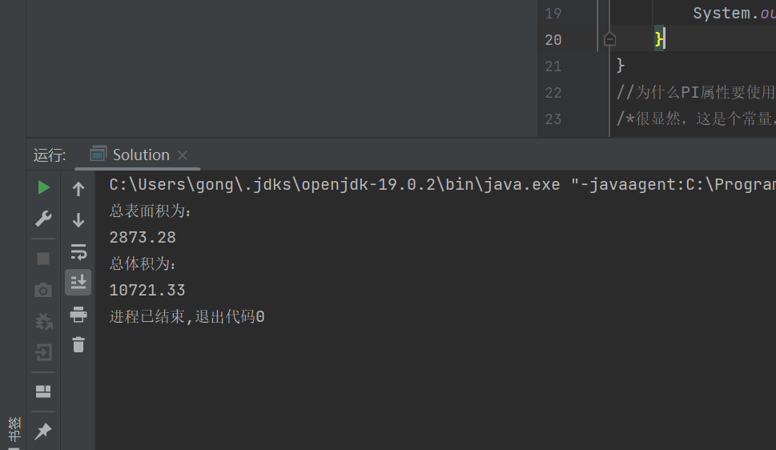
测试2：
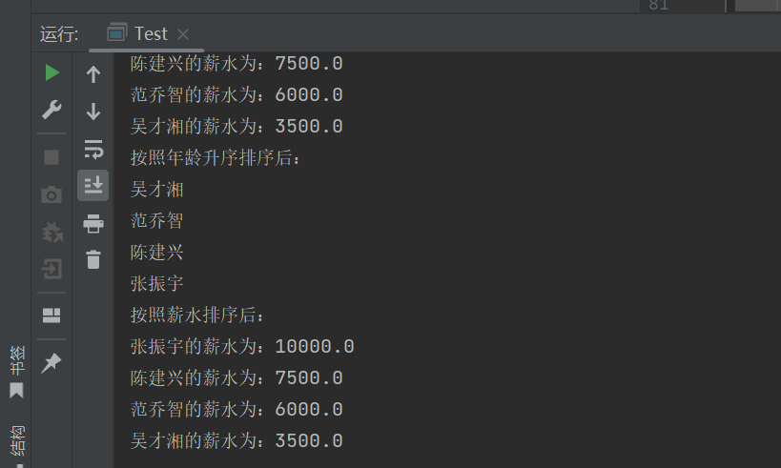
测试3：
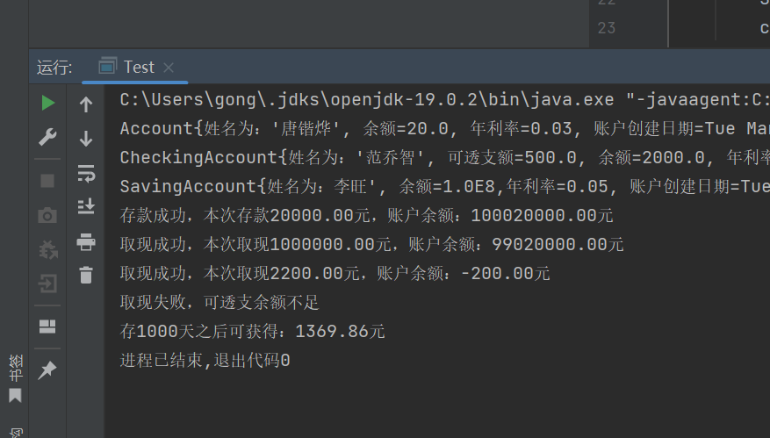
测试4：、
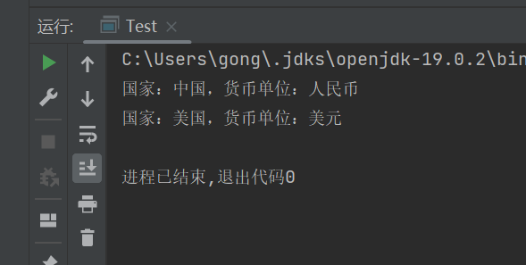
五、实验小结
1．实验中遇到的问题及解决过程
Account的排序方面遇到了问题，经过查询资料最终得到了解决
2．实验中产生的错误及原因分析
命名不规范，代码格式不规范
3．实验体会和收获。
枚举类抽象类更加加深了我对java面向对象的理解，更加深入的理解了封装继承多态一系列用法
六、附录
暂无

