集美大学计算机工程学院实验报告

课程名称：软件开发编程基础 | 班级：软件2211 | 实验成绩：
指导教师：李 旺 | 姓名：巩晨阳
实验项目名称： | 学号：202221332033 | 上机实践日期：2022.3.26
实验项目编号： | 组号： | 上机实践时间： 2 学时

一、目的
掌握接口的定义与实现；熟悉内部类机制；能够使用Comparable、Comparator接口；会使用简单的Lambda表达式
二、实验内容与设计思想
1．设计思路
Geometry与Comparable接口：
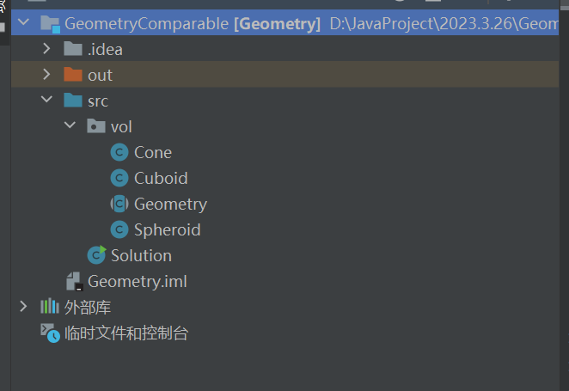
vol包里面放立方体类，其中Geometry是一个抽象类。Solution负责测试。
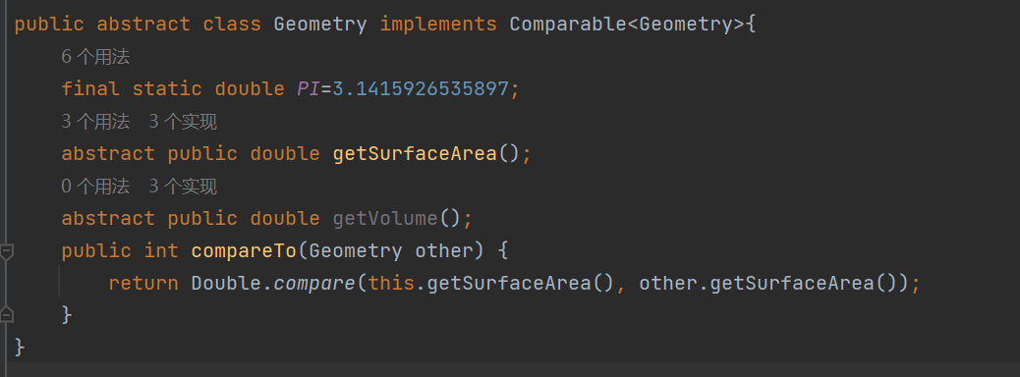
重写了comparTo方法以实现比较表面积的大小。
Staff与Comparator接口：
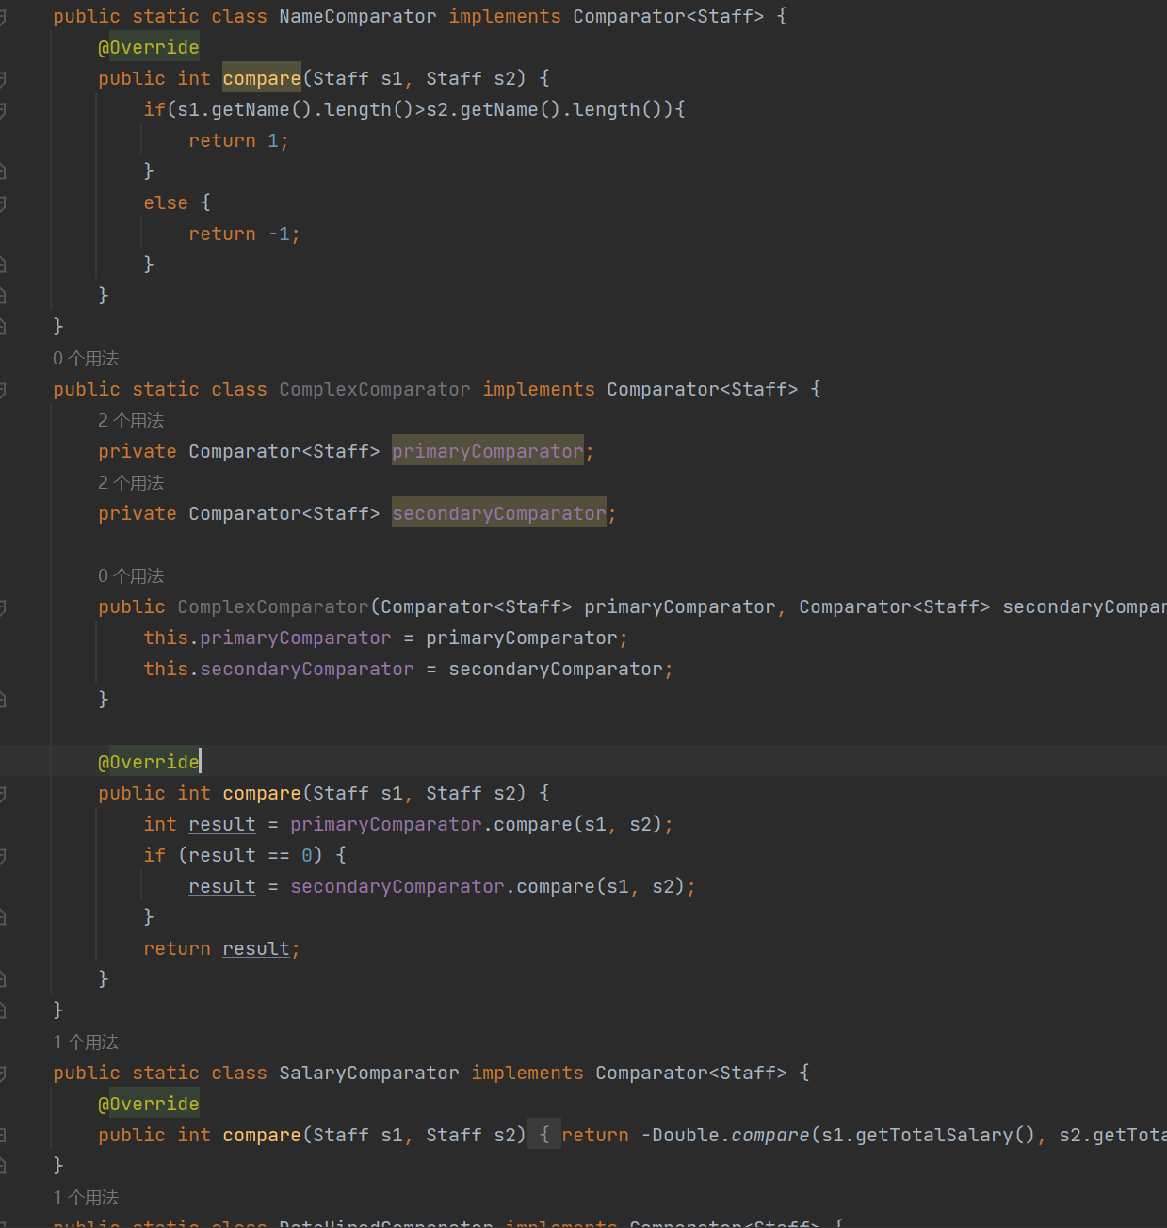
编写了一众比较器
Lambda表达式：
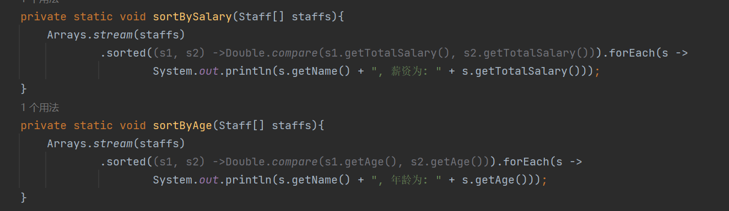
将两个排序函数简化为lambda表达式
2．主要数据结构
暂无
3．主要代码结构
Geometry：
package vol;
public abstract class Geometry implements Comparable<Geometry>{
final static double PI=3.1415926535897;
abstract public double getSurfaceArea();
abstract public double getVolume();
public int compareTo(Geometry other) {
return Double.compare(this.getSurfaceArea(), other.getSurfaceArea());
}
}
Spheroid：
package vol;
import java.util.Objects;
public class Spheroid extends Geometry {
String name="Spheroid";
private double r;
@Override
public String toString() {
return "Spheroid{" +
"r=" + r +
'}';
}
public double getR() {
return r;
}
@Override
public boolean equals(Object o) {
if (this == o) return true;
if (o == null || getClass() != o.getClass()) return false;
Spheroid spheroid = (Spheroid) o;
return Double.compare(spheroid.r, r) == 0;
}
@Override
public int hashCode() {
return Objects.hash(r);
}
public Spheroid(double r) {
this.r = r;
}
public void setR(double r) {
this.r = r;
}
@Override
public double getSurfaceArea() {
return 4 * PI * r * r;
}
@Override
public double getVolume() {
return (4 / 3) * PI * r * r * r;
}
}
Cuboid
package vol;
import java.util.Objects;
public class Cuboid extends Geometry {
String name="Cuboid";
private double length;
double wide;
double high;
@Override
public String toString() {
return "Cuboid{" +
"length=" + length +
", wide=" + wide +
", high=" + high +
'}';
}
@Override
public boolean equals(Object o) {
if (this == o) return true;
if (o == null || getClass() != o.getClass()) return false;
Cuboid cuboid = (Cuboid) o;
return Double.compare(cuboid.length, length) == 0 && Double.compare(cuboid.wide, wide) == 0 && Double.compare(cuboid.high, high) == 0;
}
@Override
public int hashCode() {
return Objects.hash(length, wide, high);
}
public double getLength() {
return length;
}
public void setLength(double length) {
this.length = length;
}
public double getWide() {
return wide;
}
public void setWide(double wide) {
this.wide = wide;
}
public double getHigh() {
return high;
}
public void setHigh(double high) {
this.high = high;
}
public Cuboid(double length, double wide, double high) {
this.length = length;
this.wide = wide;
this.high = high;
}
@Override
public double getSurfaceArea() {
return (this.high * this.length + this.wide * this.high + this.length * this.wide) * 2;
}
@Override
public double getVolume() {
return this.high * this.length * this.wide;
}
}
Cone
package vol;
import java.util.Objects;
import static java.lang.Math.pow;
public class Cone extends Geometry {
String name="Cone";
private double r, high;
@Override
public boolean equals(Object o) {
if (this == o) return true;
if (o == null || getClass() != o.getClass()) return false;
Cone cone = (Cone) o;
return Double.compare(cone.r, r) == 0 && Double.compare(cone.high, high) == 0;
}
@Override
public int hashCode() {
return Objects.hash(r, high);
}
@Override
public String toString() {
return "Cone{" +
"r=" + r +
", high=" + high +
'}';
}
public double getR() {
return r;
}
public void setR(double r) {
this.r = r;
}
public double getHigh() {
return high;
}
public void setHigh(double high) {
this.high = high;
}
public Cone(int r, int high) {
this.high = high;
this.r = r;
}
public double getSurfaceArea() {
return PI * r * r + PI * r * pow(r * r + high * high, 0.5);
}
public double getVolume() {
return 1 / 3.0 * PI * PI * r * r * high;
}
}
Solution
import vol.*;
import java.util.ArrayList;
import java.util.Arrays;
import java.util.Collections;
public class Solution {
public static void main(String[] args) {
Geometry[] geometries = new Geometry[]{
new Cuboid(2, 3, 4),
new Spheroid(2),
new Cone(2, 3),
new Cuboid(1, 2, 3),
new Spheroid(1),
new Cone(1, 2)
};
Arrays.sort(geometries);
for (Geometry i:geometries){
System.out.println("该立方体的面积为："+i.getSurfaceArea()+"\t该立方体的种类为："+i.getClass());
}
}
}
//为什么PI属性要使用final进行修饰？
/*很显然，这是个常量，要是在求值的过程中PI变了那么程序就失去了它的意义*/
/*
改写实验4中的抽象类Geometry，让其实现Comparable接口，实现对表面积的排序；在测试类中创建Geometry类型的数组或动态数组，里面有若干个Cubo
id、Spheroid和Cone对象，然后利用Arrays.sort或Collections.sort对该Geometry数组或动态数组进行排序；输出排序后Geometry数组。*/
Staff:
package human;
import java.util.Comparator;
import java.util.Date;
public class Staff {
private String name;
private String address;
private int age;
private String sex;
private double salary;
private Date dateHired;
public Staff(String name, String address, int age, String sex, double salary, Date dateHired) {
this.name = name;
this.address = address;
this.age = age;
this.sex = sex;
this.salary = salary;
this.dateHired = dateHired;
}
public String getName() {
return name;
}
public void setName(String name) {
this.name = name;
}
public String getAddress() {
return address;
}
public void setAddress(String address) {
this.address = address;
}
public int getAge() {
return age;
}
public void setAge(int age) {
this.age = age;
}
public String getSex() {
return sex;
}
public void setSex(String sex) {
this.sex = sex;
}
public double getSalary() {
return salary;
}
public double getTotalSalary() {
return getSalary();
}
public void setSalary(double salary) {
this.salary = salary;
}
public Date getDateHired() {
return dateHired;
}
public void setDateHired(Date dateHired) {
this.dateHired = dateHired;
}
public static class AgeComparator implements Comparator<Staff> {
@Override
public int compare(Staff s1, Staff s2) {
return Integer.compare(s1.getAge(), s2.getAge());
}
}
public static class NameComparator implements Comparator<Staff> {
@Override
public int compare(Staff s1, Staff s2) {
if(s1.getName().length()>s2.getName().length()){
return 1;
}
else {
return -1;
}
}
}
public static class ComplexComparator implements Comparator<Staff> {
private Comparator<Staff> primaryComparator;
private Comparator<Staff> secondaryComparator;
public ComplexComparator(Comparator<Staff> primaryComparator, Comparator<Staff> secondaryComparator) {
this.primaryComparator = primaryComparator;
this.secondaryComparator = secondaryComparator;
}
@Override
public int compare(Staff s1, Staff s2) {
int result = primaryComparator.compare(s1, s2);
if (result == 0) {
result = secondaryComparator.compare(s1, s2);
}
return result;
}
}
public static class SalaryComparator implements Comparator<Staff> {
@Override
public int compare(Staff s1, Staff s2) {
return -Double.compare(s1.getTotalSalary(), s2.getTotalSalary());
}
}
public static class DateHiredComparator implements Comparator<Staff> {
@Override
public int compare(Staff s1, Staff s2) {
return s1.getDateHired().compareTo(s2.getDateHired());
}
}
}
Teacher:
package human;
import java.util.Date;
public class Teacher extends Staff {
private String department;
private String speciality;
private double postAllowance;
public Teacher(String name, String address, int age, String sex, double salary, Date dateHired, String department, String speciality, double postAllowance) {
super(name, address, age, sex, salary, dateHired);
this.department = department;
this.speciality = speciality;
this.postAllowance = postAllowance;
}
public double getTotalSalary() {
return getSalary() + getPostAllowance();
}
public String getDepartment() {
return department;
}
public void setDepartment(String department) {
this.department = department;
}
public String getSpeciality() {
return speciality;
}
public void setSpeciality(String speciality) {
this.speciality = speciality;
}
public double getPostAllowance() {
return postAllowance;
}
public void setPostAllowance(double postAllowance) {
this.postAllowance = postAllowance;
}
}
SecurityGuard:
package human;
import java.util.Date;
public class SecurityGuard extends Staff {
private String skills;
private double dangerousAllowance;
public SecurityGuard(String name, String address, int age, String sex, double salary, Date dateHired, String skills, double dangerousAllowance) {
super(name, address, age, sex, salary, dateHired);
this.skills = skills;
this.dangerousAllowance = dangerousAllowance;
}
public double getTotalSalary() {
return getSalary()+getDangerousAllowance();
}
public String getSkills() {
return skills;
}
public void setSkills(String skills) {
this.skills = skills;
}
public double getDangerousAllowance() {
return dangerousAllowance;
}
public void setDangerousAllowance(double dangerousAllowance) {
this.dangerousAllowance = dangerousAllowance;
}
}
Dean:
package human;
import java.util.Date;
public class Dean extends Teacher {
private double adminAward;
public Dean(String name, String address, int age, String sex, double salary, Date dateHired, String department, String speciality, double postAllowance, double adminAward) {
super(name, address, age, sex, salary, dateHired, department, speciality, postAllowance);
this.adminAward = adminAward;
}
public double getAdminAward() {
return adminAward;
}
public double getTotalSalary() {
return getSalary()+getPostAllowance()+getAdminAward();
}
public void setAdminAward(double adminAward) {
this.adminAward = adminAward;
}
}
Test
import human.Dean;
import human.SecurityGuard;
import human.Staff;
import human.Teacher;
import java.sql.Array;
import java.util.Arrays;
import java.util.Comparator;
import java.util.Date;
public class Test {
private static void printName(Staff[] staffs) {
for (Staff i : staffs) {
System.out.println(i.getName());
}
}
private static void printSalary(Staff[] staffs) {
for (Staff i : staffs) {
System.out.println(i.getName() + "薪水为：" + i.getTotalSalary());
}
}
private static void printAge(Staff[] staffs) {
for (Staff i : staffs) {
System.out.println(i.getName() + "年龄为：" + i.getAge());
}
}
private static void sortBySalary(Staff[] staffs) {
Arrays.sort(staffs, new Staff.SalaryComparator());
}
private static void sortByAge(Staff[] staffs) {
Arrays.sort(staffs, new Staff.AgeComparator());
}
private static void sortByName(Staff[] staffs) {
Arrays.sort(staffs, new Staff.NameComparator());
}
private static void sortByDateHired(Staff[] staffs) {
Arrays.sort(staffs, new Staff.DateHiredComparator());
}
public static void main(String[] args) {
Staff[] staffs = new Staff[4];
staffs[0] = new Teacher("集美大学范乔智", "福建省福州市", 35, "男", 5000, new Date(2020, 1, 1), "计算机科学与技术", "软件工程", 1000);
staffs[1] = new SecurityGuard("吴才湘", "湖南省怀化市", 28, "男", 3000, new Date(1111, 1, 1), "防火", 500);
staffs[2] = new Dean("张振宇", "江苏省苏州市", 45, "男", 8000, new Date(2222, 1, 1), "计算机科学与技术", "网络工程", 2000, 3000);
staffs[3] = new Teacher("吴润", "福建省莆田市", 40, "男", 6000, new Date(5555, 1, 1), "计算机科学与技术", "智能科学与技术", 1500);
Arrays.sort(staffs, new Staff.AgeComparator());
printSalary(staffs);
Arrays.sort(staffs, new Staff.NameComparator());
printName(staffs);
sortBySalary(staffs);
printSalary(staffs);
sortByAge(staffs);
printAge(staffs);
sortByName(staffs);
printName(staffs);
sortByDateHired(staffs);
printName(staffs);
}
}
/*编写一个测试类，在测试类中添加若干个Staff, Teacher, SecurityGuard, Dean实例(个数及内容自定)，并在测试类中定义并测试如下方法：
①编写一个方法private static void printName(Staff[] staffs)打印出每个人的名字；
②编写一个方法private static void printSalary(Staff[] staffs)打印出Staff类或者其子类对象的薪水
(注意：Staff的薪水只有salary，Teacher的薪水为salary+postAllowance，SecurityGuard的薪水为salary+
dangerousAllowance，而Dean的薪水则为salary+postAllowance+adminAward)；
③编写一方法private static void sortBySalary(Staff[] staffs)，支持对Staff类及其子类按照各自的薪水降序排序；
④编写一方法private static void sortByAge(Staff[] staffs)，对Staff对象按照年龄升序排序，再编写一个方法按name升序进行排序；
⑤编写一方法sortByDateHired，支持对Staff类及其子类按照各自的dateHired升序排序，可以使用java.util.Date类的getTime方法。*/

Test
import human.Dean;
import human.SecurityGuard;
import human.Staff;
import human.Teacher;
import java.sql.Array;
import java.util.Arrays;
import java.util.Comparator;
import java.util.Date;
public class Test {
private static void printName(Staff[] staffs) {
for (Staff i : staffs) {
System.out.println(i.getName());
}
}
private static void printSalary(Staff[] staffs){
for (Staff i : staffs) {
System.out.println(i.getName() + "薪水为：" + i.getTotalSalary());
}
}
private static void printAge(Staff[] staffs) {
for (Staff i : staffs) {
System.out.println(i.getName() + "年龄为：" + i.getAge());
}
}
private static void sortBySalary(Staff[] staffs){
Arrays.stream(staffs)
.sorted((s1, s2) ->Double.compare(s1.getTotalSalary(), s2.getTotalSalary())).forEach(s ->
System.out.println(s.getName() + ", 薪资为: " + s.getTotalSalary()));
}
private static void sortByAge(Staff[] staffs){
Arrays.stream(staffs)
.sorted((s1, s2) ->Double.compare(s1.getAge(), s2.getAge())).forEach(s ->
System.out.println(s.getName() + ", 年龄为: " + s.getAge()));
}
private static void sortByName(Staff[] staffs){
Arrays.sort(staffs,new Staff.NameComparator());
}
private static void sortByDateHired(Staff[] staffs){
Arrays.sort(staffs,new Staff.DateHiredComparator());
}
public static void main(String[] args) {
Staff[] staffs = new Staff[4];
staffs[0] = new Teacher("集美大学范乔智", "福建省福州市", 35, "男", 5000, new Date(2020,1,1), "计算机科学与技术", "软件工程", 1000);
staffs[1] = new SecurityGuard("吴才湘", "湖南省怀化市", 28, "男", 3000, new Date(1111,1,1), "防火", 3455);
staffs[2] = new Dean("张振宇", "江苏省苏州市", 45, "男", 8000, new Date(2222,1,1), "计算机科学与技术", "网络工程", 2000, 3000);
staffs[3] = new Teacher("吴润", "福建省莆田市", 40, "男", 6000, new Date(5555,1,1), "计算机科学与技术", "智能科学与技术", 10001);
sortBySalary(staffs);
sortByAge(staffs);
}
}

三、实验使用环境
IntelliJ IDEA
四、实验步骤和调试过程
Geometry与Comparable接口：
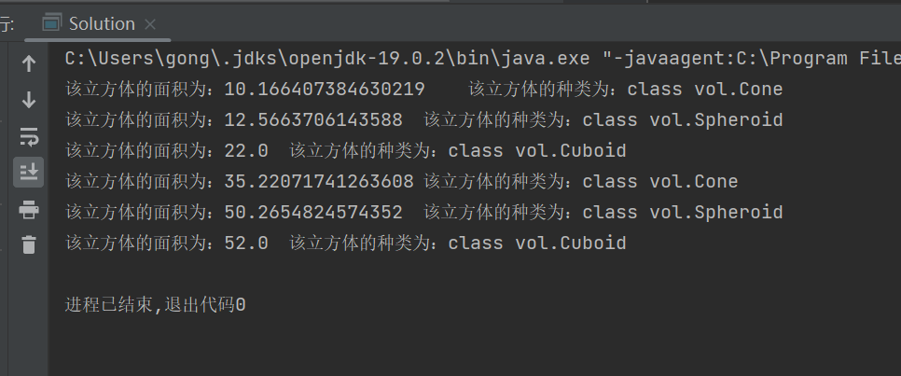

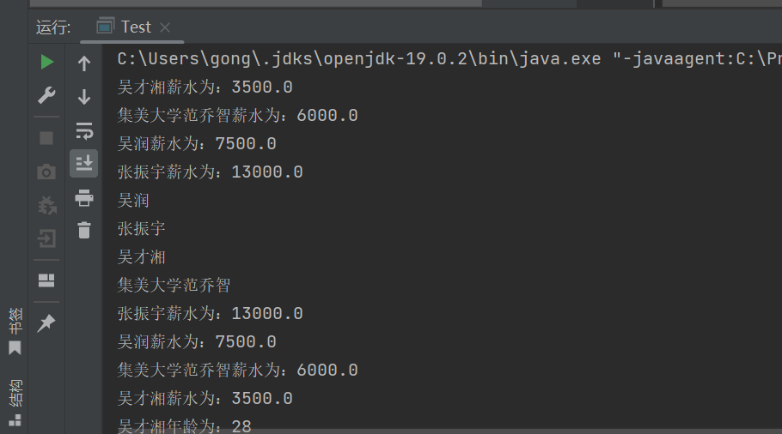

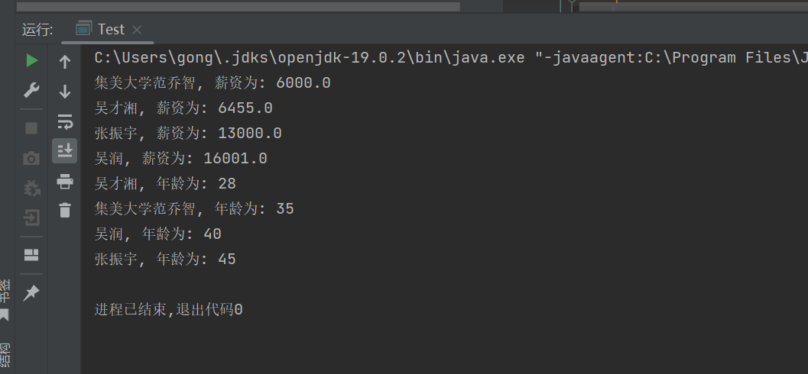
五、实验小结
1．实验中遇到的问题及解决过程
接口掌握不是很好，经过csdn得到了答案
2．实验中产生的错误及原因分析
比较器返回类型出错，经检查修改正确
3．实验体会和收获。、
这次的实验让我掌握了类的接口以及内部类的使用，增加了对于java语言的理解

