集美大学计算机工程学院实验报告

课程名称：软件开发编程基础 | 班级：软件2211 | 实验成绩：
指导教师：李 旺 | 姓名：巩晨阳
实验项目名称：流与文件 | 学号：202221332033 | 上机实践日期：
实验项目编号：09 | 组号： | 上机实践时间： 2 学时

一、目的
理解流与文件的区别与联系；掌握各种流操作方法
二、实验内容与设计思想
1. 字节流、过滤流、字符流、对象流
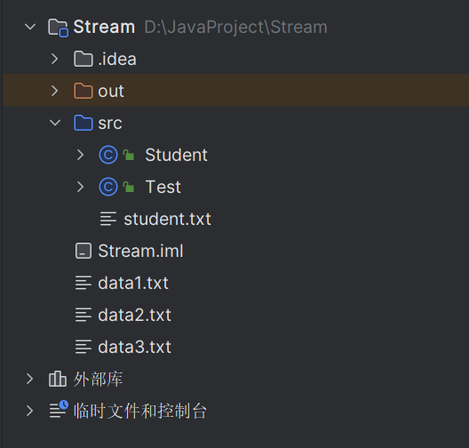
分为Student和Test两个部分
Student：
import java.io.*;
import java.util.ArrayList;
import java.util.List;
/**
* @author gong
*/
public class Student {
private int id;
private String name;
private int age;
private double grade;
public Student(int id, String name, int age, double grade) {
this.id = id;
this.name = name;
this.age = age;
this.grade = grade;
}
public static void writeStudent(List<Student> stus, ObjectOutputStream oos) throws IOException {
for (Student i : stus) {
oos.writeInt(i.getId());
oos.writeUTF(i.getName());
oos.writeInt(i.getAge());
oos.writeDouble(i.getGrade());
}
}
public static List<Student> readStudent(ObjectInputStream ois) throws IOException {
List<Student> students = new ArrayList<>(10);
for (int i = 0; i < 10; i++) {
int id = ois.readInt();
String name = ois.readUTF();
int age = ois.readInt();
double grade = ois.readDouble();
students.add(new Student(id, name, age, grade));
}
return students;
}
public int getId() {
return id;
}
public void setId(int id) {
this.id = id;
}
public String getName() {
return name;
}
public void setName(String name) {
this.name = name;
}
public int getAge() {
return age;
}
public void setAge(int age) {
this.age = age;
}
public double getGrade() {
return grade;
}
public void setGrade(double grade) {
this.grade = grade;
}
@Override
public String toString() {
return "Student{" +
"id=" + id +
", name='" + name + '\'' +
", age=" + age +
", grade=" + grade +
'}'+'\n';
}
public static void writeStudent(List<Student> students, PrintWriter pw) {
for (Student i : students) {
pw.print(i.getId() + "|");
pw.print(i.getName() + "|");
pw.print(i.getAge() + "|");
pw.print(i.getGrade());
pw.println();
}
}
public static void writeStudent(List<Student> students, DataOutputStream dos) throws IOException {
dos.writeInt(students.size());
for (Student s : students) {
writeStudent(s, dos);
}
}
public static void writeStudent(Student s, DataOutputStream dos) throws IOException {
dos.writeInt(s.getId());
dos.writeUTF(s.getName());
dos.writeInt(s.getAge());
dos.writeDouble(s.getGrade());
}
public static List<Student> readStudent(DataInputStream dis) throws IOException {
int size = dis.readInt();
List<Student> students = new ArrayList<>(size);
for (int i = 0; i < size; i++) {
int id = dis.readInt();
String name = dis.readUTF();
int age = dis.readInt();
double grade = dis.readDouble();
students.add(new Student(id, name, age, grade));
}
return students;
}
}
Test
import java.io.*;
import java.util.ArrayList;
import java.util.List;
import java.util.Scanner;
/**
* @author gong
*/
public class Test {
public static void main(String[] args) throws IOException, ClassNotFoundException {
// 生成测试数据
List<Student> stus = new ArrayList<>();
for (int i = 0; i < 10; i++) {
Student s = new Student(i + 1, "Student" , 18, 60 + i % 40);
stus.add(s);
}
// 使用 DataInputStream/DataOutputStream 写入文件
long start1 = System.currentTimeMillis();
try (DataOutputStream dos = new DataOutputStream(new FileOutputStream("data1.txt"))) {
Student.writeStudent(stus, dos);
}
try (DataInputStream dis =new DataInputStream(new FileInputStream("data1.txt"))){
System.out.println(Student.readStudent(dis));
}
long end1 = System.currentTimeMillis();
System.out.println("DataInputStream/DataOutputStream 耗时：" + (end1 - start1) + "ms");
//Scanner(或BufferedReader), PrintWriter
long start2 = System.currentTimeMillis();
try (PrintWriter pw = new PrintWriter(new FileWriter("data2.txt"))) {
Student.writeStudent(stus, pw);
}
Scanner scanner =new Scanner(new File("data2.txt"));
try {
for (Scanner it = scanner; it.hasNext(); )
{
System.out.println(it.next());
}
}catch (Exception e){
e.printStackTrace();
}
long end2 = System.currentTimeMillis();
System.out.println("Scanner/PrintWriter 耗时：" + (end2 - start2) + "ms");
//ObjectInputStream, ObjectOutputStream
long start3=System.currentTimeMillis();
ObjectOutputStream oos=new ObjectOutputStream(new FileOutputStream("data3.txt"));
ObjectInputStream ois=new ObjectInputStream(new FileInputStream("data3.txt"));
try(oos){
Student.writeStudent(stus,oos);
}catch (Exception e){
e.printStackTrace();
}
try (ois){
System.out.println(Student.readStudent(ois));
}
long end3=System.currentTimeMillis();
System.out.println("ObjectInputStream/ObjectOutputStream 耗时："+ (end3 - start3) + "ms");
}
}
2. 二进制文件查看器
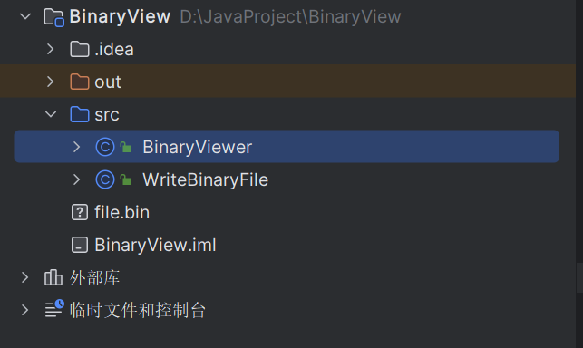
分别是写二进制文件和读二进制文件
写：
import java.io.*;
/**
* @author gong
*/
public class WriteBinaryFile {
public static void main(String[] args) throws IOException {
DataOutputStream dos = new DataOutputStream(new FileOutputStream("file.bin"));
dos.writeInt(128);
dos.writeChars("Sine");
dos.close();
}
}
读：
import java.io.File;
import java.io.FileInputStream;
import java.io.IOException;
/**
* @author gong
*/
public class BinaryViewer {
public static void main(String[] args) throws IOException {
String filename = "file.bin";
final int LINE_SIZE = 16;
byte[] buffer = new byte[LINE_SIZE];
// 打开文件
FileInputStream fis = new FileInputStream(new File(filename));
// 输出文件内容
int offset = 0;
while (fis.read(buffer) != -1) {
// 输出左侧地址
System.out.printf("%08x ", offset);
// 输出中间16字节的16进制字符并用空格分隔
for (int i = 0; i < LINE_SIZE; i++) {
if (i == 8) {
System.out.print(" ");
}
if (i < buffer.length) {
System.out.printf("%02x", buffer[i]);
} else {
System.out.print(" ");
}
System.out.print(" ");
}
// 输出右侧字符
System.out.print(" ");
for (int i = 0; i < LINE_SIZE; i++) {
if (i < buffer.length) {
if (buffer[i] >= ' ' && buffer[i] <= '~') {
System.out.print((char) buffer[i]);
} else {
System.out.print(".");
}
} else {
System.out.print(" ");
}
}
// 换行
System.out.println();
offset += LINE_SIZE;
}
// 关闭文件
fis.close();
}
}
3. 文件检索
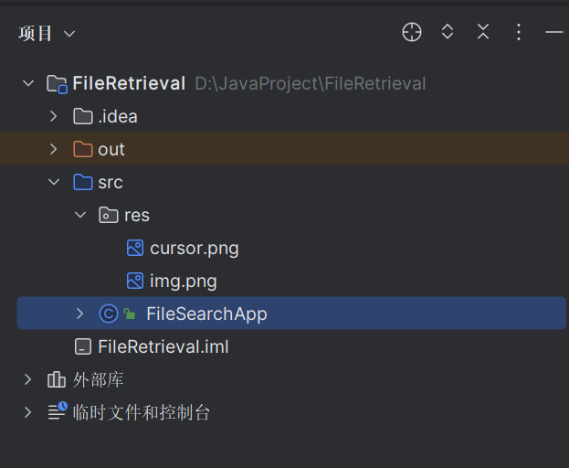
FileSearchApp：
import java.awt.*;
import java.awt.event.ActionEvent;
import java.awt.event.ActionListener;
import java.awt.image.BufferedImage;
import java.io.File;
import java.util.ArrayList;
import javax.swing.*;
/**
* @author gong
*/
public class FileSearchApp extends JFrame {
private JTextField dirField;
private JTextField extField;
private JTextArea resultsArea;
public FileSearchApp() {
super("文件搜索");
setDefaultCloseOperation(JFrame.EXIT_ON_CLOSE);
setSize(600, 400);
setLocationRelativeTo(null);
Image image= new ImageIcon("src/res/img.png").getImage();
setIconImage(image);
Image cursorImg = Toolkit.getDefaultToolkit().getImage("src/res/cursor.png");
Cursor customCursor = Toolkit.getDefaultToolkit().createCustomCursor(cursorImg, new Point(0, 0), "YuanShen");
Container contentPane = getContentPane();
contentPane.setLayout(new BorderLayout());
// 创建顶部面板
JPanel topPanel = new JPanel();
topPanel.add(new JLabel("检索目录："));
dirField = new JTextField(30);
topPanel.add(dirField);
topPanel.add(new JLabel("文件类型："));
extField = new JTextField(10);
topPanel.add(extField);
JButton searchBtn = new JButton("搜索");
searchBtn.addActionListener(new ActionListener() {
public void actionPerformed(ActionEvent e) {
searchFiles();
}
});
topPanel.add(searchBtn);
contentPane.add(topPanel, BorderLayout.NORTH);
// 创建结果显示区域
resultsArea = new JTextArea();
JScrollPane scrollPane = new JScrollPane(resultsArea);
scrollPane.setPreferredSize(new Dimension(550, 300));
contentPane.add(scrollPane, BorderLayout.CENTER);
}
private void searchFiles() {
resultsArea.setText("");
String startDir = dirField.getText().trim();
String ext = extField.getText().trim();
if (startDir.length() == 0 || ext.length() == 0) {
resultsArea.setText("请输入检索目录和文件类型");
return;
}
File dir = new File(startDir);
if (!dir.isDirectory()) {
resultsArea.setText("起始检索目录不存在或不是一个目录！");
return;
}
ArrayList<String> foundFiles = findFiles(dir, ext);
resultsArea.append("检索完成，共找到 " + foundFiles.size() + " 个符合条件的文件：\n");
for (String file : foundFiles) {
resultsArea.append(file + "\n");
}
}
private ArrayList<String> findFiles(File dir, String ext) {
ArrayList<String> fileList = new ArrayList<String>();
File[] files = dir.listFiles();
for (File file : files) {
if (file.isFile() && file.getName().endsWith(ext)) {
fileList.add(file.getAbsolutePath());
} else if (file.isDirectory()) {
ArrayList<String> subList = findFiles(file, ext);
fileList.addAll(subList);
}
}
return fileList;
}
public static void main(String[] args) {
FileSearchApp app = new FileSearchApp();
app.setVisible(true);
}
}

三、实验使用环境
IntelliJ IDEA 2022.3.2
四、实验步骤和调试过程
1. 字节流、过滤流、字符流、对象流
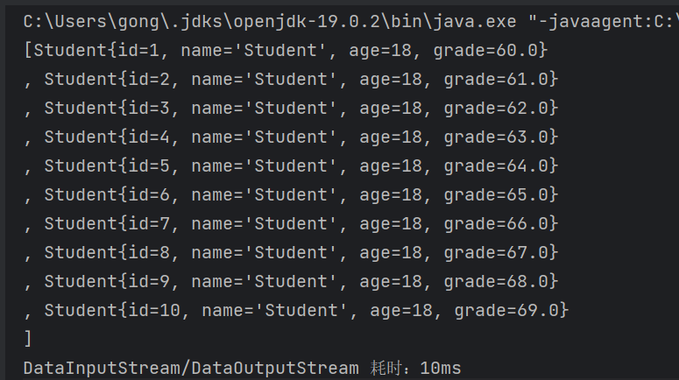
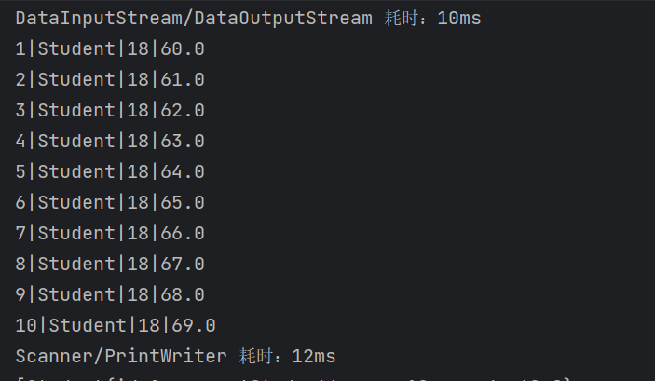
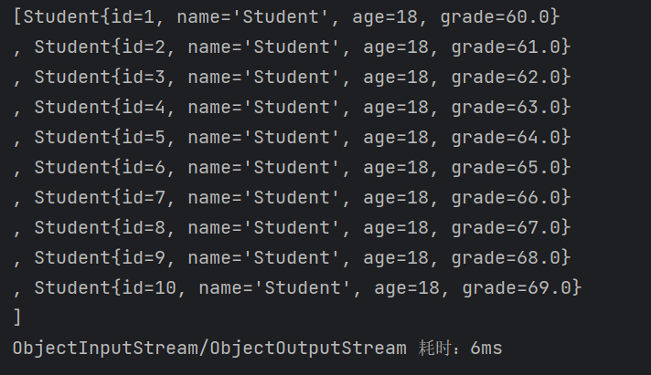
文件1大小：
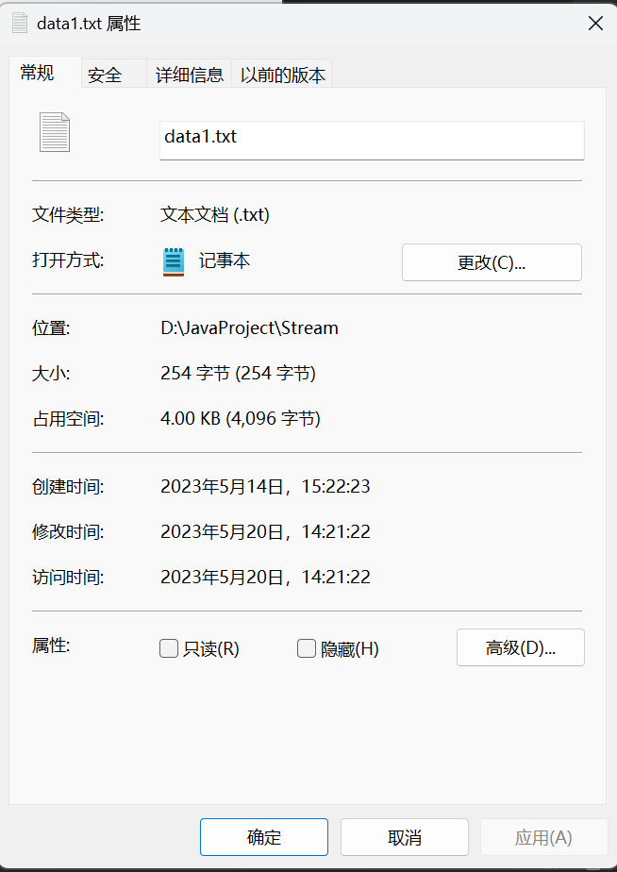
文件2大小：
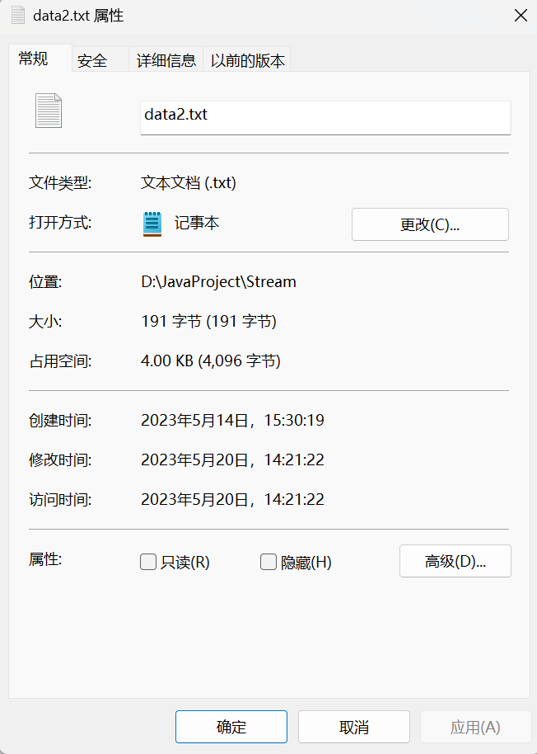
文件3大小：
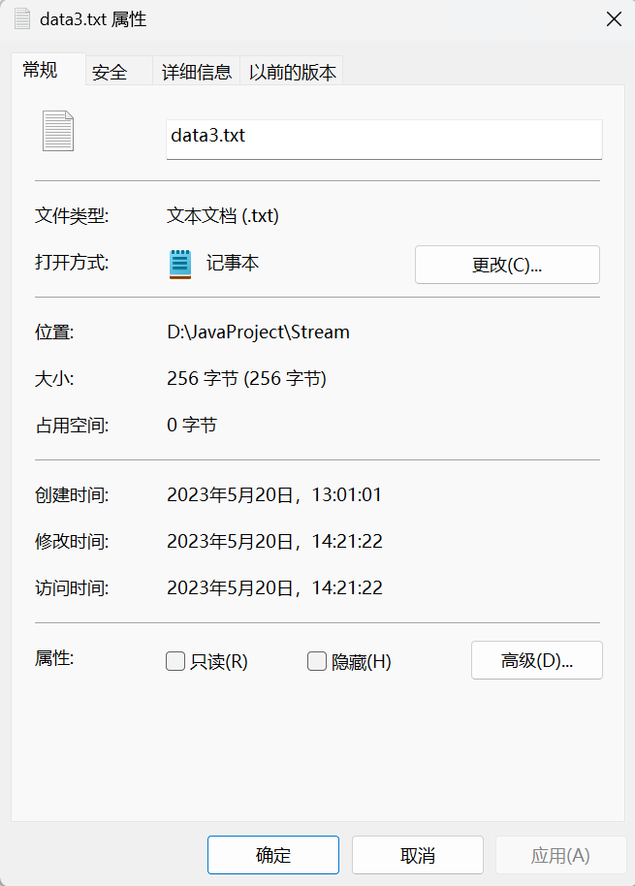
2. 二进制文件查看器
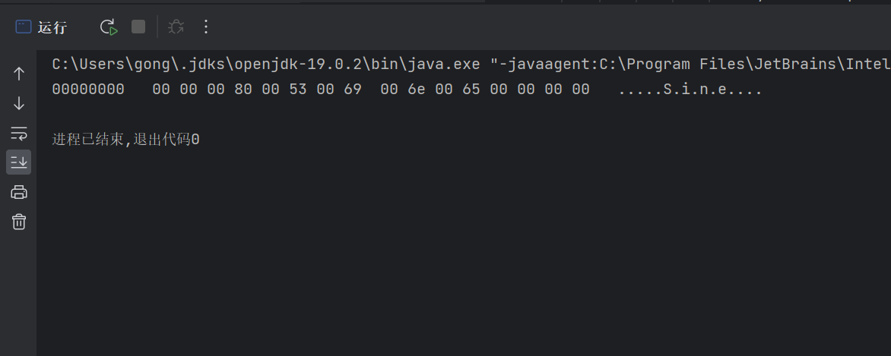
3. 文件检索
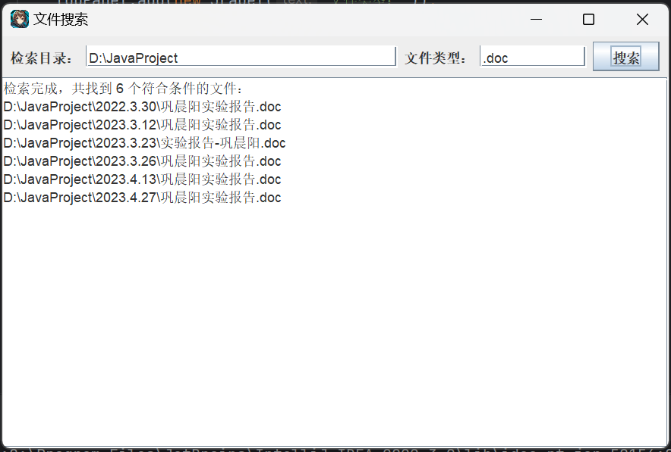
五、实验小结
流与文件总体来说我感觉比多线程要简单一点，但是在写程序的过程中也遇到了一些这样那样的问题，带着这些问题，我不断地搜索，最终调试出了代码，感觉对流与文件部分也有了部分的掌握，虽然掌握的不是那么的好，但是这毕竟是一个过程。

