E E 385V: Brain Computer Interaction Due Date: October 4th 2023
Homework #1
Course Policy: Read all the instructions below carefully before you start working on the assignment, and before
you make a submission.
- Answer to all below questions with requested figures.
- Assignments are due at the beginning of class on the due date.
- Report is individual for each student.
- Group work is encouraged.
- Reports delivered via Canvas.
- Be concise

Qs 1: Spatial filter on Motor Imagery data
- What is motor imagery? What are the neurophysiological correlates of motor imagery?
- Load the EEG data from the session (1 session in total) and run. Apply temporal filtering in the mu band and a spatial filtering (CAR or Laplacian) of your choice.
  - Describe why we temporally and spatially filter EEG data.
- Extract task trials for each class (RH and LH) based on the trigger information provided.
  - Can we deduce the number of trials? If so, how many?
- Compute the mu power of each task trial (s^2)
- Show the topological plot of the grand averaged mu power from the last 0.5s of the task trials, with and without spatial filtering. Do these for each class.
  - Describe your observations.
- Which channels do you think are physiological relevant (based on the topological plots)? Plot the grand average of the mu power of the task trials, using last 0.5s of the task trials (Fs = 512Hz). Do these for each class.

Trial structure and trigger:
All the data files provided are stored in general data format (GDF). The .gdf files can be loaded with the function provided in MATLAB as follows.
[s,h]=sload(’fileName.gdf’);
The above command will result in two variables in the MATLAB workspace. The variable s(Signal variable) will contain the Signals. The signal variable contains 36 columns (first 32 are EEG channels, and the last 4 columns should be neglected for analysis). Variable h(header structure) will hold the detailed information of various parameters involved in conducting the experiment.
The variable h includes the event information that describes the structure of EEG data recorded over time. The following fields describe event structure overtime for this dataset:
- h.EVENT.TYP : This variable provides the trigger value corresponding to an event in the data
- h.EVENT.POS : This variable provides the position of the corresponding trigger on the sample scale.

Trigger | Description
1000 | Trial start
768 | Fixation
769/770 | Cue (RH/LH)
7691/7701 | Continuous feedback starts (the bar starts moving)(RH/LH)
7692/7702  7693/7703 | Target misses or time-out  Target hit (the accumulated probabilities reached the threshold of the correct class) (RH/LH)

Trial structure:
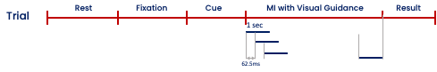
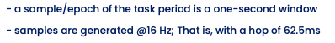

Qs 2: Spatial filter on error-related potentials (ErrPs) data
- What are error-related potentials (ErrPs)? What are the neurophysiological correlates of ErrPs?
- Description of the ErrP data provided:
  - rotation_data: 320 trials from 32 channels, and each trial is of length 2s; [-1s 1s] with respect to the trigger onset.
  - label: 0 marks a correct trial and 1 marks an error trial
  - magnitude: magnitudes can be of 0, 3, 6, 9, 12 degrees; the larger the magnitude, the more obvious the erroneous event.
  - fileID: run number
  - sessionID: session number
  - The ErrP has already been filtered in the theta band.
- Plot the grand average of the ErrP data for each magnitude, use data [-0.2s 0.8s] w.r.t trigger onset on Cz.
- Identify the ERN (first negative peak) and Pe (first positive peak) time points.
- Plot the topological plot of the grand averaged amplitude at the Pe time point, using all the error trials. Do the same for ERN time point.
  - Describe your findings.
- Perform CAR on the data, and plot the grand average of the ErrP data at Cz for each magnitude; use data [-0.2s 0.8s] w.r.t trigger onset.
  - Visualise the topological plot at Pe and ERN time points.
  - Identify one potential disadvantage of CAR.
- Use CCA to build spatial filters on the data provided. Plot the topological plots of the weights of the first 5 spatial filters (one topo plot for each), describe your findings. Note, there are two classes: error class and correct class.

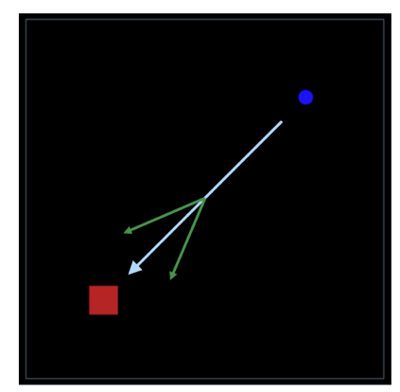
Description of the ErrP task: Participants controlled a cursor from start (top-right) to goal
locations (bottom-left) with a joystick as quick and straight as possible, using their left thumbs. In each trial, the normal joystick-cursor mapping can be violated by a rotation magnitude when the cursor exceeded a pre-defined fixed, invisible boundary, which was set to 50% of the diagonal distance between the start and goal locations. Participants were instructed to attempt to perceive the visuo-motor rotation and move the cursor. To control the levels of difficulty to perceive errors, we used four magnitudes of rotation: 3, 6, 9 and 12 degrees. The green arrows indicate directions where the cursor could be rotated.

Reference to learn more about CCA in EEG spatial filtering: Spüler, M., Walter, A., Rosenstiel, W., & Bogdan, M. (2013). Spatial filtering based on canonical correlation analysis for classification of evoked or event-related potentials in EEG data. IEEE Transactions on Neural Systems and Rehabilitation Engineering, 22(6), 1097-1103.

