Write queries in SQL, on the University schema, to answer each of the following questions:

1. You need to create a movie database. Create three tables, one for actors(AID, name), one for movies(MID, title) and one for actor_role(MID, AID, rolename). Use appropriate data types for each of the attributes, and add appropriate primary/foreign key constraints.

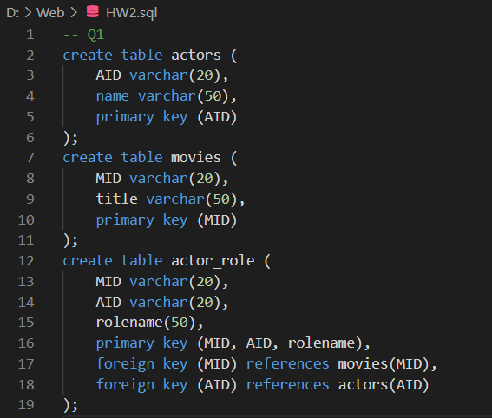

1. Insert data to the above tables (approx 3 to 6 rows in each table), including data for actor "Charlie Chaplin", and for yourself (using your roll number as ID).

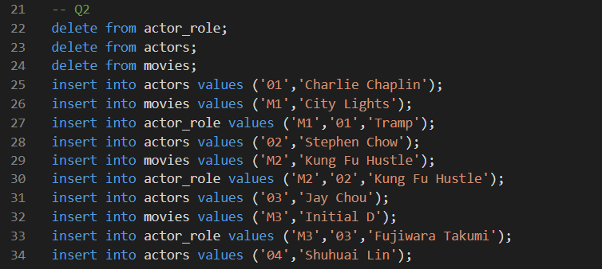

1. Write a query to list all movies in which actor "Charlie Chaplin" has acted, along with the number of roles he had in that movie.

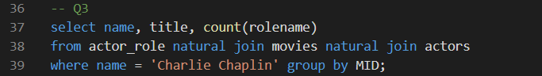

1. Write a query to list all actors who have not acted in any movie



1. 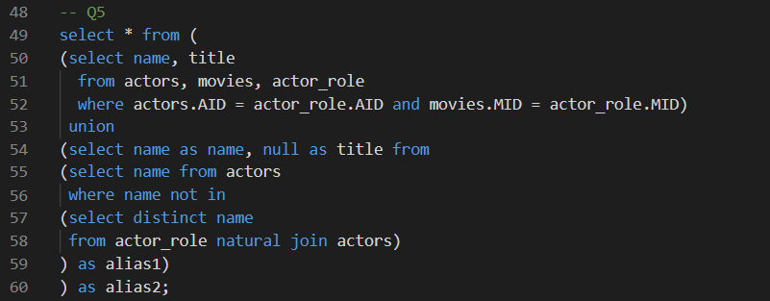List names of actors, along with titles of movies they have acted in. If they have not acted in any movie, show the movie title is null. (Do not use SQL outer join syntax here, write it from scratch.)