**COMP0113 Group Project Report**

Group 14: Pengze Li, Lucien Li

1. Introduction

Our project provides a virtual environment for people to build 3-D objects in space. In creative mode, people collaborate and assemble objects. For the Pictionary game, players are encouraged to draw and guess the word in space as fast and accurately as they can. The following parts will introduce the work from the development method, game introduction and critical designs.

1. Development Method

There are two members in our team. We use Unity and other asserts including UCL Ubiq to develop the game and an Oculus Quest 2 VR headset for testing. GitHub is used for version control, the repository URL is <https://github.com/lucieniii/UCL-VR-2022>. Both two team members attended the whole process of development. Pengze Li is mainly responsible for the scene construction and Lucien Li is mainly responsible for the coding.

1. Game Introduction

In this chapter, we will introduce how to play the Draw & Guess and the overall procedure of the game. Figure 1 is the main flow chart of the game. The game contains six phases, which are Game Start Phase, Round Start Phase, Round Pick Phase, Round Pick Word Phase, Round Play Phase, Round End Phase and Game End Phase. We will explain the phases in detail in the next few subsections.

**Figure 1. Main Flow Chart of the Game**

The progression of the game flow is dependent on the player manipulating the Panels in the game. Each player will have their own Panel and other players cannot see the content on the Panel. The eight Panels in the left picture of figure 2 are critical to the game procedure. We will also mention the Panels later.

The player will use some buttons on the controller to play the game in the VR environment. Take Oculus Quest 2 as an example (right picture in figure 2), we use the Left Stick on the controller to let the character walk around. The Main Grip Buttons are used to press the buttons in the game, and the Side Grip Buttons are linked to an important function “Grabbing” in the game. By moving one hand of the character onto the object and pressing the Side Grip Button on the corresponding hand, we can grab some graspable objects in the game like the Panel, pens and geometries we will introduce later.

Figure 2. Left: The eight critical Panels Right: The Controller of Oculus Quest 2

3.1 Game Start Phase

When the game start, the initial phase is Game Start Phase and the initial panel is the Title panel. Firstly, one player needs to create a room where all the cooperation and competition take place. After creating, this player will get into the Menu panel and receive a join code. Others will rely on this join code to get into this room.

At the Menu panel, everyone prepares for the game, including choosing a name and an avatar in this room. The Peers button is to check players’ status in the room. The Leave button is to leave the room and go back to the Title panel. After all preparation, players press the Game button to get into the last panel in Game Start Phase, the Game start panel.

Before going to the next phase, players are in creative mode, which basically means they are free to collaborate and build things, like the right picture in figure 3. All functions are available and all players are allowed to make artwork. As the left two pictures in figure 3, one can use the 3D Pens to draw things in room space. There are also reproducible, controllable, and resizable geometries helping players shape the outline. As long as players are in the same room, all the works (paintings and generated geometries) are visible to all. When everyone gets ready, one should press Draw & Guess button to start the game. Note that once a game is started, the room will be reset for the game.

3.2 Round Start Phase

The one who starts the game will be the owner of it. In one Draw & Guess game, there are several rounds and players will be back to this phase after every round. At this phase, it is the game owner who will see the Round Panel and decide what happens next, starting a new round or ending the game. During that, other players will be forcibly switched to the Waiting panel. Besides, the Home button and the Rank button are available on both the Waiting panel and the Round panel so that everyone is able to go back to change settings or check the rank board anytime. If the owner chooses to start a new round, everyone gets into the Round Pick Word Phase. If the owner goes to end the game, everyone gets into Game End Phase. See more switching details in the main flow chart above.

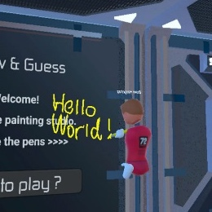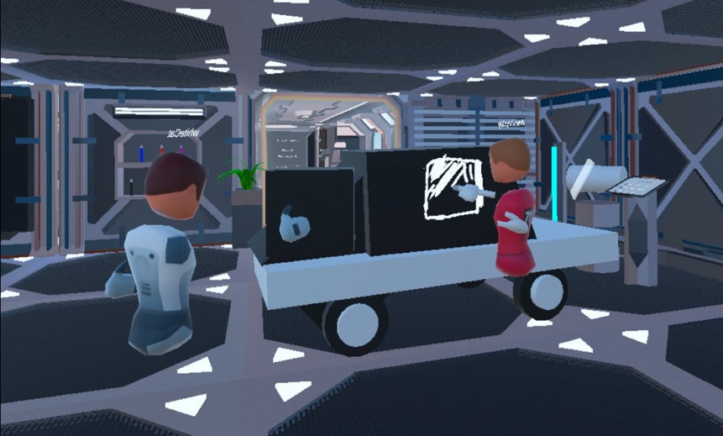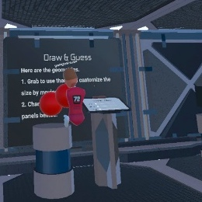

Figure 3. Left: a player using pen and duplicating sphere; Right: two players constructing a car

3.3 Round Pick Word Phase

After the Game Owner has pressed the New Round button on his Panel, the system will randomly pick an Artist from all the players. In each round of the game, players will take turns to be the Artists. Now the Artist will see the Artist Panel on his Panel, and the others, Guessers, will still see the Waiting Panel. Then the Artist should press the arrow-like button on the Panel to generate a word to draw. The word will be randomly picked from a Word List by the system. The Word List contains hundreds of words which are selected and easy for players to create. After the Artist has generated a word to draw, the game will enter the Round Play Phase.

3.4 Round Play Phase

The Round Play Phase is the core play phase of the game. In this phase, the Artist should draw the given word in the space using the pens and geometries provided by the game. The guessers will see the Guesser Panel on their Panels and should try to guess what the Artist is drawing. If they have an idea of what the Artist is drawing, they should type the word using the keyboard in the Guesser Panel and press the arrow-like button to submit the answer, then the Panel will show whether the guess is correct. Figure 4 shows some scenes in this phase.

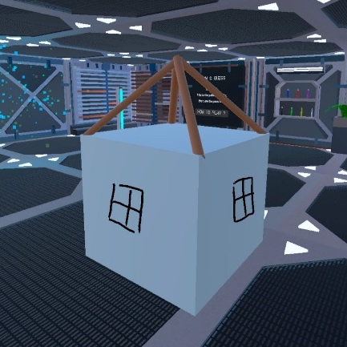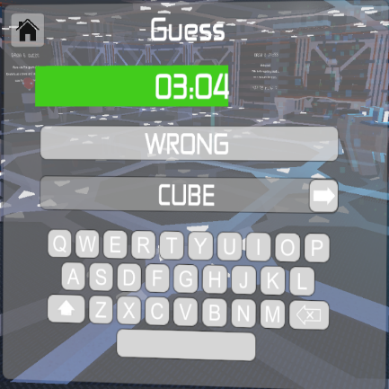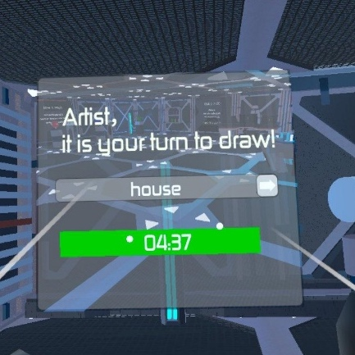

Figure 4. In one round, the house drawn by the Artist (Left),

the Artist Panel (Middle) and the Guesser Panel (Right).

The Artist can do anything like in the creative mode before the game start. The pens are graspable and when grasping the pen the player can press the Main Grip Button to draw in the space. The geometries are also graspable and players can adjust their size of them, too.

Each round has five minutes time limit. When the time is up or all the Guessers have guessed out the word, the Round Play Phase will end, and all the artwork will be removed from the scene.

3.5 Round End Phase

After a round, everyone gets into Round End Phase where the Rank panel is shown to all. On this panel, names and current scores are sorted and listed. For a guesser, the time remaining when he guessed the correct word is added to his score. As for the artist, he receives scores whenever one gets the right answer, but for fairness, this score is divided by the number of guessers. Note that the Rank panel also can be reached in other phases, but that won’t have an influence on the phase. By pressing the OK button, one gets back to the Round Start Phase.

3.6 Game End Phase

When the owner wants to end the game, he should press the End Game button on his panel, making everybody comes to this phase. This is the last phase for one Draw & Guess game. Here the final rank board will be shown again. By pressing the OK button, players will be back to Game Start Phase and enter creative mode.

1. Critical Designs

4.1 Pens

The pens can be grasped and used in the creative mode by all the players and in the Round Play Phase only by the Artist. There are 7 colours of pens in the game and each pen have its own Ubiq Network Id to keep the synchronization between different players in the same room.

4.2 Geometries

The game provides three kinds of geometries for the players to use: sphere, cube and cylinder. Users can grasp the geometries and adjust their colour or size of them.

When a user tries to grasp one new geometry, a copy of the geometry will be generated in the original place, and the grasped geometry will no longer be the new geometry (it will become an old one). If you try to grasp the old geometry, it will not leave a copy. For each geometry, up to 100 geometries (including copies) are allowed to exist in the scene. Also, when a player generates a copy of one geometry, other players in the same room can see it, too. The same copy in different plays’ scenes has the same Ubiq Network Id and the Ubiq messages are carefully designed to ensure all the players in the same room can see each other's operation.

Like the right picture in the figure 5 shows, the players can change the size of the geometries, which is one of the most difficult parts of the whole game to realize in this game. On one geometry there will be several white balls as anchors, and players can grasp and move the anchors to adjust the size of the geometry. The size of the geometry will be stretched in the direction of the player dragging the anchor. The stretching operation can also be seen by the players in the same room by the Ubiq Networking.

The colours of the geometries can be changed by operating the sliders on the panels beside the initial position of the geometries, as the left picture of figure 5 shows. If one player changes the colours, others in the same room can see it. All the functions of the geometries above can be used by all the players in the creative mode and only by the Artist in the Round Play Phase.

桌子上的蓝色电脑

Figure 5. Left: Changing the size of the cube. Right: Changing the colour of the sphere.

4.3 Auxiliary design

To help players be more immersed in the virtual environment and better enjoy it, several auxiliary designs are made.

At the start of the game, there is a bulletin board in front of players, saying how to play this game. More in-environment instructions are placed near pens and geometries.

During the game, the network is well managed so that disruptive behaviours, such as vandalizing artist's paintings, are not allowed. What’s more, at the network level, all players are always keeping in touch with others. One’s behaviour may cause a corresponding change in others’ panels or phases.

We understand that this game itself takes some training, so the creative mode is set as the initial mode. It is a good place for players to simply cooperate and build without competition.

The whole environment is based on sci-fi assets and other settings like interface/buttons/fonts are unified.

1. Conclusion

We have used Unity to develop the VR Draw & Guess game. The game allows multiple players to participate and provides pens and geometries to help the players to draw. The players can either draw in the creative mode together or play the formal Pictionary game. The scene and Panel are carefully designed to keep the sci-fi style. The game largely achieves the initial design goals, but there is still room for improvement, such as increasing the number of the Artist and optimizing the game flow.