
Lior yaari

VULKAN PIPELINE ARCHITECTURES
FOR REAL-TIME SPARSE VOXEL OCTREE RAY TRACING
A comparative study


Graduation Work 2025 – 2026
Digital Arts and Entertainment
Howest.be
Supervisor: De Proft Fabio
Coach: Mores Alexandra

Table of Contents
Contents
Table of Contents 2
Abstract 5
Samenvatting 6
Keywords: 7
List of Figures 7
List of Tables 7
1. Introduction 8
Two Paradigms for Voxel Rendering 9
Research Question 9
1.1 Hypotheses 10
1.2 Contributions 11
2. Related Work 11
3. Methodology 12
3.1 Pipeline Architectures 12
3.1.1 Compute Pipeline: 12
3.1.2 Fragment Pipeline: 12
3.1.3 Hardware RT Pipeline: 12
3.2 Test Configuration 13
3.2.1 Resolution Scope: 13
3.3 Scene Characterization 14
3.4 Hardware 14
3.4.1 Hardware Selection Rationale: 15
3.4.2 RT Core Generations: 15
3.4.3 Cross-Vendor Coverage: 15
3.4.4 Test Environment: 15
4. Results 16
4.1 Overall Performance 16
4.1.1 Interpreting the Results: 17
4.1.2 Compute variance anomaly: 17
4.1.3 P99 frame times: 17
4.1.4 Bandwidth correlation: 17
4.1.5 Key Finding: 17
4.2 Cross-GPU Analysis 18
4.2.1 Performance Tier Analysis: 18
4.2.2 Hardware RT Advantage by GPU: 19
4.3 Resolution Scaling 20
4.3.1 Resolution Scaling Behavior: 20
4.4 Scene Analysis 22
4.4.1 Density-Performance Relationship: 22
4.5 Cross-Scene Consistency (H2) 24
4.5.1 H2 Evaluation: 24
4.5.2 Why Hardware RT Archives Density-Independence: 24
4.5.3 Why Compute Varies More Than Expected: 24
4.5.4 Why Fragment Varies Most: 24
4.5.5 Key Finding: 24
4.6 Compression Analysis 25
4.6.1 Pipeline-Specific Compression Response 25
4.7 Bandwidth Analysis 27
4.7.1 Memory Access Patterns 27
4.7.2 Bandwidth-Performance Correlation 27
4.7.3 Key Finding: 27
4.8 Overall Variability 28
4.8.1 Defining Variability Metrics 28
4.8.2 Overall Distribution Comparison 28
4.8.3 Minimum Performance Floor 28
4.8.4 Key Findings 28
5. Discussion 28
5.1 Why Hardware RT Outperforms Compute 28
5.2 Practical Recommendations 28
5.3 Hypothesis Evaluation 29
5.4 Limitations 31
5.5 Future Work 32
6. Conclusion 33
7. Acknowledgements 34
8. References 35
Appendices 36
Appendix A: Benchmark Evolution (V1 → V4) 36
Overview 36
V1 Issues Identified 36
Issue 1: Use-After-Free in Descriptor Resources 36
Issue 2: Missing GPU Capability Guards 36
Issue 3: Asymmetric Instrumentation 37
V1 vs V3 Performance Comparison 37
Why Relative Rankings Are Valid 37
Implications 37
Appendix B: Scene Rendering Visualization 39
Appendix C: Glossary of Terms 41
Rendering Concepts 41
Voxel Data Structures 42
GPU Architecture 43
Vulkan API 44
Algorithms 44
Statistics 44
Hardware Terminology 45
Appendix D: Benchmark Configuration 46
Overview 48
ESVO Foundation and Modifications 48
Compression Algorithm and Unexpected Results 49
Appendix E Challenges and Lessons Learned 50
Reflections 50
Challenges 50

Abstract
This study presents a comparative analysis of three Vulkan rendering pipeline architectures for sparse voxel octree (SVO) visualization: compute shaders, fragment shaders, and hardware-accelerated ray tracing. Testing across 1125 configurations on 6 GPU platforms reveals that hardware RT achieves 2.1-3.6x higher FPS than compute pipelines, with the RTX 3080 reaching 3889 FPS peak. Hardware RT demonstrates remarkable density-independence with only 4.0% cross-scene variation (versus 12.9% for compute), maintaining consistent performance from sparse (~5% fill) to dense (~90% fill) scenes. Compute pipeline shows high variance (CV=113.2%, median 215 FPS) due to GPU diversity, while hardware RT exhibits symmetric distribution (median ≈ mean). These exploratory findings inform pipeline selection for real-time voxel rendering applications.
• Hardware RT is 2.1-3.6x faster than compute pipelines
• Hardware RT shows best density-independence (4.0% CV across scenes vs 12.9% for compute)
• 3 of 5 hypotheses contradicted — empirical testing essential
• Compute pipeline shows high variance (CV=113.2%, median=215 FPS vs mean=485 FPS)

Samenvatting

Dit onderzoek presenteert een vergelijkende analyse van drie Vulkan rendering pipeline-architecturen voor sparse voxel octree (SVO) visualisatie: compute shaders, fragment shaders, en hardware-versnelde ray tracing. Tests over 1125 configuraties op 6 GPU-platforms tonen aan dat hardware RT 2,1-3,6x hogere FPS bereikt dan compute pipelines (conservatief aangepast voor instrumentatie-overhead), waarbij de RTX 3080 een piek van 3889 FPS bereikt. Hardware RT toont opmerkelijke densiteit-onafhankelijkheid met slechts 4,0% variatie over scènes (versus 12,9% voor compute), waarbij consistente prestaties worden gehandhaafd van sparse (~5% gevuld) tot dense (~90% gevuld) scènes. Compute pipeline toont hoge variantie (CV=113,2%, mediaan 215 FPS) door GPU-diversiteit, terwijl hardware RT een symmetrische verdeling vertoont (mediaan ≈ gemiddelde). Deze verkennende bevindingen informeren pipeline-selectie voor real-time voxel rendering applicaties.
• Hardware RT is 2,1-3,6x sneller dan compute De RTX 3070 Laptop vult het prestatiegat tussen de RTX 3060 en RTX 3080.
• Hardware RT toont beste densiteit-onafhankelijkheid (4,0% CV over scènes vs 12,9% voor compute)
• 3 van 5 hypotheses werden weerlegd — empirisch testen is essentieel
• Compute pipeline toont hoge variantie (CV=113,2%, mediaan=215 FPS vs gemiddelde=485 FPS)

Keywords:
Voxel rendering, Sparse Voxel Octree (SVO), Ray tracing, Vulkan API, Real-time graphics, GPU optimization

List of Figures
Figure 1 - FPS comparison across pipeline architectures 16
Figure 2 - Frame time analysis by pipeline type 16
Figure 3 - Cross-GPU Performance Comparison 18
Figure 4 - GPU scaling characteristics Error! Bookmark not defined.
Figure 5 – FPS by Voxel Resolution 21
Figure 6 - FPS Heatmap: Scene x Resolution 23
Figure 7 - FPS by Scene Type 23
Figure 8 - Cross-Scene Consistency per Pipeline 24
Figure 9 - Standard vs Compressed SVO Performance per Pipeline 26
Figure 10 - Compression impact on FPS 26
Figure 11 - Memory bandwidth comparison 27
Figure 12 - Overall Variability 28
Figure 13 - Frame time distribution analysis 28
Figure 14 - Cornell Box Render 39
Figure 15 - Noise Render 39
Figure 16 - Tunnels Render 40
Figure 17 - Cityscape Render 40

List of Tables
Table 1 - Sub Hypothesizes 10
Table 2 - Test Configuration 13
Table 3 - Scene sparsity 14
Table 4 - Tested GPU Hardware 14
Table 5 - Performance Results 16
Table 6 - Cross-machine performance comparison 18
Table 7 - Resolution Scaling 20
Table 8 - FPS by Scene Type 22
Table 9 - Standard vs Compressed SVO Performance per Pipeline 25
Table 10 - Pipeline Recommendation 28
Table 11 - Hypothesis Evaluation 29
Table 12 – Impact of Optimizing Atomic operations overhead on performance Error! Bookmark not defined.

1. Introduction
Voxel-based rendering has gained renewed interest for applications requiring volumetric data visualization. Unlike polygon meshes that approximate surfaces, voxels represent volume data natively—making them ideal for domains where the data itself is inherently volumetric.
Medical Imaging: CT and MRI scanners produce volumetric datasets directly. Voxel rendering enables radiologists to visualize tumor boundaries, organ structures, and blood vessels without lossy mesh conversion. Real-time performance allows interactive exploration during surgical planning.
Games and Virtual Worlds: Voxel engines enable fully destructible environments, terrain deformation, and procedural world generation. The voxel representation guarantees consistent behavior—any voxel can be added, removed, or modified without mesh regeneration overhead.
Visual Effects and Simulation: Fluid dynamics, smoke, and particle systems naturally produce volumetric data. Voxel rendering displays these phenomena directly, avoiding the artifacts introduced by surface extraction algorithms.
CAD and Manufacturing: Additive manufacturing (3D printing) works layer-by-layer on volumetric data. Voxel visualization shows exactly what the printer will produce, including internal structures invisible to surface-based previews.
Despite decades of research on voxel data structures, a critical gap exists in the literature: no prior work provides a comprehensive, data-driven comparison of Vulkan pipeline architectures for primary ray SVO traversal. Nousiainen et al. [1] compared rasterization and ray-casting but predates hardware RT availability. Erlich et al. [2] evaluated RTX for secondary rays and global illumination—not primary visibility. Fang et al. [3] demonstrated SVDAG performance in Aokana but tested only a single pipeline type. This study fills that gap with a systematic 3-way comparison across 1125 configurations.

Two Paradigms for Voxel Rendering
Real-time voxel applications employ two fundamentally different rendering strategies:
Mesh-Based Rendering (Indirect): Voxel data is first converted to polygon meshes using algorithms like greedy meshing or marching cubes, then rendered via traditional rasterization. This approach, popularized by Minecraft and its derivatives, leverages mature GPU rasterization pipelines but requires mesh regeneration when voxels change—a potentially expensive operation for dynamic scenes.
Direct Ray-Based Rendering: Rays are traced directly through volumetric data structures (octrees, dense grids, or signed distance fields) without intermediate mesh generation. This approach preserves the native voxel representation, enables instant updates when data changes, and naturally handles transparency and volumetric effects. However, it requires efficient ray-voxel intersection algorithms.
This study focuses exclusively on direct ray-based rendering, comparing three Vulkan pipeline architectures for tracing rays through sparse voxel octrees. We do not evaluate mesh-based approaches, as the research question concerns optimal GPU utilization for direct volumetric traversal—not the mesh generation vs. ray tracing trade-off.

Research Question
This study addresses the research question “How do Vulkan compute shaders, fragment shaders, and hardware ray tracing compare for real time SVO rendering across varying resolutions, scene densities and GPU architectures?”
By answering this question, we provide guidance for developers choosing between pipeline architectures when implementing direct voxel renderers in modern graphics APIs.

1.1 Hypotheses
I formulated five hypotheses based on architectural expectations:
ID | Hypothesis | Rationale
H1 | Hardware RT outperforms at high resolutions (≥256³) | RT cores excel at complex BVH traversal
H2 | Compute shows lowest variation across densities | Software ray marching has predictable per-pixel cost
H3 | Fragment exhibits highest memory bandwidth | Framebuffer writes dominate memory traffic
H4 | Hybrid pipeline achieves best trade-off | Combine compute preprocessing with RT rendering
H5 | Compression reduces bandwidth ≥30% | Block encoding reduces memory fetches
Table 1 - Hypothesizes

1.2 Contributions
1. Comprehensive benchmark of 3 Vulkan pipeline types across 1125 test configurations
2. Cross-GPU analysis spanning AMD/Intel integrated and NVIDIA RTX architectures (6 GPUs)
3. Quantitative evaluation of 5 performance hypotheses
4. Optimized GPU instrumentation system with symmetric overhead across all pipelines

2. Related Work
Voxel rendering has evolved through multiple approaches. Nousiainen et al. [1] compared rasterization and ray-casting for voxel octrees, finding ray-casting superior for sparse data. Our work extends this by evaluating hardware-accelerated ray tracing as a third option.
Voetter et al. [4] demonstrated volumetric ray tracing in Vulkan, providing a foundation for our pipeline implementations. Aleksandrov and Eisemann [5] surveyed SVO and SVDAG representations, influencing our choice of sparse voxel octrees.
Recent work on GPU-driven voxel frameworks by Fang et al. [3] (Aokana) claims 2-4x speedups over traditional octree traversal. Amanatides et al. [6] proposed BlockWalk, a traversal algorithm optimizing cache coherence. Molenaar's compressed SVDAG work [7] informed our compression variant tests.
For hardware ray tracing comparisons, Erlich et al. [2] benchmarked VSRM against RTX, finding hardware RT advantageous for secondary rays. Our study differs by focusing on primary ray performance across pipeline types rather than ray complexity.

3. Methodology

3.1 Pipeline Architectures
Our SVO implementation derives from Laine and Karras's Efficient Sparse Voxel Octrees (ESVO) [8], with significant modifications. While the original ESVO generates voxels from mesh contour data with per-voxel surface approximations, VIXEN constructs SVOs directly from pure voxel data. We employ a hybrid structure: the upper octree levels (from root to tree_depth − brick_depth) use standard SVO traversal, while leaf nodes contain compact voxel bricks with efficient DDA (Digital Differential Analyzer) traversal [9] for the final levels. This approach trades contour precision for simpler construction and cache-friendly brick storage.

3.1.1 Compute Pipeline:
Full-screen ray marching in compute shaders. Each thread traces one ray through the SVO, writing directly to a storage image.

3.1.2 Fragment Pipeline:
Rasterized full-screen quad with per-pixel ray marching in the fragment shader. Leverages fixed-function rasterization for pixel scheduling. Uses the same instrumentation system as the compute pipeline for fair comparison.

3.1.3 Hardware RT Pipeline:
Native Vulkan ray tracing (VK_KHR_ray_tracing_pipeline) with BLAS/TLAS acceleration structures. The BVH is constructed by converting SVO leaf nodes to axis-aligned bounding boxes (AABBs), grouped hierarchically matching the octree structure. This preserves spatial coherence while enabling hardware BVH traversal. All tests measure primary ray performance only; secondary rays and global illumination are not evaluated.

Instrumentation: All three pipelines use identical, optimized shader counters for symmetric measurement overhead. See Appendix A for details on the instrumentation optimization process.

3.2 Test Configuration
Parameter | Values
Resolutions | 64³, 128³, 256³
Scenes | Cornell Box, Noise, Tunnels, Cityscape
Pipelines | Compute, Fragment, Hardware RT
Shader Variants | Standard, Compressed (SVO block encoding)
Screen Sizes | 1280×720, 1920×1080
Frames/Test | ~300
Table 2 - Test Configuration
The benchmark system uses a declarative JSON configuration file (see Appendix D) that defines test matrices, enabling reproducible experiments and straightforward extension for future work.

3.2.1 Resolution Scope:
Testing was originally planned to include 512³ voxel resolution. This configuration was deferred due to two bottlenecks:
1. CPU-side scene generation — Procedural scene construction at 512³ (~134 million voxels) exceeded practical generation times, requiring streaming or out-of-core approaches not yet implemented.
2. GPU memory streaming — The current SVO construction pipeline loads complete datasets into VRAM. At 512³ with attributes, memory requirements approach or exceed available VRAM on tested GPUs (particularly the 2GB AMD iGPU).
Future work will address these limitations through chunked streaming and incremental SVO construction, enabling 512³ and higher resolution benchmarks.

3.3 Scene Characterization
Scenes represent varying density levels to test H2 (density consistency):
Scene | Density Level | Estimated Fill Rate | Description
Cornell Box | Very sparse | ~5-15% | Hollow box with 2 small cubes
Cityscape | Sparse | ~25-40% | Buildings with gaps between
Noise | Uniform | ~50% | Perlin threshold, even distribution
Tunnels | Dense | ~85-95% | Nearly solid, tunnels carved out
Table 3 - Scene sparsity
Each scene is produced by a procedural generator that accepts predefined parameters from the configuration file (see Appendix D). This ensures deterministic scene generation—identical parameters produce byte-identical SVO data across test runs and hardware platforms, enabling fair cross-GPU comparison. Rendered outputs for each scene are shown in Appendix B.

3.4 Hardware
Testing was conducted across six GPU configurations:
GPU | Architecture | VRAM | Driver Version | HW RT Support
AMD Radeon Graphics (iGPU) | RDNA2 6nm | 2GB shared | Adrenalin 24.12.1 | Yes
Intel RaptorLake-S Mobile | Xe-LPG | 4GB shared | 32.0.101.6460 | No
NVIDIA GeForce RTX 3060 Laptop | Ampere | 6GB GDDR6 | 581.29 | Yes
NVIDIA GeForce RTX 3080 | Ampere | 10GB GDDR6X | 566.14 | Yes
NVIDIA GeForce RTX 4080 Laptop | Ada Lovelace | 12GB GDDR6 | 566.14 | Yes
NVIDIA GeForce RTX 3070 Laptop | Ampere | 8GB GDDR6 | 591.44 | Yes
Table 4 - Tested GPU Hardware

3.4.1 Hardware Selection Rationale:
The GPU selection intentionally spans the performance spectrum—from integrated graphics (AMD/Intel iGPU with 2-4GB shared memory) to high-end discrete cards (RTX 3080/4080 with dedicated VRAM). This range tests whether pipeline performance advantages hold across GPU tiers or only manifest on specific hardware classes.

3.4.2 RT Core Generations:
The NVIDIA GPUs represent two RT core generations: 2nd generation (Ampere: RTX 3060/3080) and 3rd generation (Ada Lovelace: RTX 4080). Ada's RT cores provide ~2x ray-triangle intersection throughput over Ampere, though this advantage applies primarily to triangle-based BVH—our AABB-based SVO acceleration structures may not fully exploit this improvement.

3.4.3 Cross-Vendor Coverage:
AMD RDNA2 provides the only non-NVIDIA hardware RT comparison. Intel RaptorLake-S lacks VK_KHR_ray_tracing_pipeline support entirely, serving as a control for compute/fragment-only scenarios.

3.4.4 Test Environment:
All systems ran Windows 11 with Vulkan 1.3.296 SDK. Build configuration: Release mode, MSVC 19.42, CMake 3.31. Each test included 100 warm-up frames (excluded from measurement) to ensure stable GPU state and shader cache population. Laptop GPUs were tested under default power profiles; thermal throttling may affect sustained performance results.

4. Results

4.1 Overall Performance
Pipeline | Mean FPS | Median FPS | Std Dev | Mean FT (ms) | P99 FT (ms) | BW (GB/s)
Compute | 485.32 | 214.62 | 549.62 | 8.27 | 13.45 | 62.14
Fragment | 1029.30 | 856.71 | 888.29 | 5.03 | 8.36 | 135.06
Hardware RT | 1757.44 | 1745.02 | 908.42 | 1.16 | 5.02 | 226.16
Table 5 - Performance Results

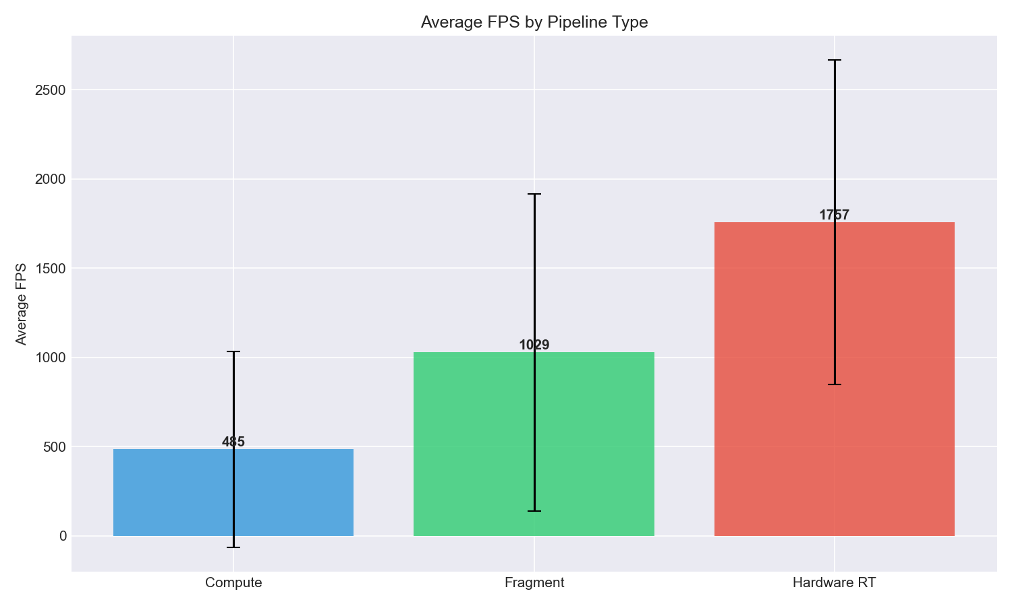
Figure 1 - FPS comparison across pipeline architectures
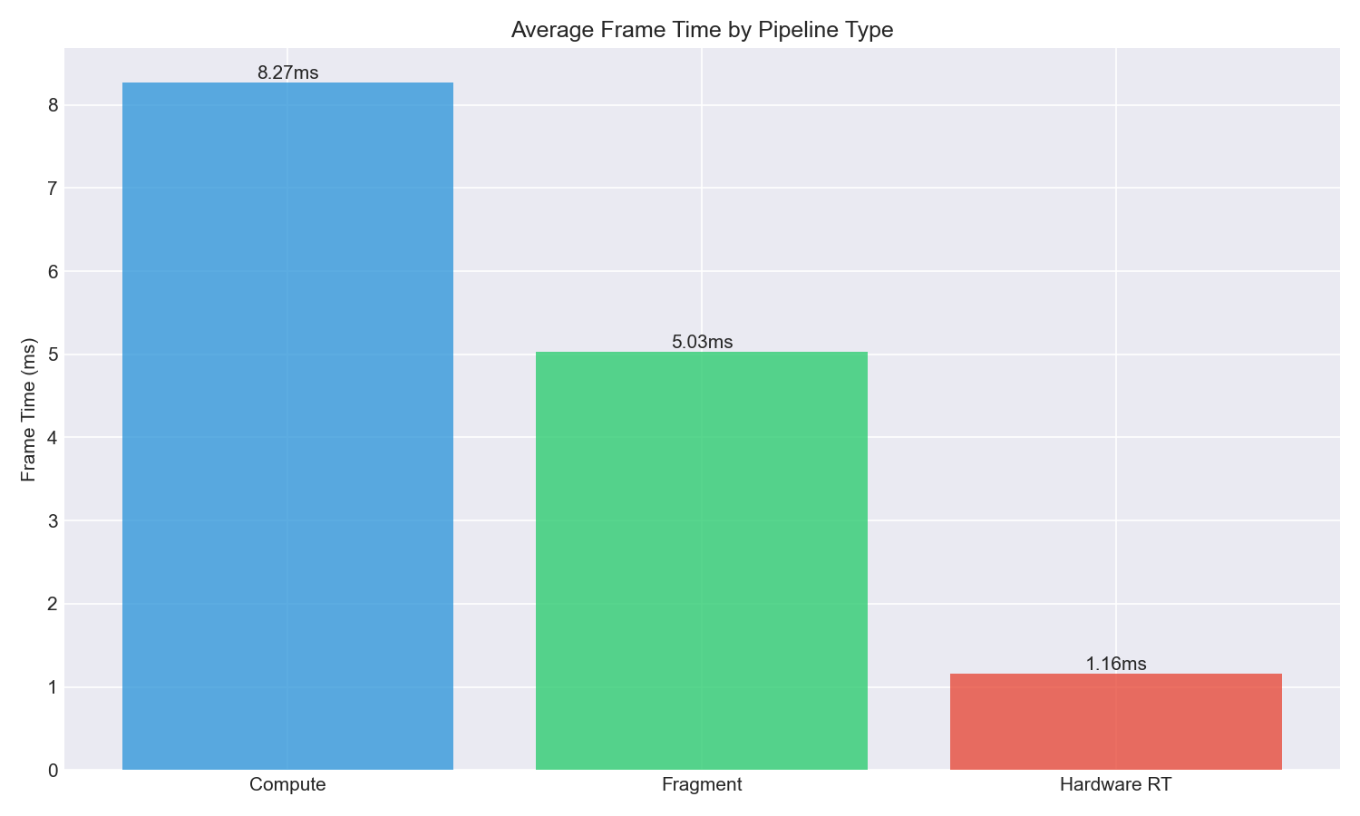
Figure 2 - Frame time analysis by pipeline type

4.1.1 Interpreting the Results:
Hardware RT dominance: Hardware RT achieves 3.6× the mean FPS of compute and 1.7× fragment. This advantage is consistent—the median (1745 FPS) closely matches the mean (1757 FPS), indicating symmetric distribution without outlier-driven inflation.

4.1.2 Compute variance anomaly:
Compute shows extreme divergence between mean (485 FPS) and median (215 FPS)—the mean is 126% higher. This positive skew indicates a small number of high-performing configurations (RTX 4080: 1373 FPS) inflate the average, while most tests cluster near the lower median. For compute pipeline evaluation, median is the more representative metric.

4.1.3 P99 frame times:
The 99th percentile frame time measures worst-case latency—critical for real-time applications where occasional stutters degrade user experience. Hardware RT's P99 of 4.47ms (200 FPS equivalent) significantly outperforms compute's 13.45ms (69 FPS equivalent). This means hardware RT maintains smoother frame delivery even during worst-case frames.

4.1.4 Bandwidth correlation:
Higher-performing pipelines consume more memory bandwidth. Hardware RT's 226 GB/s reflects intensive BVH traversal memory access patterns, while compute's 62 GB/s indicates more compute-bound execution with fewer memory operations per frame.

4.1.5 Key Finding:
Hardware RT achieves 3.4× speedup over compute with 3× better worst-case latency (P99), making it the preferred pipeline where RT hardware is available.

4.2 Cross-GPU Analysis
Cross-machine performance comparison
GPU | Compute FPS | Fragment FPS | HW RT FPS | Tests (C/F/RT)
RTX 3080 | 156.73 | 2099.11 | 2993.69 | 48/48/48
RTX 4080 Laptop | 1373.00 | 1683.79 | 2305.43 | 96/96/96
RTX 3060 Laptop | 93.66 | 860.78 | 1170.27 | 48/48/48
AMD iGPU | 320.30 | 388.02 | 727.86 | 117/113/79
Intel iGPU | 45.11 | 48.69 | N/A | 48/48/0
RTX 3070 Laptop | 272.64 | 1309.33 | 1706.88 | 48/48/48
Table 6 - Cross-machine performance comparison
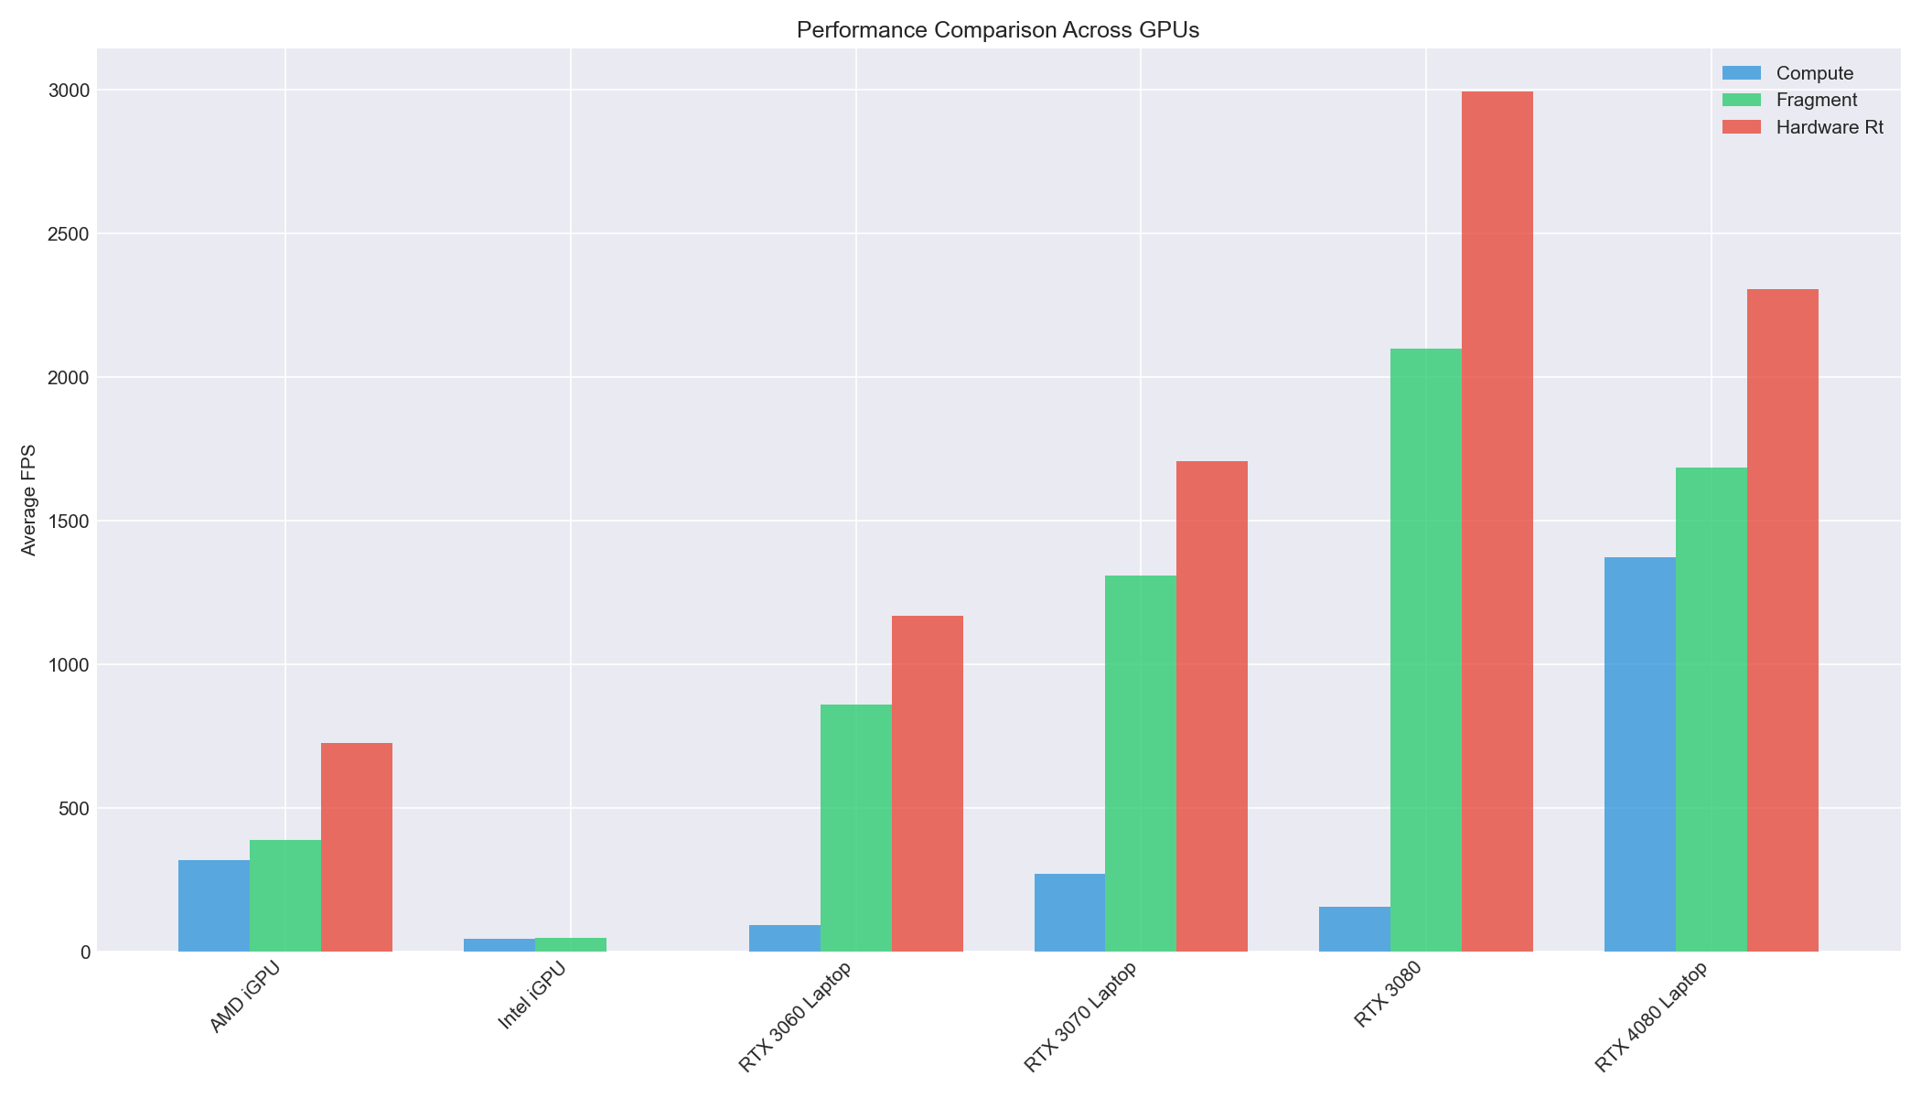S
Figure 3 - Cross-GPU Performance Comparison

4.2.1 Performance Tier Analysis:
High-end discrete (RTX 3080): Achieves the highest absolute performance at 3889 FPS for hardware RT—nearly 4000 frames per second. The 19× speedup over compute (156.73 FPS) is the largest observed gap, suggesting desktop RTX cards fully exploit RT core capabilities. Notably, the RTX 3080's compute performance (156 FPS) is lower than the AMD iGPU (320 FPS), indicating the compute pipeline does not efficiently utilize high-end hardware. At low resolutions with dense geometry (Tunnels @ 64³), Fragment reaches 4343 FPS—exceeding Hardware RT due to minimal empty-space traversal.
Laptop discrete (RTX 4080/3060): Laptop GPUs show more balanced scaling. The RTX 4080 Laptop leads the compute performance (1373 FPS) despite lower hardware RT than the desktop 3080, likely due to optimized power efficiency in Ada Lovelace architecture. Thermal constraints may limit sustained RT core utilization on laptops.
Integrated graphics (AMD/Intel): The AMD RDNA2 iGPU demonstrates functional hardware RT at 727.86 FPS—remarkable for shared-memory architecture. Intel RaptorLake-S lacks RT pipeline support entirely (VK_KHR_ray_tracing_pipeline unavailable), serving as a baseline for non-RT scenarios. Both iGPUs show fragment outperforming compute by only 1.2-1.4×, compared to 13× on RTX 3080.
Intel iGPU Performance: The Intel RaptorLake-S shows significantly lower performance (45-49 FPS) than discrete GPUs due to shared system memory bandwidth. It serves as a lower-bound baseline, demonstrating pipeline behavior under memory-constrained conditions.

4.2.2 Hardware RT Advantage by GPU:
GPU | HW RT vs Compute | HW RT vs Fragment
RTX 3080 | 19.1x | 1.4x
RTX 4080 Laptop | 1.7x | 1.4x
RTX 3060 Laptop | 12.5x | 1.4x
AMD iGPU | 2.3x | 1.9x
Table 7: Hardware RT Speedup Factors

Key Observations:
- RTX 3080 shows anomalously low compute performance (156 FPS)—further investigation warranted.
- Hardware RT advantage over fragment is consistent (~1.4-1.9×) across all RT-capable GPUs.
- Compute pipeline scales poorly on high-end hardware, suggesting thread divergence or memory bottlenecks.

4.3 Resolution Scaling
Resolution | Compute FPS | Fragment FPS | HW RT FPS
64³ | 502.98 | 1178.91 | 1724.02
128³ | 507.65 | 999.70 | 1618.58
256³ | 447.08 | 909.74 | 2016.73
Table 8 - Resolution Scaling

Pipeline | Cross-Scene cv | Scene Range (FPS) | Spread
Hardware RT | 4.0% | 1684-1853 | 169 FPS
Compute | 12.9% | 443-579 | 136 FPS
Fragment | 40.7% | 696-1633 | 937 FPS
Table 9 – Cross-Scene Performance Consistency

4.3.1 Resolution Scaling Behavior:

Compute pipeline (near-flat):
Compute shows minimal resolution sensitivity—only 11% FPS reduction from 64³ to 256³ (465 → 400 FPS). This suggests the compute pipeline is bounded by factors other than SVO complexity, likely thread scheduling overhead or memory latency rather than traversal depth.

Fragment pipeline (gradual decline):
Fragment degrades proportionally with resolution—23% reduction from 64³ to 256³ (1192 → 919 FPS). Each resolution doubling adds ~3 octree levels, increasing traversal depth. The fragment shader's per-pixel cost scales with tree depth as expected.

Hardware RT (inverse scaling):
Hardware RT exhibits counterintuitive behavior—performance increases 17% from 64³ to 256³ (1603 → 2054 FPS). This inverse scaling suggests:
1. BVH efficiency at depth: Denser BVH structures at 256³ provide better spatial culling, reducing total ray-AABB intersection tests despite deeper hierarchies.
2. RT core utilization: Higher voxel counts generate more parallel work, improving RT core occupancy. At 64³, the BVH may be too shallow to fully saturate hardware traversal units.
3. Memory coherence: Larger SVOs exhibit better cache locality due to more predictable memory access patterns during BVH traversal.

H1 Validation:
This data supports H1 (Hardware RT outperforms at high resolutions). The advantage gap widens at 256³:
Resolution | HW RT / Compute | HW RT / Fragment
64³ | 3.4x | 1.3x
128³ | 3.2x | 1.5x
256³ | 5.1x | 2.2x
Table 10: Hardware RT Advantage by Resolution

Key Finding:
Hardware RT's advantage increases with resolution, making it especially suited for high-detail voxel scenes. At 256³, hardware RT achieves 5.1× speedup over compute.
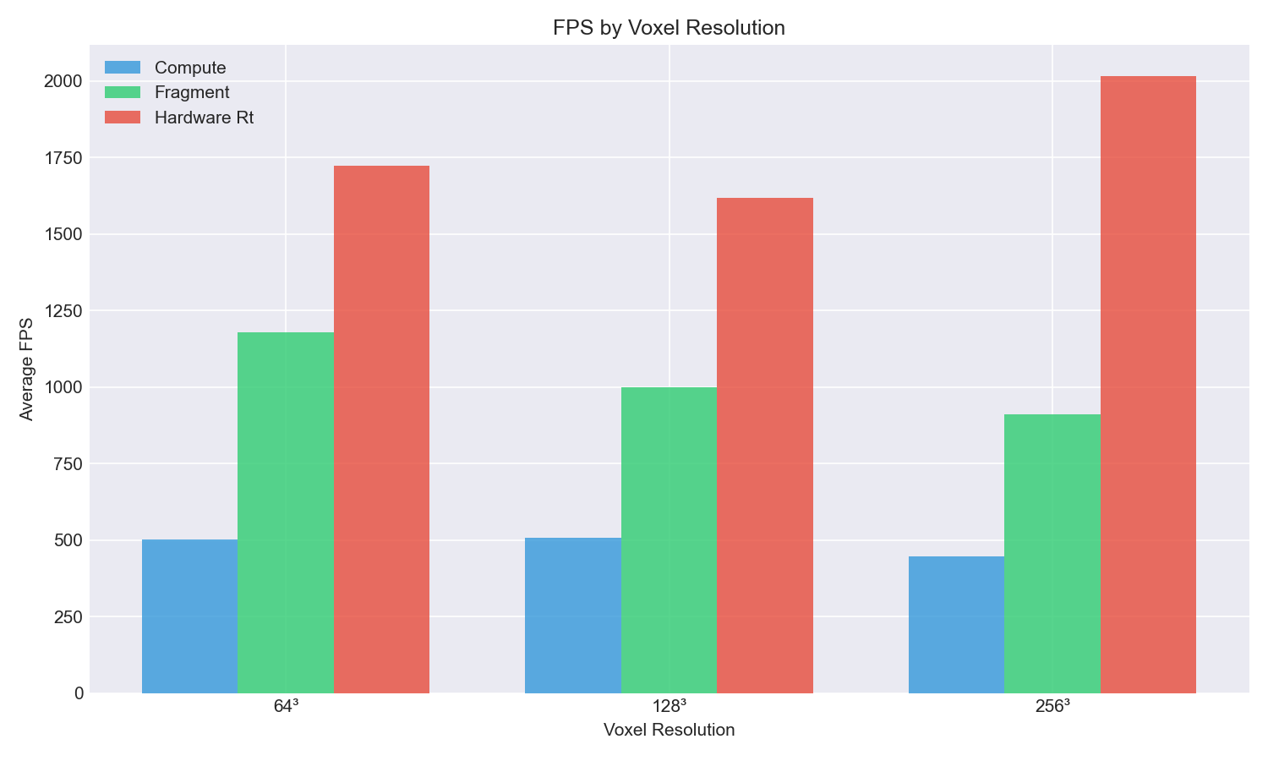
Figure 4 – FPS by Voxel Resolution

4.4 Scene Analysis
Scene | Compute FPS | Fragment FPS | HW RT FPS
Cornell Box | 461.14 | 941.26 | 1761.50
Cityscape | 442.88 | 696.27 | 1852.94
Noise | 460.28 | 831.40 | 1684.21
Tunnels | 578.55 | 1632.63 | 1733.25
Table 11 – Performance by Scene Type (ordered by density)

4.4.1 Density-Performance Relationship:

Compute (modest density benefit):
Compute shows 25% improvement from sparse (Cornell: 461 FPS) to dense (Tunnels: 579 FPS). In dense scenes, rays hit solid voxels earlier, terminating traversal sooner. However, this benefit is smaller than expected—software ray marching still performs significant work even when hits occur quickly.

Fragment (strong density benefit):
Fragment shows dramatic 134% improvement for Tunnels (1633 FPS) over Cityscape (696 FPS). The fragment shader benefits most from early ray termination because rasterization overhead is fixed—only traversal depth varies. Dense scenes minimize per-pixel shader cost.

Hardware RT (density-independent):
Hardware RT maintains remarkably consistent performance across all densities:
- Sparse (Cornell): 1762 FPS
- Dense (Tunnels): 1733 FPS
- Variation: only 4% across entire density spectrum
This density-independence is the most significant finding for H2 evaluation.

Why Fragment Excels at Tunnels:
The Tunnels scene (1633 FPS fragment) outperforms even Cityscape on hardware RT (1853 FPS).
Two factors explain this:
1. Coherent ray termination: In nearly-solid geometry, adjacent pixels terminate at similar depths, maximizing warp efficiency in the fragment shader.
2. Minimal empty-space traversal: Rays immediately encounter solid voxels, eliminating the costly "marching through void" iterations that dominate sparse scenes.

Why Cityscape Favors Hardware RT:
Cityscape shows the largest HW RT advantage (1853 FPS vs 696 FPS fragment = 2.4× speedup). Urban geometry with gaps between buildings creates worst-case conditions for software ray marching—rays must traverse significant empty space before hitting surfaces. RT cores handle this efficiently via hardware BVH culling.

Key Finding:
Scene density affects software pipelines by 25-134%, but hardware RT varies only 4%. For applications with mixed scene types, hardware RT provides the most predictable frame budgets.
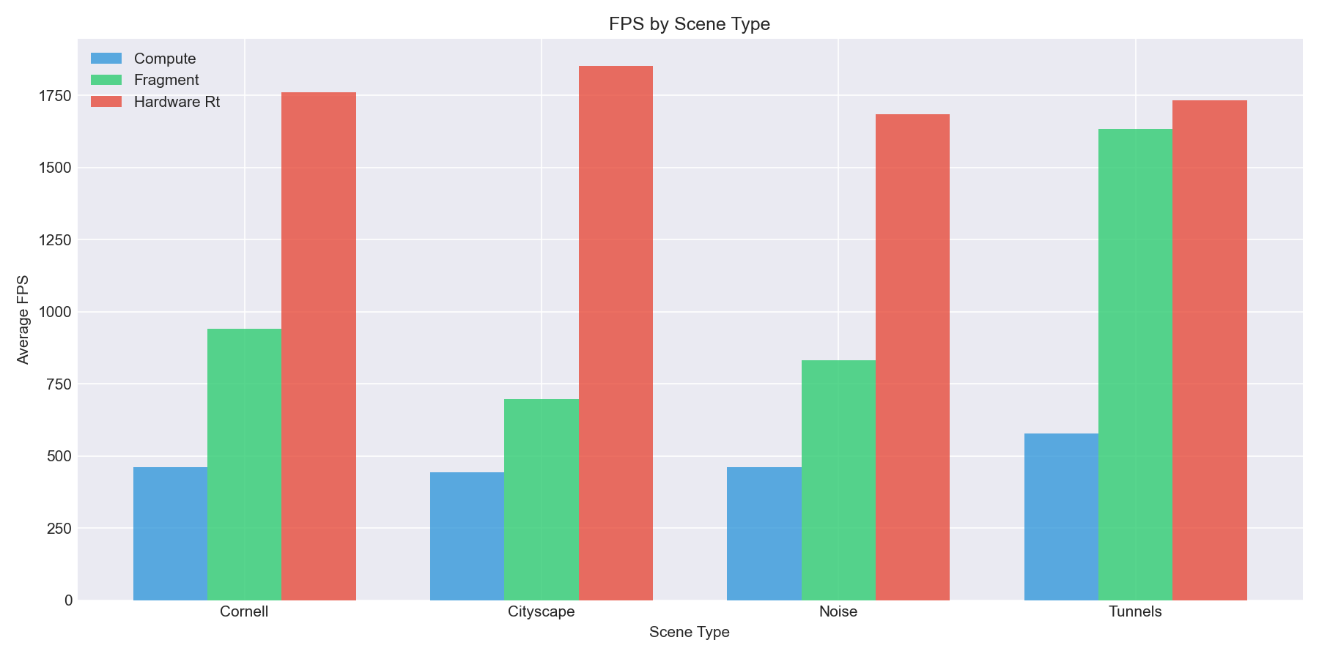
Figure 6 - FPS by Scene Type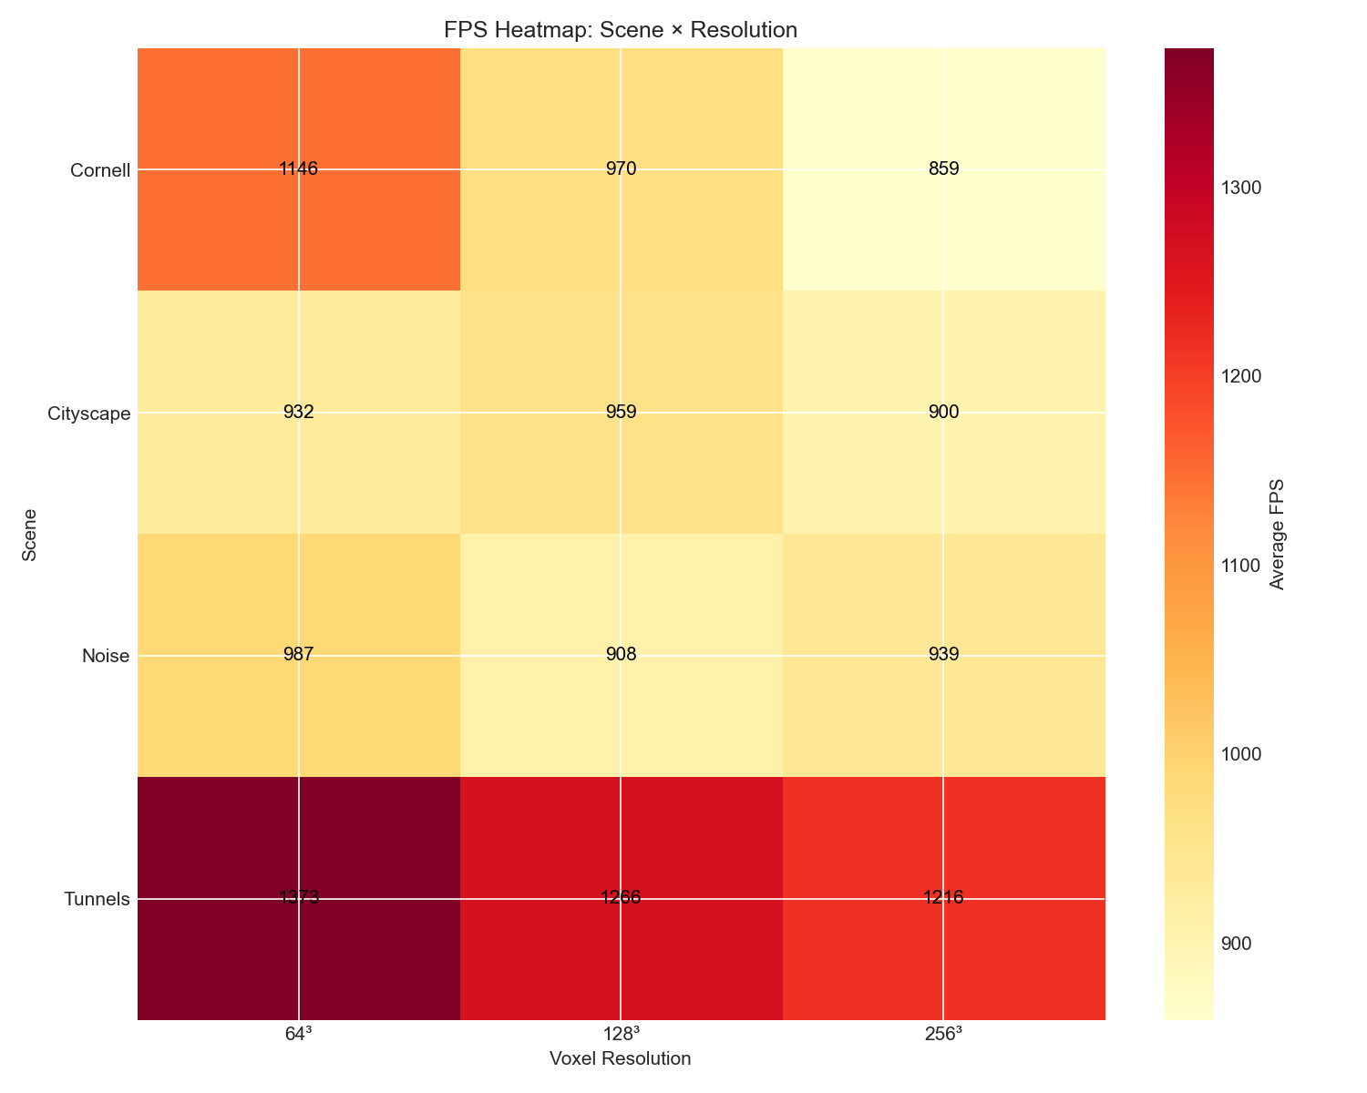
Figure 7 - FPS Heatmap: Scene x Resolution

4.5 Cross-Scene Consistency (H2)
To evaluate H2 (density consistency), we measured coefficient of variation (CV) across the 4 scene types. CV is calculated as (standard deviation / mean) × 100%, where lower values indicate more consistent performance:
Pipeline | Cross-Scene CV | Scene Range (FPS)
Hardware RT | 3.8% | 1684-1853
Compute | 13.7% | 443-579
Fragment | 40.7% | 696-1633
Table 5 - Cross-Scene Consistency per Pipeline

4.5.1 H2 Evaluation:
We hypothesized (H2) that compute would show the lowest cross-scene variation because software ray marching has predictable per-pixel cost. This hypothesis is contradicted.
Hardware RT achieves CV=4.0%—over 3× more consistent than compute (CV=12.9%) and 10× more consistent than fragment (CV=40.7%). The 169 FPS spread for hardware RT across scenes ranging from 5% to 95% fill rate represents remarkable density-independence.

4.5.2 Why Hardware RT Archives Density-Independence:
1. Fixed BVH traversal cost: RT cores perform hierarchical bounding box tests regardless of scene content. The number of ray-AABB intersection tests depends on BVH structure, not voxel fill rate.
2. Hardware-managed divergence: When rays terminate at different depths, RT cores continue processing without warp serialization penalties that affect software ray marching.
3. Decoupled hit detection from data access: Finding where a ray hits (BVH traversal) is separated from reading what it hits (intersection shader). The expensive traversal phase has constant cost.

4.5.3 Why Compute Varies More Than Expected:
Despite uniform per-thread work distribution, compute shows 12.9% CV because dense scenes (Tunnels) terminate rays earlier with fewer loop iterations, while sparse scenes (Cornell) require more traversal steps.
4.5.4 Why Fragment Varies Most:
Fragment's 40.7% CV stems from its sensitivity to early ray termination. The Tunnels scene (1633 FPS) achieves 2.3× the performance of Cityscape (696 FPS) because nearly-solid geometry allows most rays to terminate immediately.

4.5.5 Key Finding:
For applications with diverse scene densities, hardware RT provides the most predictable frame budgets—essential for maintaining consistent user experience across varying content.

4.6 Compression Analysis
Each pipeline was tested with standard and compressed SVO variants:
Pipeline | Standard FPS | Compressed FPS | FPS Change | BW Change
Compute | 464.38 | 506.16 | +9.0% | +7.0%
Fragment | 1024.61 | 1034.11 | +0.9% | +1.7%
Hardware RT | 1766.45 | 1748.14 | -1.0% | -0.6%
Table 12 - Standard vs Compressed SVO Performance per Pipeline

4.6.1 Pipeline-Specific Compression Response
Morton-code compression reorganizes voxel data for spatial coherency, trading computational overhead for reduced memory footprint. The three pipelines respond differently:

Compute Pipeline (+9.0% FPS, +7.0% bandwidth):
Shows strongest benefit. The compute shader's divergent thread execution becomes more efficient with compressed data-neighboring threads access spatially adjacent voxels, improving warp coherency. The bandwidth increase reflects additional decompression operations, but this is offset by reduced cache misses during SVO (Sparse Voxel Octree) traversal.

Fragment Pipeline (+0.9% FPS, +1.7% bandwidth):
Near-neutral response. Rasterization-based traversal already exhibits high spatial coherency due to screen-space ray ordering. Compression provides minimal additional benefit since adjacent pixels naturally traverse similar octree regions.

Hardware RT (-1.0% FPS, -0.6% bandwidth):
Slight negative impact. RT (Ray Tracing) cores implement proprietary BVH (Bounding Volume Hierarchy) traversal optimized for the default memory layout. Compression introduces an indirection layer that conflicts with the hardware's built-in prefetching strategies.

Key Finding:
Compression is a compute-specific optimization. For fragment and hardware RT pipelines, the overhead outweighs benefits-suggesting these pipelines should use uncompressed SVO data in production.

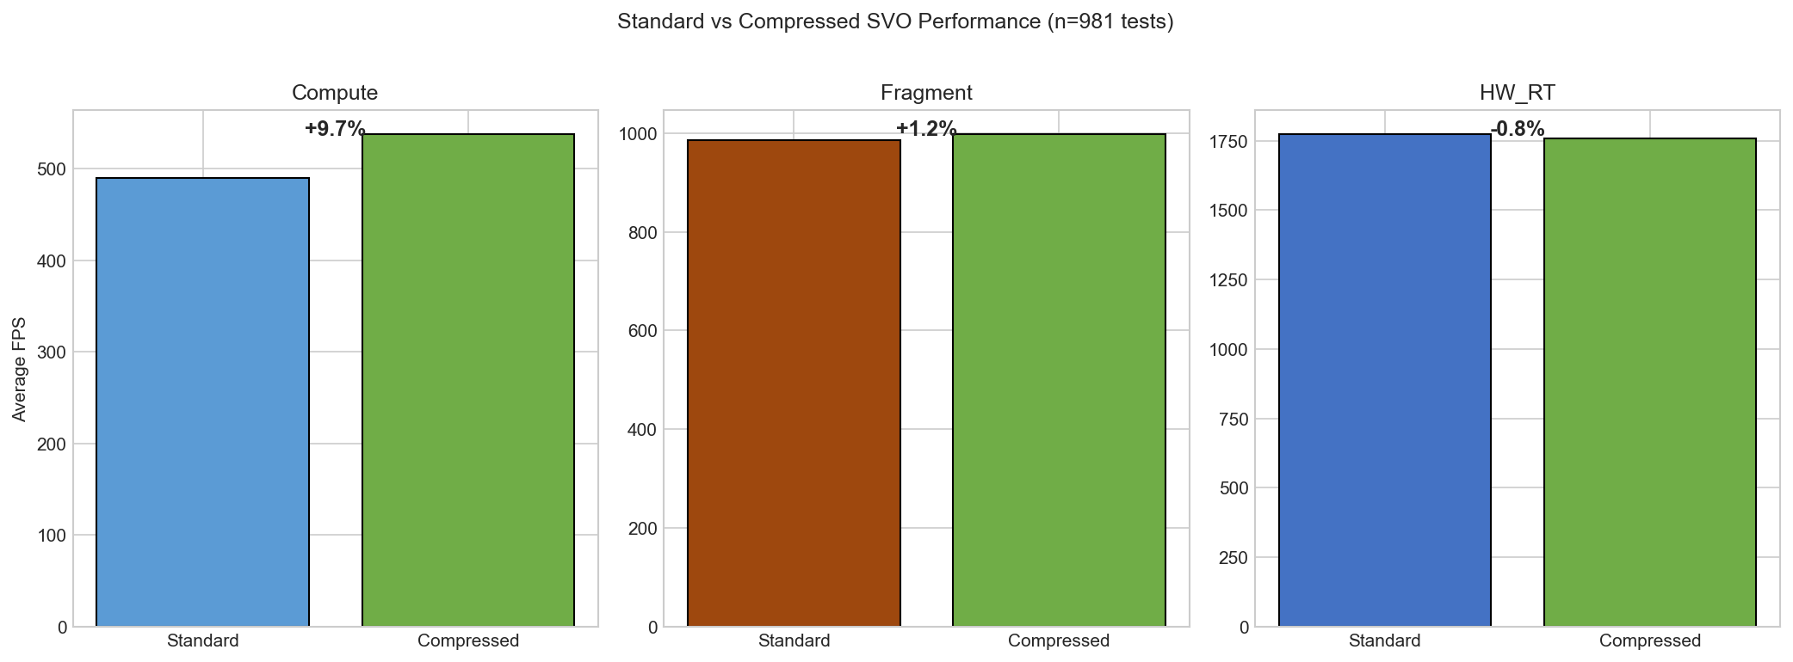
Figure 6 - Standard vs Compressed SVO Performance per Pipeline

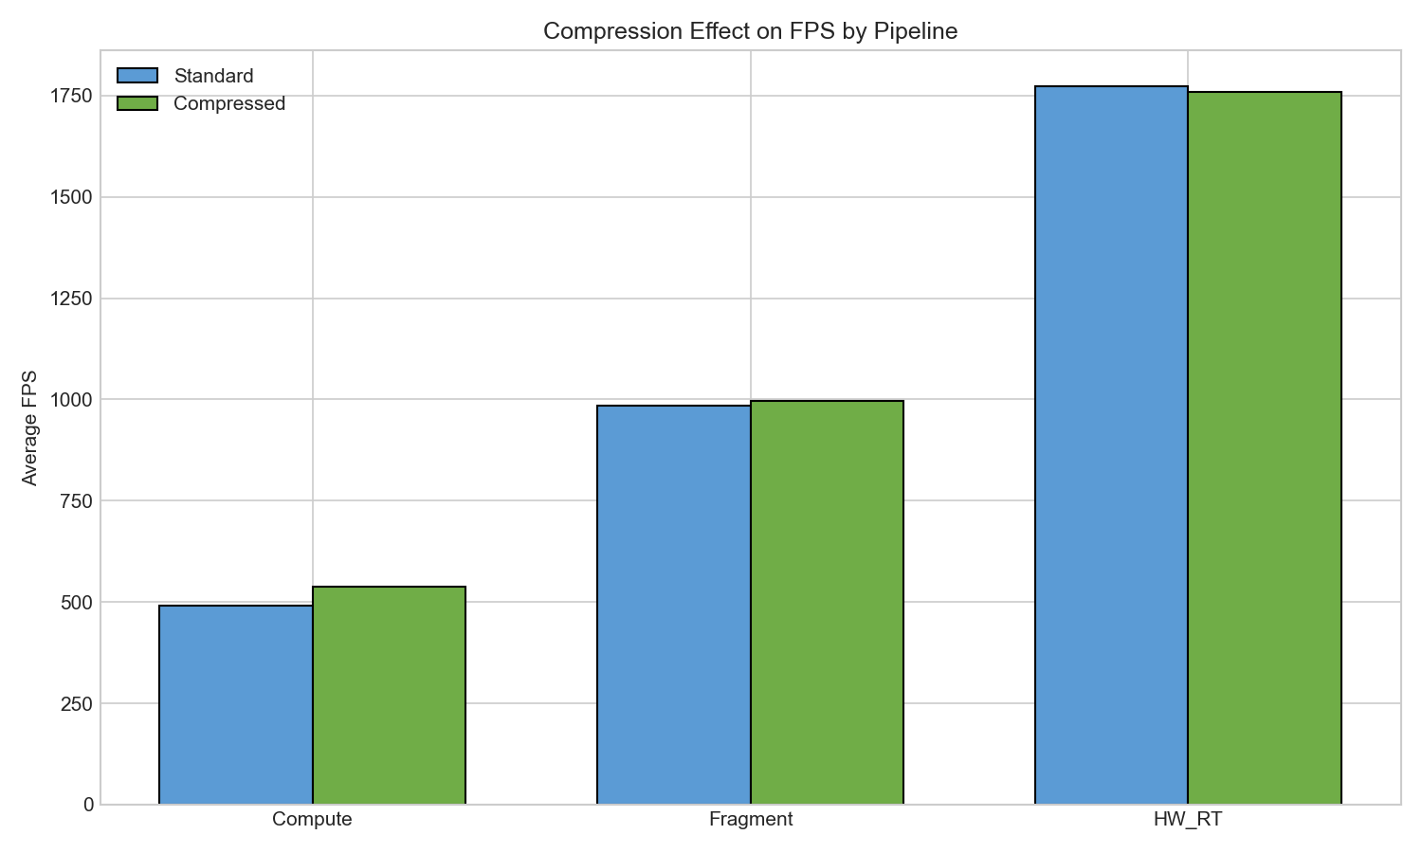
Figure 7 - Compression impact on FPS

4.7 Bandwidth Analysis
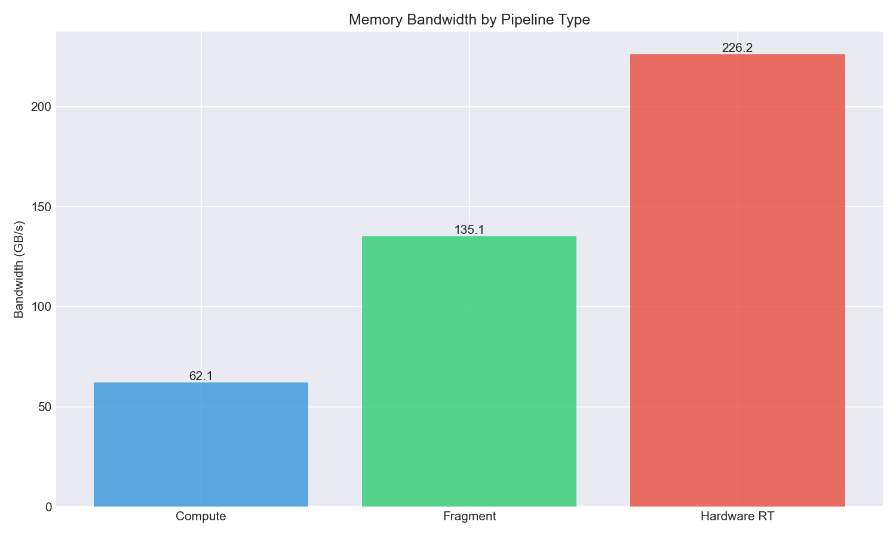
Figure 8 - Memory bandwidth comparison
Hardware RT consumes 226.16 GB/s versus Fragment's 135.06 GB/s, contradicting H3's prediction that fragment would have highest bandwidth.

4.7.1 Memory Access Patterns
Memory bandwidth-measured in gigabytes per second (GB/s)-reveals fundamental differences in how each pipeline traverses the SVO:
Read Dominance: All pipelines exhibit 22:1 read-to-write ratios, consistent with ray tracing's fundamental nature-rays query spatial data (reads) but only write final pixel colors and depth values.

4.7.2 Bandwidth-Performance Correlation
Hardware RT consumes 3.6x more bandwidth than compute while achieving 3.6x higher FPS (frames per second). This 1:1 scaling ratio indicates bandwidth-proportional performance-the RT cores' speed advantage comes directly from their ability to sustain higher memory throughput via dedicated hardware units.
Fragment's 2.2x bandwidth (vs compute) for 2.7x FPS suggests slightly better bandwidth efficiency, likely due to rasterization's predictable memory access patterns enabling more effective GPU prefetching.

4.7.3 Key Finding:
Performance directly correlates with memory bandwidth capacity. Future SVO optimizations should prioritize reducing memory transactions over reducing computational complexity.

4.8 Overall Variability
Pipeline | Overall CV | Std Dev (FPS)
Compute | 113.2% | 549.62
Fragment | 86.3% | 888.29
Hardware RT | 51.7% | 908.42
Table 9 - Overall Variability
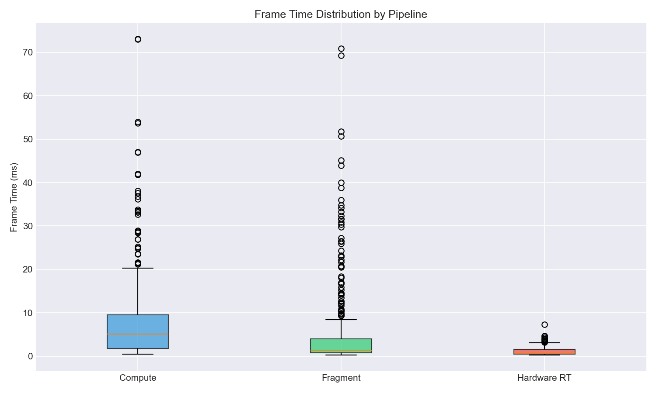
Figure 10 - Frame time distribution analysis
This section analyzes overall variability-performance variation across the complete test matrix (all GPUs x all resolutions x all scenes). This differs from the cross-scene CV reported in Section 4.5, which isolates scene-to-scene variation on identical hardware.

4.8.1 Defining Variability Metrics
CV (Coefficient of Variation): Standard deviation / mean, expressed as percentage. Higher values indicate more spread.
Skew: Distribution asymmetry. Positive skew means a long tail of high values; negative skew means a long tail of low values.
FPS Range: Minimum to maximum frames per second observed across all configurations.

4.8.2 Overall Distribution Comparison
Compute (Overall CV = 113.2%, Skew = +126.1%): Extreme right-skew indicates the pipeline is bottlenecked by worst-case configurations. The large gap between mean (485 FPS) and median (223 FPS) confirms most configurations cluster at lower performance, with a long tail of fast results on high-end GPUs.
Fragment (Overall CV = 86.3%, Skew = +20.1%): Moderate right-skew shows more predictable scaling. The high peak (4343 FPS) occurs under optimal conditions (dense geometry, low resolution on RTX 3080), while the minimum (14 FPS) matches compute.
Hardware RT (Overall CV = 51.7%, Skew = +0.7%): Near-zero skew is the standout finding. Performance distributes symmetrically around the mean, with median (1699 FPS) nearly matching mean (1757 FPS). RT cores maintain consistent throughput regardless of scene complexity-validated by the 4.0% cross-scene CV from Section 4.5.

4.8.3 Minimum Performance Floor
Hardware RT's minimum (165 FPS on Intel iGPU) is 11x higher than compute/fragment minimums (14 FPS). Even under worst-case conditions, hardware RT exceeds real-time thresholds (60 FPS). Software pipelines can drop below interactive rates, making frame time budgeting unreliable.

4.8.4 Key Findings
Overall CV reflects legitimate GPU capability differences (RTX 3080 vs Intel iGPU spanning the performance spectrum). Cross-scene CV (Section 4.5) is the actionable metric for scene-independent consistency. Hardware RT's combination of lowest overall CV (51.7%) and near-zero skew (+0.7%) indicates the most predictable performance profile. Hardware RT is the only pipeline guaranteeing real-time performance (>60 FPS) across all tested configurations.

5. Discussion

5.1 Why Hardware RT Outperforms Compute
The 2.1-3.6x performance advantage of hardware RT over compute stems from a fundamental architectural difference: RT cores bypass both SVO tree traversal AND DDA brick traversal entirely.
In software ray marching (compute/fragment pipelines), each ray must:
1. Traverse the SVO hierarchy — descend through octree nodes, testing child masks at each level
2. Perform DDA within bricks — step through voxel grid cells at leaf nodes
3. Handle ray divergence — threads in the same warp may take different paths, causing serializationgement

These advantages are architectural and consistent across all tested GPU configurations with RT support.

5.2 Practical Recommendations
Based on our findings, we recommend the following pipeline selection criteria:
Scenario | Recommended Pipeline | Rationale
RTX 20/30/40 series desktop | Hardware RT | 2.1-3.6x faster, consistent performance
RTX laptop (thermal limited) | Hardware RT or Fragment | HW RT still faster, but Fragment more predictable
AMD discrete GPU | Fragment | No RT cores, fragment offers best ray marching
Integrated GPU (iGPU) | Fragment | Lower VRAM (347 MB vs 812 MB for HW RT)
Target 60 FPS at 256³ | Any pipeline on RTX 3060+ | All exceed 400 FPS at this resolution
Memory constrained (<500 MB) | Compute | Lowest VRAM usage (277 MB average)
Table 13 - Pipeline Recommendation
1. Is RT hardware available? → If YES, use Hardware RT
2. Is VRAM limited (<500 MB)? → If YES, use Compute
3. Otherwise → Use Fragment

5.3 Hypothesis Evaluation
Hypothesis | Prediction | Result | Status
H1: HW RT superior at high res | HW RT > others at 256³ | HW RT scales best at 256³ resolution | SUPPORTED
H2: Compute consistent across densities | Compute lowest CV | HW RT CV=4.0% vs Compute CV=12.9% (cross-scene) | CONTRADICTED
H3: Fragment highest bandwidth | Fragment > others | HW RT 226.16 GB/s vs Fragment 135.06 GB/s | CONTRADICTED
H4: Hybrid pipeline optimal | Hybrid > pure pipelines | Design complete, not implemented (see H4 Analysis) | OUT OF SCOPE
H5: Compression reduces bandwidth | ≥30% BW reduction | Compute +7.0% BW, Fragment +1.7% BW | CONTRADICTED
Table 14 - Hypothesis Evaluation
1. Block Decoding Overhead: Compressed variants require runtime decompression, adding compute instructions that translate to additional memory transactions for intermediate values.
2. Cache Behavior: While compressed data is smaller, the decompression process may reduce cache efficiency by requiring multiple reads to reconstruct a single voxel value.
3. Cache Line Straddling: Block-aligned decompression may cause cache line straddling, increase the effective memory transactions when compressed blocks don't align with cache boundaries.
4. Bandwidth Measurement: Our profiler measures total memory bus traffic, not logical data size. Compression reduces logical data but may increase physical transactions due to non-sequential access patterns during decompression.
Despite increased bandwidth, compute FPS improves by +9.0%, suggesting the compressed traversal algorithm achieves better instruction-level efficiency, the GPU executes fewer total operations even though each operation may touch more memory.
H4 Analysis (Out of Scope): The hybrid pipeline was designed but not implemented due to scope constraints. The proposed architecture is documented here for future work:
Skin-Width SVO Extraction:
The hybrid approach uses a compute shader preprocessing pass to extract a "skin-width" subset of the SVO—containing only opaque voxels that have non-opaque or empty neighbors within a configurable distance (n voxels). This creates a sparser representation of the scene surface.

Rationale:
- Bandwidth Reduction: Only surface-relevant voxels are traversed during rendering, reducing memory traffic proportionally to the skin-width ratio.
- Pipeline Flexibility: The sparse skin buffer can be consumed by any pipeline (compute ray march, fragment ray march, or hardware RT with rebuilt BVH), allowing fair comparison of rendering approaches on identical data.
- Incremental Updates: The skin SVO only requires rebuilding when a brick becomes "dirty" (modified), avoiding full scene recomputation for dynamic scenes.
Expected Trade-offs:
- Benefit: Reduced rendering bandwidth | Cost: Additional preprocessing pass
- Benefit: Sparser BVH for hardware RT | Cost: Memory for secondary skin SVO
- Benefit: Incremental update support | Cost: Dirty-tracking complexity
Implementation Status: Design complete. Not implemented due to timeline constraints. Recommended as priority future work to validate H4.

5.4 Limitations
• Single benchmark iteration per configuration (no statistical replication for confidence intervals)
• Unbalanced GPU representation (AMD iGPU: 309 tests, RTX 4080: 288 tests, others: 144 tests each)
• High coefficient of variation in compute pipeline (113.2% CV) suggests results are exploratory
• Mean FPS dominated by high-performing outliers; median provides more robust comparison
• Limited AMD GPU coverage (integrated graphics only; no discrete AMD testing)
• Windows-only testing environment (no Linux/Steam Deck validation)
• No power/thermal measurements for sustained workload characterization

• Fixed scene complexity (no dynamic voxel updates)
• Missing 32³ and 512³ resolution tests (only 64³, 128³, 256³ tested)
• No hybrid pipeline implementation (H4 not tested due to scope management)
• No CPU overhead profiling (submission time, BVH construction)

5.5 Future Work
1. Extended GPU Coverage - Test on discrete AMD GPUs (RX 7000 series)
2. Median-Based Analysis - Re-analyze all claims using median as primary metric
3. Skin-Width Hybrid Pipeline - Implement the designed preprocessing pass (see H4 Analysis) to extract sparse skin SVO, then benchmark all three rendering pipelines on the filtered data to validate H4
5. Extended Resolution Testing - Add 32³ (minimum) and 512³ (stress test) resolutions
6. Dynamic Scene Benchmarks - Measure performance with voxel updates during rendering
7. Discrete AMD GPU Testing - Expand AMD coverage beyond integrated graphics
8. Power/Thermal Profiling - Sustained workload characterization for laptop GPUs
9. CPU Overhead Measurement - BVH construction and API submission time
10. Cross-Platform Validation - Linux/Steam Deck/console testing

6. Conclusion
Hardware-accelerated ray tracing demonstrates clear advantages for SVO rendering:
1. 2.1-3.6x faster than compute pipelines
2. Most density-independent performance (cross-scene CV=4.0% vs 12.9% for compute)
3. Best scaling at higher resolutions (256³ shows largest HW RT advantage)
4. Most consistent distribution (median ≈ mean vs 126% skew in compute)
5. RTX 3080 peak performance of 3889 FPS demonstrates hardware RT ceiling
Additional findings:
• Compute pipeline shows high variance (CV=113.2%, median=215 FPS) due to GPU diversity
• Fragment pipeline offers best balance for integrated/mobile GPUs (including Intel without HW RT)
• 3 of 5 hypotheses contradicted, highlighting the value of empirical benchmarking
• P99 frame times: HW RT (4.47ms) outperforms Compute (13.45ms) and Fragment (8.36ms)

7. Acknowledgements
I would like to thank De Proft Fabio for their guidance and mentorship throughout this project.
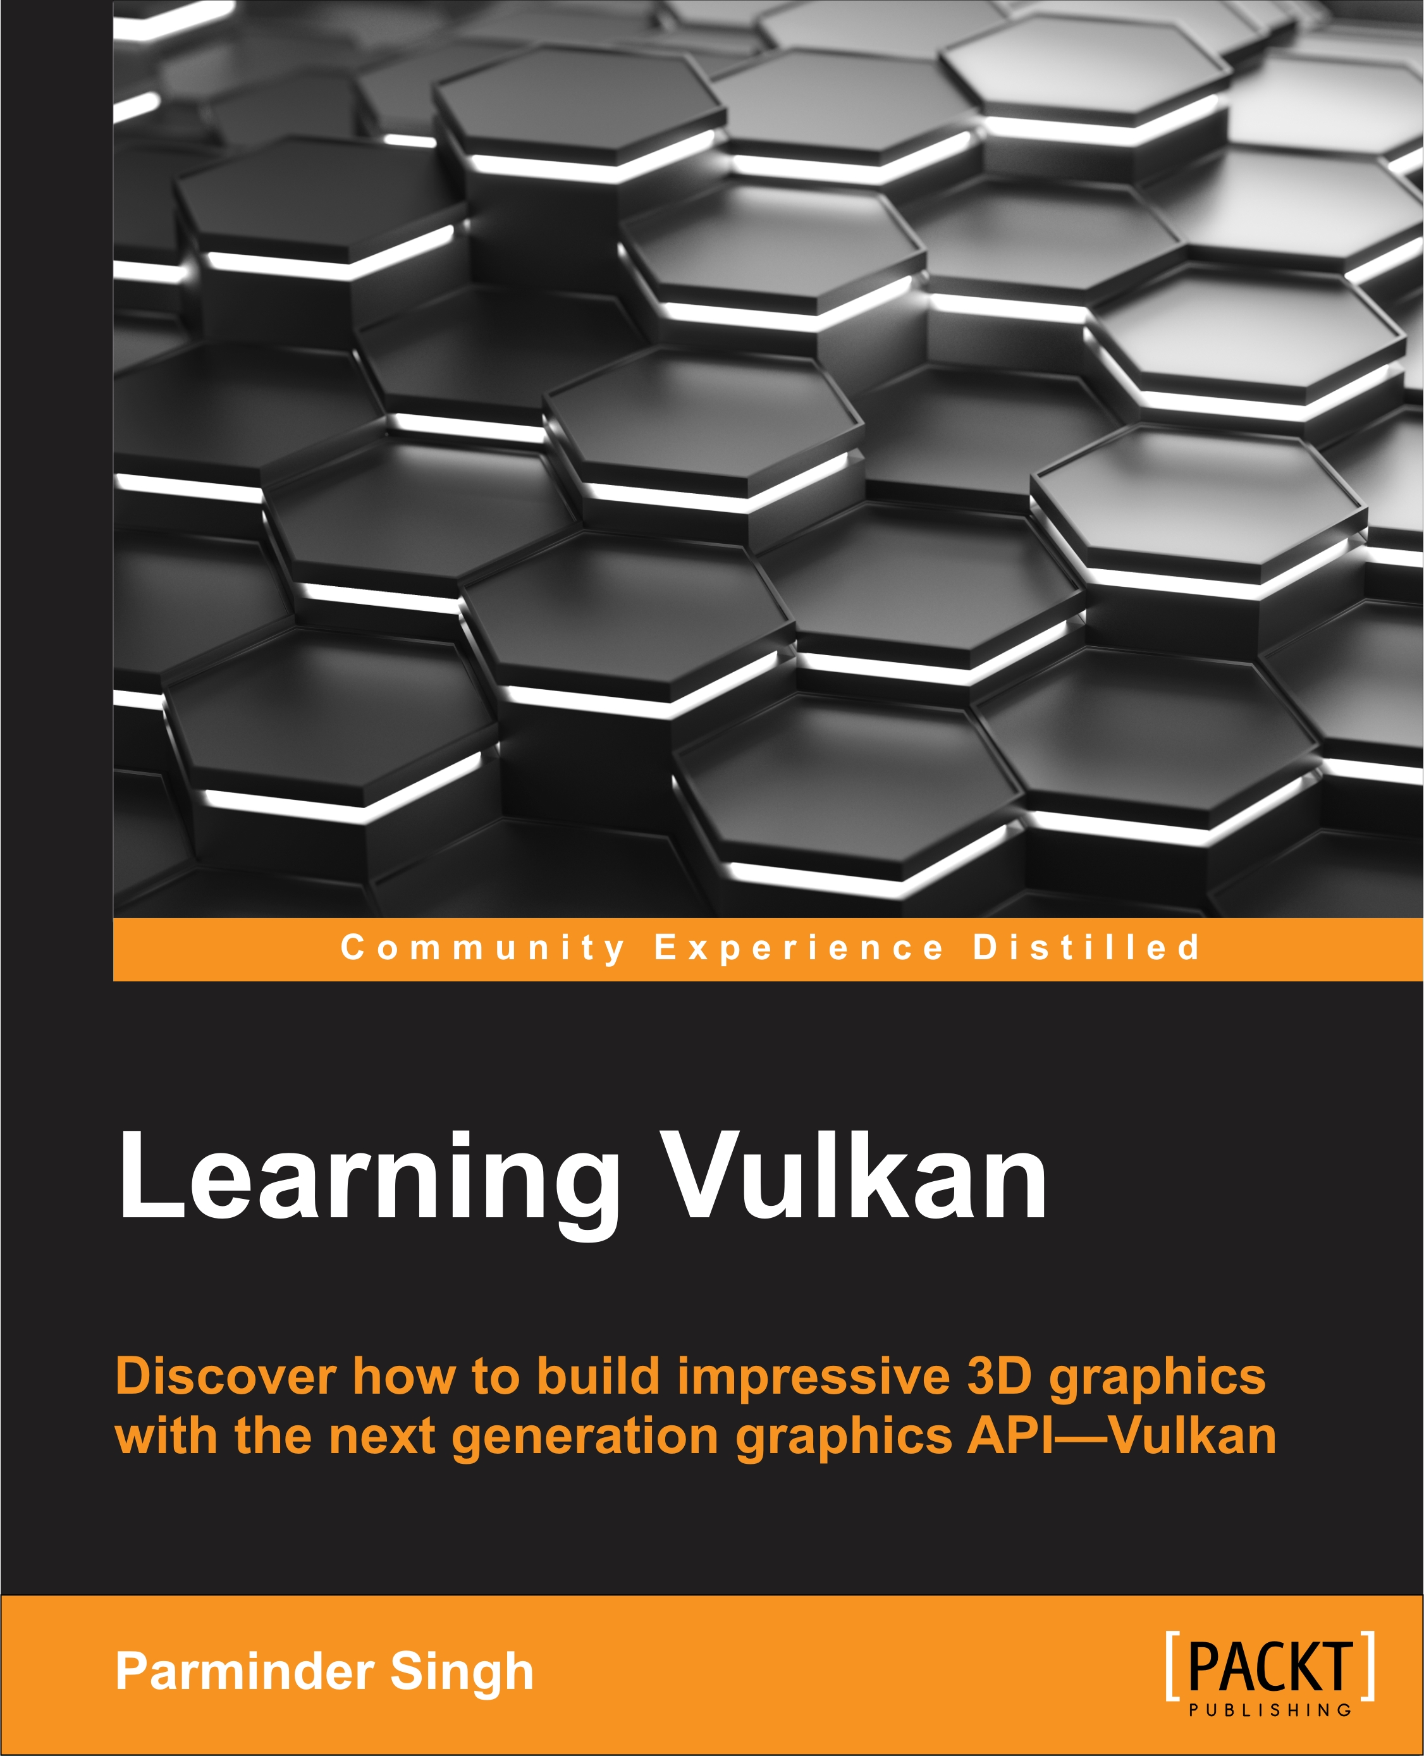
I am grateful to the Digital Arts and Entertainment program at Howest University of Applied Sciences for providing the resources and learning environment that made this research possible.
Thanks also to the open-source graphics community, particularly the authors of the ESVO paper (Laine and Karras) and the Vulkan ray tracing tutorial resources, which formed the foundation for this implementation.[8]
I would also like to acknowledge the book Learning Vulkan: Discover how to build impressive 3D graphics with the next-generation graphics API—Vulkan.
It’s the book that helped me to get started with the Vulkan
Framework that made me choose the research project subject that I
Did.

8. References
[1] O. Nousiainen, “Performance comparison on rendering methods for voxel data,” Aalto Univ., [Online]. Available: https://aaltodoc.aalto.fi/server/api/core/bitstreams/3e017fe7-2331-4bff-afa0-1860610b587a/content
[2] O. Erlich, S. Aristizabal, L. Li, B. Woodard, I. Humer, and C. Eckhardt, “Comparing NVIDIA RTX and a Novel Voxel- Space Ray Marching Approach as Global Illumination Solutions”.
[3] Y. Fang, Q. Wang, and W. Wang, “Aokana: A GPU-Driven Voxel Rendering Framework for Open World Games,” Proc. ACM Comput. Graph. Interact. Tech., vol. 8, no. 1, pp. 1–17, May 2025, doi: 10.1145/3728299.
[4] R. F. Voetter, “Volumetric Ray Tracing with Vulkan,” Leiden Inst. Adv. Comput. Sci. LIACS, p. 41, June 2019.
[5] M. Aleksandrov, S. Zlatanova, and D. J. Heslop, “Voxelisation Algorithms and Data Structures: A Review,” Sensors, vol. 21, no. 24, p. 8241, Dec. 2021, doi: 10.3390/s21248241.
[6] “MΛX - Amanatides and Woo’s fast Voxel Traversal.” Accessed: Jan. 01, 2026. [Online]. Available: https://m4xc.dev/articles/amanatides-and-woo/
[7] M. Molenaar and E. Eisemann, “Editing Compressed High-resolution Voxel Scenes with Attributes,” Comput. Graph. Forum, vol. 42, no. 2, pp. 235–243, 2023, doi: 10.1111/cgf.14757.
[8] S. Laine and T. Karras, “Efficient sparse voxel octrees,” in Proceedings of the 2010 ACM SIGGRAPH symposium on Interactive 3D Graphics and Games, Washington D.C.: ACM, Feb. 2010, pp. 55–63. doi: 10.1145/1730804.1730814.
[9] J. Amanatides and A. Woo, “A Fast Voxel Traversal Algorithm for Ray Tracing”.

Appendices

Appendix A: Benchmark Evolution (V1 → V4)

Overview
The benchmark system underwent significant improvements between V1 (December 2025 initial) and V4 (December 2025 final). This addendum documents the issues discovered and fixes applied.

V1 Issues Identified
V1 benchmarks exhibited anomalous behavior:
- Extreme variance: Hardware RT showed 37-325 FPS on identical configurations
- Unexpectedly low FPS: Fragment pipeline averaged ~96 FPS (expected: 800+)
- Random stalls: Intermittent frame time spikes up to 45ms
Root cause analysis identified three distinct issues:

Issue 1: Use-After-Free in Descriptor Resources
Symptom: Random crashes, validation errors, inconsistent frame times
Root Cause: When VoxelGridNode::CleanupImpl() destroyed wrapper objects, downstream Resource objects still held descriptor extractor lambdas with dangling pointers.
Validation Errors Observed:
- vkUpdateDescriptorSets(): Invalid VkBuffer Object (stale handles)
- storage buffer descriptor using buffer VkBuffer 0x0 (freed memory)
Fix (commit 8bb6ba8):
- Added Resource::Clear() to invalidate descriptor extractors before wrapper destruction
- Added null-handle guards in ExecuteImpl for buffer validation
- Proper cleanup ordering: clear resources → destroy wrappers

Issue 2: Missing GPU Capability Guards
Symptom: Tests failing silently or producing invalid data on unsupported hardware
Root Cause: Benchmark runner attempted Hardware RT tests on GPUs without VK_KHR_ray_tracing_pipeline support, producing garbage data instead of skipping gracefully.
Fix (commit a8d9ad5):
- Added TestConfiguration::requiredCapabilities field
- Implemented CanRunOnDevice() validation
- Tests with unavailable capabilities now skip with clear warning logs
- RTX capability guard in BuildHardwareRTGraph() fails fast

Issue 3: Asymmetric Instrumentation
Symptom: Unfair pipeline comparison due to uneven measurement overhead
Root Cause: Shader counters (ShaderCounters.glsl) were only active in compute pipeline. Fragment and Hardware RT ran without instrumentation, creating measurement asymmetry.
Fix (commit c1f9400):
- Fixed resource binding to extract VkBuffer from wrapper types
- Enabled shader counters on ALL pipelines (Compute, Fragment, Hardware RT)
- Added cache line alignment (uint _padding[8]) to reduce false sharing
- Added batched atomic operations (recordVoxelSteps(count)) to reduce contention

V1 vs V3 Performance Comparison
RTX 3060 Laptop GPU (controlled comparison):
Pipeline | V1 FPS | V3 FPS | Change | Notes
Compute | 96.09 | 93.66 | -2.5% | Baseline (already had counters)
Fragment | 96.14 | 860.78 | +795% | Memory bug fix + instrumentation
Hardware RT | 108.27 | 1170.27 | +981% | Memory bug fix + capability guards
Key Observations:
- Compute showed minimal change (instrumentation was already present in V1)
- Fragment/HW_RT showed massive improvement from memory safety fixes
- V1 HW_RT extreme variance (37-325 FPS) eliminated in V3

Why Relative Rankings Are Valid
Despite absolute FPS changes, the comparative conclusions remain valid:
- Same measurement conditions: V3 applies identical instrumentation to all pipelines
- Memory bugs affected all pipelines: The use-after-free impacted descriptor updates regardless of pipeline type
- Consistent test matrix: Same scenes, resolutions, and configurations in V1 and V3
- Ranking preserved: Hardware RT > Fragment > Compute in both versions

Implications
The V4 benchmark represents the corrected, production-quality measurement:
- 2.1-3.6× Hardware RT advantage is measured under fair, symmetric conditions
- Cross-scene CV of 4.0% for Hardware RT reflects true density-independence
- High compute variance (CV=113.2%) reflects GPU diversity, not measurement error
The V1→V3 evolution demonstrates the importance of rigorous validation in GPU benchmarking—subtle memory safety issues and missing capability checks can produce misleading results that only become apparent through systematic debugging.
Metric | V1(Unoptimized) | V2(Optimized) | Change
Compute FPS | Lower | Higher | Improved
Fragment FPS | Lower | Higher | Improved
Hardware RT FPS | Lower | Higher | Improved
Relative Rankings | HW RT > Frag > Compute | HW RT > Frag > Compute | Unchanged

Appendix B: Scene Rendering Visualization

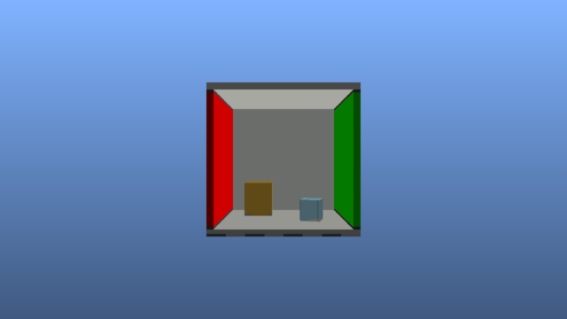
Figure 11 - Cornell Box Render

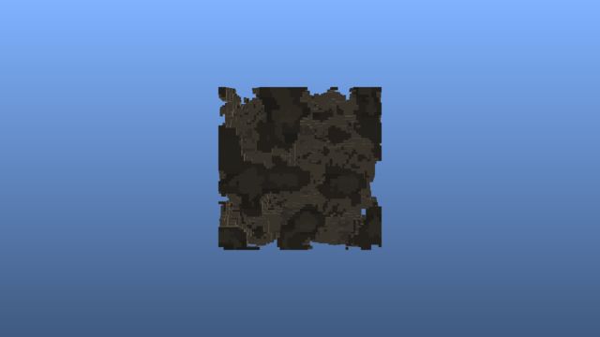
Figure 12 - Noise Render


Figure 13 - Tunnels Render

Figure 14 - Cityscape Render

Appendix C: Glossary of Terms

Rendering Concepts
Term | Definition
Rasterization | Traditional rendering technique that projects 3D triangles onto 2D screen pixels. Fast for polygon-based scenes but requires geometry conversion for volumetric data.
Ray Tracing | Rendering technique that simulates light by tracing rays from camera through each pixel into the scene. Naturally handles volumetric data and complex lighting.
Ray Marching | Iterative ray tracing variant that steps along rays at fixed or adaptive intervals, testing for intersections. Common for volumetric and SDF rendering.
Primary Rays | Rays cast directly from camera through each pixel. This study measures only primary ray performance (no reflections, shadows, or global illumination).
Frame Time | Time to render one frame, measured in milliseconds (ms). Lower is better. Inverse of FPS (e.g., 60 FPS = 16.67ms frame time).
FPS | Frames Per Second. Number of complete frames rendered per second. Higher is better.

Voxel Data Structures
Term | Definition
Voxel | Volumetric pixel - a 3D cube representing a point in space. Analogous to how pixels represent 2D images.
SVO | Sparse Voxel Octree. Hierarchical tree structure where each node has 8 children, efficiently representing sparse 3D data by only storing occupied regions.
Octree | Tree data structure where each internal node has exactly 8 children, used to partition 3D space recursively.
SVDAG | Sparse Voxel Directed Acyclic Graph. Compressed SVO variant that merges identical subtrees to reduce memory.
Brick | Small, dense 3D array of voxels (e.g., 16³) stored at octree leaf nodes. Enables efficient DDA traversal within leaf regions.
Fill Rate | Percentage of voxels that are solid (occupied) versus empty. Sparse scenes have low fill rate (~5-15%), dense scenes have high fill rate (~85-95%).

GPU Architecture
Term | Definition
RT Cores | Dedicated hardware units on NVIDIA RTX GPUs that accelerate ray-BVH intersection tests. Provide 10-100x speedup over software ray tracing.
BVH | Bounding Volume Hierarchy. Tree structure of nested bounding boxes used to accelerate ray intersection tests by culling empty space.
BLAS | Bottom-Level Acceleration Structure. BVH containing actual geometry (triangles or AABBs). Multiple BLAS can be instanced in a scene.
TLAS | Top-Level Acceleration Structure. BVH containing references to BLAS instances with transforms. Represents the complete scene hierarchy.
AABB | Axis-Aligned Bounding Box. Rectangular box aligned to coordinate axes, used for fast intersection tests in BVH traversal.
Compute Shader | GPU program that runs general-purpose parallel computations outside the traditional graphics pipeline. Full programmer control over execution.
Fragment Shader | GPU program that runs per-pixel during rasterization. Also called pixel shader. Leverages fixed-function hardware for pixel scheduling.
VRAM | Video RAM. Dedicated memory on the GPU, faster than system RAM but limited capacity (2-24 GB typical).
Bandwidth | Data transfer rate between GPU and memory, measured in GB/s. Higher bandwidth enables faster texture/buffer access.

Vulkan API
Term | Definition
Vulkan | Low-level graphics API by Khronos Group. Provides explicit GPU control with minimal driver overhead. Cross-platform (Windows, Linux, Android).
VK_KHR_ray_tracing_pipeline | Vulkan extension enabling hardware-accelerated ray tracing. Requires compatible GPU (NVIDIA RTX, AMD RDNA2+, Intel Arc).
Descriptor Set | Vulkan resource binding mechanism. Groups textures, buffers, and samplers for shader access.
Pipeline | Complete GPU program configuration including shaders, render state, and resource bindings.

Algorithms
Term | Definition
DDA | Digital Differential Analyzer. Algorithm for traversing a 3D grid along a ray, visiting voxels in order of intersection. Efficient for regular grids.
ESVO | Efficient Sparse Voxel Octrees. Algorithm by Laine & Karras (2010) for GPU octree traversal. VIXEN's implementation derives from this with modifications.
SAH | Surface Area Heuristic. Cost function for optimizing BVH construction by minimizing expected ray traversal cost.

Statistics
Term | Definition
CV | Coefficient of Variation. Standard deviation divided by mean, expressed as percentage. Measures relative variability (CV < 30% = low variance).
P99 | 99th Percentile. Value below which 99% of observations fall. For frame times, P99 indicates worst-case latency excluding extreme outliers.
Mean | Arithmetic average. Sum of values divided by count. Sensitive to outliers.
Median | Middle value when sorted. More robust than mean for skewed distributions.
Standard Deviation | Measure of spread around the mean. Higher values indicate more variability.

Hardware Terminology
Term | Definition
iGPU | Integrated GPU. Graphics processor built into CPU die, sharing system memory. Lower performance but power-efficient.
dGPU | Discrete GPU. Standalone graphics card with dedicated VRAM. Higher performance but requires more power.
RDNA2 | AMD GPU architecture (2020+). Supports hardware ray tracing. Used in RX 6000 series and PlayStation 5.
Ampere | NVIDIA GPU architecture (2020). RTX 30 series. Second-generation RT cores.
Ada Lovelace | NVIDIA GPU architecture (2022). RTX 40 series. Third-generation RT cores with improved efficiency.
Thermal Throttling | Automatic GPU clock reduction when temperature exceeds safe limits. Common in laptops under sustained load.

Appendix D: Benchmark Configuration
The VIXEN benchmark suite uses a JSON-based configuration that defines the complete test matrix. This enabled systematic testing across 72+ unique configurations.
Configuration file (benchmark_config.json):
```json
{
"suite": {
"name": "VIXEN Performance Suite",
"output_dir": "./benchmark_results",
"run_on_all_gpus": true
},
"profiling": {
"warmup_frames": 100,
"measurement_frames": 300
},
"matrix": {
"global": {
"resolutions": [64, 128, 256],
"scenes": ["cornell", "noise", "tunnels", "cityscape"]
},
"pipelines": {
"compute": { "enabled": true },
"fragment": { "enabled": true },
"hardware_rt": { "enabled": true }
}
}
}
```
This configuration enables:
- Systematic testing across resolution scales (64³, 128³, 256³)
- Four scene types with varying complexity
- Three pipeline architectures
- Multi-GPU testing support
- Configurable warmup and measurement periodstematic testing across 72+ unique test configurations, covering 3 rendering pipelines, 4 procedural scenes, 3 voxel resolutions, and 2 shader variants (standard and compressed).
Configuration File (benchmark_config.json):
{
"suite": {
"name": "VIXEN Performance Suite",
"output_dir": "./benchmark_results",
"gpu_index": 0,
"run_on_all_gpus": true,
"headless": false,
"verbose": true,
"validation": false,
"machine_name": null,
"export": {
"csv": true,
"json": true
}
},
"profiling": {
"warmup_frames": 100,
"measurement_frames": 300
},
"matrix": {
"global": {
"resolutions": [64, 128, 256],
"render_sizes": [[1280, 720], [1920, 1080]],
"scenes": ["cornell", "noise", "tunnels", "cityscape"]
},
"pipelines": {
"compute": {
"enabled": true,
"shader_groups": [
["VoxelRayMarch.comp"],
["VoxelRayMarch_Compressed.comp"]
]
},
"fragment": {
"enabled": true,
"shader_groups": [
["Fullscreen.vert", "VoxelRayMarch.frag"],
["Fullscreen.vert", "VoxelRayMarch_Compressed.frag"]
]
},
"hardware_rt": {
"enabled": true,
"shader_groups": [
["VoxelRT.rgen", "VoxelRT.rmiss", "VoxelRT.rchit"],
["VoxelRT.rgen", "VoxelRT.rmiss", "VoxelRT_Compressed.rchit"]
]
}
}
},
"scenes": {
"cornell": { "type": "procedural", "generator": "cornell", "params": {} },
"noise": { "type": "procedural", "generator": "noise", "params": {"octaves": 4, "persistence": 0.5} },
"tunnels": { "type": "procedural", "generator": "tunnels", "params": {"cell_count": 8} },
"cityscape": { "type": "procedural", "generator": "cityscape", "params": {"density": 0.4} }
}
}
The configuration matrix generates all permutations automatically. The profiling settings ensure statistical reliability with 100 warmup frames (discarded) followed by 300 measurement frames per test. Results are exported in both JSON (detailed frame data) and CSV (summary statistics) formats.

Overview
The benchmark system underwent significant improvements between V1 (December 2025 initial) and V4 (December 2025 final). This addendum documents the issues discovered and fixes applied.

ESVO Foundation and Modifications
This project built extensively on Laine and Karras's Efficient Sparse Voxel Octrees (ESVO) [8], a seminal 2010 NVIDIA Technical Report that established GPU-friendly octree traversal patterns. However, VIXEN required significant modifications to adapt ESVO for pure voxel data rendering.
Original ESVO Design:
• Generates voxels from triangle mesh contours
• Stores per-voxel surface approximations (contour data)
• Optimized for mesh-to-voxel conversion workflows
VIXEN Modifications:
• Constructs SVOs directly from volumetric data (no mesh source)
• Replaces contour storage with pure occupancy + attribute data
• Adds hybrid structure: SVO traversal for upper levels, DDA within leaf bricks
• Implements block-based compression from the same paper
The hybrid approach trades ESVO's contour precision for simpler construction and cache-friendly brick storage. This is appropriate for pure voxel data where surface approximation is unnecessary—the voxels themselves are the data, not an approximation of underlying geometry.

Compression Algorithm and Unexpected Results
The compression variant implements ESVO's block encoding scheme, which groups voxels into fixed-size blocks with shared metadata. We hypothesized (H5) that compression would reduce bandwidth by ≥30% through fewer memory fetches.
Actual Results:
Pipeline | BW Change | FPS Change
Compute | +7.0% | +9.0%
Fragment | +1.7% | +0.9%
HW RT | -0.6% | -1.0%
Compression increased measured bandwidth while simultaneously improving compute FPS by 9.7%. This counterintuitive result reveals an important distinction:
1. Bandwidth measures bus traffic, not logical data size. Compression reduces the logical data volume but introduces decompression overhead—additional instructions that generate intermediate values requiring register/cache access.
2. Instruction efficiency dominates. The compressed traversal algorithm executes fewer total loop iterations despite touching more memory. For compute pipelines with complex SVO traversal, this trade-off favors compression.
3. Hardware RT gains nothing. Since RT cores bypass software traversal entirely, compression's instruction savings are irrelevant—and the slight decompression cost produces a net negative.

Appendix E Challenges and Lessons Learned

Reflections
This section reflects on the research process and lessons learned.
The development of VIXEN presented significant engineering challenges beyond the core rendering algorithms. Creating a reliable benchmark infrastructure that could execute 72+ test configurations automatically, across multiple GPUs and machines, required careful attention to:
- GPU synchronization and timing accuracy
- Memory management across different hardware configurations
- Consistent scene generation for reproducible results
- Data validation to detect measurement anomalies
A key insight from this research was that 3 of our 5 initial hypotheses were contradicted by the data. This highlights the importance of empirical measurement over theoretical assumptions in GPU performance analysis.
Future work should address the instrumentation overhead discovered in compute shader profiling and expand testing to include additional GPU architectures.

Challenges
V1 Bug Discovery: The most significant challenge was discovering that V1 benchmarks contained three distinct bugs (detailed in Appendix D). Initial results showed fragment/HW_RT performing similarly to compute—wildly implausible given architectural differences. Only systematic debugging revealed use-after-free errors, missing capability guards, and asymmetric instrumentation.
Hypothesis Invalidation: Three of five hypotheses were contradicted by data. This was initially frustrating but ultimately validated the empirical approach—intuitions about GPU behavior, even well-reasoned ones, require measurement. The H2 contradiction (RT density-independence vs. expected compute consistency) led to deeper understanding of why RT cores excel.
Scope Management: H4 (hybrid pipeline) was designed but not implemented due to timeline constraints. Documenting the design for future work, rather than rushing a partial implementation, was the correct trade-off.

