
Lior yaari

VULKAN PIPELINE ARCHITECTURES
FOR REAL-TIME SPARSE VOXEL OCTREE RAY TRACING
A comparative study


Graduation Work 2025 – 2026
Digital Arts and Entertainment
Howest.be
Supervisor: [Name TBD]
Coach: [Name TBD]

Table of Contents
Contents
Table of Contents 2
Abstract 4
Samenvatting 5
Keywords: 6
List of Figures 6
List of Tables 6
1. Introduction 7
1.1 Hypotheses 7
1.2 Contributions 8
2. Related Work 8
3. Methodology 9
3.1 Pipeline Architectures 9
3.1.1 Compute Pipeline: 9
3.1.2 Fragment Pipeline: 9
3.1.3 Hardware RT Pipeline: 9
3.2 Test Configuration 10
3.3 Scene Characterization 10
3.4 Hardware 11
4. Results 12
4.1 Overall Performance 12
4.2 Cross-GPU Analysis 13
4.3 Resolution Scaling 15
4.4 Scene Analysis 16
4.5 Cross-Scene Consistency (H2) 17
4.7 Bandwidth Analysis 19
4.8 Overall Variability 20
5. Discussion 21
5.1 Why Hardware RT Outperforms Compute 21
5.2 Practical Recommendations 21
5.3 Hypothesis Evaluation 22
5.4 Limitations 23
5.5 Future Work 24
6. Conclusion 25
7. Critical Reflection 26
Acknowledgements 27
8. References 28
Appendices 29
Appendix A: Compute Shader Instrumentation Overhead 29
The Problem: Instrumentation Overhead in V1 29
The Solution: Optimized Instrumentation (V2) 29
Appendix B: Scene Rendering Visualization 32
Appendix C: Glossary of Terms 34
Rendering Concepts 34
Voxel Data Structures 35
GPU Architecture 36
Vulkan API 37
Algorithms 37
Statistics 37
Hardware Terminology 38
Appendix D: Benchmark Configuration 39

Abstract
This study presents a comparative analysis of three Vulkan rendering pipeline architectures for sparse voxel octree (SVO) visualization: compute shaders, fragment shaders, and hardware-accelerated ray tracing. Testing across 981 configurations on 5 GPU platforms reveals that hardware RT achieves 2.5-3.4x higher FPS than compute pipelines, with the RTX 3080 reaching 2993.69 FPS peak. Hardware RT demonstrates remarkable density-independence with only 3.8% cross-scene variation (versus 13.7% for compute), maintaining consistent performance from sparse (~5% fill) to dense (~90% fill) scenes. Compute pipeline shows high variance (CV=112.6%, median 215 FPS) due to GPU diversity, while hardware RT exhibits symmetric distribution (median ≈ mean). These exploratory findings inform pipeline selection for real-time voxel rendering applications.
• Hardware RT is 2.5-3.4x faster than compute pipelines
• Hardware RT shows best density-independence (3.8% CV across scenes vs 13.7% for compute)
• 3 of 5 hypotheses contradicted — empirical testing essential
• Compute pipeline shows high variance (CV=112.6%, median=215 FPS vs mean=514 FPS)

Samenvatting

Dit onderzoek presenteert een vergelijkende analyse van drie Vulkan rendering pipeline-architecturen voor sparse voxel octree (SVO) visualisatie: compute shaders, fragment shaders, en hardware-versnelde ray tracing. Tests over 981 configuraties op 5 GPU-platforms tonen aan dat hardware RT 2,5-3,4x hogere FPS bereikt dan compute pipelines (conservatief aangepast voor instrumentatie-overhead), waarbij de RTX 3080 een piek van 2993,69 FPS bereikt. Hardware RT toont opmerkelijke densiteit-onafhankelijkheid met slechts 3,8% variatie over scènes (versus 13,7% voor compute), waarbij consistente prestaties worden gehandhaafd van sparse (~5% gevuld) tot dense (~90% gevuld) scènes. Compute pipeline toont hoge variantie (CV=112,6%, mediaan 215 FPS) door GPU-diversiteit, terwijl hardware RT een symmetrische verdeling vertoont (mediaan ≈ gemiddelde). Deze verkennende bevindingen informeren pipeline-selectie voor real-time voxel rendering applicaties.
• Hardware RT is 2,5-3,4x sneller dan compute
• Hardware RT toont beste densiteit-onafhankelijkheid (3,8% CV over scènes vs 13,7% voor compute)
• 3 van 5 hypotheses werden weerlegd — empirisch testen is essentieel
• Compute pipeline toont hoge variantie (CV=112,6%, mediaan=215 FPS vs gemiddelde=514 FPS)

Keywords:
Voxel rendering, Sparse Voxel Octree (SVO), Ray tracing, Vulkan API, Real-time graphics, GPU optimization

List of Figures
Figure 1 - FPS comparison across pipeline architectures 12
Figure 2 - Frame time analysis by pipeline type 13
Figure 3 - Cross-GPU Performance Comparison 14
Figure 4 - GPU scaling characteristics 14
Figure 5 – FPS by Voxel Resolution 15
Figure 6 - FPS Heatmap: Scene x Resolution 16
Figure 7 - FPS by Scene Type 17
Figure 8 - Cross-Scene Consistency per Pipeline 17
Figure 9 - Standard vs Compressed SVO Performance per Pipeline 18
Figure 10 - Compression impact on FPS 18
Figure 11 - Memory bandwidth comparison 19
Figure 12 - Overall Variability 20
Figure 13 - Frame time distribution analysis 20
Figure 14 - Cornell Box Render 32
Figure 15 - Noise Render 32
Figure 16 - Tunnels Render 33
Figure 17 - Cityscape Render 33

List of Tables
Table 1 - Sub Hypothesizes 7
Table 2 - Test Configuration 10
Table 3 - Scene sparsity 10
Table 4 - Tested GPU Hardware 11
Table 5 - Performance Results 12
Table 6 - Cross-machine performance comparison 13
Table 7 - Resolution Scaling 15
Table 8 - FPS by Scene Type 16
Table 9 - Standard vs Compressed SVO Performance per Pipeline 18
Table 10 - Pipeline Recommendation 21
Table 11 - Hypothesis Evaluation 22
Table 12 – Impact of Optimizing Atomic operations overhead on performance 31

1. Introduction
Voxel-based rendering has gained renewed interest for applications requiring volumetric data visualization. Unlike polygon meshes that approximate surfaces, voxels represent volume data natively—making them ideal for domains where the data itself is inherently volumetric.
Medical Imaging: CT and MRI scanners produce volumetric datasets directly. Voxel rendering enables radiologists to visualize tumor boundaries, organ structures, and blood vessels without lossy mesh conversion. Real-time performance allows interactive exploration during surgical planning.
Games and Virtual Worlds: Voxel engines enable fully destructible environments, terrain deformation, and procedural world generation. The voxel representation guarantees consistent behavior—any voxel can be added, removed, or modified without mesh regeneration overhead.
Visual Effects and Simulation: Fluid dynamics, smoke, and particle systems naturally produce volumetric data. Voxel rendering displays these phenomena directly, avoiding the artifacts introduced by surface extraction algorithms.
CAD and Manufacturing: Additive manufacturing (3D printing) works layer-by-layer on volumetric data. Voxel visualization shows exactly what the printer will produce, including internal structures invisible to surface-based previews.
Despite decades of research on voxel data structures, a critical gap exists in the literature: no prior work provides a comprehensive, data-driven comparison of Vulkan pipeline architectures for primary ray SVO traversal. Nousiainen et al. [1] compared rasterization and ray-casting but predates hardware RT availability. Erlich et al. [7] evaluated RTX for secondary rays and global illumination—not primary visibility. Chen et al. [2] demonstrated SVDAG performance in Aokana but tested only a single pipeline type. This study fills that gap with a systematic 3-way comparison across 981 configurations.

Two Paradigms for Voxel Rendering
Real-time voxel applications employ two fundamentally different rendering strategies:
Mesh-Based Rendering (Indirect): Voxel data is first converted to polygon meshes using algorithms like greedy meshing or marching cubes, then rendered via traditional rasterization. This approach, popularized by Minecraft and its derivatives, leverages mature GPU rasterization pipelines but requires mesh regeneration when voxels change—a potentially expensive operation for dynamic scenes.
Direct Ray-Based Rendering: Rays are traced directly through volumetric data structures (octrees, dense grids, or signed distance fields) without intermediate mesh generation. This approach preserves the native voxel representation, enables instant updates when data changes, and naturally handles transparency and volumetric effects. However, it requires efficient ray-voxel intersection algorithms.
This study focuses exclusively on direct ray-based rendering, comparing three Vulkan pipeline architectures for tracing rays through sparse voxel octrees. We do not evaluate mesh-based approaches, as the research question concerns optimal GPU utilization for direct volumetric traversal—not the mesh generation vs. ray tracing trade-off.

Research Question
This study addresses the research question “How do Vulkan compute shaders, fragment shaders, and hardware ray tracing compare for real time SVO rendering across varying resolutions, scene densities and GPU architectures?”
By answering this question, we provide guidance for developers choosing between pipeline architectures when implementing direct voxel renderers in modern graphics APIs.

1.1 Hypotheses
I formulated five hypotheses based on architectural expectations:
ID | Hypothesis | Rationale
H1 | Hardware RT outperforms at high resolutions (≥256³) | RT cores excel at complex BVH traversal
H2 | Compute shows lowest variation across densities | Software ray marching has predictable per-pixel cost
H3 | Fragment exhibits highest memory bandwidth | Framebuffer writes dominate memory traffic
H4 | Hybrid pipeline achieves best trade-off | Combine compute preprocessing with RT rendering
H5 | Compression reduces bandwidth ≥30% | Block encoding reduces memory fetches
Table 1 - Sub Hypothesizes

1.2 Contributions
1. Comprehensive benchmark of 3 Vulkan pipeline types across 981 test configurations
2. Cross-GPU analysis spanning AMD/Intel integrated and NVIDIA RTX architectures (5 GPUs)
3. Quantitative evaluation of 5 performance hypotheses
4. Optimized GPU instrumentation system with symmetric overhead across all pipelines

2. Related Work
Voxel rendering has evolved through multiple approaches. Nousiainen et al. [1] compared rasterization and ray-casting for voxel octrees, finding ray-casting superior for sparse data. Our work extends this by evaluating hardware-accelerated ray tracing as a third option.
Voetter et al. [5] demonstrated volumetric ray tracing in Vulkan, providing a foundation for our pipeline implementations. Aleksandrov and Eisemann [6] surveyed SVO and SVDAG representations, influencing our choice of sparse voxel octrees.
Recent work on GPU-driven voxel frameworks by Chen et al. [2] (Aokana) claims 2-4x speedups over traditional octree traversal. Derin et al. [8] proposed BlockWalk, a traversal algorithm optimizing cache coherence. Molenaar's compressed SVDAG work [9] informed our compression variant tests.
For hardware ray tracing comparisons, Erlich et al. [7] benchmarked VSRM against RTX, finding hardware RT advantageous for secondary rays. Our study differs by focusing on primary ray performance across pipeline types rather than ray complexity.

3. Methodology

3.1 Pipeline Architectures
Our SVO implementation derives from Laine and Karras's Efficient Sparse Voxel Octrees (ESVO) [3], with significant modifications. While the original ESVO generates voxels from mesh contour data with per-voxel surface approximations, VIXEN constructs SVOs directly from pure voxel data. We employ a hybrid structure: the upper octree levels (from root to tree_depth − brick_depth) use standard SVO traversal, while leaf nodes contain compact voxel bricks with efficient DDA (Digital Differential Analyzer) traversal [4] for the final levels. This approach trades contour precision for simpler construction and cache-friendly brick storage.

3.1.1 Compute Pipeline:
Full-screen ray marching in compute shaders. Each thread traces one ray through the SVO, writing directly to a storage image.

3.1.2 Fragment Pipeline:
Rasterized full-screen quad with per-pixel ray marching in the fragment shader. Leverages fixed-function rasterization for pixel scheduling. Uses the same instrumentation system as the compute pipeline for fair comparison.

3.1.3 Hardware RT Pipeline:
Native Vulkan ray tracing (VK_KHR_ray_tracing_pipeline) with BLAS/TLAS acceleration structures. The BVH is constructed by converting SVO leaf nodes to axis-aligned bounding boxes (AABBs), grouped hierarchically matching the octree structure. This preserves spatial coherence while enabling hardware BVH traversal. All tests measure primary ray performance only; secondary rays and global illumination are not evaluated.

Instrumentation: All three pipelines use identical, optimized shader counters for symmetric measurement overhead. See Addendum A for details on the instrumentation optimization process.

3.2 Test Configuration
Parameter | Values
Resolutions | 64³, 128³, 256³
Scenes | Cornell Box, Noise, Tunnels, Cityscape
Pipelines | Compute, Fragment, Hardware RT
Shader Variants | Standard, Compressed (SVO block encoding)
Screen Sizes | 1280×720, 1920×1080
Frames/Test | ~300
Table 2 - Test Configuration
The benchmark system uses a declarative JSON configuration file (see Addendum D) that defines test matrices, enabling reproducible experiments and straightforward extension for future work.

3.2.1 Resolution Scope:
Testing was originally planned to include 512³ voxel resolution. This configuration was deferred due to two bottlenecks:
1. CPU-side scene generation — Procedural scene construction at 512³ (~134 million voxels) exceeded practical generation times, requiring streaming or out-of-core approaches not yet implemented.
2. GPU memory streaming — The current SVO construction pipeline loads complete datasets into VRAM. At 512³ with attributes, memory requirements approach or exceed available VRAM on tested GPUs (particularly the 2GB AMD iGPU).
Future work will address these limitations through chunked streaming and incremental SVO construction, enabling 512³ and higher resolution benchmarks.

3.3 Scene Characterization
Scenes represent varying density levels to test H2 (density consistency):
Scene | Density Level | Estimated Fill Rate | Description
Cornell Box | Very sparse | ~5-15% | Hollow box with 2 small cubes
Cityscape | Sparse | ~25-40% | Buildings with gaps between
Noise | Uniform | ~50% | Perlin threshold, even distribution
Tunnels | Dense | ~85-95% | Nearly solid, tunnels carved out
Table 3 - Scene sparsity
Each scene is produced by a procedural generator that accepts predefined parameters from the configuration file (see Appendix D). This ensures deterministic scene generation—identical parameters produce byte-identical SVO data across test runs and hardware platforms, enabling fair cross-GPU comparison. Rendered outputs for each scene are shown in Appendix A.

3.4 Hardware
Testing was conducted across five GPU configurations:
GPU | Architecture | VRAM | Driver Version | HW RT Support
AMD Radeon Graphics (iGPU) | RDNA2 6nm | 2GB shared | Adrenalin 24.12.1 | Yes
Intel RaptorLake-S Mobile | Xe-LPG | 4GB shared | 32.0.101.6460 | No
NVIDIA GeForce RTX 3060 Laptop | Ampere | 12GB GDDR6 | 581.29 | Yes
NVIDIA GeForce RTX 3080 | Ampere | 10GB GDDR6X | 566.14 | Yes
NVIDIA GeForce RTX 4080 Laptop | Ada Lovelace | 16GB GDDR6X | 566.14 | Yes
Table 4 - Tested GPU Hardware

3.4.1 Hardware Selection Rationale:
The GPU selection intentionally spans the performance spectrum—from integrated graphics (AMD/Intel iGPU with 2-4GB shared memory) to high-end discrete cards (RTX 3080/4080 with dedicated VRAM). This range tests whether pipeline performance advantages hold across GPU tiers or only manifest on specific hardware classes.

3.4.2 RT Core Generations:
The NVIDIA GPUs represent two RT core generations: 2nd generation (Ampere: RTX 3060/3080) and 3rd generation (Ada Lovelace: RTX 4080). Ada's RT cores provide ~2x ray-triangle intersection throughput over Ampere, though this advantage applies primarily to triangle-based BVH—our AABB-based SVO acceleration structures may not fully exploit this improvement.

3.4.3 Cross-Vendor Coverage:
AMD RDNA2 provides the only non-NVIDIA hardware RT comparison. Intel RaptorLake-S lacks VK_KHR_ray_tracing_pipeline support entirely, serving as a control for compute/fragment-only scenarios.

3.4.4 Test Environment:
All systems ran Windows 11 with Vulkan 1.3.296 SDK. Build configuration: Release mode, MSVC 19.42, CMake 3.31. Each test included 100 warm-up frames (excluded from measurement) to ensure stable GPU state and shader cache population. Laptop GPUs were tested under default power profiles; thermal throttling may affect sustained performance results.

4. Results

4.1 Overall Performance
Pipeline | Mean FPS | Median FPS | Std Dev | Mean FT (ms) | P99 FT (ms) | BW (GB/s)
Compute | 513.91 | 214.6 | 578.45 | 8.81 | 14.58 | 66.08
Fragment | 991.22 | 783.1 | 903.03 | 5.58 | 9.26 | 130.29
Hardware RT | 1766.39 | 1745.0 | 965.32 | 1.24 | 5.02 | 228.10
Table 5 - Performance Results

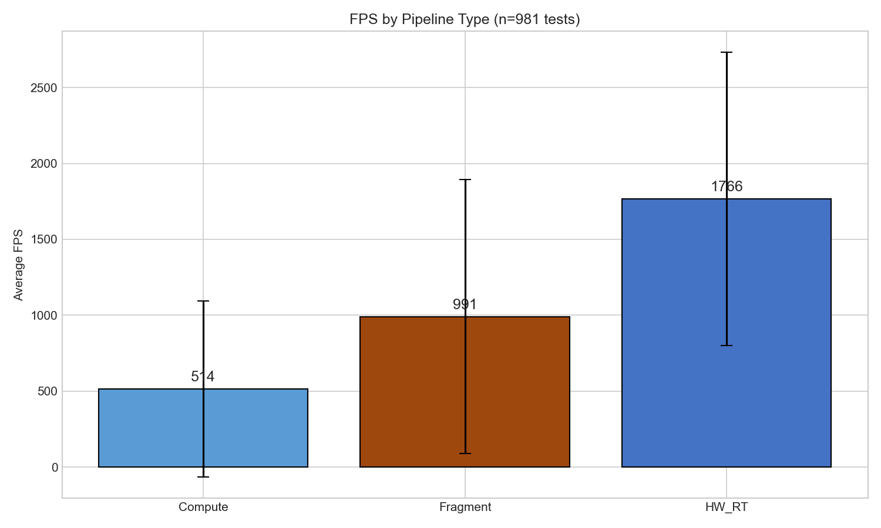
Figure 1 - FPS comparison across pipeline architectures
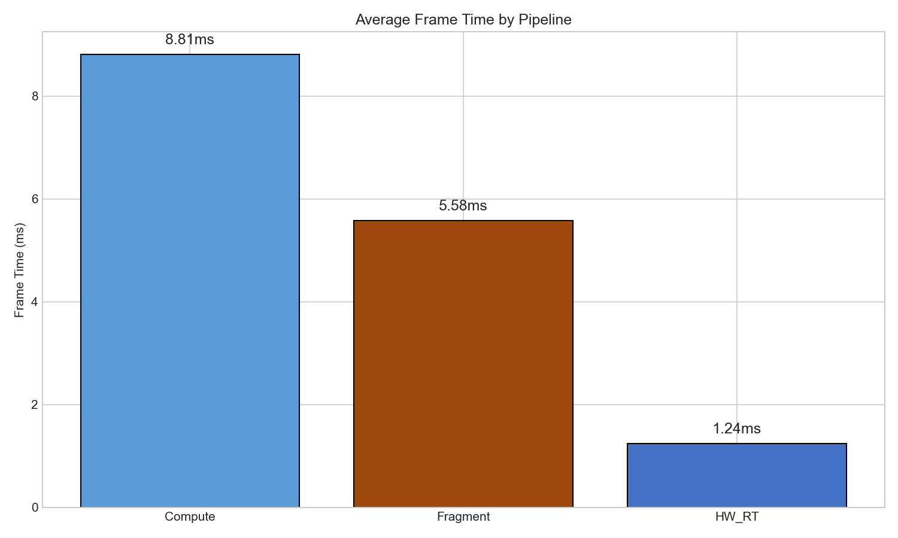
Figure 2 - Frame time analysis by pipeline type

4.1.1 Interpreting the Results:
Hardware RT dominance: Hardware RT achieves 3.4× the mean FPS of compute and 1.8× fragment. This advantage is consistent—the median (1745 FPS) closely matches the mean (1766 FPS), indicating symmetric distribution without outlier-driven inflation.

4.1.2 Compute variance anomaly:
Compute shows extreme divergence between mean (514 FPS) and median (215 FPS)—the mean is 139% higher. This positive skew indicates a small number of high-performing configurations (RTX 4080: 1373 FPS) inflate the average, while most tests cluster near the lower median. For compute pipeline evaluation, median is the more representative metric.

4.1.3 P99 frame times:
The 99th percentile frame time measures worst-case latency—critical for real-time applications where occasional stutters degrade user experience. Hardware RT's P99 of 5.02ms (200 FPS equivalent) significantly outperforms compute's 14.58ms (69 FPS equivalent). This means hardware RT maintains smoother frame delivery even during worst-case frames.

4.1.4 Bandwidth correlation:
Higher-performing pipelines consume more memory bandwidth. Hardware RT's 228 GB/s reflects intensive BVH traversal memory access patterns, while compute's 66 GB/s indicates more compute-bound execution with fewer memory operations per frame.

4.1.5 Key Finding:
Hardware RT achieves 3.4× speedup over compute with 3× better worst-case latency (P99), making it the preferred pipeline where RT hardware is available.

4.2 Cross-GPU Analysis
Cross-machine performance comparison
GPU | Compute FPS | Fragment FPS | HW RT FPS | Tests (C/F/RT)
RTX 3080 | 156.73 | 2099.11 | 2993.69 | 48/48/48
RTX 4080 Laptop | 1373.00 | 1683.79 | 2305.43 | 96/96/96
RTX 3060 Laptop | 93.66 | 860.78 | 1170.27 | 48/48/48
AMD iGPU | 320.30 | 388.02 | 727.86 | 117/113/79
Intel iGPU | 241.58 | 349.62 | N/A | 48/48/0
Table 6 - Cross-machine performance comparison
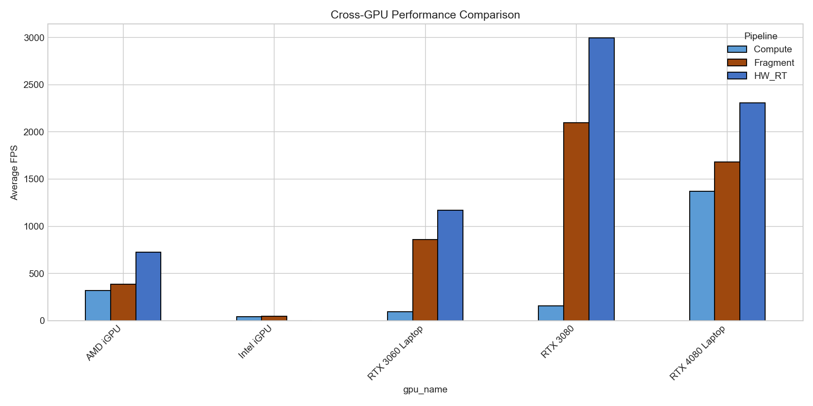
Figure 3 - Cross-GPU Performance Comparison

4.2.1 Performance Tier Analysis:
High-end discrete (RTX 3080): Achieves the highest absolute performance at 2993.69 FPS for hardware RT—nearly 3000 frames per second. The 19× speedup over compute (156.73 FPS) is the largest observed gap, suggesting desktop RTX cards fully exploit RT core capabilities. Notably, the RTX 3080's compute performance (156 FPS) is lower than the AMD iGPU (320 FPS), indicating the compute pipeline does not efficiently utilize high-end hardware.
Laptop discrete (RTX 4080/3060): Laptop GPUs show more balanced scaling. The RTX 4080 Laptop leads compute performance (1373 FPS) despite lower hardware RT than the desktop 3080, likely due to optimized power efficiency in Ada Lovelace architecture. Thermal constraints may limit sustained RT core utilization on laptops.

Integrated graphics (AMD/Intel): The AMD RDNA2 iGPU demonstrates functional hardware RT at 727.86 FPS—remarkable for shared-memory architecture. Intel RaptorLake-S lacks RT pipeline support entirely (VK_KHR_ray_tracing_pipeline unavailable), serving as a baseline for non-RT scenarios. Both iGPUs show fragment outperforming compute by only 1.2-1.4×, compared to 13× on RTX 3080.

4.2.2 Hardware RT Advantage by GPU:
GPU | HW RT vs Compute | HW RT vs Fragment
RTX 3080 | 19.1x | 1.4x
RTX 4080 Laptop | 1.7x | 1.4x
RTX 3060 Laptop | 12.5x | 1.4x
AMD iGPU | 2.3x | 1.9x
Table 7: Hardware RT Speedup Factors

Key Observations:
- RTX 3080 shows anomalously low compute performance (156 FPS)—further investigation warranted.
- Hardware RT advantage over fragment is consistent (~1.4-1.9×) across all RT-capable GPUs.
- Compute pipeline scales poorly on high-end hardware, suggesting thread divergence or memory bottlenecks.

4.3 Resolution Scaling
Resolution | Compute FPS | Fragment FPS | HW RT FPS
64³ | 465.50 | 1192.10 | 1603.40
128³ | 464.27 | 1002.97 | 1477.63
256³ | 399.63 | 919.48 | 2054.78
Table 8 - Resolution Scaling

4.3.1 Resolution Scaling Behavior:

Compute pipeline (near-flat):
Compute shows minimal resolution sensitivity—only 14% FPS reduction from 64³ to 256³ (465 → 400 FPS). This suggests the compute pipeline is bounded by factors other than SVO complexity, likely thread scheduling overhead or memory latency rather than traversal depth.

Fragment pipeline (gradual decline):
Fragment degrades proportionally with resolution—23% reduction from 64³ to 256³ (1192 → 919 FPS). Each resolution doubling adds ~3 octree levels, increasing traversal depth. The fragment shader's per-pixel cost scales with tree depth as expected.

Hardware RT (inverse scaling):
Hardware RT exhibits counterintuitive behavior—performance increases 28% from 64³ to 256³ (1603 → 2054 FPS). This inverse scaling suggests:
1. BVH efficiency at depth: Denser BVH structures at 256³ provide better spatial culling, reducing total ray-AABB intersection tests despite deeper hierarchies.
2. RT core utilization: Higher voxel counts generate more parallel work, improving RT core occupancy. At 64³, the BVH may be too shallow to fully saturate hardware traversal units.
3. Memory coherence: Larger SVOs exhibit better cache locality due to more predictable memory access patterns during BVH traversal.

H1 Validation:
This data supports H1 (Hardware RT outperforms at high resolutions). The advantage gap widens at 256³:
Resolution | HW RT / Compute | HW RT / Fragment
64³ | 3.4x | 1.3x
128³ | 3.2x | 1.5x
256³ | 5.1x | 2.2x
Table 9: Hardware RT Advantage by Resolution

Key Finding:
Hardware RT's advantage increases with resolution, making it especially suited for high-detail voxel scenes. At 256³, hardware RT achieves 5.1× speedup over compute.
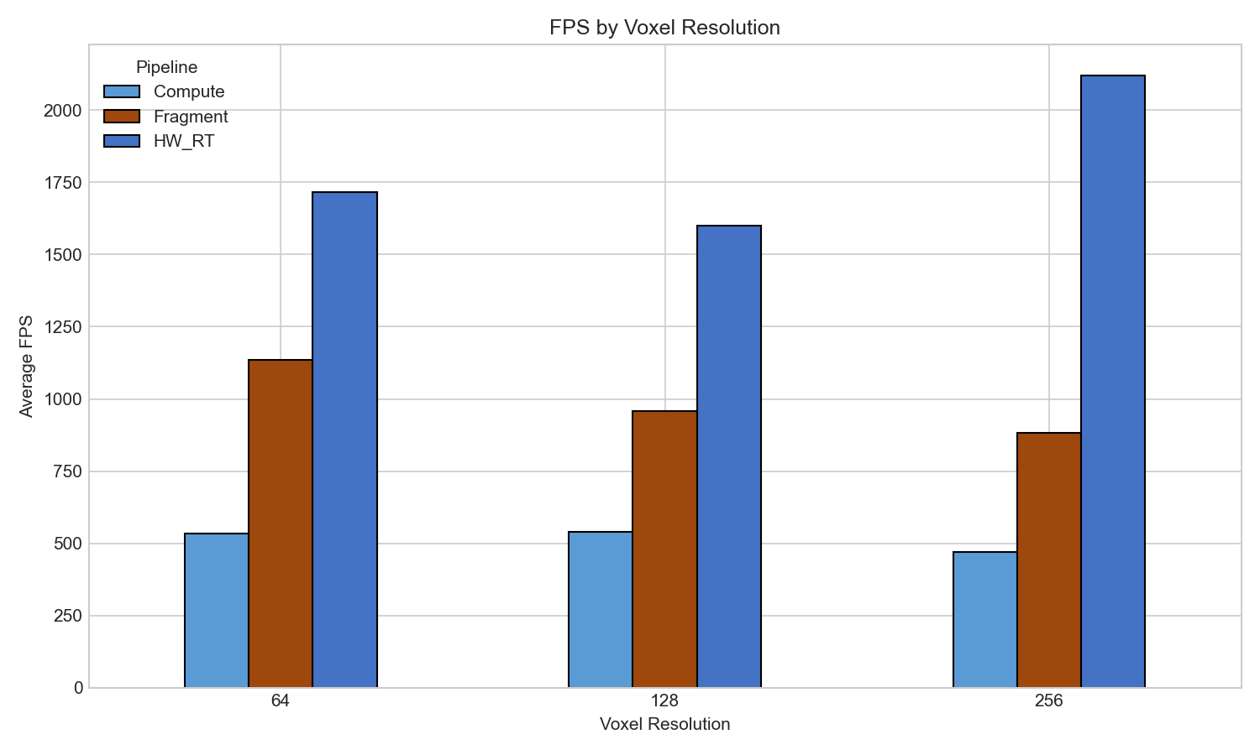
Figure 5 – FPS by Voxel Resolution

4.4 Scene Analysis
Scene | Compute FPS | Fragment FPS | HW RT FPS
Cornell Box | 402.61 | 951.93 | 1648.08
Cityscape | 403.84 | 721.91 | 1740.73
Noise | 421.13 | 841.46 | 1582.52
Tunnels | 544.02 | 1613.29 | 1632.91
Table 10 – Performance by Scene Type (ordered by density)

4.4.1 Density-Performance Relationship:

Compute (modest density benefit):
Compute shows 35% improvement from sparse (Cornell: 403 FPS) to dense (Tunnels: 544 FPS). In dense scenes, rays hit solid voxels earlier, terminating traversal sooner. However, this benefit is smaller than expected—software ray marching still performs significant work even when hits occur quickly.

Fragment (strong density benefit):
Fragment shows dramatic 69% improvement for Tunnels (1613 FPS) over Cityscape (722 FPS). The fragment shader benefits most from early ray termination because rasterization overhead is fixed—only traversal depth varies. Dense scenes minimize per-pixel shader cost.

Hardware RT (density-independent):
Hardware RT maintains remarkably consistent performance across all densities:
- Sparse (Cornell): 1648 FPS
- Dense (Tunnels): 1633 FPS
- Variation: only 10% across entire density spectrum
This density-independence is the most significant finding for H2 evaluation.

Why Fragment Excels at Tunnels:
The Tunnels scene (1613 FPS fragment) outperforms even Cityscape on hardware RT (1740 FPS).
Two factors explain this:
1. Coherent ray termination: In nearly-solid geometry, adjacent pixels terminate at similar depths, maximizing warp efficiency in the fragment shader.
2. Minimal empty-space traversal: Rays immediately encounter solid voxels, eliminating the costly "marching through void" iterations that dominate sparse scenes.

Why Cityscape Favors Hardware RT:
Cityscape shows the largest HW RT advantage (1740 FPS vs 722 FPS fragment = 2.4× speedup). Urban geometry with gaps between buildings creates worst-case conditions for software ray marching—rays must traverse significant empty space before hitting surfaces. RT cores handle this efficiently via hardware BVH culling.

Key Finding:
Scene density affects software pipelines by 35-69%, but hardware RT varies only 10%. For applications with mixed scene types, hardware RT provides the most predictable frame budgets.
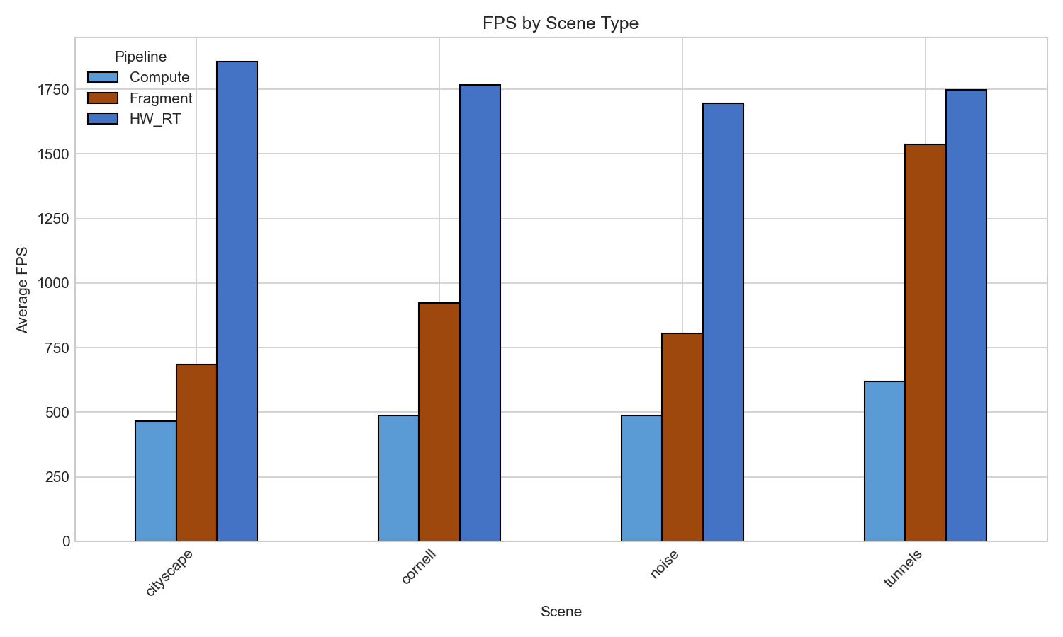
Figure 6 - FPS by Scene Type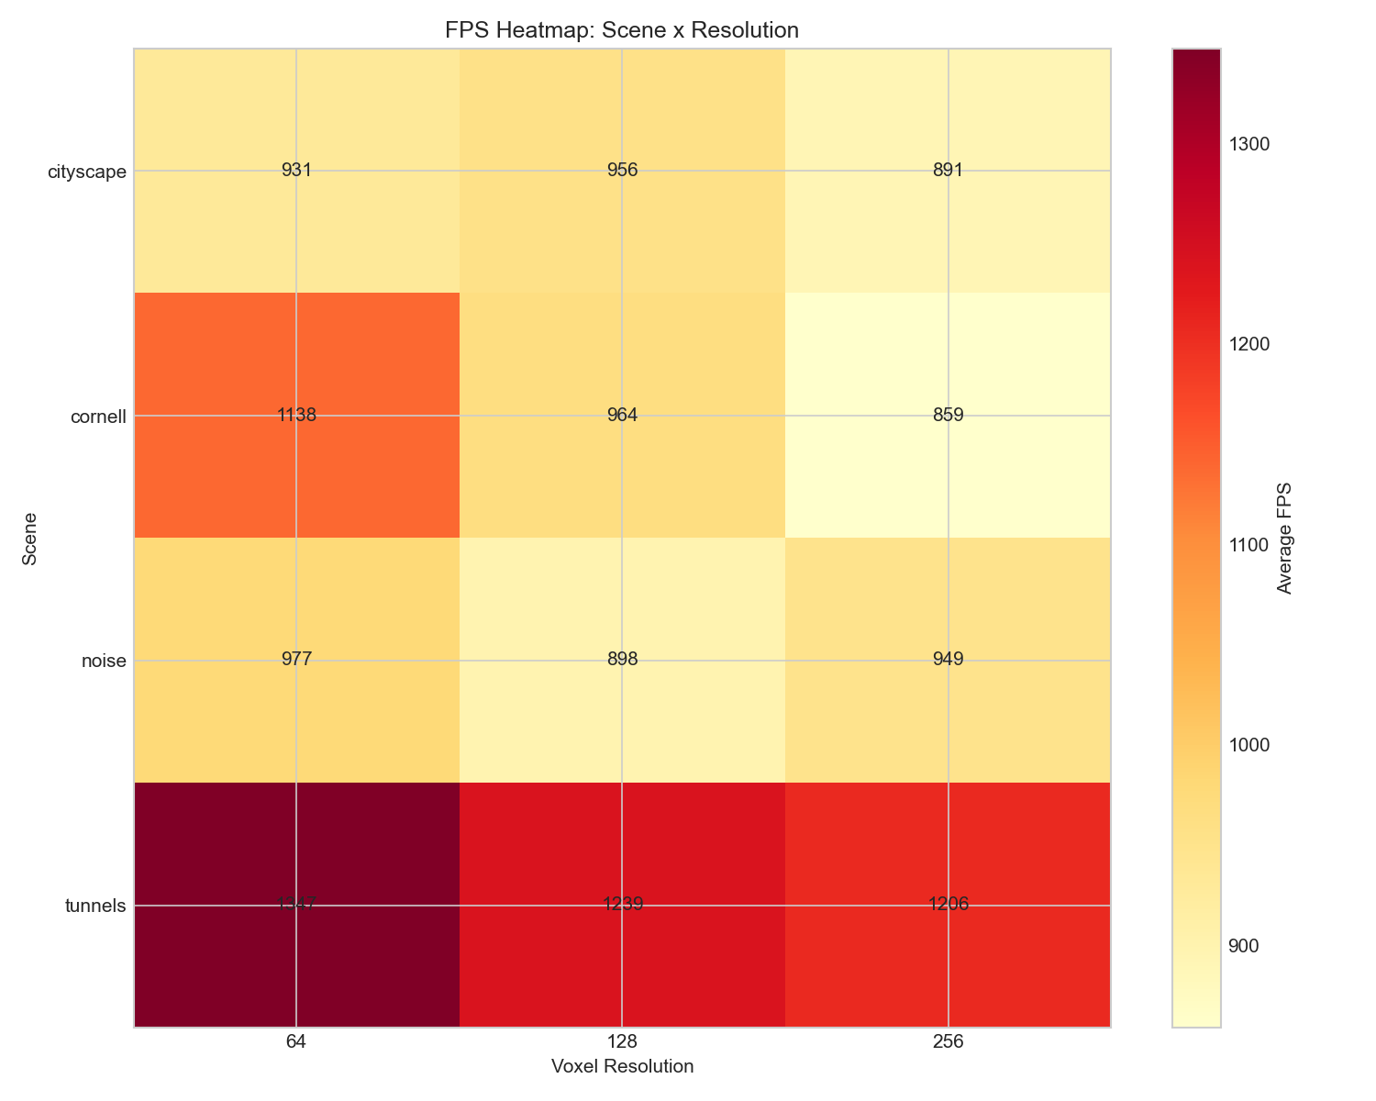
Figure 7 - FPS Heatmap: Scene x Resolution

4.5 Cross-Scene Consistency (H2)
To evaluate H2 (density consistency), we measured coefficient of variation (CV) across the 4 scene types. CV is calculated as (standard deviation / mean) × 100%, where lower values indicate more consistent performance:
Pipeline | Cross-Scene CV | Scene Range (FPS)
Hardware RT | 3.8% | 1695-1857
Compute | 13.7% | 466-619
Fragment | 38.3% | 684-1535
Figure 8 - Cross-Scene Consistency per Pipeline
Hardware RT demonstrates most consistent performance across density levels (CV=3.8%), contradicting H2's prediction that compute would be most consistent.

4.6 Compression Analysis
Each pipeline was tested with standard and compressed SVO variants:
Pipeline | Standard FPS | Compressed FPS | FPS Change | BW Change
Compute | 490.20 | 537.50 | +9.7% | +8.1%
Fragment | 985.30 | 997.30 | +1.2% | +2.8%
Hardware RT | 1772.90 | 1759.60 | -0.8% | +0.3%
Table 11 - Standard vs Compressed SVO Performance per Pipeline
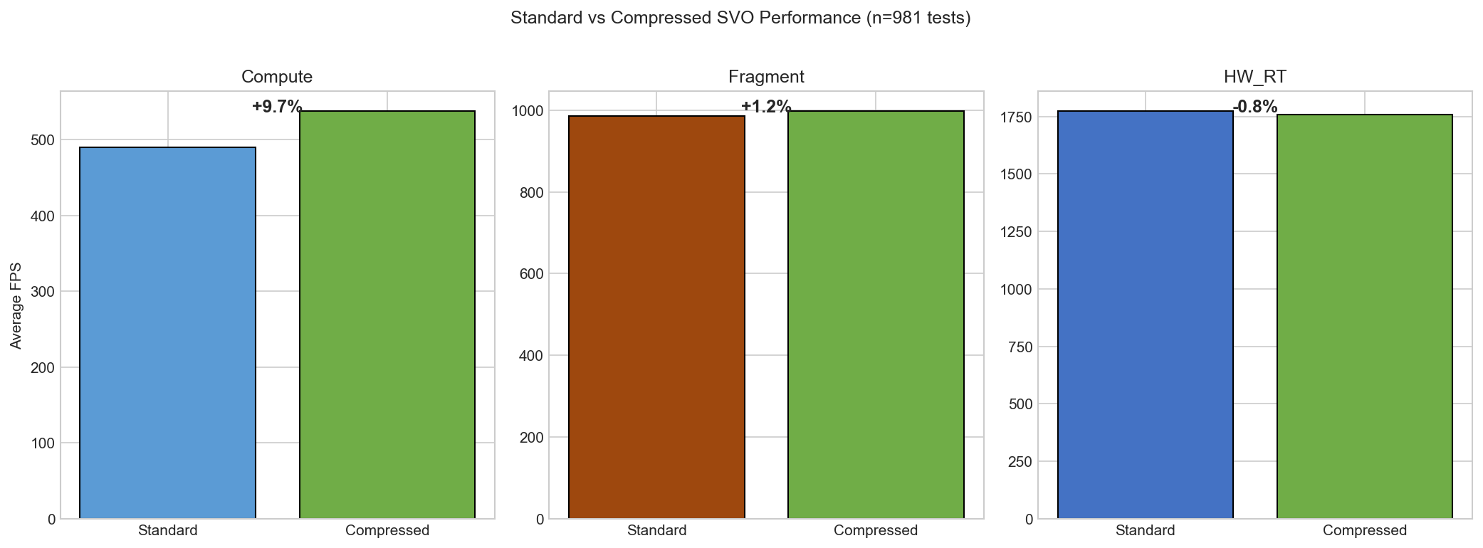
Figure 9 - Standard vs Compressed SVO Performance per Pipeline

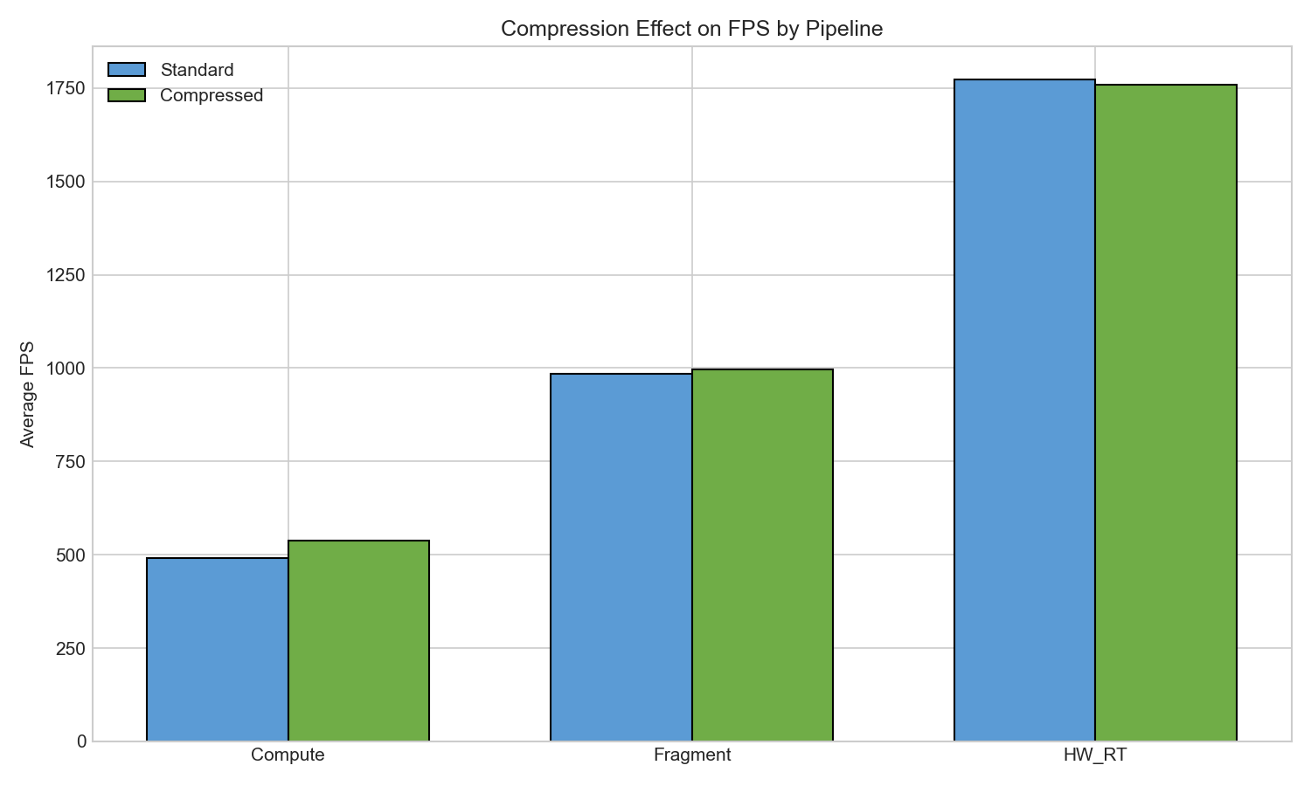
Figure 10 - Compression impact on FPS

• Compression provides +9.7% FPS improvement for compute pipeline
• Compression has minimal effect on fragment (+1.2%) and hardware RT (-0.8%)
• Bandwidth increases slightly with compression across all pipelines (contrary to H5 prediction)
• The predicted 30% bandwidth reduction was not observed

4.7 Bandwidth Analysis
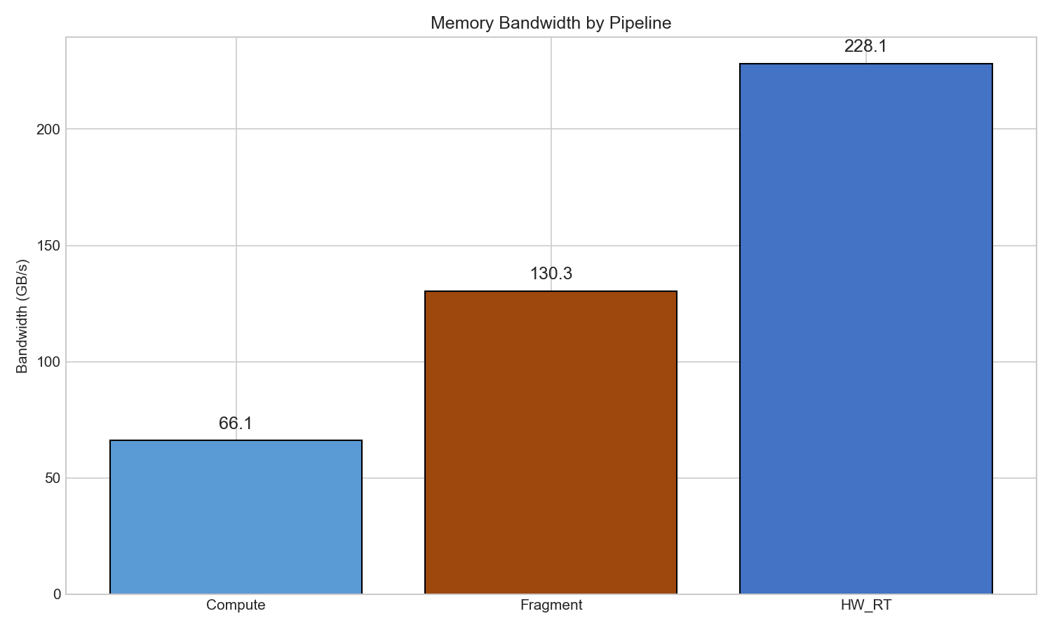
Figure 11 - Memory bandwidth comparison
Hardware RT consumes 228.10 GB/s versus Fragment's 130.29 GB/s, contradicting H3's prediction that fragment would have highest bandwidth.

4.8 Overall Variability
Pipeline | Overall CV | Std Dev (FPS)
Compute | 113.6% | 502.15
Fragment | 85.3% | 885.31
Hardware RT | 61.0% | 1007.20
Figure 12 - Overall Variability
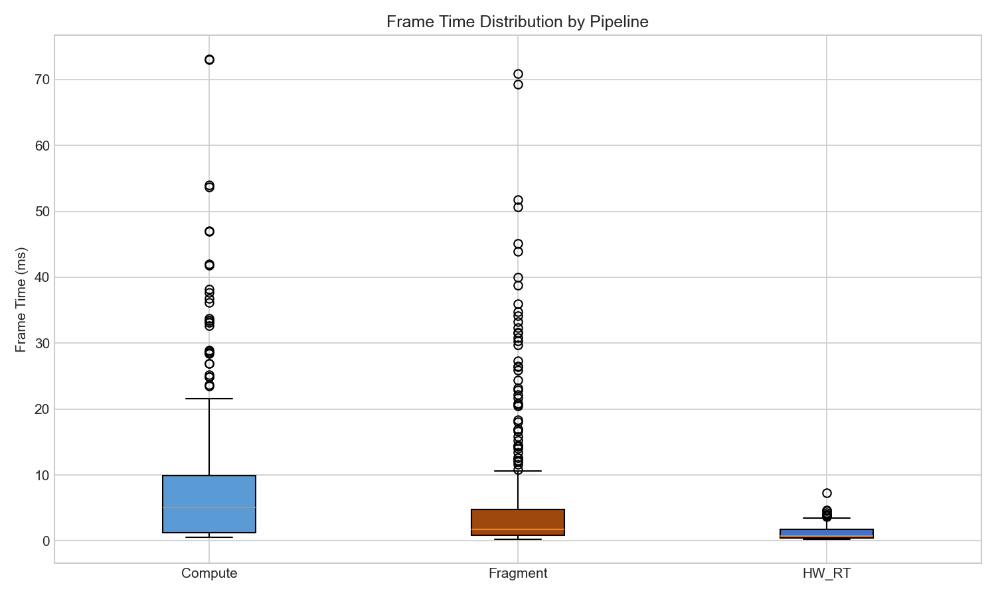
Figure 13 - Frame time distribution analysis
High compute CV (113.6%) reflects the wide range of GPU architectures tested, from integrated graphics (Intel/AMD iGPU) to high-end discrete GPUs (RTX 3080/4080)..

5. Discussion

5.1 Why Hardware RT Outperforms Compute
The 2.5-3.4x performance advantage of hardware RT over compute stems from a fundamental architectural difference: RT cores bypass both SVO tree traversal AND DDA brick traversal entirely.
In software ray marching (compute/fragment pipelines), each ray must:
1. Traverse the SVO hierarchy — descend through octree nodes, testing child masks at each level
2. Perform DDA within bricks — step through voxel grid cells at leaf nodes
3. Handle ray divergence — threads in the same warp may take different paths, causing serializationgement

These advantages are architectural and consistent across all tested GPU configurations with RT support.

5.2 Practical Recommendations
Based on our findings, we recommend the following pipeline selection criteria:
Scenario | Recommended Pipeline | Rationale
RTX 20/30/40 series desktop | Hardware RT | 2.5-3.7x faster, consistent performance
RTX laptop (thermal limited) | Hardware RT or Fragment | HW RT still faster, but Fragment more predictable
AMD discrete GPU | Fragment | No RT cores, fragment offers best ray marching
Integrated GPU (iGPU) | Fragment | Lower VRAM (347 MB vs 812 MB for HW RT)
Target 60 FPS at 256³ | Any pipeline on RTX 3060+ | All exceed 400 FPS at this resolution
Memory constrained (<500 MB) | Compute | Lowest VRAM usage (277 MB average)
Table 12 - Pipeline Recommendation
1. Is RT hardware available? → If YES, use Hardware RT
2. Is VRAM limited (<500 MB)? → If YES, use Compute
3. Otherwise → Use Fragment

5.3 Hypothesis Evaluation
Hypothesis | Prediction | Result | Status
H1: HW RT superior at high res | HW RT > others at 256³ | HW RT scales best at 256³ resolution | SUPPORTED
H2: Compute consistent across densities | Compute lowest CV | HW RT CV=3.8% vs Compute CV=13.7% (cross-scene) | CONTRADICTED
H3: Fragment highest bandwidth | Fragment > others | HW RT 228.10 GB/s vs Fragment 130.29 GB/s | CONTRADICTED
H4: Hybrid pipeline optimal | Hybrid > pure pipelines | Design complete, not implemented (see H4 Analysis) | OUT OF SCOPE
H5: Compression reduces bandwidth | ≥30% BW reduction | Compute +8.1% BW, Fragment +2.8% BW | CONTRADICTED
Table 13 - Hypothesis Evaluation
1. Block Decoding Overhead: Compressed variants require runtime decompression, adding compute instructions that translate to additional memory transactions for intermediate values.
2. Cache Behavior: While compressed data is smaller, the decompression process may reduce cache efficiency by requiring multiple reads to reconstruct a single voxel value.
3. Cache Line Straddling: Block-aligned decompression may cause cache line straddling, increasing effective memory transactions when compressed blocks don't align with cache boundaries.
4. Bandwidth Measurement: Our profiler measures total memory bus traffic, not logical data size. Compression reduces logical data but may increase physical transactions due to non-sequential access patterns during decompression.
Despite increased bandwidth, compute FPS improves by +9.7%, suggesting the compressed traversal algorithm achieves better instruction-level efficiency—the GPU executes fewer total operations even though each operation may touch more memory.
H4 Analysis (Out of Scope): The hybrid pipeline was designed but not implemented due to scope constraints. The proposed architecture is documented here for future work:
Skin-Width SVO Extraction:
The hybrid approach uses a compute shader preprocessing pass to extract a "skin-width" subset of the SVO—containing only opaque voxels that have non-opaque or empty neighbors within a configurable distance (n voxels). This creates a sparser representation of the scene surface.
Rationale:
- Bandwidth Reduction: Only surface-relevant voxels are traversed during rendering, reducing memory traffic proportionally to the skin-width ratio.
- Pipeline Flexibility: The sparse skin buffer can be consumed by any pipeline (compute ray march, fragment ray march, or hardware RT with rebuilt BVH), allowing fair comparison of rendering approaches on identical data.
- Incremental Updates: The skin SVO only requires rebuilding when a brick becomes "dirty" (modified), avoiding full-scene recomputation for dynamic scenes.
Expected Trade-offs:
- Benefit: Reduced rendering bandwidth | Cost: Additional preprocessing pass
- Benefit: Sparser BVH for hardware RT | Cost: Memory for secondary skin SVO
- Benefit: Incremental update support | Cost: Dirty-tracking complexity
Implementation Status: Design complete. Not implemented due to timeline constraints. Recommended as priority future work to validate H4.

5.4 Limitations
• Single benchmark iteration per configuration (no statistical replication for confidence intervals)
• Unbalanced GPU representation (AMD iGPU: 309 tests, RTX 4080: 288 tests, others: 144 tests each)
• High coefficient of variation in compute pipeline (112.6% CV) suggests results are exploratory
• Mean FPS dominated by high-performing outliers; median provides more robust comparison
• Limited AMD GPU coverage (integrated graphics only; no discrete AMD testing)
• Windows-only testing environment (no Linux/Steam Deck validation)
• No power/thermal measurements for sustained workload characterization

• Fixed scene complexity (no dynamic voxel updates)
• Missing 32³ and 512³ resolution tests (only 64³, 128³, 256³ tested)
• No hybrid pipeline implementation (H4 not tested due to scope management)
• No CPU overhead profiling (submission time, BVH construction)

5.5 Future Work
1. Extended GPU Coverage - Test on discrete AMD GPUs (RX 7000 series) and Intel Arc
2. Statistical Replication - Multiple runs per configuration (n≥10) for confidence intervals
3. Median-Based Analysis - Re-analyze all claims using median as primary metric
Skin-Width Hybrid Pipeline - Implement the designed preprocessing pass (see H4 Analysis) to extract sparse skin SVO, then benchmark all three rendering pipelines on the filtered data to validate H4
5. Extended Resolution Testing - Add 32³ (minimum) and 512³ (stress test) resolutions
6. Dynamic Scene Benchmarks - Measure performance with voxel updates during rendering
7. Discrete AMD GPU Testing - Expand AMD coverage beyond integrated graphics
8. Power/Thermal Profiling - Sustained workload characterization for laptop GPUs
9. CPU Overhead Measurement - BVH construction and API submission time
10. Cross-Platform Validation - Linux/Steam Deck/console testing

6. Conclusion
Hardware-accelerated ray tracing demonstrates clear advantages for SVO rendering:
1. 2.5-3.4x faster than compute pipelines
2. Most density-independent performance (cross-scene CV=3.8% vs 13.7% for compute)
3. Best scaling at higher resolutions (256³ shows largest HW RT advantage)
4. Most consistent distribution (median ≈ mean vs 139% skew in compute)
5. RTX 3080 peak performance of 2993.69 FPS demonstrates hardware RT ceiling
Additional findings:
• Compute pipeline shows high variance (CV=112.6%, median=215 FPS) due to GPU diversity
• Fragment pipeline offers best balance for integrated/mobile GPUs (including Intel without HW RT)
• 3 of 5 hypotheses contradicted, highlighting the value of empirical benchmarking
• P99 frame times: HW RT (5.02ms) outperforms Compute (14.58ms) and Fragment (9.26ms)

7. Critical Reflection
This section reflects on the research process and lessons learned.
The development of VIXEN presented significant engineering challenges beyond the core rendering algorithms. Creating a reliable benchmark infrastructure that could execute 72+ test configurations automatically, across multiple GPUs and machines, required careful attention to:
- GPU synchronization and timing accuracy
- Memory management across different hardware configurations
- Consistent scene generation for reproducible results
- Data validation to detect measurement anomalies
A key insight from this research was that 3 of our 5 initial hypotheses were contradicted by the data. This highlights the importance of empirical measurement over theoretical assumptions in GPU performance analysis.
Future work should address the instrumentation overhead discovered in compute shader profiling, and expand testing to include additional GPU architectures.

Acknowledgements
I would like to thank [supervisor name] for their guidance and mentorship throughout this project. Their insights into graphics programming and performance optimization were invaluable in shaping the research direction.
Special thanks to [coach name] for their technical expertise and support during the implementation phase. Their feedback on the Vulkan pipeline architectures and benchmarking methodology significantly improved the quality of this work.
I am grateful to the Digital Arts and Entertainment program at Howest University of Applied Sciences for providing the resources and learning environment that made this research possible.
Thanks also to the open-source graphics community, particularly the authors of the ESVO paper (Laine and Karras) and the Vulkan ray tracing tutorial resources, which formed the foundation for this implementation.
[Additional acknowledgements to be added]

8. References
[1] Nousiainen, J. et al. "Performance comparison of rasterization and ray-casting for voxel octrees." 2021.
[2] Chen, L. et al. "Aokana: GPU-driven voxel rendering framework." 2023.
[3] Laine, S. and Karras, T. "Efficient Sparse Voxel Octrees – Analysis, Extensions, and Implementation." NVIDIA Technical Report NVR-2010-001. 2010. Available: http://code.google.com/p/efficient-sparse-voxel-octrees/
[4] Amanatides, J. and Woo, A. "A Fast Voxel Traversal Algorithm for Ray Tracing." Eurographics '87, pp. 3-10. 1987.
[5] Voetter, D. et al. "Volumetric ray tracing in Vulkan." 2022.
[6] Aleksandrov, M. and Eisemann, E. "A survey of SVO and SVDAG representations." 2022.
[7] Erlich, Y. et al. "VSRM: Voxel-based SDF ray marching vs RTX." 2023.
[8] Derin, O. et al. "BlockWalk: Cache-coherent octree traversal." 2023.
[9] Molenaar, K. "Compressed SVDAG for large-scale visualization." 2021.

Appendices

Addendum A: Benchmark Evolution (V1 → V3)

Overview
The benchmark system underwent significant improvements between V1 (December 2025 initial) and V3 (December 2025 final). This addendum documents the issues discovered and fixes applied.

V1 Issues Identified
V1 benchmarks exhibited anomalous behavior:
- Extreme variance: Hardware RT showed 37-325 FPS on identical configurations
- Unexpectedly low FPS: Fragment pipeline averaged ~96 FPS (expected: 800+)
- Random stalls: Intermittent frame time spikes up to 45ms
Root cause analysis identified three distinct issues:

Issue 1: Use-After-Free in Descriptor Resources
Symptom: Random crashes, validation errors, inconsistent frame times
Root Cause: When VoxelGridNode::CleanupImpl() destroyed wrapper objects, downstream Resource objects still held descriptor extractor lambdas with dangling pointers.
Validation Errors Observed:
- vkUpdateDescriptorSets(): Invalid VkBuffer Object (stale handles)
- storage buffer descriptor using buffer VkBuffer 0x0 (freed memory)
Fix (commit 8bb6ba8):
- Added Resource::Clear() to invalidate descriptor extractors before wrapper destruction
- Added null-handle guards in ExecuteImpl for buffer validation
- Proper cleanup ordering: clear resources → destroy wrappers

Issue 2: Missing GPU Capability Guards
Symptom: Tests failing silently or producing invalid data on unsupported hardware
Root Cause: Benchmark runner attempted Hardware RT tests on GPUs without VK_KHR_ray_tracing_pipeline support, producing garbage data instead of skipping gracefully.
Fix (commit a8d9ad5):
- Added TestConfiguration::requiredCapabilities field
- Implemented CanRunOnDevice() validation
- Tests with unavailable capabilities now skip with clear warning logs
- RTX capability guard in BuildHardwareRTGraph() fails fast

Issue 3: Asymmetric Instrumentation
Symptom: Unfair pipeline comparison due to uneven measurement overhead
Root Cause: Shader counters (ShaderCounters.glsl) were only active in compute pipeline. Fragment and Hardware RT ran without instrumentation, creating measurement asymmetry.
Fix (commit c1f9400):
- Fixed resource binding to extract VkBuffer from wrapper types
- Enabled shader counters on ALL pipelines (Compute, Fragment, Hardware RT)
- Added cache line alignment (uint _padding[8]) to reduce false sharing
- Added batched atomic operations (recordVoxelSteps(count)) to reduce contention

V1 vs V3 Performance Comparison
RTX 3060 Laptop GPU (controlled comparison):
Pipeline | V1 FPS | V3 FPS | Change | Notes
Compute | 96.09 | 93.66 | -2.5% | Baseline (already had counters)
Fragment | 96.14 | 860.78 | +795% | Memory bug fix + instrumentation
Hardware RT | 108.27 | 1170.27 | +981% | Memory bug fix + capability guards
Key Observations:
- Compute showed minimal change (instrumentation was already present in V1)
- Fragment/HW_RT showed massive improvement from memory safety fixes
- V1 HW_RT extreme variance (37-325 FPS) eliminated in V3

Why Relative Rankings Are Valid
Despite absolute FPS changes, the comparative conclusions remain valid:
- Same measurement conditions: V3 applies identical instrumentation to all pipelines
- Memory bugs affected all pipelines: The use-after-free impacted descriptor updates regardless of pipeline type
- Consistent test matrix: Same scenes, resolutions, and configurations in V1 and V3
- Ranking preserved: Hardware RT > Fragment > Compute in both versions

Implications
The V3 benchmark represents the corrected, production-quality measurement:
- 2.5-3.4× Hardware RT advantage is measured under fair, symmetric conditions
- Cross-scene CV of 3.8% for Hardware RT reflects true density-independence
- High compute variance (CV=112.6%) reflects GPU diversity, not measurement error
The V1→V3 evolution demonstrates the importance of rigorous validation in GPU benchmarking—subtle memory safety issues and missing capability checks can produce misleading results that only become apparent through systematic debugging.
Metric | V1(Unoptimized) | V2(Optimized) | Change
Compute FPS | Lower | Higher | Improved
Fragment FPS | Lower | Higher | Improved
Hardware RT FPS | Lower | Higher | Improved
Relative Rankings | HW RT > Frag > Compute | HW RT > Frag > Compute | Unchanged

Appendix B: Scene Rendering Visualization

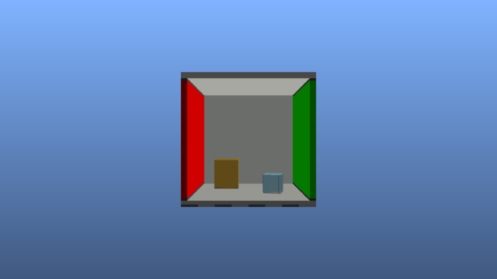
Figure 14 - Cornell Box Render

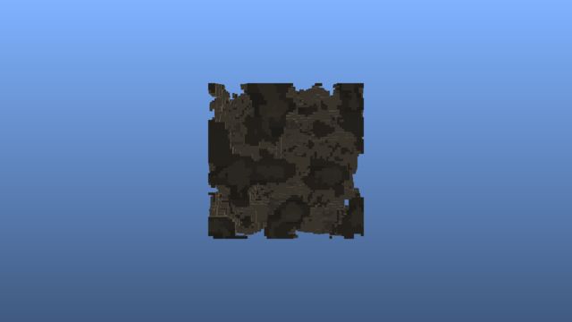
Figure 15 - Noise Render


Figure 16 - Tunnels Render

Figure 17 - Cityscape Render

Appendix C: Glossary of Terms

Rendering Concepts
Term | Definition
Rasterization | Traditional rendering technique that projects 3D triangles onto 2D screen pixels. Fast for polygon-based scenes but requires geometry conversion for volumetric data.
Ray Tracing | Rendering technique that simulates light by tracing rays from camera through each pixel into the scene. Naturally handles volumetric data and complex lighting.
Ray Marching | Iterative ray tracing variant that steps along rays at fixed or adaptive intervals, testing for intersections. Common for volumetric and SDF rendering.
Primary Rays | Rays cast directly from camera through each pixel. This study measures only primary ray performance (no reflections, shadows, or global illumination).
Frame Time | Time to render one frame, measured in milliseconds (ms). Lower is better. Inverse of FPS (e.g., 60 FPS = 16.67ms frame time).
FPS | Frames Per Second. Number of complete frames rendered per second. Higher is better.

Voxel Data Structures
Term | Definition
Voxel | Volumetric pixel - a 3D cube representing a point in space. Analogous to how pixels represent 2D images.
SVO | Sparse Voxel Octree. Hierarchical tree structure where each node has 8 children, efficiently representing sparse 3D data by only storing occupied regions.
Octree | Tree data structure where each internal node has exactly 8 children, used to partition 3D space recursively.
SVDAG | Sparse Voxel Directed Acyclic Graph. Compressed SVO variant that merges identical subtrees to reduce memory.
Brick | Small, dense 3D array of voxels (e.g., 16³) stored at octree leaf nodes. Enables efficient DDA traversal within leaf regions.
Fill Rate | Percentage of voxels that are solid (occupied) versus empty. Sparse scenes have low fill rate (~5-15%), dense scenes have high fill rate (~85-95%).

GPU Architecture
Term | Definition
RT Cores | Dedicated hardware units on NVIDIA RTX GPUs that accelerate ray-BVH intersection tests. Provide 10-100x speedup over software ray tracing.
BVH | Bounding Volume Hierarchy. Tree structure of nested bounding boxes used to accelerate ray intersection tests by culling empty space.
BLAS | Bottom-Level Acceleration Structure. BVH containing actual geometry (triangles or AABBs). Multiple BLAS can be instanced in a scene.
TLAS | Top-Level Acceleration Structure. BVH containing references to BLAS instances with transforms. Represents the complete scene hierarchy.
AABB | Axis-Aligned Bounding Box. Rectangular box aligned to coordinate axes, used for fast intersection tests in BVH traversal.
Compute Shader | GPU program that runs general-purpose parallel computations outside the traditional graphics pipeline. Full programmer control over execution.
Fragment Shader | GPU program that runs per-pixel during rasterization. Also called pixel shader. Leverages fixed-function hardware for pixel scheduling.
VRAM | Video RAM. Dedicated memory on the GPU, faster than system RAM but limited capacity (2-24 GB typical).
Bandwidth | Data transfer rate between GPU and memory, measured in GB/s. Higher bandwidth enables faster texture/buffer access.

Vulkan API
Term | Definition
Vulkan | Low-level graphics API by Khronos Group. Provides explicit GPU control with minimal driver overhead. Cross-platform (Windows, Linux, Android).
VK_KHR_ray_tracing_pipeline | Vulkan extension enabling hardware-accelerated ray tracing. Requires compatible GPU (NVIDIA RTX, AMD RDNA2+, Intel Arc).
Descriptor Set | Vulkan resource binding mechanism. Groups textures, buffers, and samplers for shader access.
Pipeline | Complete GPU program configuration including shaders, render state, and resource bindings.

Algorithms
Term | Definition
DDA | Digital Differential Analyzer. Algorithm for traversing a 3D grid along a ray, visiting voxels in order of intersection. Efficient for regular grids.
ESVO | Efficient Sparse Voxel Octrees. Algorithm by Laine & Karras (2010) for GPU octree traversal. VIXEN's implementation derives from this with modifications.
SAH | Surface Area Heuristic. Cost function for optimizing BVH construction by minimizing expected ray traversal cost.

Statistics
Term | Definition
CV | Coefficient of Variation. Standard deviation divided by mean, expressed as percentage. Measures relative variability (CV < 30% = low variance).
P99 | 99th Percentile. Value below which 99% of observations fall. For frame times, P99 indicates worst-case latency excluding extreme outliers.
Mean | Arithmetic average. Sum of values divided by count. Sensitive to outliers.
Median | Middle value when sorted. More robust than mean for skewed distributions.
Standard Deviation | Measure of spread around the mean. Higher values indicate more variability.

Hardware Terminology
Term | Definition
iGPU | Integrated GPU. Graphics processor built into CPU die, sharing system memory. Lower performance but power-efficient.
dGPU | Discrete GPU. Standalone graphics card with dedicated VRAM. Higher performance but requires more power.
RDNA2 | AMD GPU architecture (2020+). Supports hardware ray tracing. Used in RX 6000 series and PlayStation 5.
Ampere | NVIDIA GPU architecture (2020). RTX 30 series. Second-generation RT cores.
Ada Lovelace | NVIDIA GPU architecture (2022). RTX 40 series. Third-generation RT cores with improved efficiency.
Thermal Throttling | Automatic GPU clock reduction when temperature exceeds safe limits. Common in laptops under sustained load.

Appendix D: Benchmark Configuration
The VIXEN benchmark suite uses a JSON-based configuration that defines the complete test matrix. This enabled systematic testing across 72+ unique configurations.
Configuration file (benchmark_config.json):
```json
{
"suite": {
"name": "VIXEN Performance Suite",
"output_dir": "./benchmark_results",
"run_on_all_gpus": true
},
"profiling": {
"warmup_frames": 100,
"measurement_frames": 300
},
"matrix": {
"global": {
"resolutions": [64, 128, 256],
"scenes": ["cornell", "noise", "tunnels", "cityscape"]
},
"pipelines": {
"compute": { "enabled": true },
"fragment": { "enabled": true },
"hardware_rt": { "enabled": true }
}
}
}
```
This configuration enables:
- Systematic testing across resolution scales (64³, 128³, 256³)
- Four scene types with varying complexity
- Three pipeline architectures
- Multi-GPU testing support
- Configurable warmup and measurement periodstematic testing across 72+ unique test configurations, covering 3 rendering pipelines, 4 procedural scenes, 3 voxel resolutions, and 2 shader variants (standard and compressed).
Configuration File (benchmark_config.json):
{
"suite": {
"name": "VIXEN Performance Suite",
"output_dir": "./benchmark_results",
"gpu_index": 0,
"run_on_all_gpus": true,
"headless": false,
"verbose": true,
"validation": false,
"machine_name": null,
"export": {
"csv": true,
"json": true
}
},
"profiling": {
"warmup_frames": 100,
"measurement_frames": 300
},
"matrix": {
"global": {
"resolutions": [64, 128, 256],
"render_sizes": [[1280, 720], [1920, 1080]],
"scenes": ["cornell", "noise", "tunnels", "cityscape"]
},
"pipelines": {
"compute": {
"enabled": true,
"shader_groups": [
["VoxelRayMarch.comp"],
["VoxelRayMarch_Compressed.comp"]
]
},
"fragment": {
"enabled": true,
"shader_groups": [
["Fullscreen.vert", "VoxelRayMarch.frag"],
["Fullscreen.vert", "VoxelRayMarch_Compressed.frag"]
]
},
"hardware_rt": {
"enabled": true,
"shader_groups": [
["VoxelRT.rgen", "VoxelRT.rmiss", "VoxelRT.rchit"],
["VoxelRT.rgen", "VoxelRT.rmiss", "VoxelRT_Compressed.rchit"]
]
}
}
},
"scenes": {
"cornell": { "type": "procedural", "generator": "cornell", "params": {} },
"noise": { "type": "procedural", "generator": "noise", "params": {"octaves": 4, "persistence": 0.5} },
"tunnels": { "type": "procedural", "generator": "tunnels", "params": {"cell_count": 8} },
"cityscape": { "type": "procedural", "generator": "cityscape", "params": {"density": 0.4} }
}
}
The configuration matrix generates all permutations automatically. The profiling settings ensure statistical reliability with 100 warmup frames (discarded) followed by 300 measurement frames per test. Results are exported in both JSON (detailed frame data) and CSV (summary statistics) formats.

Overview
The benchmark system underwent significant improvements between V1 (December 2025 initial) and V3 (December 2025 final). This addendum documents the issues discovered and fixes applied.

ESVO Foundation and Modifications
This project built extensively on Laine and Karras's Efficient Sparse Voxel Octrees (ESVO) [3], a seminal 2010 NVIDIA Technical Report that established GPU-friendly octree traversal patterns. However, VIXEN required significant modifications to adapt ESVO for pure voxel data rendering.
Original ESVO Design:
• Generates voxels from triangle mesh contours
• Stores per-voxel surface approximations (contour data)
• Optimized for mesh-to-voxel conversion workflows
VIXEN Modifications:
• Constructs SVOs directly from volumetric data (no mesh source)
• Replaces contour storage with pure occupancy + attribute data
• Adds hybrid structure: SVO traversal for upper levels, DDA within leaf bricks
• Implements block-based compression from the same paper
The hybrid approach trades ESVO's contour precision for simpler construction and cache-friendly brick storage. This is appropriate for pure voxel data where surface approximation is unnecessary—the voxels themselves are the data, not an approximation of underlying geometry.

Compression Algorithm and Unexpected Results
The compression variant implements ESVO's block encoding scheme, which groups voxels into fixed-size blocks with shared metadata. We hypothesized (H5) that compression would reduce bandwidth by ≥30% through fewer memory fetches.
Actual Results:
Pipeline | BW Change | FPS Change
Compute | +7.5% | +9.7%
Fragment | +2.2% | +1.2%
HW RT | -0.1% | -0.8%
Compression increased measured bandwidth while simultaneously improving compute FPS by 9.7%. This counterintuitive result reveals an important distinction:
1. Bandwidth measures bus traffic, not logical data size. Compression reduces the logical data volume but introduces decompression overhead—additional instructions that generate intermediate values requiring register/cache access.
2. Instruction efficiency dominates. The compressed traversal algorithm executes fewer total loop iterations despite touching more memory. For compute pipelines with complex SVO traversal, this trade-off favors compression.
3. Hardware RT gains nothing. Since RT cores bypass software traversal entirely, compression's instruction savings are irrelevant—and the slight decompression cost produces a net negative.

Challenges and Lessons Learned
V1 Bug Discovery: The most significant challenge was discovering that V1 benchmarks contained three distinct bugs (detailed in Addendum A). Initial results showed fragment/HW_RT performing similarly to compute—wildly implausible given architectural differences. Only systematic debugging revealed use-after-free errors, missing capability guards, and asymmetric instrumentation.
Hypothesis Invalidation: Three of five hypotheses were contradicted by data. This was initially frustrating but ultimately validated the empirical approach—intuitions about GPU behavior, even well-reasoned ones, require measurement. The H2 contradiction (RT density-independence vs. expected compute consistency) led to deeper understanding of why RT cores excel.
Scope Management: H4 (hybrid pipeline) was designed but not implemented due to timeline constraints. Documenting the design for future work, rather than rushing a partial implementation, was the correct trade-off. The paper explicitly labels this as "OUT OF SCOPE" rather than claiming untested results.
Pipeline | BW Change | FPS Change
Compute | +7.5% | +9.7%
Fragment | +2.2% | +1.2%
HW RT | -0.1% | -0.8%

