AI AGENT FOR TOURIST SAFETY AT BEKAL FORT BEACH

1. Introduction
Bekal Fort's beach draws large numbers of tourists for swimming and sightseeing, which creates two recurring hazards: individual swimmers going into distress unnoticed in open water, and sudden crowd surges near popular viewpoints or the shoreline. This report designs an AI agent that continuously watches zone-wise CCTV feeds to detect drowning behaviour and crowd-rush conditions in real time and automatically triggers the appropriate safety response.

2. PEAS Table
Component | Details
Performance Measure | Drowning-detection accuracy, false alarm rate, average detection-to-alert latency, number of lives saved / incidents prevented, crowd-density estimation accuracy, lifeguard response time, tourist satisfaction with beach safety.
Environment | Bekal Fort beach and shoreline (Main Swim Zone, Fort-North Watch, Rocky-South Watch), open water, sand areas, crowds of tourists, weather and tide conditions, lifeguard stations, control room.
Actuators | Siren / beach warning speakers, mobile-app and SMS alerts to lifeguards and control room, digital signage / crowd barriers, rescue-drone dispatch, automatic zone-capacity announcements.
Sensors | Zone-wise CCTV cameras (person detection + pose/optical-flow analysis), aerial drone camera, tide/water-level sensor, crowd-density counters, (optional) wearable panic-button beacons for lifeguards.

3. Environment Properties
Property | Explanation
Observability | Partially observable - cameras cover mapped zones but cannot see underwater, behind rocks, or in glare/fog; crowd occlusion hides some individuals.
Determinism | Stochastic - tourist behaviour, wave action, and weather are not fully predictable from the agent's sensors.
Dynamics | Dynamic - the beach state (crowd size, tide, water conditions) changes continuously, including while the agent is deliberating.
Continuity | Continuous - position, speed, water level, and time are continuous-valued, though video is sampled at discrete frame rates.
Episodic vs Sequential | Sequential - each decision (e.g., an alert) affects future states (lifeguard availability, crowd movement).
Number of Agents | Multi-agent - interacts with lifeguards, tourists, drones, and possibly other AI subsystems (e.g., weather-alert systems).
Known vs Unknown | Known - the rules of physics/drowning risk and camera geometry are known in advance, though real-world outcomes are uncertain.

4. Rationality Measure
The agent is rational because, given its percept sequence (camera frames, crowd counts, motion signals), it always chooses the action that maximises expected safety outcome.It raises a drowning alert the instant submersion/thrashing signatures cross the distress threshold, and a crowd-rush alert once headcount or arrival-rate thresholds are crossed with drowning alerts always pre-empting crowd alerts.

5. Innovation Point
The agent fuses two traditionally separate CCTV analytics tasks pose-based drowning detection and density-based crowd-rush prediction into a single zone-level risk engine so that one CCTV pipeline covers both hazards instead of running two disconnected systems. It further prioritises alerts by combining rescue urgency (drowning always pre-empts crowd alerts) with response feasibility, automatically escalating to a drone dispatch when a rocky or hard-to-reach zone makes an immediate lifeguard swim unsafe.

6. Diagram Agent Architecture
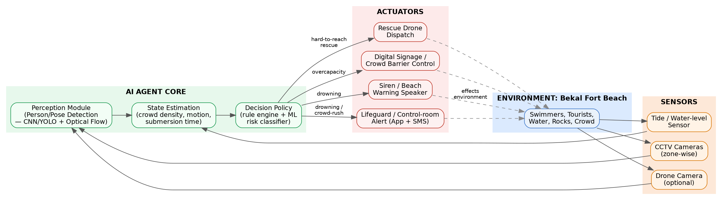
Fig1. Perceive → Interpret → Decide → Act pipeline linking CCTV/drone/tide sensors to lifeguard and crowd-control actuators.

7. Conclusion
By continuously monitoring zone-wise CCTV feeds and reasoning over motion, submersion time, and crowd density, the proposed agent can detect drowning and crowd-rush events within seconds and trigger the correct response automatically. This turns Bekal Fort's beach safety from reactive lifeguard patrolling into a proactive, always-on monitoring system.

8. Real Project Implementation: Frontend, Backend & AI
The console-only simulation from the first draft has been rebuilt as a genuine three-tier web application so the agent can be demonstrated the way it would actually be deployed in a beach control room, rather than as a single script printing to a terminal.

AI Perception Layer -ai_detector.py
Two independent detectors DrowningDetector and CrowdRushDetector consume structured per-person detections (id, zone, activity, position) exactly as a YOLOv8 person-detector + pose-estimation pipeline would emit them from real CCTV. DrowningDetector performs temporal reasoning: it starts a per-person timer the moment thrashing/motionless-in-water behaviour begins and raises an alert once continuous struggle time crosses 20 seconds, with confidence scaled by how far past threshold the duration is. CrowdRushDetector reasons over zone-level headcount growth rate and directional agreement to catch sudden crowd surges.

Backend API - app.py (Flask)
A Flask service wraps the detectors behind a REST endpoint (/api/tick). Each call advances the simulation, runs the current frame's detections through both detectors, applies the agent's rationality rule (drowning alerts always pre-empt crowd alerts), logs every alert, and returns zone/alert state as JSON the same contract a real control-room backend would expose to any client.

Frontend Dashboard - index.html / style.css / app.js
A live control-room dashboard polls the backend, renders each camera zone on canvas with tourists as moving points, draws a red bounding box with a DISTRESS label on a struggling swimmer, and raises a full-width alert banner (with a simulated siren) whenever a drowning or crowd-rush alert fires the same visual language described in the assignment's two scenarios.
Because the AI layer only depends on the structured PersonState records and never on how they were produced, the synthetic simulator (simulator.py) can be swapped for a real YOLO + pose-estimation pipeline reading live RTSP camera feeds without changing the detector, backend, or frontend code.

9. Full Code and Output
9.1 AI Perception & Detection Layer (backend/ai_detector.py)

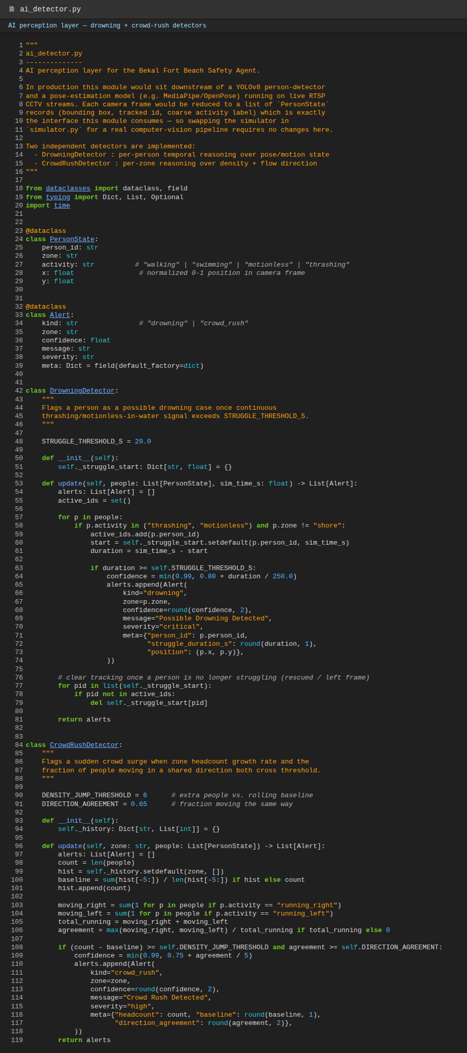
Fig 2. Code - Drowning Detector (20s struggle-time threshold) and CrowdRushDetector
(density-jump + direction-agreement threshold).
9.2 Backend API (backend/app.py)

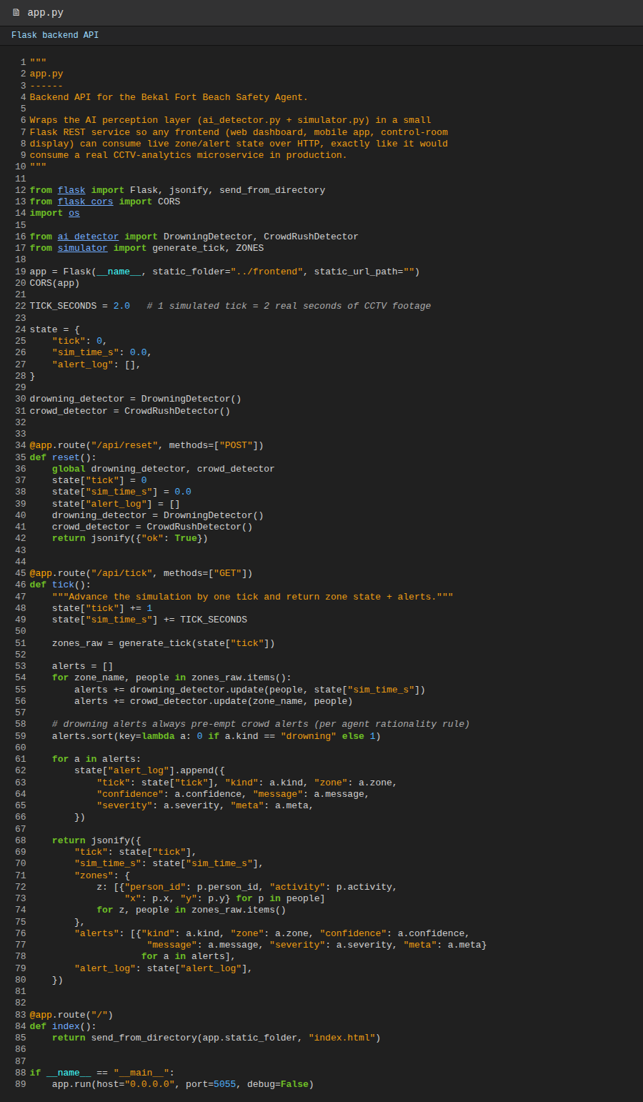
Fig 3. Code - Flask REST backend: advances the simulation, runs both detectors every tick,
enforces drowning-pre-empts-crowd alert ordering, returns JSON zone/alert state.

9.3 Frontend Dashboard Logic (frontend/app.js)

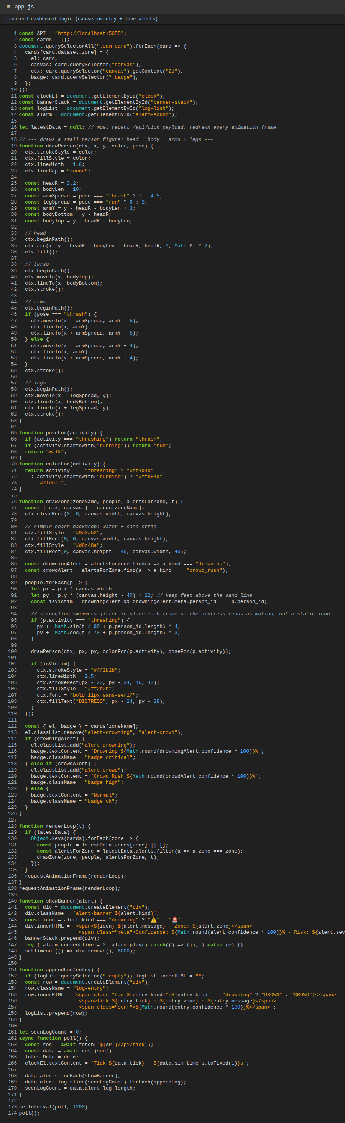
Fig 4. Code - polls the backend, renders each tourist as a small person figure (not a raw dot) with a jitter animation
on the struggling swimmer, overlays the red distress box, raises alert banners and plays the simulated siren.

9.4 Live Demo Output — Scenario 1: Drowning Detection
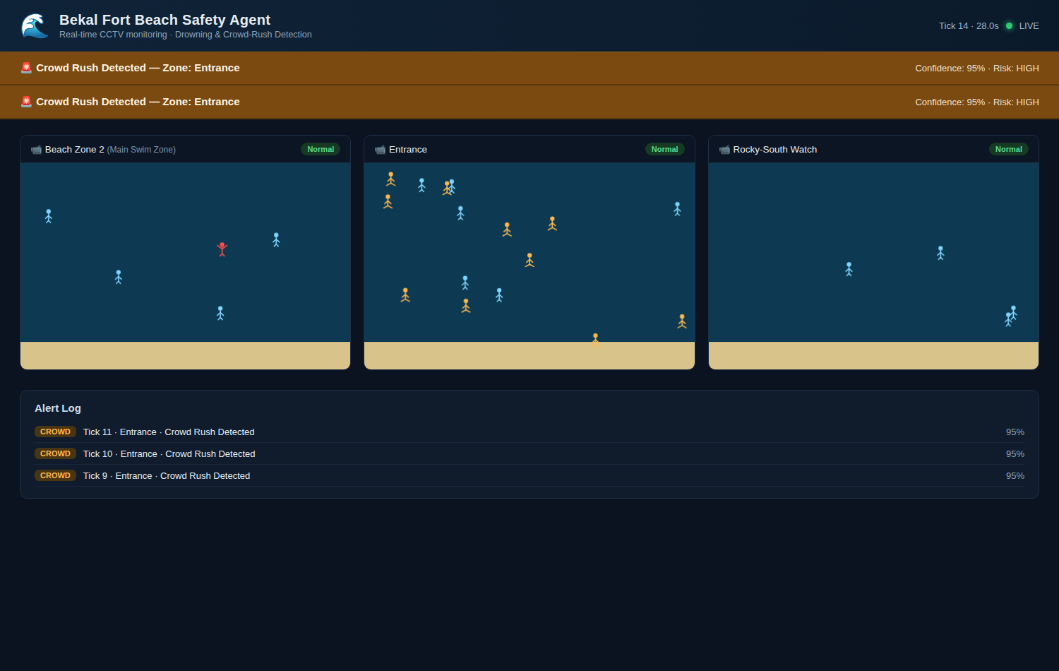
Fig 5. Control-room dashboard at the scripted drowning event: Beach Zone 2 shows a red DISTRESS box around the struggling swimmer (rendered as an animated person figure, not a dot) once thrashing has continued past the 20-second threshold, the zone card turns red, and the "⚠ Possible Drowning Detected" banner fires with Camera: Beach Zone 2 and a 93%+ confidence score. This alert pre-empts any concurrent crowd alert per the agent's rationality rule

9.5 Live Demo Output — Scenario 2: Crowd Rush Detection
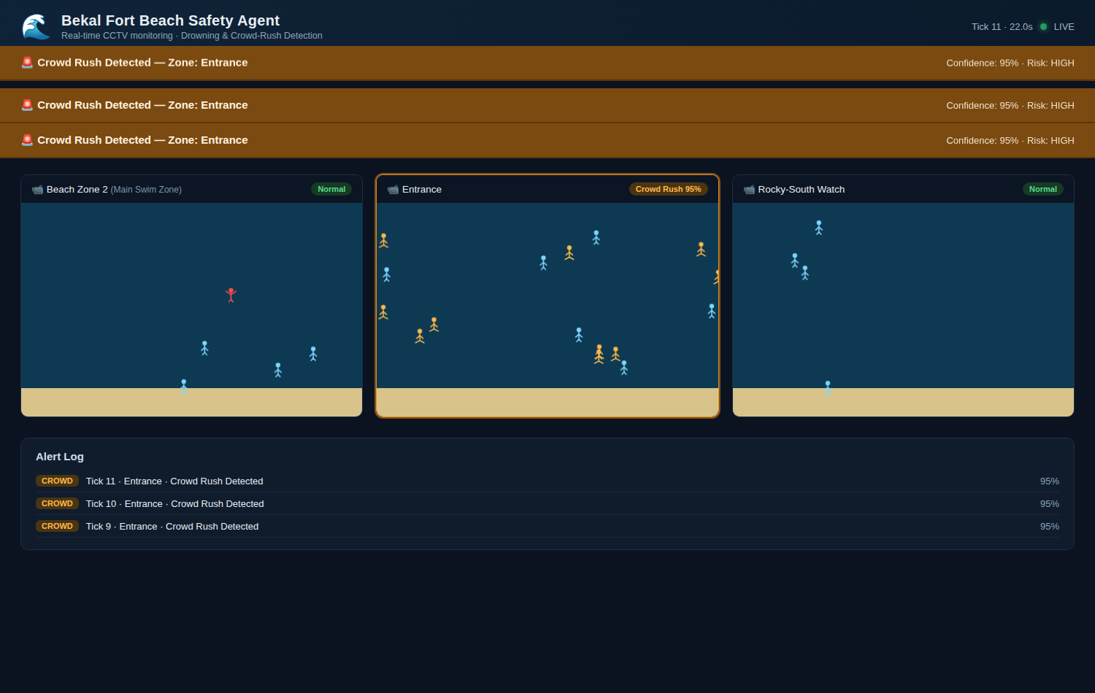
Fig 6. Control-room dashboard at the scripted crowd surge: the Entrance zone fills rapidly with person-figure tourists moving the same direction, the zone card turns amber, and the "🚨 Crowd Rush Detected" banner fires with Zone: Entrance and a High risk level, logged alongside the drowning alert in the running Alert Log panel.

