**HAPPY FRUIT TUTORIAL**

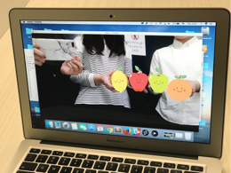

**For this project you will need**:

* PC with Webcam
* Installed Processing(Go to Processing.org and download processing.)
* Colorful items(We used fruits in this project: red apple, green apple, orange and lemon.)

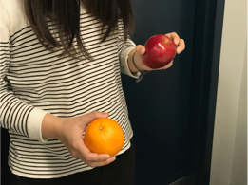

* Relative images(We designed happy fruit images



**Step 1: Processing**

Open Processing and download Video library in processing to connect to webcam. Define track color variables and fruit images.

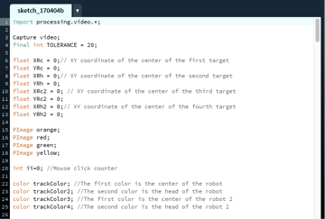

**Step 2: Set up device and insert images**

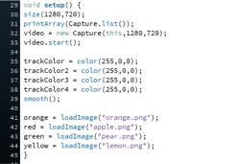

**Step 3. Draw video pictures and track the colors**

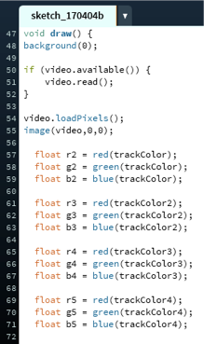

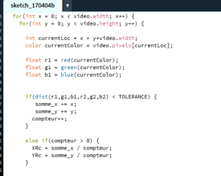

**Step 4. Draw pictures at four targets**

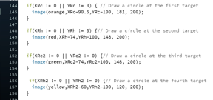

**Step 5. Create mouse events**

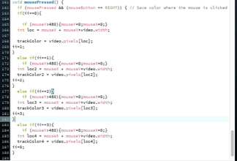

When webcam captures real fruit, click the fruit on screen, then the corresponding image will show up on screen. It means the webcam has already captured the color of the real fruit. The image will move on screen following the movement of real fruits.