Картинки по запросу github blue iconКартинки по запросу skype blue icon

https://github.com/Linus22288

Linus2228



Linus2228@gmail.com



+375447428428

**Dmitry Kudla**

Middle Frontend Developer

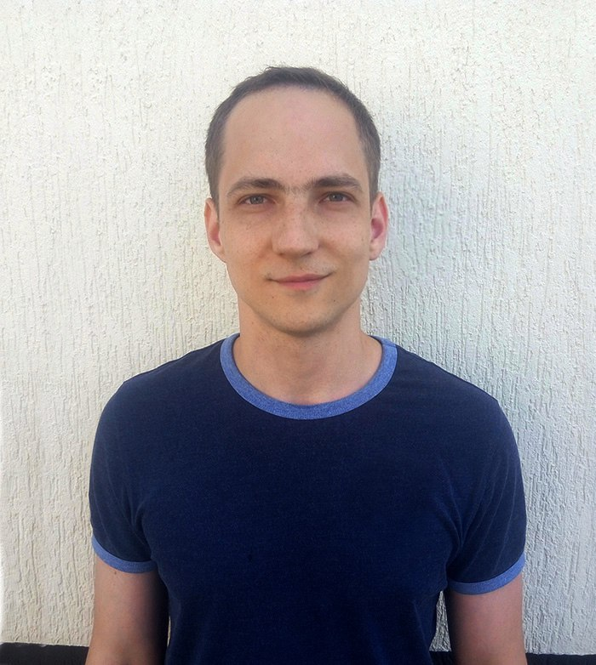

**Education**

**WORK EXPERIENCE**  
1 Year

* BSEU 2005-2010 years
* The Rolling Scope School 2017/Q1



**Professional Qualifications and Affiliations**

* HTML, CSS, Sass, Bootstrap
* JS core, Jquery, React, Redux
* Git, Webpack, Gulp



**Career Proactivity**

* TOP 150 on Codewars <https://www.codewars.com/users/Dmitry%20Kudla>
* The personal blog on Medium – the articles translations <https://medium.com/@linus2228>
* A mentor for two persons in frontend development
* The participation in Rolling Scope School 2017
* Permanent self-education
* Full-stack developer in the future ( JS core/react + node.js)



**Work Experience**

May 2017 – Current  
**Frontend developer**  
Epam Systems, Minsk



**Languages**

* English B1+ (speaking and writing skills, inner Epam’s assessment)



**Personal Interests**

|  |  |
| --- | --- |
| * Self-education |  |
| * Swimming |  |
| * Chess |  |



**Personal Details**

Birthday: August 19, 1987 Marital Status: Married  
Gender: Male Nationality: Belorussian