The report must contain the following:

•Front page with the task title, names and e-mail addresses of the report's participants, the start and end date of the project period and signatures of the participants.

•Automatically generated table of contents.

•Page header with the report's participants, date and title of the task

• Footer with page numbers

•Introduction / Presentation - Foreword and Purpose

•Problem formulation

•Proposed solutions and applied technologies (OOAD and UML)

•Requirement specification

•Planning

•Discussion

•Implementation

•Conclusion

•Enclosed Documentation Appendix

•All diagrams and code must be attached.

•All code must have comments attached so that a third party can read the code

•The system / program must be comprehensible to third parties by means of documentation.

•References and source

## Introduction

This Project is made for mechanic students. The main reason behind making of this product is so that mechanic students can easily see how if they have enough amount of the tool or whatever they need in their inventory.

Program can store information about like number of tools and other things. Just like its administrative page you can easily understand what this program is capable of.

### Administrative

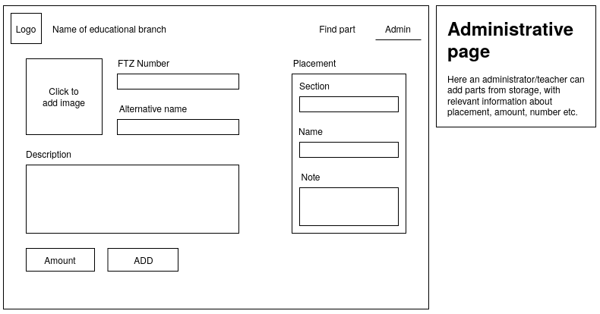

As you can you can add

* An image
* FTZ number
* A name
* Description

And on the right side you can see where can I find it

* Section
* Name
* Note

From this you can see that administrative page is the main page of this program, adding all the main information.

After adding all the information on the administrative page, user given info will go to the next page called Search Page

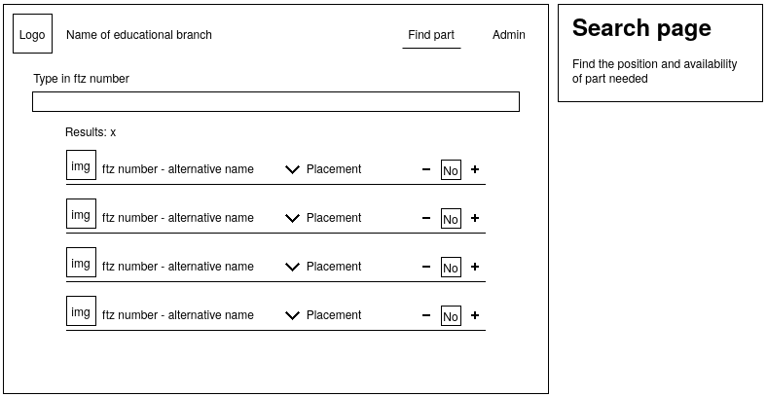

As you can see it simple show how the information will look like in the end

You will see an image of the product and both it number and name next to it. On the right side you have option of placement and how many you want to place.

If you look at the head of the program you can see at the left side you have a logo and the name of the educational branch. On the right side you have the option to change page but clicking on it like right now you are on the search page but if you want to go back to the administrative page you can just click on the Admin on the top right side.

Because of this program user will be able to easily access everything they have in their inventory. At first user will be able to see all everything but if your wants to see a specific thing user can just type its name or its FTZ number in the textbox underneath the label where it says “Type in ftz number”

User will be able to easily tell what they’d like to borrow, the amount of something that they’d like to borrow.

Under Requirements

### Specifications

* Admin can configure the product’s critical amount manually.
* System will let user know if the product reaches its critical amount.
* Only admin can change the minimum critical amount of a product that a product can reach.
* Admin can add a maximum amount for a product to be borrowed manually.
* System will let user know if the amount of product user wants to borrowed is over the maximum number.
* Only admin can change the maximum amount of a product that can be borrowed.