**Final Project - Mesh Processing**

**学号：161810225姓名：王烨文 班级：1618104**

**分数：**

**一个月时间完成**

1．计算三角网格中每个三角形(face)的面积；10分

Scalar calc_facet_area(const FacetHandle& _fh)

代码如下：

ExKernelT<ExItems>::calc_facet_area(const FacetHandle& _fh){/////计算三角形的面积

///得到半边句柄

assert(_fh.is_valid());

assert(_fh.idx() < facet_size());

const HalfedgeHandle& hh = halfedge_handle(_fh);

const HalfedgeHandle& p_hh = prev_halfedge_handle(hh);

const HalfedgeHandle& n_hh = next_halfedge_handle(hh);

////由半边句柄得到边句柄

const EdgeHandle& e_hh = edge_handle(hh);

const EdgeHandle& e_phh = edge_handle(p_hh);

const EdgeHandle& e_nhh = edge_handle(n_hh);

////由边句柄得到各边长

double length0 = calc_edge_length(e_hh);

double length1 = calc_edge_length(e_phh);

double length2 = calc_edge_length(e_nhh);

double p = (length0 + length1 + length2) / 2;

////利用海伦公式求面积s=sqrt(p(p-a)(p-b)(p-c))

Scalar area = 0.0;

area = sqrt(p * (p - length0) * (p - length1) * (p - length2));

facet_ref(_fh).area_ = area;

return area;

}

2．**计算三角网格中每个顶点(vertex) 的法向；20分**

Normal calc_normal(const VertexHandle& _vh)

代码如下：

ExKernelT<ExItems>::calc_normal(const VertexHandle& _vh) {////更新一个顶点的法向

assert( _vh.is_valid());

assert( _vh.idx() < vertex_size() );

Normal norm(0,0,0);///////用norm存储求得的法向值

//////////////////////////在此实现////////////////////////////////////

std::vector<FacetHandle> _fhs;

HalfedgeHandle& hh = halfedge_handle(_vh);

VertexHandle vhs;

vhs = vertex_handle(hh);

FacetHandle _fh = facet_handle(hh);

HalfedgeHandle& hhv = halfedge_handle(vhs);

HalfedgeHandle cursor(hhv);

FacetHandle fh = facet_handle(cursor);

_fhs.push_back(_fh);//放入第一面

int j;

do {

FacetHandle fh = facet_handle(cursor);

if (fh.is_valid() && fh != _fh) {

if (_fhs.size() != 0) {

for (j = 0; j < _fhs.size(); j++) {

if (fh.idx() == _fhs[j].idx()) break;

}//end for

if (j >= _fhs.size()) _fhs.push_back(fh);

}//end if

else _fhs.push_back(fh);

}//end if

cursor = cw_rotated(cursor);

} while (hhv != cursor);//end for do while

double total_area = 0.0;

for (int i = 0; i < _fhs.size(); i++)

{

total_area += calc_facet_area(_fhs[i]);

}

for (int i = 0; i < _fhs.size(); i++)

{

double weight = calc_facet_area(_fhs[i]) / total_area;

norm += calc_normal(_fhs[i]) * weight;

}

/////////////////////////////////////////////////////////////////////

return norm.normalize();

}

3．**用OpenGL把三角网格中每个三角面片(face)的法向画出来（提示：在每个三角面片的重心处画）**；20分

bool ogl_writer2(bool _orient = true, bool _smooth = false);

代码如下：

bool ReaderWriterT<Mesh>::ogl_writer2(bool _orient, bool _smooth){////在里面把三角面片法向画出

HalfedgeHandle cshh;

Mesh::FacetIterator fit(mesh_->facet_begin());

//glShadeModel(GL_FLAT);

glShadeModel(GL_SMOOTH);

int orient = true;// (_orient) ? 1 : -1;

mesh_->update_normals();

ogl_writer(_orient, _smooth);

for (; fit != mesh_->facet_end(); ++fit) {

if ((*fit).status_.is_deleted()) continue;

cshh = fit->halfedge_handle_;

FacetHandle fh = mesh_->facet_handle(cshh);

Mesh::Normal norm = mesh_->calc_normal(fh);

const HalfedgeHandle& hh = mesh_->halfedge_handle(fh);

const HalfedgeHandle& p_hh = mesh_->prev_halfedge_handle(hh);

const HalfedgeHandle& n_hh = mesh_->next_halfedge_handle(hh);

const Coord& cd0 = mesh_->coord(mesh_->vertex_handle(hh));

const Coord& cd1 = mesh_->coord(mesh_->vertex_handle(p_hh));

const Coord& cd2 = mesh_->coord(mesh_->vertex_handle(n_hh));

double gpx = (cd0.data_[0] + cd1.data_[0] + cd2.data_[0]) / 3;

double gpy = (cd0.data_[1] + cd1.data_[1] + cd2.data_[1]) / 3;

double gpz = (cd0.data_[2] + cd1.data_[2] + cd2.data_[2]) / 3;

glBegin(GL_LINES);

glVertex3f(gpx,gpy,gpz);

glVertex3f(gpx + 0.3 * norm.x, gpy + 0.3 * norm.y, gpz + 0.3 * norm.z);

glVertex3f(gpx + 0.3 * norm.x, gpy + 0.3 * norm.y, gpz + 0.3 * norm.z);

glVertex3f(gpx + 0.2 * norm.x - 0.05 , gpy + 0.25 * norm.y, gpz + 0.25 * norm.z);

glVertex3f(gpx + 0.3 * norm.x, gpy + 0.3 * norm.y, gpz + 0.3 * norm.z);

glVertex3f(gpx + 0.2 * norm.x + 0.05, gpy + 0.25 * norm.y, gpz + 0.25 * norm.z);

glEnd();

}

return true;

}

效果如下（**注意：贴自己的实验结果！！！**）：

|  |
| --- |
|  |

4．**实现一种简单的三角网格去噪算法（例如拉普拉斯光顺）；30分**

void Laplacian_Smoothing();

代码如下：

void ExKernelT<ExItems>::Laplacian_Smoothing() {

/////请实现自己的去噪算法////////

int n;

std::cout << "请输入迭代次数:";

std::cin >> n;

double laplac = 0.0;

std::cout << "请输入拉普拉斯系数(越接近本身->1):";

std::cin >> laplac;

for (int i = 1; i <= n; i++)

{

std::vector<Coord> updateVertexPosition;

std::vector<VertexHandle> v_near;

int vertex_num = vertex_size();

updateVertexPosition.resize(vertex_num);

for (int i = 0; i < vertex_num; i++) {

VertexHandle vh(i);

getNeighborRing(vh, 1, v_near);

double xsum = 0.0, ysum = 0.0, zsum = 0.0, dsum = 0.0;

double d = 0.0;

for (int j = 1; j < v_near.size(); j++)

{

d = sqrt((coord(v_near[j]).x- coord(v_near[0]).x) * (coord(v_near[j]).x - coord(v_near[0]).x) + (coord(v_near[j]).y - coord(v_near[0]).y) * (coord(v_near[j]).y - coord(v_near[0]).y) + (coord(v_near[j]).z - coord(v_near[0]).z) * (coord(v_near[j]).z - coord(v_near[0]).z));

dsum += d;

xsum += coord(v_near[j]).x*d;

ysum += coord(v_near[j]).y*d;

zsum += coord(v_near[j]).z*d;

}

xsum = xsum / dsum;

ysum = ysum / dsum;

zsum = zsum / dsum;

Coord cd(xsum, ysum, zsum);

updateVertexPosition[i] = coord(v_near[0]) * laplac + cd * (1 - laplac);

v_near.clear();

}

for (int i = 0; i < vertex_num; i++)

{

vertex_ref(VertexHandle(i)).coord_ = updateVertexPosition[i];

}

}

}

效果如下（**注意：贴自己的实验结果！！！**）：

|  |  |
| --- | --- |
| 去噪前 | 迭代5次，拉普拉斯系数0.8  去噪后 |

**5.（可选/可做可不做）实现一种基于三角网格的操作（例如，特征提取，三角网格分割，三角网格平面参数化，三角网格变形等等）；20分**

void mesh_process();

代码如下：

void ExKernelT<ExItems>::mesh_process(std::map<VertexHandle,double> &Gosk){///////(可选，在三角网格上实现一种操作，例如特征提取，网格分割，三角网格变形等等)

VertexIterator vi = vertex_begin();

for (; vi != vertex_end(); ++vi) {

if (vi->status_.is_deleted()) continue;

assert(vi->halfedge_handle_.is_valid());

VertexHandle& vh = vertex_handle(vi->halfedge_handle_);

std::vector<FacetHandle> _fhs;

HalfedgeHandle& hh = halfedge_handle(vh);

VertexHandle vhs;

vhs = vertex_handle(hh);

FacetHandle _fh = facet_handle(hh);

HalfedgeHandle& hhv = halfedge_handle(vhs);

HalfedgeHandle cursor(hhv);

FacetHandle fh = facet_handle(cursor);

_fhs.push_back(_fh);//放入第一面

int j;

do {

FacetHandle fh = facet_handle(cursor);

if (fh.is_valid() && fh != _fh) {

if (_fhs.size() != 0) {

for (j = 0; j < _fhs.size(); j++) {

if (fh.idx() == _fhs[j].idx()) break;

}//end for

if (j >= _fhs.size()) _fhs.push_back(fh);

}//end if

else _fhs.push_back(fh);

}//end if

cursor = cw_rotated(cursor);

} while (hhv != cursor);//end for do while

double total_area = 0.0;

double area = 0.0;

double Angle = 2 * 3.1415926535898;

for (int i = 0; i < _fhs.size(); i++) {

const HalfedgeHandle& hh = halfedge_handle(_fhs[i]);

const HalfedgeHandle& p_hh = prev_halfedge_handle(hh);

const HalfedgeHandle& n_hh = next_halfedge_handle(hh);

Coord cd0 = coord(vertex_handle(hh));

Coord cd1 = coord(vertex_handle(p_hh));

Coord cd2 = coord(vertex_handle(n_hh));

Coord cd_ori = coord(vh);

if (cd_ori == cd0) {

;

}

else if (cd_ori == cd1) {

cd1 = coord(vertex_handle(hh));

cd0 = coord(vh);

}

else if (cd_ori == cd2) {

cd2 = coord(vertex_handle(hh));

cd0 = coord(vh);

}

double a = sqrt(pow(cd0.data_[0] - cd1.data_[0], 2) + pow(cd0.data_[1] - cd1.data_[1], 2) + pow(cd0.data_[2] - cd1.data_[2], 2));

double b = sqrt(pow(cd0.data_[0] - cd2.data_[0], 2) + pow(cd0.data_[1] - cd2.data_[1], 2) + pow(cd0.data_[2] - cd2.data_[2], 2));

double c = sqrt(pow(cd2.data_[0] - cd1.data_[0], 2) + pow(cd2.data_[1] - cd1.data_[1], 2) + pow(cd2.data_[2] - cd1.data_[2], 2));

int tri = 0;//0-锐角,1-钝角,2-直角

if (a * a + b * b > c * c && a * a + c * c > b * b && b * b + c * c > a * a) {

tri = 0;

}

else if (a * a + b * b == c * c || a * a + c * c == b * b || b * b + c * c == a * a) {

tri = 2;

}

else {

tri = 1;

}

double angle_ori = acos((a * a + b * b - c * c) / (2 * a * b));

Angle -= angle_ori;

double anglej = acos((a * a + c * c - b * b) / (2 * a * c));

double anglej1 = acos((b * b + c * c - a * a) / (2 * b * c));

if (tri == 0) {

double temp = 1 / tan(anglej);

double temp2 = 1 / tan(anglej1);

area = (0.125) * (b*b*temp+c*c*temp2);

}

else if (tri == 1) {

area = (calc_facet_area(_fhs[i])) - (1 / 8) * (c * c * tan(anglej)) - (1 / 8) * (a * a * tan(anglej1));

}

else if (tri == 2) {

area = (1 / 8) * ((b * b) * (1 / tan(anglej)) + (c * c) * (1 / tan(anglej1)));

}

total_area += area;

}

double GossK = Angle / total_area;

Gosk.insert(std::pair<VertexHandle,double>{ vh,GossK });

}

}

bool ReaderWriterT<Mesh>::ogl_writer3(bool _orient, bool _smooth) {////在里面把三角面片法向画出

//Mesh::FacetIterator fit(mesh_->facet_begin());

std::map<VertexHandle,double> Gosk;

mesh_->mesh_process(Gosk);

HalfedgeHandle cshh;

Mesh::FacetIterator fit(mesh_->facet_begin());

double minn = 60000, maxn = -60000;

for (std::map<VertexHandle, double>::iterator it = Gosk.begin(); it != Gosk.end(); it++)

{

if (it->second < minn)

minn = it->second;

if (it->second > maxn)

maxn = it->second;

}

double dx = maxn - minn;

double inter = dx / 5;

//glShadeModel(GL_FLAT);

glShadeModel(GL_SMOOTH);

int orient = true;// (_orient) ? 1 : -1;

mesh_->update_normals();

for (; fit != mesh_->facet_end(); ++fit) {

if ((*fit).status_.is_deleted()) continue;

cshh = fit->halfedge_handle_;

FacetHandle fh = mesh_->facet_handle(cshh);

const VertexHandle& vh0 = mesh_->vertex_handle(cshh);

double in = 80.0 / 20.0;

glBegin(GL_TRIANGLES);

do {

const VertexHandle& vh = mesh_->vertex_handle(cshh);

for (int i = 0; i < 19; i++)

{

if (Gosk[vh] > 40.0)

glColor3f(1.0, 0.3, 0.0);

else if (Gosk[vh] < -40.0)

glColor3f(0.0, 0.3, 1.0);

else if (Gosk[vh] < 40 - in * i && Gosk[vh]>40 - in * (i + 1))

glColor3f(1.0 - (i + 1) * 0.05, 0.35, 0.0 + (i + 1) * 0.05);

}

glNormal3fv(mesh_->normal(fh) * orient);

glVertex3fv(mesh_->coord(vh));

cshh = mesh_->next_halfedge_handle(cshh);

} while (cshh != fit->halfedge_handle_);

glEnd();

}

return true;

}

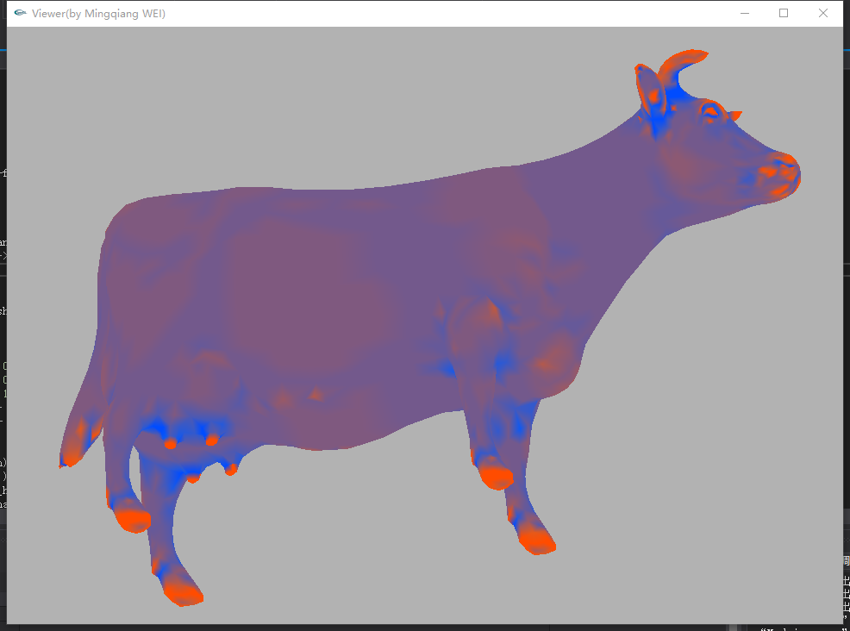效果如下：

Tips.显红处至显蓝处高斯曲率数值逐渐下降（凹凸性）