深入理解大数据实验报告

课程名称 | 深入理解大数据
项目名称 | PageRank网页排名算法

pageRank网页排名算法

一、实验目的
熟悉，理解，运用PageRank网页排名算法，组合倒排索引和PageRank，使用TF分词，学习大数据组件的使用。

二、实验平台
- Mac ox 11.14
- hadoop 2.7.1
- JDK 1.8
- spark 2.3.3
- scala 2.11.8

实验步骤

3.1 将下载的源数据上传至hdfs
bin/hdfs dfs -put /Users/mac/workspace/ii/inverted-index/dataset /

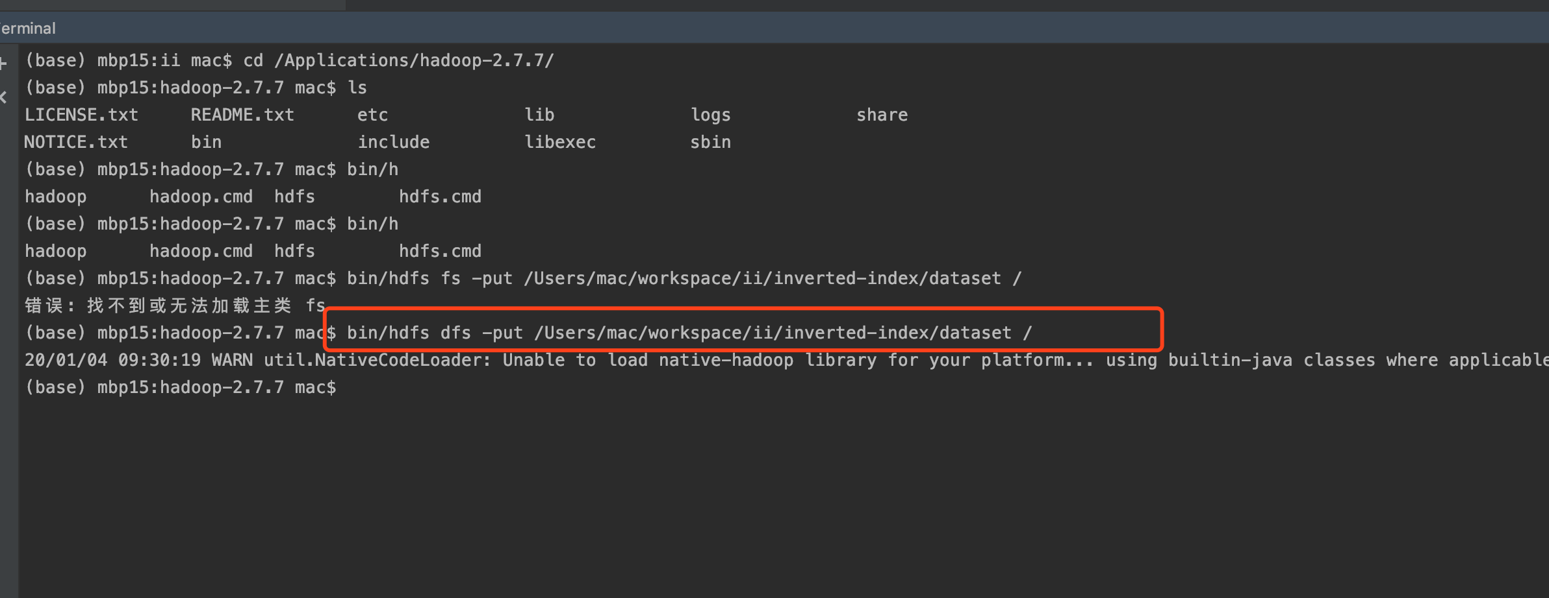
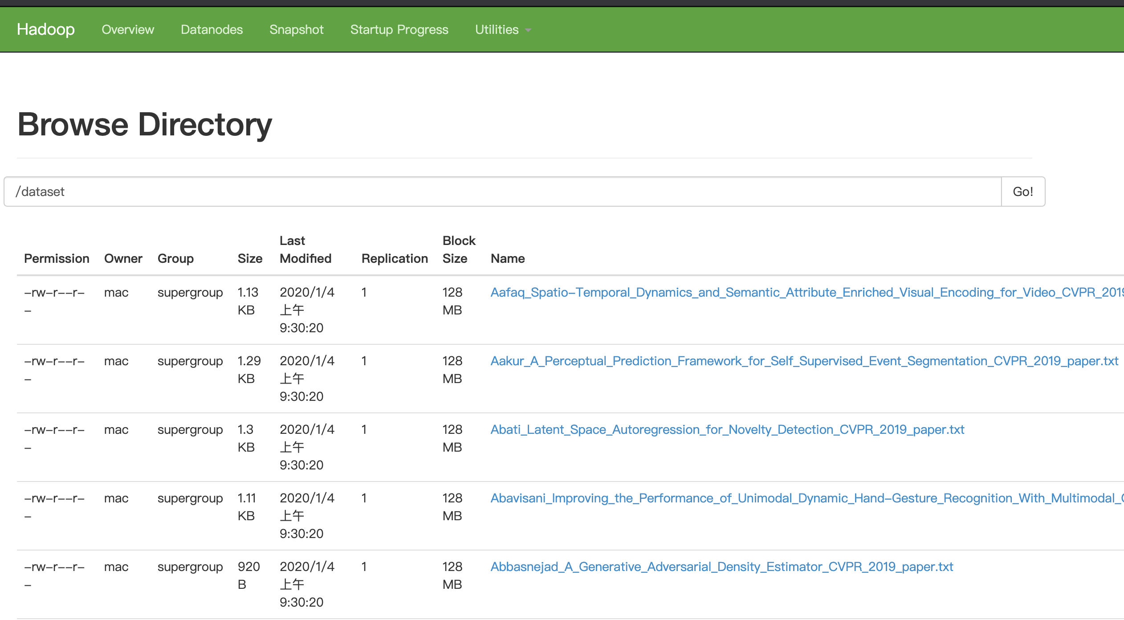

3.2用MapReduce实现PageRank

IDF.java
package tfidf;

import java.io.File;
import java.io.IOException;
import java.util.ArrayList;
import java.util.List;
import java.util.StringTokenizer;
import org.apache.hadoop.io.Text;
import org.apache.hadoop.mapreduce.Mapper;
import org.apache.hadoop.mapreduce.Reducer;

/**
* @author cong.yu
* @date 2019-12-18 21:14
*/
public class IDF {

public static class IDFMapper extends Mapper<Object, Text, Text, Text> {

@Override
protected void map(Object key, Text value, Context context)
throws IOException, InterruptedException {
/*
1. 接上个reduce的输出为输入: (word:fileName, tf)
2. 将其拆解为(word, tf:filename)形式， 输出
*/
Text keyLabel = new Text();
Text fileNameLabel = new Text();
if (value.toString() != null && !"".equals(value.toString())) {
StringTokenizer tokenizer = new StringTokenizer(value.toString());
String token = tokenizer.nextToken();
keyLabel.set(token.split(":")[0]);
if (token.split(":")[1] != null && !"".equals(token.split(":")[1])) {
fileNameLabel.set(String.join(":", tokenizer.nextToken(), token.split(":")[1]));
}
context.write(keyLabel, fileNameLabel);
}
}
}

public static class IDFReducer extends Reducer<Text, Text, Text, Text> {

private int totalFileCount = 0;

@Override
protected void setup(Context context) throws IOException, InterruptedException {
//需要获得文件的总个数
File dir = new File("/Users/mac/workspace/ii/inverted-index/dataset");
totalFileCount = dir.list().length;
}

@Override
protected void reduce(Text key, Iterable<Text> values, Context context)
throws IOException, InterruptedException {
if (values == null) {
return;
}

int fileCount = 0;
List<String> valList = new ArrayList<>();
for (Text value : values) {
valList.add(value.toString());
//统计word一个在多少个文件中出现过
fileCount++;
}

//根据公式计算idf
Double idf = Math.log10(1.0 * totalFileCount / (fileCount + 1));

//计算tf-idf，再将输入拆解为(word:fileName,tf-idf)输出
Text label = new Text();
for (String value : valList) {
Double tfidf = Double.parseDouble(value.split(":")[0]) * idf;
label.set(String.join(":", key.toString(), value.split(":")[1]));
context.write(label, new Text(String.valueOf(tfidf)));
}
}
}
}

Job.java
package tfidf;

import java.io.IOException;
import java.util.Date;
import org.apache.hadoop.conf.Configuration;
import org.apache.hadoop.fs.Path;
import org.apache.hadoop.io.IntWritable;
import org.apache.hadoop.io.Text;
import org.apache.hadoop.mapreduce.lib.input.FileInputFormat;
import org.apache.hadoop.mapreduce.lib.output.FileOutputFormat;
import tfidf.IDF.IDFMapper;
import tfidf.IDF.IDFReducer;
import tfidf.TF.TFMapper;
import tfidf.TF.TFReducer;

/**
* @author cong.yu
* @date 2019-12-18 21:30
*/
public class Job {

public static void main(String[] args)
throws InterruptedException, IOException, ClassNotFoundException {
//执行两个mapreduce任务
runTf(args);
runIdf(args);
System.out.println(new Date());
}

public static void runTf(String[] args)
throws InterruptedException, IOException, ClassNotFoundException {
Configuration conf = new Configuration();
org.apache.hadoop.mapreduce.Job job = org.apache.hadoop.mapreduce.Job.getInstance(conf);

job.setJarByClass(TF.class);

job.setMapperClass(TFMapper.class);
job.setMapOutputKeyClass(Text.class);
job.setMapOutputValueClass(Text.class);
FileInputFormat.setInputPaths(job, new Path(args[0]));

job.setReducerClass(TFReducer.class);
job.setOutputKeyClass(Text.class);
job.setOutputValueClass(Text.class);
FileOutputFormat.setOutputPath(job, new Path(args[1]));

job.waitForCompletion(true);
}

public static void runIdf(String[] args)
throws InterruptedException, IOException, ClassNotFoundException {
Configuration conf = new Configuration();
org.apache.hadoop.mapreduce.Job job = org.apache.hadoop.mapreduce.Job.getInstance(conf);

job.setJarByClass(IDF.class);

job.setMapperClass(IDFMapper.class);
job.setMapOutputKeyClass(Text.class);
job.setMapOutputValueClass(Text.class);
FileInputFormat.setInputPaths(job, new Path(args[2]));

job.setReducerClass(IDFReducer.class);
job.setOutputKeyClass(Text.class);
job.setOutputValueClass(Text.class);
FileOutputFormat.setOutputPath(job, new Path(args[3]));

job.waitForCompletion(true);
}
}

Query.java
package tfidf;

import java.io.BufferedReader;
import java.io.FileReader;
import java.io.IOException;
import java.util.ArrayList;
import java.util.Collections;
import java.util.Comparator;
import java.util.HashMap;
import java.util.List;
import java.util.Map;
import java.util.Map.Entry;
import java.util.TreeMap;

/**
* @author cong.yu
* @date 2019-12-18 22:29
*/
public class Query {

public static void main(String[] args) throws IOException {
Map<String, Map<String, Double>> map = new HashMap<>();
BufferedReader br = new BufferedReader(
new FileReader(args[0]));

String line;
//构建可供查询的索引
//Map<String, Map<String, Double>> key为查询的单词， value的map存放的是key: 单词及所在文本, value: tf-idf
while ((line = br.readLine()) != null) {
String[] strArr = line.split("\t");
String[] keyArr = strArr[0].split(":");
if (strArr.length != 2 || keyArr.length != 2) {
continue;
}
if (map.get(keyArr[0]) == null) {
//如果不存在则新建
Map<String, Double> sub = new TreeMap<>();
sub.put(strArr[0], Double.valueOf(strArr[1]));
map.put(keyArr[0], sub);
} else {
Map<String, Double> sub = map.get(keyArr[0]);
sub.put(strArr[0], Double.valueOf(strArr[1]));
}
}

System.out.println("Your input word: " + args[1]);
if (map.get(args[1]) == null) {
System.out.println("Not found!");
} else {
List<Map.Entry<String, Double>> list = new ArrayList<>(map.get(args[1]).entrySet());
Collections.sort(list, new Comparator<Entry<String, Double>>() {
@Override
public int compare(Entry<String, Double> o1, Entry<String, Double> o2) {
return o2.getValue().compareTo(o1.getValue());
}
});
System.out.println("the following documents contain the input word: ");
for (Entry<String, Double> entry : list) {
System.out.println(entry.getKey().split(":")[1] + "\t" + "TF-IDF: " + entry.getValue());
}
}
}
}

Test.java
package tfidf;

/**
* @author cong.yu
* @date 2019-12-18 22:41
*/
public class Test {

public static void main(String[] args) {

String str = "asd,as \"df'9a-sd()ad.";

System.out.println(str.replaceAll("[.,:;!?\\-()\"']",""));

String str1 = "According:Baek_Character_Region_Awareness_for_Text_Detection_CVPR_2019_paper.txt\t5.5880051697755604E-6\n";

System.out.println(Math.log10(1.0*1293/2));
}
}

TF.java
package tfidf;

import java.io.IOException;
import java.util.ArrayList;
import java.util.List;
import java.util.StringTokenizer;
import org.apache.hadoop.io.IntWritable;
import org.apache.hadoop.io.Text;
import org.apache.hadoop.mapreduce.InputSplit;
import org.apache.hadoop.mapreduce.Mapper;
import org.apache.hadoop.mapreduce.Reducer;
import org.apache.hadoop.mapreduce.lib.input.FileSplit;

/**
* @author cong.yu
* @date 2019-12-18 20:54
*/
public class TF {

public static class TFMapper extends Mapper<Object, Text, Text, Text> {

private String fileName = "";

@Override
protected void setup(Context context) throws IOException, InterruptedException {
InputSplit inputSplit = (InputSplit) context.getInputSplit();
fileName = ((FileSplit) inputSplit).getPath().getName();
}

@Override
protected void map(Object key, Text value, Context context)
throws IOException, InterruptedException {

//统计该文本总共有多少分词
int totalCount = 0;
List<String> list = new ArrayList<>();

StringTokenizer tokenizer = new StringTokenizer(
value.toString().replaceAll("[.,:;!?\\-()\"']", " "));
Text label = new Text();
IntWritable count = new IntWritable(1);
while (tokenizer.hasMoreTokens()) {
label.set(tokenizer.nextToken().toLowerCase() + ":" + fileName);
list.add(label + "\t" + count);
totalCount++;
}
/*
1. 一个文本只包含一条记录
2. 将分词后的word与其所在文件组成key, 形式为word:fileName
3. 将totalCount也拼接进value中， 后面reduce计算TF需要用到， 由于是每个文件分别做的mr， 因此需要将totalCount分别带入对应的key中(大致思路)
4. map端输出，(word:fileName, count:totalCount)
*/
for (String tuple2 : list) {
context.write(new Text(tuple2.split("\t")[0]),
new Text(tuple2.split("\t")[1] + ":" + totalCount));
}
}
}

public static class TFReducer extends Reducer<Text, Text, Text, Text> {

@Override
protected void reduce(Text key, Iterable<Text> values, Context context)
throws IOException, InterruptedException {

if (values == null) {
return;
}

int totalCount = 0;
int sumCount = 0;
for (Text value : values) {
sumCount += Integer.valueOf(value.toString().split(":")[0]);
totalCount = Integer.valueOf(value.toString().split(":")[1]);
}

/*
1. sumCount相当于计算的每个单词在文本中出现的次数
2. 根据公式计算TF
3. reduce端输出，(word:fileName, tf)
*/
Double tf = 1.0 * sumCount / totalCount;
context.write(new Text(key.toString()),
new Text(String.valueOf(tf.isInfinite() ? Double.MIN_VALUE : tf.doubleValue())));
}

@Override
public void run(Context context) throws IOException, InterruptedException {
super.run(context);
}
}
}

源文件信息和配置信息配置
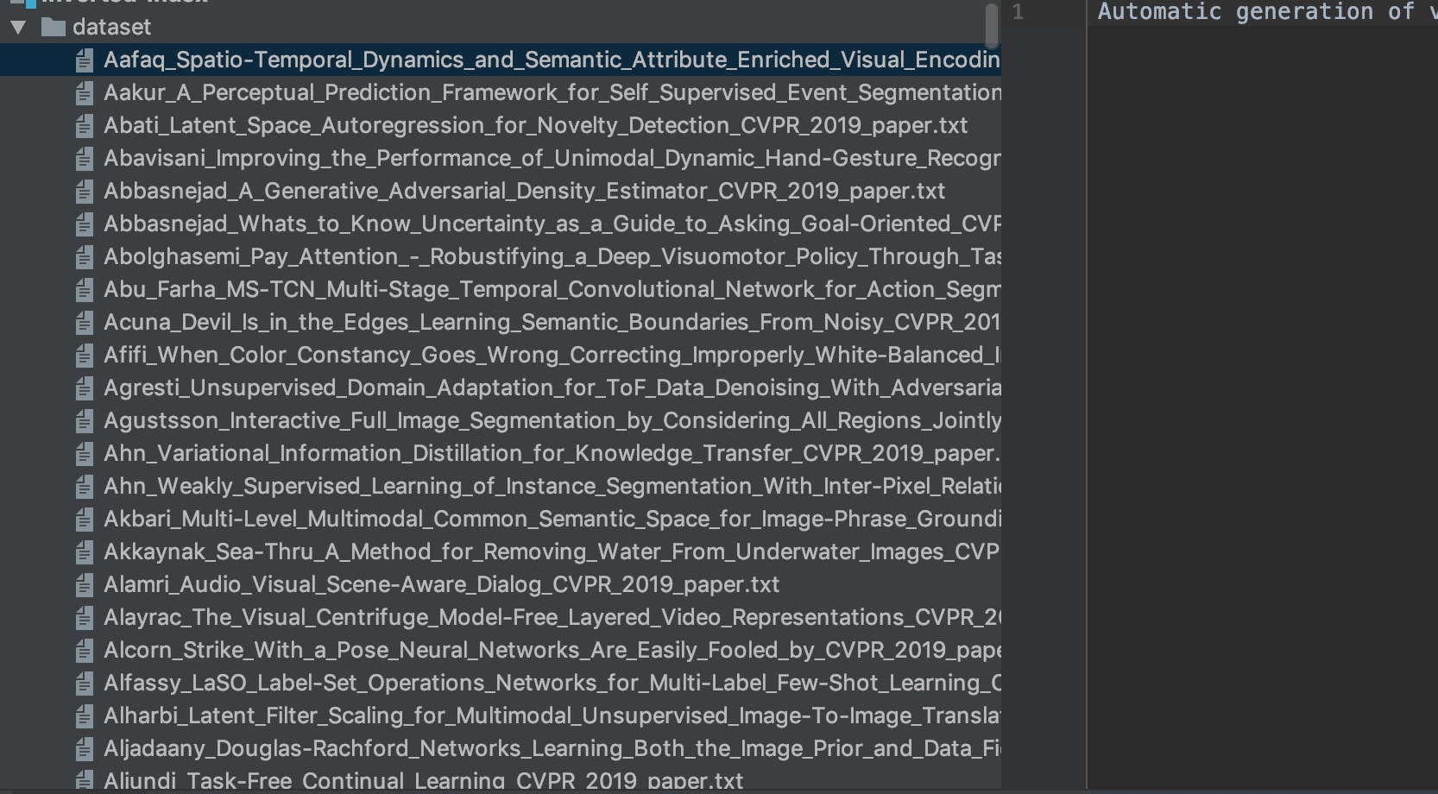
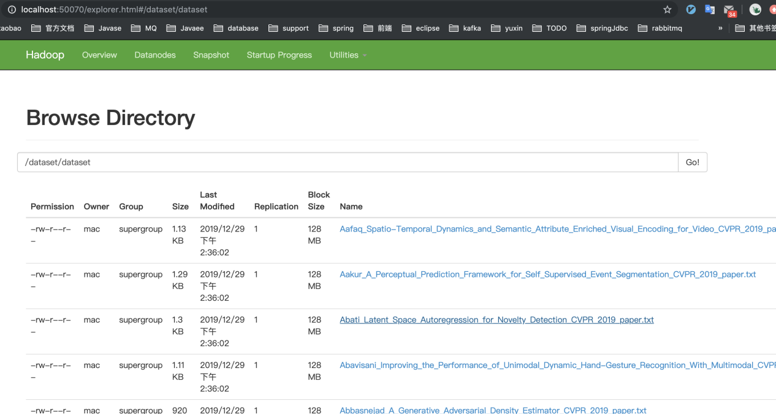
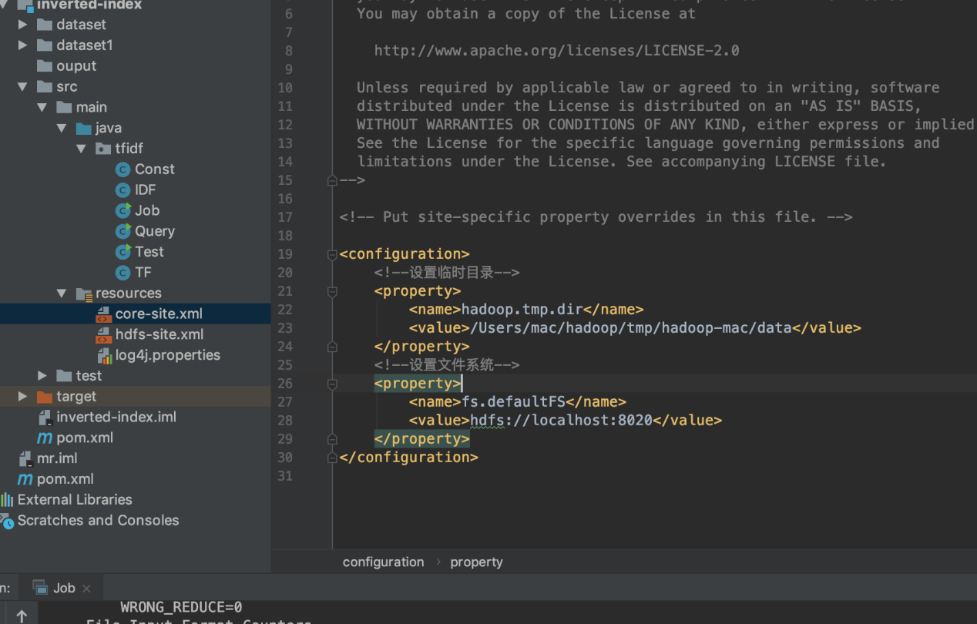

五，运行截图
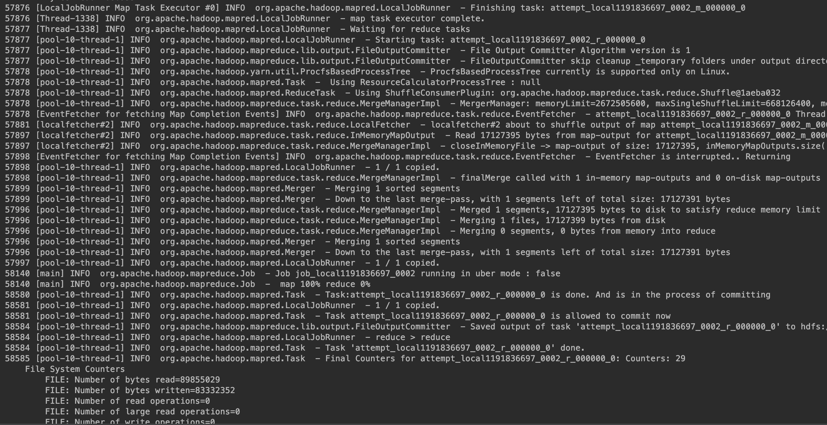

运行结果

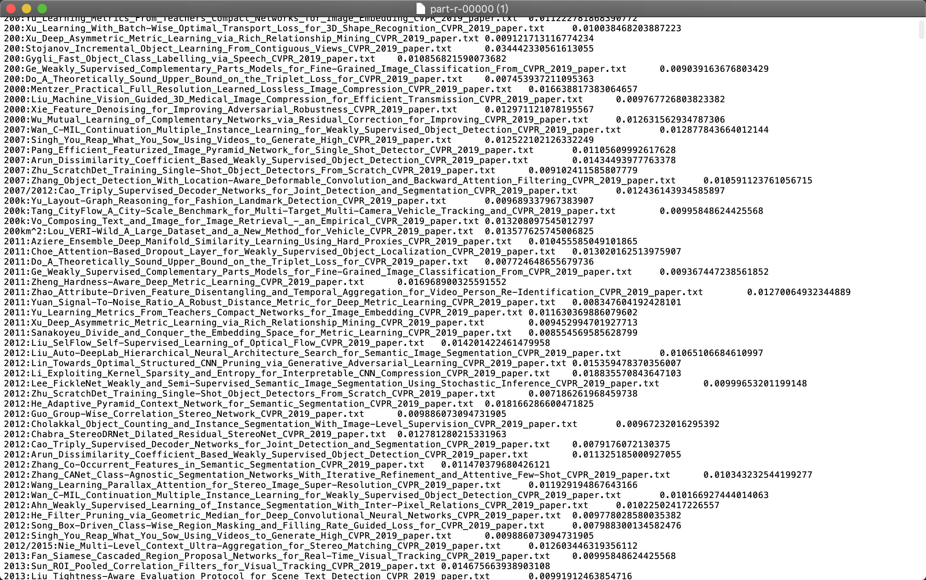

七，实验总结

1、 在动手实现的过程中，先将算法的思想和思路理解清楚，对于后续动手实现有很大帮助。
2、 在实现之前，对于每步要做什么要有概念，然后对于不会实现的部分代码先查找相应的用法，在进行整体编写。
3、 在实现算法后，在寻找数据验证算法的过程中比较困难。作为初学者，对于数据量大的数据的处理存在难度，但数据量的数据很难寻找，所以难以进行实例分析。

