1，启动hadoop组件
Start-all.sh
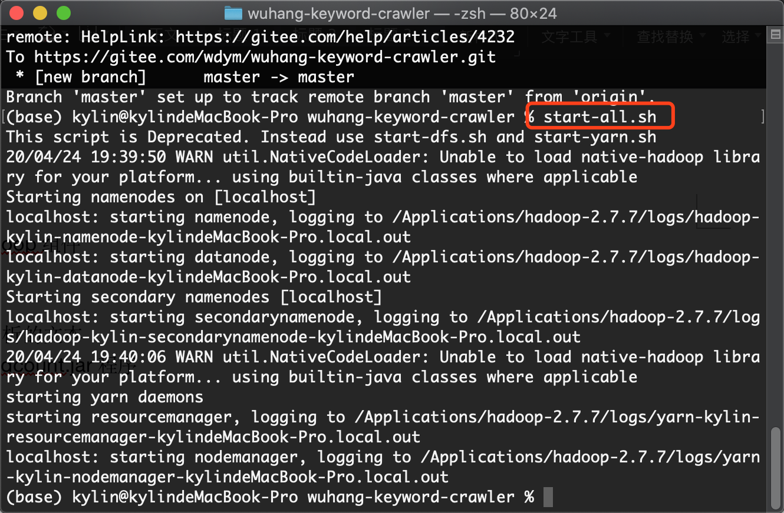

2，导入要分析的文本
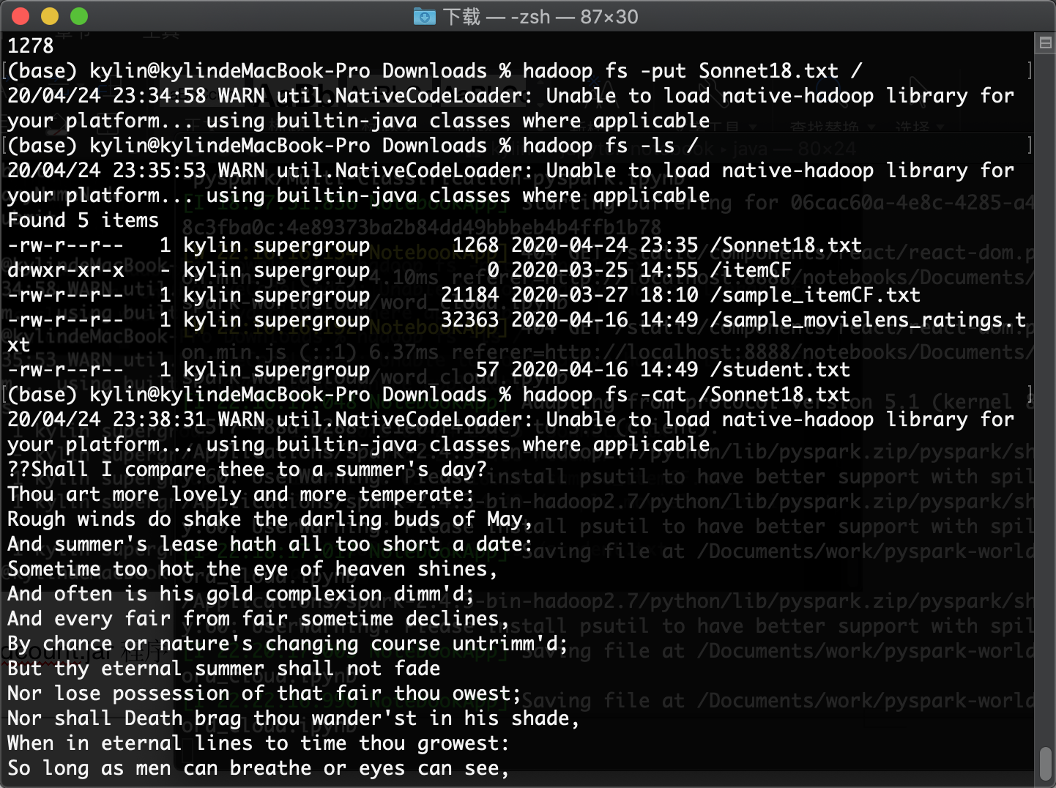

3，运行wordcount.jar程序
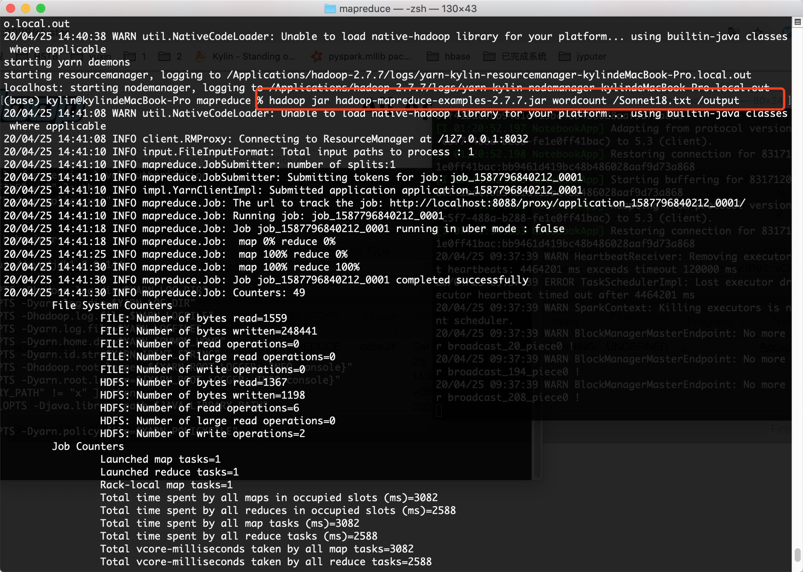

4，查看yarn监控
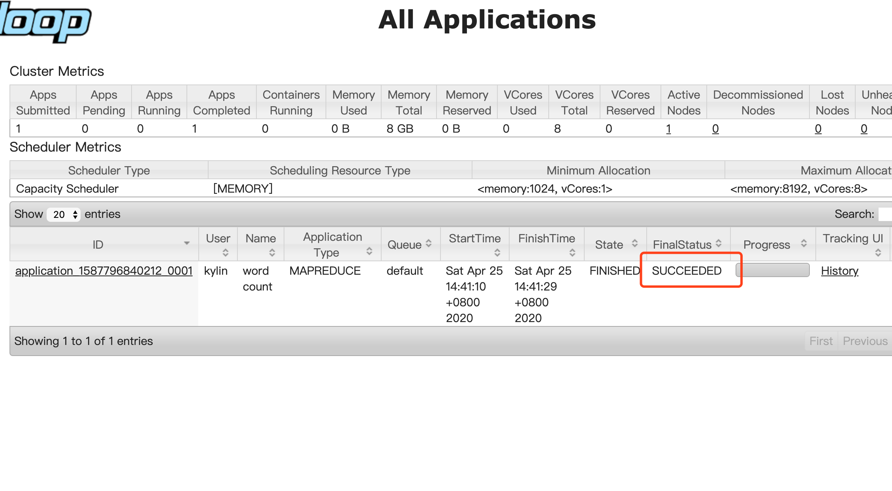
5，查看输出结果
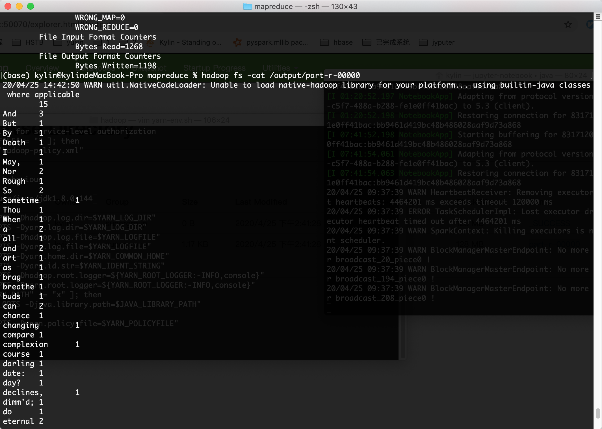
15
And 3
But 1
By 1
Death 1
I 1
May, 1
Nor 2
Rough 1
So 2
Sometime 1
Thou 1
When 1
a 2
all 1
and 2
art 1
as 1
brag 1
breathe 1
buds 1
can 2
chance 1
changing 1
compare 1
complexion 1
course 1
darling 1
date: 1
day? 1
declines, 1
dimm'd; 1
do 1
eternal 2
every 1
eye 1
eyes 1
fade 1
fair 3
from 1
gives 1
gold 1
growest: 1
hath 1
heaven 1
his 2
hot 1
in 2
is 1
lease 1
life 1
lines 1
lives 1
long 2
lose 1
lovely 1
men 1
more 2
nature's 1
not 1
of 3
often 1
or 2
owest; 1
possession 1
see, 1
shade, 1
shake 1
shall 2
shines, 1
short 1
sometime 1
summer 1
summer's 2
temperate: 1
that 1
the 2
thee 1
thee. 1
this 2
thou 3
thy 1
time 1
to 3
too 2
untrimm'd; 1
wander'st 1
winds 1
Shall 1

