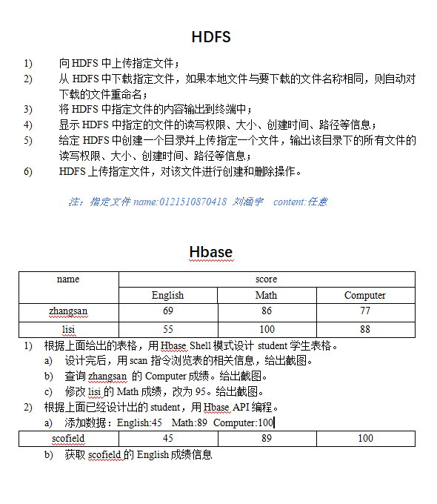

Hdfs
- 向hdfs中上传指定文件；
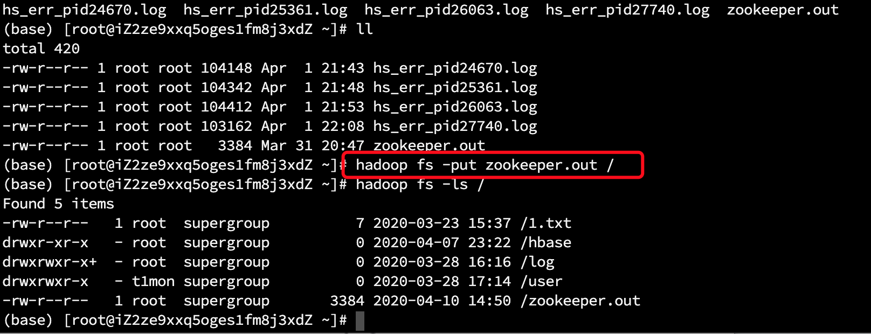
- 从hdfs上下载文件：
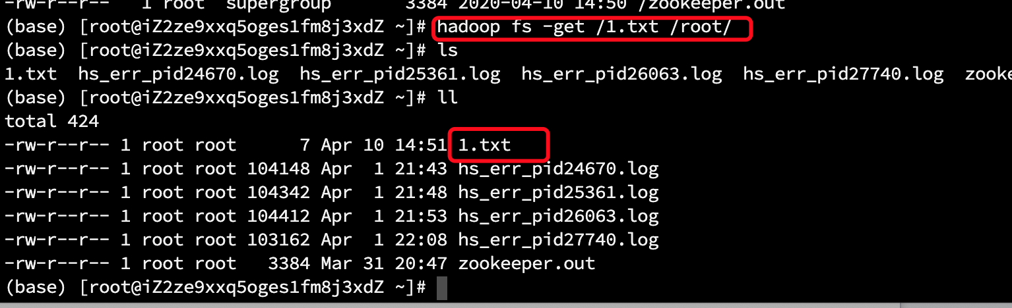
- 将hdfs中指定文件的内容输出到终端中：
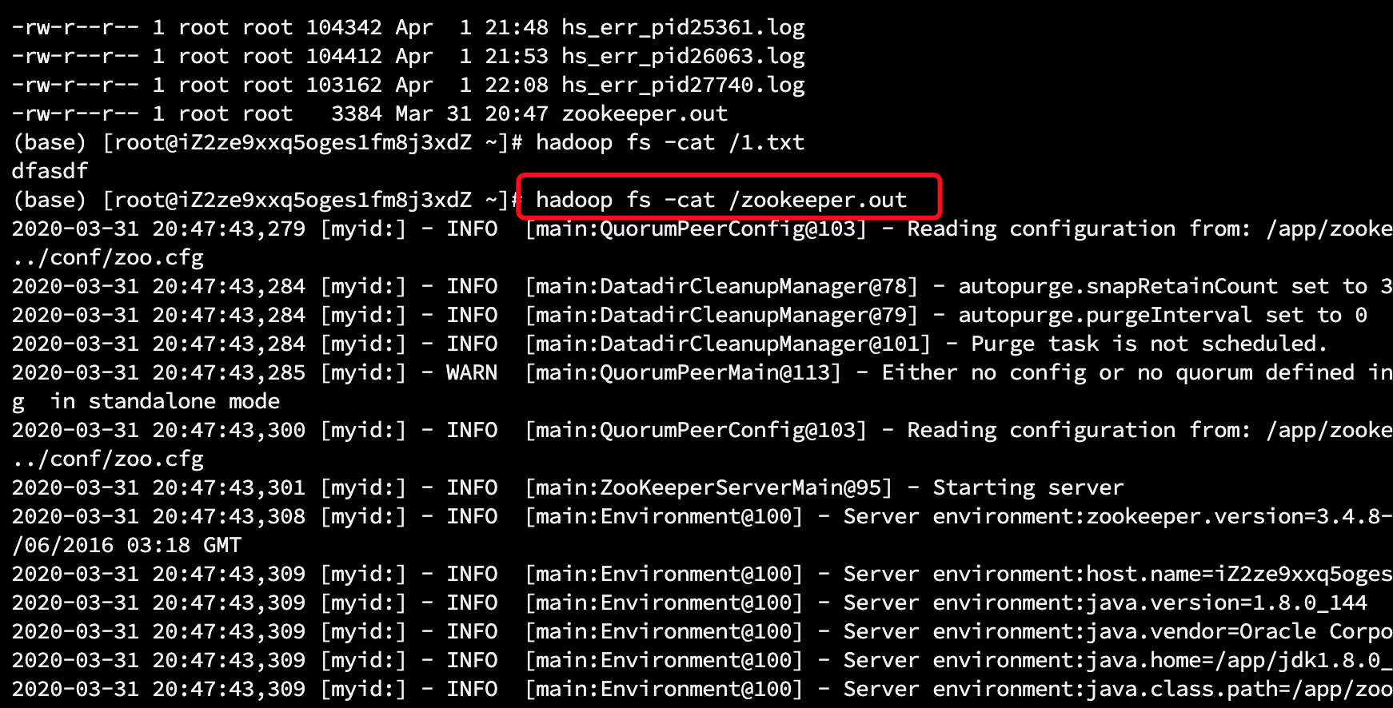
- 显示hdfs中指定的文件的权限等信息：
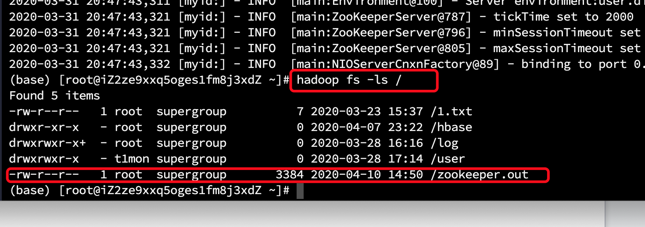
- 创建hdfs目录并上传文件，输入改目录下的文件的权限等信息：
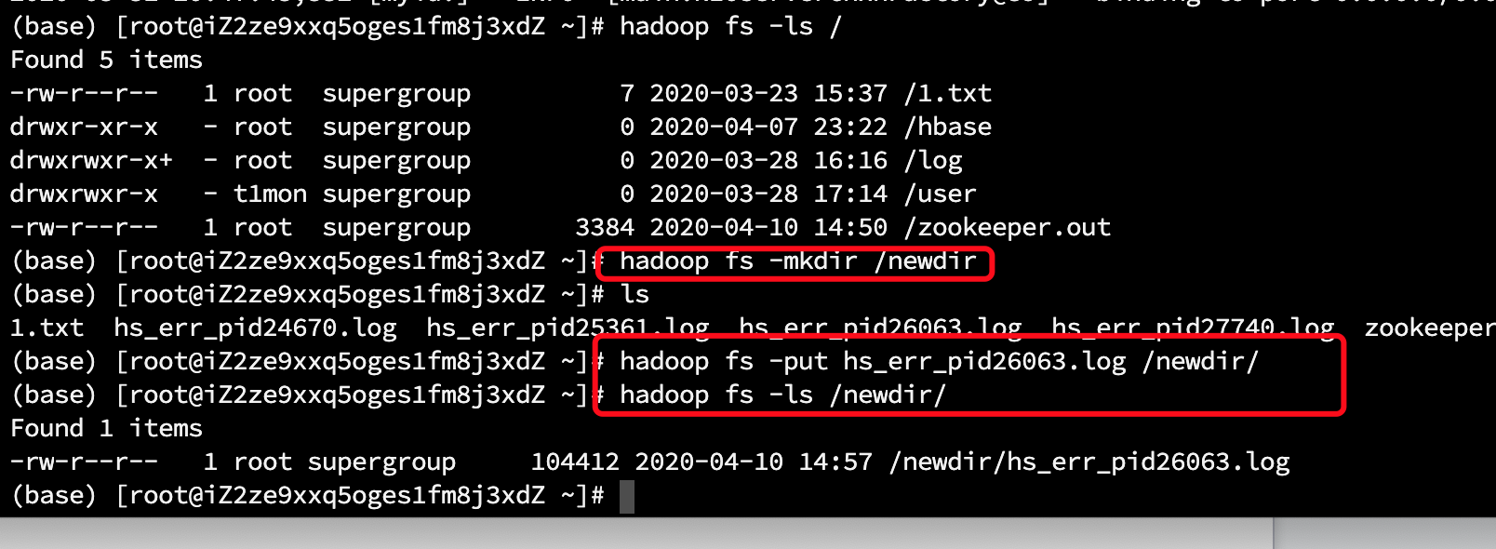
- hdfs文件创建和删除：
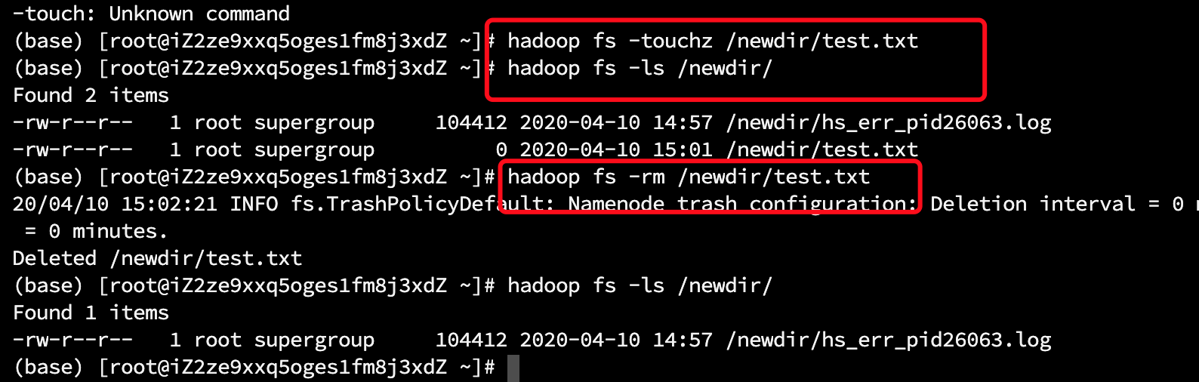

Hbase
- a) create 'student', {NAME=>'name'},{NAME=>'score'}

put 'student', '001','name:name','zhangsan';
put 'student', '001','score:English','69';
put 'student', '001','score:Math','86';
put 'student', '001','score:Computer','77';

put 'student', '002','name:name','lisi';
put 'student', '002','score:English','55';
put 'student', '002','score:Math','100';
put'student','002','score:Computer','88';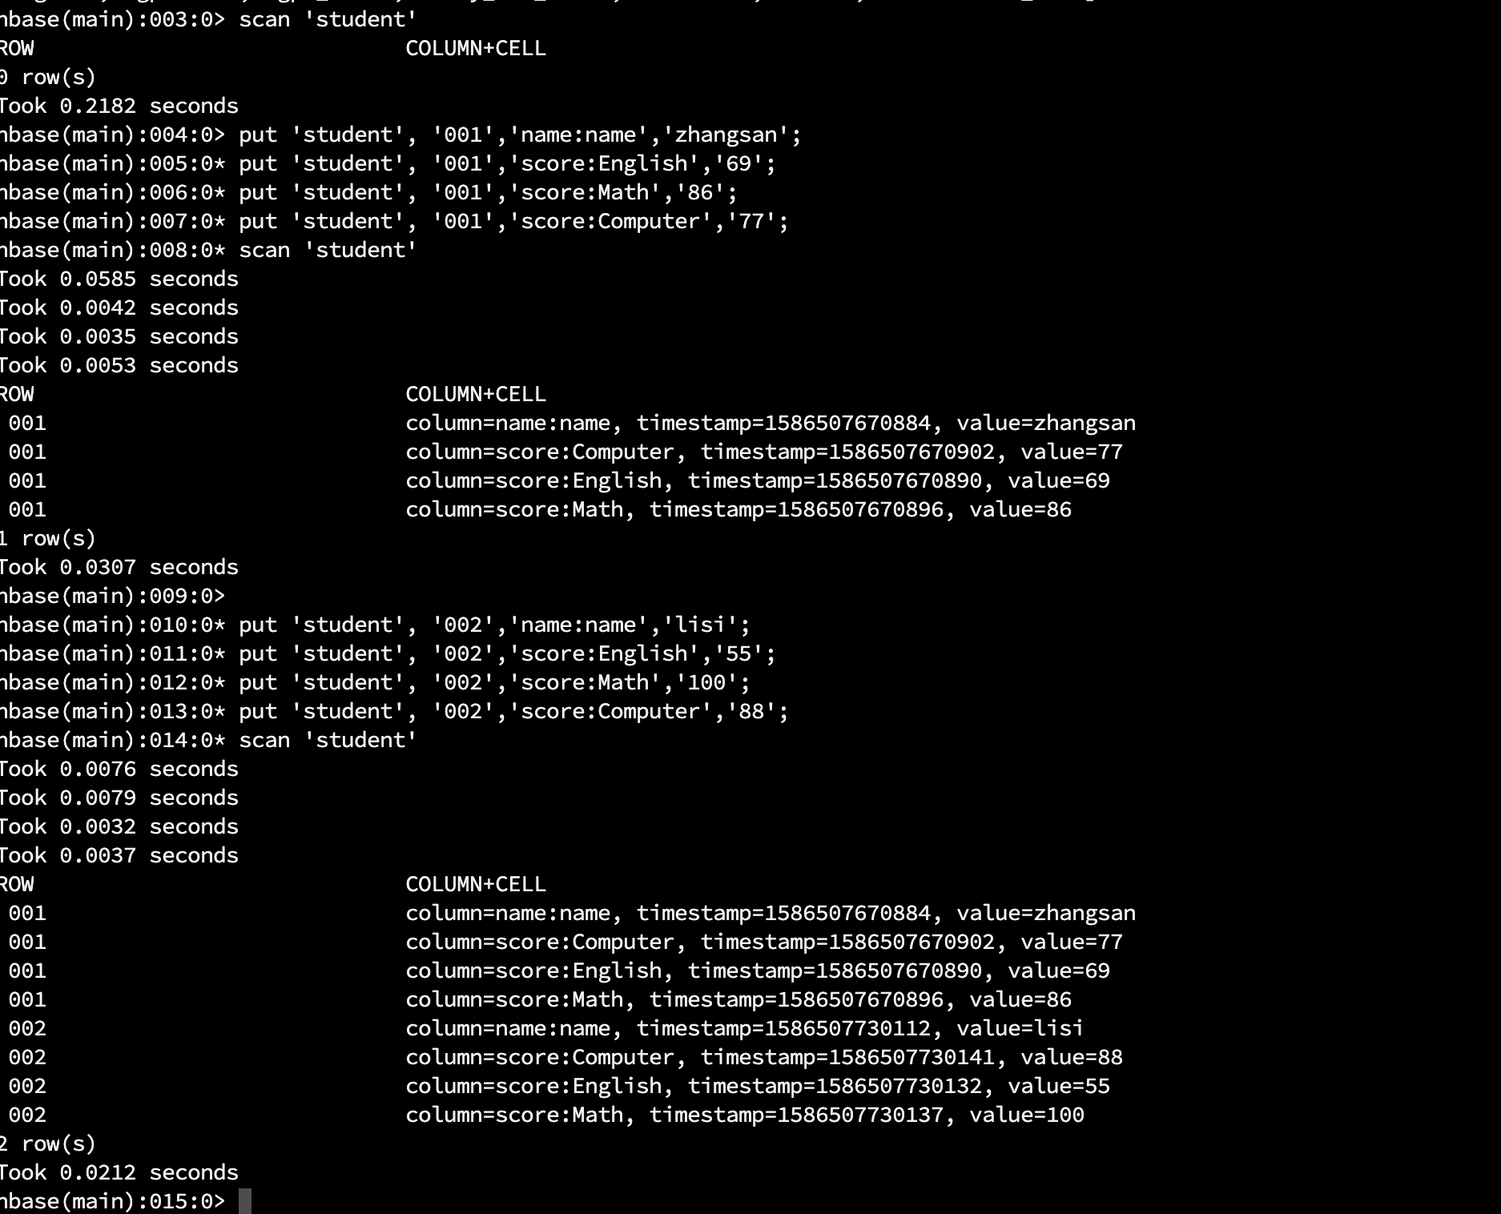

- b)查询zhangsan的信息：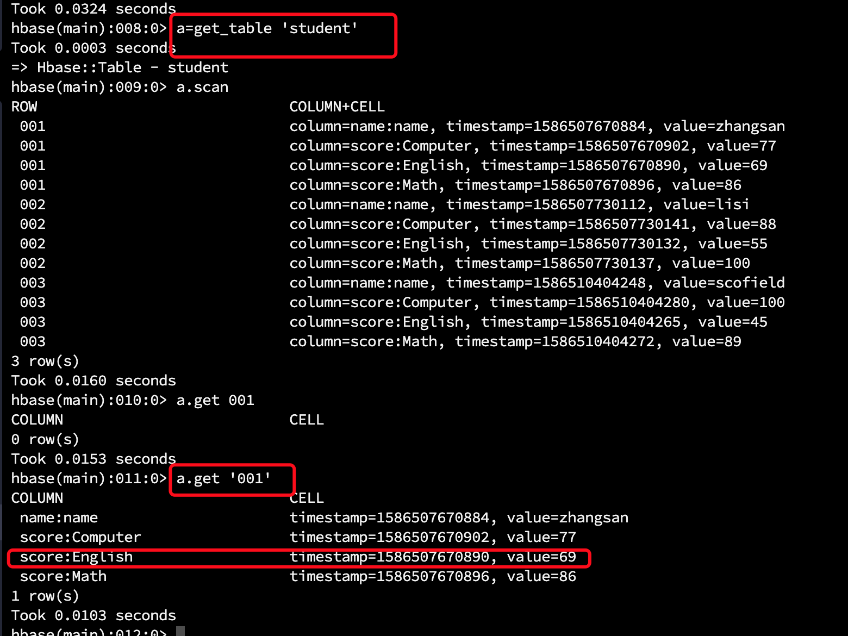
- c）修改lisi的信息
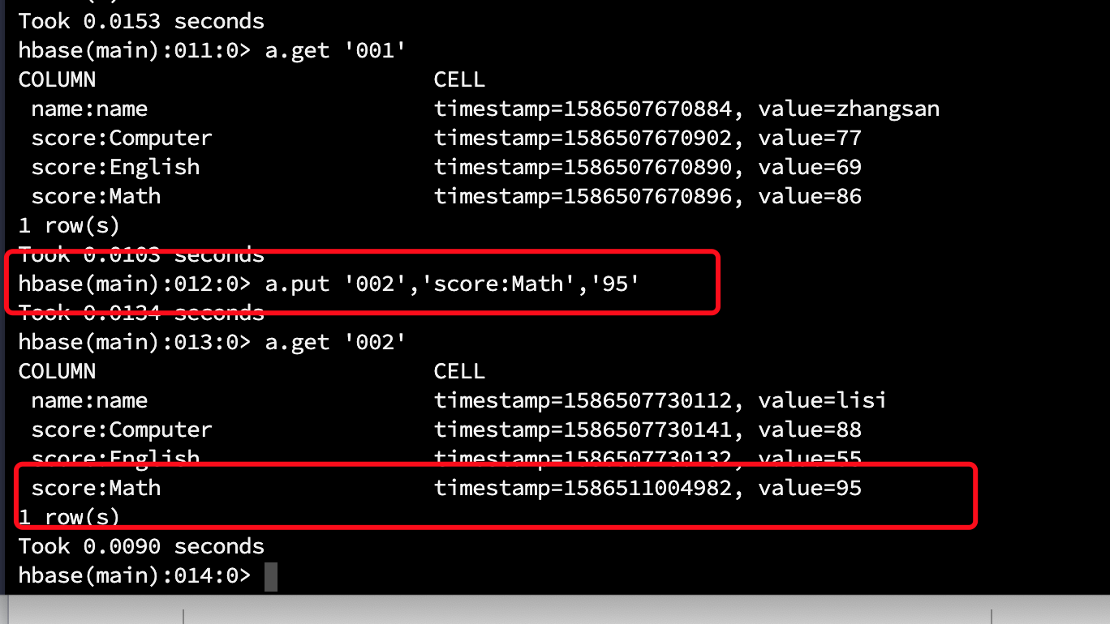

- hbase api方法如下：

最终显示结果：
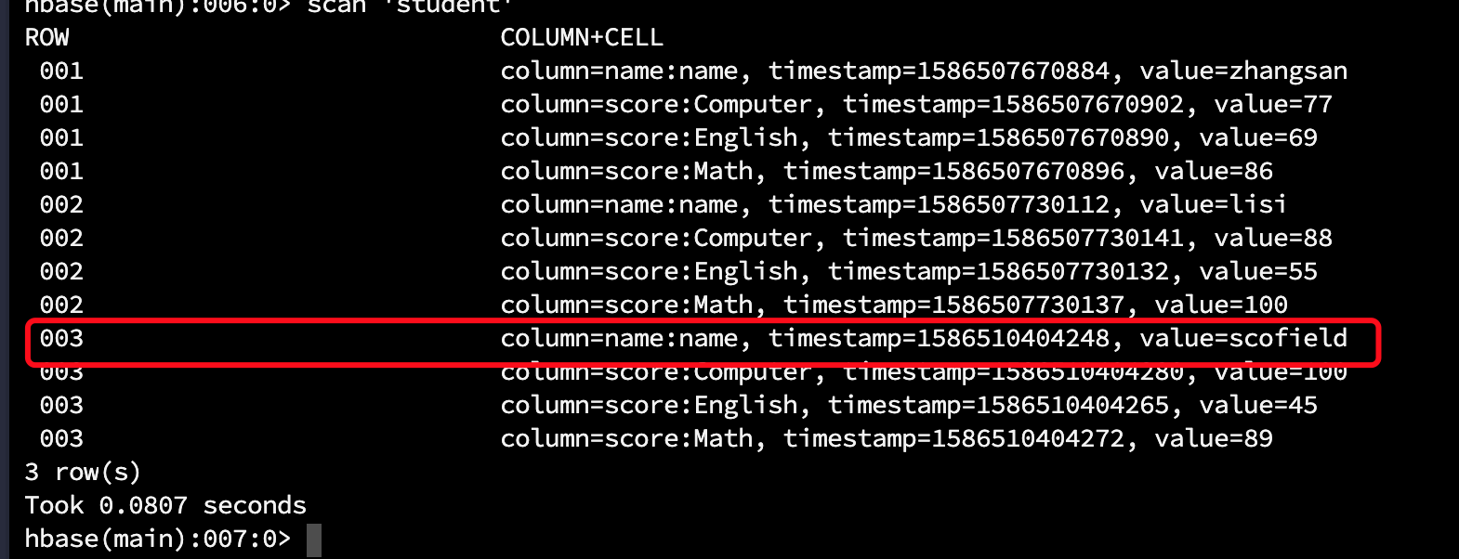
import java.util.List;

import org.apache.hadoop.conf.Configuration;
import org.apache.hadoop.hbase.Cell;
import org.apache.hadoop.hbase.HBaseConfiguration;
import org.apache.hadoop.hbase.HColumnDescriptor;
import org.apache.hadoop.hbase.HTableDescriptor;
import org.apache.hadoop.hbase.KeyValue;
import org.apache.hadoop.hbase.TableName;
import org.apache.hadoop.hbase.client.Delete;
import org.apache.hadoop.hbase.client.Get;
import org.apache.hadoop.hbase.client.HBaseAdmin;
import org.apache.hadoop.hbase.client.HTable;
import org.apache.hadoop.hbase.client.Put;
import org.apache.hadoop.hbase.client.Result;
import org.apache.hadoop.hbase.client.ResultScanner;
import org.apache.hadoop.hbase.client.Scan;
import org.apache.hadoop.hbase.protobuf.generated.ZooKeeperProtos.Table;
import org.apache.hadoop.hbase.util.Bytes;

public class Hbasedome implements HBaseDemoInterface{

static Configuration conf =null;
private static final String ZKconnect="192.168.123.212:2181,192.168.123.213:2181,192.168.123.214:2181";
static{
conf=HBaseConfiguration.create();
conf.set("hbase.zookeeper.quorum", ZKconnect);
}
// static String tableName="student";
// static String[] family={"lie01","lie02"};

public static void main(String[] args) {
Hbasedome a =new Hbasedome();
String tableName="student11";
String[] family={"lie01","lie02"};
try {
HTableDescriptor htds =new HTableDescriptor(tableName);
for(int z=0;z<family.length;z++){
HColumnDescriptor h=new HColumnDescriptor(family[z]);
htds.addFamily(h);
}
// a.descTable("table03");
// a.createTable(tableName, htds);
// a.descTable("table03");
// a.getAllTables();
// a.createTable(tableName,family);
// a.getResult("table03", "usr001");
// a.dropTable("user1");
// a.getAllTables();
// a.putData("table03", "usr005", "liezu01", "name", "liu");
// a.getResult("table03", "usr001");
// a.getResultScann("table03");
// a.getResultScann("table03","");

Result result = a.getResult("table03", "usr001");
System.out.println(result.toString());
List<Cell> cells = result.listCells();
for (int i = 0; i < cells.size(); i++) {
Cell cell = cells.get(i);
System.out.println(cell.toString());
// printCell(cell);
}

// List<KeyValue> list = result.list();
// for (int i = 0; i < list.size(); i++) {
// KeyValue kv = list.get(i);
// printKeyValye(kv);
// }
} catch (Exception e) {
// TODO Auto-generated catch block
e.printStackTrace();
}

}
public static void printKeyValye(KeyValue kv) {
System.out.println(Bytes.toString(kv.getRow()) + "\t" + Bytes.toString(kv.getFamily()) + "\t" + Bytes.toString(kv.getQualifier()) + "\t" + Bytes.toString(kv.getValue()) + "\t" + kv.getTimestamp());
}
public static void printCell(Cell cell) {
System.out.println(Bytes.toString(cell.getRow()) + "\t" + Bytes.toString(cell.getFamily()) + "\t" + Bytes.toString(cell.getQualifier()) + "\t" + Bytes.toString(cell.getValue()) + "\t" + cell.getTimestamp());
}
//创建表
@Override
public void createTable(String tableName, String[] family) throws Exception {
HBaseAdmin admin=new HBaseAdmin(conf);
HTableDescriptor desc =new HTableDescriptor(tableName);

for(int i=0;i<family.length;i++){
desc.addFamily(new HColumnDescriptor(family[i]));
System.out.println("11111111111"+family[i]);
}
if(admin.tableExists(tableName)){
System.out.println("表已经存在，别瞎输行吗");
// System.exit(0);
}else{
admin.createTable(desc);
System.out.println("表创建成功");
}
}

//创建表
@Override
public void createTable(String tableName, HTableDescriptor htds) throws Exception {
HBaseAdmin admin=new HBaseAdmin(conf);
boolean tableExists1 = admin.tableExists(Bytes.toBytes(tableName));
System.out.println(tableExists1 ? "表已存在" : "表不存在");
admin.createTable(htds);
boolean tableExists = admin.tableExists(Bytes.toBytes(tableName));
System.out.println(tableExists ? "创建表成功" : "创建失败");
}

@Override
public void descTable(String tableName) throws Exception {
HBaseAdmin admin=new HBaseAdmin(conf);
HTable table=new HTable(conf, tableName);
HTableDescriptor desc =table.getTableDescriptor();
HColumnDescriptor[] columnFamilies = desc.getColumnFamilies();

for(HColumnDescriptor t:columnFamilies){
System.out.println(Bytes.toString(t.getName()));
}

}

//// 这种方式是替换该表tableName的所有列簇
@Override
public void modifyTable(String tableName) throws Exception {
HBaseAdmin admin=new HBaseAdmin(conf);
HTableDescriptor htd = new HTableDescriptor(TableName.valueOf(tableName));
htd.addFamily(new HColumnDescriptor(Bytes.toBytes("cf3")));
htd.addFamily(new HColumnDescriptor(Bytes.toBytes("cf2")));
admin.modifyTable(tableName, htd);

// 删除该表tableName当中的特定的列簇
// admin.deleteColumn(tableName, "cf3");

System.out.println("修改成功");

}

@Override
public void getAllTables() throws Exception {
HBaseAdmin admin =new HBaseAdmin(conf);

String[] tableNames = admin.getTableNames();
for(int i=0;i<tableNames.length;i++){
System.out.println(tableNames[i]);
}
}

//更新数据 插入数据
@Override
public void putData(String tableName, String rowKey, String familyName, String columnName, String value)
throws Exception {
HTable htable=new HTable(conf, Bytes.toBytes(tableName));
Put put=new Put(Bytes.toBytes(rowKey));
put.add(Bytes.toBytes(familyName), Bytes.toBytes(columnName), Bytes.toBytes(value));
htable.put(put);

}

//为表添加数据
@Override
public void addData(String tableName, String rowKey, String[] column1, String[] value1, String[] column2,
String[] value2) throws Exception {

Put put=new Put(Bytes.toBytes(rowKey));
HTable htable=new HTable(conf, Bytes.toBytes(tableName));
HColumnDescriptor[] columnFamilies = htable.getTableDescriptor().getColumnFamilies();
for(int i=0;i<=columnFamilies.length;i++){
String nameAsString = columnFamilies[i].getNameAsString();
if(nameAsString.equals("lie01")){
for(int j=0;j<column1.length;j++){
put.add(Bytes.toBytes(nameAsString), Bytes.toBytes(column1[j]),Bytes.toBytes(value1[j]));
}
}
if(nameAsString.equals("lie02")){
for(int j=0;j<column2.length;j++){
put.add(Bytes.toBytes(nameAsString), Bytes.toBytes(column2[j]),Bytes.toBytes(value2[j]));
}
}

}
htable.put(put);
System.out.println("addData ok!");
}

//根据rowkey 查询
@Override
public Result getResult(String tableName, String rowKey) throws Exception {
Get get=new Get(Bytes.toBytes(rowKey));
HTable htable=new HTable(conf, Bytes.toBytes(tableName));
Result result=htable.get(get);
// for(KeyValue k:result.list()){
// System.out.println(Bytes.toString(k.getFamily()));
// System.out.println(Bytes.toString(k.getQualifier()));
// System.out.println(Bytes.toString(k.getValue()));
// System.out.println(k.getTimestamp());
// }
return result;
}

//查询指定的某列
@Override
public Result getResult(String tableName, String rowKey, String familyName, String columnName) throws Exception {
Get get=new Get(Bytes.toBytes(rowKey));
HTable htable=new HTable(conf, Bytes.toBytes(tableName));
get.addColumn(Bytes.toBytes(familyName),Bytes.toBytes(columnName));
Result result=htable.get(get);
for(KeyValue k:result.list()){
System.out.println(Bytes.toString(k.getFamily()));
System.out.println(Bytes.toString(k.getQualifier()));
System.out.println(Bytes.toString(k.getValue()));
System.out.println(k.getTimestamp());
}
return result;
}

//遍历查询表
@Override
public ResultScanner getResultScann(String tableName) throws Exception {

Scan scan=new Scan();
ResultScanner rs =null;
HTable htable=new HTable(conf, tableName);
try{
rs=htable.getScanner(scan);
for(Result r: rs){
for(KeyValue kv:r.list()){

System.out.println(Bytes.toString(kv.getRow()));
System.out.println(Bytes.toString(kv.getFamily()));
System.out.println(Bytes.toString(kv.getQualifier()));
System.out.println(Bytes.toString(kv.getValue()));
System.out.println(kv.getTimestamp());
}
}
}finally{
rs.close();
}
return rs;
}

@Override
public ResultScanner getResultScann(String tableName, Scan scan) throws Exception {

ResultScanner rs =null;
HTable htable=new HTable(conf, tableName);
try{
rs=htable.getScanner(scan);
for(Result r: rs){
for(KeyValue kv:r.list()){

System.out.println(Bytes.toString(kv.getRow()));
System.out.println(Bytes.toString(kv.getFamily()));
System.out.println(Bytes.toString(kv.getQualifier()));
System.out.println(Bytes.toString(kv.getValue()));
System.out.println(kv.getTimestamp());
}
}
}finally{
rs.close();
}
return rs;
}

//查询表中的某一列
@Override
public Result getResultByColumn(String tableName, String rowKey, String familyName, String columnName)
throws Exception {

HTable htable=new HTable(conf, tableName);
Get get=new Get(Bytes.toBytes(rowKey));
get.addColumn(Bytes.toBytes(familyName),Bytes.toBytes(columnName));
Result result=htable.get(get);
for(KeyValue kv: result.list()){

System.out.println(Bytes.toString(kv.getFamily()));
System.out.println(Bytes.toString(kv.getQualifier()));
System.out.println(Bytes.toString(kv.getValue()));
System.out.println(kv.getTimestamp());

}
return result;
}

//查询某列数据的某个版本
@Override
public Result getResultByVersion(String tableName, String rowKey, String familyName, String columnName,
int versions) throws Exception {

HTable htable=new HTable(conf, tableName);
Get get =new Get(Bytes.toBytes(rowKey));
get.addColumn(Bytes.toBytes(familyName), Bytes.toBytes(columnName));
get.setMaxVersions(versions);
Result result=htable.get(get);

for(KeyValue kv: result.list()){

System.out.println(Bytes.toString(kv.getFamily()));
System.out.println(Bytes.toString(kv.getQualifier()));
System.out.println(Bytes.toString(kv.getValue()));
System.out.println(kv.getTimestamp());

}

return result;
}

//删除指定某列
@Override
public void deleteColumn(String tableName, String rowKey, String falilyName, String columnName) throws Exception {

HTable htable=new HTable(conf, tableName);
// Delete delete1=new Delete(Bytes.toBytes(rowKey));
Delete de =new Delete(Bytes.toBytes(rowKey));
de.deleteColumn(Bytes.toBytes(falilyName), Bytes.toBytes(columnName));
htable.delete(de);
}

//删除指定的某个rowkey
@Override
public void deleteColumn(String tableName, String rowKey) throws Exception {
HTable htable=new HTable(conf, tableName);

Delete de =new Delete(Bytes.toBytes(rowKey));
htable.delete(de);

}

//让该表失效
@Override
public void disableTable(String tableName) throws Exception {
HBaseAdmin admin=new HBaseAdmin(conf);
admin.disableTable(tableName);

}

//删除表
@Override
public void dropTable(String tableName) throws Exception {

HBaseAdmin admin=new HBaseAdmin(conf);
admin.disableTable(tableName);
admin.deleteTable(tableName);

}

}

