Hdfs操作
- 向hdfs中上传指定文件；
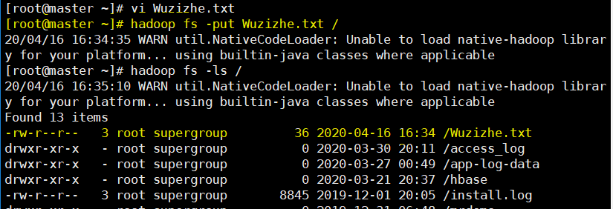

- 从hdfs上下载文件：
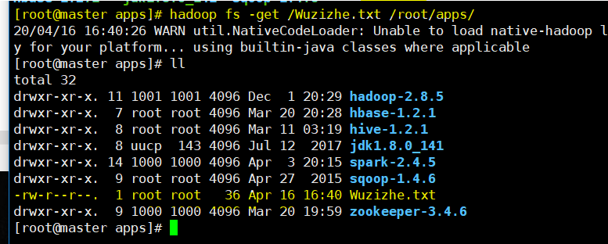
- 将hdfs中指定文件的内容输出到终端中：
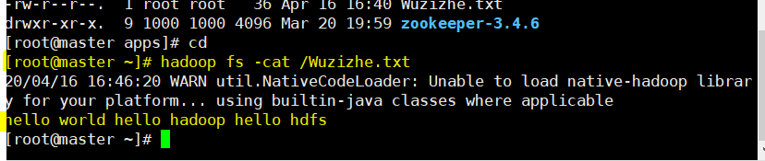
- 显示hdfs中指定的文件的权限等信息：
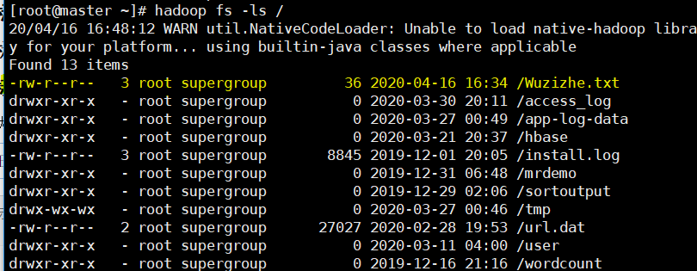
- 创建hdfs目录并上传文件：
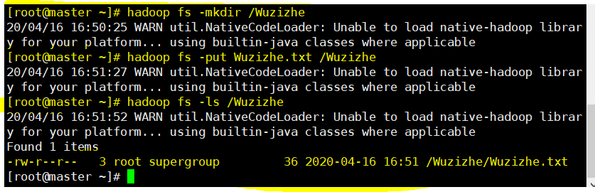
- hdfs文件创建和删除：
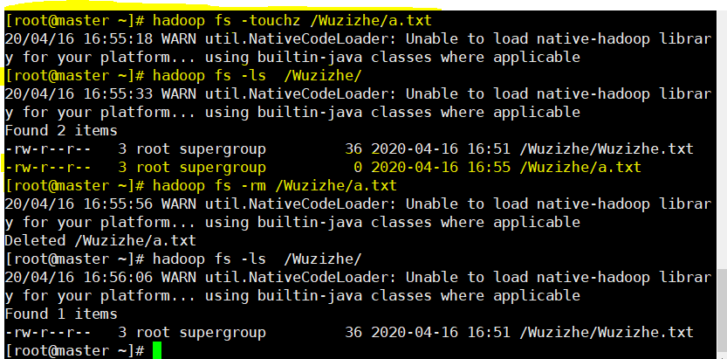

HDFS的java-api操作截图及代码
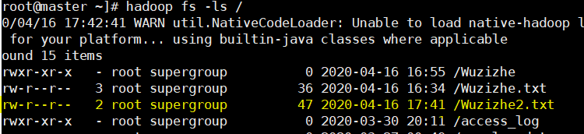

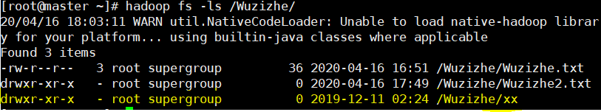
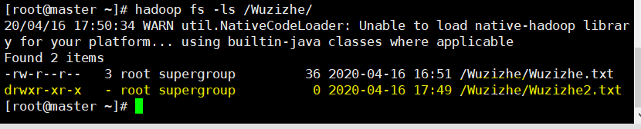
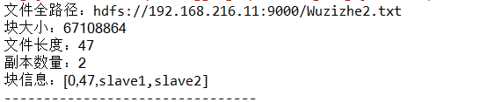
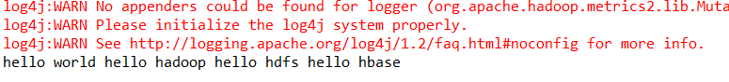

package cn.wuzizhe.hdfs;

import java.io.BufferedReader;
import java.io.FileInputStream;
import java.io.IOException;
import java.io.InputStreamReader;
import java.net.URI;
import java.util.Arrays;
import org.apache.hadoop.conf.Configuration;
import org.apache.hadoop.fs.FSDataInputStream;
import org.apache.hadoop.fs.FSDataOutputStream;
import org.apache.hadoop.fs.FileStatus;
import org.apache.hadoop.fs.FileSystem;
import org.apache.hadoop.fs.LocatedFileStatus;
import org.apache.hadoop.fs.Path;
import org.apache.hadoop.fs.RemoteIterator;
import org.junit.Before;
import org.junit.Test;

public class HdfsDemo {
public static void main(String[] args) throws Exception {

Configuration conf =new Configuration();

conf.set("dfs.replication","2");

conf.set("dfs.blocksize","64m");
FileSystem fs = FileSystem.get(new URI("hdfs://192.168.216.11:9000/"),conf,"root");

fs.copyFromLocalFile(new Path("E:/Wuzizhe2.txt"), new Path("/"));
fs.close();

}

FileSystem fs = null;

@Before
public void init() throws Exception {
Configuration conf = new Configuration();
conf.set("dfs.replication", "2");
conf.set("dfs.blocksize", "64m");

fs = FileSystem.get(new URI("hdfs://192.168.216.11:9000/"), conf, "root");

}

/**
* 从HDFS中下载文件到客户端本地磁盘
*
* @throws IOException
* @throws IllegalArgumentException
*/
@Test
public void testGet() throws IllegalArgumentException, IOException {

fs.copyToLocalFile(new Path("/Wuzizhe2.txt"), new Path("D:/"));
fs.close();

}

/**
* 在hdfs内部移动文件\修改名称
*/
@Test
public void testRename() throws Exception {

fs.rename(new Path("/xx"), new Path("/Wuzizhe"));

fs.close();

}

/**
* 在hdfs中创建文件夹
*/
@Test
public void testMkdir() throws Exception {

fs.mkdirs(new Path("/Wuzizhe/Wuzizhe2.txt"));

fs.close();
}

/**
* 在hdfs中删除文件或文件夹
*/
@Test
public void testRm() throws Exception {

fs.delete(new Path("/Wuzizhe/Wuzizhe2.tx"), true);

fs.close();
}

/**
* 查询hdfs指定目录下的文件信息
*/
@Test
public void testLs() throws Exception {
// 只查询文件的信息,不返回文件夹的信息
RemoteIterator<LocatedFileStatus> iter = fs.listFiles(new Path("/Wuzizhe2.txt"), true);

while (iter.hasNext()) {
LocatedFileStatus status = iter.next();
System.out.println("文件全路径：" + status.getPath());
System.out.println("块大小：" + status.getBlockSize());
System.out.println("文件长度：" + status.getLen());
System.out.println("副本数量：" + status.getReplication());
System.out.println("块信息：" + Arrays.toString(status.getBlockLocations()));

System.out.println("--------------------------------");
}
fs.close();
}

/**
* 读取hdfs中的文件的内容
*
* @throws IOException
* @throws IllegalArgumentException
*/
@Test
public void testReadData() throws IllegalArgumentException, IOException {

FSDataInputStream in = fs.open(new Path("/Wuzizhe2.txt"));

BufferedReader br = new BufferedReader(new InputStreamReader(in, "utf-8"));

String line = null;
while ((line = br.readLine()) != null) {
System.out.println(line);
}

br.close();
in.close();
fs.close();

}

}

