Support information

More data of DMRG and spin wave ground states of the J1-J2-J3-D model
We employed the density matrix renormalization group (DMRG) calculation (ref 6,7) with spin $U(1)$ symmetry to investigate the ground state magnetic properties for the $J_{1}-J_{2}-J_{3}-D$ model on cylinders which have open boundary condition (OBC) along the $x$-direction but periodic boundary conditions (PBC) along the $y$-direction. In figure S1, we show the conventional geometry, XC-cylinder and YC-cylinder, in usual DMRG calculation of honeycomb lattices. Note that both geometries have PBC along the $y$-direction. We keep the bond dimension up to 15000 to obtain reliable results with typical truncation error $ϵ\sim 5×{10}^{-7}$ (for XC6-cylinder) and $ϵ\sim 1×{10}^{-5}$ (for YC6-cylinder). The DMRG ground state in XC6-cylinder produces $\left|\left\langle S_{i}^{z}\right\rangle \right|≃1×{10}^{-5}$ and almost restore the spin inversion symmetry.
Fig. S1 caption:

Here, we give the results of YC6-cylinder as a complement to the results of XC6-cylinder in the main text. Figure S2 (a) shows the in-plane spin correlations in a YC6-cylinder with $L_{x}=12$, where the purple cross is the reference point. The red arrows represent positive valued correlations while the blue arrows represent negative. The spin correlations exhibit zig-zag order along the leg of the cylinder. And in the central half part of the cylinder, the correlations almost do not decay. We also calculate the sublattice structure factor in Fig. S2 (b). The peak occurring at the M-point in the first Brillion zone corroborates the zig-zag order. And it also gives the anti-ferromagnetic magnetization $\sqrt{M^{2}\left(Q\right)}=0.75$, coinciding with magnetization in XC6-cylinder.
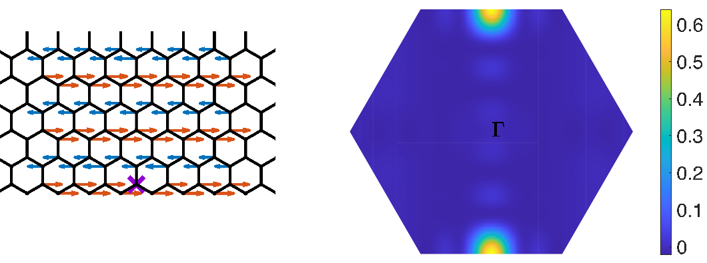
Fig. S2 caption:

Calculation details: classical Monte Carlo simulation
We adopted the Wolff cluster algorithm (2,3) combined with the Metropolis algorithm (1) in our classical Monte Carlo calculation. One Metropolis sweep of the entire spin lattice and 100 Wolff cluster update were done for each measurement. $2×{10}^{5}$ samples were gathered for calculating thermodynamic quantities at a given temperature. And the first half samples were discarded for thermalization.
The BKT transition is determined by the temperature which provides abrupt vanishing of the spin stiffness. (4) Here, the spin stiffness is defined by the second derivative of the free energy with respect to the twist angle about $z$-axis in spin space. The corresponding averaged stiffness $ρ_{s}$ is given by
$$\frac{3\sqrt{3}}{2}L^{2}ρ_{s}=\sum_{i,j}{J_{ij}{\left({\hat{e}}_{ij}⋅\hat{u}\right)}^{2}\left\langle S_{i}^{x}S_{j}^{x}+S_{i}^{y}S_{j}^{y}\right\rangle }-\frac{1}{T}{\left\langle \sum_{i,j}{ J_{ij}\left({\hat{e}}_{ij}⋅\hat{u}\right)\left(S_{i}^{x}S_{j}^{y}-S_{i}^{y}S_{j}^{x}\right)}\right\rangle }^{2},$$
where $L$ is the linear size of the system, $S_{i}^{α}$ is the spin component at site $i$ in the $α$ direction, $T$ is the temperature, ${\hat{e}}_{ij}$ are vectors along interaction bonds, and $\hat{u}$ is the direction of the twist in the lattice. The prefactor in Eq. (1) has been chosen to normalize the stiffness by the lattice area. The expression $⟨O⟩$ denotes the thermal average of the quantity $O$, which can be obtained from the average over configurations generated by a large number of successive MC sweeps.
The standard process to extrapolate the BKT transition temperature is following. The renormalization group calculation predicts a universal jump of the stiffness $ρ_{s}(T_{BKT})$ at transition temperature $T_{BKT}$, with a value of (4)
$$ρ_{s}\left(T_{BKT}\right)=\frac{2T_{BKT}}{π},$$
with a finite size correction (5)
$$ρ_{s}\left(T_{BKT}, L\right)=ρ_{s}\left(T, ∞\right){\left(1+\frac{1}{2\ln{L }+c}\right)}^{2}.$$
Thus, one firstly plots the curves of stiffness and the line of $ρ_{s}=2T/π$ simultaneously. The intersection points give the transition temperature in finite size system $T^{*}(L)$. Then, one fit the linear relationship between $T^{*}(L)$ with ${\left(\ln{L}\right)}^{2}$ and the intercept gives the transition temperature $T_{BKT}$ at infinite size system. We carried out above procedure when finding out the transition temperature of NiPS3 in the main text.

SIA dependence of the transition temperature
In the main text we chose the SIA $D=0.113meV$ which comes from the DFT calculation (cite 8). Different value $D≃1.1meV$ is also suggested in previous molecular-field theory analysis (cite 9). Here, we do a Monte Carlo simulation with D = 0.3meV to find the SIA dependence of the transition temperature. We show the stiffness data in Figure S3. The extrapolated transition temperature is about 143.6K, which is close to the transition temperature 141K at D=0.1meV. We thus conclude that the transition temperature is not sensitive to the value of D.

Reference:
- Metropolis, N.; Rosenbluth, A. W.; Rosenbluth, M. N.; Teller, A. H.; Teller, E. Equation of State Calculations by Fast Computing Machines. J. Chem. Phys. 1953, 21, 1087-1092.
- Wolff, U. Collective Monte Carlo Updating for Spin Systems. Phys. Rev. Lett. 1989, 62, 361–364.
- D’Onorio De Meo, M.; Oh, S. K. Wolff Algorithm and Anisotropic Continuous-Spin Models: An Application to the Spin–van Der Waals Model. Phys. Rev. B 1992, 46, 257–260.
- Daivd R. Nelson and J. M. Kosterlitz, Universal Jump in the Superfluid Density of Two-Dimensional Superfluids, Phys. Rev. Lett. 39, 1201
- H. Weber, P. Minnhagen, Phys. Rev. B 27, (1987) 5986.
- S. R. White, Density matrix formulation for quantum renormalization groups, Phys. Rev. Lett. 69, 2863 (1992)
- S. R. White, Density matrix algorithms for quantum renormalization groups, Phys. Rev. B 48, 10345 (1993)
- Magnetic anisotropy and Magnetic Ordering of Transition-Metal Phosphorus Trisulfides, Tae Yun Kim and Cheol-Hwan Park, Nano Letter 2021, 21, 10114-10121
- Magnetism in the layered transition-metal thiophosphates MPS3 (…), P.A. Joy and S. Vasudevan, PRB 1992

