Support information

**DMRG results of the *J1-J2-J3-D* model on YC6-cylinder**

In order to convince the reader about the zig-zag ground state for the *J1-J2-J3-D* model, we show the results on YC6-cylinder as a complement to those on XC6-cylinder in the main text. Figure S1 (a) shows the in-plane spin correlations in a YC6-cylinder with $L_{x}=12$, where the purple cross is the reference point. The red arrows represent positive correlations, while the blue arrows represent negative ones. The spin correlations exhibit zig-zag order along the legs of the cylinder, and they almost do not decay in the central half of the cylinder. We also calculate the sublattice structure factor in Fig. S1 (b). The peak occurring at the *M*-point in the first Brillion zone confirms the zig-zag order. It gives the anti-ferromagnetic magnetization of $\sqrt{M^{2}\left(Q\right)}=0.75$, close to that on XC6-cylinder.

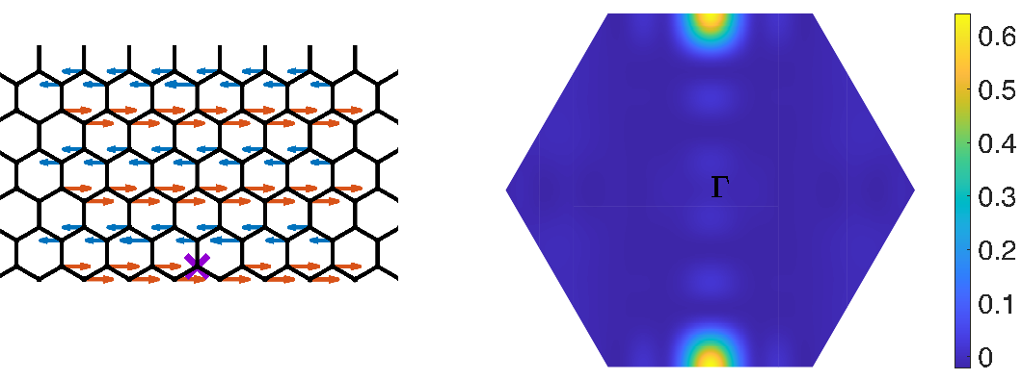

Fig. S1 caption: zig-zag ground state for the *J1-J2-J3-D* model on YC6-cylinder. (a) in-plane spin correlation. (b) sublattice spin structure factor.

**SIA dependence of the transition temperature**

In the main text we choose the SIA $D=0.113meV$ which comes from the DFT calculation (cite 1). Different value $D≃1.1meV$ is also suggested in previous molecular-field theory analysis (cite 2). Here, we perform Monte Carlo simulations with different value of *D* to investigate the SIA dependence of the transition temperature. We show the stiffness data in Figure S2. For $D=0.3 meV$ [Fig. S2 (a)], the transition temperature is about 143.6 K. While for $D=1 meV$ [Fig. S2 (b)], the transition temperature is about 150.1 K. Although *D* increases from 0.1 meV to 1 meV, the transition temperature only increases by about 10 K. We therefore conclude that the transition temperature does not strongly depend on the value of *D*.



Fig. S2 caption: The spin stiffness v.s. temperature for the *J1-J2-J3-D* model with (a) $D=0.3 meV$, (b) $D=1 meV$. The insets: the finite-size extrapolations for the transition temperature.

**Reference:**

1. Magnetic anisotropy and Magnetic Ordering of Transition-Metal Phosphorus Trisulfides, Tae Yun Kim and Cheol-Hwan Park, Nano Letter 2021, 21, 10114-10121
2. Magnetism in the layered transition-metal thiophosphates MPS3 (…), P.A. Joy and S. Vasudevan, PRB 1992