**Appendix**

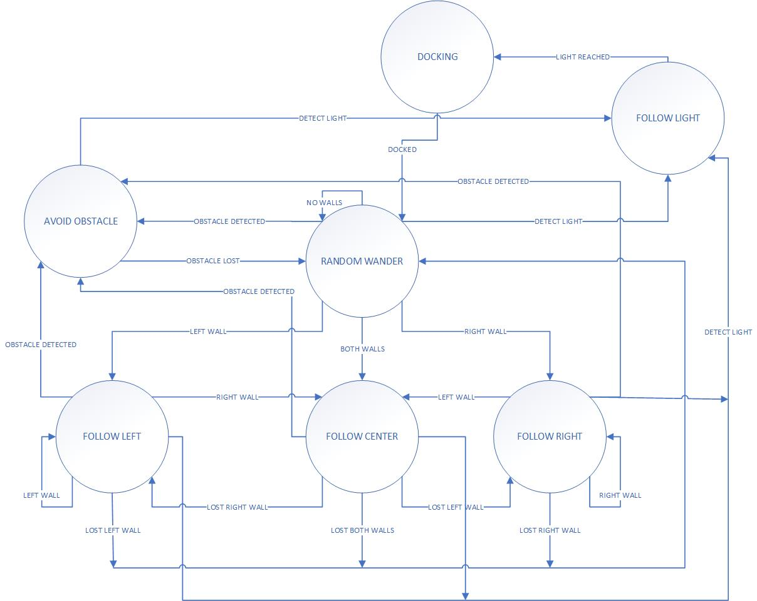

Figure 1: State Machine with wall following, obstacle avoidance, random wander, and light following

Table 1: State Transitions for the State machine

|  |  |  |  |
| --- | --- | --- | --- |
| **State** | **Input** | **Output** | **Next State** |
| Random Wander | No Walls | No Walls | Random Wander |
| Random Wander | Obstacle Lost | Obstacle Detected | Avoid Obstacle |
| Random Wander | Lost Right Wall | Right Wall | Follow Right |
| Random Wander | Lost Left Wall | Left Wall | Follow Left |
| Random Wander | Lost Both Walls | Both Walls | Follow Center |
| Random Wander | Light Reached | Light Detected | Follow Light |
| Avoid Obstacle | Obstacle Detected | Obstacle Lost | Random Wander |
| Avoid Obstacle |  | Light Detected | Follow Light |
| Follow Left | Left Wall | Left Wall | Follow Left |
| Follow Left | Left Wall | Lost Left Wall | Random Wander |
| Follow Left | Lost Right Wall | Right Wall | Follow Center |
| Follow Left |  | Obstacle Detected | Avoid Obstacle |
| Follow Left |  | Light Detected | Follow Light |
| Follow Right | Right Wall | Right Wall | Follow Right |
| Follow Right | Right Wall | Lost Right Wall | Random Wander |
| Follow Right | Lost Left Wall | Left Wall | Follow Center |
| Follow Right |  | Obstacle Detected | Avoid Obstacle |
| Follow Right |  | Light Detected | Follow Light |
| Follow Center | Both Walls | Lost Both Walls | Random Wander |
| Follow Center | Right Wall | Lost Right Wall | Follow Left |
| Follow Center | Left Wall | Lost Left Wall | Follow Right |
| Follow Center |  | Obstacle Detected | Avoid Obstacle |
| Follow Center |  | Light Detected | Follow Light |
| Follow Light | Light Detected | Light Reached | Random Wander |
| Docking | Light Reached | Docked | Random Wander |

Table 2: Photoresistor values in different conditions

|  |  |  |
| --- | --- | --- |
| Conditions | Left Photoresistor (V) | Right Photoresistor (V) |
| Ambient light on the table | 870 | 925 |
| Ambient light under the table | 610 | 770 |
| Sensor covered | 170 | 120 |
| In front of a flashlight or cell phone light | 1010 | 1015 |

Table 3: Photoresistor values in different conditions and different lengths

|  |  |  |  |  |  |  |  |
| --- | --- | --- | --- | --- | --- | --- | --- |
|  |  | Left Photoresistor (V) | | | Right Photoresistor (V) | | |
| Environment | Distance (in) | Angle of Incidence  -45 deg | Angle of Incidence 0 deg | Angle of Incidence +45 deg | Angle of Incidence  -45 deg | Angle of Incidence 0 deg | Angle of Incidence +45 deg |
| On the table | 6 | 940 | 915 | 905 | 935 | 945 | 965 |
| On the table | 12 | 895 | 890 | 900 | 925 | 930 | 945 |
| On the table | 18 | 880 | 880 | 895 | 925 | 925 | 940 |
| On the table | 24 | 870 | 875 | 890 | 925 | 923 | 935 |
| On the table | 30 | 870 | 875 | 890 | 920 | 920 | 935 |
| Under the table | 6 | 920 | 875 | 815 | 895 | 925 | 945 |
| Under the table | 12 | 845 | 795 | 765 | 885 | 880 | 885 |
| Under the table | 18 | 805 | 735 | 730 | 875 | 845 | 850 |
| Under the table | 24 | 785 | 695 | 710 | 875 | 825 | 825 |
| Under the table | 30 | 775 | 670 | 690 | 870 | 810 | 810 |