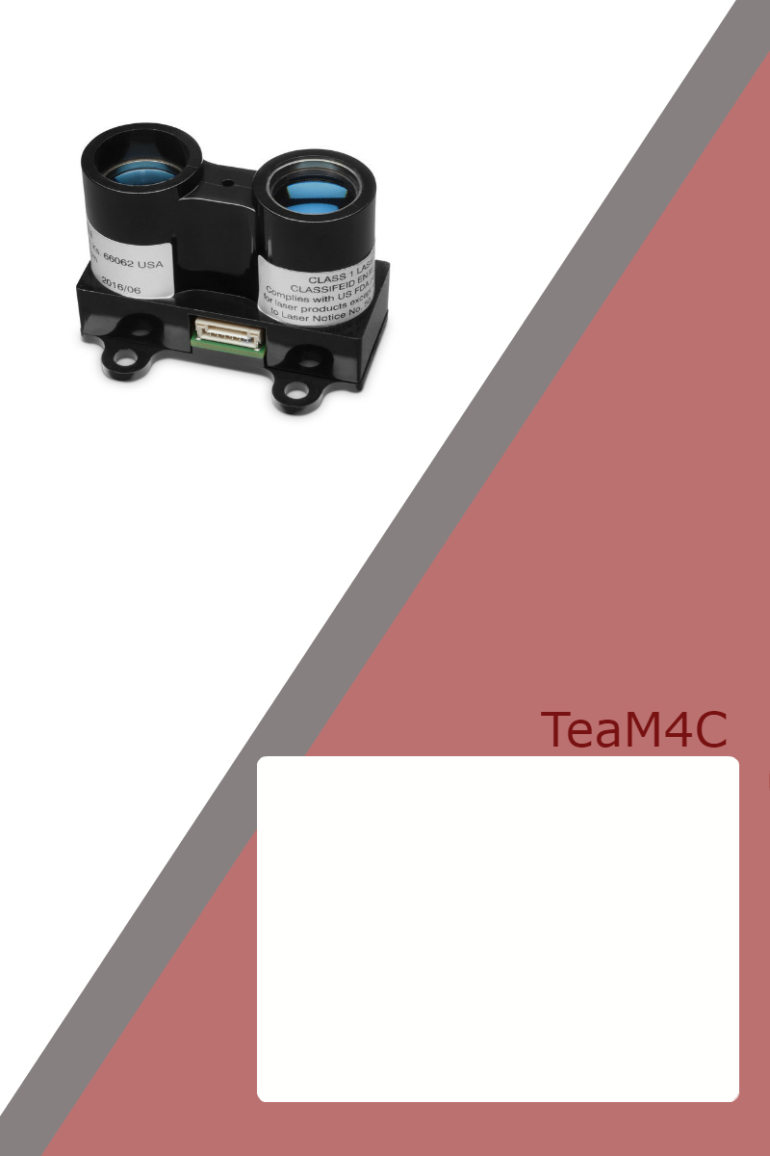

©Copyright 2018, TeaM4C – All rights reserved.

The contents of this document may not be reproduced in whole or in part without the written consent of the copyright owner.



Table of Contents 2

Acronyms and Abbreviations 3

Reference Documentation 4

Safety Instructions 5

TBA

.

.

.



TBA



The following documents form part of this specification. In the event of a conflict between documents referenced herein and the contents of this specification, the contents of this specification shall be considered a superseding requirement.

TBA

.

.

.

<Insert topics here>

Note: Headers are generated in the following website:

Pixlr.com/editor

The headers use the following:

canvas size : 600x60

background color: RGB Hex code: 9c3232

Text font/style: 35 – Century Gothic