CS 388: High Performance Computer Architecture
Final Project: A comparison of two division algorithms
Krystal Thomason, Michael Wisley, Jay-R Studer, Nathan Jarus

November 26, 2012
CS 388
Dr. Ali Hurson
Introduction
The objective of this project was to simulate two divider algorithms, Divisor Reciprocation and Multiplicative Division, and compare their time cost over various different dividend and divisor lengths. Both algorithms use add and multiple as part of their algorithms. Each algorithm used the same add and multiple function to ensure the cost results are comparable. This report will detail which fast adder and fast multiple algorithms were used and why. This project also assumed some standard delays shown in table 1.

Object | Delay
Basic Gate | Δt
Full adder | 4*Δt
2's Comp | n₁*Δt

Fast Adder
The fast adder chosen in this project was Carry Look Ahead Scheme 2. It was not implemented in code as directly as it could have been, but the time cost was used. This scheme was used since it had a relatively low time cost. The time delay for the CLA 2 was (4*(n/4) + 1)Δt. Each CLA 2 module takes 5Δt to run, but there is an overlap of 1Δt.

Fast Multiple
The fast multiple algorithm chosen for this project was the full adder tree. It was decided this was the simplest to implement in C++ and still had a fairly short time cost. The full adder tree has a time cost of 4Δt*log₂(n)+(n-1)*4Δt. There are log₂(n) stages for the multiple, each stage takes 4Δt. It must process each column, but it can do so in a pipeline fashion so each additional column takes another 4Δt. The algorithm starts by making a matrix of summands. The columns of this are then run through the full adder tree. Each level of the tree has half of the full adders as it did in the previous level. The tree calculates each of the bit positions of the result in a pipeline fashion. Our of all the fast multiple algorithms this was the simplest to simulate in C++ while still keeping as close to the algorithm as possible. There was only one multiple function written for both divider algorithms to ensure that timing of both methods was comparable.
Divisor Reciprocation
The Divisor Reciprocation function is an iterative method that generates the reciprocal of the divisor. The reciprocal of the divisor is then multiplied by the dividend to find the quotient. The divisor must be a positive, normalized number. The starting value of for the divisor reciprocal (X_{o}) is computed from a logic circuit or looked found up in table. Then an iterative cycle uses the equations in table 2 to generate the X_{n} required. This method requires a relative error as a stopping criteria to determine the number of iterations (n) to cycle through.

Table 2: Equations
a_{o} =Bx_{o}
x_{n+1}=x_{n} (2- a_{n} )
a_{n+1}=a_{n} (2- a_{n} )

The simulation results are shown below in the chart. There is a corner case that has not been completely work out in the Divisor Reciprocation algorithm. This caused a error in the data and yielded an incorrect quotient when dividing due to an overflow condition. This error could not be corrected at this time, but may be able to be corrected at a future date. The cost values given are reasonable and steady increase with and increase in the number of bits in the divisor. This is to be expected.
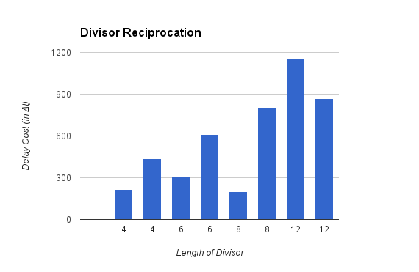
There is a larger variation in the cost when comparing two sets of equations with the same number of bits. This lead to the question if this would be a good method to use in a processor since the time required to generate a quotient. This is to be expected from this algorithm however; since the Divisor Reciprocation algorithm since a proper lookup table was not used. Having a proper lookup table would be essential in using this algorithm in practical application since uniformity would be a desirable trait for high system utilization.
Multiplicative Division
The implementation of the multiplicative division began with an initial F value (F₀) close to one. It was found that choosing an F₀ that was slightly less than one prevented issues with zero padding and truncation. The algorithm began a loop that brought the value of B, the denominator, close to one. It was assumed that the simulated hardware was capable of doing two multiplication operations in parallel. As such, the cost of each iteration increase by a maximum cost of a multiplication. The time required for the longest multiplication was used as the cost when operations were done in parallel. Each multiplication operation resulted in a value that had twice as many bits as the longer of the two operands. It was assumed that the simulator had a limited number of bits to store values. As such, the result of each multiplication operation is truncated to the size of the dividend. At the end of each loop, the next F_{i} value was calculated. This was done by performing a 2’s complement of the recently calculated B_{i} value. The cost of the two’s complement operation is included in the cost of the division algorithm.

The results from the Multiplicative Division algorithm are charted below. The values were within a range of what was expected. The delay cost increase as the bit length increase. The cost when comparing equal bit lengths was very consistent. This is to be expected since there are no look up values required and that the stopping criteria is standard. This would be a good algorithm to use in a practical application since it has a narrow range expected time cost.
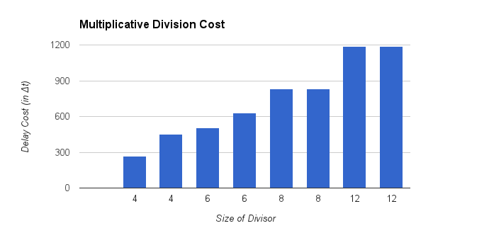
Comparison
The results from both division algorithms were charted together on the chart before for a more direct comparison. The Divisor Reciprocation method time cost was shorter in every case, but less uniform in time cost values. This raise the question which algorithm would be the best to use. This question can not be accurately answered at this time. More combinations need to be run and the small error in the Divisor Reciprocation method need to be corrected. As they stand now, the Multiplicative Divisor would be the best choice as it only takes slightly more time in most cases and it is more uniform. This uniformity allows for the calculation of the penalties involving data hazards. In Divisor Reciprocation method, the penalties can be calculated, but there would be less utilization of time and hardware due to the larger variation in time cost.
