**IQ PREDICTION USING FACE FEATURES**

A project report submitted for prefinal year of

### Bachelor of Technology

in

**Computer Science and Engineering**

By

Bhavani (N150469)

Devi (N150270)

Bhargav (N150200)

*Under the Supervision of*

# Mrs.V.Pavani

**Computer Science and Engineering**



##### Department of Computer Science Engineering

**Rajiv Gandhi University of Knowledge Technologies – Nuzvid ,Nuzvid, Krishna – 521202**

**RAJIV GANDHI UNIVERSITY OF KNOWLEDGE TECHNOLOGIES**

**(A.P. Government Act 18 of 2008) RGUKT- NUZVID, Krishna Dist - 521202**

TeleFax: 08656 – 235557/235150

**CERTIFICATE OF COMPLETION**

This is to certify that the work entitled, “**IQ Prediction**” is the bonafied work of **R.N.V.S.L.Bhavani,*IDNo:N150469,G.Devi,IDNo:N150270,M.BhargavSai,IDNo:N150200*** carried out under my guidance and supervision for pre final year project of **Bachelor of Technology** in the department of **Computer Science and Engineering** under RGUKT IIIT Nuzvid. This work is done during the academic session August – November, under our guidance.

---------------------------- ---------------------------

**Mrs.V.Pavani Mr. Upendar**

Project Supervisor Head of Department

Lecturer,Dept. of CSE Assistant Professor Dept. of CSE RGUKT IIIT Nuzvid. RGUKT IIIT Nuzvid.

##### RAJIV GANDHI UNIVERSITY OF KNOWLEDGE TECHNOLOGIES

**(A.P. Government Act 18 of 2008) RGUKT-NUZVID,**

**Krishna Dist - 521202**

Tele Fax : 08656 – 235557/235150

**CERTIFICATE OF EXAMINATION**

This is to certify that the work entitled, “**IQ Prediction”** is the bonafide work of

**R.N.V.S.L.Bhavani,*IDNo:N150469, G.Devi, IDNo:N150270, M.BhargavSai,IDNo:N150200*** and here by accord our approval of it as a study carried out and presented in a manner required for its acceptance in pre final year of **Bachelor of Technology** for which it has been submitted. This approval does not necessarily endorse or accept every statement made, opinion expressed or conclusion drawn, as a recorded in this thesis. It only signifies the acceptance of this thesis for the purpose for which it has been submitted.

---------------------------- ---------------------------

#### Mrs.V.Pavani Examiner

Project Supervisor Project Examiner

Lecturer Dept. of CSE Lecturer Dept. of CSE RGUKT IIIT Nuzvid. RGUKT IIIT Nuzvid.

##### RAJIV GANDHI UNIVERSITY OF KNOWLEDGE TECHNOLOGIES

**(A.P. Government Act 18 of 2008) RGUKT-NUZVID, Krishna Dist - 521202** Tele Fax: 08656 – 235557/235150

**DECLARATION**

We,**R.N.V.S.L.Bhavani,*IDNo:N150469,G.Devi,IDNo:N150270,M.BhargavSai,IDNo:N150200*** hereby declare that the project report entitle “**IQ Prediction”** done by us under the guidance of **Mrs.V.Pavani** is submitted for pre final year of **Bachelor of Technology** in **Computer Science and Engineering** the academic session August 2019 to November 2019 at RGUKT – Nuzvid.

We also declare that this project is a result of our own effort and has not been copied or imitated from any source. Citations from any websites are mentioned in the references.

The results embodied in this project report have not been submitted to any other university or institute for the award of any degree or diploma.

**Date:18-11-2019 R. Bhavani [N150469]**

**G. Devi [N150270]**

**Place: Nuzvid M. Bhargav[N150200]**

**ACKNOWLEDGMENT**

We would like to express our profound gratitude and deep regards to my guide ***Mrs.V.Pavani*** for her exemplary guidance, monitoring and constant encouragement throughout the course of this thesis.

We are extremely grateful for the confidence bestowed in us and entrusting our project entitled “IQ Prediction from face features”.

At this juncture we feel deeply honored in expressing our sincere thanks to her for making the resources available at right time and providing valuable insights leading to the successful completion of our project.

We would like to thank RGUKT Nuzvid Director, faculty and staff for their valuable suggestions and discussions.

Last but not least I thank almighty,and I place a deep sense of gratitude to my family members and my friends who have been constant source of information during the preparation of this project work.

R Bhavani

G Devi

M Bhargav

**ABSTRACT**

The project primary objective is to determine the Intelligent Quotient (IQ) of a person using face features. This system is useful to predict the IQ of a person by inputting his/her image to a well-trained model by a considerable data set. First, we conducted an IQ test to group of people,then we captured the faces of those people and labeled them according to their IQ range. In this process we trained our model. As per our research, no existing models have the features to predict the IQ using face features.

**CONTENTS**

1. Introduction………………………………

1.1 Introduction

2. Requirements…………………………….

* 1. Project Domain
  2. Packages used

##### 3. Procedure………………………………..

* 1. IQ Test
  2. Data Collection (Face Images)
  3. Code
  4. Output
  5. Applications

**4. Conclusion and Future Scope……………………………………….**

**CHAPTER 1**

## INTRODUCTION

* 1. **What is IQ ?**

An **intelligence quotient** (**IQ**) is a total score derived from several standardized tests designed to assess human intelligence.

* 1. **How to calculate IQ ?**

The equation used to **calculate** a person's **IQ** score is **Mental Age /**

**Chronological Age x 100**. Mental Age means based on the IQ test we will assign some age

to that person. Chronological Age means the actual age of the person.

* 1. **PROBLEM**

Can we predict IQ of a person by insight of him? Generally it is very difficult to

calculate the person IQ by seeing the person. How can we predict the IQ of a person from

his/her Face features?

**SOLUTION**

To get solutions for all the above mentioned questions that is (IQFF) one of the best

solution. IQFF[Intelligent Quotient prediction from Face Features] it will predict IQ from

the persons face. Firstly we will arrange the people based on their IQ result, then we will

extract the common similarities from the same group of people. In this way we will train our model. If we want to test a persons IQ, then we will input his/her image to our model. Our model is very fortunate to predict the IQ of that person. In the pattern of HYPOTHESIS Testing we will train our model with small group of people and test the whole population.

**CHAPTER 2**

**2.REQUIREMENTS**

**2.1 Project domain**

Our project domain is Machine learning. Machine learning is the

scientific study of algorithms and statistical models that computer system

use to perform a specific task without using explicit instructions. Machine

learning algorithms build a mathematical model based on sample data

known as "training data", in order to make predictions or decisions without

being explicitly programmed to perform the task.

**2.2 .Libraries involved**

**NumPy :**

NumPy is a library for the python programming language ,adding support for large ,multi-dimensional arrays and matrices,along with a large collection of high level mathematical functions to operate on these arrays.

**CV2:**

It is easier for users to understand open cv-python than cv2 and it makes it easier to find the package with search engines.It is used read the image by using VideoCapture method.

**Mahotas:**

**Mahotas** is a computer vision **library** for Python. It contains traditional image processing functionality such as filtering and morphological operations as well as more modern computer vision functions for feature computation, including interest point detection and local descriptors.

**Cross Validation :**

**Cross**-**validation** is a resampling procedure used to evaluate machine learning models on a limited data sample. The procedure has a single parameter called k that refers to the number of groups that a given data sample is to be split into. As such, the procedure is often called k-**fold cross**-**validation**

**Imutils :**

**Imutils** are a series of convenience functions to make basic image processing functions such as translation, rotation, resizing, skeletonization, and displaying Matplotlib images easier with OpenCV and both Python 2.7 and Python 3

**DecisionTreeClassifier :**

Decision Trees (DTs) are a non-parametric supervised learning method used for classification and regression. Decision trees learn from data to approximate a sine curve with a set of if-then-else decision rules. The deeper the tree, the more complex the decision rules and the fitter the model.

Decision tree builds classification or regression models in the form of a tree structure. It breaks down a data set into smaller and smaller subsets while at the same time an associated decision tree is incrementally developed. The final result is a tree with decision nodes and leaf nodes. A decision node has two or more branches. Leaf node represents a classification or decision. The topmost decision node in a tree which corresponds to the best predictor called root node. Decision trees can handle both categorical and numerical data.

**CHAPTER 3**

### 3 PROCEDURE

##### 3.1 IQ Test

The IQ test consists of a number of tasks measuring various measures of intelligence including short-term memory, analytical thinking, mathematical ability and spatial recognition. Like all IQ tests it does not attempt to measure the amount of information you have learned but rather your capacity to learn. Once you've provided your answers we compare your results to people of your age and then we provide a normalized score. Normalized scoring can be difficult to understand for those without a background in statistics.

In online we have many IQ tests among all we got the best one that is SEE MY PERSONALITY IQ TEST. It will test our IQ in Memory , Perception , Logical , Reasoning , Mathematical , Spatial. After testing in all these categories it will give some IQ range.

LINK : http://www.seemypersonality.com/IQ-Test

**Sample Images:**

**1.Memory:**

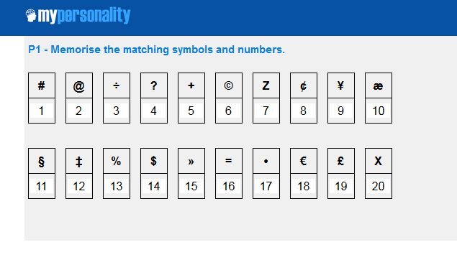

1. **Perception:**

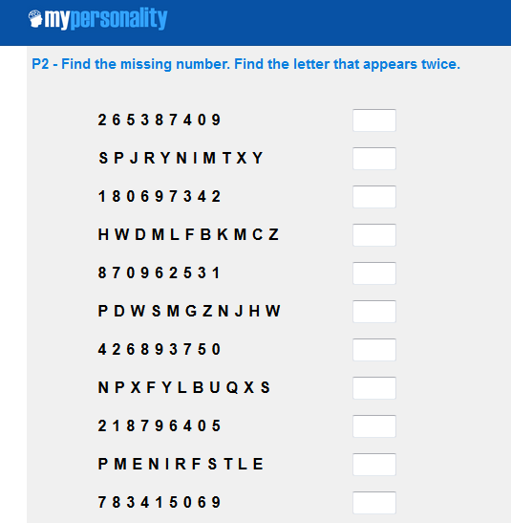

1. **Word Comprehension:**

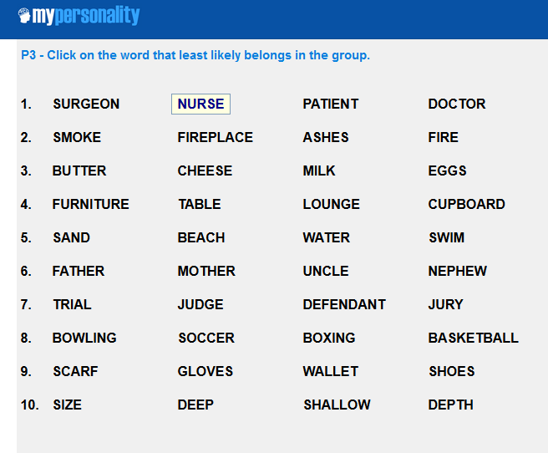

1. **Visual Designs:**

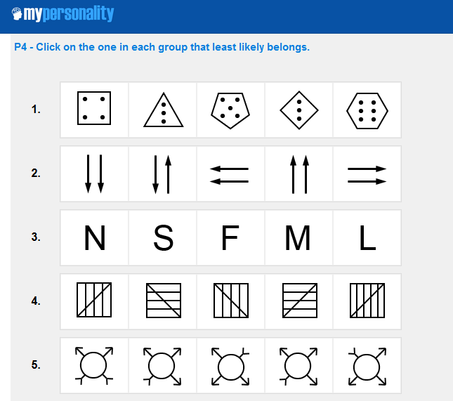

1. **Logic:**

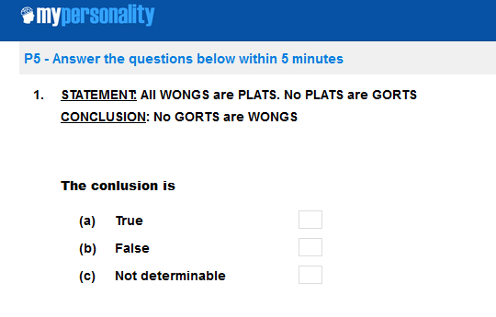

1. **Spatial Relations:**

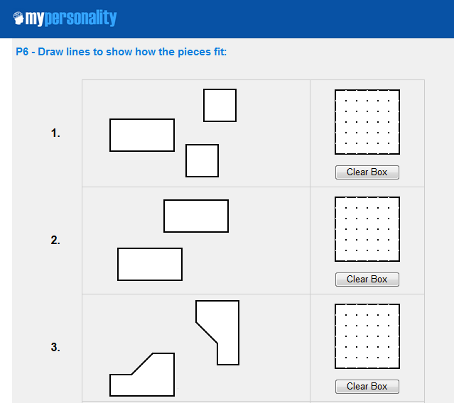

1. **Numerical Sequence:**

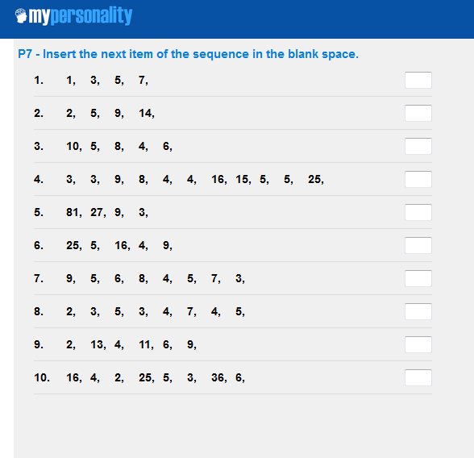

### **Creativity:**

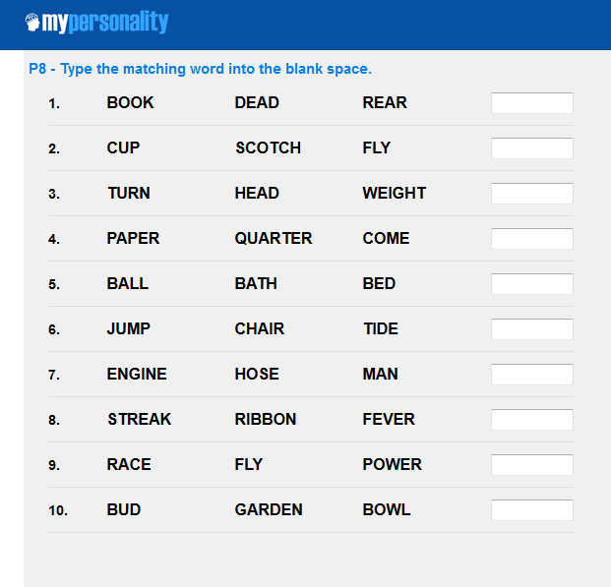

**Sample Result:**

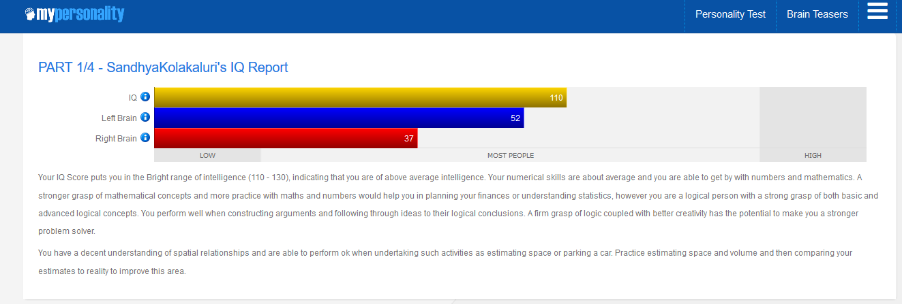

**3.2 Data Collection (Face Images) :**

Capture the face images of the people. Based on their IQ Result order them in some ranges. The Data set is Labelled based on the IQ Ranges.Categorising the IQ ranges as Below Average, Average, High Average, Superior.

1.Below Average - Lessthan 90

2.Average - 90 to 109

3.High Average - 110 to 129

4.Superior - Greaterthan 130

**Sample Images:**

**1.Below Average**

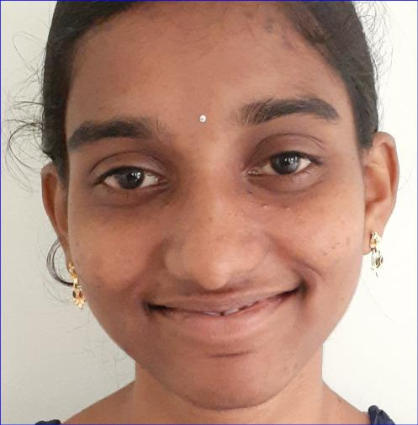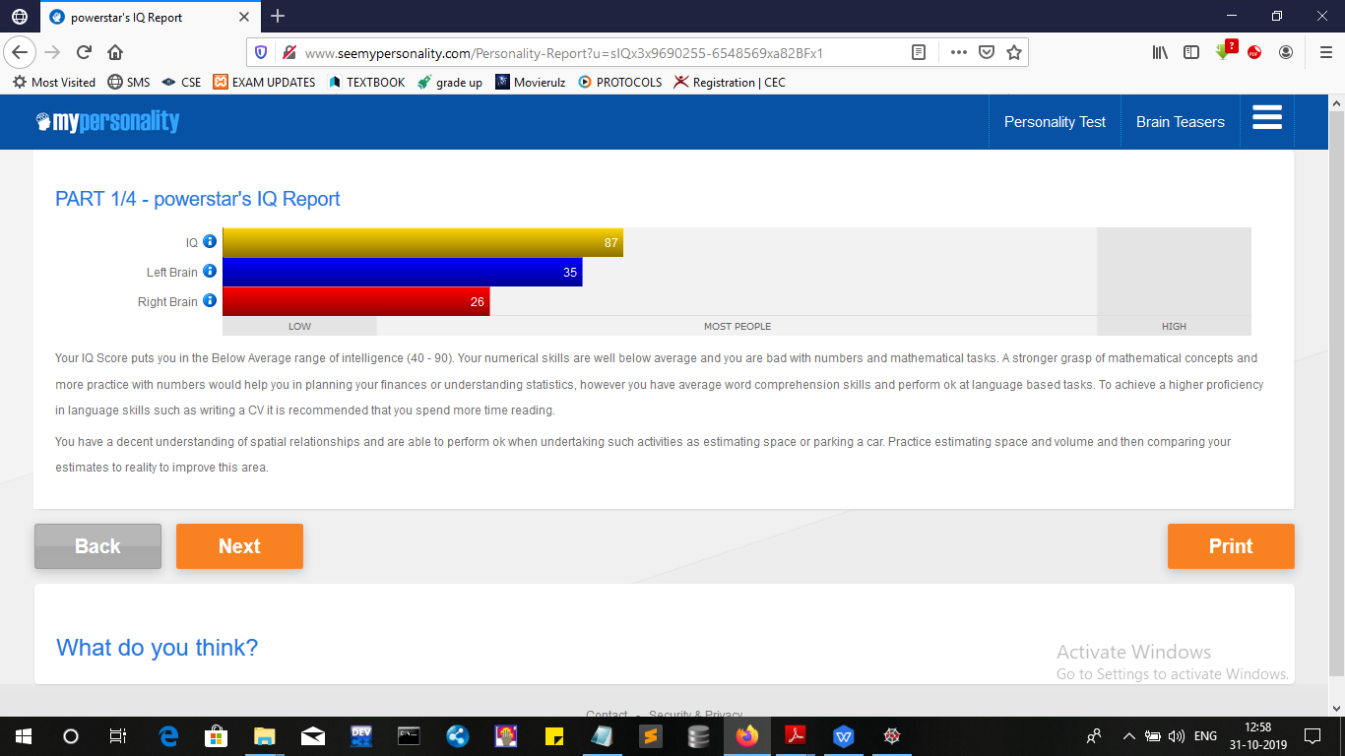

1. **Average:**

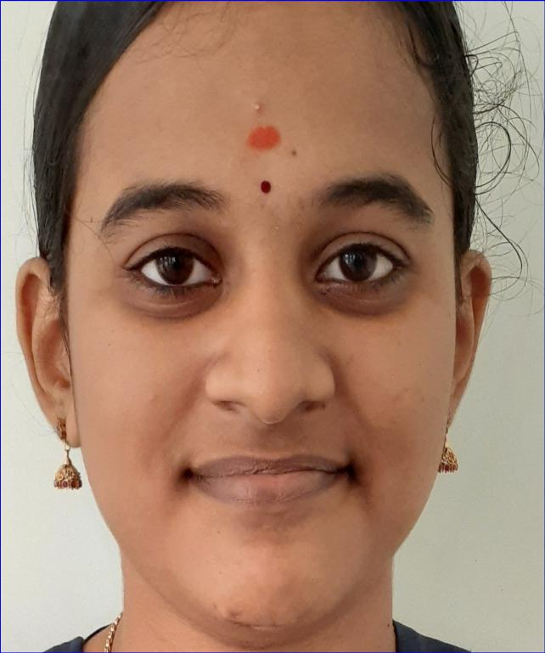

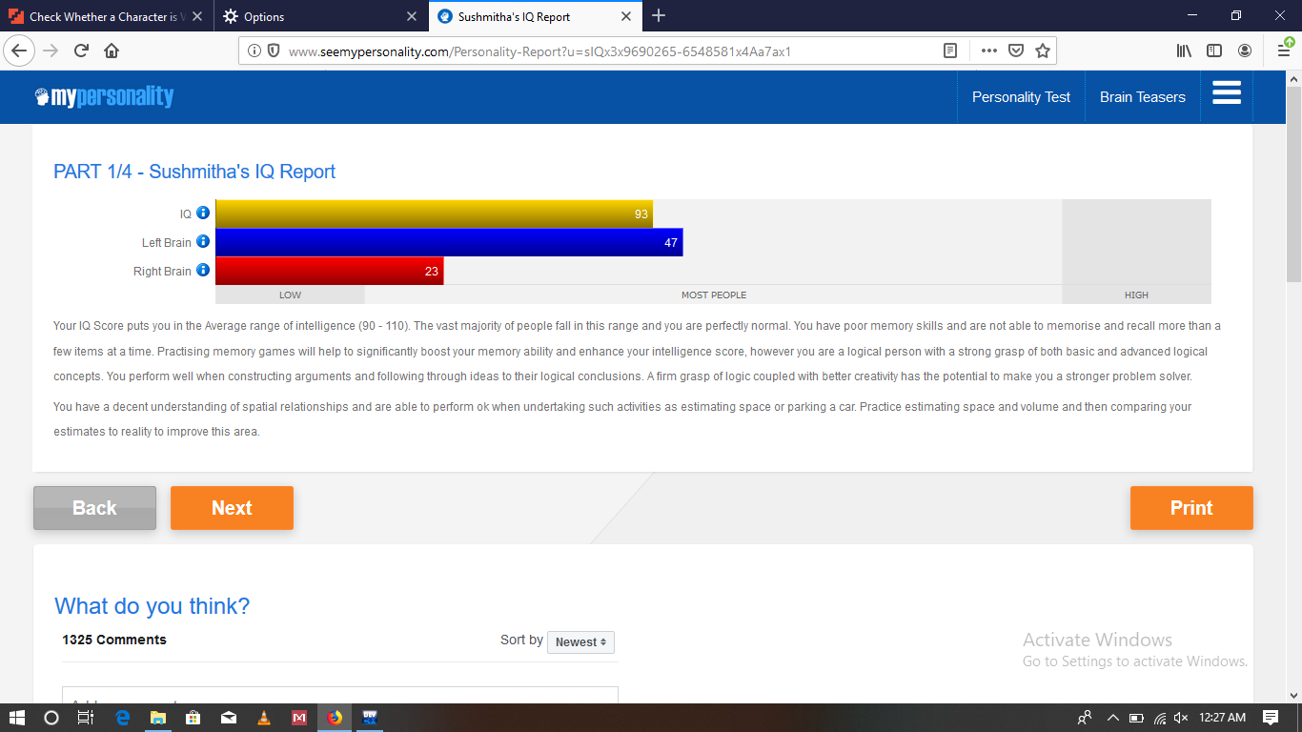

1. **Above Average :**

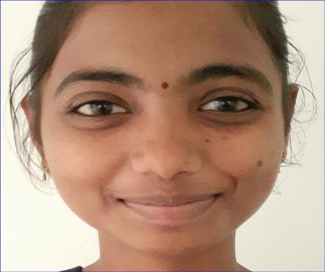



1. **Superior:**

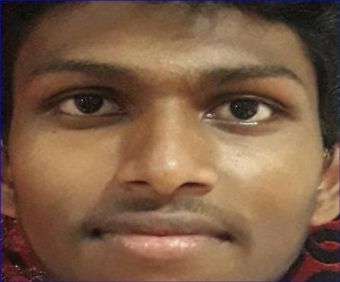

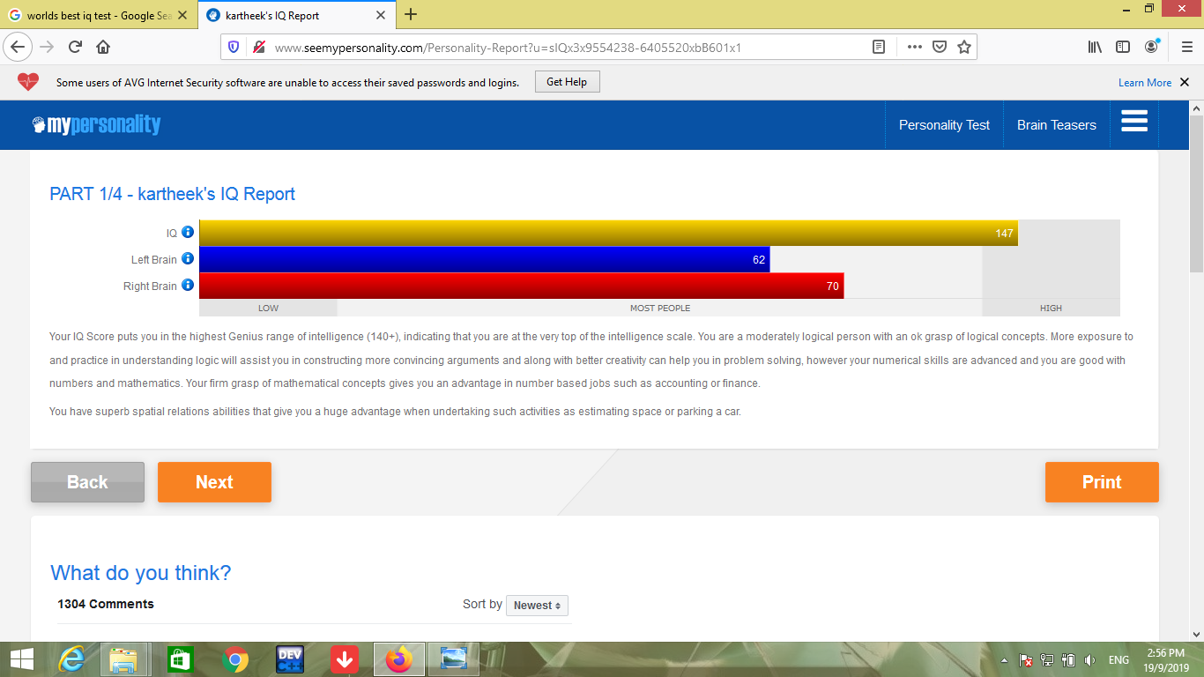

**3.3 CODE :**

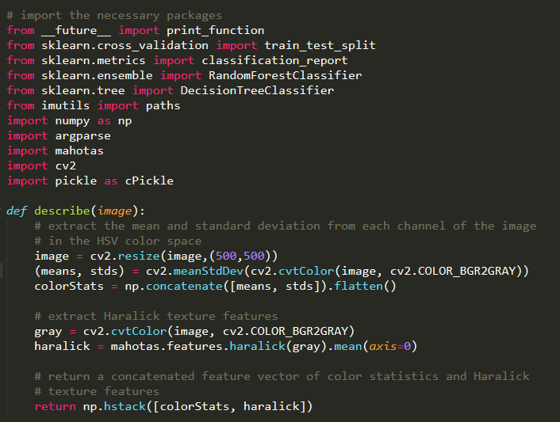

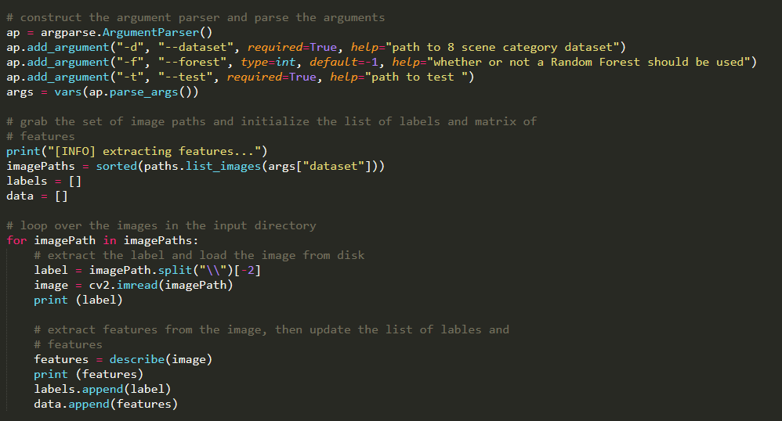

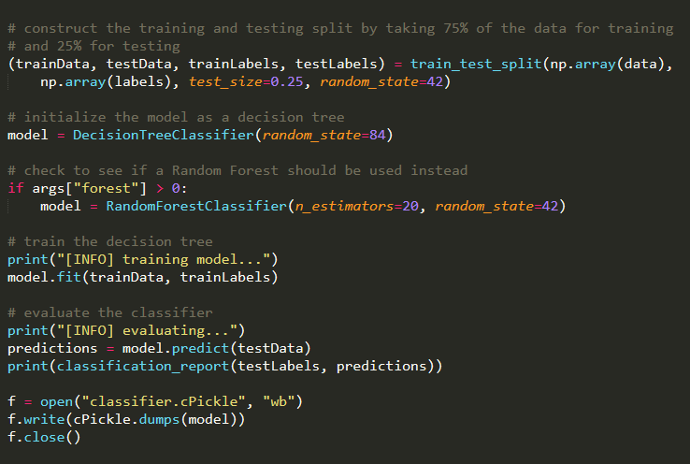

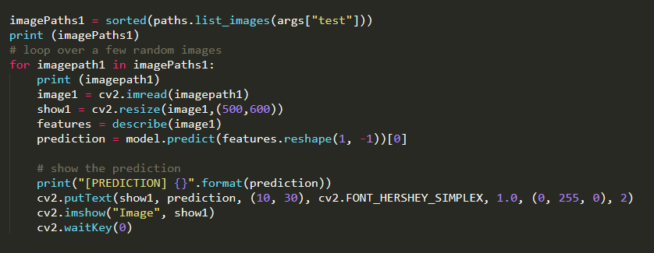

**3.4 OUTPUT :**

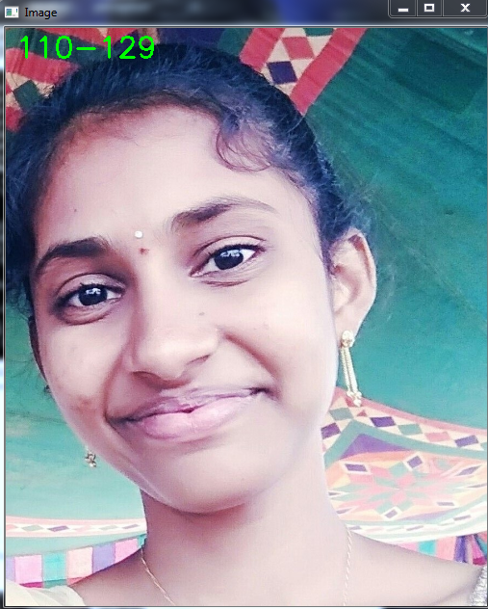

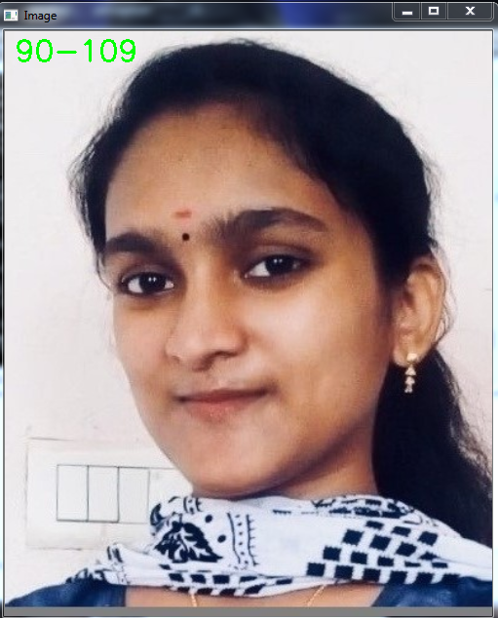

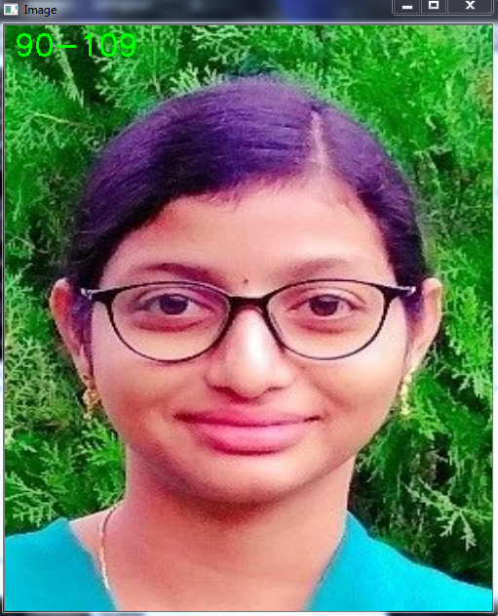

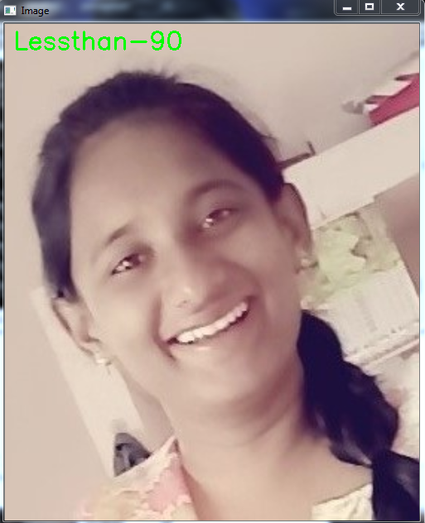

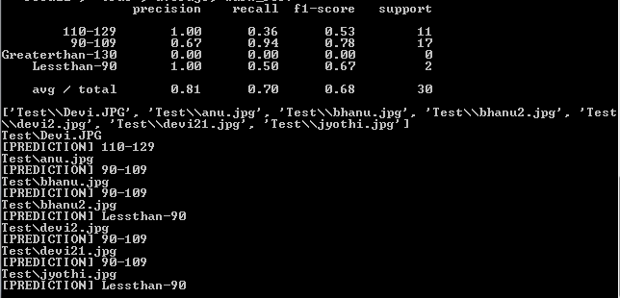

**CHAPTER 4**

**Conclusion and Future Scope :**

This project can be widely used whenever it required. Generally if we want to calculate IQ of a person through IQ Test it takes much time and there is a case that,if we are calculating IQ of an illiterate person IQ Test might be problematic. That person may not attend the test in this case our project is very useful. Its really magical if we are predicting IQ of a person by seeing the person face. In interviews the interviewer can easily predict the intelligence of the person who came to the interview. In a class the teacher can easily predict the Intelligent student.

* This system can be easily developed for user convenience.
* Generates good accuracy.
* This system gives good time management where existed IQ test can’t prove it.
* In future this project will have good scope.
* In future this system can be developed in advance.