

Midterm Project Report

Advanced Computer Programming

Student Name : 陳逸凱
Student ID : 110021085
Teacher : DINH-TRUNG VU

2024-04

Introduction

Github
- Personal Github Account: https://github.com/110021085
- GroupProjectRepository:https://github.com/Linx25059/group-5

Overview
The primary objective of this project is to develop an automated web crawler using the Scrapy framework The crawler is designed to precisely extract repository information from a designated GitHub profile. and export the collected data into a structured XML format for further analysis.

Implementation

Class 1
This class inherits from scrapy.Spider, serving as the central engine of the project. Its primary role is to define the crawling behavior, manage network requests, and parse the HTML structure of GitHub. By leveraging Scrapy’s asynchronous processing, it efficiently navigates through repository lists and project details..

Fields
- name: Defined as "github_user", which serves as the unique identifier for the crawler.
- start_urls: Set to the target user's repository tab: https://github.com/110021085?tab=repositories.
- custom_settings: A configuration dictionary that includes a browser-like USER_AGENT to bypass bot detection, FEED_EXPORT_ENCODING for UTF-8 support, and ROBOTSTXT_OBEY set to False to ensure full access to the required pages.

Methods
- parse(self, response): The primary entry-point method that iterates through the repository list. It extracts individual repository names and URLs using CSS and XPath selectors, then passes them to the next parsing stage using meta data.
- parse_details(self, response): A specialized callback method that analyzes the internal page of each repository. It performs deep extraction of specific fields such as programming languages and commit counts.

Functions
- Data Normalization Logic: Within parse_details, the function evaluates if a repository is empty. If the "About" field is missing but the repository contains content, it automatically populates the field with the Repository Name to satisfy project requirements.
- Final Item Yielding: Packages all scraped data into a structured dictionary (URL, About, LastUpdated, Languages, Number_of_Commits) for XML exportation.

Class 2

Method/Function 1

Method/Function 2
.

Results

Result 1
.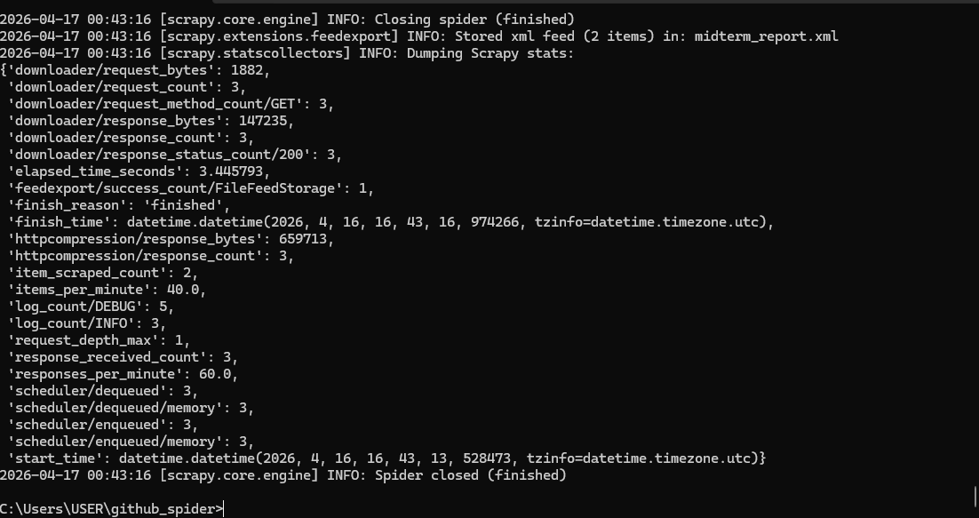

Result 2
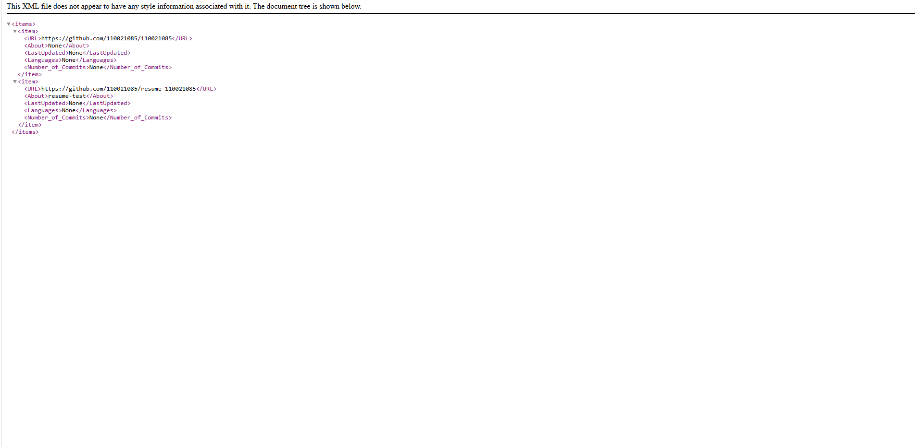

Conclusions
Through this implementation, I have successfully developed an automated web crawler using the Scrapy framework. It is capable of automatically navigating to a specific GitHub profile and performing deep extraction of each repository's details. Furthermore, I integrated conditional logic into the code to handle incomplete web data

