Description for P4

Description: Using a program to update items in Arango DB collections.

First, import necessary packages:

from arango import ArangoClient  
import json  
import os  
import time

Then, initialize client for ArangoDB and set the path of Json files:

# Initialize the client for ArangoDB. And some other info need to type in  
client = ArangoClient(hosts="http://localhost:8529")  
sys_db = client.db("_system", username="root", password="")  
path='E:\DAMG7275\DataP3'

Next, initialize to see if any files in the path has changed:

# Initial and See if any file change  
dicts = {}  
zd = {}  
def file_state(dic,path):  
 file = os.listdir(path)  
 for files in file:  
 file_path = path+files  
 if os.path.isfile(file_path):  
 dic[file_path] = os.path.getmtime(file_path)  
 return  
  
file_state(zd,path)

Then, using a loop to update the file:

# Begin loop to update the file  
while True:  
 time.sleep(3)  
 file_state(dicts, path)  
 for i in dicts:  
 if dicts[i] == zd[i]:  
 pass  
 else:  
 zd[i] = os.path.getmtime(i)  
 filepath, tmpfilename = os.path.split(i)  
 shotname, extension = os.path.splitext(tmpfilename)  
 print(shotname + " is updated, something new will be update into database")  
 coll = sys_db.collection(str(shotname)) #Open file and import into database  
 with open(i) as fd:  
 data = json.load(fd)  
 coll.import_bulk(documents=data, on_duplicate ='update')

The result is showed as below:

Before:

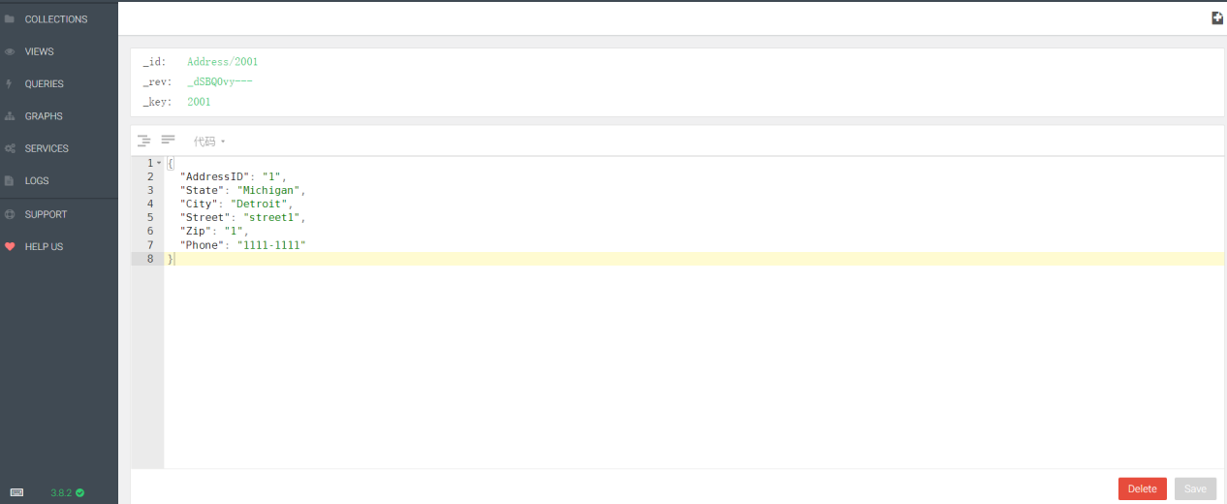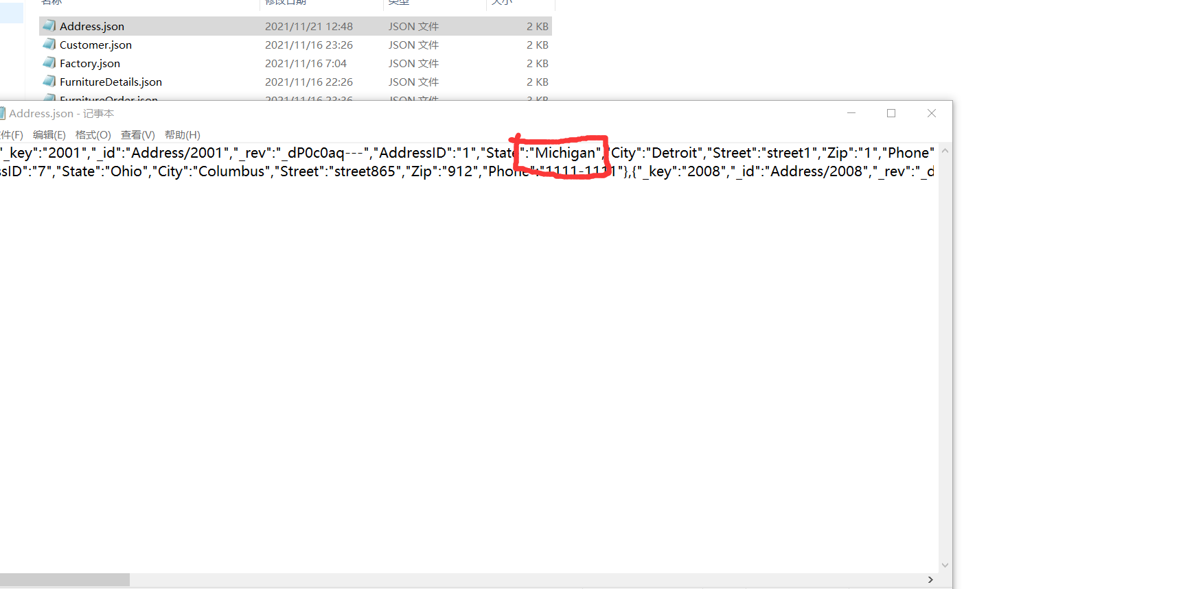

After:

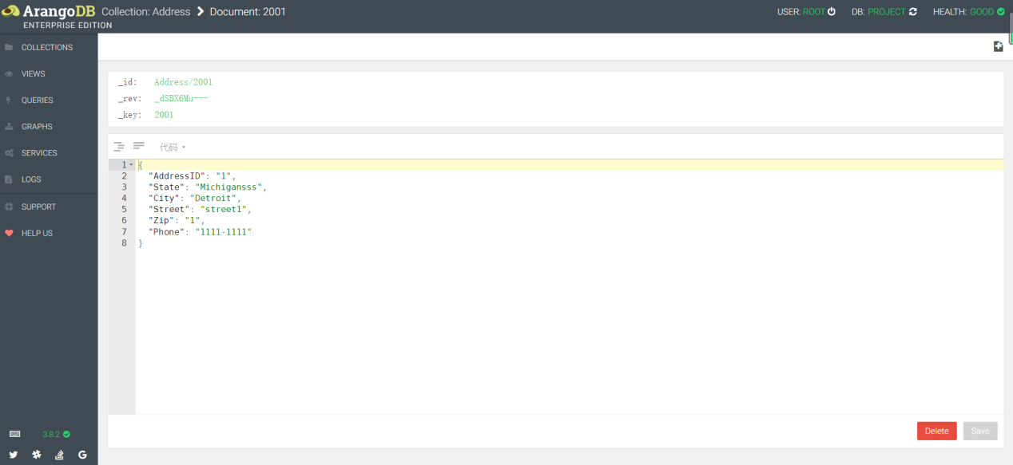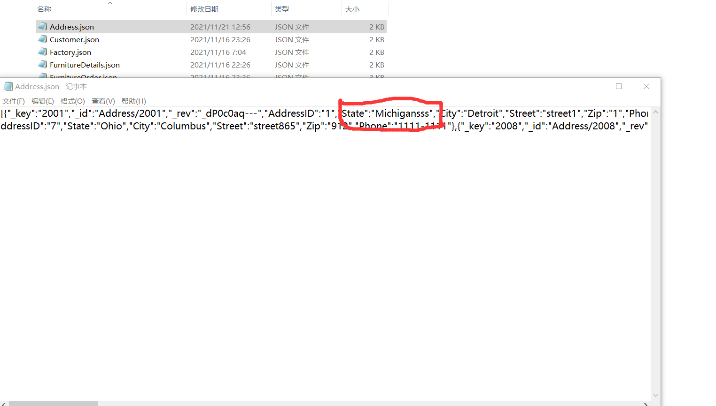

Running result:

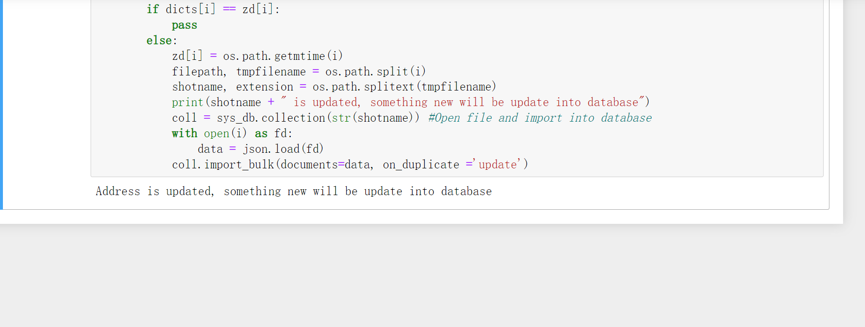

Code:programme.py