**FINAL PROJECT FOR COURSE MACHINE LEARNING**

***Establishment of neural network model and analysis of Radar Traffic Data***

Students:

Linxue Lai, Weicheng He

Professor:

Christophe Cerisara

Dec. 14th ,2020

## 1 Introduction

This report is about our final project for the course Machine Learning [1]. We worked in a team of two members. Our task is to Build a deep learning model that predicts the traffic volume. The data that should be analyzed is called “Radar Traffic Data”, which can be download in Kaggle [2]. The traffic data is collected from radar sensors deployed by the city of Austin.

This report is developed by the following parts: data analysis and processing, model construction and parameter setting, experimental process and conclusions, personal experience (individual notes).

The following is our work plan:

|  |  |
| --- | --- |
| Duration | task |
| 16/11/2020 - 23/11/2020 | * Start the project: create a github project for our co-work, create a shared Google doc and a shared kaggle notebook for sharing ideas or articles referring to our project. * Conduct preliminary data analysis and read related papers |
| 24/11/2020 - 01/12/2020 | * Chose the appropriate time series analysis model: LSTM, GRU |
| 02/12/2020 - 08/12/2020 | (Weicheng HE) Construction of model LSTM and improve model.  (Linxue LAI) Construction of model GRU and improve model. |
| 09/12/2020 - 13/12/2020 | Improve codes, summarize experimental results, write report |

## 2 data analysis and processing

In order to facilitate data visualization and data analysis, we use the shareable notebook of the kaggle platform for data analysis and processing.

### 2.2 Data description:

Traffic data collected from the several Wavetronix radar sensors deployed by the City of Austin. Dataset is augmented with geo coordinates from sensor location dataset.

# Load data

df = pd.read_csv("/kaggle/input/radar-traffic-data/Radar_Traffic_Counts.csv")

df.head(10)

The following is an overview of some of the data:

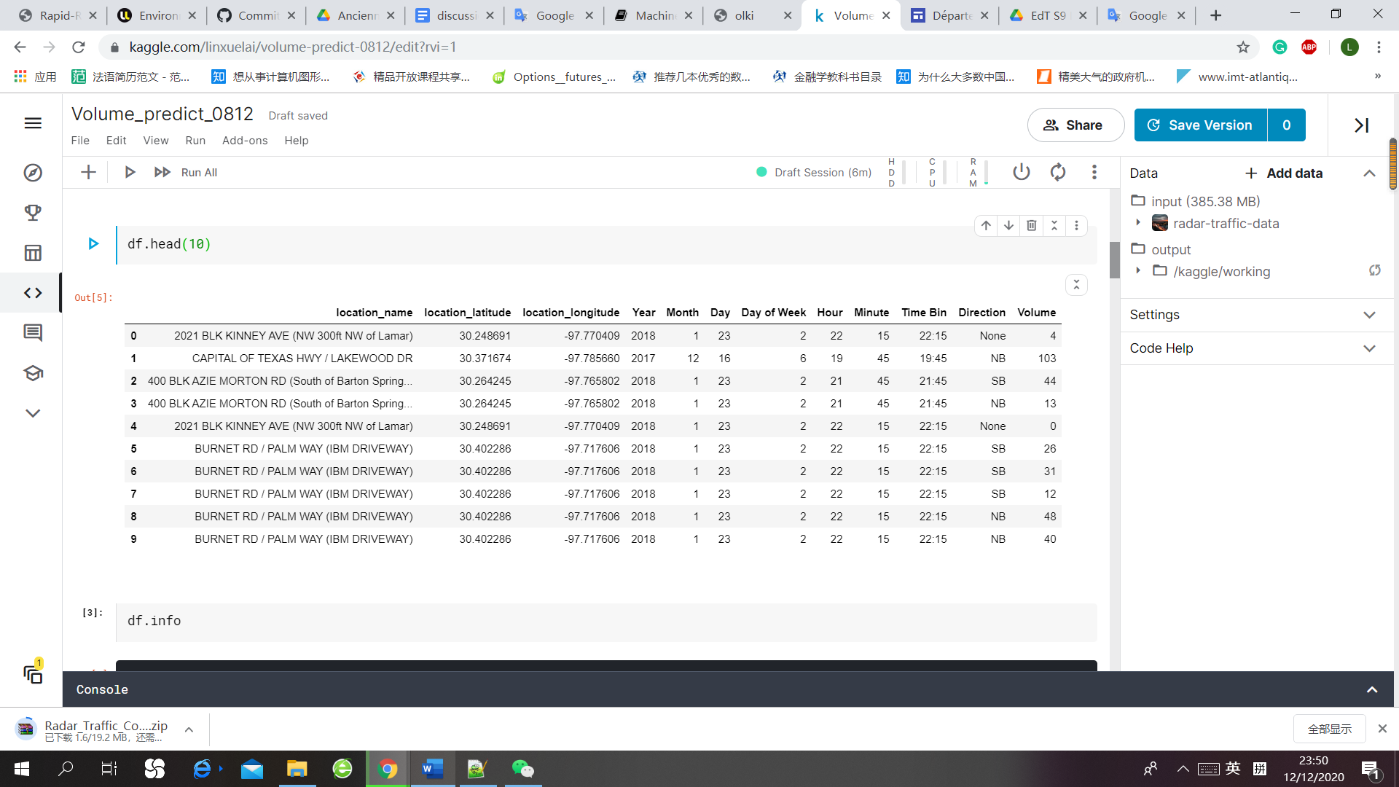

As traffic flow data has obvious periodic change characteristics, we consider using the commonly used LSTM model and GRU model for time series analysis.

There is a question to consider: Is it necessary to consider both time and space factors?

In order to simplify the problem and make it easier to understand, we first consider the changes of traffic volume at a single location over time. By looking at the data of a certain location in a certain period of time, we found that the data has an obvious cycle nature of daily changes. For example:

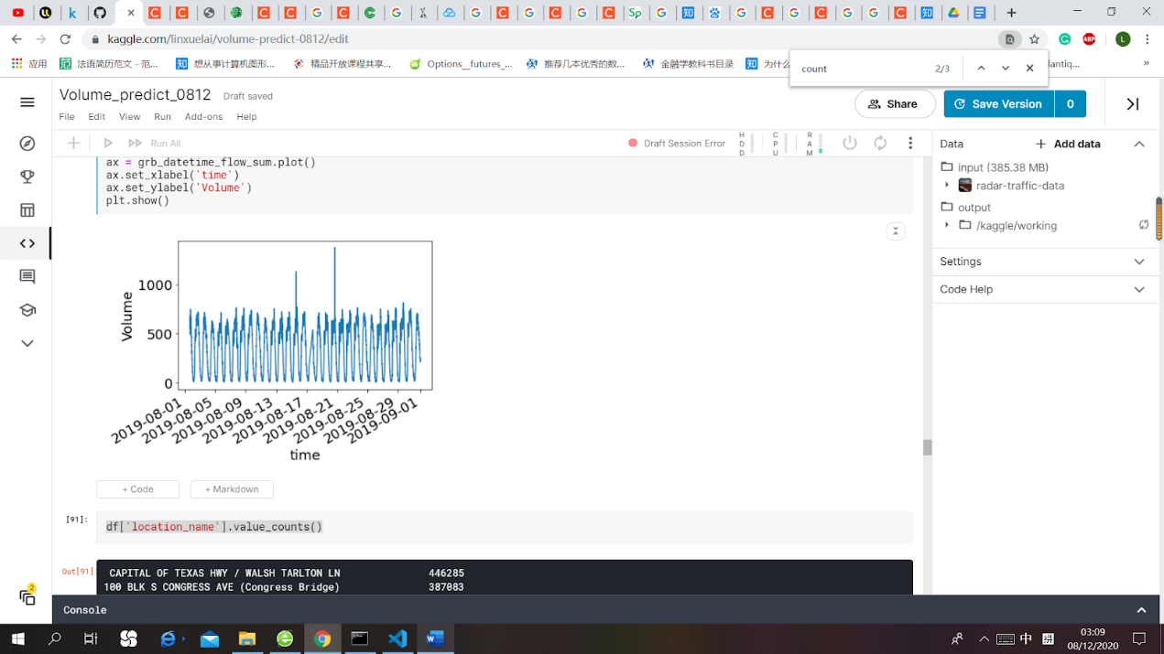

*Location 1： 3201 BLK S LAMAR BLVD (BROKEN SPOKE)*

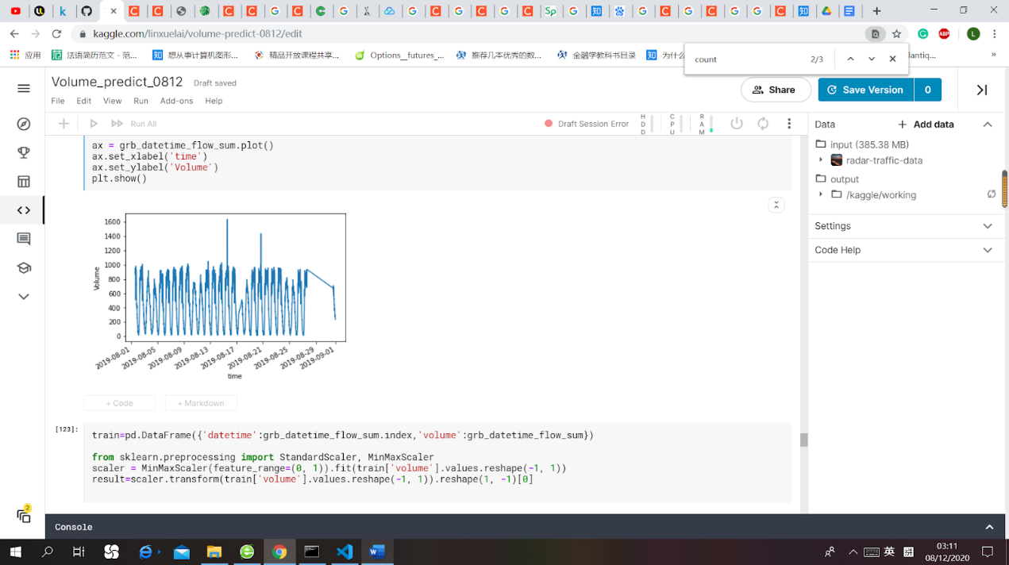

*location 2：100 BLK S CONGRESS AVE (Congress Bridge)*

The number of locations: 23 different locations by location_name; according to actual latitude and longitude: 18 different locations.

df['location_name'].value_counts()

df[['location_latitude','location_longitude']].value_counts()

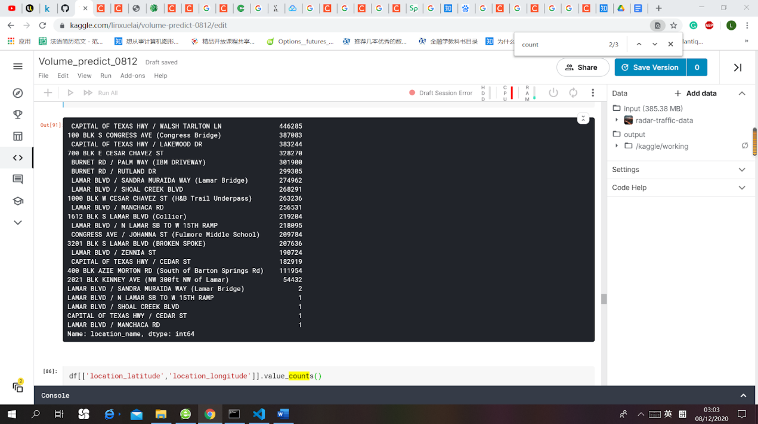 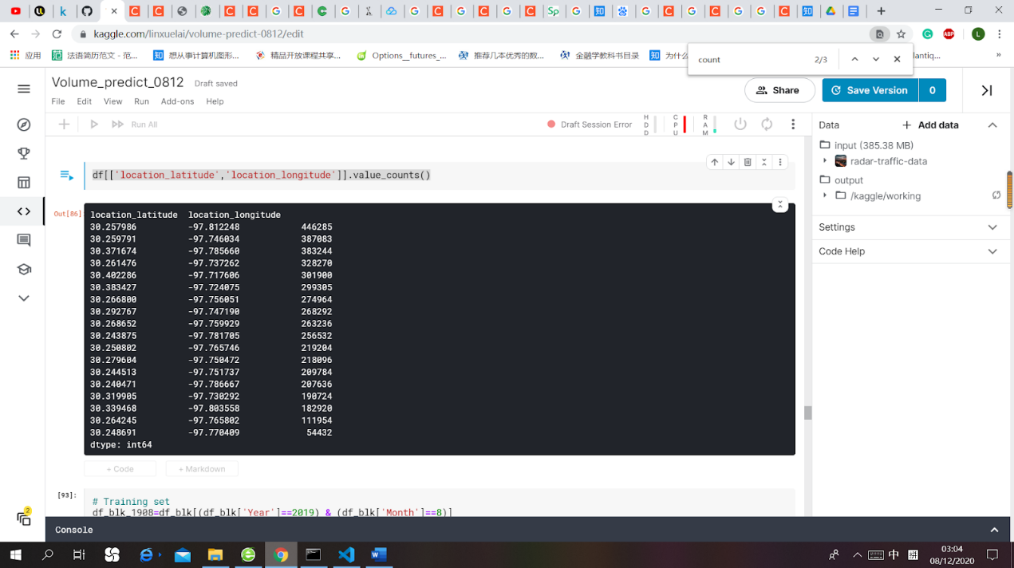

The following is a map-based visualization (see the codes in annexes 1):

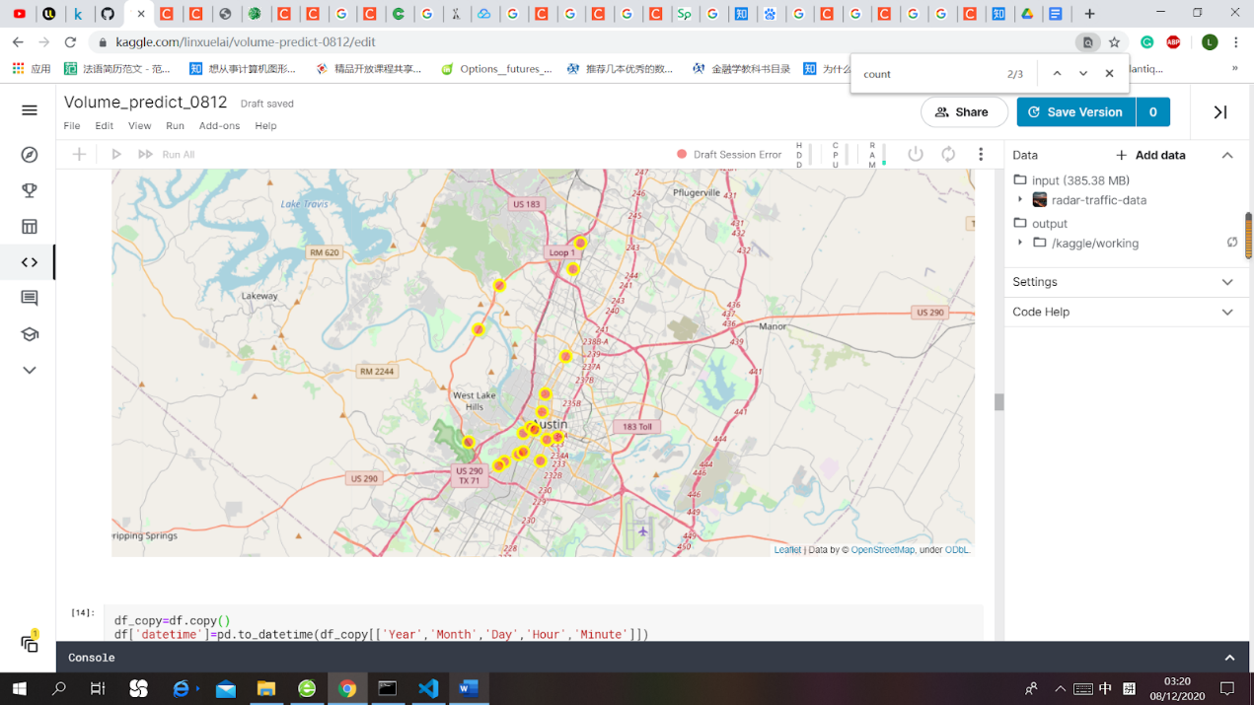

## 3 Models

### We built an LSTM model and a GRU model, trained and tested traffic flow data at a certain location, and compared the results of the two models.

### 3.1 LSTM

### 3.2 GRU

选择了其中一个位置，选择某时间段的某地点进行GRU的训练，只考虑时序性。

相邻数据以15min为间隔

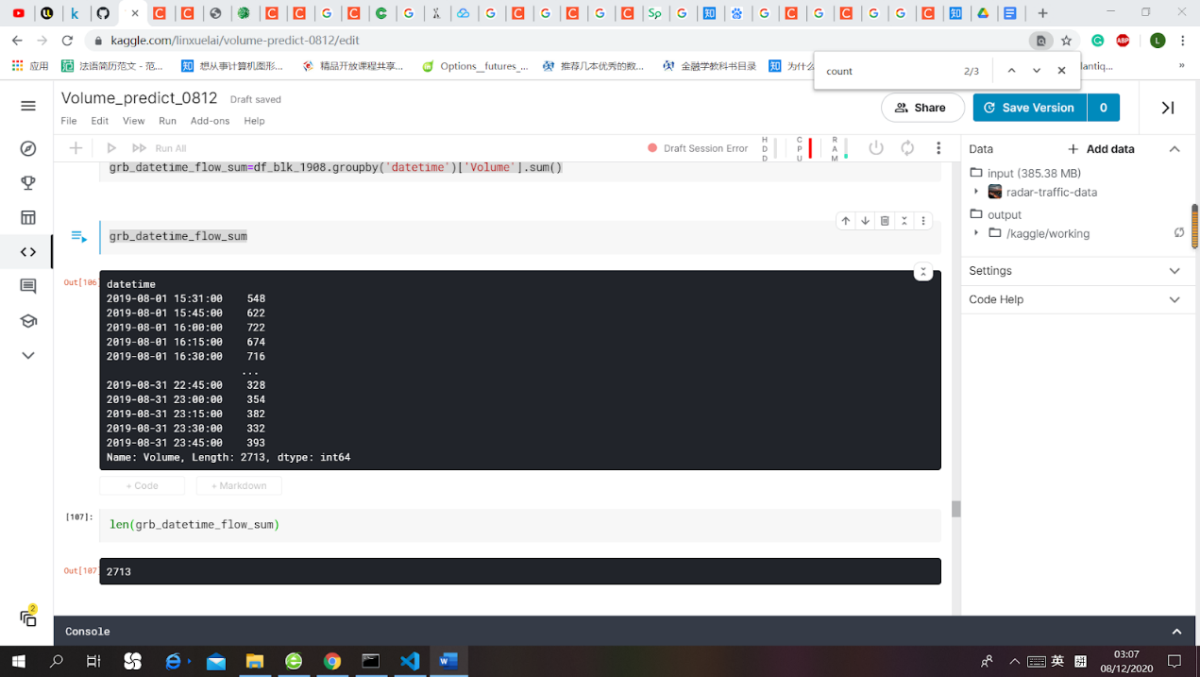

# Training set

lags = 4

config = {"batch": 256, "epochs": 600}

raw_data = 'data/Radar_Traffic_Counts.csv'

location='100 BLK S CONGRESS AVE (Congress Bridge)'

units=[lags,64,64,1]

pv=predict_volume(raw_data,location,units,lags,config)

pv.training()

pv.model_evaluation()

测试结果：

### 3.3 Comparison

## 4 Conclusion

## 5 References

[1] course link: <https://members.loria.fr/CCerisara/#courses/machine_learning/>

[2] data link: <https://www.kaggle.com/vinayshanbhag/radar-traffic-data?select=Radar_Traffic_Counts.csv>

[3]

## Annexes 1: map visualization

import folium

import pandas as pd

df = pd.read_csv("/kaggle/input/radar-traffic-data/Radar_Traffic_Counts.csv")

# define the world map

world_map = folium.Map()

# display world map

world_map

lat_lon = pd.DataFrame(df,columns=['location_name','location_latitude','location_longitude'])

lat_lon.drop_duplicates(['location_name','location_latitude','location_longitude'], keep='first', inplace=True)

print(lat_lon)

lat_lon.drop_duplicates(['location_latitude','location_longitude'], keep='first', inplace=True)

print(lat_lon)

print(len(lat_lon))

# get the data in map

limit = len(lat_lon)

data = lat_lon.iloc[0:limit, :]

latitude,longitude = lat_lon['location_latitude'][0],lat_lon['location_longitude'][0]

# Instantiate a feature group in the dataframe

index = folium.map.FeatureGroup()

# Loop through the data and add each to the feature group

for lat, lng, in zip(lat_lon.location_latitude, lat_lon.location_longitude):

index.add_child(

folium.CircleMarker(

[lat, lng],

radius=7, # define how big you want the circle markers to be

color='yellow',

fill=True,

fill_color='red',

fill_opacity=0.4

)

)

# Add to map

v_map = folium.Map(location=[latitude, longitude], zoom_start=12)

v_map.add_child(index)