OKAFOR VICTOR SOMTO  FULL-STACK DEVELOPER • AI-NATIVE SOFTWARE ENGINEER  Nigeria | Victor4all2015@gmail.com | +234 812 291 1210  GitHub: github.com/Linxvicky2049 | LinkedIn: linkedin.com/in/okafor-victor-2717783b4  Portfolio: linxvicky2049.github.io/portfolio-website/ | Gaming-Africa: gaming-africa.com | 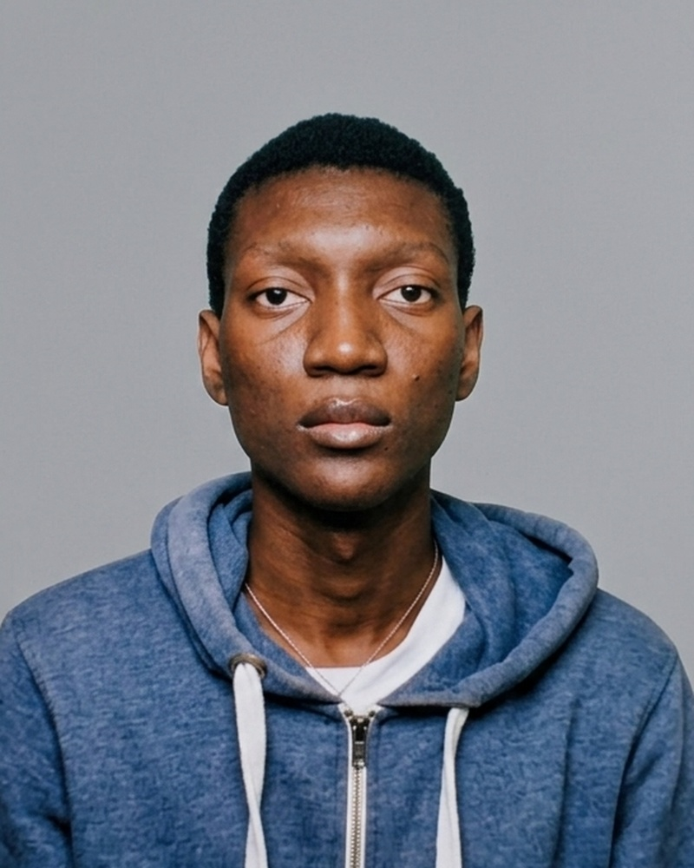

PROFESSIONAL SUMMARY
Full-stack developer and creative technologist experienced in building modern web applications, APIs, AI-assisted systems and interactive interfaces. Strong working knowledge of TypeScript, JavaScript, React, Next.js, Node.js and Python, with practical experience integrating APIs, databases, authentication and complex product workflows. Comfortable using AI-assisted development for implementation, debugging, refactoring, documentation and problem solving while reviewing and validating generated code.
TECHNICAL SKILLS
Frontend | React, Next.js, TypeScript, JavaScript, HTML, CSS, Responsive UI, Figma
Backend | Node.js, Express.js, Python, FastAPI, REST APIs, Authentication, API Design
Databases | MongoDB, PostgreSQL, Prisma
AI & Intelligent Systems | AI-assisted development, PyTorch, Computer Vision, OCR, AI workflows
Engineering | Git, GitHub, Debugging, API Testing, Software Architecture, Environment Configuration
IoT | ESP32-S3, WiFi CSI, Signal Processing, Hardware-Software Integration
SELECTED PROJECTS
BIZBUYSELL | Luxury Interior Marketplace | Next.js, TypeScript, PostgreSQL, Prisma
• Developing a full-stack marketplace connecting customers with interior designers, furniture sellers and service providers.
• Designed workflows covering authentication, products, sellers, cart, checkout, orders, quotes, messaging and delivery.
• Worked across frontend, backend, database and product-flow requirements using reusable application architecture.
GAMING HUB AFRICA | Gaming Platform | React, TypeScript, Node.js, MongoDB, Firebase
• Built a gaming-focused platform with authentication, profiles, community features and platform workflows.
• Developed responsive interfaces and integrated frontend services with backend APIs and databases.
• Worked on deployment, environment configuration and application debugging.
KAGEFLOW AI | AI Manga Motion System | React, TypeScript, Pixi.js, OCR, AI
• Developed an experimental system for converting manga/comic imagery into animated motion sequences.
• Designed a pipeline combining OCR, rule-based motion compilation and interactive Pixi.js playback.
• Used AI-assisted development to explore implementation strategies, debug issues and accelerate development.
SENSEGRID | IoT Presence & Fall Detection | Python, ESP32-S3, Signal Processing
• Developed an experimental WiFi CSI-based sensing system using ESP32-S3 devices.
• Applied Savitzky-Golay filtering, Butterworth filtering and FFT-based signal analysis.
CREATIVE & DESIGN EXPERIENCE
Freelance graphic designer through BLACKSUN, creating logos, brand graphics, flyers, banners, business cards and AI-assisted visual content. Use Canva and Figma to create visual systems and user-facing digital experiences.
EDUCATION
B.Sc. Physics | Federal University of Petroleum Resources Effurun (FUPRE), Nigeria
ADDITIONAL STRENGTHS
Independent problem solving • AI-native development mindset • Fast learner • Git/GitHub workflows • Cross-functional frontend/backend thinking • Strong interest in software quality, testing and production engineering

