seasadj simu

linyiguo

2019.5.26

Well, I am here again. In this log, I am going to reproduce the three seasonal adjustment methods from StatCan stuff based on the data I generated in last log **simulate data**.  
The first two should be relatively easier, at least this is what Aaron told me last week…well, I hope so. The first one is X12-ARIMA, which is actually a software package developed by U.S. Census Bureau. In R, we can use package *x12* to access the X12-ARIMA method.

为了能在周一见面的时候给Aaron一份相对满意的答卷，我决定今晚上熬夜奋战一下。毕竟按我现在的结果，是明显不能让他满意的。也的确需要push一下自己，赶一赶进度了。晃晃悠悠地看书，不知道什么时候才能做出来东西了。加油吧，小伙子！今晚上把这两个model的curve给做出来！你可以的！Come On!

*–Update 5.28–* 呵呵呵，Aaron把我鸽了，这也正好给了我多一天的时间来想怎么build the model of state space model.

# X-12-ARIMA

学新知识的道路上注定要经历各种弯路，就像我现在一样。According to [wiki](https://en.wikipedia.org/wiki/X-12-ARIMA), X-12-ARIMA is the successor of X-11-ARIMA, and the current version is X-13ARIMA-SEATS(or X-13, and seats means Signal Extraction in ARIMA Time Series). As for the relations between these models, check [website](https://www.r-bloggers.com/seasonal-adjusment-on-the-fly-with-x-13arima-seats-seasonal-and-ggplot2/) and introduction of the [paper](https://cran.r-project.org/web/packages/seasonal/vignettes/seas.pdf). I guess I am going to use the latest version, that is X-13, to remove seasonal component in our ts.  
为了节省时间，也为了降低难度，第一个例子我用上面提到的paper中的数据来进行分析：

library("seasonal")  
# The seas function provides the core functionality of the package, and the 1st argument is 'ts'  
# The unemp example series measures US unemployment and is included in seasonal  
m <- seas(unemp)  
summary(m)

##   
## Call:  
## seas(x = unemp)  
##   
## Coefficients:  
## Estimate Std. Error z value Pr(>|z|)   
## AR-Nonseasonal-01 0.94360 0.03441 27.43 <2e-16 ***  
## MA-Nonseasonal-01 0.82540 0.05654 14.60 <2e-16 ***  
## MA-Seasonal-12 0.85071 0.03362 25.30 <2e-16 ***  
## ---  
## Signif. codes: 0 '***' 0.001 '**' 0.01 '*' 0.05 '.' 0.1 ' ' 1  
##   
## SEATS adj. ARIMA: (1 1 1)(0 1 1) Obs.: 323 Transform: none  
## AICc: 4324, BIC: 4339 QS (no seasonality in final): 0   
## Box-Ljung (no autocorr.): 22.04 Shapiro (normality): 0.9946

plot(m)

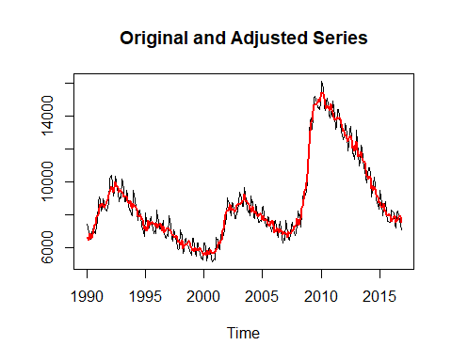

# The result is close but not identical to the official seasonally adjusted series.

By default, a call to seas also invokes the following automatic procedures of X-13: * Transformation selection (log / no log);  
* Detection of trading day and Easter effects;  
* Outlier detection;  
* ARIMA model search.  
In the example above, X-13 opts to perform no pre-transformation, does not adjust for weekday or Easter effects, detects no outliers and models the series by a (1 1 1)(0 1 1) seasonal ARIMA (autoregressive integrated moving average) model. This can be seen from the summary output: There are no coefficients for Easter or outliers, and the ARIMA specification and the transformation are shown at the bottom  
By default, seas calls the *SEATS* adjustment procedure(which decomposes the ARIMA model).To perform the alternative *X-11* adjustment procedure, the following option can be used:

library("seasonal")  
library("seasonalview")

## Registered S3 method overwritten by 'xts':  
## method from  
## as.zoo.xts zoo

##   
## Attaching package: 'seasonalview'

## The following object is masked from 'package:seasonal':  
##   
## view

eg_seats <- seas(unemp)  
eg_x11 <- seas(unemp, x11 = "")  
plot(unemp,col="lightblue",ylim=c(5500,15300),ylab="")  
par(new=T)  
plot(final(eg_seats),col="red",ylim=c(5500,15300),ylab="")  
par(new=T)  
plot(final(eg_x11),col="blue",ylim=c(5500,15300),ylab="")

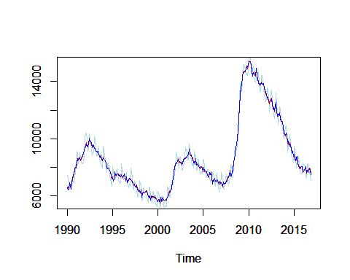

seas(x = unemp,arima.model = "(1 1 1)(0 1 1)",regression.aictest = NULL,outlier = NULL,transform.function = "none")

##   
## Call:  
## seas(x = unemp, transform.function = "none", regression.aictest = NULL,   
## outlier = NULL, arima.model = "(1 1 1)(0 1 1)")  
##   
## Coefficients:  
## AR-Nonseasonal-01 MA-Nonseasonal-01 MA-Seasonal-12   
## 0.9436 0.8254 0.8507

Well, the results here seem to be good.

### Let’s try our own data

library(forecast)

## Registered S3 methods overwritten by 'ggplot2':  
## method from   
## [.quosures rlang  
## c.quosures rlang  
## print.quosures rlang

## Registered S3 method overwritten by 'quantmod':  
## method from  
## as.zoo.data.frame zoo

## Registered S3 methods overwritten by 'forecast':  
## method from   
## fitted.fracdiff fracdiff  
## residuals.fracdiff fracdiff

library(seasonal)  
set.seed(1)  
model <- Arima(ts(rnorm(24000),freq=12), order=c(0,1,1), seasonal=c(0,1,1),fixed=c(theta=0.5, Theta=0.5))  
data <- simulate(model,nsim=240)  
plot(data)

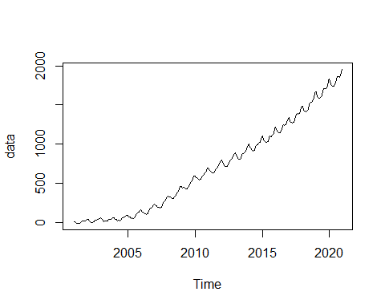

m_x11 <- seas(data, x11 = "", regression.aictest = NULL)  
plot(m_x11)

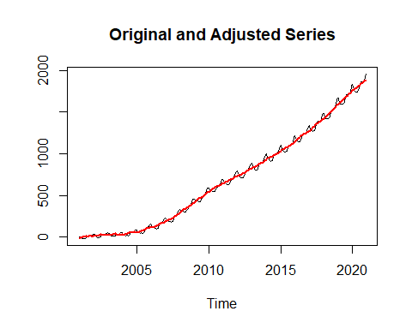

m_seats <- seas(data, regression.aictest = NULL)

## Model used in SEATS is different: (0 1 1)(0 1 0)

plot(m_seats)

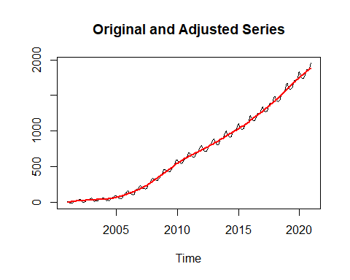

summary(m_seats)

##   
## Call:  
## seas(x = data, regression.aictest = NULL)  
##   
## Coefficients:  
## Estimate Std. Error z value Pr(>|z|)   
## MA-Nonseasonal-01 -0.47429 0.05798 -8.180 2.85e-16 ***  
## MA-Seasonal-12 -0.53983 0.05679 -9.506 < 2e-16 ***  
## ---  
## Signif. codes: 0 '***' 0.001 '**' 0.01 '*' 0.05 '.' 0.1 ' ' 1  
##   
## SEATS adj. ARIMA: (0 1 1)(0 1 1) Obs.: 240 Transform: none  
## AICc: 1279, BIC: 1289 QS (no seasonality in final): 0   
## Box-Ljung (no autocorr.): 21.33 Shapiro (normality): 0.9955   
## Messages generated by X-13:  
## Warnings:  
## - Automatic transformation selection cannot be done on a  
## series with zero or negative values.  
##   
## Notes:  
## - Model used for SEATS decomposition is different from the  
## model estimated in the regARIMA modeling module of  
## X-13ARIMA-SEATS.

summary(m_x11)

##   
## Call:  
## seas(x = data, regression.aictest = NULL, x11 = "")  
##   
## Coefficients:  
## Estimate Std. Error z value Pr(>|z|)   
## MA-Nonseasonal-01 -0.47429 0.05798 -8.180 2.85e-16 ***  
## MA-Seasonal-12 -0.53983 0.05679 -9.506 < 2e-16 ***  
## ---  
## Signif. codes: 0 '***' 0.001 '**' 0.01 '*' 0.05 '.' 0.1 ' ' 1  
##   
## X11 adj. ARIMA: (0 1 1)(0 1 1) Obs.: 240 Transform: none  
## AICc: 1279, BIC: 1289 QS (no seasonality in final):92.12 ***  
## Box-Ljung (no autocorr.): 21.33 Shapiro (normality): 0.9955   
## Messages generated by X-13:  
## Warnings:  
## - Automatic transformation selection cannot be done on a  
## series with zero or negative values.

plot(data,col="green",ylim=c(-10,2000),ylab="")  
par(new=T)  
plot(final(m_x11),col="red",ylim=c(-10,2000),ylab="")  
par(new=T)  
plot(final(m_seats),col="blue",ylim=c(-10,2000),ylab="")  
legend("topleft",c("Data","X11","SEATS"),col=c("green","red","blue"),lty=c(1,1,1))

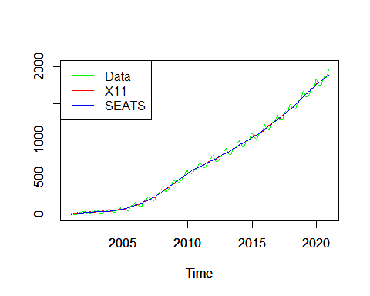

# Messing things up after here.  
plot(data-final(m_seats))

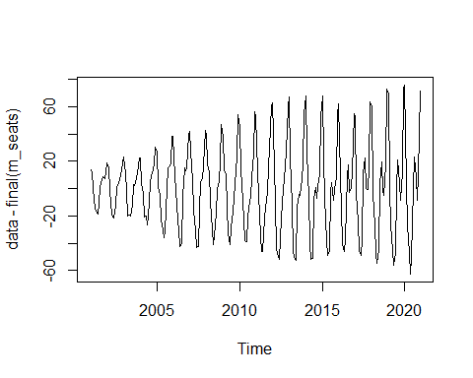

emmm, I am confused that why the result from the *SEATS* is different from that out of *X-11*. The model from X-11 is $(0,1,1)(0,1,1)_{12}$ but SEATS gives me $(0,1,1)(0,1,0)_{12}$. The former one is right and the corresponding estimation of $θ,Θ$ is also close.

# SEATS

See above.

# State Space Model

I just spent a whole day working on the state space model, trying to figure out the steps in this process. To be honest, I was not very, like 80%, clear about bootstrap particle filter, although I spent much time on it during last term. But I have to admit the effort I paid before is worthy, otherwise I can’t come up with the following code within one day. The resource is mainly from **BOOK Monte Carlo Statistical Methods** and the [lecture](https://onlinelibrary.wiley.com/doi/abs/10.1111/1467-842X.00104).  
*题外话：刚刚基本一个半小时的时间内我都在处理转pdf的bug，但是目前这个对我来说并不是很重要。只希望自己以后做事情，要知道自己的主要目的是什么，不要因为一些外在的小事情而耽误太长时间，最终得不偿失。*

library(forecast)  
set.seed(1)  
model <- Arima(ts(rnorm(24000),freq=12), order=c(0,1,1), seasonal=c(0,1,1),fixed=c(theta=0.5, Theta=0.5))  
data <- simulate(model,nsim=240)  
# let's try SIS(Sequential Importance Sampling) at first  
# Initialization  
Tr_0 <- rep(rnorm(1),100)  
Se_0 <- rep(rnorm(1),100)  
w_0 <- rep(1/100,100)  
  
# Generate particles  
Tr_1 <- Tr_0 + rnorm(100)  
Se_1 <- -Se_0 + rnorm(100)  
  
# Compute weights  
w_1 <- w_0 * dnorm(rep(data[1],100) - Tr_1 - Se_1)  
w_1 <- w_1 / sum(w_1) # normalize  
  
# compute state value  
T_1 <- sum(w_1 * Tr_1)  
S_1 <- sum(w_1 * Se_1)

这里，我们只把t_1时刻的trend和seasonal摘了出来。我们最终的目的是把整个过程（240个时刻）的trend和seasonal求出来。

set.seed(1)  
S <- matrix(0,100,251) # Cause Seasonal component's state space model, we have additional 11 zero-values.  
Tr <- matrix(0,100,251)  
S[,12] <- S_1  
Tr[,12] <- T_1  
w <- w_1  
component <- c(T_1,S_1)  
for (i in 13:251) {  
 # update particles  
 Tr[,i] <- Tr[,i-1] + rnorm(100)  
 for (j in 1:11) S[,i] <- S[,i]-S[,i-j]  
 S[,i] <- S[,i] + rnorm(100)  
   
 # update weights  
 w <- w * dnorm(rep(data[i-11],100)-Tr[,i]-S[,i])  
 w <- w / sum(w)  
   
 # evaluate state value  
 t <- sum(w * Tr[,i])  
 s <- sum(w * S[,i])  
   
 # add to our component path  
 component <- rbind(component, c(t,s))  
}  
  
trend <- ts(component[,1],frequency = 12, start = c(2001,1),end = c(2020,12))  
season <- ts(component[,2],frequency = 12, start = c(2001,1),end = c(2020,12))  
plot(trend)

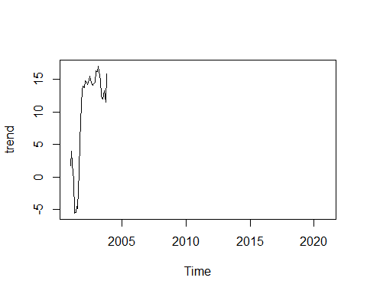

plot(season)

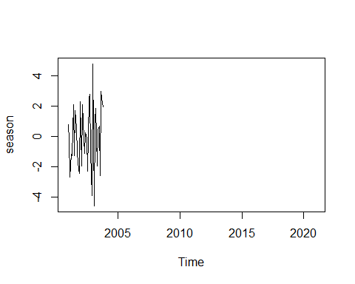

plot(data,type="l",ylab="", ylim=c(-50,2000))  
lines(data-season, ylab="",ylim=c(-50,2000),col="red")

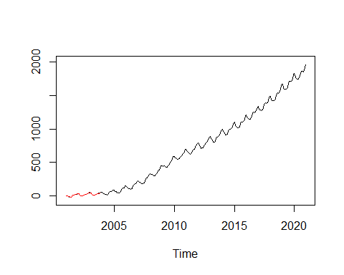

Well, I think something is wrong here again! it’s normal to show some degeneracy here, but the curve after adjusting does not look like that.  
I am going to try it on the data set **unemp**:

library("seasonal")  
Data <- unemp # 1990.1-2016.11 # 323 records  
summary(Data)

## Min. 1st Qu. Median Mean 3rd Qu. Max.   
## 5153 7012 8078 8766 9476 16147

set.seed(1)  
S <- matrix(0,100,334) # Cause Seasonal component's state space model, we have additional 11 zero-values.  
Tr <- matrix(0,100,334) # Hence 323+11 columns  
S[,11] <- rep(0,100)  
Tr[,11] <- rep(0,100)  
w <- rep(1/100,100)  
component <- c()  
for (i in 12:334) {  
 # update particles  
 Tr[,i] <- Tr[,i-1] + rnorm(100)  
 for (j in 1:11) S[,i] <- S[,i]-S[,i-j]  
 S[,i] <- S[,i] + rnorm(100)  
   
 # update weights  
 w <- w * dnorm(rep(data[i-11],100)-Tr[,i]-S[,i])  
 w <- w / sum(w)  
   
 # evaluate state value  
 t <- sum(w * Tr[,i])  
 s <- sum(w * S[,i])  
   
 # add to our component path  
 component <- rbind(component, c(t,s))  
}  
trend <- ts(component[,1],frequency = 12, start = c(1990,1),end = c(2016,11))  
season <- ts(component[,2],frequency = 12, start = c(1990,1),end = c(2016,11))  
plot(trend)

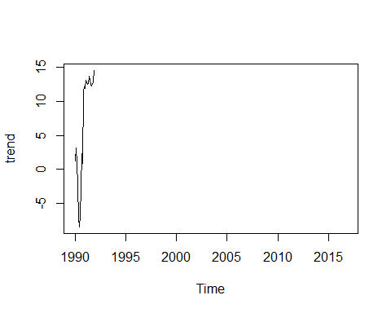

plot(season)

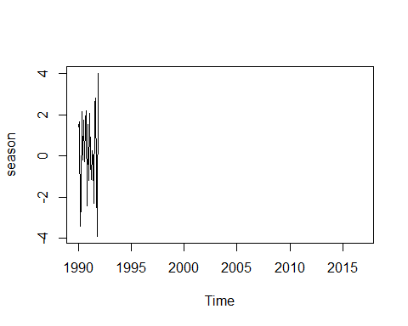

plot(Data,type="l",ylab="", ylim=c(5000,16500))  
lines(Data-season, ylab="",ylim=c(5000,16500),col="red")

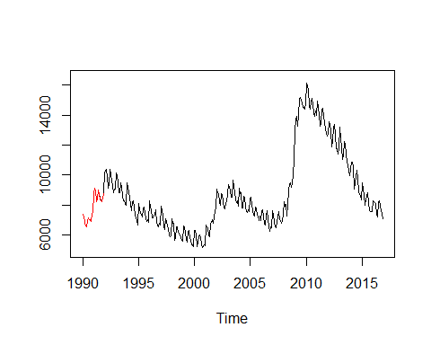

The result is still not ideal. I think the initialization is not appropriate, since the trend and seasonal values are too small. I am going to test my guess by using **SIR(Sequential Importance Resampling)**. Since in SIR, there should not have ‘degeneracy’ phenomenon, so if the result is still like the pics above, there must be something wrong.(Use **unemp** data)

library("seasonal")  
Data <- unemp # 1990.1-2016.11 # 323 records  
summary(Data)  
set.seed(1)  
S <- matrix(0,100,334) # Cause Seasonal component's state space model, we have additional 11 zero-values.  
Tr <- matrix(0,100,334) # Hence 323+11 columns  
component <- c()  
for (i in 12:334) {  
 # update particles  
 Tr[,i] <- Tr[,i-1] + rnorm(100)  
 for (j in 1:11) S[,i] <- S[,i]-S[,i-j]  
 S[,i] <- S[,i] + rnorm(100)  
   
 # update weights  
 w <- dnorm(rep(Data[i-11],100)-Tr[,i]-S[,i])  
 w <- w / sum(w)  
   
 # evaluate state value  
 t <- sum(w * Tr[,i])  
 s <- sum(w * S[,i])  
   
 # add to our component path  
 component <- rbind(component, c(t,s))  
   
 # resample  
 Tr[,i] <- sample(Tr[,i], size=100, replace=TRUE, prob=w)  
 S[,i] <- sample(S[,i], size=100, replace=TRUE, prob=w)  
}  
trend <- ts(component[,1],frequency = 12, start = c(1990,1),end = c(2016,11))  
season <- ts(component[,2],frequency = 12, start = c(1990,1),end = c(2016,11))  
plot(trend)  
plot(season)  
plot(Data,type="l",ylab="", ylim=c(5000,16500))  
lines(Data-season, ylab="",ylim=c(5000,16500),col="red")

library("seasonal")  
Data <- unemp # 1990.1-2016.11 # 323 records  
summary(Data)

## Min. 1st Qu. Median Mean 3rd Qu. Max.   
## 5153 7012 8078 8766 9476 16147

set.seed(1)  
S <- matrix(0,100,334) # Cause Seasonal component's state space model, we have additional 11 zero-values.  
Tr <- matrix(0,100,334) # Hence 323+11 columns  
component <- c()  
for (i in 12:334) {  
 # update particles  
 Tr[,i] <- Tr[,i-1] + rnorm(100)  
 for (j in 1:11) S[,i] <- S[,i]-S[,i-j]  
 S[,i] <- S[,i] + rnorm(100)  
 # update weights  
 w <- dnorm(rep(Data[i-11],100)-Tr[,i]-S[,i])  
 w <- w / sum(w)  
}  
dnorm(rep(Data[323],100)-Tr[,334]-S[,334])

## [1] 0 0 0 0 0 0 0 0 0 0 0 0 0 0 0 0 0 0 0 0 0 0 0 0 0 0 0 0 0 0 0 0 0 0 0  
## [36] 0 0 0 0 0 0 0 0 0 0 0 0 0 0 0 0 0 0 0 0 0 0 0 0 0 0 0 0 0 0 0 0 0 0 0  
## [71] 0 0 0 0 0 0 0 0 0 0 0 0 0 0 0 0 0 0 0 0 0 0 0 0 0 0 0 0 0 0

# update weights  
 w <- dnorm(rep(Data[1],100)-Tr[,12]-S[,12])  
 w <- w / sum(w)

**- Update 6.2 -** 从上次和Aaron见完之后，就一直在划水，心里也挺不过意不去的。因为种种事情都没有静下心来学习，感觉今天积攒了很久的洪荒之力可以稍微发泄一下？另外就是手腕这两天也一直没有休息过来，还是要多加注意呀。接下来说正事儿吧。

If we analyse the case above why the weights are zeros, it is not difficult to find our initializations are around 0 and $Y$, our data is quite large. If we use $ϕ(y_{t}−T_{t}−S_{t})$ to generate our weights, it is obvious that weights are gonna very small, almost 0.( $ϕ()$ is the density of standard normal distribution.)  
So why don’t I let the first trend component (i.e. $T_{1}$) to be equal to $Y_{1}$? Cause we suppose

$$\sum_{i=0}^{s−1}{S_{t−i}}=0$$

well,no more talking, let’s try. (Hope it works well)

library("seasonal")  
Data <- unemp # 1990.1-2016.11 # 323 records  
summary(Data)  
set.seed(1)  
S <- matrix(0,100,334) # Cause Seasonal component's state space model, we have additional 11 zero-values.  
Tr <- matrix(0,100,334) # Hence 323+11 columns  
Tr[,11] <- Data[1]  
component <- c()  
for (i in 12:334) {  
 # update particles  
 Tr[,i] <- Tr[,i-1] + rnorm(100)  
 for (j in 1:11) S[,i] <- S[,i]-S[,i-j]  
 S[,i] <- S[,i] + rnorm(100)  
   
 # update weights  
 w <- dnorm(rep(Data[i-11],100)-Tr[,i]-S[,i])  
 w <- w / sum(w)  
   
 # evaluate state value  
 t <- sum(w * Tr[,i])  
 s <- sum(w * S[,i])  
   
 # add to our component path  
 component <- rbind(component, c(t,s))  
   
 # resample  
 Tr[,i] <- sample(Tr[,i], size=100, replace=TRUE, prob=w)  
 S[,i] <- sample(S[,i], size=100, replace=TRUE, prob=w)  
}  
trend <- ts(component[,1],frequency = 12, start = c(1990,1),end = c(2016,11))  
season <- ts(component[,2],frequency = 12, start = c(1990,1),end = c(2016,11))  
plot(trend)  
plot(season)  
plot(Data,type="l",ylab="", ylim=c(5000,16500),lwd=1.5)  
lines(Data-season, ylab="",ylim=c(5000,16500),col="red")

This chunk is wrong since the weights’ problem. I am going to check the weights below:

set.seed(1)  
S <- matrix(0,100,334) # Cause Seasonal component's state space model, we have additional 11 zero-values.  
Tr <- matrix(0,100,334) # Hence 323+11 columns  
Tr[,11] <- Data[1]  
  
for (i in 12) {  
   
 # update particles  
 Tr[,i] <- Tr[,i-1] + rnorm(100)  
 for (j in 1:11) {  
 S[,i] <- S[,i]-S[,i-j]   
 }  
 S[,i] <- S[,i] + rnorm(100)  
   
 # update weights  
 w <- dnorm(Data[i-11]-Tr[,i]-S[,i])  
 w <- w / sum(w)  
}  
  
Tr[,13] <- Tr[,12] +rnorm(100)  
S[,13] = -S[,12] + rnorm(100)  
w<-dnorm(Data[2]-Tr[,13]-S[,13])  
w

## [1] 0 0 0 0 0 0 0 0 0 0 0 0 0 0 0 0 0 0 0 0 0 0 0 0 0 0 0 0 0 0 0 0 0 0 0  
## [36] 0 0 0 0 0 0 0 0 0 0 0 0 0 0 0 0 0 0 0 0 0 0 0 0 0 0 0 0 0 0 0 0 0 0 0  
## [71] 0 0 0 0 0 0 0 0 0 0 0 0 0 0 0 0 0 0 0 0 0 0 0 0 0 0 0 0 0 0

Data[2]-Tr[,13]-S[,13]

## [1] -118.2970 -117.7831 -120.6332 -117.7227 -117.3530 -118.4221 -117.5208  
## [8] -117.9367 -116.1536 -115.8456 -120.0268 -118.3713 -114.0921 -113.4100  
## [15] -119.2842 -119.9368 -116.5111 -116.8486 -116.6751 -118.2208 -117.9996  
## [22] -117.9383 -117.4735 -112.9794 -117.0455 -118.4905 -116.2332 -114.1319  
## [29] -116.5367 -118.6846 -116.9856 -113.0281 -115.8482 -120.3995 -114.9224  
## [36] -118.7560 -118.4141 -116.2869 -119.4966 -117.2850 -120.1967 -115.5407  
## [43] -119.8316 -116.8520 -116.3252 -113.6343 -115.6486 -117.3042 -118.8111  
## [50] -122.4297 -118.5580 -117.4910 -117.9695 -116.3595 -122.1939 -121.7981  
## [57] -112.0561 -116.9942 -117.4100 -114.3751 -117.3352 -118.1242 -115.7114  
## [64] -116.5690 -118.4263 -115.8650 -115.7062 -119.2689 -116.3941 -116.6620  
## [71] -114.5199 -116.8565 -115.4788 -118.7234 -115.0687 -118.4481 -113.6088  
## [78] -115.5210 -114.5668 -117.8859 -118.8234 -116.5848 -118.3592 -116.4068  
## [85] -117.6471 -116.4341 -113.8010 -118.7519 -116.3290 -118.3872 -117.5685  
## [92] -118.7979 -120.2280 -115.7502 -121.4632 -117.8166 -116.6408 -118.4427  
## [99] -114.5977 -117.4671

…stupid… The result is still not right. The assumption just worked at the first moment then failed.

Maybe I can use the first twelve values $Y_{1},...,Y_{12}$ to generate an initial set of seasonal components? In other words, i) compute the average $\overline{Y}$; ii) use the differences as seasonal components of one loop. But this will be only correct when there is no trend influence in this ts!

**WHAT CAN I DO ?** 自己再多想一想 总会有办法的。网上查查资料吧。

Wait… 我为什么不试一试我自己的数据呢？如果trend是缓慢变化的话(*-Update 6.4- actually I am not sure whether we can use the state space model above in* ***unemp*** *data set, since the sarima model of it is different from that of Durbin’s report*)，某种程度上SIR应该是可以用的吧？ try it:

set.seed(1)  
S <- matrix(0,100,251) # Cause Seasonal component's state space model, we have additional 11 zero-values.  
Tr <- matrix(0,100,251)  
Tr[,11] <- data[1]  
component <- c()  
for (i in 12:251) {  
   
 # update particles  
 Tr[,i] <- Tr[,i-1] + rnorm(100)  
 for (j in 1:11) S[,i] <- S[,i]-S[,i-j]  
 S[,i] <- S[,i] + rnorm(100)  
   
 # update weights  
 w <- dnorm(data[i-11]-Tr[,i]-S[,i])  
 w <- w / sum(w)  
   
 # evaluate state value  
 t <- sum(w * Tr[,i])  
 s <- sum(w * S[,i])  
   
 # add to our component path  
 component <- rbind(component, c(t,s))  
   
 # resample  
 Tr[,i] <- sample(Tr[,i], size =100, replace = TRUE, prob = w)  
 S[,i] <- sample(S[,i], size = 100, replace = TRUE, prob = w)  
}  
  
trend <- ts(component[,1],frequency = 12, start = c(2001,1),end = c(2020,12))  
season <- ts(component[,2],frequency = 12, start = c(2001,1),end = c(2020,12))  
plot(trend)  
plot(season)  
plot(data,type="l",ylab="", ylim=c(-50,2000))  
lines(data-season, ylab="",ylim=c(-50,2000),col="red")

The chunk above can not run. The code below is to check where the degeneracy happens:

set.seed(1)  
S <- matrix(0,100,251) # Cause Seasonal component's state space model, we have additional 11 zero-values.  
Tr <- matrix(0,100,251)  
Tr[,11] <- data[1]  
component <- c()  
for (i in 12:14) {  
   
 # update particles  
 Tr[,i] <- Tr[,i-1] + rnorm(100)  
 for (j in 1:11) S[,i] <- S[,i]-S[,i-j]  
 S[,i] <- S[,i] + rnorm(100)  
   
 # update weights  
 w <- dnorm(data[i-11]-Tr[,i]-S[,i])  
 w <- w/sum(w)  
   
 # evaluate state value  
 t <- sum(w * Tr[,i])  
 s <- sum(w * S[,i])  
   
 # add to our component path  
 component <- rbind(component, c(t,s))  
   
 # resample  
 Tr[,i] <- sample(Tr[,i], size =100, replace = TRUE, prob = w)  
 S[,i] <- sample(S[,i], size = 100, replace = TRUE, prob = w)  
}  
w

## [1] 2.189091e-24 2.326805e-34 1.453344e-22 2.441187e-09 2.014216e-08  
## [6] 1.762221e-03 4.396355e-05 7.945319e-11 3.757556e-18 4.418994e-36  
## [11] 1.073132e-21 1.629745e-30 1.429414e-05 3.265350e-10 2.720454e-20  
## [16] 5.763297e-06 9.120677e-18 9.231106e-12 7.140953e-20 5.607044e-11  
## [21] 4.899712e-06 5.591104e-07 7.726781e-28 4.144347e-25 2.530796e-18  
## [26] 3.589514e-15 4.510176e-10 5.292965e-09 1.169976e-09 2.031101e-21  
## [31] 2.325723e-08 1.059966e-09 8.206373e-03 1.149813e-12 1.629605e-16  
## [36] 1.070495e-24 7.651830e-18 2.495841e-25 1.838943e-09 1.159049e-20  
## [41] 4.345031e-03 4.117133e-11 2.436136e-30 2.867601e-18 4.302048e-15  
## [46] 7.983313e-13 4.773519e-14 3.259247e-09 9.021973e-22 3.200885e-21  
## [51] 1.028877e-10 6.213282e-09 3.301319e-12 1.386625e-18 1.950140e-13  
## [56] 1.764682e-02 1.479019e-35 7.262959e-20 5.795653e-12 3.308094e-12  
## [61] 4.730831e-16 1.791086e-14 1.514309e-07 5.856578e-12 2.038496e-13  
## [66] 2.313757e-24 6.958226e-11 2.208192e-27 3.243754e-29 2.250399e-19  
## [71] 1.440509e-01 3.880587e-10 2.857292e-15 5.844375e-10 1.335457e-28  
## [76] 1.773912e-11 1.298437e-14 2.161121e-26 3.018623e-13 5.813938e-12  
## [81] 3.499301e-12 7.486624e-09 1.720131e-18 5.330352e-29 2.705016e-29  
## [86] 9.156298e-06 1.859245e-17 1.903414e-19 6.750105e-11 3.220691e-22  
## [91] 1.191600e-10 3.542694e-14 2.149015e-09 9.207351e-28 2.169345e-16  
## [96] 1.917820e-17 8.239033e-01 6.491148e-06 1.056944e-15 3.806593e-14

# seperate   
w <- dnorm(data[3]-Tr[,14]-S[,14])  
w <- w/sum(w)  
w

## [1] 1.101409e-02 1.101409e-02 1.101409e-02 5.144544e-06 5.144544e-06  
## [6] 1.101409e-02 1.101409e-02 1.101409e-02 1.101409e-02 1.101409e-02  
## [11] 1.101409e-02 1.101409e-02 1.101409e-02 1.101409e-02 5.144544e-06  
## [16] 1.925698e-03 1.101409e-02 1.101409e-02 1.101409e-02 5.144544e-06  
## [21] 1.101409e-02 1.101409e-02 3.477036e-02 1.167785e-02 1.101409e-02  
## [26] 5.144544e-06 1.101409e-02 1.925698e-03 1.101409e-02 1.101409e-02  
## [31] 6.619043e-03 1.101409e-02 1.101409e-02 1.101409e-02 1.101409e-02  
## [36] 1.101409e-02 1.101409e-02 1.101409e-02 1.101409e-02 1.101409e-02  
## [41] 3.477036e-02 1.841524e-02 5.144544e-06 1.101409e-02 1.101409e-02  
## [46] 1.101409e-02 1.101409e-02 3.477036e-02 1.101409e-02 5.144544e-06  
## [51] 1.101409e-02 1.101409e-02 1.101409e-02 1.101409e-02 2.781106e-05  
## [56] 1.101409e-02 1.101409e-02 1.101409e-02 1.101409e-02 1.101409e-02  
## [61] 1.101409e-02 1.101409e-02 5.144544e-06 1.101409e-02 5.144544e-06  
## [66] 5.144544e-06 1.101409e-02 1.101409e-02 3.477036e-02 1.101409e-02  
## [71] 1.925698e-03 5.144544e-06 2.781106e-05 1.101409e-02 3.477036e-02  
## [76] 1.101409e-02 1.101409e-02 5.144544e-06 1.101409e-02 1.101409e-02  
## [81] 4.989486e-05 1.101409e-02 1.101409e-02 5.144544e-06 4.137657e-03  
## [86] 5.144544e-06 1.101409e-02 5.144544e-06 1.101409e-02 6.619043e-03  
## [91] 1.101409e-02 1.101409e-02 5.144544e-06 1.101409e-02 3.477036e-02  
## [96] 1.101409e-02 1.101409e-02 1.101409e-02 1.101409e-02 1.101409e-02

It is very weird. The result from the for loop is different from that of separate code.  
**-Update 6.4-** after talking with Aaron, I realized where I made a mistake. The Tr and S I used in the seperate case is after resampling…(stupid -_-|)

——————————–**UPDATE 6.4**————————————-