simulation exercise

linyiguo

2019.5.24

我在想借助**R Markdown**这个工具来记录我平时学习的心路历程。在做研究的过程中，势必会产生很多感想，不论是感性上还是理性上，我都愿意把这些ideas记录下来，这样也许更有助于我理清自己的思路，不至于脑子里总是一盆浆糊。在以后，我可能更想用英语来写，但目前个人能力有限，就慢慢来吧。

After meeting with Aaron，I think I still need to spend more time on research, although I have other plans on working out and ielts. But research should be my first goal, given my current situation. Well, let’s say what we were talking about in this morning: I am trying to simulate some data from different models and these data will be used in my later research(since I do not have real data now).

# Auto-regressive model

Let’s say we want to simulate data corresponding to model *AR(1)*:

$$Z_{t}=0.9*Z_{t−1}+ϵ_{t}$$

where $ϵ∼N(0,1)$, $Z_{0}=1$

set.seed(1)  
epsilon <- rnorm(1000)  
Z <- rep(0,1001)  
Z[1] <- 1  
for(i in 2:1001) Z[i] <- 0.9*Z[i-1] + epsilon[i-1]  
plot(Z[2:1001], type="l")

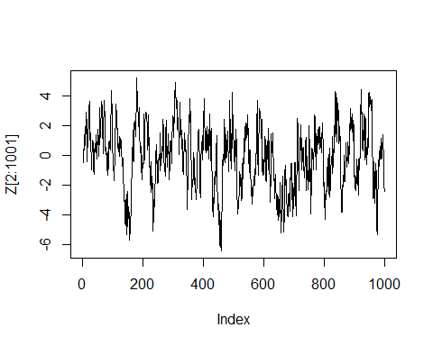

set.seed(1)  
epsilon <- rnorm(1000)  
Z <- rep(0,1001)  
Z[1] <- 100  
for(i in 2:1001) Z[i] <- 0.9*Z[i-1] + epsilon[i-1]  
plot(Z[2:1001], type="l")

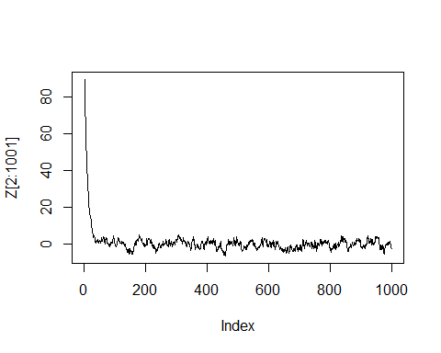

set.seed(1)  
Z <- rep(0,1001)  
Z[1] <- 1  
for(i in 2:1001) Z[i] <- 0.01*Z[i-1] + epsilon[i-1]  
plot(Z[2:1001], type="l")

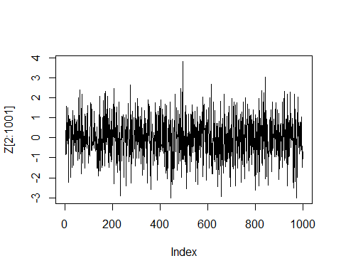

set.seed(1)  
Z <- rep(0,5001)  
e <- rnorm(5000)  
Z[1] <- 1  
for(i in 2:5001) Z[i] <- 0.9*Z[i-1] + e[i-1]  
plot(Z[2:5001], type="l")

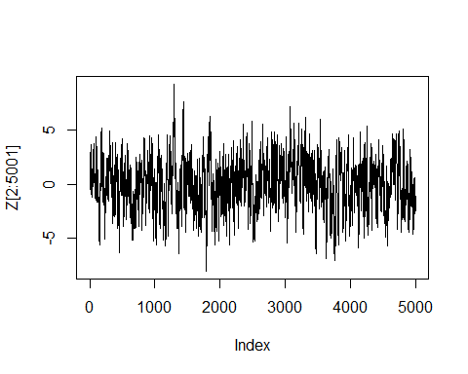

**comment:** 从上面的图像可以看出，，振幅就越大；同时，初始值 $Z_{0}$ 不会对最终的结果产生影响。我在想一个问题，为什么 $ϕ_{1}$ 的值和ts的amplitude有关？Intuitively， $Z_{t−1}$ is also a variable, which has a normal dist’n as well(since we assume noises are normal), so $Z_{t}$ is the sum of several normal dist’n, but is mainly determined by the first ones(since $ϕ<0$, efficients converge to 0).

# Moving-average model

Here, we simulate data to fit the model *MA(1)*:

$$Z_{t}=ϵ_{t}+0.9*ϵ_{t−1}$$

where $ϵ∼N(0,1)$, $Z_{0}=1$

set.seed(1)  
Z <- rep(0,1001)  
epsilon <- rnorm(1001)  
Z[1] <- 0  
for(i in 2:1001) Z[i] = epsilon[i]+0.9*epsilon[i-1]  
plot(Z[2:1001],type="l")

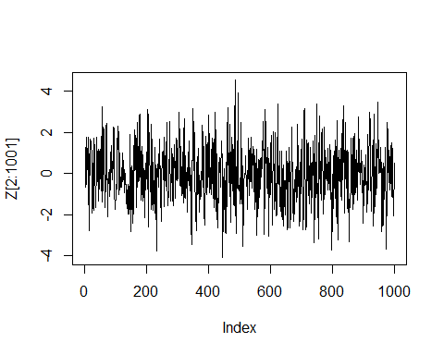

# Auto-regressive moving-average model

Let’s say we want to simulate data according to an *ARMA(1,1)* model:

$$Z_{t}−0.9*Z_{t−1}=ϵ_{t}+0.9*ϵ_{t−1}$$

where $ϵ∼N(0,1)$, $Z_{0}=1$

set.seed(1)  
Z <- rep(0,2001)  
e <- rnorm(2000)  
for(i in 2:2001) Z[i] = 0.9*Z[i-1]+e[i]+0.9*e[i-1]  
plot(Z,type="l")

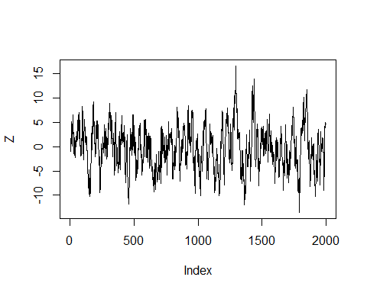

**[update 2019.5.26]** 其实我发现simulate数据并不是我想的这么麻烦，在R中有一些code可以帮助我们很轻易地模拟得到想要的数据，比如：

a <- arima.sim(model=list(ar=c(0.9),ma=c(0.9)), n=1000,innov = rnorm(1000))  
plot(a)

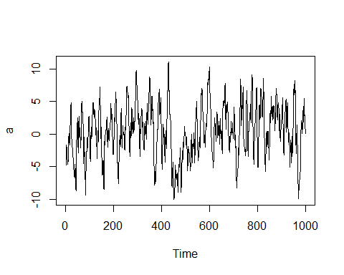

# Auto-regressive integrated moving-average model

Suppose we want to simulate data to fit *ARIMA(1,1,1)* model:

$$(1−0.9B)(1−B)Z_{t}=ϵ_{t}+0.9*ϵ_{t−1}$$

where $ϵ∼N(0,1)$, $Z_{0}=Z_{1}=1$

set.seed(1)  
Z <- rep(0,1001)  
e <- rnorm(1000)  
Z[1] <- 1  
Z[2] <- 1  
for (i in 3:1001) Z[i] <- 1.9*Z[i-1]-0.9*Z[i-2]+e[i-1]+0.9*e[i-2]  
plot(Z[3:1001],type="l")

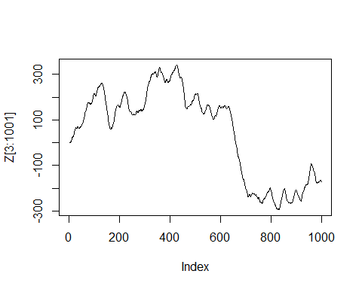

Y <- Z[2:1001] - Z[1:1000]  
plot(Y, type="l")

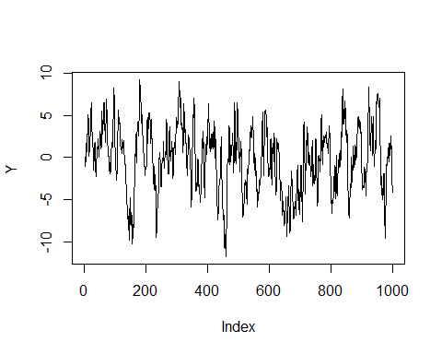

**comment**:

# Seasonal Autoregressive Moving-average Model

Now, we consider *SARIMA* model， which can be viewed as an expanded model of *ARIMA*. Let’s say our model is $ARIMA(1,1,1)*(1,1,1)_{4}$, that is,

$$(1−0.9B)(1−0.9B^{4})(1−B)(1−B^{4})Z_{t}=(1−0.9B)(1−0.9B^{4})ϵ_{t}$$

After expansion, we have

$$(1−1.9B+0.9B^{2}−1.9B^{4}+3.61B^{5}−1.71B^{6}+0.9B^{8}−1.71B^{9}+0.81B^{10})*Z_{t}=(1−0.9B−0.9B^{4}+0.81B^{5})*ϵ_{t}$$

where $ϵ∼N(0,1)$, we take $Z_{1},Z_{2},...,Z_{10}$ randomly from normal distribution N(0,1).

set.seed(1)  
Z <- rep(0,1001)  
e <- rnorm(1001)  
#Z[1:10] <- rnorm(10)  
Z[1:10] <- c(1,2,3,4,1,2,3,4,1,2)  
for (i in 11:1001) {  
 Z[i] <- e[i]-0.9*e[i-1]-0.9*e[i-4]+0.81*e[i-5]+1.9*Z[i-1]-0.9*Z[i-2]+1.9*Z[i-4]-3.61*Z[i-5]+1.71*Z[i-6]-0.9*Z[i-8]+1.71*Z[i-9]-0.81*Z[i-10]  
}  
plot(Z[11:1001],type="l")

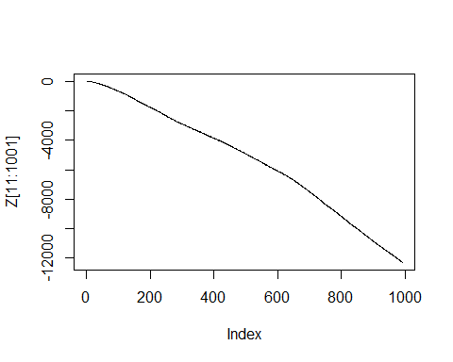

Y <- Z[6:1001]-Z[5:1000]-Z[2:997]+Z[1:996]  
plot(Y,type="l")

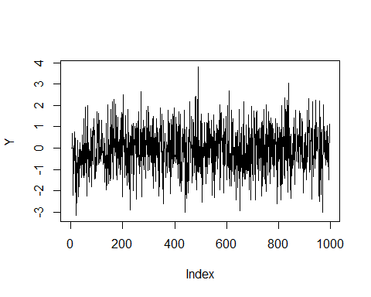

plot(Z[1:10],type="l")

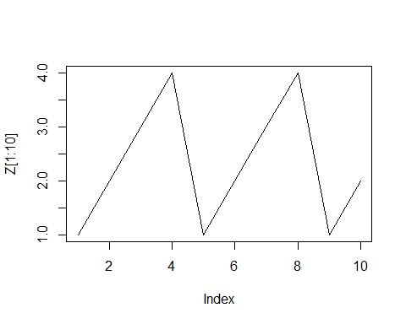

Well, this is a little weird, cause the curve I expect should be with obvious seasonal fluctuations. Let’s try another *SARIMA* model:

$$(1−B)(1−B^{4})Z_{t}=(1−0.4B)(1−0.6B^{4})ϵ_{t}$$

which is equal to

$$Z_{t}=Z_{t−1}+Z_{t−4}−Z_{t−5}+ϵ_{t}−0.4*ϵ_{t−1}−0.6*ϵ_{t−4}+0.24*ϵ_{t−5}$$

Z <- rep(0,100)  
e <- rnorm(100)  
Z[1:5] <- c(3,10,5,0.1,3.5)  
for (i in 6:100) Z[i] <- Z[i-1]+Z[i-4]-Z[i-5]+e[i]-0.4*e[i-1]-0.6*e[i-4]+0.24*e[i-5]  
  
plot(Z,type="l")

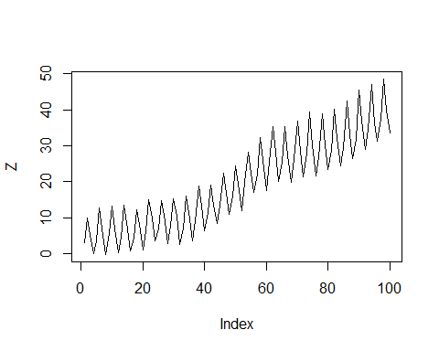

Y <- Z[6:100]-Z[5:99]-Z[2:96]+Z[1:95]  
plot(Y,type="l")

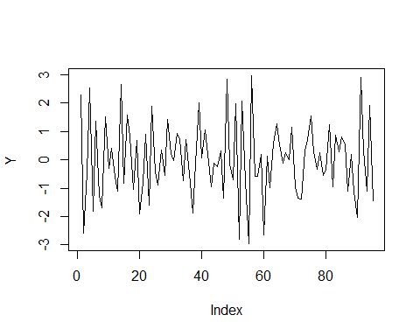

I saw a method to simulate data for a known dist’n([source](https://robjhyndman.com/hyndsight/simulating-from-a-specified-seasonal-arima-model/)), let’s try:

library(forecast)

## Registered S3 methods overwritten by 'ggplot2':  
## method from   
## [.quosures rlang  
## c.quosures rlang  
## print.quosures rlang

## Registered S3 method overwritten by 'xts':  
## method from  
## as.zoo.xts zoo

## Registered S3 method overwritten by 'quantmod':  
## method from  
## as.zoo.data.frame zoo

## Registered S3 methods overwritten by 'forecast':  
## method from   
## fitted.fracdiff fracdiff  
## residuals.fracdiff fracdiff

set.seed(1)  
model <- Arima(ts(rnorm(24000),freq=12), order=c(0,1,1), seasonal=c(0,1,1),fixed=c(theta=0.313, Theta=0.817))  
foo <- simulate(model,nsim = 240)  
plot(foo,type="l")

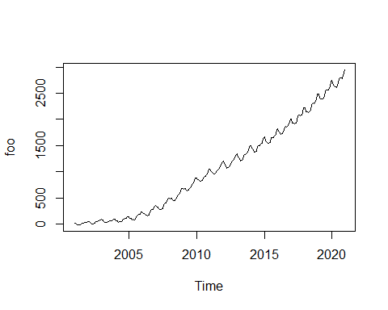

foo

## Jan Feb Mar Apr May  
## 2001 10.3408032 11.2264006 -0.9604257 -14.8070713 -13.5772513  
## 2002 50.3907762 47.6905099 23.2798942 -1.8270887 -0.9011335  
## 2003 84.4329722 69.5446959 48.6671463 22.8438096 24.7184622  
## 2004 96.8827042 68.1862340 64.5230956 37.1204034 43.9962427  
## 2005 138.6868890 103.2394906 109.1220867 79.7727820 87.3522521  
## 2006 233.8640890 194.4476100 192.8628578 163.9490385 165.3996883  
## 2007 348.3970770 316.0691704 317.1798696 289.8313020 281.9089861  
## 2008 493.5886701 475.7920618 487.7115568 463.7267696 451.2597762  
## 2009 676.5103128 660.5762374 675.2845740 651.1063055 639.4900008  
## 2010 878.5850876 845.7284190 854.2341604 824.1072746 816.8156419  
## 2011 1049.2271060 1000.3351041 993.5976658 955.4308774 951.5920538  
## 2012 1198.1862439 1136.2601561 1112.9924479 1070.4753178 1078.2603282  
## 2013 1347.2836581 1284.6252336 1252.4697929 1210.7021340 1221.8822675  
## 2014 1501.7267257 1446.8332758 1418.3647548 1375.6020213 1375.7372164  
## 2015 1660.1586641 1600.0516280 1576.2705779 1538.8688000 1538.4472391  
## 2016 1825.3464651 1758.1330828 1745.2148310 1720.1782383 1729.5556365  
## 2017 2006.9801360 1935.2096809 1932.4426273 1914.4567240 1930.4088229  
## 2018 2225.5190303 2146.9179456 2143.9723535 2127.2963478 2140.8231377  
## 2019 2488.8387882 2402.7384114 2395.8135960 2384.9781634 2390.6515395  
## 2020 2745.1812622 2649.9981864 2634.0703994 2622.4640545 2616.0963185  
## Jun Jul Aug Sep Oct  
## 2001 -12.2068474 -0.7280686 16.9448287 21.8299733 27.8209287  
## 2002 2.3337353 18.5976583 42.8542247 45.1201207 53.9783825  
## 2003 29.5488333 40.1019091 62.9246449 54.9975986 68.0087913  
## 2004 39.1243511 51.9636292 92.8812687 94.3217415 108.2604452  
## 2005 77.2960645 93.4422099 150.1555975 169.1391994 180.0502818  
## 2006 157.5114997 171.2907353 237.9187892 269.6925844 273.0126647  
## 2007 276.8036169 289.1070811 350.2236738 387.5357566 401.9674400  
## 2008 453.3386509 475.2320355 521.4923505 557.6723219 582.0191890  
## 2009 647.0350792 680.8852711 714.2948435 743.4982193 773.6346799  
## 2010 832.5891847 872.3028533 891.2863807 914.6763674 948.0271065  
## 2011 969.7088605 1016.6779244 1032.6215934 1061.7735120 1099.7531818  
## 2012 1087.7299796 1148.0961755 1168.3381098 1198.5489140 1236.7330131  
## 2013 1234.3568392 1310.1042178 1326.9537276 1342.0105923 1374.5564290  
## 2014 1394.2791691 1478.9510289 1492.1753387 1492.9543660 1522.9551960  
## 2015 1559.8835779 1643.9110050 1658.0537242 1653.4728151 1685.8352316  
## 2016 1763.8054172 1851.8340570 1869.1976235 1852.9965589 1881.6535296  
## 2017 1970.0569893 2064.1551227 2087.8783668 2066.0838530 2090.4058012  
## 2018 2180.4136732 2277.9086180 2310.8898600 2296.7906261 2318.6258937  
## 2019 2431.5680263 2525.0783066 2568.2517211 2556.6222628 2562.9503008  
## 2020 2661.2222267 2755.5171362 2800.4116153 2790.7061190 2783.0522744  
## Nov Dec  
## 2001 24.4657549 36.3180075  
## 2002 55.1437472 75.8807984  
## 2003 71.1121628 93.5097456  
## 2004 114.5743881 141.0896547  
## 2005 187.6891221 230.0530013  
## 2006 284.0037685 336.3064711  
## 2007 427.8087441 486.0252321  
## 2008 619.2790918 679.1338747  
## 2009 820.7172141 881.9302128  
## 2010 986.2552497 1049.0367844  
## 2011 1126.1721616 1189.2242164  
## 2012 1263.1629425 1329.4626998  
## 2013 1399.9202331 1475.3637103  
## 2014 1543.1112577 1630.0228110  
## 2015 1707.4959638 1803.6917045  
## 2016 1911.2588828 2000.7056088  
## 2017 2129.5361416 2224.4124532  
## 2018 2373.1193621 2485.5844926  
## 2019 2617.7381824 2734.7282969  
## 2020 2833.5408806 2949.9900040

summary(model)

## Series: ts(rnorm(24000), freq = 12)   
## ARIMA(0,1,1)(0,1,1)[12]   
##   
## Coefficients:  
## ma1 sma1   
## 0.313 0.817   
##   
## sigma^2 estimated as 31.02: log likelihood=-75233.5  
## AIC=150469 AICc=150469 BIC=150477.1  
##   
## Training set error measures:  
## ME RMSE MAE MPE MAPE MASE  
## Training set 0.0001462373 5.567472 4.429197 256.4385 4375.639 3.916237  
## ACF1  
## Training set -0.6522161

**Comment:**  our final SARIMA model is

$$(1−B)(1−B^{12})Z_{t}=(1−0.5B)(1−0.5B^{12})ϵ_{t}$$

. If we take one unit as one year(12 observations), then we have ten years’ data.

**—UPDATE 2019.5.26—** I am trying to check the method from the [answer](https://stackoverflow.com/questions/20273104/simulating-a-basic-sarima-model-in-r), but:

# install.packages("devtools")  
library("devtools")  
devtools::install_github("smac-group/gmwm")  
  
# Set seed for reproducibility  
set.seed(1)  
  
# Specify a SARIMA(0,1,1)(0,1,1)[12]   
mod = SARIMA(i=1, ma=.5, si = 1, sma = .5, s = 12, sigma2 = 1.5)  
  
# Generate the data  
xt2 = gen.gts(mod, 1e3)  
  
# Validate output  
arima(xt2, order=c(0,1,1), seasonal=list(order=c(0,1,1), period = 12))

## end(perhaps ?)

我感觉数据这块到这这儿就差不多了吧(**too young too naive**)，虽然最后*SARIMA*花了很长时间，走了很多弯路，而且最后的数据我现在还不是很确定能不能用，但是也只能先暂且相信网上的大牛们和自己的判断了。前路茫茫啊，年轻人，不要气馁，继续努力！感觉不能一直给自己说慢慢来，因为感觉目前自己的节奏真的有点太悠闲自在了些…不管怎样，还是要相信自己，坚持你的梦想，朝着梦想前进！别人能做到，为什么我不能呢！多思考，年轻人 :) Cheers ~