Preliminary Insight Development: Used Car Prices in India
COMM5000 Data Literacy · Case Study Project · Milestone 1 · Term 3, 2026
Word count: 996 (headings included; tables, figures, captions, notes, references and appendix excluded)

1 Introduction
India’s used car market now outsells the new car market, yet price appraisal still relies on manual valuation (UNSW Business School 2026, p. 4). Our client, an online marketplace, needs a fast and consistent price estimate at appraisal to support instant cash offers, spot mispriced listings and forecast stock turnover. An offer set too high erodes margin and one set too low loses the seller, so the client needs a typical price and its likely spread.
This report explores the 1,005,000 listings in the course dataset (Stable Space 2026) against the two project objectives (UNSW Business School 2026, p. 4): how Car_Price relates to the other variables, including brand segment, and how the methods could be improved. Section 2 presents the analysis and Section 3 the findings and plan.

2 Data Summaries and Descriptive Statistics

2.1 Data preparation
The analysis uses the workbook randomised on 26 September 2026 (Dataset sheet, cell B6); Excel formulas calculate every number. Labels were corrected only where the intended category was obvious, and no listing was deleted (Table 1). ‘Unknown’ entries were kept as a category because they affect 28.2% of rows and cannot be recovered. No cell is blank because the macro fills gaps (Stable Space 2026, cell B4) and sets negative draws to zero, so technical zeros were treated as missing.
The randomising macro (Franch 2026, slide 7) rewrites five numeric columns in its code, so repeated listings no longer look identical. Matching rows on the other 15 fields gives 31,575 identical pairs, about 4,750 more than the 26,821 expected by chance. They cannot be told apart from chance matches, so were flagged but kept. Keeping one row per match moves the median by only 0.01% (Table A4).
The guide treats more than 1,000,000 km as implausible (UNSW Business School 2026, p. 7). These 6,134 listings are close to the 6,102 expected from a log-normal fit, so they may be a genuine tail, but were left out of the usage analysis. A few isolated values, such as 4.6 hp, are too few to matter (Table 1).
Table 1 Data problems and how they were treated
Problem | Found with | Size | Treatment
Brand labels with extra spaces (e.g. ‘ BMW ’) | TRIM, EXACT | 10,040 rows (2,334 luxury) | Trimmed; 13 brands
Fuel_Type variants (PETROL, petrol, diesel with spaces, hybridd, electrik) | LOWER, TRIM, lookup table | 20,123 rows | Mapped to CNG, Diesel, Electric, Hybrid, Petrol; Unknown kept
Other text fields (Model, Transmission, Owner_Type, Color, City) | LEN, TRIM, category lists | No variants found | None needed
‘Unknown’ in Fuel_Type, Transmission, Color, City | COUNTIF | 78,733; 80,385; 80,419; 80,430. 283,648 rows have at least one | Kept as a category
Blank cells | COUNTBLANK | 0 | None; the macro fills gaps
Zero technical values (the macro sets negative draws to 0) | COUNTIF | Mileage 4; Engine 12; Horsepower 10 | Blank for that field only
Technical values beyond mean ± 3 SD | AVERAGEIF, STDEV.S, COUNTIFS | Mileage 36; Engine 52; Horsepower 33 (raw maxima 40.8 km/l, 5,502 cc, 393 hp) | Blank for that field only; far from the main range
Isolated values inside the ± 3 SD limits | MIN, COUNTIFS | hp: 44 < 50, 67 > 190; cc: 60 < 850, 97 > 2,250; km/l: 42 < 11, 37 > 25.5; price: 44 < INR 20,000 | Kept; too few to move any median
Identical rows on all 20 fields | FREQUENCY on Car_Price | 0 | None needed
Repeated rows on the 15 non-randomised fields | Sorted key, run count, category shares | 31,575 pairs in 29,640 repeat rows; 26,821 pairs expected by chance | Flagged and kept
Kms_Driven above 1,000,000 km | COUNTIF; NORM.DIST on LN(km) | 6,134 rows (0.61%), up to 5.8 million km (6,102 expected) | Excluded from usage analysis only (998,866 rows left)
Extreme Car_Price (3 × IQR on log scale) | QUARTILE, COUNTIF | 1 low, 2 high | Kept
Year and Registration_Age consistency | SUMPRODUCT | Sum is 2025 in all rows | Age used as supplied
Source: calculated from Stable Space (2026). A group of k identical rows gives k(k − 1)/2 pairs and k − 1 repeat rows. The chance count multiplies, over 13 fields, the probability that two random rows share a category (sum of squared shares); Brand and Year are left out because Model and Registration_Age already fix them. Limits for isolated values are the edges of the dense main range of each frequency distribution.

2.2 The variables
Table A1 describes all 20 fields and Table 2 groups them by type. Car_Price is in Indian rupees (INR), and Year and Registration_Age carry the same information. Registration_Age is spread evenly over 1 to 25 years, and Engine_CC, Horsepower and Mileage_kmpl are roughly flat across their main range, so their modes in Table 3 are not typical values.
Table 2 Variable types and how each type is summarised
Type | Fields | Summaries used
Numeric, continuous | Car_Price, Kms_Driven, Engine_CC, Horsepower, Mileage_kmpl | Mean, median, modal class, SD, min, max, quartiles; correlation with price
Numeric, discrete | Registration_Age, Year, Accidents, Number_of_Doors, Seats | The same, with the exact mode; count of each value
Categorical | Brand, Model, Fuel_Type, Transmission, Owner_Type, Color, City | Count and share of each category, Unknown kept; median price per category
Binary (1 = yes, 0 = no) | Insurance_Valid, Service_History, Tax_Paid | Share of 1s; here a 0 means “no”, not a missing value
Source: Stable Space (2026, cell B5). Results are in Tables 3 and A1 to A3.

2.3 Distribution of Car_Price
Car_Price is strongly right-skewed (Table 3; skewness 4.9). The long right tail lifts the mean of INR 1,015,107 to 50.7% above the median of INR 673,522, and 67.5% of listings sit below the mean (Figure 1a). The median and interquartile range (INR 365,843 to 1,240,714) therefore describe a typical car better and should be reported to the client. Log price is almost symmetric (skewness 0.001; Figure 1b), so price is roughly log-normal.
Table 3 Numerical summaries for all listings, luxury (Audi, BMW, Mercedes) and non-luxury listings
Variable | Group | n | Mean | Median | Modeᶜ | SD | Min | Max
Car_Price (INR) | All | 1,005,000 | 1,015,107 | 673,522 | 275,000 | 1,147,780 | 8,043 | 51,993,222
 | Luxury | 232,172 | 1,012,738 | 672,614 | 325,000 | 1,130,612 | 11,017 | 41,975,979
 | Non-luxury | 772,828 | 1,015,818 | 673,731 | 275,000 | 1,152,888 | 8,043 | 51,993,222
Registration_Age (years) | All | 1,005,000 | 13.0 | 13.0 | 6.0 | 7.2 | 1.0 | 25.0
 | Luxury | 232,172 | 13.0 | 13.0 | 18.0 | 7.2 | 1.0 | 25.0
 | Non-luxury | 772,828 | 13.0 | 13.0 | 19.0 | 7.2 | 1.0 | 25.0
Kms_Driven (km)ᵃ | All | 998,866 | 196,142 | 152,610 | 95,000 | 150,624 | 3,216 | 999,999
 | Luxury | 230,726 | 196,322 | 153,009 | 95,000 | 150,612 | 3,216 | 999,919
 | Non-luxury | 768,140 | 196,089 | 152,494 | 85,000 | 150,628 | 3,546 | 999,999
Engine_CC (cc)ᵇ | All | 1,004,936 | 1,506 | 1,494 | 875 | 408 | 304 | 2,720
 | Luxury | 232,158 | 1,507 | 1,495 | 875 | 409 | 304 | 2,664
 | Non-luxury | 772,778 | 1,506 | 1,494 | 875 | 408 | 305 | 2,720
Horsepower (hp)ᵇ | All | 1,004,957 | 120.5 | 119.8 | 62.5 | 38.7 | 4.6 | 235.2
 | Luxury | 232,159 | 120.5 | 119.8 | 57.5 | 38.8 | 7.6 | 234.0
 | Non-luxury | 772,798 | 120.5 | 119.8 | 62.5 | 38.7 | 4.6 | 235.2
Mileage_kmpl (km/l)ᵇ | All | 1,004,960 | 18.00 | 18.00 | 11.25 | 4.18 | 5.60 | 30.32
 | Luxury | 232,164 | 18.00 | 17.99 | 11.25 | 4.17 | 5.70 | 27.11
 | Non-luxury | 772,796 | 18.01 | 18.00 | 11.25 | 4.18 | 5.60 | 30.32
Accidents (count) | All | 1,005,000 | 0.30 | 0.00 | 0.00 | 0.55 | 0.00 | 5.00
 | Luxury | 232,172 | 0.30 | 0.00 | 0.00 | 0.55 | 0.00 | 5.00
 | Non-luxury | 772,828 | 0.30 | 0.00 | 0.00 | 0.55 | 0.00 | 5.00
Source: calculated from Stable Space (2026). ᵃ Kms_Driven ≤ 1,000,000. ᵇ Zeros and values beyond mean ± 3 SD excluded; Min and Max are isolated values (Table 1). ᶜ Exact mode for Registration_Age and Accidents; the continuous variables have no repeated value, so the midpoint of the most frequent class is shown (price 50,000; km 10,000; cc 50; hp 5; km/l 0.5). SD: sample standard deviation.
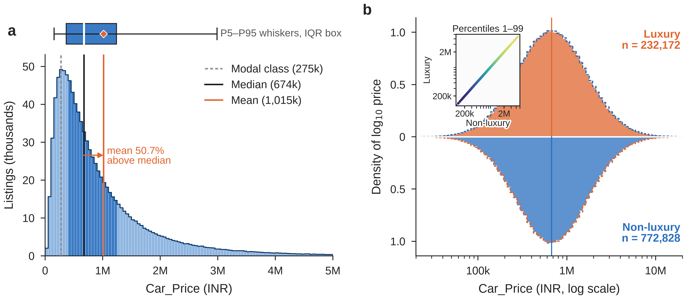
Figure 1 Distribution of Car_Price (n = 1,005,000). (a) Raw scale in INR 50,000 classes; darker bars and the box mark the interquartile range (IQR), whiskers the 5th to 95th percentiles and the diamond the mean; the 1.3% of listings above INR 5 million are not shown. (b) Log scale, luxury above and non-luxury mirrored below (dashed outline = the other segment). The inset plots the 1st to 99th percentiles of the two segments against each other; points on the diagonal mean the same distribution. M = million, k = thousand. Source: calculated from Stable Space (2026).

2.4 Price, vehicle age and usage
Price was plotted for 5,000 randomly chosen listings, the largest sample the guide suggests (UNSW Business School 2026, p. 7), beside medians for all listings (Figure 2). Registration_Age shows no clear association with price (r = 0.0001). Its median stays between INR 667,024 and 681,532 across all 25 ages (Figure 2b).
Usage has a weak negative association with price (r = −0.051). The median falls from INR 756,694 in the lowest usage decile to INR 603,779 in the highest, 20% lower. This compares different cars, not one car over time. Prices within each decile vary far more (Figure 2d). The median surface in Figure 3a slopes along usage and stays flat along age. In a 5,000-row sample, chance alone moves r by about ±0.028 (Figure 3b).
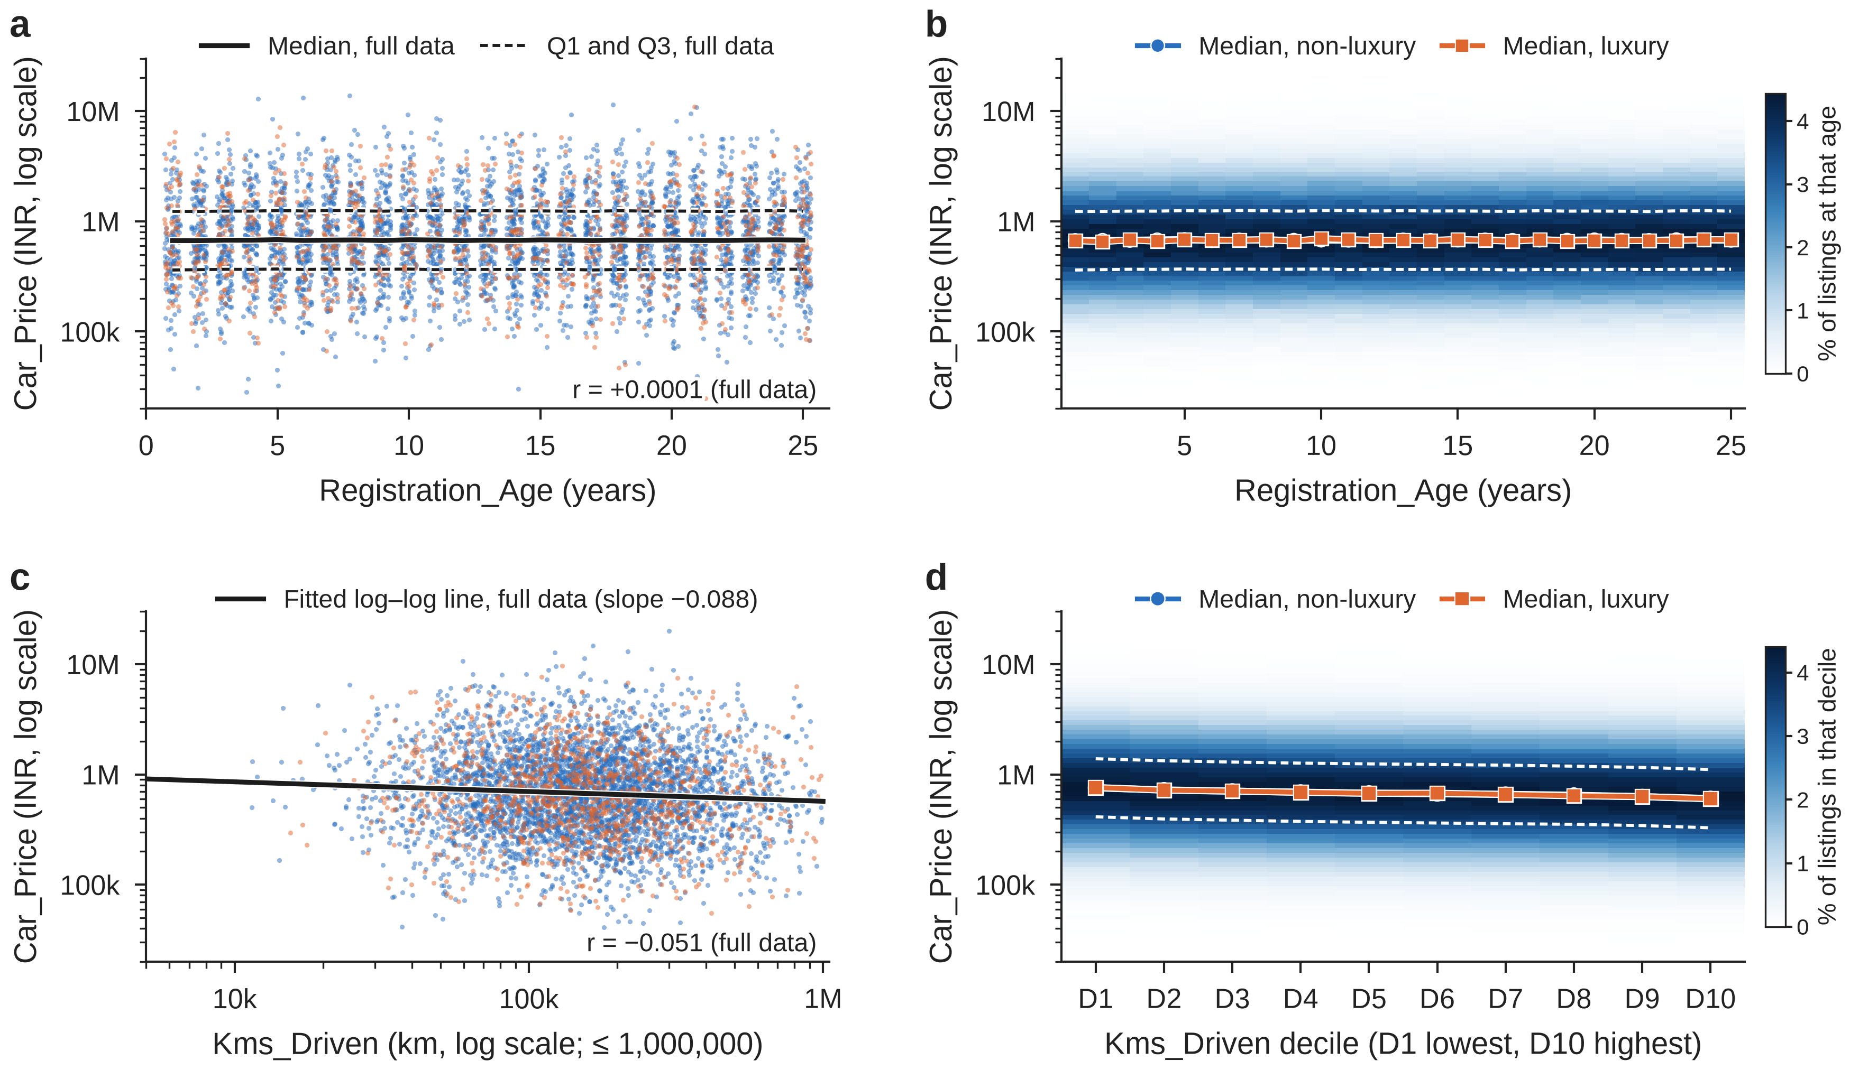
Figure 2 Car_Price against Registration_Age (a, b) and Kms_Driven (c, d). (a) and (c) Random samples of 5,000 listings (orange = luxury, blue = non-luxury); ages in (a) are spread by up to 0.3 years so that points do not overlap. Black lines use all listings: the median and quartiles by age in (a) and the fitted log–log line in (c). (b) and (d) Shading shows the share of all listings in each price class at each age or usage decile, with segment medians and the quartiles (white dashed). (c) and (d) use listings with Kms_Driven ≤ 1,000,000. Source: calculated from Stable Space (2026).
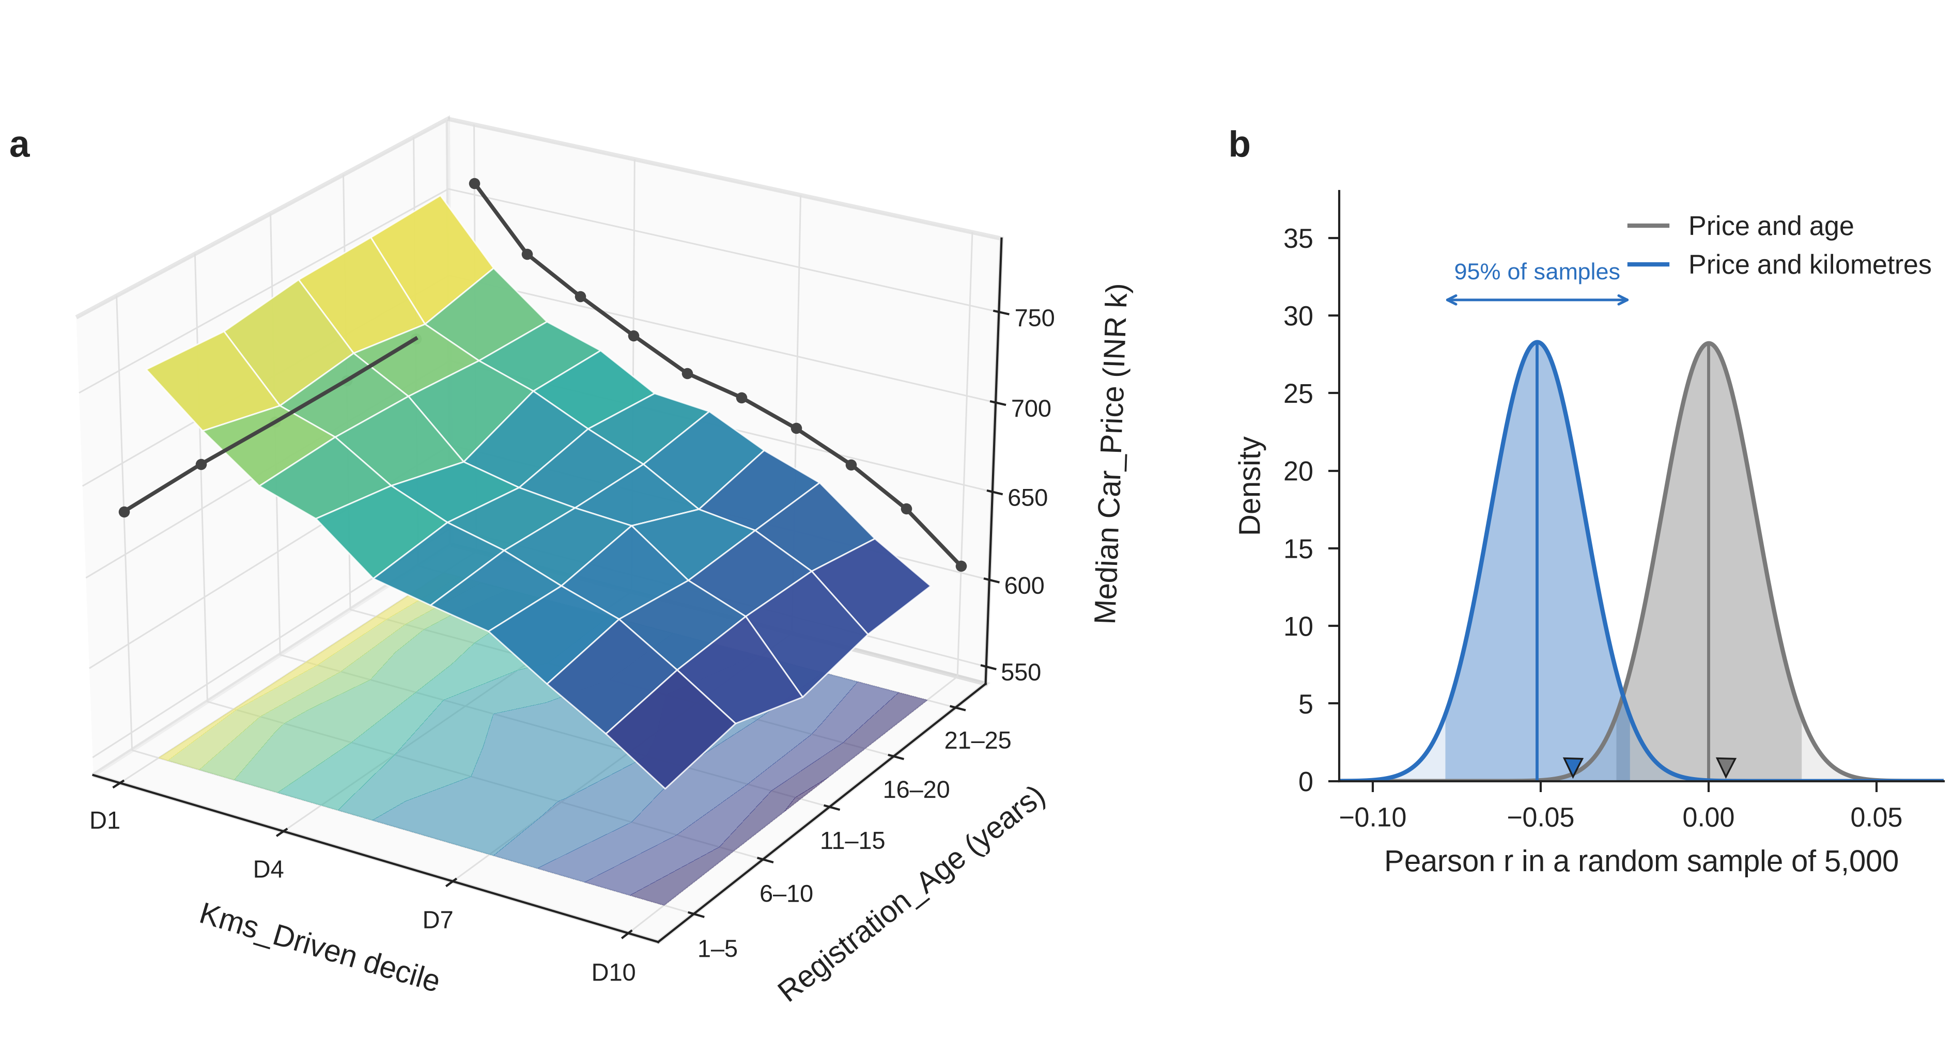
Figure 3 (a) Median Car_Price by five-year age band and usage decile, about 20,000 listings per cell. The floor repeats the surface as contours, the dark lines on the back walls are the medians by usage decile and by age band, and the vertical axis starts at INR 540,000. (b) Expected spread of the correlation in a random sample of 5,000 rows (normal approximation; darker shading = middle 95%); vertical lines mark the full-data values and triangles the samples used in Figure 2. Source: calculated from Stable Space (2026).

2.5 Brand segment and other variables
Luxury listings carry no price premium. Their mean price is 0.30% lower than for non-luxury cars and their median 0.17% lower, trivial next to a price SD of INR 1.15 million. The 13 brand medians lie within 1.24% of each other with overlapping intervals (Figure 4a). The two segments’ price distributions almost coincide, with lower and upper quartiles within 0.1% (Figure 1b; Table 4).
Table 4 Car_Price quartiles by segment (INR)
Group | n | Q1 | Median | Q3 | IQR
All | 1,005,000 | 365,843 | 673,522 | 1,240,714 | 874,871
Luxury | 232,172 | 365,600 | 672,614 | 1,239,750 | 874,150
Non-luxury | 772,828 | 365,894 | 673,731 | 1,241,027 | 875,133
Source: calculated from Stable Space (2026). Quartiles as Excel PERCENTILE.INC; IQR = Q3 − Q1.
Among the other numeric fields, only Horsepower (+0.033) and Engine_CC (+0.026) exceed ±0.005 in any segment (Figure 4b; Table A2). Other category medians differ by at most 1.53%, and the 3.2% spread across the 39 models is about what chance gives (Table A3). The conclusions hold without Unknown rows, extreme prices or possible duplicates (Table A4).
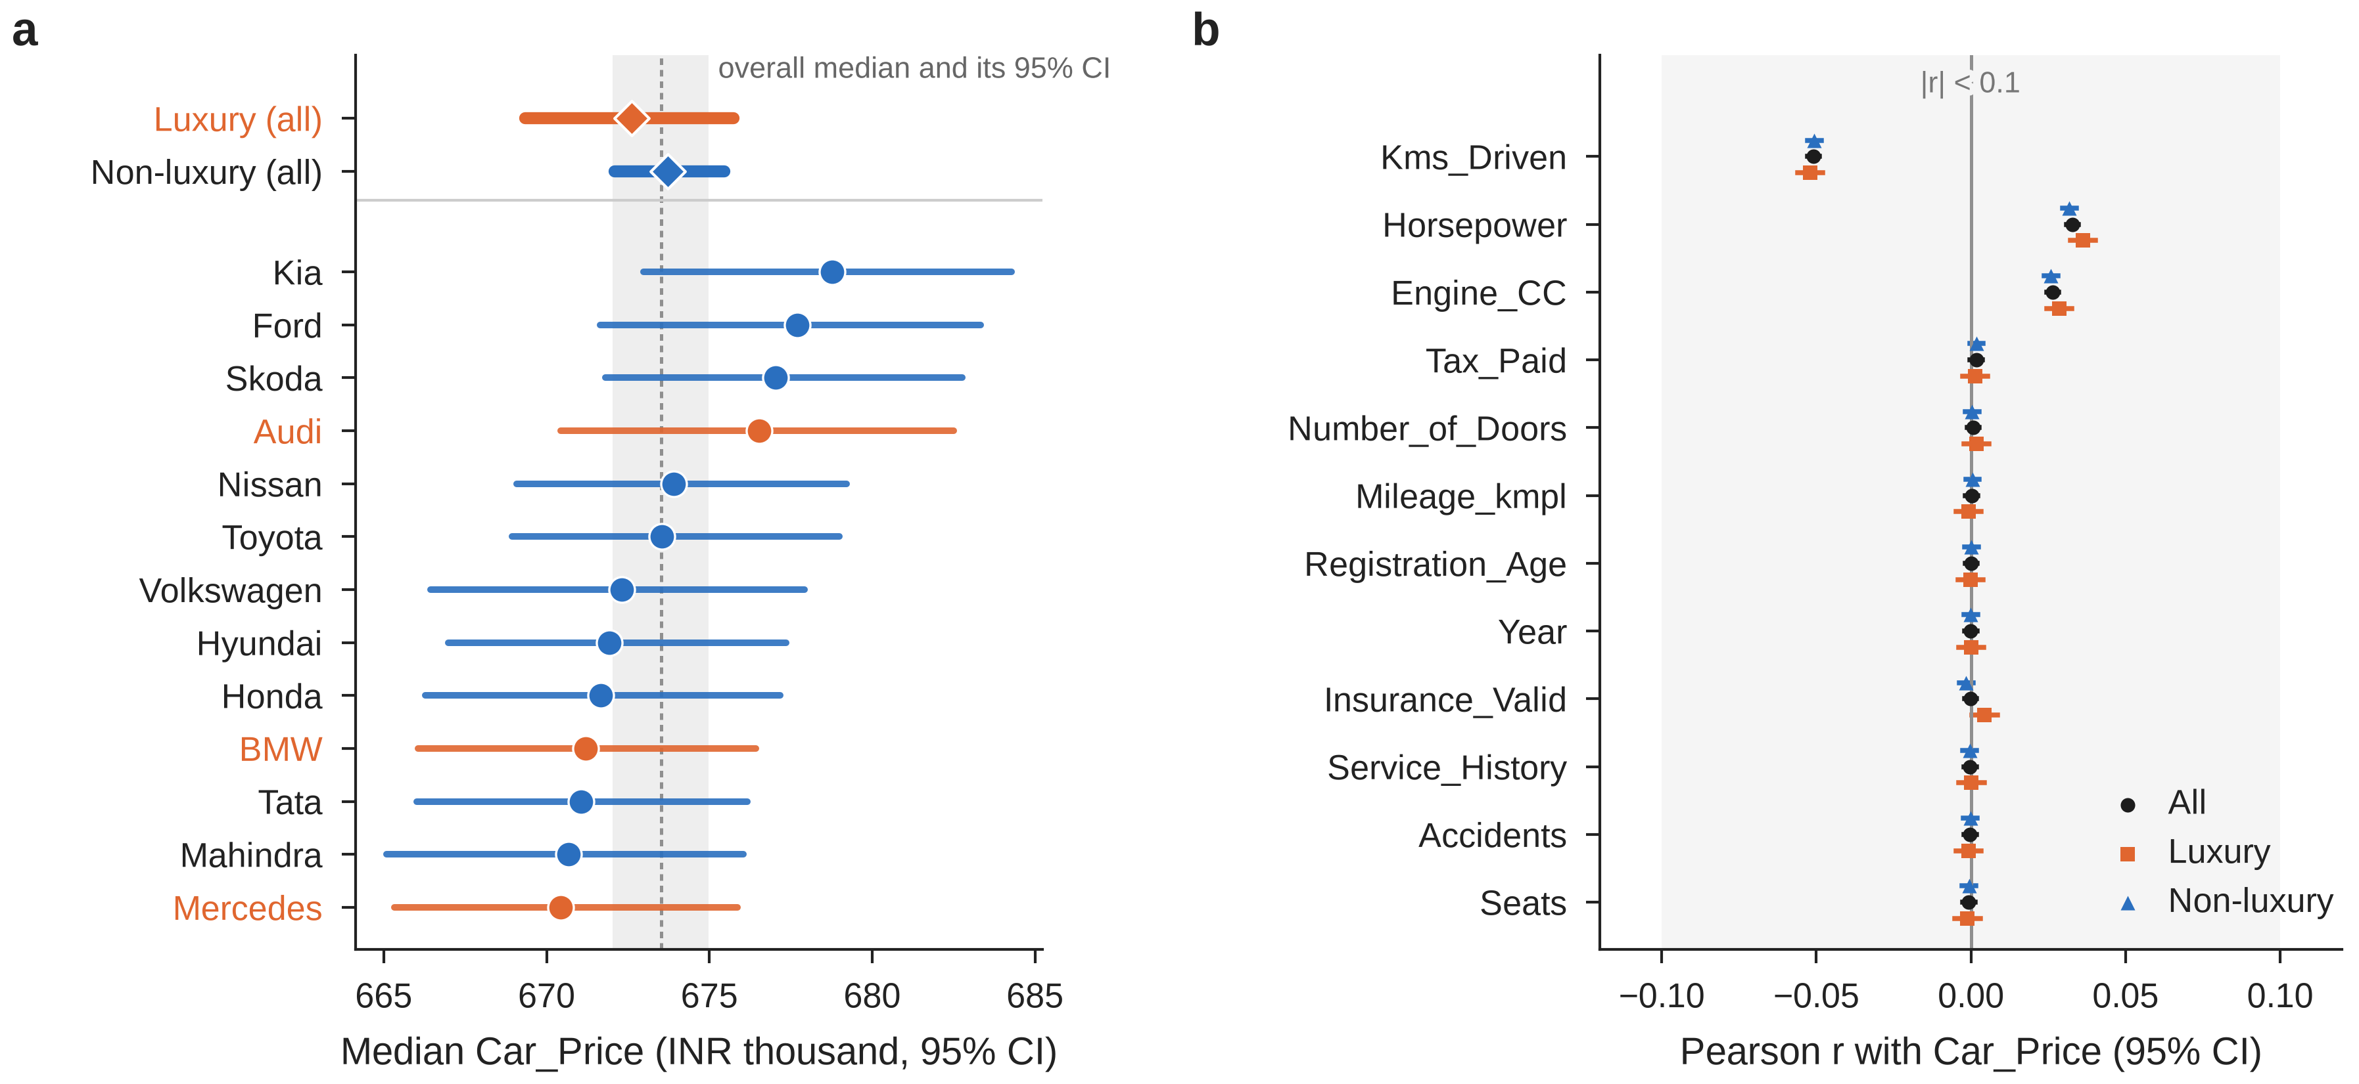
Figure 4 (a) Median Car_Price by brand and segment (orange = luxury, blue = non-luxury; marker size grows with the number of listings) with 95% intervals (ranks n/2 ± 1.96√n/2 of the sorted prices); the axis does not start at zero, and the dashed line and grey band are the overall median and its interval. The 95% confidence interval for the luxury minus non-luxury difference in mean price, as a percentage of the non-luxury mean, is −0.82% to +0.22%. (b) Pearson correlation of each numeric field with Car_Price and its 95% confidence interval (Fisher z; most are narrower than the markers); shading marks |r| < 0.1. Source: calculated from Stable Space (2026).

3 Conclusion and Development Plan

3.1 Findings
Price should be described by its median and modelled on a log scale. Usage has a weak negative association with price, Horsepower and Engine_CC weaker positive ones, and age, brand segment, model and the other fields none of practical size. The client should therefore add no luxury premium, nor treat age and kilometres alone as a precise valuation. Table 5 sets out recommendations with evidence and risks; Table A5 gives the price bands.
Table 5 Recommendations for the client
Recommendation | Evidence | Constraints and risks | Implication
Quote each offer as a median-based price with a range, not a single figure | Skewness 4.9; typical error 55% for the kilometre line (Sections 2.3 and 3.2) | Ranges may look less precise to sellers | Clearer offers; a wide range signals a car that needs an appraiser
Use kilometres only as a small adjustment | r = −0.051; about 0.8% lower price per 10% more km; wide spread within each decile (Figure 2d) | The signal is weak and may differ in real sales | Kilometres should not drive an offer on their own
Apply no luxury premium and no separate segment pricing | Luxury mean −0.30% (95% CI −0.82% to +0.22%); brand medians within 1.24% (Figure 4a) | The data are simulated; a real market may show a premium | Re-test on the client’s own sales before segment pricing or targeted marketing
Screen listings priced outside the 5th to 95th percentile of their usage decile for an appraiser | Band limits fall with usage (P95 INR 3,339,005 in D1, 2,638,995 in D10); by design 10.0% of listings fall outside (Table A5) | Flags unusual prices, not proven mispricing; bands need refreshing as prices move; listings above 1,000,000 km need their own check | Appraiser time goes to the 10% most unusual prices; other offers keep the standard process until the hold-out test (last row)
Tighten data entry: fixed lists for brand and fuel, required fields, no zero specifications, checks for repeats and for more than 1,000,000 km | Table 1: 10,040 brand and 20,123 fuel labels fixed; 283,648 rows with Unknown; about 4,750 excess repeat pairs | Form changes take time; stricter checks may slow listing | Cleaner data and fewer Unknown values for later models
Beyond this project, collect condition, trim and final sale price | The supplied fields explain little of price (Section 3.2) | The project model must use only the supplied variables (Franch 2026, slide 3); collection has a cost | Future models can target sale prices, not asking prices
Automate offers only after a hold-out test and a trial on completed sales | In-sample error 55.2% against 55.3% for the overall median | Delays automation | Avoids systematic over- or under-offers

3.2 Limitations and a better approach
The data are simulated for assessment (UNSW Business School 2026, p. 4), and the macro’s code regenerates Mileage_kmpl, Engine_CC, Horsepower, Kms_Driven and Car_Price without reference to brand or age. This probably explains the missing associations. Each summary also looks at one variable at a time. A straight line of log price on log kilometres, fitted and checked on the same listings, misses the listed price by a median of 55.2%, barely better than quoting the overall median (55.3%). On that line, 10% more kilometres means a price about 0.8% lower. A better approach would fit a multiple regression on log price, check it on a hold-out sample and quote a price range. Beyond this project, whose model must use only the supplied variables (Franch 2026, slide 3), the client could collect condition, trim and final sale price (Table 5).

3.3 Development plan
Milestone 2 will test the hypotheses in Table 6. The final report will then fit and validate the regression, allowing for the strong Engine_CC–Horsepower correlation (r = 0.81).
Table 6 Development plan
Question | Stage | Method | Output
Is vehicle age associated with price? | Milestone 2 | H0: the correlation of age and log price is zero; H1: it is not. Compare age bands | Test result and 95% confidence interval
How strongly is usage associated with price? | Milestone 2 | H0: the slope of log price on log kilometres is zero; H1: it is not. Compare the two segments | Estimated slope with confidence interval
Is brand segment associated with price? | Milestone 2 | H0: mean log price is equal for the two segments; H1: it differs. Two-sample t-test | Test result and 95% confidence interval
Can the fields predict price? | Final report | Multiple regression on log price; fit on 80% of rows, check on the other 20% | Typical error against the median benchmark; price ranges
Do the choices in Table 1 matter? | Both | Repeat key results without Unknown rows, extreme values or possible duplicates | Conclusions kept only if unchanged

References
Franch, F 2026, ‘Used cars: course and Milestone 1 project’, lecture slides, COMM5000 Data Literacy, University of New South Wales, Sydney, viewed 26 September 2026, <https://moodle.telt.unsw.edu.au>.
Stable Space 2026, Used car price prediction dataset, data set, Kaggle, <https://www.kaggle.com/datasets/sharmajicoder/used-car-price-prediction-dataset> (page since removed); randomised copy COMM5000-Used_Car_Price_Prediction.xlsm, UNSW Moodle, viewed 26 September 2026, <https://moodle.telt.unsw.edu.au>.
UNSW Business School 2026, Assessment guide COMM5000 Data Literacy: case study project, Milestone 1 information, University of New South Wales, Sydney, viewed 26 September 2026, <https://moodle.telt.unsw.edu.au>.

Appendix
Table A1 The 20 fields in the dataset, with the share of listings in each category
Field | Type | Unit or values | Note
Brand | Text | 13 brands after trimming | Luxury = Audi, BMW, Mercedes; about 7.7% each
Model | Text | 39 models, each with one brand | About 2.6% each
Year | Numeric | 2000 to 2024 | Year + Registration_Age = 2025
Mileage_kmpl | Numeric | km per litre | Fuel efficiency, not distance
Engine_CC | Numeric | cc
Horsepower | Numeric | hp
Fuel_Type | Text | CNG, Diesel, Electric, Hybrid, Petrol, Unknown | Petrol 41.2%, Diesel 27.7%, CNG 9.0%, Electric 7.5%, Hybrid 6.6%, Unknown 7.8%
Transmission | Text | Automatic, Manual, Unknown | Manual 59.8%, Automatic 32.2%, Unknown 8.0%
Owner_Type | Text | First, Second, Third, Fourth+ | First 59.9%, Second 25.0%, Third 10.0%, Fourth+ 5.0%
Color | Text | 7 colours, Unknown | 13.1% to 13.2% each; Unknown 8.0%
City | Text | 8 cities, Unknown | 11.4% to 11.5% each; Unknown 8.0%
Kms_Driven | Numeric | km | Usage; cap 1,000,000 for analysis
Insurance_Valid | Binary | 1 = valid | 84.9% valid
Service_History | Binary | 1 = records available | 75.1% available
Accidents | Numeric | count, 0 to 5 | 0: 74.1%, 1: 22.2%, 2 or more: 3.7%
Tax_Paid | Binary | 1 = paid | 90.0% paid
Number_of_Doors | Numeric | 2, 4 or 5 | 4: 60.1%, 5: 34.9%, 2: 5.0%
Seats | Numeric | 2, 4, 5 or 7 | 5: 75.0%, 7: 15.0%, 4: 8.0%, 2: 2.0%
Registration_Age | Numeric | years, 1 to 25 | About 40,000 cars at each age
Car_Price | Numeric | INR | Target variable
Source: calculated from Stable Space (2026). Shares are of all 1,005,000 listings; no share differs by more than 0.2 percentage points between the luxury and non-luxury segments.
Table A2 Pearson correlation between Car_Price and each numeric field
Field | All | Luxury | Non-luxury
Kms_Driven (≤ 1,000,000 km) | −0.0510 | −0.0520 | −0.0507
Horsepower | +0.0328 | +0.0362 | +0.0318
Engine_CC | +0.0264 | +0.0285 | +0.0258
Tax_Paid | +0.0017 | +0.0013 | +0.0018
Number_of_Doors | +0.0007 | +0.0018 | +0.0003
Mileage_kmpl | +0.0002 | −0.0008 | +0.0005
Registration_Age | +0.0001 | −0.0001 | +0.0001
Year | −0.0001 | +0.0001 | −0.0001
Insurance_Valid | −0.0002 | +0.0044 | −0.0016
Service_History | −0.0003 | +0.0002 | −0.0004
Accidents | −0.0003 | −0.0007 | −0.0002
Seats | −0.0007 | −0.0011 | −0.0006
Source: calculated from Stable Space (2026). Engine_CC and Horsepower are strongly correlated with each other (r = 0.81).
Table A3 Median Car_Price across categories (INR)
Field | Categories | Rows per category | Lowest median | Highest median | Spread
Fuel_Type | 6 | 66,793 to 414,245 | Hybrid (671,803) | Electric (676,520) | 0.70%
Transmission | 3 | 80,385 to 600,630 | Manual (672,277) | Unknown (676,611) | 0.64%
Owner_Type | 4 | 50,267 to 602,365 | Fourth+ (672,954) | First (673,811) | 0.13%
Color | 8 | 80,419 to 132,535 | Red (671,579) | Unknown (675,846) | 0.64%
City | 9 | 80,430 to 115,999 | Hyderabad (668,837) | Unknown (679,097) | 1.53%
Model | 39 | 25,524 to 26,046 | Civic (660,261) | Seltos (681,372) | 3.20%
Source: calculated from Stable Space (2026). Spread = highest median / lowest median − 1. For 38 of the 39 models, the 95% interval of the median contains the overall median.
Table A4 Sensitivity of the main results to the cleaning choices
Scenario | Rows | Median price (INR) | r (age) | r (km) | Luxury median gap
All rows | 1,005,000 | 673,522 | +0.00007 | −0.0510 | −0.17%
Without rows containing Unknown | 721,352 | 672,595 | +0.00057 | −0.0516 | +0.14%
Without the 3 extreme prices | 1,004,997 | 673,521 | −0.00002 | −0.0513 | −0.17%
First row of each 15-field match only | 975,360 | 673,436 |  |  | −0.19%
Kms cap 500,000 | 947,751 |  |  | −0.0487
Kms cap 750,000 | 987,792 |  |  | −0.0503
Kms cap 1,500,000 | 1,003,790 |  |  | −0.0507
No kms cap | 1,005,000 |  |  | −0.0493
Source: calculated from Stable Space (2026). The duplicate scenario uses a sorted copy holding only price and segment.
Table A5 Car_Price bands by Kms_Driven decile (INR; listings with Kms_Driven ≤ 1,000,000)
Decile | Kms_Driven (km) | n | P5 | Q1 | Median | Q3 | P95
D1 | 3,216 to 58,680 | 99,887 | 169,069 | 412,498 | 756,694 | 1,387,144 | 3,339,005
D2 | 58,680 to 81,556 | 99,887 | 163,796 | 394,299 | 722,737 | 1,331,816 | 3,189,281
D3 | 81,556 to 103,446 | 99,886 | 159,446 | 384,591 | 705,564 | 1,295,140 | 3,104,325
D4 | 103,446 to 126,516 | 99,887 | 156,335 | 374,729 | 690,205 | 1,265,987 | 3,045,450
D5 | 126,516 to 152,610 | 99,886 | 154,404 | 367,915 | 675,761 | 1,247,316 | 3,025,470
D6 | 152,610 to 184,108 | 99,887 | 151,476 | 362,523 | 669,288 | 1,230,314 | 2,933,993
D7 | 184,108 to 224,840 | 99,886 | 147,982 | 356,983 | 659,175 | 1,213,957 | 2,916,713
D8 | 224,840 to 284,119 | 99,887 | 146,505 | 352,845 | 646,141 | 1,188,585 | 2,846,771
D9 | 284,119 to 390,183 | 99,886 | 143,444 | 343,595 | 628,605 | 1,157,695 | 2,796,179
D10 | 390,187 to 999,999 | 99,887 | 135,828 | 327,841 | 603,779 | 1,108,006 | 2,638,995
Source: calculated from Stable Space (2026). Listings below P5 or above P95 of their own decile make up 10.0% of the 998,866 listings in this table (screening rule in Table 5).

