Preliminary Insight Development: Used Car Prices in India
COMM5000 Data Literacy · Case Study Project · Milestone 1 · Term 3, 2026
Word count: 979 (excluding tables, figures, captions and references)

1 Introduction
India’s used car market now outsells the new car market, yet price appraisal still relies heavily on manual valuation (UNSW Business School 2026, p. 4). Our client, an online marketplace, needs a fast and consistent price estimate at appraisal to support instant cash offers, spot mispriced listings and forecast stock turnover. It first needs to know what is linked to price and how reliable the data are.
This report explores the 1,005,000 listings in the course dataset (Stable Space 2026) against the two project objectives (UNSW Business School 2026, p. 4): how Car_Price relates to the other variables, including brand segment, and how the methods could be improved. Section 2 presents the analysis and Section 3 the findings and plan.

2 Data Summaries and Descriptive Statistics

2.1 Data preparation
The analysis uses the workbook as randomised on 26 September 2026 (stamp in cell B6 of the Dataset sheet), with every number calculated by Excel formulas. Labels were corrected only where the intended category was obvious, and no listing was deleted (Table 1). ‘Unknown’ entries were kept as a category because they affect 28.2% of rows and cannot be recovered. No cell is blank because the macro fills missing values (Stable Space 2026), so impossible zeros in the three technical fields were treated as missing.
The randomising macro (Franch 2026, slide 7) rewrites five numeric columns in its code, so repeated listings no longer look identical. Matching rows on the other 15 fields gives 31,575 identical pairs, about 4,750 more than the 26,821 expected by chance. These possible repeats cannot be told apart from chance matches, so they were flagged but kept. Keeping one row per match moves the median by only 0.01% (Table A4).
The guide treats more than 1,000,000 km as implausible (UNSW Business School 2026, p. 7). These 6,134 listings match the 6,102 expected from a log-normal fit, so they may be a genuine tail, but were left out of the usage analysis. A few isolated values, such as 4.6 hp or a price of INR 8,043, are implausible for a car but too few to matter (Table 1).
Table 1 Data problems and how they were treated
Problem | Found with | Size | Treatment
Brand labels with extra spaces (e.g. ‘ BMW ’) | TRIM, EXACT | 10,040 rows (2,334 luxury) | Trimmed; 13 brands
Fuel_Type variants (PETROL, petrol, diesel with spaces, hybridd, electrik) | LOWER, TRIM, lookup table | 20,123 rows | Mapped to CNG, Diesel, Electric, Hybrid, Petrol; Unknown kept
Other text fields (Model, Transmission, Owner_Type, Color, City) | LEN, TRIM, category lists | No variants found | None needed
‘Unknown’ in Fuel_Type, Transmission, Color, City | COUNTIF | 78,733; 80,385; 80,419; 80,430. 283,648 rows have at least one | Kept as a category
Blank cells | COUNTBLANK | 0 | None; the macro fills gaps
Zero technical values (missing-value code) | COUNTIF | Mileage 4; Engine 12; Horsepower 10 | Blank for that field only
Technical values beyond mean ± 3 SD | AVERAGEIF, STDEV.S, COUNTIFS | Mileage 36; Engine 52; Horsepower 33 | Blank for that field only; far from the main range
Isolated values inside the ± 3 SD limits | MIN, COUNTIFS | Horsepower 44 below 50, 67 above 190; Engine 60 below 850, 97 above 2,250; Mileage 42 below 11, 37 above 25.5; Car_Price 44 below INR 20,000 | Kept; too few to move any median
Identical rows on all 20 fields | FREQUENCY on Car_Price | 0 | None needed
Repeated rows on the 15 non-randomised fields | Sorted key, run count, category shares | 31,575 pairs in 29,640 repeat rows; 26,821 pairs expected by chance | Flagged and kept
Kms_Driven above 1,000,000 km | COUNTIF; NORM.DIST on LN(km) | 6,134 rows, up to 5.8 million km (6,102 expected) | Excluded from usage analysis only
Extreme Car_Price (3 × IQR on log scale) | QUARTILE, COUNTIF | 1 low, 2 high | Kept
Year and Registration_Age consistency | SUMPRODUCT | Sum is 2025 in all rows | Age used as supplied
Source: calculated from Stable Space (2026). A group of k identical rows gives k(k − 1)/2 pairs and k − 1 repeat rows. The chance count multiplies the category shares of 13 fields and leaves out Brand and Year, which Model and Registration_Age already fix.

2.2 The variables
Table A1 describes all 20 fields. Car_Price is in Indian rupees (INR), and Year and Registration_Age carry the same information. Registration_Age is spread evenly over 1 to 25 years, and Engine_CC, Horsepower and Mileage_kmpl are almost flat across their main range, so their modes in Table 2 are not typical values.

2.3 Distribution of Car_Price
Car_Price is strongly right-skewed (Table 2; skewness 4.9). The long right tail lifts the mean of INR 1,015,107 to 50.7% above the median of INR 673,522, and 67.5% of listings sit below the mean (Figure 1a). The median and interquartile range (INR 365,843 to 1,240,714) therefore describe a typical car better and should be reported to the client. Log price is almost symmetric (skewness 0.001; Figure 1b), which suits later modelling.
Table 2 Numerical summaries for all listings, luxury (Audi, BMW, Mercedes) and non-luxury listings
Variable | Group | n | Mean | Median | Modeᶜ | SD | Min | Max
Car_Price (INR) | All | 1,005,000 | 1,015,107 | 673,522 | 275,000 | 1,147,780 | 8,043 | 51,993,222
 | Luxury | 232,172 | 1,012,738 | 672,614 | 325,000 | 1,130,612 | 11,017 | 41,975,979
 | Non-luxury | 772,828 | 1,015,818 | 673,731 | 275,000 | 1,152,888 | 8,043 | 51,993,222
Registration_Age (years) | All | 1,005,000 | 13.0 | 13.0 | 6.0 | 7.2 | 1.0 | 25.0
 | Luxury | 232,172 | 13.0 | 13.0 | 18.0 | 7.2 | 1.0 | 25.0
 | Non-luxury | 772,828 | 13.0 | 13.0 | 19.0 | 7.2 | 1.0 | 25.0
Kms_Driven (km)ᵃ | All | 998,866 | 196,142 | 152,610 | 95,000 | 150,624 | 3,216 | 999,999
 | Luxury | 230,726 | 196,322 | 153,009 | 95,000 | 150,612 | 3,216 | 999,919
 | Non-luxury | 768,140 | 196,089 | 152,494 | 85,000 | 150,628 | 3,546 | 999,999
Engine_CC (cc)ᵇ | All | 1,004,936 | 1,506 | 1,494 | 875 | 408 | 304 | 2,720
 | Luxury | 232,158 | 1,507 | 1,495 | 875 | 409 | 304 | 2,664
 | Non-luxury | 772,778 | 1,506 | 1,494 | 875 | 408 | 305 | 2,720
Horsepower (hp)ᵇ | All | 1,004,957 | 120.5 | 119.8 | 62.5 | 38.7 | 4.6 | 235.2
 | Luxury | 232,159 | 120.5 | 119.8 | 57.5 | 38.8 | 7.6 | 234.0
 | Non-luxury | 772,798 | 120.5 | 119.8 | 62.5 | 38.7 | 4.6 | 235.2
Mileage_kmpl (km/l)ᵇ | All | 1,004,960 | 18.00 | 18.00 | 11.25 | 4.18 | 5.60 | 30.32
 | Luxury | 232,164 | 18.00 | 17.99 | 11.25 | 4.17 | 5.70 | 27.11
 | Non-luxury | 772,796 | 18.01 | 18.00 | 11.25 | 4.18 | 5.60 | 30.32
Accidents (count) | All | 1,005,000 | 0.30 | 0.00 | 0.00 | 0.55 | 0.00 | 5.00
 | Luxury | 232,172 | 0.30 | 0.00 | 0.00 | 0.55 | 0.00 | 5.00
 | Non-luxury | 772,828 | 0.30 | 0.00 | 0.00 | 0.55 | 0.00 | 5.00
Source: calculated from Stable Space (2026). ᵃ Rows with Kms_Driven ≤ 1,000,000. ᵇ Zero values and values beyond the mean ± 3 SD excluded. ᶜ Exact most frequent value for Registration_Age and Accidents. No exact value repeats for the continuous variables, so the midpoint of the most frequent class is shown (classes: price 50,000; km 10,000; cc 50; hp 5; km/l 0.5). Min and Max of the technical fields are isolated values (Table 1). SD is the sample standard deviation.
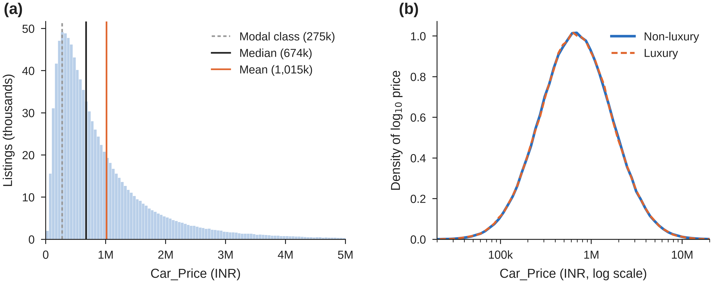
Figure 1 Distribution of Car_Price (n = 1,005,000). (a) Raw scale in INR 50,000 classes; the 1.3% of listings above INR 5 million are not shown. (b) Log scale by segment. M = million, k = thousand. Source: calculated from Stable Space (2026).

2.4 Price, vehicle age and usage
Price was plotted for 5,000 listings chosen with RAND() and frozen as values, the largest sample the guide suggests (UNSW Business School 2026, p. 7), beside medians for all listings (Figure 2). Registration_Age shows no clear association with price (r = 0.0001). Its median stays between INR 667,024 and 681,532 across all 25 ages (Figure 2b).
Usage has a weak negative association with price. The correlation is −0.051, and the median falls from INR 756,694 in the lowest usage decile to INR 603,779 in the highest, 20% lower. This compares different cars, not one car over time. Prices within each decile still vary far more than this (Figure 2d). The median surface in Figure 3a slopes along usage and stays flat along age. Figure 3b shows that chance alone moves r in a 5,000-row sample by about ±0.028 (95% of samples).
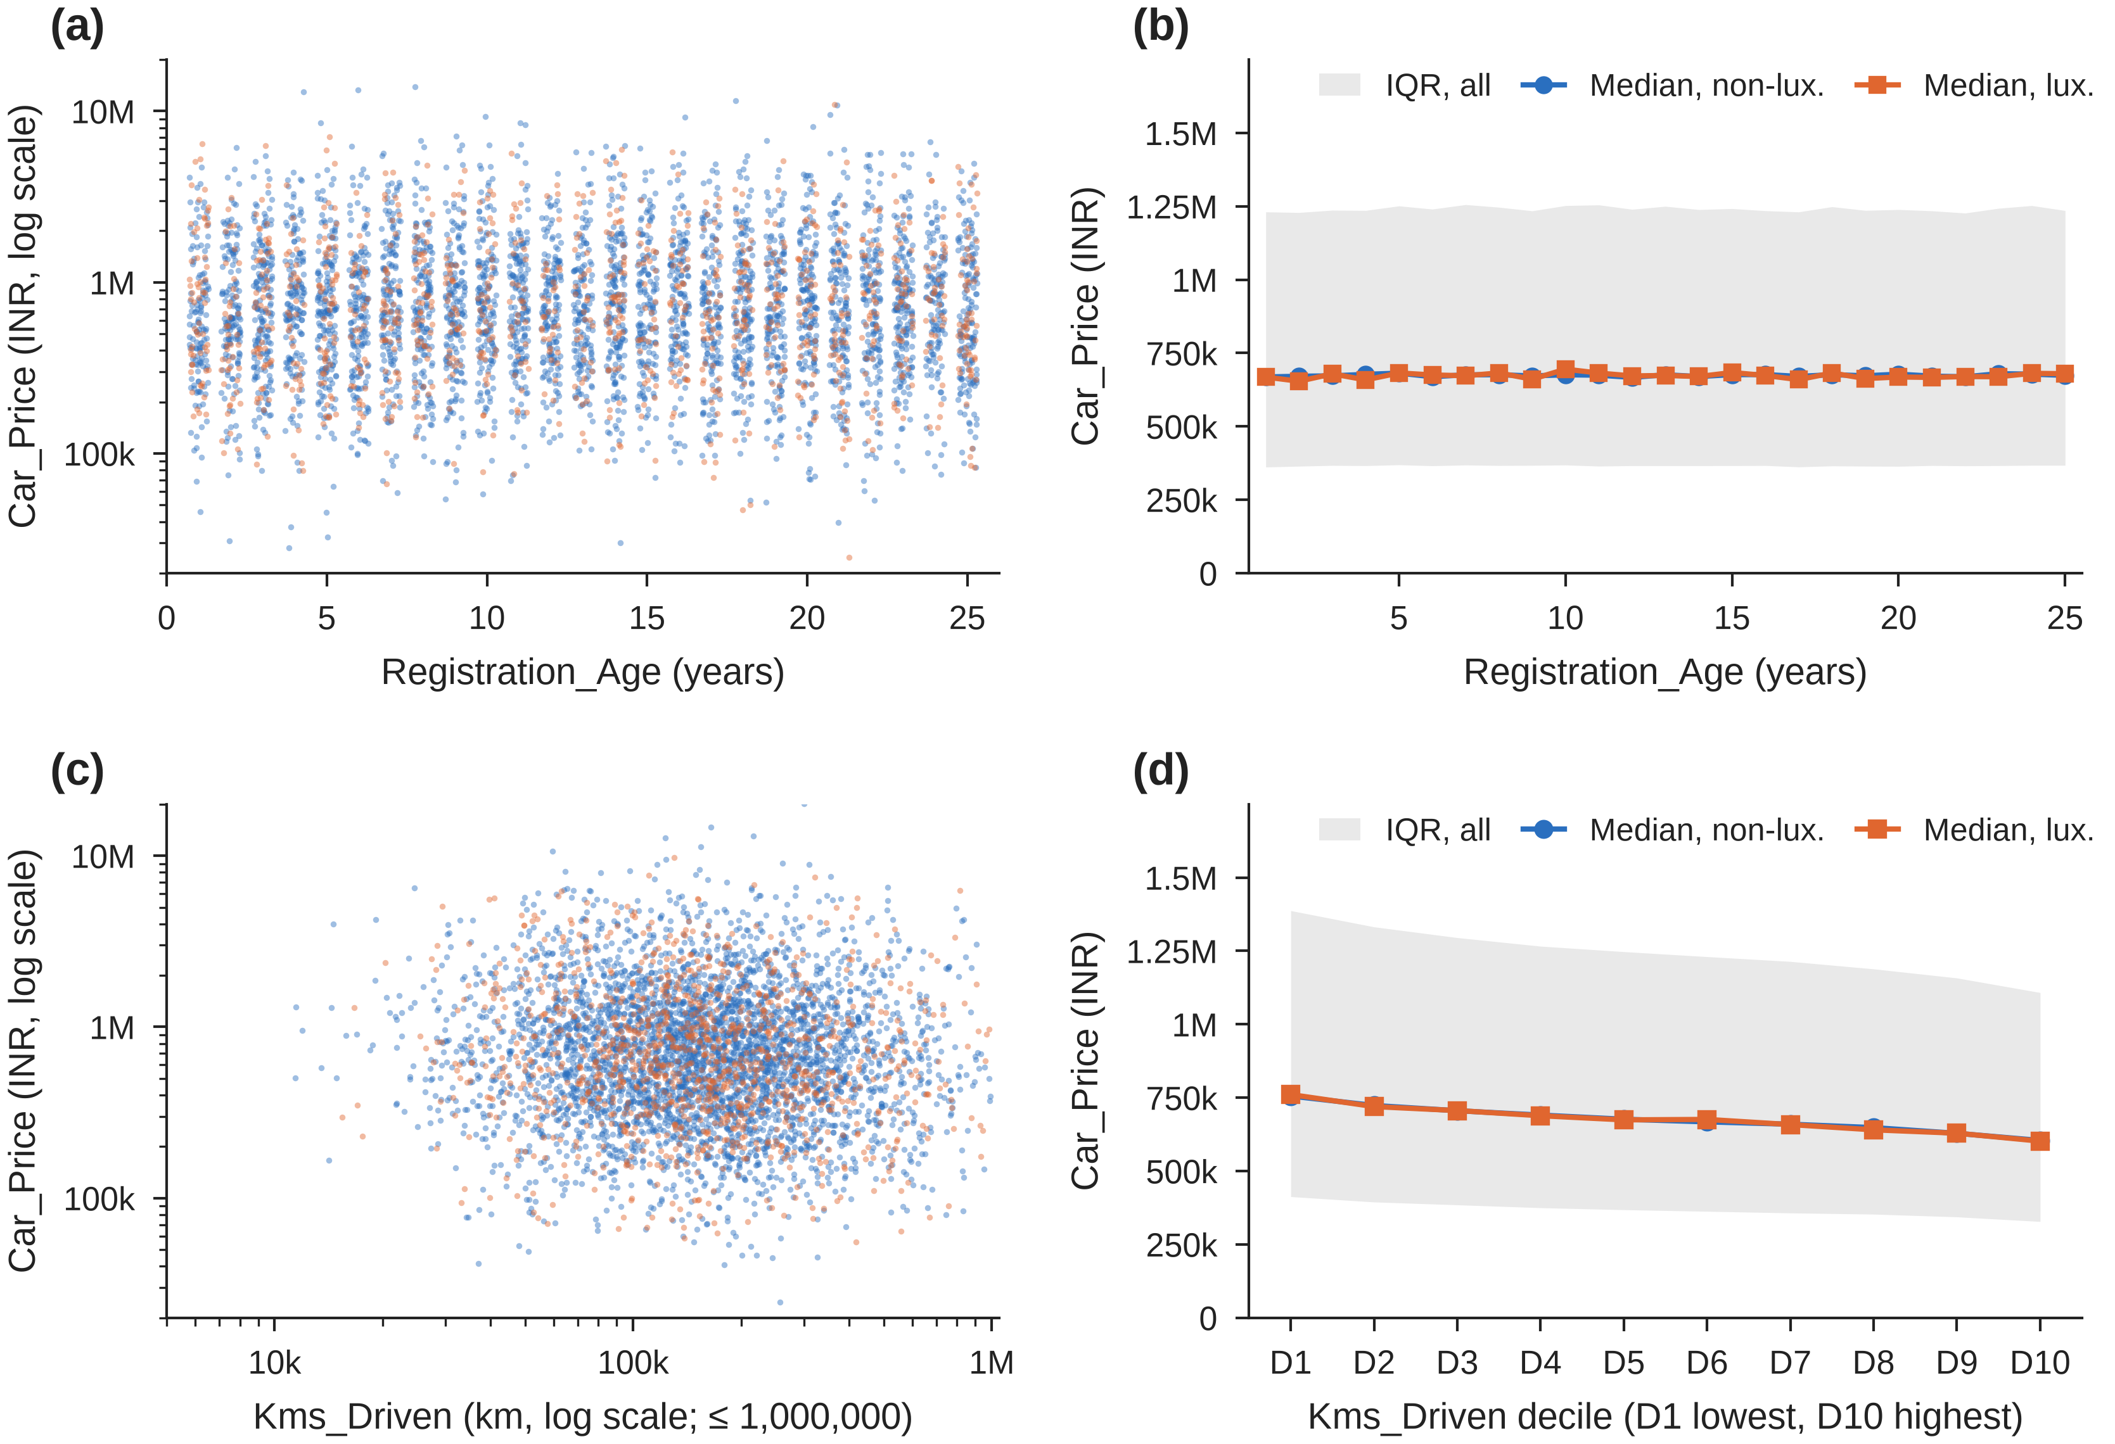
Figure 2 Car_Price against Registration_Age (a, b) and Kms_Driven (c, d). (a) and (c) Random samples of 5,000 listings; ages in (a) are spread by up to 0.3 years so that points do not overlap. (b) and (d) Medians by segment with the interquartile range (IQR) for all listings; (c) and (d) use listings with Kms_Driven ≤ 1,000,000. Source: calculated from Stable Space (2026).
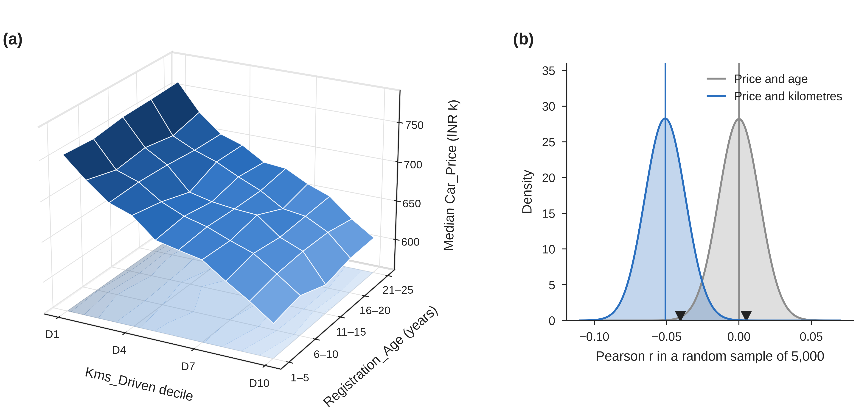
Figure 3 (a) Median Car_Price by five-year age band and usage decile, about 20,000 listings per cell; the vertical axis starts at INR 560,000. (b) Expected spread of the correlation in a random sample of 5,000 rows (normal approximation); vertical lines mark the full-data values and triangles the samples used in Figure 2. Source: calculated from Stable Space (2026).

2.5 Brand segment and other variables
Luxury listings carry no price premium. Their mean price is 0.30% lower than for non-luxury cars and their median 0.17% lower, trivial next to a price SD of INR 1.15 million. The 13 brand medians lie within 1.3% of each other with overlapping intervals (Figure 4a).
Among the other numeric fields, only Horsepower (+0.033) and Engine_CC (+0.026) come near Kms_Driven. All others stay within ±0.005 in every segment (Figure 4b; Table A2). Other category medians differ by at most 1.6%, and the 3.2% spread across the 39 models is about what chance gives (Table A3). The conclusions hold without Unknown rows, extreme prices or possible duplicates (Table A4).
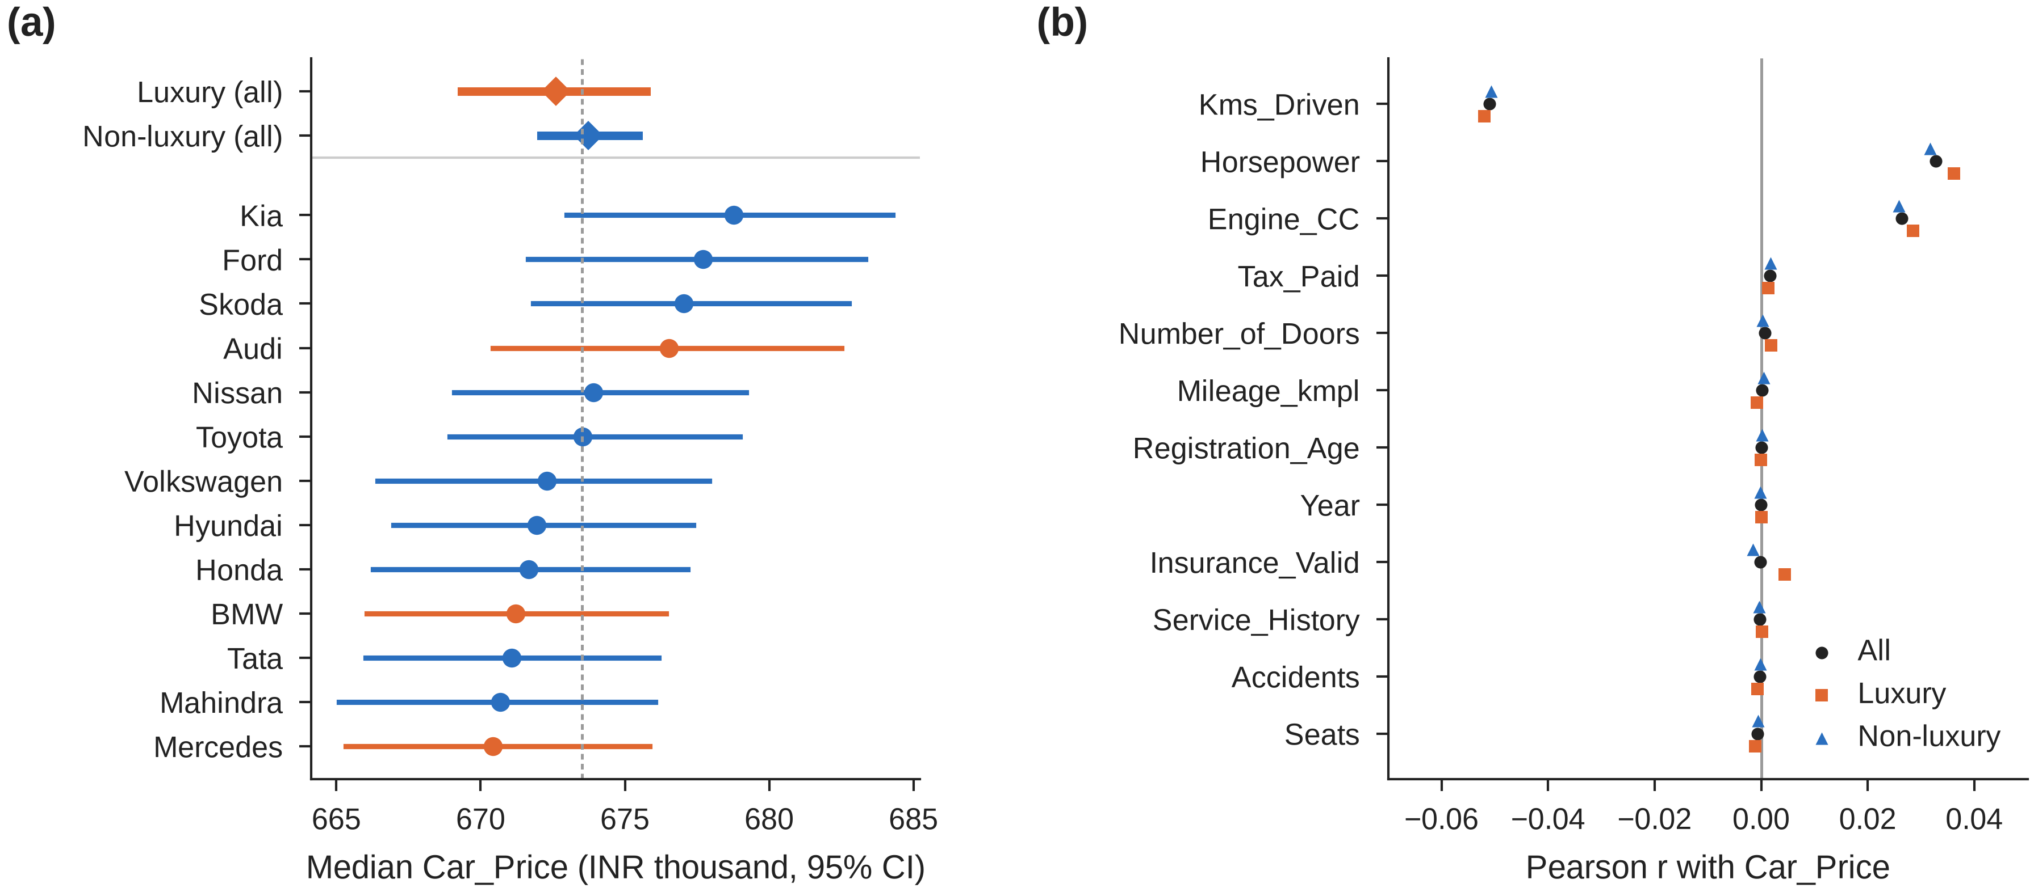
Figure 4 (a) Median Car_Price by brand and segment with 95% intervals (ranks n/2 ± 1.96√n/2 of the sorted prices); the axis does not start at zero and the dashed line is the overall median. The 95% confidence interval for the luxury minus non-luxury difference in mean price is −0.82% to +0.22%. (b) Pearson correlation of each numeric field with Car_Price. Source: calculated from Stable Space (2026).

3 Conclusion and Development Plan

3.1 Findings
Price should be described by its median and modelled on a log scale. Usage has a weak negative association with price, Horsepower and Engine_CC weaker positive ones, and age, brand segment, model and the other fields none. A luxury premium in cash offers is therefore not supported. Any model must also handle Unknown fields (28% of rows) and possible duplicates.

3.2 Limitations and a better approach
The data are simulated for assessment (UNSW Business School 2026, p. 4), and the macro’s code regenerates Mileage_kmpl, Engine_CC, Horsepower, Kms_Driven and Car_Price without reference to brand or age. This probably explains the missing associations. Each summary also looks at one variable at a time. A straight line of log price on log kilometres (Excel SLOPE and INTERCEPT), fitted and checked on the same listings, misses the listed price by a median of 55.2%, barely better than quoting the overall median (55.3%). Offers based on kilometres alone would be unreliable. A better approach would fit a multiple regression on log price, check it on a hold-out sample and quote a price range. The client should also record inspection condition and trim level, and validate any model on its own final sale prices.

3.3 Development plan
Milestone 2 will test the hypotheses in Table 3. The final report will then fit and validate the regression, allowing for the strong Engine_CC–Horsepower correlation (r = 0.81).
Table 3 Development plan
Question | Stage | Method | Output
Is vehicle age associated with price? | Milestone 2 | H0: the correlation of age and log price is zero; H1: it is not. Compare age bands | Test result and 95% confidence interval
How strongly is usage associated with price? | Milestone 2 | H0: the slope of log price on log kilometres is zero; H1: it is not. Compare the two segments | Estimated slope with confidence interval
Is there a luxury premium? | Milestone 2 | H0: mean log price is equal for the two segments; H1: luxury is higher. Two-sample t-test | Test result and 95% confidence interval
Can the fields predict price? | Final report | Multiple regression on log price; fit on 80% of rows, check on the other 20% | Typical error against the median benchmark; price ranges
Do the choices in Table 1 matter? | Both | Repeat key results without Unknown rows, extreme values or possible duplicates | Conclusions kept only if unchanged

References
Franch, F 2026, ‘Used cars: course and Milestone 1 project’, lecture slides, COMM5000 Data Literacy, University of New South Wales, Sydney, viewed 26 September 2026, <https://moodle.telt.unsw.edu.au>.
Stable Space 2026, Used car price prediction dataset, data set, Kaggle, <https://www.kaggle.com/datasets/sharmajicoder/used-car-price-prediction-dataset> (page since removed); randomised copy COMM5000-Used_Car_Price_Prediction.xlsm, UNSW Moodle, viewed 26 September 2026, <https://moodle.telt.unsw.edu.au>.
UNSW Business School 2026, Assessment guide COMM5000 Data Literacy: case study project, Milestone 1 information, University of New South Wales, Sydney, viewed 26 September 2026, <https://moodle.telt.unsw.edu.au>.

Appendix
Table A1 The 20 fields in the dataset
Field | Type | Unit or values | Note
Brand | Text | 13 brands after trimming | Luxury = Audi, BMW, Mercedes
Model | Text | 39 models, each with one brand
Year | Numeric | 2000 to 2024 | Year + Registration_Age = 2025
Mileage_kmpl | Numeric | km per litre | Fuel efficiency, not distance
Engine_CC | Numeric | cc
Horsepower | Numeric | hp
Fuel_Type | Text | CNG, Diesel, Electric, Hybrid, Petrol, Unknown | Labels cleaned
Transmission | Text | Automatic, Manual, Unknown
Owner_Type | Text | First, Second, Third, Fourth+
Color | Text | 7 colours, Unknown
City | Text | 8 cities, Unknown
Kms_Driven | Numeric | km | Usage; cap 1,000,000 for analysis
Insurance_Valid | Binary | 1 = valid | 84.9% valid
Service_History | Binary | 1 = records available | 75.1% available
Accidents | Numeric | count, 0 to 5
Tax_Paid | Binary | 1 = paid | 90.0% paid
Number_of_Doors | Numeric | 2, 4 or 5
Seats | Numeric | 2, 4, 5 or 7
Registration_Age | Numeric | years, 1 to 25 | About 40,000 cars at each age
Car_Price | Numeric | INR | Target variable

Table A2 Pearson correlation between Car_Price and each numeric field
Field | All | Luxury | Non-luxury
Kms_Driven (≤ 1,000,000 km) | −0.0510 | −0.0520 | −0.0507
Horsepower | +0.0328 | +0.0362 | +0.0318
Engine_CC | +0.0264 | +0.0285 | +0.0258
Tax_Paid | +0.0017 | +0.0013 | +0.0018
Number_of_Doors | +0.0007 | +0.0018 | +0.0003
Mileage_kmpl | +0.0002 | −0.0008 | +0.0005
Registration_Age | +0.0001 | −0.0001 | +0.0001
Year | −0.0001 | +0.0001 | −0.0001
Insurance_Valid | −0.0002 | +0.0044 | −0.0016
Service_History | −0.0003 | +0.0002 | −0.0004
Accidents | −0.0003 | −0.0007 | −0.0002
Seats | −0.0007 | −0.0011 | −0.0006
Source: calculated from Stable Space (2026). Engine_CC and Horsepower are strongly correlated with each other (r = 0.81).
Table A3 Median Car_Price across categories (INR)
Field | Categories | Rows per category | Lowest median | Highest median | Spread
Fuel_Type | 6 | 66,793 to 414,245 | Hybrid (671,803) | Electric (676,520) | 0.70%
Transmission | 3 | 80,385 to 600,630 | Manual (672,277) | Unknown (676,611) | 0.64%
Owner_Type | 4 | 50,267 to 602,365 | Fourth+ (672,954) | First (673,811) | 0.13%
Color | 8 | 80,419 to 132,535 | Red (671,579) | Unknown (675,846) | 0.64%
City | 9 | 80,430 to 115,999 | Hyderabad (668,837) | Unknown (679,097) | 1.53%
Model | 39 | 25,524 to 26,046 | Civic (660,261) | Seltos (681,372) | 3.20%
Source: calculated from Stable Space (2026). Spread = highest median / lowest median − 1. For 38 of the 39 models, the 95% interval of the median contains the overall median.
Table A4 Sensitivity of the main results to the cleaning choices
Scenario | Rows | Median price | r (age) | r (km) | Luxury median gap
All rows | 1,005,000 | 673,522 | +0.00007 | −0.0510 | −0.17%
Without rows containing Unknown | 721,352 | 672,595 | +0.00057 | −0.0516 | +0.14%
Without the 3 extreme prices | 1,004,997 | 673,521 | −0.00002 | −0.0513 | −0.17%
First row of each 15-field match only | 975,360 | 673,436 |  |  | −0.19%
Kms cap 500,000 | 947,751 |  |  | −0.0487
Kms cap 750,000 | 987,792 |  |  | −0.0503
Kms cap 1,500,000 | 1,003,790 |  |  | −0.0507
No kms cap | 1,005,000 |  |  | −0.0493
Source: calculated from Stable Space (2026). The duplicate scenario uses a sorted copy that holds only price and segment, so correlations are not shown for it. Without Unknown rows the small luxury gap turns positive, but it stays trivial.

