操作步骤：

打开postman-按下图所示进行配置，输入所要调取接口的相关网址及指令，更新APP ID等参数，点击Send即可。
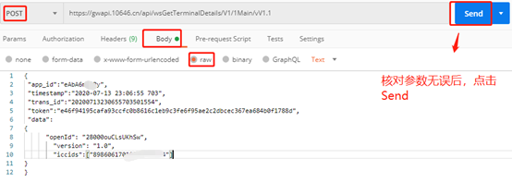其中
1、URL地址来源：可在API接口URL_V2.0中，根据调用接口名查询；
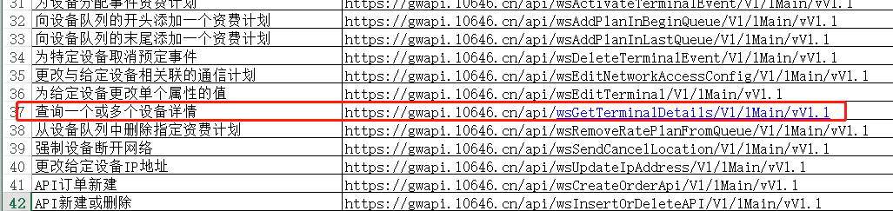
2、APP ID（接入标识码）、APP SECRET（密钥）、OPEN ID（创建者ID）来源：在统一门户网站中，在我的应用-应用列表里查看
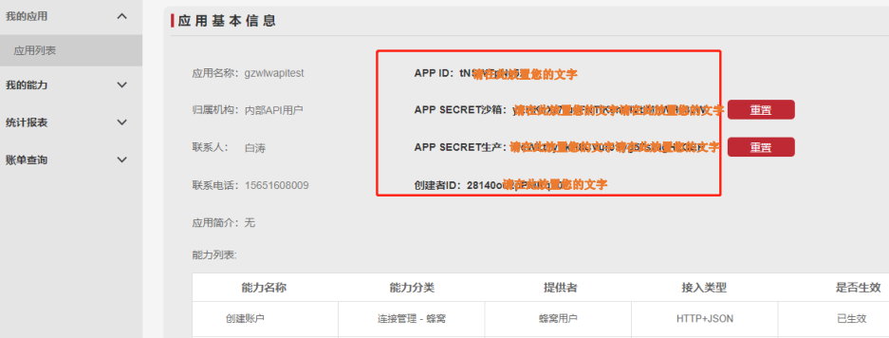

3、token（签名信息）、timestamp（时间戳）、trans_id（序列号）来源：

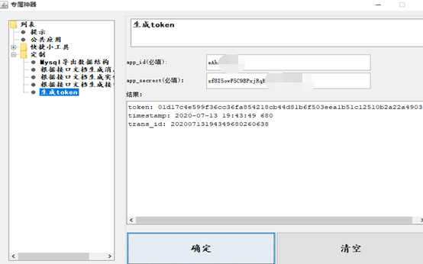

Eg：
1、查询设备详情
输入：
{
"app_id":"********",
"timestamp":"2020-07-13 19:32:12 409",
"trans_id":"20200713193212409680698",
"token":"64f93ee26e7243bbc103d36035e4a7296eed4b4812be4641b1dc3ea56da79324",
"data":
{
"openId": "************",
"version": "1.0",
"iccids":["********"]
}
}

返回：
{
"message": "成功",
"status": "0000",
"data": {
"messageId": "200701007655187459",
"resultCode": "0000",
"terminals": [
{
"ratePlan": 18518635,
"dateReceivied": "2020-05-12 20:07:38",
"Customer": null,
"fieldValue6": "",
"monthToDateVoiceUsageMO": "0",
"fieldValue5": "",
"fieldValue4": "",
"fieldValue3": "",
"fieldValue2": "",
"fieldValue1": "",
"deviceId": "200501160895680100",
"dateAdded": "2018-04-25 09:15:54.0",
"iccid": "8986061701000169XXXX",
"ctdSessionCount": 0,
"overageLimitOverride": "0",
"customerCustom1": "",
"customerCustom2": "",
"fixedIpAddress": "",
"customerCustom5": "",
"customerCustom3": "",
"fieldValue10": "",
"customerCustom4": "",
"secureSimId": "1",
"accountId": "18040222142608XXXX",
"monthToDateSMSUsageMO": "0",
"monthToDateVoiceUsage": "0",
"simNotes": "2",
"operatorAccountId": "1322330",
"monthToDateUsage": "0",
"copyRulePwd": "1",
"modemId": "",
"imsi": "460069001035359",
"operatorCustom2": "",
"monthToDateSMSUsage": "0",
"operatorCustom1": "",
"operatorCustom4": "",
"overageLimitReached": "197010",
"operatorCustom3": "",
"lockStatus": "0",
"dateShipped": "2020-05-12 00:00:00",
"msisdn": "8610646190XXXX",
"monthToDateDataUsage": "0",
"provinceCusutom1": "",
"dateModified": "2020-07-10 09:04:46.0",
"provinceCusutom4": "",
"realNameStatus": "0",
"operatorCustom5": "",
"provinceCusutom5": "",
"provinceCusutom2": "",
"provinceCusutom3": "",
"fieldValue9": "",
"fieldValue8": "",
"fieldValue7": "",
"imei": "",
"simStatus": "3",
"dateActivated": "2020-05-12 20:08:47"
}
],
"timestamp": "2020-07-13 23:25:48",
"version": "1.0"
}
}

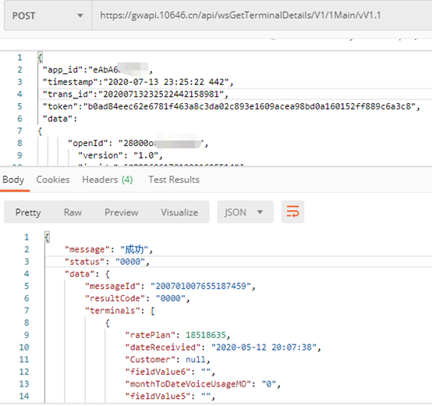
2、变更SIM卡状态：

输入：
{
"app_id": "********",
"timestamp": "2020-07-14 14:12:40 316",
"trans_id": "20200714141240316254680",
"token": "272e7655ac0306b79132431d4c5c9400b4c521db6548283dfd8859fa13bd3bb5",
"data": {
"messageId": "1",
"openId": "********",
"version": "1.0",
"asynchronous":"0",
"iccid":"********",
"changeType":"3",
"targetValue":"2"
}
}
返回：
{
"message": "成功",
"status": "0000",
"data": {
"effectiveDate": "2020-07-14 14:13:38",
"iccid": "8986061701000169XXXX",
"messageId": "1",
"resultCode": "0000",
"timestamp": "2020-07-14 14:13:42",
"version": "1.0"
}
}

