Server Infrastructure SLA Violation Report
Date: March 29, 2026 | Severity: HIGH | Status: Active Investigation

1. Executive Summary
Two of five production servers are currently violating service level agreement (SLA) thresholds. Server B is experiencing critical performance degradation with both latency and packet loss exceeding acceptable limits. Server D is violating packet loss thresholds. Immediate corrective action is required to restore service quality and prevent potential customer impact.
Key Findings:
- 40% of servers (2/5) are violating SLA thresholds
- Server B requires immediate attention: 120ms latency (2× threshold) and 3.2% packet loss (3.2× threshold)
- Server D violating packet loss SLA at 1.5% (1.5× threshold)
- Three servers (A, C, E) remain compliant with all SLA requirements

2. SLA Thresholds
The following performance thresholds are defined in our infrastructure SLA:
Metric | Threshold | Priority
Latency (Average) | < 60ms | Critical
Packet Loss | < 1.0% | Critical

3. Detailed Analysis of SLA Violations
Current telemetry data from all five production servers:
Server | Latency | Status | Packet Loss | Status | Overall
Server A | 45ms | ✅ Pass | 0.5% | ✅ Pass | COMPLIANT
Server B | 120ms | ❌ FAIL | 3.2% | ❌ FAIL | VIOLATING
Server C | 30ms | ✅ Pass | 0.1% | ✅ Pass | COMPLIANT
Server D | 55ms | ✅ Pass | 1.5% | ❌ FAIL | VIOLATING
Server E | 48ms | ✅ Pass | 0.8% | ✅ Pass | COMPLIANT

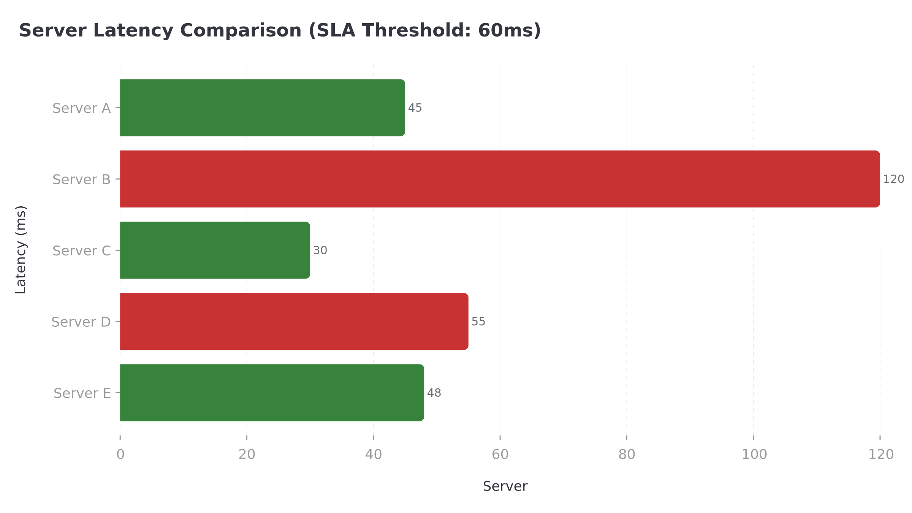
Figure 1: Server Latency Comparison (Red bars indicate SLA violations)

3.1 Server B – Critical Violation
Server B is experiencing severe performance degradation across both metrics:
Metric | Current Value | Deviation
Latency | 120ms | +100% over threshold
Packet Loss | 3.2% | +220% over threshold

3.2 Server D – Warning Violation
Server D is violating packet loss thresholds:
Metric | Current Value | Deviation
Latency | 55ms | Within threshold (8% margin)
Packet Loss | 1.5% | +50% over threshold

4. Root Cause Analysis Recommendations
Based on the violation patterns, the following potential root causes should be investigated:
4.1 Network Infrastructure Issues
- Congested network links or bandwidth saturation on Server B and D paths
- Faulty network interface cards (NICs) or switch ports
- Routing issues or suboptimal traffic paths
- Physical layer problems (cabling, connectors)
4.2 Server Resource Constraints
- CPU or memory exhaustion causing packet drops
- Disk I/O bottlenecks affecting network stack performance
- Operating system kernel issues or misconfigurations
4.3 Application Layer Issues
- Application-level bottlenecks causing response delays
- Database connection pool exhaustion
- Background processes consuming excessive resources
4.4 Recommended Diagnostic Actions
- Run network diagnostics (ping, traceroute, mtr) from affected servers
- Check system resource utilization (CPU, memory, disk, network)
- Review server and network device logs for errors
- Perform packet capture analysis on affected interfaces
- Compare configurations with compliant servers (A, C, E)

5. Prioritized Corrective Actions
Immediate and short-term actions to restore SLA compliance:
Priority | Action | Owner | Timeline
P1 | Investigate Server B network path and run diagnostics | Network Team | Immediate
P1 | Check Server B resource utilization and restart if needed | Ops Team | < 2 hours
P2 | Investigate Server D packet loss - check NIC and switch port | Network Team | < 4 hours
P3 | Review and optimize network routing for affected servers | Network Team | < 24 hours
P3 | Implement enhanced monitoring and alerting thresholds | Ops Team | < 48 hours
P4 | Document root cause and update runbooks | All Teams | < 1 week

6. Next Steps
Immediate actions required:
- Network and Ops teams to begin diagnostics on Server B within 30 minutes
- Establish incident bridge for real-time coordination
- Provide hourly status updates to senior management until resolution
- Prepare customer communication if SLA breaches extend beyond 4 hours
- Schedule post-incident review within 48 hours of resolution

————————————————————————————————————————————————————
Report Generated: March 29, 2026 | Classification: CONFIDENTIAL

