v1: Original conception, using Selenium only
v2: Added BeautifulSoup to get the link name as well.
v3: Moving past the limitation of how either links or text may lack the phrase ‘SCP-’
Let’s jump to the 3Ks and beyond to see if they have their own issues.
I might have to run a compare between the link and text versions to catch any discrepancies
Unless I can confirm that all links will have the four digits available, and just take those. But how to filter only those elements with four digits?
v4: There are two types of links. The types that lead to the page, and the link text. Somehow, I still cannot distinguish between the two. And that’s assuming all the pages link correctly. It should, but I can’t confirm because format screws are becoming more in fashion
I need to check the ‘a href’ for all the exceptions and expected exceptions. Which is the link element? Are there multiple link elements?
Split the code into functions that checks an ascending numerical sequence for missing entries.

v5: This project is taking far too long and I’m starting to lose sight of the data analytics I wanted to run. I’m not even reading the entries any more. So let’s take a new approach: Export the webpage elements to a sheet so I can go over them one by one. Whatever entries are not numbers, I want to see the element itself and its adjacent elements.
The link always redirects to the correct page, no matter the display text. So why am I getting the display text on many occasions? Why can’t I just go to the link itself? So this brute-force approach is mainly to identify the link element.
OK I don’t know how to export to OpenOffice Calc, and the tutorial looks long. So let’s just continue working with pandas.
I think it’s still wise to keep the number checks. But I want to find out why not all the elements are captured.
The folder that pip installed pyoo to was different from the folder used by Spyder. I’ll need to resolve that soon. For now I’ve put shortcuts to each folder for easier transfer. If I still forget that I’ll search for the new library and the paths.
IT WORKED. This is the dict containing all duplicates and missing entries.
{0: {'dupes': {245: 200}, 'missing_entries': {}},
1: {'dupes': {}, 'missing_entries': {}},
2: {'dupes': {710: 2700, 761: 2763},
'missing_entries': {234: 2, 563: 2, 928: 2}},
3: {'dupes': {970: 3900, 906: 3908},
'missing_entries': {182: 2, 568: 2, 940: 2}},
4: {'dupes': {}, 'missing_entries': {389: 2, 425: 2, 732: 2, 802: 2, 0: -10}},
5: {'dupes': {}, 'missing_entries': {557: 2, 917: 2}}}
So at least when I sift through all the web elements, I’ll be able to keep an eye out for these.
I think I found the issue. I identify the page links using the string ‘SCP-’. But those articles with format screws will have different link texts. So I’m still filtering by text, instead of href.

I tried this:
test_list = driver.find_element_by_xpath('//a[contains(@href, "scp-")]')
test_list.get_attribute('href')
Output: 'http://www.scpwiki.com/scp-series-6'
That’s a surprise. The method kind of works. But it returned a single element instead of a list, and there are non-article links. The key is that these non-article links should remain constant over each series page. So from Series I, we can filter out by links that don’t contain the format ‘/scp-#’, then reuse that list for filtering for the remaining Series. This will catch any future changes to the pages as well.
These two lines seem to be the key:
test_list = driver.find_elements_by_xpath('//a[contains(@href, "scp-")]')
test_series = [x for x in test_list if x.get_attribute('href').split('scp-')[1].isdigit() == True]
Just need to record if there are any dupes or omissions due to format screw... again. Thankfully in this case, binary search is enough to eyeball.

It’s not enough to split and then check string.isdigit(). Have to find if there is a sequence of three consecutive digits (for Series I) within the link.
Then if there are any dupes, it’s enough to remove the second. Only SCP-4955 is an issue, but I’m willing to let a single exception slide.
We are very close now. BTW I think I shall also try the pyscp API/library thing. The main lesson I’ve learnt is that APIs are invaluable or else you waste months trying to scrape data you should be able to see with your eyes. (I can’t use this because it needs Visual Basic but I already installed VisualStudio to no effect.)

Series | First entry | Remarks
I | 001 | None
II | 1000 | http://www.scpwiki.com/1231-warning
III | 2000 | http://www.scpwiki.com/scp-2615-j
IV | 3000 | SCP-3908 - SCP-3908
V | 4000 | SCP-4955 KNIFE - A Knife Only Seen Through Gaslight
VI | 5000 | None

I’m pleased to say I’ve made immense progress within the past week alone. Perhaps even tonight, because I’ve written plenty of functions to squeeze the metadata from each page. The main issue is how I’ll get all the data from a page at one go, because I don’t want to make multiple runs of this. Apparently it’s also possible to take a snapshot of the wiki and then scrape that.
Now I’m looking for any links to other SCP articles, and after double-checking the few exceptions, it appears that actually the links do exist, they’re just separated by an extra layer. So I might add another column to note any non-standard links, and then generate the actual standard link to follow.
Anyway, this means I can just look for any hrefs with ‘scp-’ inside, and filter out the forum page, adjacent articles and then we’re good.

OK I’ve done the first run. It took about 10 hours to go through everything and I’ve got plenty of data for the first draft. Lots of missing values, but we’ll find ways to clean it up. Might have to do that snapshot thing as well. It takes really long to run this. Maybe also add a range so I can stop it halfway? Curious is that SCP-4310 has a lot of links to other SCPs, but I can’t find the element containing those links on the page. They’re present in the source, but why? Easter eggs? But this is perhaps exactly what I was looking for – another layer of meaning to each page.
I can also track changes over time. While comparing the tags I scraped with the old method vs the new method, I noticed one discrepancy for SCP-445. One new tag had been added earlier today, 30 Aug 2020. That is quite invaluable. The next was SCP-2615 which has a joke version. SCP-3967 which is in-deletion again as of today. Poor scip got a rating of -10. SCP-5175 is new. SCP-5234 is in-deletion. SCP-5470 swapped tags. In other words, every change was driven by a revision, which is as expected.
There’s still much left to do. Find a way to store each scrape into different dates. Scrape faster. Anything I can do to speed up the scraping will be useful because it’s multiplied by 6000 pages. At an arbitrary 0.1s each, that would save 10min per improvement. Perhaps recognise articles that haven’t been written yet and skip?
Also, there are still 1286 scips with incomplete data. Many of these are unwritten. Thing is, I don’t know which ones. And I predict a significiant portion are those with the memo_classification, the fancy crossed-octagon one. Question is, how do I find the causes of incompleteness for each scip?

Cause | Count
[Object_Class] | 773
[Object_Class, Rating, Num_of_Revn, Last_revn_date, Discussion_count, Languages] | 512
[Rating] | 1

OK that breaks it down pretty well. Object Class is really the major concern. The rest are, I think, unwritten articles. And one has a rating issue: SCP-2721. The address redirects to http://www.scpwiki.com/protected:scp-2721, which has no rating indeed. So that’s explained.
I also checked up on the unwritten articles. Actually, while the vast majority is indeed unwritten and lies within Series VI, a few are actually deleted articles. I must confess that I resorted to Excel for this final check because I’m not that great at using Pandas. Or maybe it’s a visibility issue.
Ok, so I can submit these indexes for a second run and then see how things go. At the same time, I can also try to run performance improvements so that the second run will go even quicker. Also, I’d like to store each run within a timestamp. Best-case at 1s per page: 6000s = 1h40min.
I’ve hit another roadblock. But I have made some discoveries along the way. I wrote a diagnostic function to record the errors for each missing Object_Class. And if you run the code in parallel consoles, it runs much much faster. The downside is that I haven’t found a way to optimise the latter. Anyway, this is the breakdown:

Cause | Count
NoSuchElementException | 706
IndexError | 67

NoSuchElementException appears to have two caues: Use of a different classification format, or the article is hidden within a collapsible. (Selenium mimics how a human user reads the webpage, so it also cannot see the content of a collapsible until it’s opened.) I haven’t actually encountered IndexError yet though. I have a feeling that I might have to hack away at this bit by bit.
More about classification formats. Most articles follow this format:
- Item No.
- Object Class
- Special Containiment Procedures
- Description
- Attachments
A more fancy system is described here: http://scp-wiki.wikidot.com/anomaly-classification-system-guide
It uses icons and colours to provide a comprehensive breakdown of the threat posed by the scip.
memo_classification = ['Containment', 'Secondary', 'Disruption', 'Risk', 'Clearance']
This seems to be the primary reason for the failure of the previous function: Object Class is replaced by Containment Class. It’s that simple. But now that means there’s more info to scrape from the page.

A third system I saw was Atzak-style, named for the page it links to from SCP-3000.
atzak_info = ['Site Responsible', 'Director', 'Research Head', 'Assigned Task Force']

Apparently there’s yet one more: Midgard style for Project Midgard? Found for SCP-5708.

So I have to hack away if there are yet more strange formats. SCP-5999 is another offender because the reduced format leads to a different link.

IndexError seems to occur when the ‘Object Class:’ text is stored under an additional layer. Maybe I need to check if the text of the upper layer is also ‘Object Class:’, and if so, continue going up layers until we get different text and then split.
It works for a few. The rest seem to be either due to collapsibles, alternative classification formats or a total lack of ‘Object Class:’. It’s a bit odd that the second has overlap with NoSuchElementException. But as I said: hacking away. IndexError worked, but for too few of the articles. I think I need to tackle both the collapsibles and alternative classification formats now.

NoSuchElementException: I’m assuming these articles are hidden in collapsible blocks. But other non-hidden articles often have collapsible blocks for the appendices and attachments. How do I differentiate the two? Perhaps a check must fail first? Or I really just look for a collapsible and assume that’s all?...
I’m really stuck. Maybe I’ll do another full run, and record the errors that appear. I can do it over 10 consoles now, so it’d take as much time as a 600-entry run.
Don’t have time to do a run. Need a flowchart. About 75% of articles can be scraped with existing code. Almost 10% of articles are empty/deleted. The remaining 15% maybe falls under IndexError, NoSuchElementException and/or collapsible.
I don’t quite have a feel for the data yet. Need to play around with it a bit more. I’m almost there.

Type of article |  |  |  | Count
Total |  |  |  | 6000
 | Object Class scraped |  |  | 4715
 |  | Object Class error only |  | 773
 |  |  | IndexError | 67
 |  |  | Alternative classification | ???
 |  |  | ACS | 209 (+16)
 |  |  | NoSuchElementException | ???
 |  |  | Object Class found | 51
 |  |  | Alternative formats | 277
 |  | Other errors (empty) |  | 512

The remaining 773 is my issue right now.
Found this for the Anomaly Classification System: https://github.com/Woedenaz/acs-database
It’s supposed to keep track of the articles that use the ACS. Not sure if it’s worth pulling the data from there, or going to each page instead. But based on that list, I’ve updated the table. The additional number in the bracket is for SCP-001 proposals and SCP-5000 contest entries.
After my first crack, I’ve cleared 328 articles, or about 40% of the remainder.
Think I might switch over to analysis of the current data. I’ll eventually funnel the rest into the mainstream.

2718, 4773 have no object classes based on the format. SCP-2718 has class DAMMERUNG based on the Procedures.

Series | First entry | Remarks
I | 001 | 200 repeated at 245 – FIXED  No exceptions
II | 1000 | No issue  No exceptions
III | 2000 | 2235 skipped – URA-9611  2236 skipped – Why?  2565 skipped – Link name is Allison Eckhart  2700 repeated between 2711 and 2712  2930 skipped – SCCP-2930  2769 should have been skipped but wasn’t – SCP-61231
IV | 3000 | 3183 skipped – dissociation  3570 skipped -- EE-3570  3900 repeated at 3972  3492 should have been skipped – UNDEFINED
V | 4000 | 4000 skipped – Taboo  4391 skipped - Periapsis  4428 skipped – Dr Michaels  4807 skipped – ‘4807’ only without ‘SCP-’  4073 maybe? - Additional N subscript  4239 should have been skipped – strange symbols  4736 should have been skipped – DEAD WEIGHT ≡ DON'T KILL THE VIBE  4773-2 should have been skipped – SCP-4773-2  4955 should have been skipped – SCP-4955 KNIFE
VI | 5000 | No issue

Variables:
- series_links → link
- series_names_raw → series_names
  - series_text
  - series_nums_raw → series_nums
- theory_series_nums
  - delta_series_nums
  - prev_delta_sum
  - extra_nums
  - last_zero_delta
- outliers

NOTE: To deal with below exception, need to download the latest version of ChromeDriver and replace it at the link in the driver variable.
SessionNotCreatedException: session not created: This version of ChromeDriver only supports Chrome version 80

driver = webdriver.Chrome(r"C:\Users\Julio Hong\chromedriver_win32\chromedriver")
scp_series01 = 'http://www.scp-wiki.net/scp-series'

# Get all SCP Names
# ==============================
# Find all the SCP Series pages available

# Might need a companion doc to help break down the webpage.
# (Low prio if not expected to change)
# Go to the webpage of SCP Series I
driver.get(scp_series01)
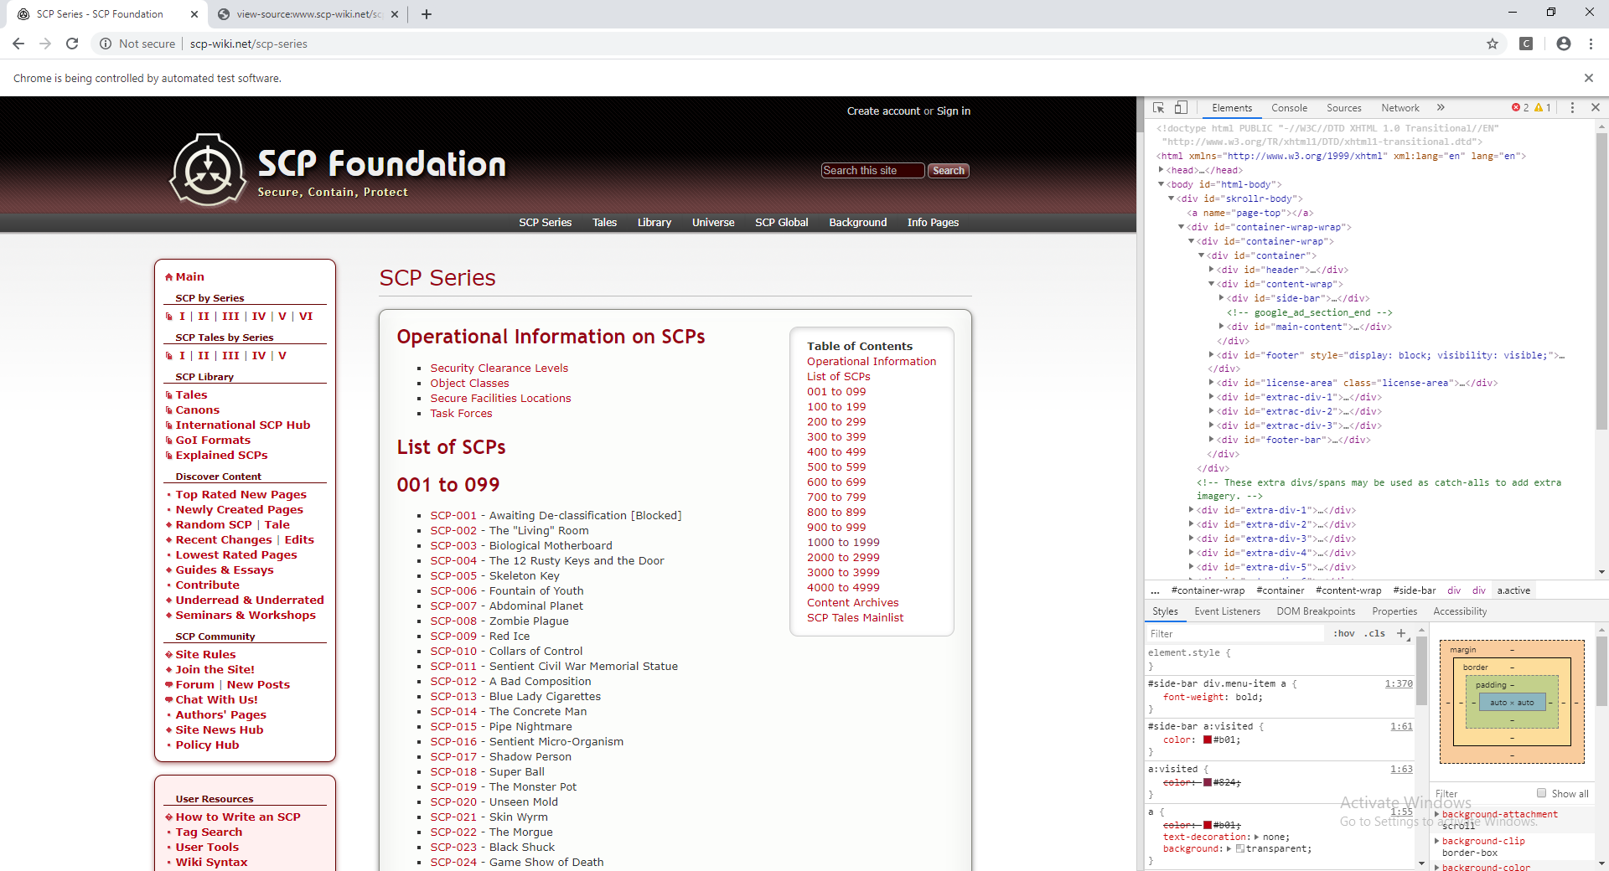

# Locate the sidebar which covers the boxes on the left side: Main, User Resouces, Social Media and Languages
side_bar = driver.find_element_by_id("side-bar")
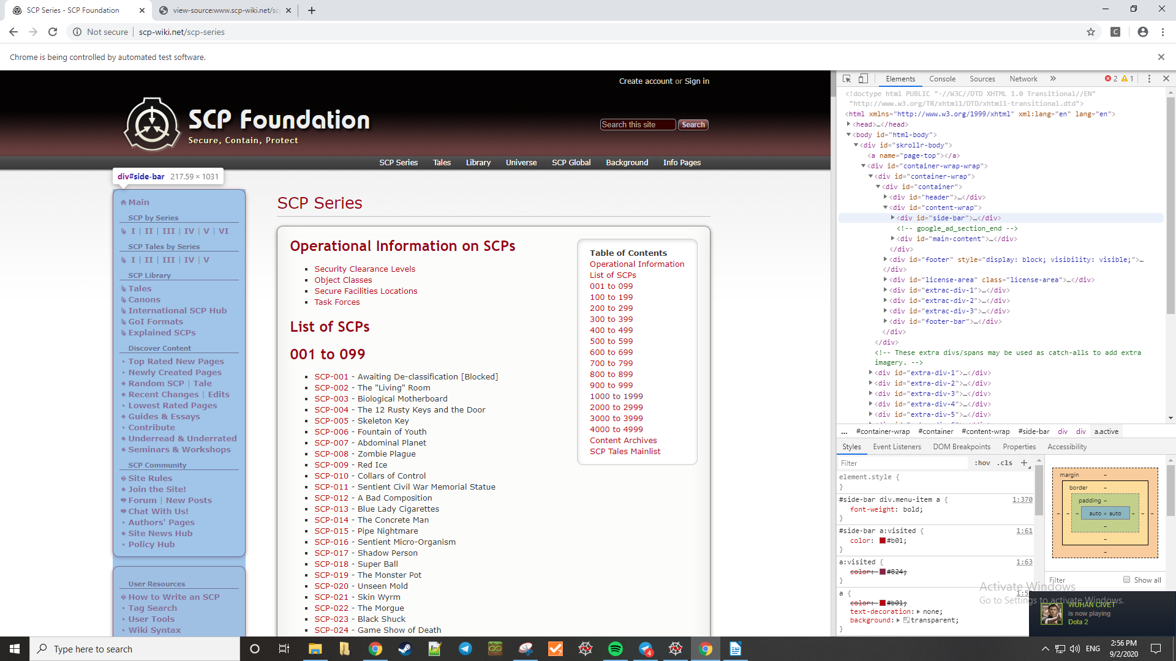
# Locate the first box which is Main
side_block = side_bar.find_elements_by_class_name("side-block")[0]
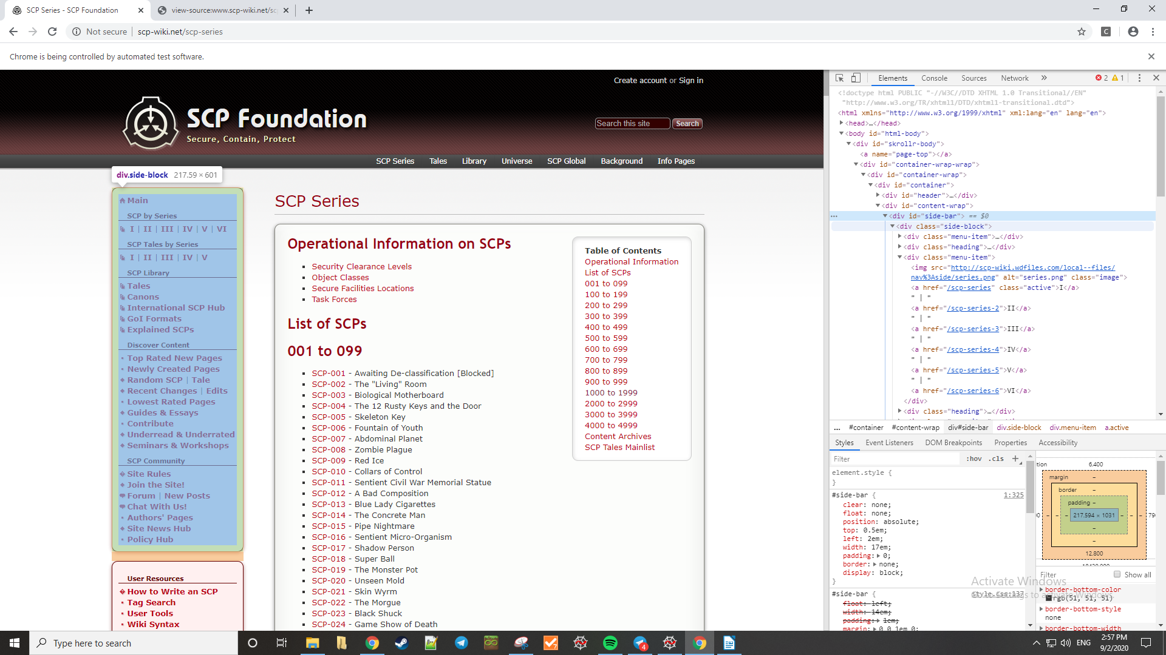

# Brutal way to reach this, and haven't even extracted the links.
# Find the heading called 'SCP by Series'
scp_series_body = side_block.find_element_by_xpath("//p[contains(text(), 'SCP by Series')]")
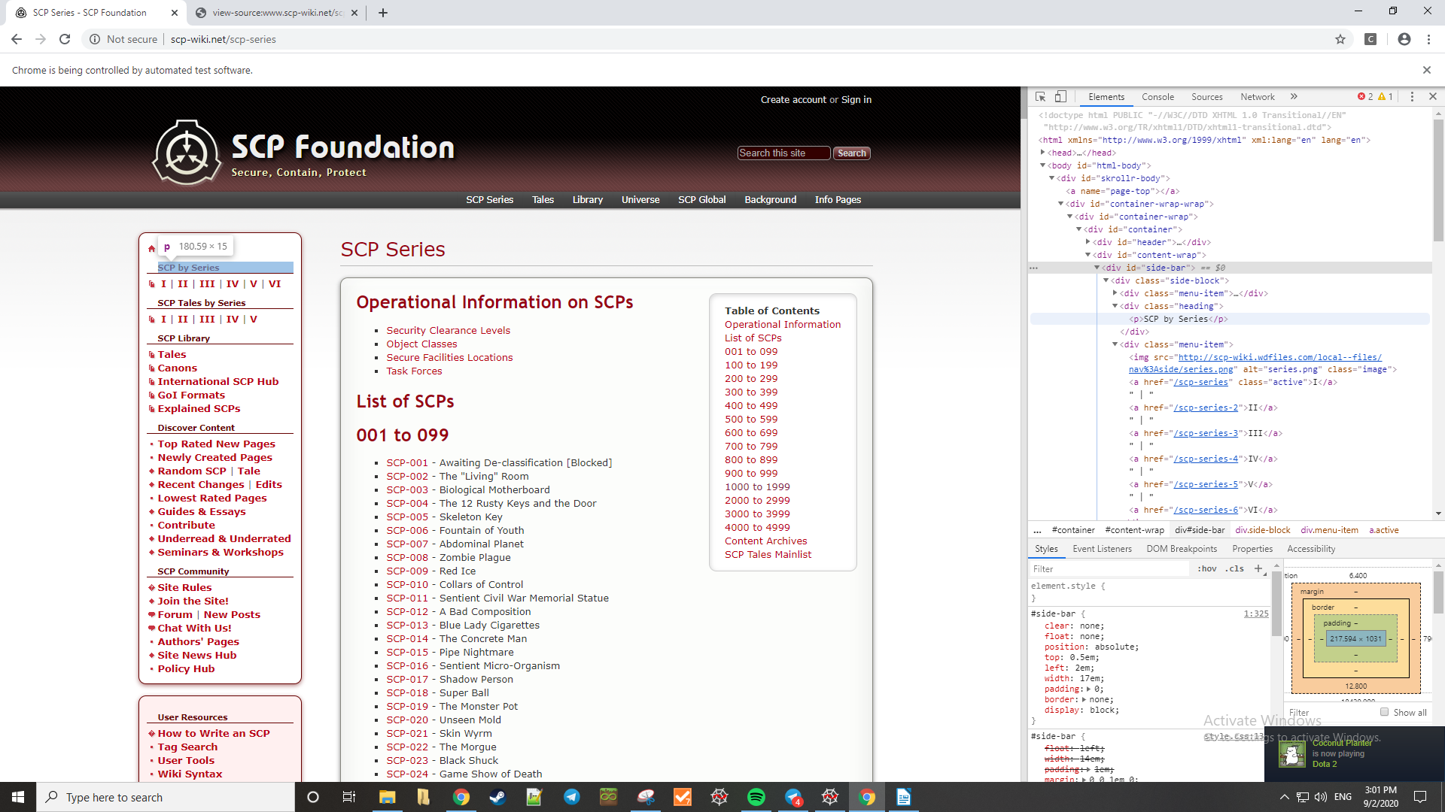
# Go up one hierarchy level to the heading object itself
scp_series_body = scp_series_body.find_element_by_xpath("..")
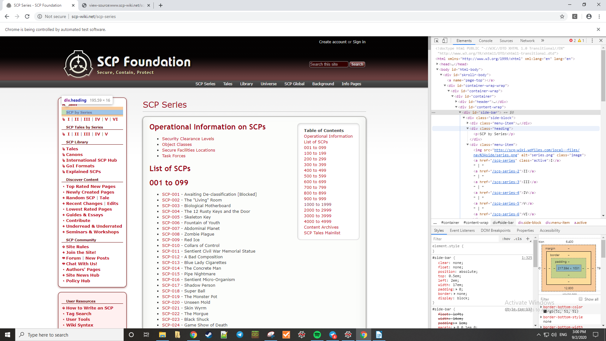
# Move to the next menu-item which contains all the SCP Series links
# FYI as of Feb'20, SCP Series VI is online following the conlcusion of the SCP-5000 contest: Mystery
scp_series_body = scp_series_body.find_element_by_xpath("following-sibling::*")
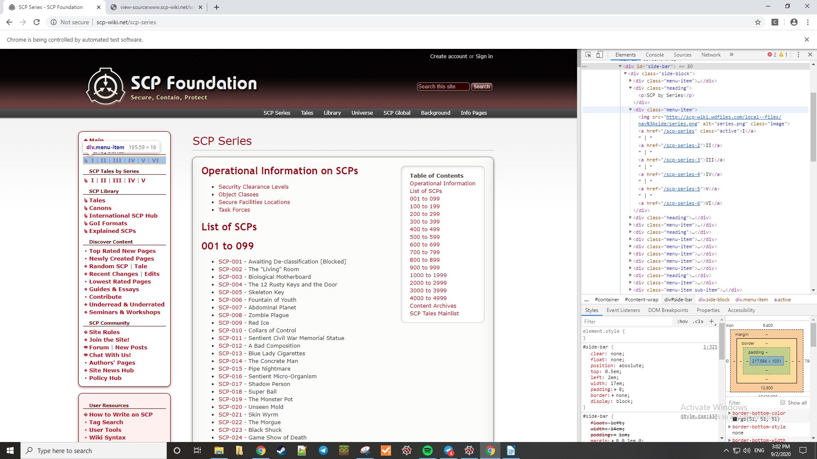
# Move down one level again and find all the objects within.
# Length of this list should correspond to the number of links + the papers icon at leftmost
(Screenshot shows the papers icon as the first object on this level)
scp_series = scp_series_body.find_elements_by_xpath(".//*")
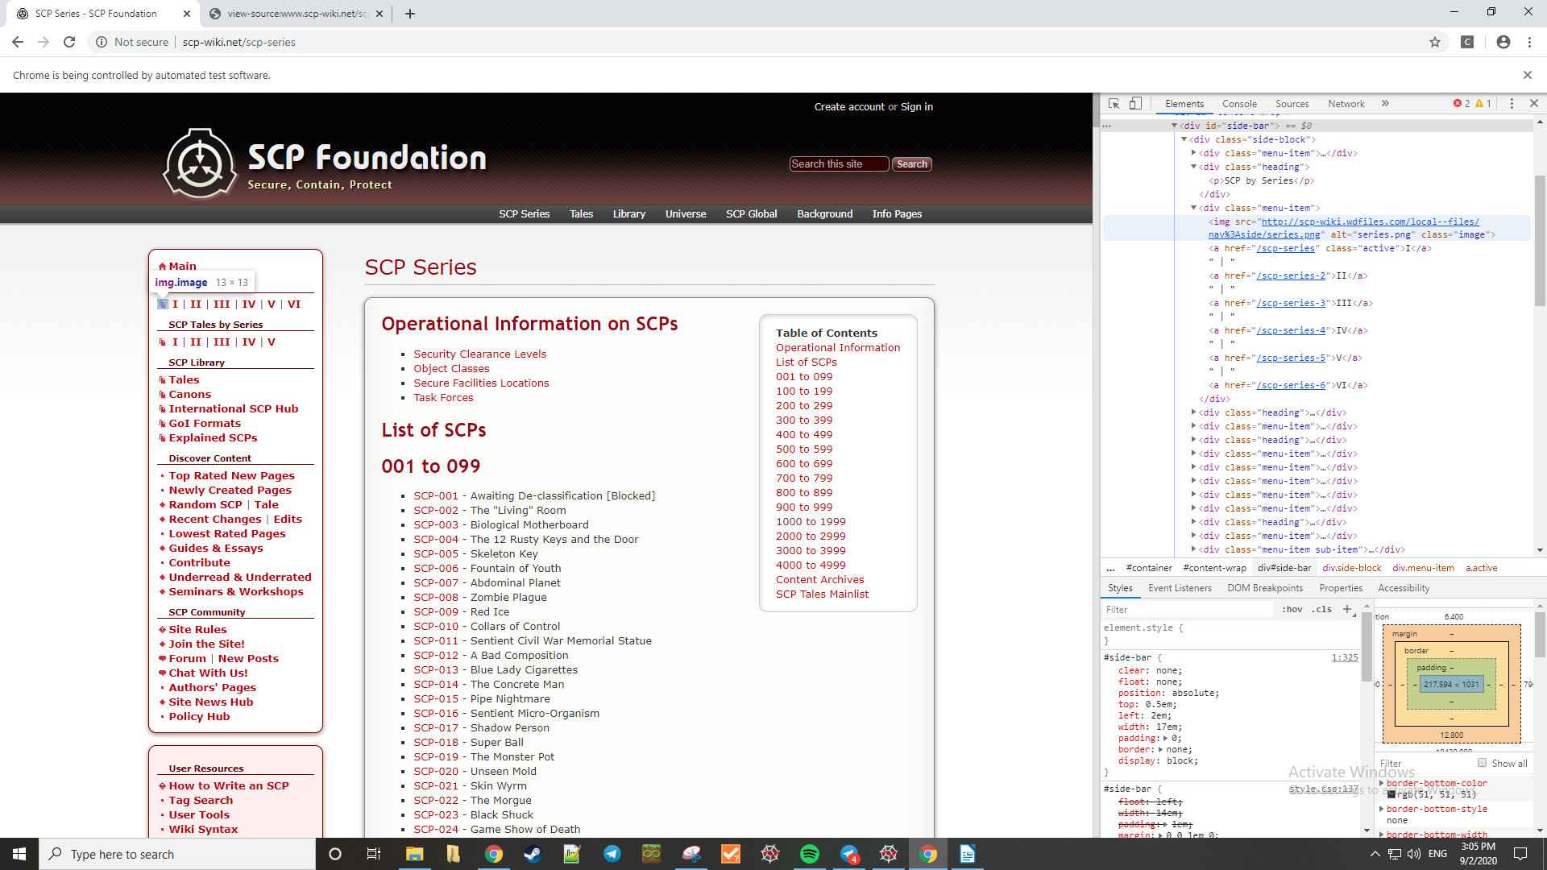
# Starting from the 2nd element, get the text within the href attribute which is a link
#for x in scp_series[1:]:
# print(x.get_attribute('href'))
series_links = [x.get_attribute('href') for x in scp_series][1:]
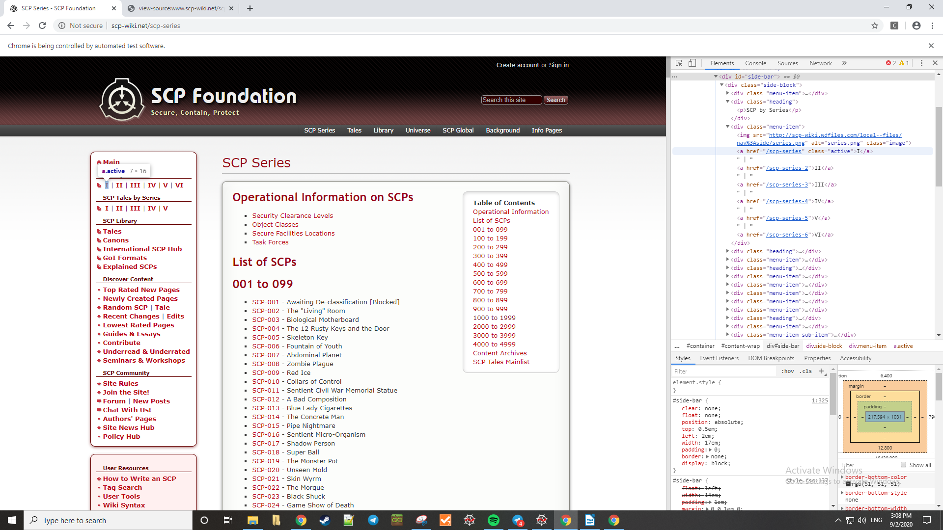
# Attempt #3
# Handle SCP-000 which isn't listed
scip_names = ['SCP-000']
scip_nums = ['SCP-000']
#many_series = []
thousands_digit = 0

for link in series_links:
print('Start ' + link.split('net')[-1] + ' at ' + str(dt.datetime.now()))
driver.get(link)

# # This basically looks for the text of the link, which may not necessarily follow the SCP-#### format.
# # So some number entries are missing.
# series_names = driver.find_elements_by_xpath("//*[contains(text(), 'SCP-')]")

# What I actually want is simple: Copy the link text, and then copy the text after that.
# Find all the li's, which are elements that contains the text 'SCP-'
series_names = driver.find_elements_by_xpath("//*[contains(text(), 'SCP-')]")
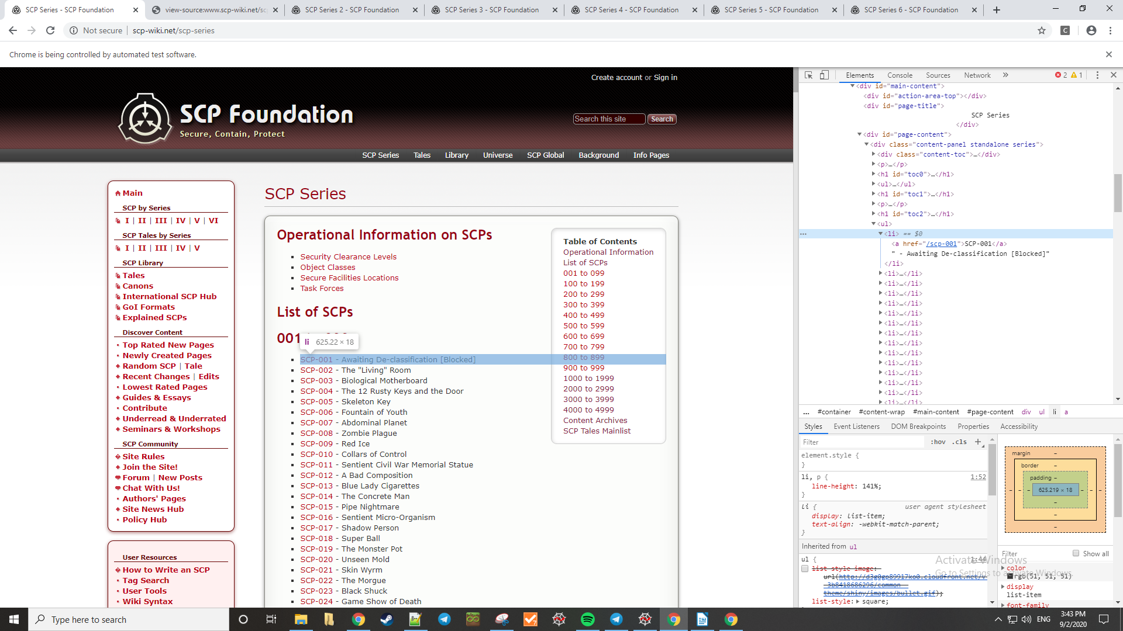
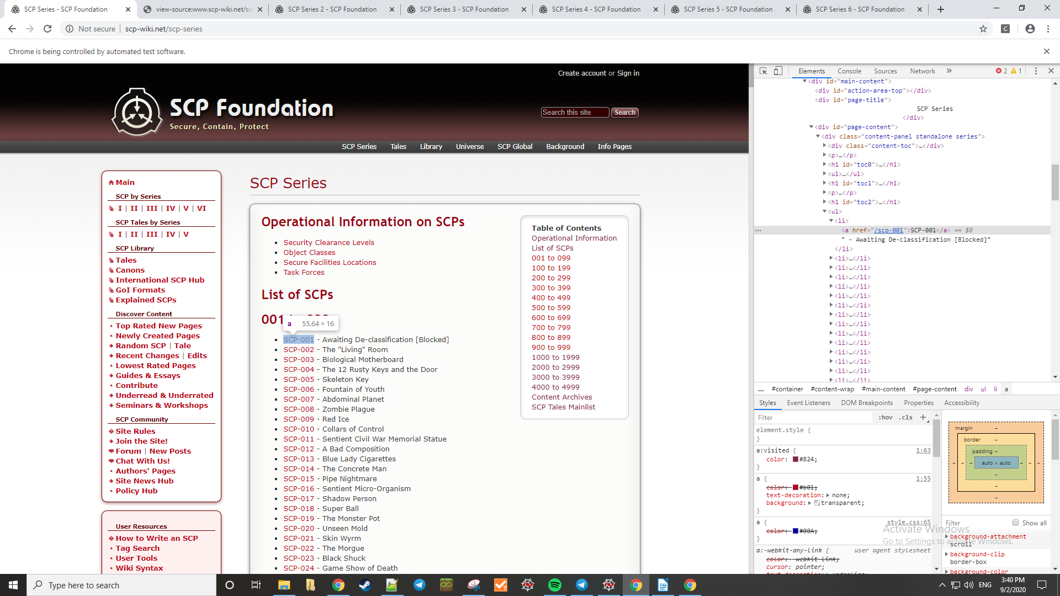
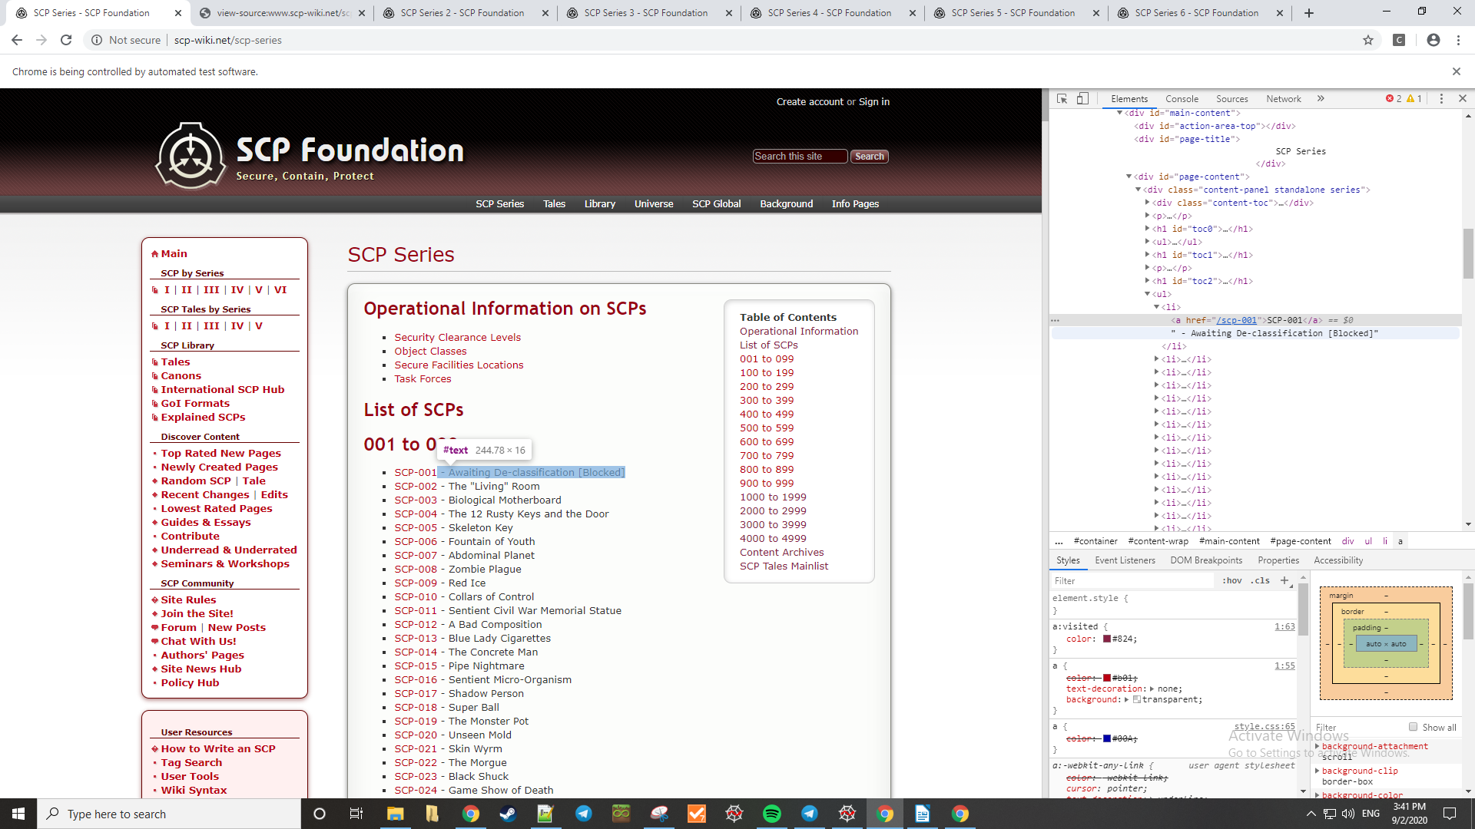
series_names = [x.find_element_by_xpath("..") for x in series_names]

series_text = series_names.copy()
series_text = [x.text for x in series_names]

series_nums = [x.text.split(' - ')[0] for x in series_names]
series_names = [x.text.split(' - ')[-1] for x in series_names]
series_names = series_names[:-1]
# Need to remove SCP-EX
print(len(series_nums))
while 'SCP-EX' in series_nums:
series_nums.remove('SCP-EX')
print(len(series_nums))

# Check the sum of series_num using the formula: (n+1)*(n/2)
# Replace thousands digit with the final number, except for the first series where the final char is the letter 's'
if link[-1] != 's':
thousands_digit = int(link[-1])
print(link[-1])
series_sum_check = (0 + 999 + 2*1000*thousands_digit) * (1000/2)
series_nums_only = [int(x.split('-')[-1][4]) if len(x.split('-')[-1]) > 3 else int(x.split('-')[-1]) for x in series_nums]
if link[-1] != 's':
series_nums_only = [x.split('-')[-1][:4] for x in series_nums]
else:
series_nums_only = [x.split('-')[-1] for x in series_nums]

# print('Sum-check series numbers: ' + str(sum(series_nums_only)) + ' vs. ' + str(series_sum_check))

scip_nums = scip_nums + series_nums
scip_names = scip_names + series_names

many_series.append(series_text)

print('End at ' + str(dt.datetime.now()))

