Swinburne University of Technology
DATA VISUALISATION DESIGN BOOK
Unit: COS30045 Data Visualisation
Student: Viet Nguyen 104838373 | Khang Huynh 104849346
Tutorial: Raihaneh Aghaie
Due Date: 11/06/2026

Contents
1. Introduction 3
1.1 Background and Motivation 3
1.2 Visualisation Purpose 3
2. Data 3
2.1 Data Source and Governance 3
2.2 Data Processing and Analysis 3
2.3 Data Exploration 3
3. Visualisation Design 3
3.1 Website Design 4
3.2 Visualisation Design 4
3.3 Interaction Design 4
4. Iteration and Validation 4
4.1 Testing and Refinements 4
4.2 Usability Evaluation 4
5. Conclusion and Future Improvements 4
References 4
Appendices 4

1. Introduction

1.1 Background and Motivation
- Target audience: State and federal transport policymakers, road-safety researchers, public health officials, and the public.
- Problem addressed: Road-crash hospitalisations in Australia have risen steadily over the past decade, but the scale of the problem differs sharply by state and by road-user type. The official BITRE/AIHW publication splits this story across many separate tables and static charts. Policymakers need to see geography, composition, and trend in one connected view — so they can identify which states and which road-user groups most urgently need targeted intervention.
- Key user tasks:
  - Compare First Nations vs non‑Indigenous hospitalisations in any state
  - See trends from 2011 to 2021
  - Spot which states need priority

1.2 Visualisation Purpose
Specific questions users can answer:
- In a selected year, which state or territory has the highest number of road-crash hospitalisations — and which has the lowest?
- How has the national hospitalisation total changed from 2011 to 2021, and is the overall trend rising or falling?
- Is the gap closing or widening in each jurisdiction?
- For a specific state (e.g., Victoria vs. NT), what does the road-user breakdown look like, and how does it differ from the national picture?
Benefits – impact on decision‑making:
- Budget allocation: State transport departments can compare their hospitalisation counts against other jurisdictions and prioritise funding where the burden is greatest.
- Targeted policies: Federal agencies (BITRE, AIHW) can design road-user-specific interventions — e.g., motorcycle safety campaigns in states where motorcyclist hospitalisations are disproportionately high — instead of one-size-fits-all approaches.
- Advocacy: Policymakers can track whether existing programs are working by watching year-over-year movement in both the total and the road-user mix.
- Public awareness: Residents see their own state's situation and the relative risk of different transport modes, fostering informed community discussion about road safety

2. Data

2.1 Data Source and Governance
Original data sources:
Dataset | Source | Link
First Nations hospitalised injuries | BITRE / AIHW | https://www.bitre.gov.au/publications/ongoing/hospitalised-injury
State and territory hospitalised injuries | BITRE / AIHW | https://www.bitre.gov.au/publications/ongoing/hospitalised-injury
- Both files are part of BITRE’s Hospitalised injuries from road crashes publication (September 2023 update).
Data summary table:
Attribute | Value
Time period | 2011 – 2021 (annual, plus 6-monthly in raw sheets)
Number of records (raw sheets) | ~2,500 rows per file (after filtering cause of injury = Traffic)
Key attributes | calendar year, state/territory, First Nations status, count of cases, road user, age group, counterparty
Update frequency | Irregular (~every 2-3 years)

Data governance:
Aspect | Details
Data collection process | AIHW collects hospital admission data from states/territories → National Hospital Morbidity Database (NHMD) → BITRE extracts road-crash related cases.
Data quality assessment | Generally high for major states (NSW, Vic, Qld, WA). Limitations: n.p. (not for publication) for small counts; break in series for NSW (June 2017) and Victoria (2012).
Security, privacy, ethics | De‑identified aggregated data only. “n.p.” suppresses small numbers to prevent re‑identification. Publicly available open data – no ethical concerns.

How data supports answering questions from Section 1.2
Our visualisation’s four key questions require comparing First Nations vs non-Indigenous hospitalisations by state and over time. The two datasets provide exactly that:
- In any selected state/territory, how do First Nations hospitalisation numbers compare with non‑Indigenous?
- Merging on year + state puts both groups side-by-side per state.
- Which state/territory has the largest gap – and has that ranking changed from 2011 to 2021?
- State breakdown allows ranking across 8 jurisdictions over 11 years.
- Is the gap closing or widening in each jurisdiction?
- Year-by-year trends reveal direction of change.
- What is the long‑term trend for a specific state (e.g., NT vs NSW)?
- 2011-2021 time series for each state shows trajectory.

2.2 Data Processing and Analysis
The two raw BITRE/AIHW workbooks were not analysis ready. The National file was a clean long-form table on its raw sheet (117,919 rows, monthly granularity); the State/Territory file was a raw sheet with five separate tables placed side-by-side in one worksheet (1,372 rows of mixed-header structure). Both files had to be cleaned, normalised, aggregated, and merged in KNIME before they could be loaded by the dashboard. The output was a single CSV (mergedData.csv, 1,384 rows × 9 columns) consumed at runtime via d3.csv ().
Key attributes and data types
Attribute | Data type | Example values | Used by
Calendar year | Interval (discrete numeric) | 2011, 2012, …, 2021 | Stream graph x-axis; filter
6-monthly | Ordinal categorical | Jan–Jun, Jul–Dec | Temporal grain (not exposed in UI)
Cause of injury | Nominal categorical | Traffic | Filter constant (kept only "Traffic")
State or territory | Nominal categorical | NSW, Vic, Qld, WA, SA, NT, Tas, ACT, Australia | Choropleth; state filter
Breakdown type | Nominal categorical | Total, Road user | Routing data to the right chart
Breakdown value | Nominal categorical | Car driver/passenger, Motorcyclist, Pedal cyclist, Pedestrian, Heavy transport, Pick-up/van, Bus, Other, Total | Stream/Parliament/Waffle colour & shape
Data level | Nominal categorical | National, State/Territory | Aggregation routing
Hospitalisations | Ratio (quantitative) | 1,191 | Primary measure encoded by every chart
Bed days | Ratio (quantitative) | 6,147 | Reserved for future "severity" view

2.3 Data Exploration
Write your content here.

3. Visualisation Design

3.1 Website Design
The website is a single-page interactive dashboard built in HTML, CSS, and JavaScript with D3.js v7. It is laid out as a vertical stack of three horizontal regions, sized to fit one viewport with no page scrolling.
- Header strip — title ("Hospitalised injuries from road crashes"), subtitle, data source, and a hero panel showing the currently selected year.
- KPI row — four cards showing Total hospitalisations for the selected year, Top state/territory, Selected-period trend %, and Current focus state.
- Cube workspace (main region) — three columns from left to right:
  - Filter panel: year, state/territory, multi-select road-user checkboxes, metric toggle, and a Reset View button.
  - Holographic projection chamber: a dark rounded panel with a perspective floor grid that houses the rotating 3D cube.
  - Snap-control sidebar: one button per face (Stream / Parliament / Waffle / Choropleth), pause/resume auto-rotation, and a "now viewing" status pill.
- Footer — data caveats (n.p. suppression, NSW 2017 and Vic 2012 break-in-series).
The dashboard uses a light, cyan-accented theme overall, with the cube sitting inside a dark sci-fi-style chamber for contrast. The layout is responsive — on screens under 900 px wide, the filter and control panels stack above and below the cube.

3.2 Visualisation Design
Rather than a static grid of charts, the four planned visualisations sit on the four side faces of a single 3D cube the user rotates to browse.
Face | Chart type | Encodes | Why this chart
Front | Stream graph | Road-user hospitalisations 2011–2021 | Stream thickness shows both category trend and shifting composition over time. Wiggle baseline emphasises change.
Right | Parliament chart | Road-user composition for the selected year | ~150 dots arranged in a semicircle of concentric arcs; one seat ≈ a fixed share of hospitalisations. Familiar political metaphor; makes proportion tangible.
Back | Waffle chart | Road-user share of selected year (10×10 grid) | Each cell = 1%, filled bottom-up by category. Easier to read small percentages precisely than pie or donut.
Left | Choropleth map | Hospitalisations per state for selected year | Sequential green → yellow → red scale (low to high). Geographic distribution that a bar chart cannot convey.
The top and bottom of the cube are decorative translucent glass "caps" with no chart — they keep the 3D solid intact when tilted.
Colour scheme: bright neon road-user colours chosen for legibility on the dark translucent face glass — sky blue for cars, violet for motorcycle, teal for bicycle, gold for pedestrian. The choropleth uses a separate green-to-red sequential scale, so it does not compete with the road-user palette.

3.3 Interaction Design
- Drag to rotate — click-and-drag spins the cube on the vertical axis. Vertical tilt is hard clamped to ±18° so the cube cannot tumble upside-down or become unreadable.
- Auto-rotate — after 3.5 seconds idle the cube resumes a slow horizontal spin, gently easing the tilt back to its resting angle.
- Snap to face — the four buttons on the right sidebar rotate the cube directly to the chosen face along the shortest arc and reset tilt to a clean reading angle.
- Keyboard shortcuts — number keys 1–4 snap to face; Left/Right arrows nudge rotation; Up/Down arrows tilt within the clamp.
- Cross-face linking (signature interaction) — clicking any state on the choropleth (Left face) updates the other three faces to show that state's road-user breakdown. The four faces behave like one connected exploration, not four separate charts.
- Global filters — year, state, road-user multi-select, and metric toggle all update every face simultaneously.
- Hover tooltips — each chart shows a holographic tooltip with category, value, and percentage.
- Highlight by click — clicking a road user in any chart dims that category in the others.
- Pause/Resume spin — single button toggles auto-rotation off and on.

4. Iteration and Validation

4.1 Testing and Refinements
Iteration 1 — Flat Figma Dashboard (Week 11). The first prototype was a conventional flat dashboard wireframed in Figma: a state-comparison bar chart, a national-trend line, a stacked bar for road-user composition, and a sidebar of filters arranged in a 2×2 grid.
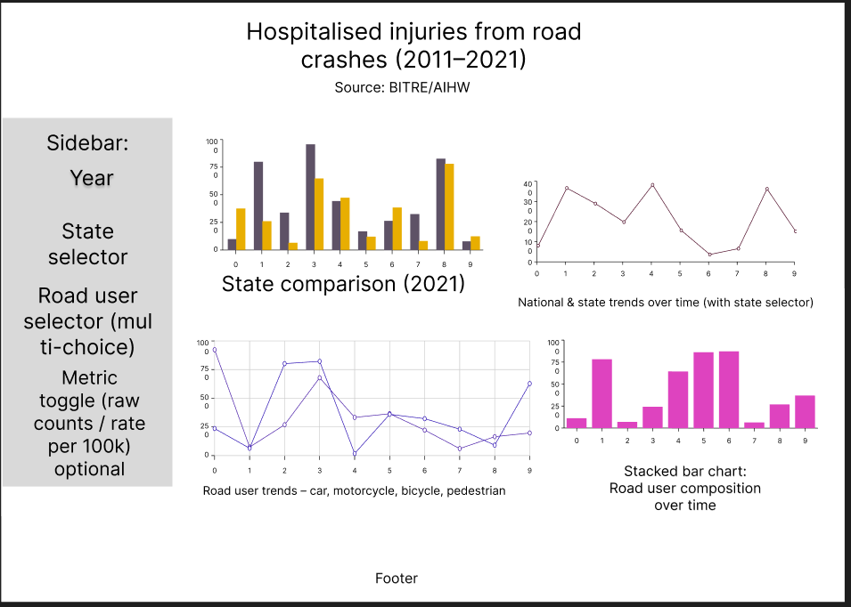
Figure 1. dashboard wireframed in Figma
Tutor feedback (end of Week 11). The tutor (Raihaneh Aghaie) gave critical feedback comparing our Figma layout against the official BITRE/AIHW "Hospitalised injuries from road crashes" dashboard. Her key point was that our design was not more creative than the reference, and that the reference already covered the main story with line, bar, donut, and KPI tiles. To meet the assessment criteria for design quality, we needed to do something the BITRE dashboard cannot.
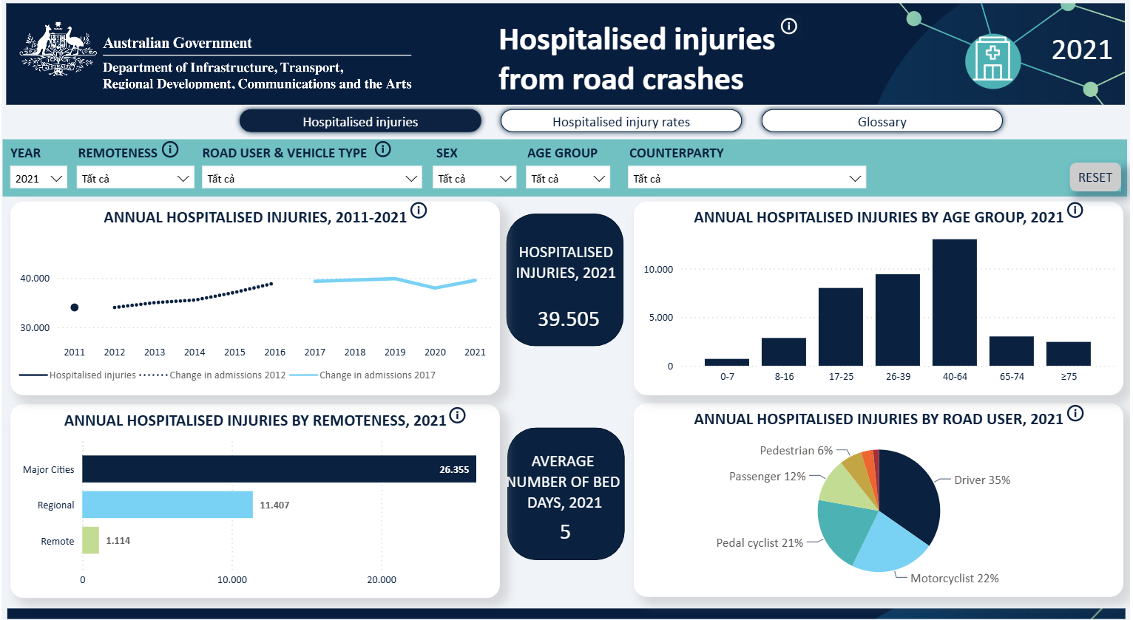
Figure 2."Hospitalised injuries from road crashes" dashboard
Iteration 2 — 3D Holographic Data Cube (Week 12). We discarded the flat 4-panel grid and rebuilt the visualization as a rotating 3D data cube housed in a dark "holographic projection chamber". The table below sets the three designs side by side.
Aspect | BITRE / AIHW dashboard (reference) | Our Figma wireframe (Iter. 1) | Our Cube (Iter. 2)
Layout | Static 4-panel grid | Static 4-panel grid | One rotating object, 4 linked faces
Chart types | Line, bar, donut, KPI tiles | Line, bar, stacked bar | Stream, Parliament, Waffle, Choropleth
Faces visible | All at once | All at once | Revealed by user-driven rotation
Cross-chart link | None | None | Click a map state → other 3 faces update
Theme | Standard government light | Standard light | Translucent holographic glass + neon
Novelty vs. BITRE | — | Similar / lower polish | All 4 chart types absent from BITRE
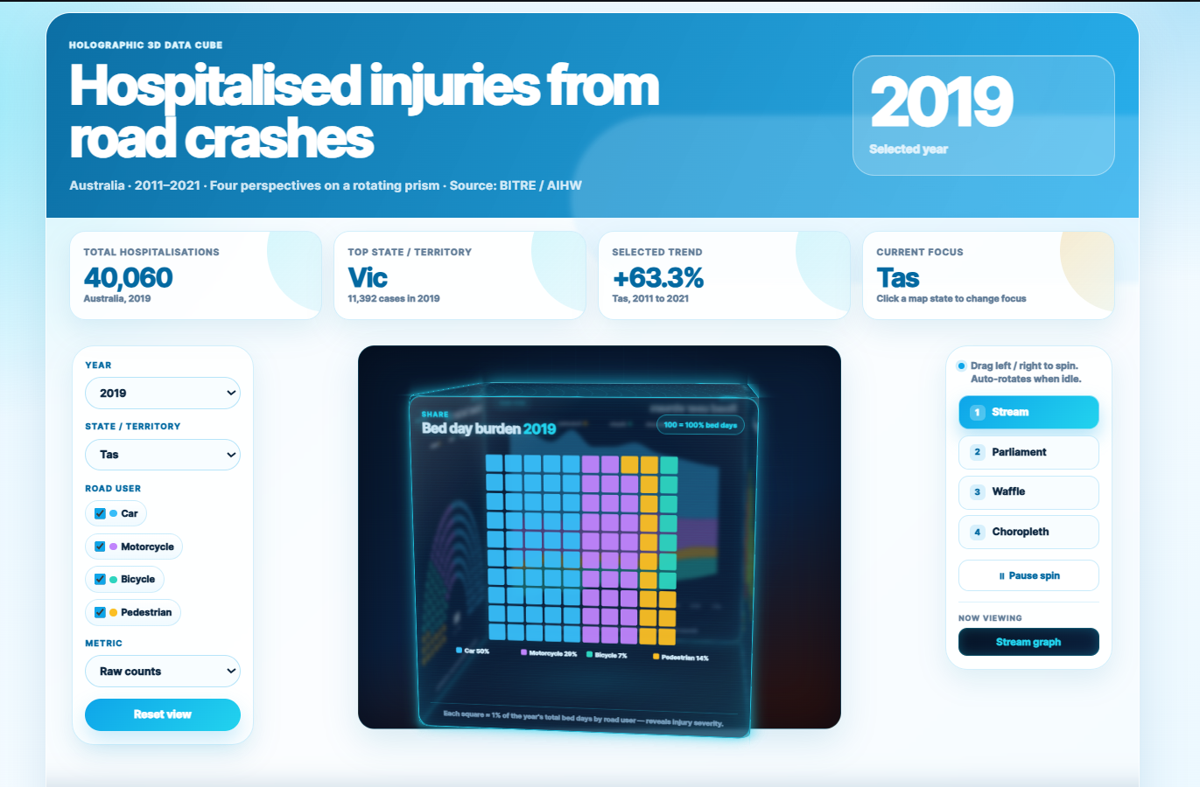
Figure 3. "Hospitalised injuries from road crashes" dashboard after improving
Specific refinements made during Week 12 implementation:
- Cube rotation constraint — unrestricted drag let users tumble the cube upside-down. Clamp vertical tilt to ±18° and add a gentle autocorrection during auto-rotate so the cube stays readable.
- One-viewport layout — initial build required page scrolling. Refactored the dashboard to 100dvh flex layout so everything fits one screen.
- Choropleth winding-order bug — d3.geoMercator uses spherical math and interpreted some clockwise-wound polygons as the globe complement, causing WA/Qld/Tas to cover the entire map. Switched to d3.geoIdentity(). reflectY(true) (planar projection) which ignores winding.
- Choropleth color scale — first version was monochrome blue, which made high and low states hard to tell apart immediately. Replaced with a green → yellow → red sequential scale.
- Waffle legend overlaps legend originally ran horizontally below the grid and got clipped. Reshaped the layout to reserve a bottom band and stacked the legend vertically, centered horizontally, reading bottom-to-top so it matches the waffle's bottom-up fill order.
- National road-user data — discovered the source data has no national row for road-user breakdown; values only exist at state level. Aggregated state rows to produce a national view and made the road-user charts respect the selected state (so clicking Victoria on the map shows Victoria's breakdown on the other three faces).

4.2 Usability Evaluation
To be completed in Week 13. Planned protocol:
- Participants: 3–5 testers drawn from the cohort, plus the tutor where possible.
Tasks:
- Find the state with the most hospitalizations in 2021.
- Compare the trend for cyclist’s vs pedestrians from 2011 to 2021.
- Click on Tasmania and identify its top road-user category.
- Rotate to the parliament face using only the keyboard.
Metrics: task completion rate, time-on-task, error count, System Usability Scale (SUS) score post-session.
Questions to probe:
- Is the cube metaphor intuitive to first-time users or does it confuse navigation?
- Does the green-red choropleth read clearly to colour-blind testers (we will run a Daltonism simulation as a backup check)?
- Do users discover the interaction between the click-to-link-faces interaction without being told?

5. Conclusion and Future Improvements
Write your content here.

References
Use APA referencing style.

Appendices
- GenAI Declaration
- Usability materials
- Notes/data

