While trying to connect to Aa VM instance through cosole.cloud.google.com as shown below in the snapshot.

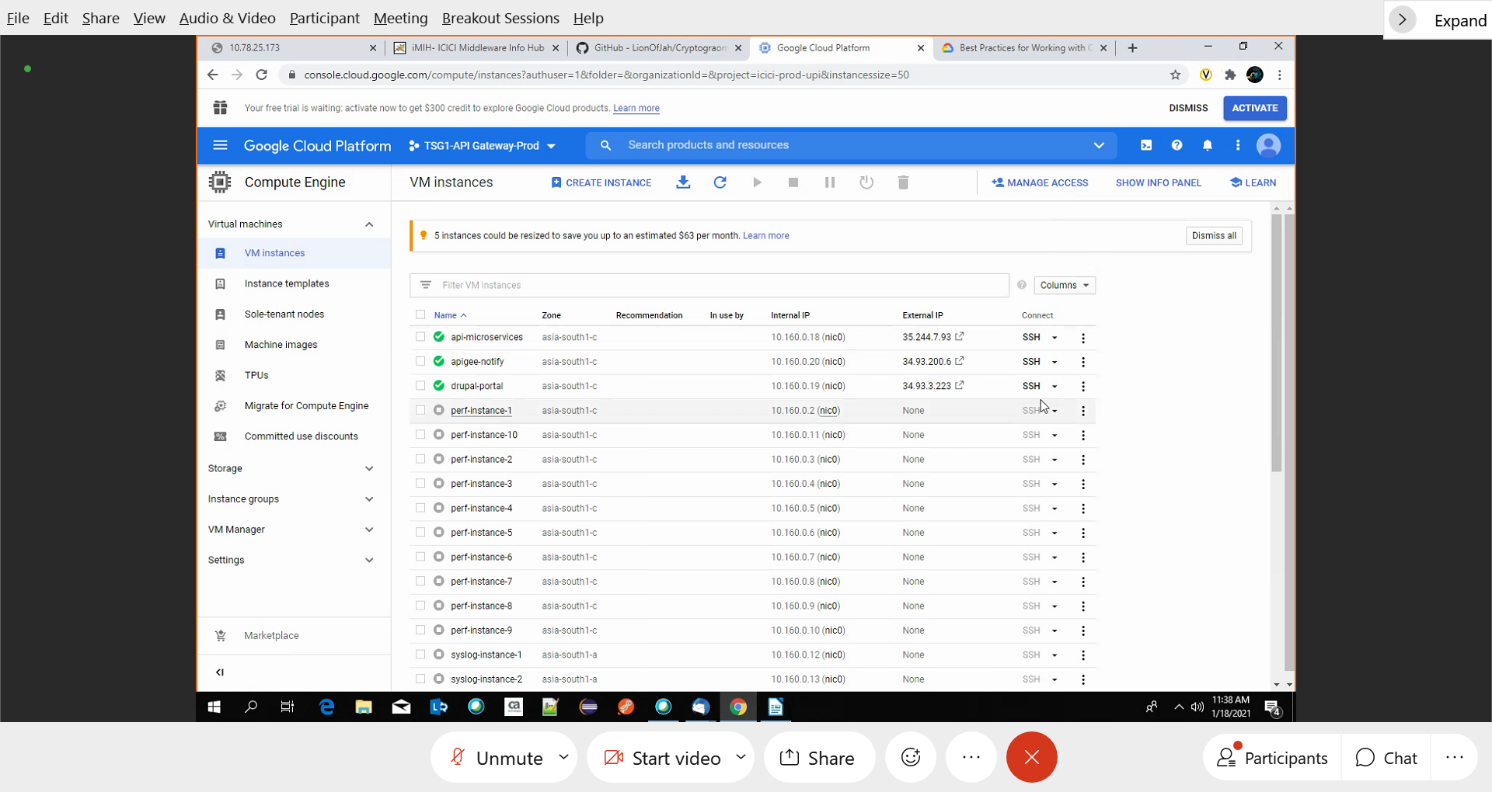

As you can see, we are not able to connect to the terminal when connecting through SSH.

