

***Дисциплина: Учебная практика***

**Отчет по выполнению задания на тему: «Lesson 8».**

Выполнил:

Шоматов Арслан

Проверил преподаватель:

.

**Задание 8:**

GO

create table Info (

IDNumber int identity,

Name_ nvarchar(50) not null,

General nvarchar(50) not null,

Question int,

Place nvarchar(50) not null,

Constraint PK_Info_IDNumber primary key (IDNumber)

);

insert into Info (Name_,General,Question,Place)

values ('Первый раздел','информация о предприятии','1','Москва'),

('Второй раздел','информация о предприятии','2','Москва'),

('Третий раздел','информация о предприятии','3','Москва'),

('Четвертый раздел','информация о предприятии','4','Москва');

create table Product1 (

ID1 int identity,

Name_ nvarchar (50) not null,

Class nvarchar (50) not null,

Weight_ int not null,

Place nvarchar(50) not null,

Сostt int,

Constraint PK_Product_ID1 primary key (ID1)

);

insert into Product1 (Name_,Class,Weight_,Place,Сostt)

values ('Пирог','Выпечка','450','Москва','600'),

('Конфеты','Сладость','200','Красноярск','250'),

('Рулет','Выпечка','105','Норильск','200'),

('Торт','Выпечка','600','Ленинград','500');

create table Product2 (

ID2 int identity,

Name_ nvarchar (50) not null,

Class nvarchar (50) not null,

Weight_ int not null,

Place nvarchar(50) not null,

Сostt int,

Constraint PK_Product2_ID2 primary key (ID2)

);

insert into Product2 (Name_,Class,Weight_,Place,Сostt)

values ('Бисквит','Выпечка','450','Москва','300'),

('Коса','Сладость','100','Красноярск','50'),

('Сливовый пирог','Выпечка','700','Норильск','500'),

('Пончики','Выпечка','600','Ленинград','50');

create table Product3 (

ID3 int identity,

Name_ nvarchar (50) not null,

Class nvarchar (50) not null,

Weight_ int not null,

Place nvarchar(50) not null,

Сostt int,

Constraint PK_Product3_ID3 primary key (ID3)

);

insert into Product3 (Name_,Class,Weight_,Place,Сostt)

values ('Блины','Выпечка','450','Москва','200'),

('Круассан','Выпечка','200','Красноярск','100'),

('Ругувачки','Выпечка','105','Норильск','400'),

('Булочка','Выпечка','160','Ленинград','50');

Select Name_ as Name_

From Info

Select * From Product1;

Select * From Product2

Order by Weight_;

SELECT * FROM Product2

WHERE Weight_ = '700';

SELECT * FROM Product1

WHERE Weight_ = '600';

SELECT * FROM Product1

WHERE Name_ = 'Пирог';

SELECT * FROM Product2

WHERE Name_ = 'Бисквит';

SELECT * FROM Product2

WHERE Weight_ > 200;

SELECT * FROM Product1

WHERE Weight_ < 2000;

SELECT * FROM Product2

WHERE Place = 'Москва';

SELECT * FROM Product3

WHERE Weight_ > 25;

SELECT * FROM Product2

WHERE Place IN ('Москва','Красноярск');

SELECT * FROM Product1

WHERE Weight_ IN ('700','600');

SELECT * FROM Product3

WHERE Place NOT IN ('Норильск','Ленинград');

SELECT * FROM Product1

WHERE Weight_ BETWEEN 100 AND 500;

SELECT * FROM Product2

WHERE Weight_ NOT BETWEEN 500 AND 800;

SELECT * FROM Product3

WHERE Weight_ BETWEEN 250 AND 300;

UPDATE Product2

SET Weight_ = Weight_ + 100;

DELETE Product3

WHERE Place='Норильск';

SELECT Weight_, COUNT(*) AS cost

FROM Product1

GROUP BY Weight_;

SELECT Weight_, COUNT(*) AS cost

FROM Product2

GROUP BY Weight_

HAVING COUNT(*) > 1;

SELECT AVG(Weight_) FROM Product1

WHERE Place = 'Ленинград';

SELECT SUM (Weight_*Сostt) FROM Product2;

SELECT MIN (Сostt) FROM Product2;

SELECT MAX (Сostt) FROM Product1;

SELECT COUNT(*) FROM Product1;

SELECT AVG(DISTINCT Сostt) AS average_price FROM Product2;

SELECT Weight_, COUNT (*) AS model, SUM(Сostt) AS cost

FROM Product1

GROUP BY Weight_ WITH ROLLUP;

SELECT Weight_, COUNT (*) AS name_, SUM(Сostt) AS cost

FROM Product2

GROUP BY Weight_ WITH ROLLUP;

SELECT Weight_, COUNT (*) AS Weight_, SUM(Сostt) AS cost

FROM Product3

GROUP BY Weight_ WITH ROLLUP;

SELECT Weight_, COUNT (*) AS Class, SUM(Сostt) AS cost

FROM Product1

GROUP BY Weight_ WITH CUBE;

SELECT Weight_, COUNT (*) AS Name_, SUM(Сostt) AS cost

FROM Product2

GROUP BY Weight_ WITH CUBE;

SELECT Weight_, COUNT (*) AS Weight_, SUM(Сostt) AS cost

FROM Product3

GROUP BY Weight_ WITH CUBE;

SELECT Weight_, COUNT (*) AS Class, Сostt

FROM Product1

GROUP BY GROUPING SETS(Weight_, Сostt);

SELECT Weight_, COUNT (*) AS Name_, Сostt

FROM Product2

GROUP BY GROUPING SETS(Weight_, Сostt);

SELECT Weight_, COUNT (*) AS Weight_, Сostt

FROM Product3

GROUP BY GROUPING SETS(Weight_, Сostt);

SELECT Name_, Weight_, Сostt,

COUNT(*) OVER (PARTITION BY Weight_) AS Place,

SUM(Сostt) OVER (PARTITION BY Weight_) AS Cost

FROM Product1

SELECT Name_, Weight_, Сostt,

COUNT(*) OVER (PARTITION BY Weight_) AS Place,

SUM(Сostt) OVER (PARTITION BY Weight_) AS Cost

FROM Product2

SELECT Name_, Weight_, Сostt,

COUNT(*) OVER (PARTITION BY Weight_) AS Place,

SUM(Сostt) OVER (PARTITION BY Weight_) AS Cost

FROM Product3

SELECT Product1.Name_, Product1.Place, Product1.Weight_

From Product1

Join Product2

on Product1.ID1 = Product2.ID2

SELECT Product1.Name_, Product1.Place, Product1.Weight_

From Product1

left Join Product2

on Product1.ID1 = Product2.ID2

SELECT Product1.Name_, Product1.Place, Product1.Weight_

From Product1

right Join Product2

on Product1.ID1 = Product2.ID2

SELECT Product1.Name_, Product1.Place, Product1.Weight_

From Product1

Join Product2

on Product1.ID1 = Product2.ID2 and Product1.Weight_<500

order by Product1.Name_

select * from Product1

Cross JOin Product2

select * from

Product1,Product2

select Name_, Weight_, Сostt from Product1 union select Name_, Weight_, Сostt from Product2;

select Weight_ + '' + Сostt as Weight__Сostt from Product1 union select Weight_ + '' + Сostt as Сostt_Weight_ from Product2 order by Weight__Сostt desc;

select Name_, Weight_, Сostt from Product1 except select Name_, Weight_, Сostt from Product2;

select Weight_ + '' + Сostt as Weight__Сostt from Product1 except select Weight_ + '' + Сostt as Сostt_Weight_ from Product2 order by Weight__Сostt desc;

select Name_, General, Question, Place from Info intersect select Name_, General, Question, Place from Info;

select Name_ from Product1 intersect select Name_ from Product2;

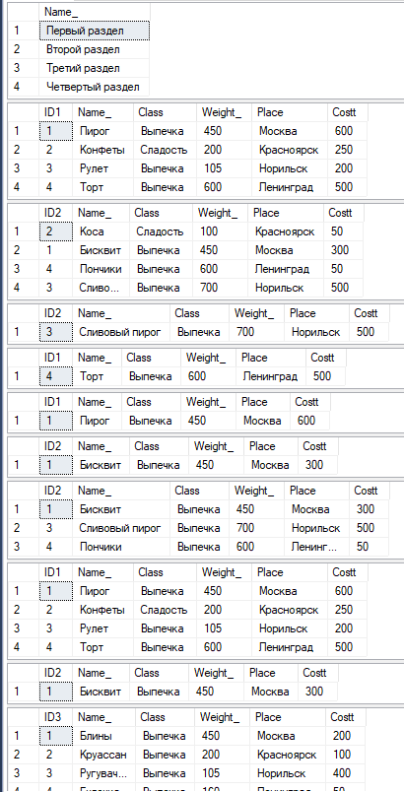

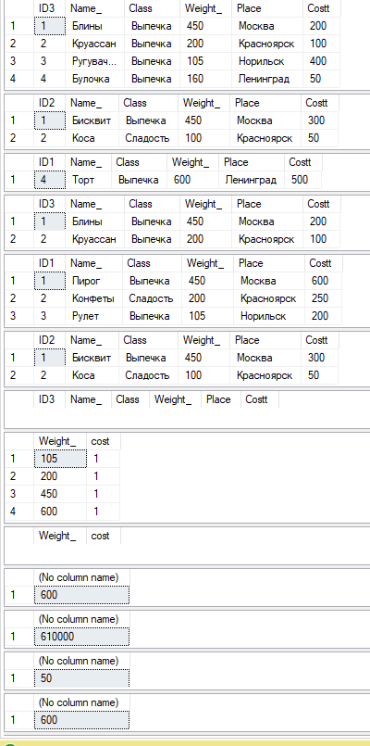

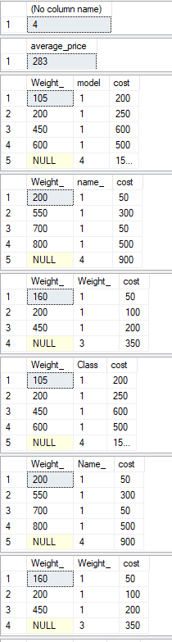

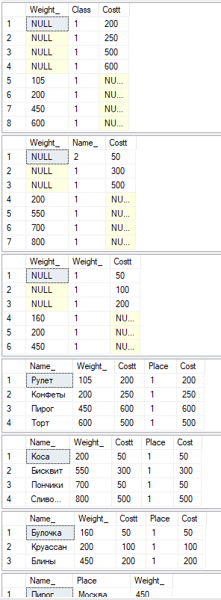

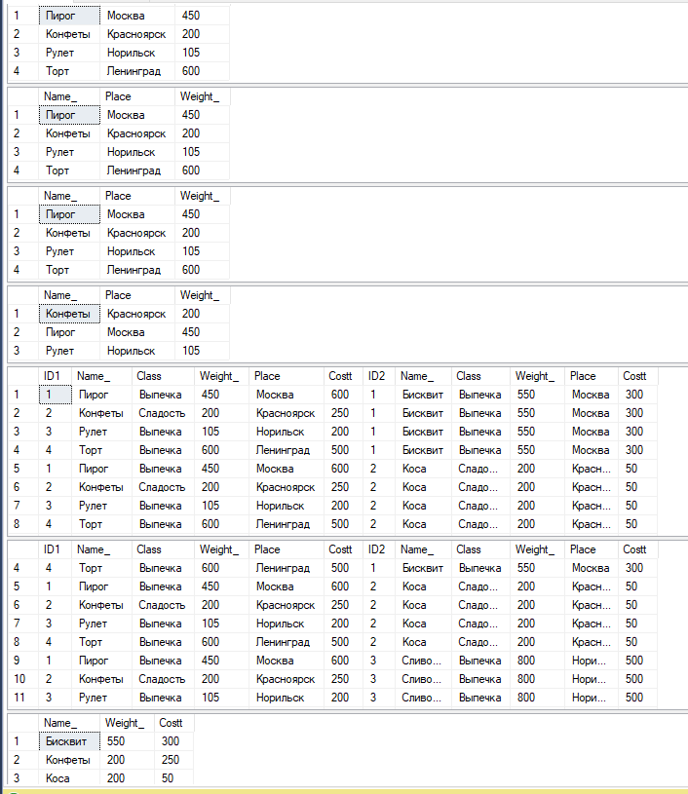

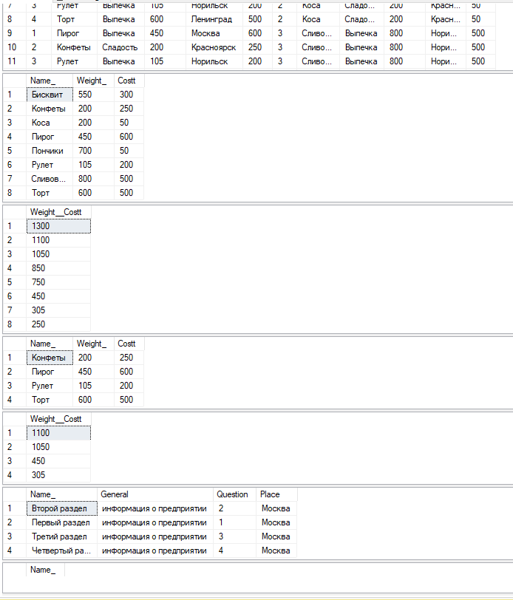

**Задание 8.1:**

**GO**

**create table Info1 (**

**IDNumber1 int identity,**

**Name_ nvarchar(500) not null,**

**General nvarchar(50) not null,**

**Question int not null,**

**Place nvarchar(50) not null,**

**Constraint PK_Info_IDNumber1 primary key (IDNumber1),**

**Code1 int Not Null,**

**Code2 int Not Null,**

**Code3 int Not Null,**

**Code4 int Not Null,**

**Code5 int Not Null,**

**Code6 int Not Null**

**);**

**insert into Info1 (Name_,General,Question,Place, Code1,Code2, Code3, Code4, Code5, Code6)**

**values ('Первый раздел','информация о предприятии','1','Москва',1,2,3,4,5,6),**

**('Второй раздел','информация о предприятии','2','Москва',1,2,3,4,5,6),**

**('Третий раздел','информация о предприятии','3','Москва',1,2,3,4,5,6),**

**('Четвертый раздел','информация о предприятии','4','Москва',1,2,3,4,5,6),**

**('Пятый раздел','информация о предприятии','1','Москва',1,2,3,4,5,6),**

**('Шестой раздел','информация о предприятии','2','Москва',1,2,3,4,5,6),**

**('Седьмой раздел','информация о предприятии','3','Москва',1,2,3,4,5,6),**

**('Восьмой раздел','информация о предприятии','4','Москва',1,2,3,4,5,6),**

**('Девять раздел','информация о предприятии','1','Москва',1,2,3,4,5,6),**

**('Десятый раздел','информация о предприятии','2','Москва',1,2,3,4,5,6),**

**('Одиннадцатый раздел','информация о предприятии','3','Москва',1,2,3,4,5,6),**

**('Двенадцатый раздел','информация о предприятии','4','Москва',1,2,3,4,5,6),**

**('Тринадцатый раздел','информация о предприятии','1','Москва',1,2,3,4,5,6),**

**('Четырнадцатый раздел','информация о предприятии','2','Москва',1,2,3,4,5,6),**

**('Пятьнадцатый раздел','информация о предприятии','3','Москва',1,2,3,4,5,6);**

**create table Info2 (**

**IDNumber2 int identity,**

**Name_ nvarchar(500) not null,**

**General nvarchar(50) not null,**

**Question int not null,**

**Place nvarchar(50) not null, Code1 int Not Null,**

**Code2 int Not Null,**

**Code3 int Not Null,**

**Code4 int Not Null,**

**Code5 int Not Null,**

**Code6 int Not Null,**

**Constraint PK_Info_IDNumber2 primary key (IDNumber2)**

**);**

**insert into Info2 (Name_,General,Question,Place, Code1,Code2, Code3, Code4, Code5, Code6)**

**values ('Первый раздел','информация о предприятии','1','Москва',1,2,3,4,5,6),**

**('Второй раздел','информация о предприятии','2','Москва',1,2,3,4,5,6),**

**('Третий раздел','информация о предприятии','3','Москва',1,2,3,4,5,6),**

**('Четвертый раздел','информация о предприятии','4','Москва',1,2,3,4,5,6),**

**('Пятый раздел','информация о предприятии','1','Москва',1,2,3,4,5,6),**

**('Шестой раздел','информация о предприятии','2','Москва',1,2,3,4,5,6),**

**('Седьмой раздел','информация о предприятии','3','Москва',1,2,3,4,5,6),**

**('Восьмой раздел','информация о предприятии','4','Москва',1,2,3,4,5,6),**

**('Девять раздел','информация о предприятии','1','Москва',1,2,3,4,5,6),**

**('Десятый раздел','информация о предприятии','2','Москва',1,2,3,4,5,6),**

**('Одиннадцатый раздел','информация о предприятии','3','Москва',1,2,3,4,5,6),**

**('Двенадцатый раздел','информация о предприятии','4','Москва',1,2,3,4,5,6),**

**('Тринадцатый раздел','информация о предприятии','1','Москва',1,2,3,4,5,6),**

**('Четырнадцатый раздел','информация о предприятии','2','Москва',1,2,3,4,5,6),**

**('Пятьнадцатый раздел','информация о предприятии','3','Москва',1,2,3,4,5,6);**

**create table Info3 (**

**IDNumber3 int identity,**

**Name_ nvarchar(500) not null,**

**General nvarchar(50) not null,**

**Question int not null,**

**Place nvarchar(50) not null, Code1 int Not Null,**

**Code2 int Not Null,**

**Code3 int Not Null,**

**Code4 int Not Null,**

**Code5 int Not Null,**

**Code6 int Not Null,**

**Constraint PK_Info_IDNumber3 primary key (IDNumber3)**

**);**

**insert into Info3 (Name_,General,Question,Place, Code1,Code2, Code3, Code4, Code5, Code6)**

**values ('Первый раздел','информация о предприятии','1','Москва',1,2,3,4,5,6),**

**('Второй раздел','информация о предприятии','2','Москва',1,2,3,4,5,6),**

**('Третий раздел','информация о предприятии','3','Москва',1,2,3,4,5,6),**

**('Четвертый раздел','информация о предприятии','4','Москва',1,2,3,4,5,6),**

**('Пятый раздел','информация о предприятии','1','Москва',1,2,3,4,5,6),**

**('Шестой раздел','информация о предприятии','2','Москва',1,2,3,4,5,6),**

**('Седьмой раздел','информация о предприятии','3','Москва',1,2,3,4,5,6),**

**('Восьмой раздел','информация о предприятии','4','Москва',1,2,3,4,5,6),**

**('Девять раздел','информация о предприятии','1','Москва',1,2,3,4,5,6),**

**('Десятый раздел','информация о предприятии','2','Москва',1,2,3,4,5,6),**

**('Одиннадцатый раздел','информация о предприятии','3','Москва',1,2,3,4,5,6),**

**('Двенадцатый раздел','информация о предприятии','4','Москва',1,2,3,4,5,6),**

**('Тринадцатый раздел','информация о предприятии','1','Москва',1,2,3,4,5,6),**

**('Четырнадцатый раздел','информация о предприятии','2','Москва',1,2,3,4,5,6),**

**('Пятьнадцатый раздел','информация о предприятии','3','Москва',1,2,3,4,5,6);**

**create table Product1 (**

**ID1 int identity,**

**Name_ nvarchar (50) not null,**

**Class nvarchar (50) not null,**

**Weight_ int,**

**Place nvarchar(50) not null,**

**Costt int,**

**Code1 int Not Null,**

**Code2 int Not Null,**

**Code3 int Not Null,**

**Code4 int Not Null,**

**Code5 int Not Null,**

**Code6 int Not Null,**

**Constraint PK_Product_ID1 primary key (ID1)**

**);**

**insert into Product1 (Name_,Class,Weight_,Place,Costt, Code1,Code2, Code3, Code4, Code5, Code6)**

**values ('s9','light','450','Москва','40000',1,2,3,4,5,6),**

**('wm21s','hard','2000','Красноярск','250000',1,2,3,4,5,6),**

**('s11','medium','1050','Норильск','50000',1,2,3,4,5,6),**

**('l11','medium','6500','Ленинград','67500',1,2,3,4,5,6),**

**('s13','medium','4550','Москва','80000',1,2,3,4,5,6),**

**('s15','medium','2000','Красноярск','50000',1,2,3,4,5,6),**

**('s17','hard','1350','Норильск','90000',1,2,3,4,5,6),**

**('s19','hard','6500','Ленинград','97500',1,2,3,4,5,6),**

**('s21','hard','5450','Москва','100000',1,2,3,4,5,6),**

**('wm25s','hard','2000','Красноярск','250000',1,2,3,4,5,6),**

**('G32','hard','5550','Норильск','70000',1,2,3,4,5,6),**

**('A11 ','hard','6500','Ленинград','107500',1,2,3,4,5,6),**

**('STU-U1++','hard','4650','Москва','90000',1,2,3,4,5,6),**

**('Z15','hard','3500','Красноярск','250000',1,2,3,4,5,6),**

**('M31S','hard','5050','Норильск','220000',1,2,3,4,5,6);**

**create table Product2 (**

**ID2 int identity,**

**Name_ nvarchar (50) not null,**

**Class nvarchar (50) not null,**

**Weight_ int,**

**Place nvarchar(50) not null,**

**Costt int,**

**Code1 int Not Null,**

**Code2 int Not Null,**

**Code3 int Not Null,**

**Code4 int Not Null,**

**Code5 int Not Null,**

**Code6 int Not Null,**

**Constraint PK_Product_ID2 primary key (ID2)**

**);**

**insert into Product2 (Name_,Class,Weight_,Place,Costt, Code1,Code2, Code3, Code4, Code5, Code6)**

**values ('s9','light','450','Москва','40000',1,2,3,4,5,6),**

**('wm21s','hard','2000','Красноярск','250000',1,2,3,4,5,6),**

**('s11','medium','1050','Норильск','50000',1,2,3,4,5,6),**

**('l11','medium','6500','Ленинград','67500',1,2,3,4,5,6),**

**('s13','medium','4550','Москва','80000',1,2,3,4,5,6),**

**('s15','medium','2000','Красноярск','50000',1,2,3,4,5,6),**

**('s17','hard','1350','Норильск','90000',1,2,3,4,5,6),**

**('s19','hard','6500','Ленинград','97500',1,2,3,4,5,6),**

**('s21','hard','5450','Москва','100000',1,2,3,4,5,6),**

**('wm25s','hard','2000','Красноярск','250000',1,2,3,4,5,6),**

**('G32','hard','5550','Норильск','70000',1,2,3,4,5,6),**

**('A11 ','hard','6500','Ленинград','107500',1,2,3,4,5,6),**

**('STU-U1++','hard','4650','Москва','90000',1,2,3,4,5,6),**

**('Z15','hard','3500','Красноярск','250000',1,2,3,4,5,6),**

**('M31S','hard','5050','Норильск','220000',1,2,3,4,5,6);**

**create table Product3 (**

**ID3 int identity,**

**Name_ nvarchar (50) not null,**

**Class nvarchar (50) not null,**

**Weight_ int,**

**Place nvarchar(50) not null,**

**Costt int,**

**Code1 int Not Null,**

**Code2 int Not Null,**

**Code3 int Not Null,**

**Code4 int Not Null,**

**Code5 int Not Null,**

**Code6 int Not Null,**

**Constraint PK_Product_ID3 primary key (ID3)**

**);**

**insert into Product3 (Name_,Class,Weight_,Place,Costt, Code1,Code2, Code3, Code4, Code5, Code6)**

**values ('s9','light','450','Москва','40000',1,2,3,4,5,6),**

**('wm21s','hard','2000','Красноярск','250000',1,2,3,4,5,6),**

**('s11','medium','1050','Норильск','50000',1,2,3,4,5,6),**

**('l11','medium','6500','Ленинград','67500',1,2,3,4,5,6),**

**('s13','medium','4550','Москва','80000',1,2,3,4,5,6),**

**('s15','medium','2000','Красноярск','50000',1,2,3,4,5,6),**

**('s17','hard','1350','Норильск','90000',1,2,3,4,5,6),**

**('s19','hard','6500','Ленинград','97500',1,2,3,4,5,6),**

**('s21','hard','5450','Москва','100000',1,2,3,4,5,6),**

**('wm25s','hard','2000','Красноярск','250000',1,2,3,4,5,6),**

**('G32','hard','5550','Норильск','70000',1,2,3,4,5,6),**

**('A11 ','hard','6500','Ленинград','107500',1,2,3,4,5,6),**

**('STU-U1++','hard','4650','Москва','90000',1,2,3,4,5,6),**

**('Z15','hard','3500','Красноярск','250000',1,2,3,4,5,6),**

**('M31S','hard','5050','Норильск','220000',1,2,3,4,5,6);**

**create table Product4 (**

**ID4 int identity,**

**Name_ nvarchar (50) not null,**

**Class nvarchar (50) not null,**

**Weight_ int ,**

**Place nvarchar(50) not null,**

**Costt int,**

**Code1 int Not Null,**

**Code2 int Not Null,**

**Code3 int Not Null,**

**Code4 int Not Null,**

**Code5 int Not Null,**

**Code6 int Not Null,**

**Constraint PK_Product_ID4 primary key (ID4)**

**);**

**insert into Product4 (Name_,Class,Weight_,Place,Costt, Code1,Code2, Code3, Code4, Code5, Code6)**

**values ('s9','light','450','Москва','40000',1,2,3,4,5,6),**

**('wm21s','hard','2000','Красноярск','250000',1,2,3,4,5,6),**

**('s11','medium','1050','Норильск','50000',1,2,3,4,5,6),**

**('l11','medium','6500','Ленинград','67500',1,2,3,4,5,6),**

**('s13','medium','4550','Москва','80000',1,2,3,4,5,6),**

**('s15','medium','2000','Красноярск','50000',1,2,3,4,5,6),**

**('s17','hard','1350','Норильск','90000',1,2,3,4,5,6),**

**('s19','hard','6500','Ленинград','97500',1,2,3,4,5,6),**

**('s21','hard','5450','Москва','100000',1,2,3,4,5,6),**

**('wm25s','hard','2000','Красноярск','250000',1,2,3,4,5,6),**

**('G32','hard','5550','Норильск','70000',1,2,3,4,5,6),**

**('A11 ','hard','6500','Ленинград','107500',1,2,3,4,5,6),**

**('STU-U1++','hard','4650','Москва','90000',1,2,3,4,5,6),**

**('Z15','hard','3500','Красноярск','250000',1,2,3,4,5,6),**

**('M31S','hard','5050','Норильск','220000',1,2,3,4,5,6);**

**create table Product5 (**

**ID5 int identity,**

**Name_ nvarchar (50) not null,**

**Class nvarchar (50) not null,**

**Weight_ int,**

**Place nvarchar(50) not null,**

**Costt int,**

**Code1 int Not Null,**

**Code2 int Not Null,**

**Code3 int Not Null,**

**Code4 int Not Null,**

**Code5 int Not Null,**

**Code6 int Not Null,**

**Constraint PK_Product_ID5 primary key (ID5)**

**);**

**insert into Product5(Name_,Class,Weight_,Place,Costt, Code1,Code2, Code3, Code4, Code5, Code6)**

**values ('s9','light','450','Москва','40000',1,2,3,4,5,6),**

**('wm21s','hard','2000','Красноярск','250000',1,2,3,4,5,6),**

**('s11','medium','1050','Норильск','50000',1,2,3,4,5,6),**

**('l11','medium','6500','Ленинград','67500',1,2,3,4,5,6),**

**('s13','medium','4550','Москва','80000',1,2,3,4,5,6),**

**('s15','medium','2000','Красноярск','50000',1,2,3,4,5,6),**

**('s17','hard','1350','Норильск','90000',1,2,3,4,5,6),**

**('s19','hard','6500','Ленинград','97500',1,2,3,4,5,6),**

**('s21','hard','5450','Москва','100000',1,2,3,4,5,6),**

**('wm25s','hard','2000','Красноярск','250000',1,2,3,4,5,6),**

**('G32','hard','5550','Норильск','70000',1,2,3,4,5,6),**

**('A11 ','hard','6500','Ленинград','107500',1,2,3,4,5,6),**

**('STU-U1++','hard','4650','Москва','90000',1,2,3,4,5,6),**

**('Z15','hard','3500','Красноярск','250000',1,2,3,4,5,6),**

**('M31S','hard','5050','Норильск','220000',1,2,3,4,5,6);**

**create table Product6 (**

**ID6 int identity,**

**Name_ nvarchar (50) not null,**

**Class nvarchar (50) not null,**

**Weight_ int,**

**Place nvarchar(50) not null,**

**Costt int,**

**Code1 int Not Null,**

**Code2 int Not Null,**

**Code3 int Not Null,**

**Code4 int Not Null,**

**Code5 int Not Null,**

**Code6 int Not Null,**

**Constraint PK_Product_ID6 primary key (ID6)**

**);**

**insert into Product6 (Name_,Class,Weight_,Place,Costt, Code1,Code2, Code3, Code4, Code5, Code6)**

**values ('s9','light','450','Москва','40000',1,2,3,4,5,6),**

**('wm21s','hard','2000','Красноярск','250000',1,2,3,4,5,6),**

**('s11','medium','1050','Норильск','50000',1,2,3,4,5,6),**

**('l11','medium','6500','Ленинград','67500',1,2,3,4,5,6),**

**('s13','medium','4550','Москва','80000',1,2,3,4,5,6),**

**('s15','medium','2000','Красноярск','50000',1,2,3,4,5,6),**

**('s17','hard','1350','Норильск','90000',1,2,3,4,5,6),**

**('s19','hard','6500','Ленинград','97500',1,2,3,4,5,6),**

**('s21','hard','5450','Москва','100000',1,2,3,4,5,6),**

**('wm25s','hard','2000','Красноярск','250000',1,2,3,4,5,6),**

**('G32','hard','5550','Норильск','70000',1,2,3,4,5,6),**

**('A11 ','hard','6500','Ленинград','107500',1,2,3,4,5,6),**

**('STU-U1++','hard','4650','Москва','90000',1,2,3,4,5,6),**

**('Z15','hard','3500','Красноярск','250000',1,2,3,4,5,6),**

**('M31S','hard','5050','Норильск','220000',1,2,3,4,5,6);**

**create table Product7 (**

**ID7 int identity,**

**Name_ nvarchar (50) not null,**

**Class nvarchar (50) not null,**

**Weight_ int,**

**Place nvarchar(50) not null,**

**Costt int,**

**Code1 int Not Null,**

**Code2 int Not Null,**

**Code3 int Not Null,**

**Code4 int Not Null,**

**Code5 int Not Null,**

**Code6 int Not Null,**

**Constraint PK_Product_ID7 primary key (ID7)**

**);**

**insert into Product7 (Name_,Class,Weight_,Place,Costt, Code1,Code2, Code3, Code4, Code5, Code6)**

**values ('s9','light','450','Москва','40000',1,2,3,4,5,6),**

**('wm21s','hard','2000','Красноярск','250000',1,2,3,4,5,6),**

**('s11','medium','1050','Норильск','50000',1,2,3,4,5,6),**

**('l11','medium','6500','Ленинград','67500',1,2,3,4,5,6),**

**('s13','medium','4550','Москва','80000',1,2,3,4,5,6),**

**('s15','medium','2000','Красноярск','50000',1,2,3,4,5,6),**

**('s17','hard','1350','Норильск','90000',1,2,3,4,5,6),**

**('s19','hard','6500','Ленинград','97500',1,2,3,4,5,6),**

**('s21','hard','5450','Москва','100000',1,2,3,4,5,6),**

**('wm25s','hard','2000','Красноярск','250000',1,2,3,4,5,6),**

**('G32','hard','5550','Норильск','70000',1,2,3,4,5,6),**

**('A11 ','hard','6500','Ленинград','107500',1,2,3,4,5,6),**

**('STU-U1++','hard','4650','Москва','90000',1,2,3,4,5,6),**

**('Z15','hard','3500','Красноярск','250000',1,2,3,4,5,6),**

**('M31S','hard','5050','Норильск','220000',1,2,3,4,5,6);**

**create table Product8 (**

**ID8 int identity,**

**Name_ nvarchar (50) not null,**

**Class nvarchar (50) not null,**

**Weight_ int,**

**Place nvarchar(50) not null,**

**Costt int,**

**Code1 int Not Null,**

**Code2 int Not Null,**

**Code3 int Not Null,**

**Code4 int Not Null,**

**Code5 int Not Null,**

**Code6 int Not Null,**

**Constraint PK_Product_ID8 primary key (ID8)**

**);**

**insert into Product8 (Name_,Class,Weight_,Place,Costt, Code1,Code2, Code3, Code4, Code5, Code6)**

**values ('s9','light','450','Москва','40000',1,2,3,4,5,6),**

**('wm21s','hard','2000','Красноярск','250000',1,2,3,4,5,6),**

**('s11','medium','1050','Норильск','50000',1,2,3,4,5,6),**

**('l11','medium','6500','Ленинград','67500',1,2,3,4,5,6),**

**('s13','medium','4550','Москва','80000',1,2,3,4,5,6),**

**('s15','medium','2000','Красноярск','50000',1,2,3,4,5,6),**

**('s17','hard','1350','Норильск','90000',1,2,3,4,5,6),**

**('s19','hard','6500','Ленинград','97500',1,2,3,4,5,6),**

**('s21','hard','5450','Москва','100000',1,2,3,4,5,6),**

**('wm25s','hard','2000','Красноярск','250000',1,2,3,4,5,6),**

**('G32','hard','5550','Норильск','70000',1,2,3,4,5,6),**

**('A11 ','hard','6500','Ленинград','107500',1,2,3,4,5,6),**

**('STU-U1++','hard','4650','Москва','90000',1,2,3,4,5,6),**

**('Z15','hard','3500','Красноярск','250000',1,2,3,4,5,6),**

**('M31S','hard','5050','Норильск','220000',1,2,3,4,5,6);**

**create table Product9 (**

**ID9 int identity,**

**Name_ nvarchar (50) not null,**

**Class nvarchar (50) not null,**

**Weight_ int,**

**Place nvarchar(50) not null,**

**Costt int, Code1 int Not Null,**

**Code2 int Not Null,**

**Code3 int Not Null,**

**Code4 int Not Null,**

**Code5 int Not Null,**

**Code6 int Not Null,**

**Constraint PK_Product_ID9 primary key (ID9)**

**);**

**insert into Product9 (Name_,Class,Weight_,Place,Costt, Code1,Code2, Code3, Code4, Code5, Code6)**

**values ('s9','light','450','Москва','40000',1,2,3,4,5,6),**

**('wm21s','hard','2000','Красноярск','250000',1,2,3,4,5,6),**

**('s11','medium','1050','Норильск','50000',1,2,3,4,5,6),**

**('l11','medium','6500','Ленинград','67500',1,2,3,4,5,6),**

**('s13','medium','4550','Москва','80000',1,2,3,4,5,6),**

**('s15','medium','2000','Красноярск','50000',1,2,3,4,5,6),**

**('s17','hard','1350','Норильск','90000',1,2,3,4,5,6),**

**('s19','hard','6500','Ленинград','97500',1,2,3,4,5,6),**

**('s21','hard','5450','Москва','100000',1,2,3,4,5,6),**

**('wm25s','hard','2000','Красноярск','250000',1,2,3,4,5,6),**

**('G32','hard','5550','Норильск','70000',1,2,3,4,5,6),**

**('A11 ','hard','6500','Ленинград','107500',1,2,3,4,5,6),**

**('STU-U1++','hard','4650','Москва','90000',1,2,3,4,5,6),**

**('Z15','hard','3500','Красноярск','250000',1,2,3,4,5,6),**

**('M31S','hard','5050','Норильск','220000',1,2,3,4,5,6);**

**create table Product10 (**

**ID10 int identity,**

**Name_ nvarchar (50) not null,**

**Class nvarchar (50) not null,**

**Weight_ int ,**

**Place nvarchar(50) not null,**

**Costt int, Code1 int Not Null,**

**Code2 int Not Null,**

**Code3 int Not Null,**

**Code4 int Not Null,**

**Code5 int Not Null,**

**Code6 int Not Null,**

**Constraint PK_Product_ID10 primary key (ID10)**

**);**

**insert into Product10 (Name_,Class,Weight_,Place,Costt, Code1,Code2, Code3, Code4, Code5, Code6)**

**values ('s9','light','450','Москва','40000',1,2,3,4,5,6),**

**('wm21s','hard','2000','Красноярск','250000',1,2,3,4,5,6),**

**('s11','medium','1050','Норильск','50000',1,2,3,4,5,6),**

**('l11','medium','6500','Ленинград','67500',1,2,3,4,5,6),**

**('s13','medium','4550','Москва','80000',1,2,3,4,5,6),**

**('s15','medium','2000','Красноярск','50000',1,2,3,4,5,6),**

**('s17','hard','1350','Норильск','90000',1,2,3,4,5,6),**

**('s19','hard','6500','Ленинград','97500',1,2,3,4,5,6),**

**('s21','hard','5450','Москва','100000',1,2,3,4,5,6),**

**('wm25s','hard','2000','Красноярск','250000',1,2,3,4,5,6),**

**('G32','hard','5550','Норильск','70000',1,2,3,4,5,6),**

**('A11 ','hard','6500','Ленинград','107500',1,2,3,4,5,6),**

**('STU-U1++','hard','4650','Москва','90000',1,2,3,4,5,6),**

**('Z15','hard','3500','Красноярск','250000',1,2,3,4,5,6),**

**('M31S','hard','5050','Норильск','220000',1,2,3,4,5,6);**

**create table Product11 (**

**ID11 int identity,**

**Name_ nvarchar (50) not null,**

**Class nvarchar (50) not null,**

**Weight_ int,**

**Place nvarchar(50) not null,**

**Costt int, Code1 int Not Null,**

**Code2 int Not Null,**

**Code3 int Not Null,**

**Code4 int Not Null,**

**Code5 int Not Null,**

**Code6 int Not Null,**

**Constraint PK_Product_ID11 primary key (ID11)**

**);**

**insert into Product11 (Name_,Class,Weight_,Place,Costt, Code1,Code2, Code3, Code4, Code5, Code6)**

**values ('s9','light','450','Москва','40000',1,2,3,4,5,6),**

**('wm21s','hard','2000','Красноярск','250000',1,2,3,4,5,6),**

**('s11','medium','1050','Норильск','50000',1,2,3,4,5,6),**

**('l11','medium','6500','Ленинград','67500',1,2,3,4,5,6),**

**('s13','medium','4550','Москва','80000',1,2,3,4,5,6),**

**('s15','medium','2000','Красноярск','50000',1,2,3,4,5,6),**

**('s17','hard','1350','Норильск','90000',1,2,3,4,5,6),**

**('s19','hard','6500','Ленинград','97500',1,2,3,4,5,6),**

**('s21','hard','5450','Москва','100000',1,2,3,4,5,6),**

**('wm25s','hard','2000','Красноярск','250000',1,2,3,4,5,6),**

**('G32','hard','5550','Норильск','70000',1,2,3,4,5,6),**

**('A11 ','hard','6500','Ленинград','107500',1,2,3,4,5,6),**

**('STU-U1++','hard','4650','Москва','90000',1,2,3,4,5,6),**

**('Z15','hard','3500','Красноярск','250000',1,2,3,4,5,6),**

**('M31S','hard','5050','Норильск','220000',1,2,3,4,5,6);**

**create table Product12 (**

**ID12 int identity,**

**Name_ nvarchar (50) not null,**

**Class nvarchar (50) not null,**

**Weight_ int,**

**Place nvarchar(50) not null,**

**Costt int, Code1 int Not Null,**

**Code2 int Not Null,**

**Code3 int Not Null,**

**Code4 int Not Null,**

**Code5 int Not Null,**

**Code6 int Not Null,**

**Constraint PK_Product_ID12 primary key (ID12)**

**);**

**insert into Product12 (Name_,Class,Weight_,Place,Costt, Code1,Code2, Code3, Code4, Code5, Code6)**

**values ('s9','light','450','Москва','40000',1,2,3,4,5,6),**

**('wm21s','hard','2000','Красноярск','250000',1,2,3,4,5,6),**

**('s11','medium','1050','Норильск','50000',1,2,3,4,5,6),**

**('l11','medium','6500','Ленинград','67500',1,2,3,4,5,6),**

**('s13','medium','4550','Москва','80000',1,2,3,4,5,6),**

**('s15','medium','2000','Красноярск','50000',1,2,3,4,5,6),**

**('s17','hard','1350','Норильск','90000',1,2,3,4,5,6),**

**('s19','hard','6500','Ленинград','97500',1,2,3,4,5,6),**

**('s21','hard','5450','Москва','100000',1,2,3,4,5,6),**

**('wm25s','hard','2000','Красноярск','250000',1,2,3,4,5,6),**

**('G32','hard','5550','Норильск','70000',1,2,3,4,5,6),**

**('A11 ','hard','6500','Ленинград','107500',1,2,3,4,5,6),**

**('STU-U1++','hard','4650','Москва','90000',1,2,3,4,5,6),**

**('Z15','hard','3500','Красноярск','250000',1,2,3,4,5,6),**

**('M31S','hard','5050','Норильск','220000',1,2,3,4,5,6);**

**create table Product13 (**

**ID13 int identity,**

**Name_ nvarchar (50) not null,**

**Class nvarchar (50) not null,**

**Weight_ int,**

**Place nvarchar(50) not null,**

**Costt int, Code1 int Not Null,**

**Code2 int Not Null,**

**Code3 int Not Null,**

**Code4 int Not Null,**

**Code5 int Not Null,**

**Code6 int Not Null,**

**Constraint PK_Product_ID13 primary key (ID13)**

**);**

**insert into Product13(Name_,Class,Weight_,Place,Costt, Code1,Code2, Code3, Code4, Code5, Code6)**

**values ('s9','light','450','Москва','40000',1,2,3,4,5,6),**

**('wm21s','hard','2000','Красноярск','250000',1,2,3,4,5,6),**

**('s11','medium','1050','Норильск','50000',1,2,3,4,5,6),**

**('l11','medium','6500','Ленинград','67500',1,2,3,4,5,6),**

**('s13','medium','4550','Москва','80000',1,2,3,4,5,6),**

**('s15','medium','2000','Красноярск','50000',1,2,3,4,5,6),**

**('s17','hard','1350','Норильск','90000',1,2,3,4,5,6),**

**('s19','hard','6500','Ленинград','97500',1,2,3,4,5,6),**

**('s21','hard','5450','Москва','100000',1,2,3,4,5,6),**

**('wm25s','hard','2000','Красноярск','250000',1,2,3,4,5,6),**

**('G32','hard','5550','Норильск','70000',1,2,3,4,5,6),**

**('A11 ','hard','6500','Ленинград','107500',1,2,3,4,5,6),**

**('STU-U1++','hard','4650','Москва','90000',1,2,3,4,5,6),**

**('Z15','hard','3500','Красноярск','250000',1,2,3,4,5,6),**

**('M31S','hard','5050','Норильск','220000',1,2,3,4,5,6);**

**create table Product14 (**

**ID14 int identity,**

**Name_ nvarchar (50) not null,**

**Class nvarchar (50) not null,**

**Weight_ int,**

**Place nvarchar(50) not null,**

**Costt int, Code1 int Not Null,**

**Code2 int Not Null,**

**Code3 int Not Null,**

**Code4 int Not Null,**

**Code5 int Not Null,**

**Code6 int Not Null,**

**Constraint PK_Product_ID14 primary key (ID14)**

**);**

**insert into Product14(Name_,Class,Weight_,Place,Costt, Code1,Code2, Code3, Code4, Code5, Code6)**

**values ('s9','light','450','Москва','40000',1,2,3,4,5,6),**

**('wm21s','hard','2000','Красноярск','250000',1,2,3,4,5,6),**

**('s11','medium','1050','Норильск','50000',1,2,3,4,5,6),**

**('l11','medium','6500','Ленинград','67500',1,2,3,4,5,6),**

**('s13','medium','4550','Москва','80000',1,2,3,4,5,6),**

**('s15','medium','2000','Красноярск','50000',1,2,3,4,5,6),**

**('s17','hard','1350','Норильск','90000',1,2,3,4,5,6),**

**('s19','hard','6500','Ленинград','97500',1,2,3,4,5,6),**

**('s21','hard','5450','Москва','100000',1,2,3,4,5,6),**

**('wm25s','hard','2000','Красноярск','250000',1,2,3,4,5,6),**

**('G32','hard','5550','Норильск','70000',1,2,3,4,5,6),**

**('A11 ','hard','6500','Ленинград','107500',1,2,3,4,5,6),**

**('STU-U1++','hard','4650','Москва','90000',1,2,3,4,5,6),**

**('Z15','hard','3500','Красноярск','250000',1,2,3,4,5,6),**

**('M31S','hard','5050','Норильск','220000',1,2,3,4,5,6);**

**select * from Info1;**

**select * from Info2;**

**select * from Info3;**

**select * from Product1;**

**select * from Product2;**

**select * from Product3;**

**select * from Product4;**

**select * from Product5;**

**select * from Product6;**

**select * from Product7;**

**select * from Product8;**

**select * from Product9;**

**select * from Product10;**

**select * from Product11;**

**select * from Product12;**

**select * from Product13;**

**select * from Product14;**

**Select Name_ as Name_**

**From Info1**

**Select * From Product9;**

**Select * From Product10**

**Order by Weight_;**

**SELECT * FROM Product11**

**WHERE Weight_ = '1350';**

**SELECT * FROM Product12**

**WHERE Weight_ = '5550';**

**SELECT * FROM Product13**

**WHERE Name_ = 's19';**

**SELECT * FROM Product14**

**WHERE Name_ = 's21';**

**SELECT * FROM Product8**

**WHERE Weight_ > 200;**

**SELECT * FROM Product7**

**WHERE Weight_ < 2000;**

**SELECT * FROM Product10**

**WHERE Place = 'Москва';**

**SELECT * FROM Product11**

**WHERE Weight_ > 25;**

**SELECT * FROM Product13**

**WHERE Place IN ('Москва','Красноярск');**

**SELECT * FROM Product14**

**WHERE Weight_ IN ('5050','450');**

**SELECT * FROM Product3**

**WHERE Place NOT IN ('Норильск','Ленинград');**

**SELECT * FROM Product11**

**WHERE Weight_ BETWEEN 100 AND 5000;**

**SELECT * FROM Product12**

**WHERE Weight_ NOT BETWEEN 5000 AND 8000;**

**SELECT * FROM Product13**

**WHERE Weight_ BETWEEN 2500 AND 3500;**

**UPDATE Product14**

**SET Weight_ = Weight_ + 100;**

**DELETE Product14**

**WHERE Place='Норильск';**

**SELECT Weight_, COUNT(*) AS Costt**

**FROM Product12**

**GROUP BY Weight_;**

**SELECT Weight_, COUNT(*) AS Costt**

**FROM Product7**

**GROUP BY Weight_**

**HAVING COUNT(*) > 1;**

**SELECT AVG(Weight_) FROM Product11**

**WHERE Place = 'Ленинград';**

**SELECT SUM (Weight_+Costt) FROM Product12;**

**SELECT MIN (Costt) FROM Product11;**

**SELECT MAX (Costt) FROM Product13;**

**SELECT COUNT(*) FROM Product14;**

**SELECT AVG(DISTINCT Costt) AS average_price FROM Product2;**

**SELECT Weight_, COUNT (*) AS model, SUM(Costt) AS Costt**

**FROM Product11**

**GROUP BY Weight_ WITH ROLLUP;**

**SELECT Weight_, COUNT (*) AS name_, SUM(Costt) AS Costt**

**FROM Product12**

**GROUP BY Weight_ WITH ROLLUP;**

**SELECT Weight_, COUNT (*) AS Weight_, SUM(Costt) AS Costt**

**FROM Product13**

**GROUP BY Weight_ WITH ROLLUP;**

**SELECT Weight_, COUNT (*) AS Class, SUM(Costt) AS Costt**

**FROM Product11**

**GROUP BY Weight_ WITH CUBE;**

**SELECT Weight_, COUNT (*) AS Name_, SUM(Costt) AS Costt**

**FROM Product12**

**GROUP BY Weight_ WITH CUBE;**

**SELECT Weight_, COUNT (*) AS Weight_, SUM(Costt) AS Costt**

**FROM Product13**

**GROUP BY Weight_ WITH CUBE;**

**SELECT Weight_, COUNT (*) AS Class, Costt**

**FROM Product9**

**GROUP BY GROUPING SETS(Weight_, Costt);**

**SELECT Weight_, COUNT (*) AS Name_, Costt**

**FROM Product12**

**GROUP BY GROUPING SETS(Weight_, Costt);**

**SELECT Weight_, COUNT (*) AS Weight_, Costt**

**FROM Product13**

**GROUP BY GROUPING SETS(Weight_, Costt);**

**SELECT Name_, Weight_, Costt,**

**COUNT(*) OVER (PARTITION BY Weight_) AS Place,**

**SUM(Costt) OVER (PARTITION BY Weight_) AS Costt**

**FROM Product11**

**SELECT Name_, Weight_, Costt,**

**COUNT(*) OVER (PARTITION BY Weight_) AS Place,**

**SUM(Costt) OVER (PARTITION BY Weight_) AS Costt**

**FROM Product12**

**SELECT Name_, Weight_, Costt,**

**COUNT(*) OVER (PARTITION BY Weight_) AS Place,**

**SUM(Costt) OVER (PARTITION BY Weight_) AS Costt**

**FROM Product13**

**Select Name_ as Name_**

**From Info1**

**Select * From Product1;**

**Select * From Product2**

**Order by Weight_;**

**SELECT * FROM Product2**

**WHERE Weight_ = '700';**

**SELECT * FROM Product1**

**WHERE Weight_ = '600';**

**SELECT * FROM Product1**

**WHERE Name_ = 'Пирог';**

**SELECT * FROM Product2**

**WHERE Name_ = 'Бисквит';**

**SELECT * FROM Product2**

**WHERE Weight_ > 200;**

**SELECT * FROM Product1**

**WHERE Weight_ < 2000;**

**SELECT * FROM Product2**

**WHERE Place = 'Москва';**

**SELECT * FROM Product3**

**WHERE Weight_ > 25;**

**SELECT * FROM Product2**

**WHERE Place IN ('Москва','Красноярск');**

**SELECT * FROM Product1**

**WHERE Weight_ IN ('700','600');**

**SELECT * FROM Product3**

**WHERE Place NOT IN ('Норильск','Ленинград');**

**SELECT * FROM Product1**

**WHERE Weight_ BETWEEN 100 AND 500;**

**SELECT * FROM Product2**

**WHERE Weight_ NOT BETWEEN 500 AND 800;**

**SELECT * FROM Product3**

**WHERE Weight_ BETWEEN 250 AND 300;**

**UPDATE Product2**

**SET Weight_ = Weight_ + 100;**

**DELETE Product3**

**WHERE Place='Норильск';**

**SELECT Weight_, COUNT(*) AS Costt**

**FROM Product1**

**GROUP BY Weight_;**

**SELECT Weight_, COUNT(*) AS Costt**

**FROM Product2**

**GROUP BY Weight_**

**HAVING COUNT(*) > 1;**

**SELECT AVG(Weight_) FROM Product1**

**WHERE Place = 'Ленинград';**

**SELECT SUM (Weight_+Costt) FROM Product2;**

**SELECT MIN (Costt) FROM Product2;**

**SELECT MAX (Costt) FROM Product1;**

**SELECT COUNT(*) FROM Product1;**

**SELECT AVG(DISTINCT Costt) AS average_price FROM Product2;**

**SELECT Weight_, COUNT (*) AS model, SUM(Costt) AS Costt**

**FROM Product1**

**GROUP BY Weight_ WITH ROLLUP;**

**SELECT Weight_, COUNT (*) AS name_, SUM(Costt) AS Costt**

**FROM Product2**

**GROUP BY Weight_ WITH ROLLUP;**

**SELECT Weight_, COUNT (*) AS Weight_, SUM(Costt) AS Costt**

**FROM Product3**

**GROUP BY Weight_ WITH ROLLUP;**

**SELECT Weight_, COUNT (*) AS Class, SUM(Costt) AS Costt**

**FROM Product1**

**GROUP BY Weight_ WITH CUBE;**

**SELECT Weight_, COUNT (*) AS Name_, SUM(Costt) AS Costt**

**FROM Product2**

**GROUP BY Weight_ WITH CUBE;**

**SELECT Weight_, COUNT (*) AS Weight_, SUM(Costt) AS Costt**

**FROM Product3**

**GROUP BY Weight_ WITH CUBE;**

**SELECT Weight_, COUNT (*) AS Class, Costt**

**FROM Product1**

**GROUP BY GROUPING SETS(Weight_, Costt);**

**SELECT Weight_, COUNT (*) AS Name_, Costt**

**FROM Product2**

**GROUP BY GROUPING SETS(Weight_, Costt);**

**SELECT Weight_, COUNT (*) AS Weight_, Costt**

**FROM Product3**

**GROUP BY GROUPING SETS(Weight_, Costt);**

**SELECT Name_, Weight_, Costt,**

**COUNT(*) OVER (PARTITION BY Weight_) AS Place,**

**SUM(Costt) OVER (PARTITION BY Weight_) AS Costt**

**FROM Product1**

**SELECT Name_, Weight_, Costt,**

**COUNT(*) OVER (PARTITION BY Weight_) AS Place,**

**SUM(Costt) OVER (PARTITION BY Weight_) AS Costt**

**FROM Product2**

**SELECT Name_, Weight_, Costt,**

**COUNT(*) OVER (PARTITION BY Weight_) AS Place,**

**SUM(Costt) OVER (PARTITION BY Weight_) AS Costt**

**FROM Product3**

**Select Name_ as Name_**

**From Info1**

**Select * From Product1;**

**Select * From Product2**

**Order by Weight_;**

**SELECT * FROM Product3**

**WHERE Weight_ = '450';**

**SELECT * FROM Product1**

**WHERE Weight_ = '2000';**

**SELECT * FROM Product4**

**WHERE Name_ = 's9';**

**SELECT * FROM Product2**

**WHERE Name_ = 's11';**

**SELECT * FROM Product3**

**WHERE Weight_ > 200;**

**SELECT * FROM Product5**

**WHERE Weight_ < 2000;**

**SELECT * FROM Product6**

**WHERE Place = 'Москва';**

**SELECT * FROM Product2**

**WHERE Weight_ > 2500;**

**SELECT * FROM Product2**

**WHERE Place IN ('Москва','Красноярск');**

**SELECT * FROM Product1**

**WHERE Weight_ IN ('1050','3050');**

**SELECT * FROM Product8**

**WHERE Place NOT IN ('Норильск','Ленинград');**

**SELECT * FROM Product9**

**WHERE Weight_ BETWEEN 100 AND 5000;**

**SELECT * FROM Product10**

**WHERE Weight_ NOT BETWEEN 5000 AND 8008;**

**SELECT * FROM Product3**

**WHERE Weight_ BETWEEN 1060 AND 3000;**

**UPDATE Product9**

**SET Weight_ = Weight_ + 100;**

**DELETE Product3**

**WHERE Place='Норильск';**

**SELECT Weight_, COUNT(*) AS Costt**

**FROM Product1**

**GROUP BY Weight_;**

**SELECT Weight_, COUNT(*) AS Costt**

**FROM Product2**

**GROUP BY Weight_**

**HAVING COUNT(*) > 1;**

**SELECT AVG(Weight_) FROM Product1**

**WHERE Place = 'Ленинград';**

**SELECT SUM (Weight_+ Costt) FROM Product2;**

**SELECT MIN (Costt) FROM Product2;**

**SELECT MAX (Costt) FROM Product1;**

**SELECT COUNT(*) FROM Product1;**

**SELECT AVG(DISTINCT Costt) AS average_price FROM Product2;**

**SELECT Weight_, COUNT (*) AS model, SUM(Costt) AS Costt**

**FROM Product1**

**GROUP BY Weight_ WITH ROLLUP;**

**SELECT Weight_, COUNT (*) AS name_, SUM(Costt) AS Costt**

**FROM Product2**

**GROUP BY Weight_ WITH ROLLUP;**

**SELECT Weight_, COUNT (*) AS Weight_, SUM(Costt) AS Costt**

**FROM Product3**

**GROUP BY Weight_ WITH ROLLUP;**

**SELECT Weight_, COUNT (*) AS Class, SUM(Costt) AS Costt**

**FROM Product4**

**GROUP BY Weight_ WITH CUBE;**

**SELECT Weight_, COUNT (*) AS Name_, SUM(Costt) AS Costt**

**FROM Product5**

**GROUP BY Weight_ WITH CUBE;**

**SELECT Weight_, COUNT (*) AS Weight_, SUM(Costt) AS Costt**

**FROM Product6**

**GROUP BY Weight_ WITH CUBE;**

**SELECT Weight_, COUNT (*) AS Class, Costt**

**FROM Product7**

**GROUP BY GROUPING SETS(Weight_, Costt);**

**SELECT Weight_, COUNT (*) AS Name_, Costt**

**FROM Product8**

**GROUP BY GROUPING SETS(Weight_, Costt);**

**SELECT Weight_, COUNT (*) AS Weight_, Costt**

**FROM Product9**

**GROUP BY GROUPING SETS(Weight_, Costt);**

**SELECT Name_, Weight_, Costt,**

**COUNT(*) OVER (PARTITION BY Weight_) AS Place,**

**SUM(Costt) OVER (PARTITION BY Weight_) AS Costt**

**FROM Product1**

**SELECT Name_, Weight_, Costt,**

**COUNT(*) OVER (PARTITION BY Weight_) AS Place,**

**SUM(Costt) OVER (PARTITION BY Weight_) AS Costt**

**FROM Product2**

**SELECT Name_, Weight_, Costt,**

**COUNT(*) OVER (PARTITION BY Weight_) AS Place,**

**SUM(Costt) OVER (PARTITION BY Weight_) AS Costt**

**FROM Product3**

**SELECT Product1.Name_, Product1.Place, Product1.Weight_**

**From Product1**

**Join Product2**

**on Product1.ID1 = Product2.ID2**

**SELECT Product1.Name_, Product1.Place, Product1.Weight_**

**From Product1**

**left Join Product2**

**on Product1.ID1 = Product2.ID2**

**SELECT Product1.Name_, Product1.Place, Product1.Weight_**

**From Product1**

**right Join Product2**

**on Product1.ID1 = Product2.ID2**

**SELECT Product1.Name_, Product1.Place, Product1.Weight_**

**From Product1**

**Join Product2**

**on Product1.ID1 = Product2.ID2 and Product1.Weight_<5000**

**order by Product1.Name_**

**select * from Product1**

**Cross JOin Product2**

**select * from**

**Product1,Product2**

**SELECT Product3.Name_, Product3.Place, Product3.Weight_**

**From Product3**

**Join Product4**

**on Product3.ID3 = Product4.ID4**

**SELECT Product3.Name_, Product3.Place, Product3.Weight_**

**From Product3**

**left Join Product4**

**on Product3.ID3 = Product4.ID4**

**SELECT Product3.Name_, Product3.Place, Product3.Weight_**

**From Product3**

**right Join Product4**

**on Product3.ID3 = Product4.ID4**

**SELECT Product3.Name_, Product3.Place, Product3.Weight_**

**From Product3**

**Join Product4**

**on Product3.ID3 = Product4.ID4 and Product3.Weight_<5000**

**order by Product3.Name_**

**select * from Product3**

**Cross JOin Product4**

**select * from**

**Product3,Product4**

**select Name_, Class, Weight_, Place, Costt from product1 union select Name_, Class, Weight_, Place, Costt from product2;**

**select Name_ + '' + Class as FullName from product3 union select Name_ + '' + Class as FullName1 from product4 order by FullName desc;**

**select * from product5 union all select * from product6;**

**select Name_ + '' + Place as Name__Place from product1 union select Name_ + '' + Place as Name__Place from product2 order by Name__Place desc;**

**select Name_, Class, Weight_, Place, Costt from product1 except select Name_, Class, Weight_, Place, Costt from product4;**

**select Name_ + '' + Class as FullName from product5 except select Name_ + '' + Class as Full_Name from product6 order by FullName desc;**

**select * from product7 except select * from product8;**

**select Name_ + '' + Place as Name__Place from product1 except select Name_ + '' + Place as Name__Place from product2 order by Name__Place desc;**

**select Weight_, Name_, Class from product1 intersect select Weight_, Name_, Class from product4;**

**select Name_ + '' + Class as FullName from product5 intersect select Name_ + '' + Class as Full_Name from product6 order by FullName desc;**

**select * from product7 intersect select * from product8;**

**select Name_ + '' + Place as Name__Place from product1 intersect select Name_ + '' + Place as Name__Place from product2 order by Name__Place desc;**

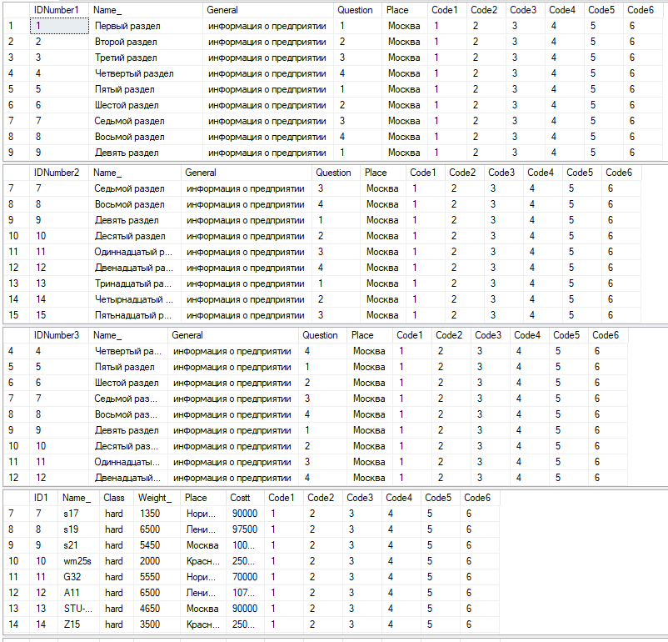

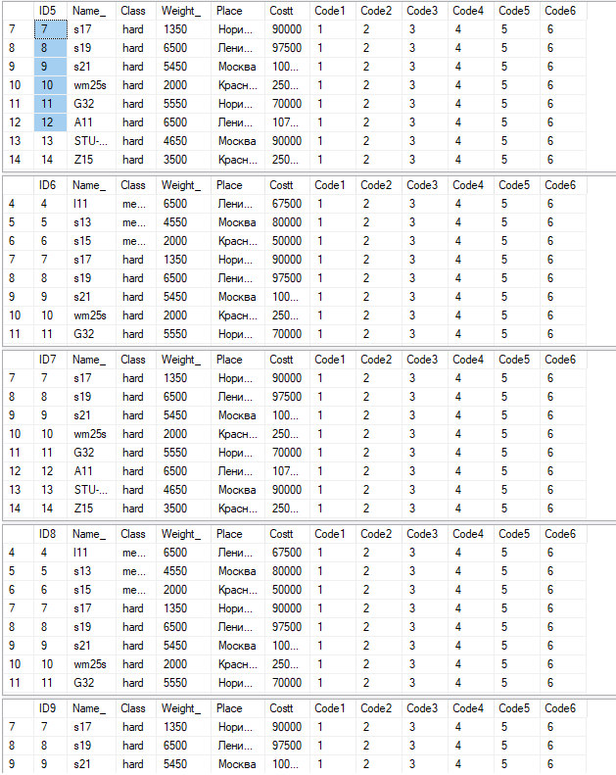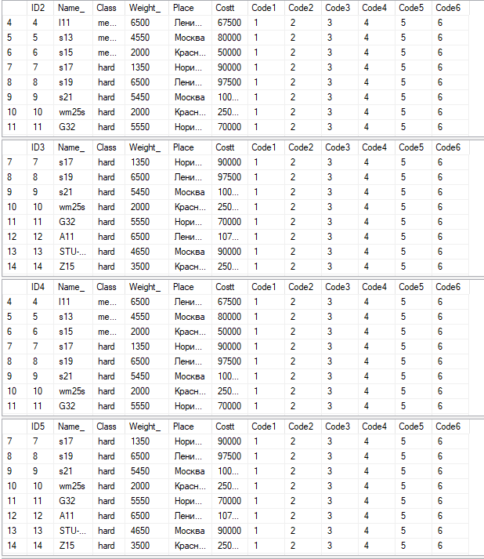

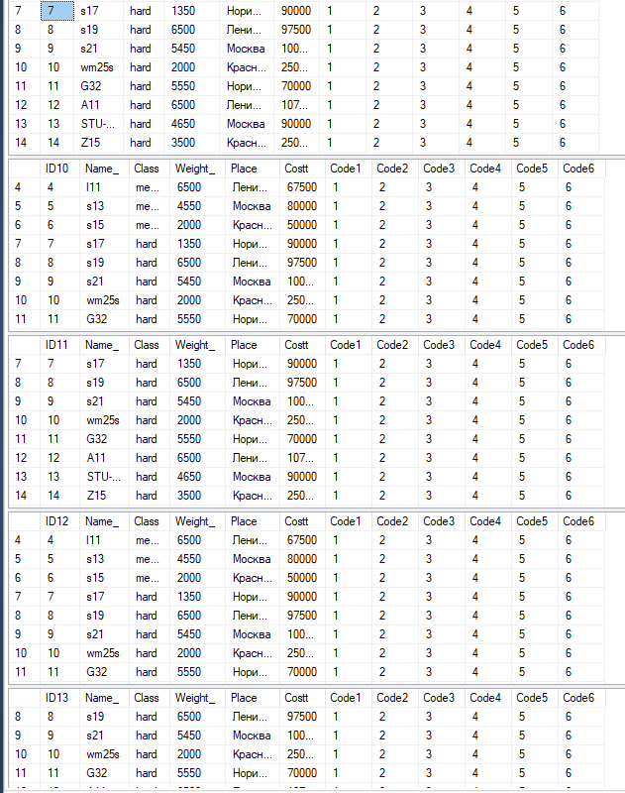

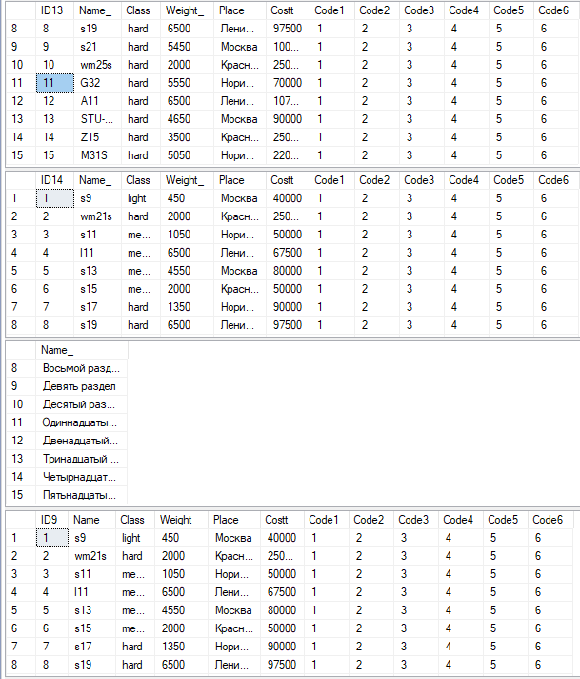

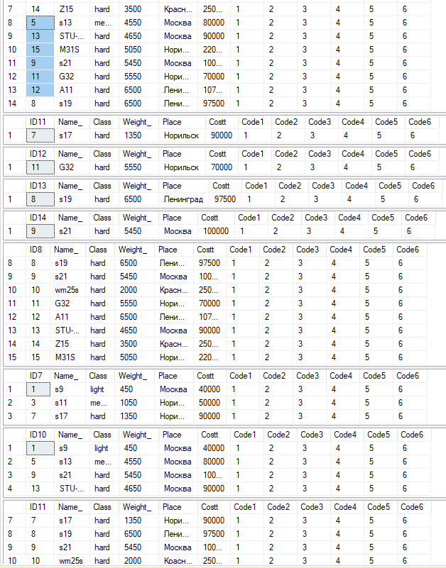

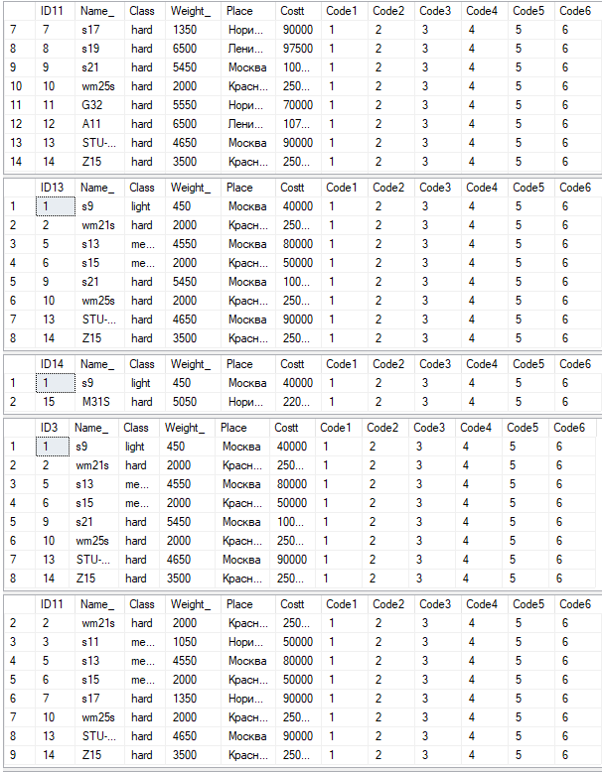

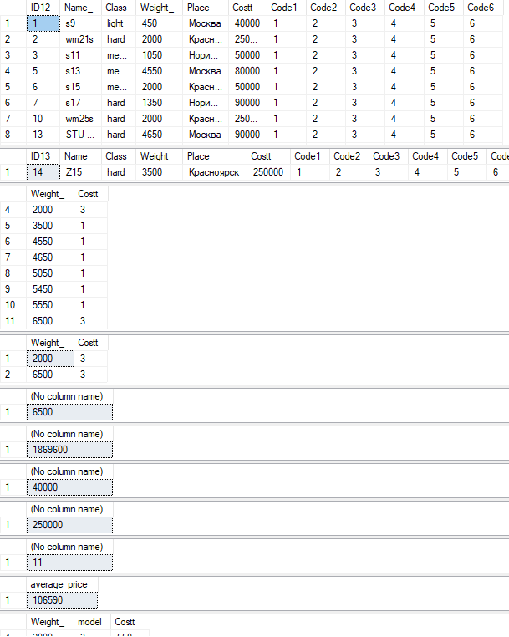

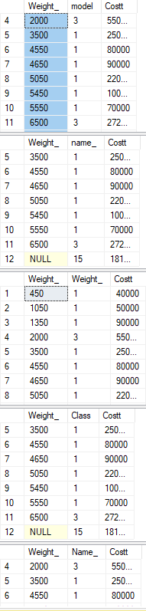

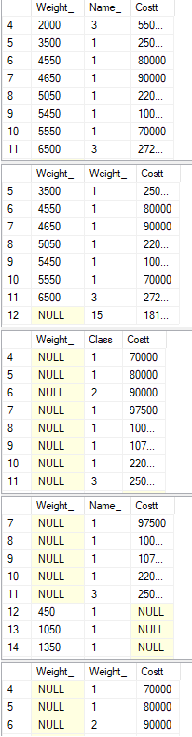

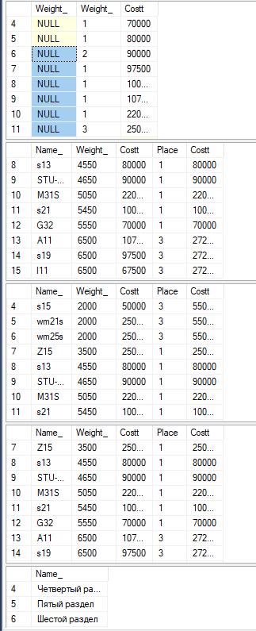

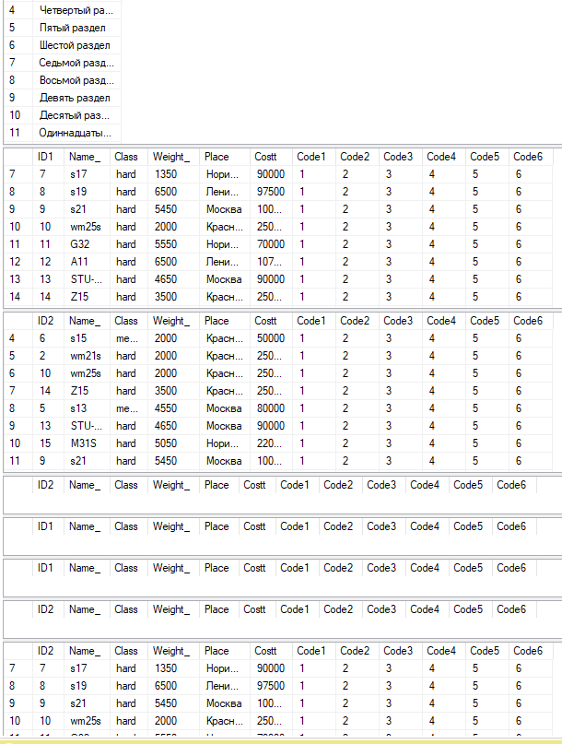

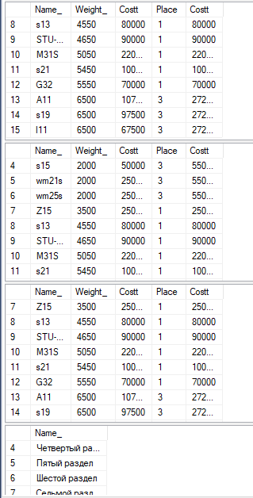

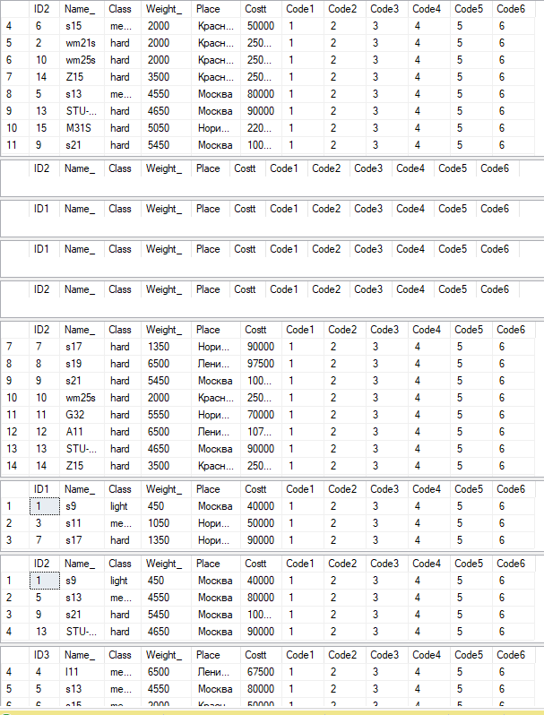

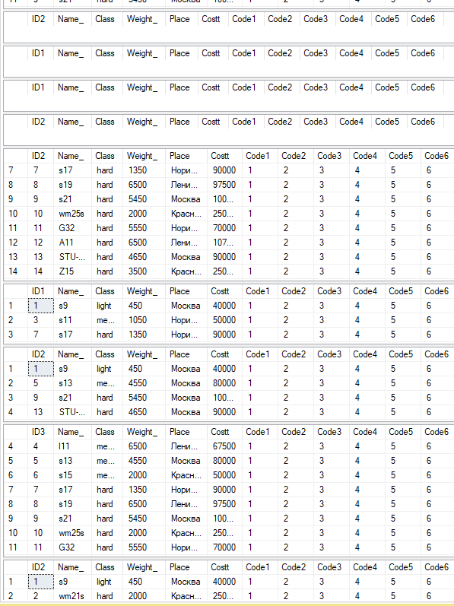

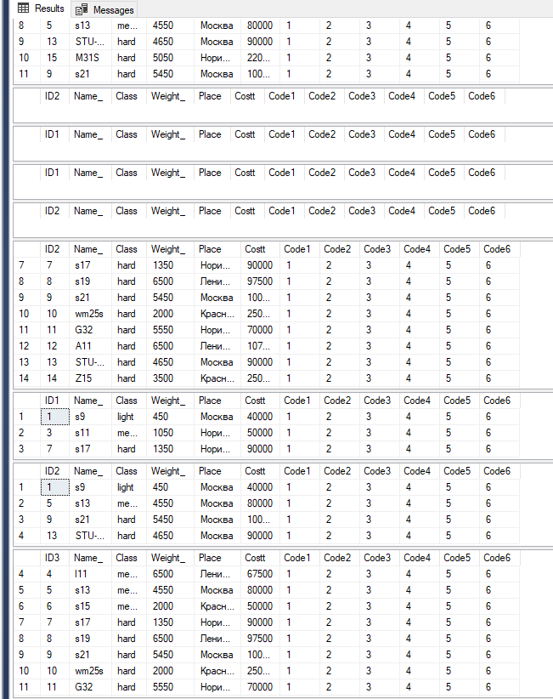

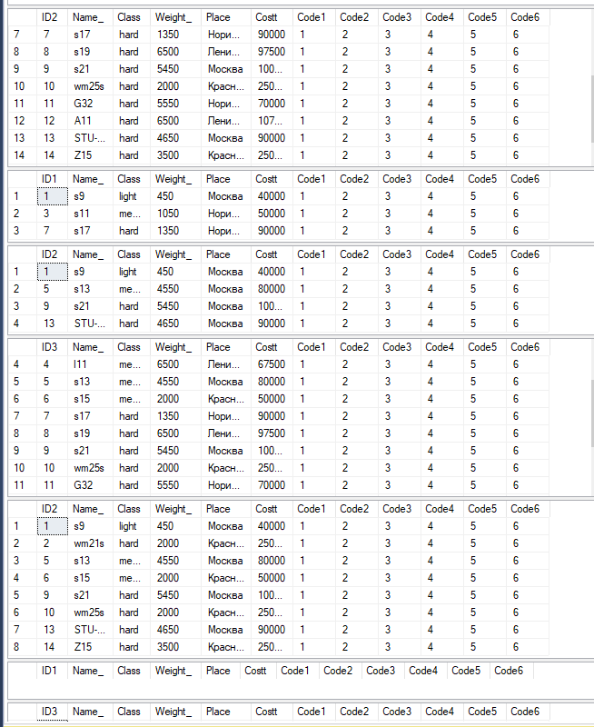

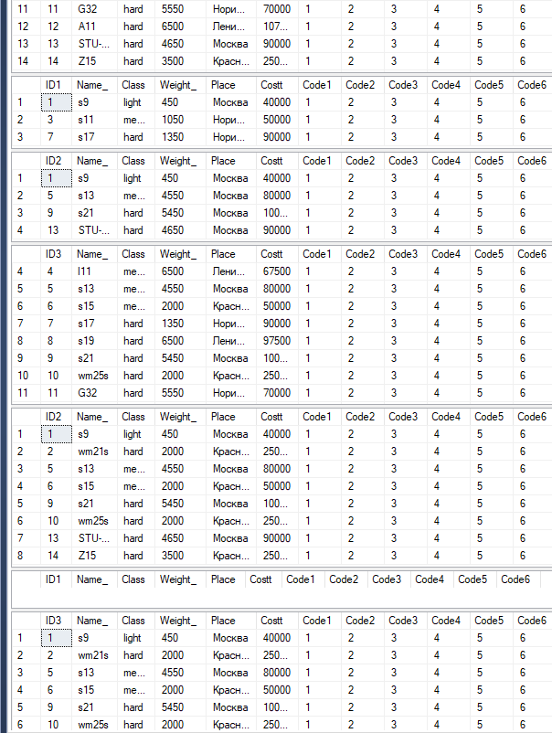

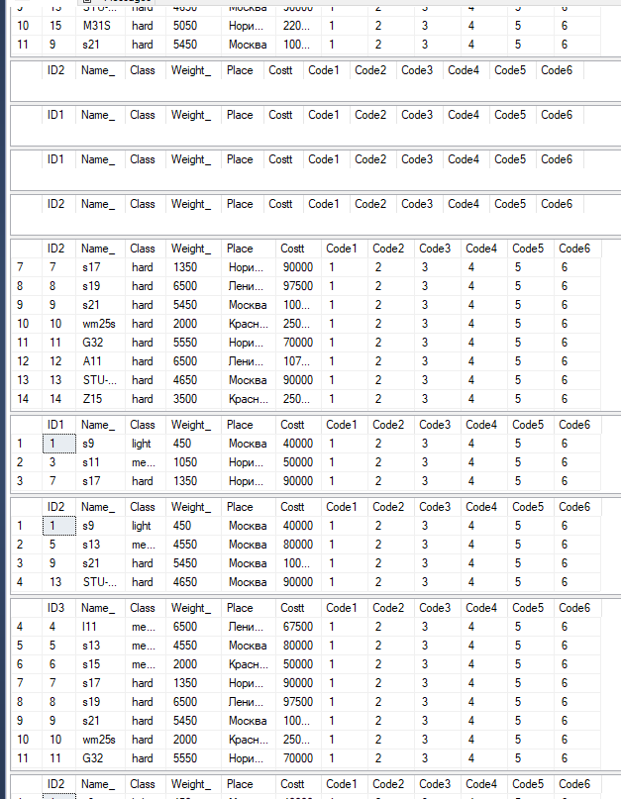

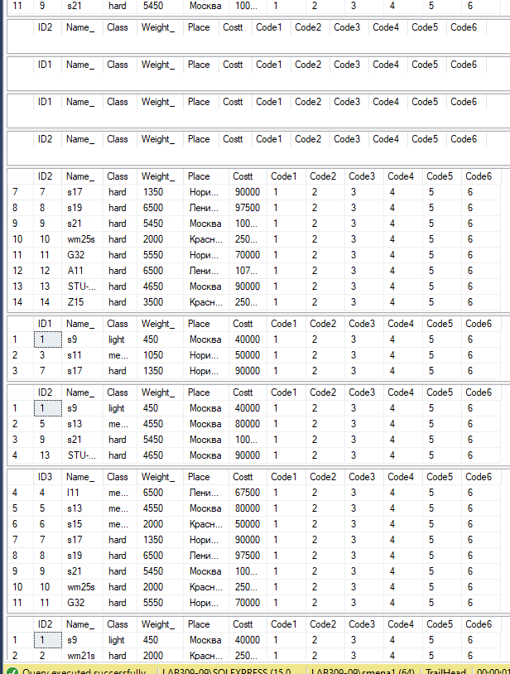

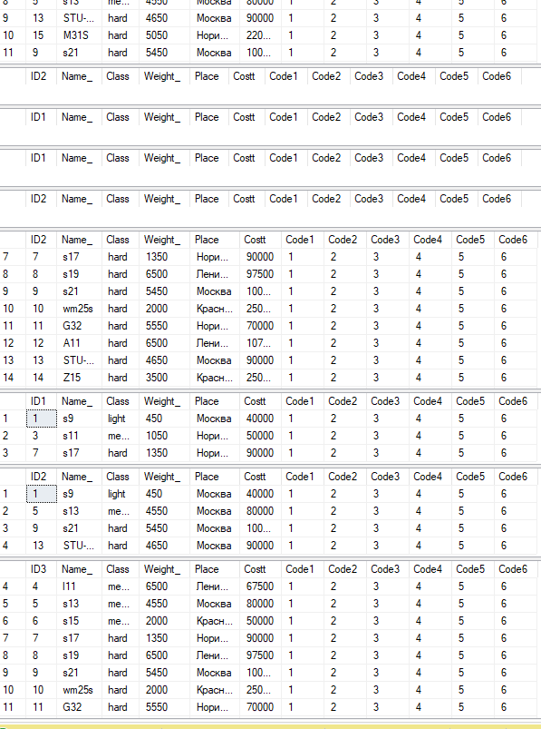

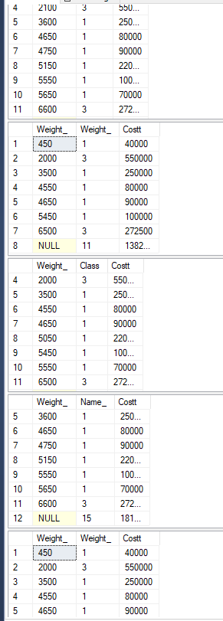

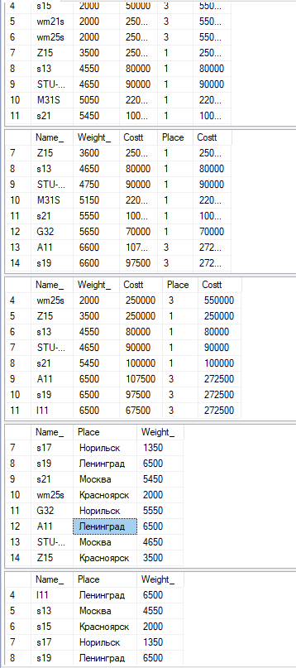

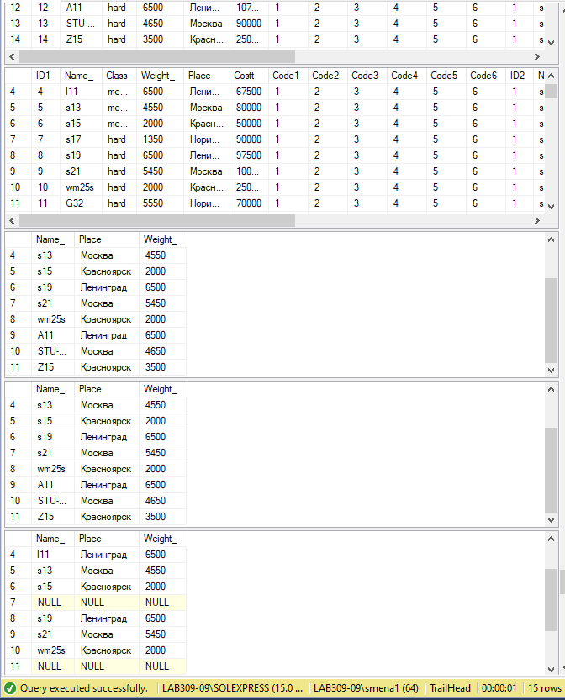

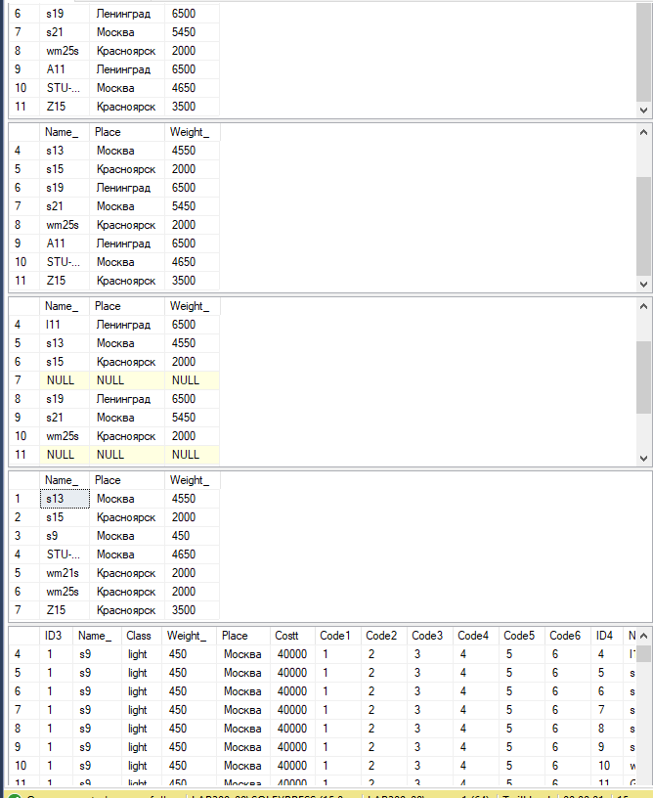

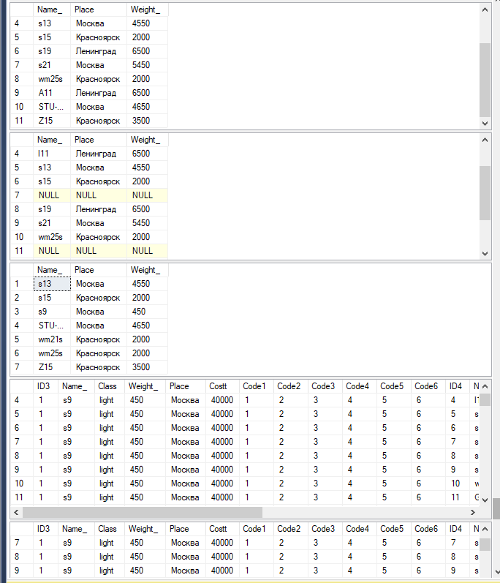

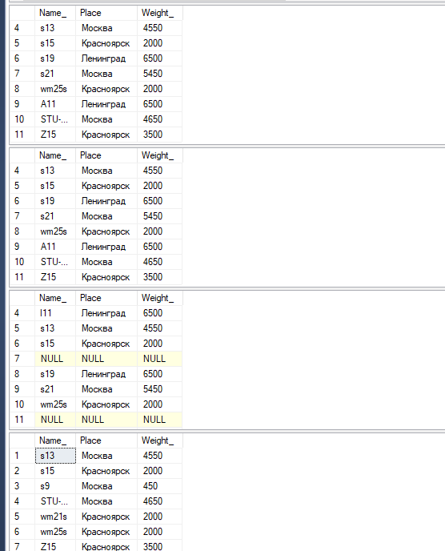

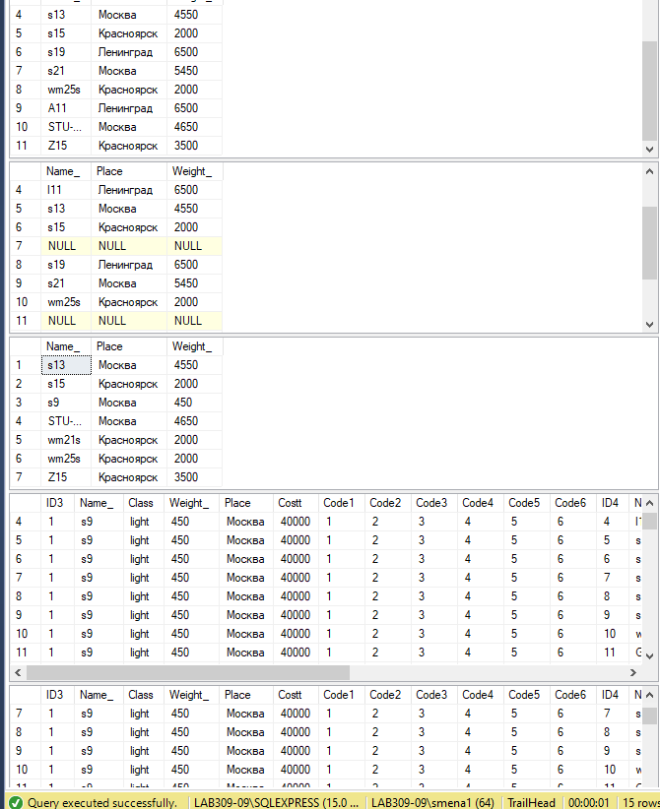

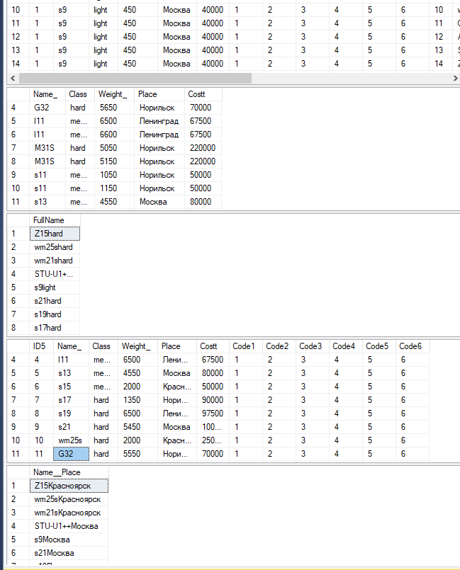

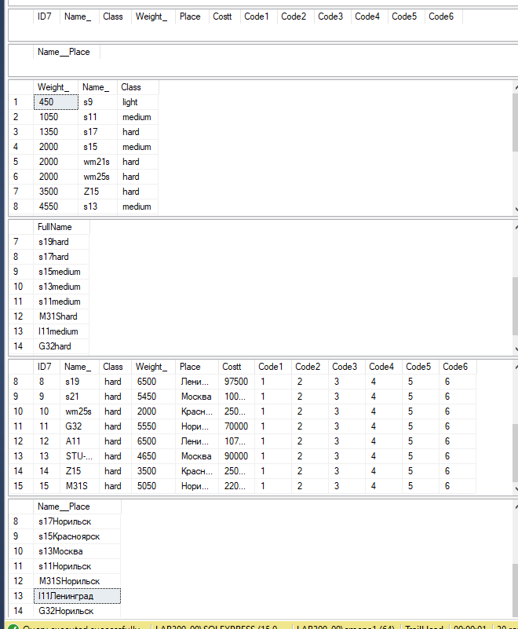

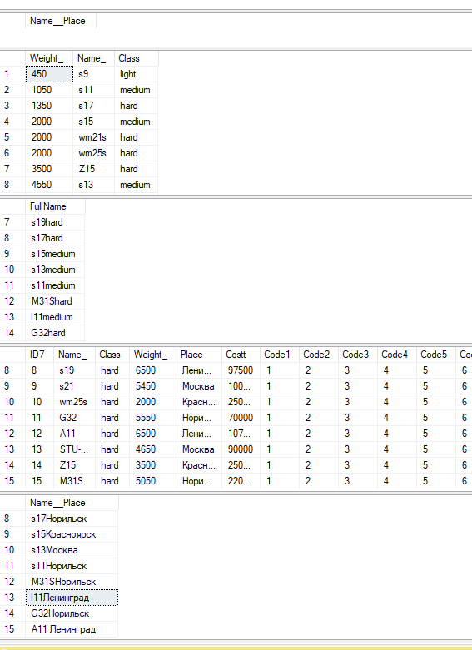

**Задание №8.2**

**GO**

**create table Info1 (**

**IDNumber1 int identity,**

**Name_ nvarchar(500) not null,**

**General nvarchar(50) not null,**

**Question int not null,**

**Place nvarchar(50) not null,**

**Constraint PK_Info_IDNumber1 primary key (IDNumber1),**

**Code1 int Not Null,**

**Code2 int Not Null,**

**Code3 int Not Null,**

**Code4 int Not Null,**

**Code5 int Not Null,**

**Code6 int Not Null**

**);**

**insert into Info1 (Name_,General,Question,Place, Code1,Code2, Code3, Code4, Code5, Code6)**

**values ('Первый раздел','информация о предприятии','1','Москва',1,2,3,4,5,6),**

**('Второй раздел','информация о предприятии','2','Москва',1,2,3,4,5,6),**

**('Третий раздел','информация о предприятии','3','Москва',1,2,3,4,5,6),**

**('Четвертый раздел','информация о предприятии','4','Москва',1,2,3,4,5,6),**

**('Пятый раздел','информация о предприятии','1','Москва',1,2,3,4,5,6),**

**('Шестой раздел','информация о предприятии','2','Москва',1,2,3,4,5,6),**

**('Седьмой раздел','информация о предприятии','3','Москва',1,2,3,4,5,6),**

**('Восьмой раздел','информация о предприятии','4','Москва',1,2,3,4,5,6),**

**('Девять раздел','информация о предприятии','1','Москва',1,2,3,4,5,6),**

**('Десятый раздел','информация о предприятии','2','Москва',1,2,3,4,5,6),**

**('Одиннадцатый раздел','информация о предприятии','3','Москва',1,2,3,4,5,6),**

**('Двенадцатый раздел','информация о предприятии','4','Москва',1,2,3,4,5,6),**

**('Тринадцатый раздел','информация о предприятии','1','Москва',1,2,3,4,5,6),**

**('Четырнадцатый раздел','информация о предприятии','2','Москва',1,2,3,4,5,6),**

**('Пятьнадцатый раздел','информация о предприятии','3','Москва',1,2,3,4,5,6);**

**create table Info2 (**

**IDNumber2 int identity,**

**Name_ nvarchar(500) not null,**

**General nvarchar(50) not null,**

**Question int not null,**

**Place nvarchar(50) not null, Code1 int Not Null,**

**Code2 int Not Null,**

**Code3 int Not Null,**

**Code4 int Not Null,**

**Code5 int Not Null,**

**Code6 int Not Null,**

**Constraint PK_Info_IDNumber2 primary key (IDNumber2)**

**);**

**insert into Info2 (Name_,General,Question,Place, Code1,Code2, Code3, Code4, Code5, Code6)**

**values ('Первый раздел','информация о предприятии','1','Москва',1,2,3,4,5,6),**

**('Второй раздел','информация о предприятии','2','Москва',1,2,3,4,5,6),**

**('Третий раздел','информация о предприятии','3','Москва',1,2,3,4,5,6),**

**('Четвертый раздел','информация о предприятии','4','Москва',1,2,3,4,5,6),**

**('Пятый раздел','информация о предприятии','1','Москва',1,2,3,4,5,6),**

**('Шестой раздел','информация о предприятии','2','Москва',1,2,3,4,5,6),**

**('Седьмой раздел','информация о предприятии','3','Москва',1,2,3,4,5,6),**

**('Восьмой раздел','информация о предприятии','4','Москва',1,2,3,4,5,6),**

**('Девять раздел','информация о предприятии','1','Москва',1,2,3,4,5,6),**

**('Десятый раздел','информация о предприятии','2','Москва',1,2,3,4,5,6),**

**('Одиннадцатый раздел','информация о предприятии','3','Москва',1,2,3,4,5,6),**

**('Двенадцатый раздел','информация о предприятии','4','Москва',1,2,3,4,5,6),**

**('Тринадцатый раздел','информация о предприятии','1','Москва',1,2,3,4,5,6),**

**('Четырнадцатый раздел','информация о предприятии','2','Москва',1,2,3,4,5,6),**

**('Пятьнадцатый раздел','информация о предприятии','3','Москва',1,2,3,4,5,6);**

**create table Info3 (**

**IDNumber3 int identity,**

**Name_ nvarchar(500) not null,**

**General nvarchar(50) not null,**

**Question int not null,**

**Place nvarchar(50) not null, Code1 int Not Null,**

**Code2 int Not Null,**

**Code3 int Not Null,**

**Code4 int Not Null,**

**Code5 int Not Null,**

**Code6 int Not Null,**

**Constraint PK_Info_IDNumber3 primary key (IDNumber3)**

**);**

**insert into Info3 (Name_,General,Question,Place, Code1,Code2, Code3, Code4, Code5, Code6)**

**values ('Первый раздел','информация о предприятии','1','Москва',1,2,3,4,5,6),**

**('Второй раздел','информация о предприятии','2','Москва',1,2,3,4,5,6),**

**('Третий раздел','информация о предприятии','3','Москва',1,2,3,4,5,6),**

**('Четвертый раздел','информация о предприятии','4','Москва',1,2,3,4,5,6),**

**('Пятый раздел','информация о предприятии','1','Москва',1,2,3,4,5,6),**

**('Шестой раздел','информация о предприятии','2','Москва',1,2,3,4,5,6),**

**('Седьмой раздел','информация о предприятии','3','Москва',1,2,3,4,5,6),**

**('Восьмой раздел','информация о предприятии','4','Москва',1,2,3,4,5,6),**

**('Девять раздел','информация о предприятии','1','Москва',1,2,3,4,5,6),**

**('Десятый раздел','информация о предприятии','2','Москва',1,2,3,4,5,6),**

**('Одиннадцатый раздел','информация о предприятии','3','Москва',1,2,3,4,5,6),**

**('Двенадцатый раздел','информация о предприятии','4','Москва',1,2,3,4,5,6),**

**('Тринадцатый раздел','информация о предприятии','1','Москва',1,2,3,4,5,6),**

**('Четырнадцатый раздел','информация о предприятии','2','Москва',1,2,3,4,5,6),**

**('Пятьнадцатый раздел','информация о предприятии','3','Москва',1,2,3,4,5,6);**

**create table Product1 (**

**ID1 int identity,**

**Name_ nvarchar (50) not null,**

**Class nvarchar (50) not null,**

**Weight_ int,**

**Place nvarchar(50) not null,**

**Costt int,**

**Code1 int Not Null,**

**Code2 int Not Null,**

**Code3 int Not Null,**

**Code4 int Not Null,**

**Code5 int Not Null,**

**Code6 int Not Null,**

**Constraint PK_Product_ID1 primary key (ID1)**

**);**

**insert into Product1 (Name_,Class,Weight_,Place,Costt, Code1,Code2, Code3, Code4, Code5, Code6)**

**values ('s9','light','450','Москва','40000',1,2,3,4,5,6),**

**('wm21s','hard','2000','Красноярск','250000',1,2,3,4,5,6),**

**('s11','medium','1050','Норильск','50000',1,2,3,4,5,6),**

**('l11','medium','6500','Ленинград','67500',1,2,3,4,5,6),**

**('s13','medium','4550','Москва','80000',1,2,3,4,5,6),**

**('s15','medium','2000','Красноярск','50000',1,2,3,4,5,6),**

**('s17','hard','1350','Норильск','90000',1,2,3,4,5,6),**

**('s19','hard','6500','Ленинград','97500',1,2,3,4,5,6),**

**('s21','hard','5450','Москва','100000',1,2,3,4,5,6),**

**('wm25s','hard','2000','Красноярск','250000',1,2,3,4,5,6),**

**('G32','hard','5550','Норильск','70000',1,2,3,4,5,6),**

**('A11 ','hard','6500','Ленинград','107500',1,2,3,4,5,6),**

**('STU-U1++','hard','4650','Москва','90000',1,2,3,4,5,6),**

**('Z15','hard','3500','Красноярск','250000',1,2,3,4,5,6),**

**('M31S','hard','5050','Норильск','220000',1,2,3,4,5,6);**

**create table Product2 (**

**ID2 int identity,**

**Name_ nvarchar (50) not null,**

**Class nvarchar (50) not null,**

**Weight_ int,**

**Place nvarchar(50) not null,**

**Costt int,**

**Code1 int Not Null,**

**Code2 int Not Null,**

**Code3 int Not Null,**

**Code4 int Not Null,**

**Code5 int Not Null,**

**Code6 int Not Null,**

**Constraint PK_Product_ID2 primary key (ID2)**

**);**

**insert into Product2 (Name_,Class,Weight_,Place,Costt, Code1,Code2, Code3, Code4, Code5, Code6)**

**values ('s9','light','450','Москва','40000',1,2,3,4,5,6),**

**('wm21s','hard','2000','Красноярск','250000',1,2,3,4,5,6),**

**('s11','medium','1050','Норильск','50000',1,2,3,4,5,6),**

**('l11','medium','6500','Ленинград','67500',1,2,3,4,5,6),**

**('s13','medium','4550','Москва','80000',1,2,3,4,5,6),**

**('s15','medium','2000','Красноярск','50000',1,2,3,4,5,6),**

**('s17','hard','1350','Норильск','90000',1,2,3,4,5,6),**

**('s19','hard','6500','Ленинград','97500',1,2,3,4,5,6),**

**('s21','hard','5450','Москва','100000',1,2,3,4,5,6),**

**('wm25s','hard','2000','Красноярск','250000',1,2,3,4,5,6),**

**('G32','hard','5550','Норильск','70000',1,2,3,4,5,6),**

**('A11 ','hard','6500','Ленинград','107500',1,2,3,4,5,6),**

**('STU-U1++','hard','4650','Москва','90000',1,2,3,4,5,6),**

**('Z15','hard','3500','Красноярск','250000',1,2,3,4,5,6),**

**('M31S','hard','5050','Норильск','220000',1,2,3,4,5,6);**

**create table Product3 (**

**ID3 int identity,**

**Name_ nvarchar (50) not null,**

**Class nvarchar (50) not null,**

**Weight_ int,**

**Place nvarchar(50) not null,**

**Costt int,**

**Code1 int Not Null,**

**Code2 int Not Null,**

**Code3 int Not Null,**

**Code4 int Not Null,**

**Code5 int Not Null,**

**Code6 int Not Null,**

**Constraint PK_Product_ID3 primary key (ID3)**

**);**

**insert into Product3 (Name_,Class,Weight_,Place,Costt, Code1,Code2, Code3, Code4, Code5, Code6)**

**values ('s9','light','450','Москва','40000',1,2,3,4,5,6),**

**('wm21s','hard','2000','Красноярск','250000',1,2,3,4,5,6),**

**('s11','medium','1050','Норильск','50000',1,2,3,4,5,6),**

**('l11','medium','6500','Ленинград','67500',1,2,3,4,5,6),**

**('s13','medium','4550','Москва','80000',1,2,3,4,5,6),**

**('s15','medium','2000','Красноярск','50000',1,2,3,4,5,6),**

**('s17','hard','1350','Норильск','90000',1,2,3,4,5,6),**

**('s19','hard','6500','Ленинград','97500',1,2,3,4,5,6),**

**('s21','hard','5450','Москва','100000',1,2,3,4,5,6),**

**('wm25s','hard','2000','Красноярск','250000',1,2,3,4,5,6),**

**('G32','hard','5550','Норильск','70000',1,2,3,4,5,6),**

**('A11 ','hard','6500','Ленинград','107500',1,2,3,4,5,6),**

**('STU-U1++','hard','4650','Москва','90000',1,2,3,4,5,6),**

**('Z15','hard','3500','Красноярск','250000',1,2,3,4,5,6),**

**('M31S','hard','5050','Норильск','220000',1,2,3,4,5,6);**

**create table Product4 (**

**ID4 int identity,**

**Name_ nvarchar (50) not null,**

**Class nvarchar (50) not null,**

**Weight_ int ,**

**Place nvarchar(50) not null,**

**Costt int,**

**Code1 int Not Null,**

**Code2 int Not Null,**

**Code3 int Not Null,**

**Code4 int Not Null,**

**Code5 int Not Null,**

**Code6 int Not Null,**

**Constraint PK_Product_ID4 primary key (ID4)**

**);**

**insert into Product4 (Name_,Class,Weight_,Place,Costt, Code1,Code2, Code3, Code4, Code5, Code6)**

**values ('s9','light','450','Москва','40000',1,2,3,4,5,6),**

**('wm21s','hard','2000','Красноярск','250000',1,2,3,4,5,6),**

**('s11','medium','1050','Норильск','50000',1,2,3,4,5,6),**

**('l11','medium','6500','Ленинград','67500',1,2,3,4,5,6),**

**('s13','medium','4550','Москва','80000',1,2,3,4,5,6),**

**('s15','medium','2000','Красноярск','50000',1,2,3,4,5,6),**

**('s17','hard','1350','Норильск','90000',1,2,3,4,5,6),**

**('s19','hard','6500','Ленинград','97500',1,2,3,4,5,6),**

**('s21','hard','5450','Москва','100000',1,2,3,4,5,6),**

**('wm25s','hard','2000','Красноярск','250000',1,2,3,4,5,6),**

**('G32','hard','5550','Норильск','70000',1,2,3,4,5,6),**

**('A11 ','hard','6500','Ленинград','107500',1,2,3,4,5,6),**

**('STU-U1++','hard','4650','Москва','90000',1,2,3,4,5,6),**

**('Z15','hard','3500','Красноярск','250000',1,2,3,4,5,6),**

**('M31S','hard','5050','Норильск','220000',1,2,3,4,5,6);**

**create table Product5 (**

**ID5 int identity,**

**Name_ nvarchar (50) not null,**

**Class nvarchar (50) not null,**

**Weight_ int,**

**Place nvarchar(50) not null,**

**Costt int,**

**Code1 int Not Null,**

**Code2 int Not Null,**

**Code3 int Not Null,**

**Code4 int Not Null,**

**Code5 int Not Null,**

**Code6 int Not Null,**

**Constraint PK_Product_ID5 primary key (ID5)**

**);**

**insert into Product5(Name_,Class,Weight_,Place,Costt, Code1,Code2, Code3, Code4, Code5, Code6)**

**values ('s9','light','450','Москва','40000',1,2,3,4,5,6),**

**('wm21s','hard','2000','Красноярск','250000',1,2,3,4,5,6),**

**('s11','medium','1050','Норильск','50000',1,2,3,4,5,6),**

**('l11','medium','6500','Ленинград','67500',1,2,3,4,5,6),**

**('s13','medium','4550','Москва','80000',1,2,3,4,5,6),**

**('s15','medium','2000','Красноярск','50000',1,2,3,4,5,6),**

**('s17','hard','1350','Норильск','90000',1,2,3,4,5,6),**

**('s19','hard','6500','Ленинград','97500',1,2,3,4,5,6),**

**('s21','hard','5450','Москва','100000',1,2,3,4,5,6),**

**('wm25s','hard','2000','Красноярск','250000',1,2,3,4,5,6),**

**('G32','hard','5550','Норильск','70000',1,2,3,4,5,6),**

**('A11 ','hard','6500','Ленинград','107500',1,2,3,4,5,6),**

**('STU-U1++','hard','4650','Москва','90000',1,2,3,4,5,6),**

**('Z15','hard','3500','Красноярск','250000',1,2,3,4,5,6),**

**('M31S','hard','5050','Норильск','220000',1,2,3,4,5,6);**

**create table Product6 (**

**ID6 int identity,**

**Name_ nvarchar (50) not null,**

**Class nvarchar (50) not null,**

**Weight_ int,**

**Place nvarchar(50) not null,**

**Costt int,**

**Code1 int Not Null,**

**Code2 int Not Null,**

**Code3 int Not Null,**

**Code4 int Not Null,**

**Code5 int Not Null,**

**Code6 int Not Null,**

**Constraint PK_Product_ID6 primary key (ID6)**

**);**

**insert into Product6 (Name_,Class,Weight_,Place,Costt, Code1,Code2, Code3, Code4, Code5, Code6)**

**values ('s9','light','450','Москва','40000',1,2,3,4,5,6),**

**('wm21s','hard','2000','Красноярск','250000',1,2,3,4,5,6),**

**('s11','medium','1050','Норильск','50000',1,2,3,4,5,6),**

**('l11','medium','6500','Ленинград','67500',1,2,3,4,5,6),**

**('s13','medium','4550','Москва','80000',1,2,3,4,5,6),**

**('s15','medium','2000','Красноярск','50000',1,2,3,4,5,6),**

**('s17','hard','1350','Норильск','90000',1,2,3,4,5,6),**

**('s19','hard','6500','Ленинград','97500',1,2,3,4,5,6),**

**('s21','hard','5450','Москва','100000',1,2,3,4,5,6),**

**('wm25s','hard','2000','Красноярск','250000',1,2,3,4,5,6),**

**('G32','hard','5550','Норильск','70000',1,2,3,4,5,6),**

**('A11 ','hard','6500','Ленинград','107500',1,2,3,4,5,6),**

**('STU-U1++','hard','4650','Москва','90000',1,2,3,4,5,6),**

**('Z15','hard','3500','Красноярск','250000',1,2,3,4,5,6),**

**('M31S','hard','5050','Норильск','220000',1,2,3,4,5,6);**

**create table Product7 (**

**ID7 int identity,**

**Name_ nvarchar (50) not null,**

**Class nvarchar (50) not null,**

**Weight_ int,**

**Place nvarchar(50) not null,**

**Costt int,**

**Code1 int Not Null,**

**Code2 int Not Null,**

**Code3 int Not Null,**

**Code4 int Not Null,**

**Code5 int Not Null,**

**Code6 int Not Null,**

**Constraint PK_Product_ID7 primary key (ID7)**

**);**

**insert into Product7 (Name_,Class,Weight_,Place,Costt, Code1,Code2, Code3, Code4, Code5, Code6)**

**values ('s9','light','450','Москва','40000',1,2,3,4,5,6),**

**('wm21s','hard','2000','Красноярск','250000',1,2,3,4,5,6),**

**('s11','medium','1050','Норильск','50000',1,2,3,4,5,6),**

**('l11','medium','6500','Ленинград','67500',1,2,3,4,5,6),**

**('s13','medium','4550','Москва','80000',1,2,3,4,5,6),**

**('s15','medium','2000','Красноярск','50000',1,2,3,4,5,6),**

**('s17','hard','1350','Норильск','90000',1,2,3,4,5,6),**

**('s19','hard','6500','Ленинград','97500',1,2,3,4,5,6),**

**('s21','hard','5450','Москва','100000',1,2,3,4,5,6),**

**('wm25s','hard','2000','Красноярск','250000',1,2,3,4,5,6),**

**('G32','hard','5550','Норильск','70000',1,2,3,4,5,6),**

**('A11 ','hard','6500','Ленинград','107500',1,2,3,4,5,6),**

**('STU-U1++','hard','4650','Москва','90000',1,2,3,4,5,6),**

**('Z15','hard','3500','Красноярск','250000',1,2,3,4,5,6),**

**('M31S','hard','5050','Норильск','220000',1,2,3,4,5,6);**

**create table Product8 (**

**ID8 int identity,**

**Name_ nvarchar (50) not null,**

**Class nvarchar (50) not null,**

**Weight_ int,**

**Place nvarchar(50) not null,**

**Costt int,**

**Code1 int Not Null,**

**Code2 int Not Null,**

**Code3 int Not Null,**

**Code4 int Not Null,**

**Code5 int Not Null,**

**Code6 int Not Null,**

**Constraint PK_Product_ID8 primary key (ID8)**

**);**

**insert into Product8 (Name_,Class,Weight_,Place,Costt, Code1,Code2, Code3, Code4, Code5, Code6)**

**values ('s9','light','450','Москва','40000',1,2,3,4,5,6),**

**('wm21s','hard','2000','Красноярск','250000',1,2,3,4,5,6),**

**('s11','medium','1050','Норильск','50000',1,2,3,4,5,6),**

**('l11','medium','6500','Ленинград','67500',1,2,3,4,5,6),**

**('s13','medium','4550','Москва','80000',1,2,3,4,5,6),**

**('s15','medium','2000','Красноярск','50000',1,2,3,4,5,6),**

**('s17','hard','1350','Норильск','90000',1,2,3,4,5,6),**

**('s19','hard','6500','Ленинград','97500',1,2,3,4,5,6),**

**('s21','hard','5450','Москва','100000',1,2,3,4,5,6),**

**('wm25s','hard','2000','Красноярск','250000',1,2,3,4,5,6),**

**('G32','hard','5550','Норильск','70000',1,2,3,4,5,6),**

**('A11 ','hard','6500','Ленинград','107500',1,2,3,4,5,6),**

**('STU-U1++','hard','4650','Москва','90000',1,2,3,4,5,6),**

**('Z15','hard','3500','Красноярск','250000',1,2,3,4,5,6),**

**('M31S','hard','5050','Норильск','220000',1,2,3,4,5,6);**

**create table Product9 (**

**ID9 int identity,**

**Name_ nvarchar (50) not null,**

**Class nvarchar (50) not null,**

**Weight_ int,**

**Place nvarchar(50) not null,**

**Costt int, Code1 int Not Null,**

**Code2 int Not Null,**

**Code3 int Not Null,**

**Code4 int Not Null,**

**Code5 int Not Null,**

**Code6 int Not Null,**

**Constraint PK_Product_ID9 primary key (ID9)**

**);**

**insert into Product9 (Name_,Class,Weight_,Place,Costt, Code1,Code2, Code3, Code4, Code5, Code6)**

**values ('s9','light','450','Москва','40000',1,2,3,4,5,6),**

**('wm21s','hard','2000','Красноярск','250000',1,2,3,4,5,6),**

**('s11','medium','1050','Норильск','50000',1,2,3,4,5,6),**

**('l11','medium','6500','Ленинград','67500',1,2,3,4,5,6),**

**('s13','medium','4550','Москва','80000',1,2,3,4,5,6),**

**('s15','medium','2000','Красноярск','50000',1,2,3,4,5,6),**

**('s17','hard','1350','Норильск','90000',1,2,3,4,5,6),**

**('s19','hard','6500','Ленинград','97500',1,2,3,4,5,6),**

**('s21','hard','5450','Москва','100000',1,2,3,4,5,6),**

**('wm25s','hard','2000','Красноярск','250000',1,2,3,4,5,6),**

**('G32','hard','5550','Норильск','70000',1,2,3,4,5,6),**

**('A11 ','hard','6500','Ленинград','107500',1,2,3,4,5,6),**

**('STU-U1++','hard','4650','Москва','90000',1,2,3,4,5,6),**

**('Z15','hard','3500','Красноярск','250000',1,2,3,4,5,6),**

**('M31S','hard','5050','Норильск','220000',1,2,3,4,5,6);**

**create table Product10 (**

**ID10 int identity,**

**Name_ nvarchar (50) not null,**

**Class nvarchar (50) not null,**

**Weight_ int ,**

**Place nvarchar(50) not null,**

**Costt int, Code1 int Not Null,**

**Code2 int Not Null,**

**Code3 int Not Null,**

**Code4 int Not Null,**

**Code5 int Not Null,**

**Code6 int Not Null,**

**Constraint PK_Product_ID10 primary key (ID10)**

**);**

**insert into Product10 (Name_,Class,Weight_,Place,Costt, Code1,Code2, Code3, Code4, Code5, Code6)**

**values ('s9','light','450','Москва','40000',1,2,3,4,5,6),**

**('wm21s','hard','2000','Красноярск','250000',1,2,3,4,5,6),**

**('s11','medium','1050','Норильск','50000',1,2,3,4,5,6),**

**('l11','medium','6500','Ленинград','67500',1,2,3,4,5,6),**

**('s13','medium','4550','Москва','80000',1,2,3,4,5,6),**

**('s15','medium','2000','Красноярск','50000',1,2,3,4,5,6),**

**('s17','hard','1350','Норильск','90000',1,2,3,4,5,6),**

**('s19','hard','6500','Ленинград','97500',1,2,3,4,5,6),**

**('s21','hard','5450','Москва','100000',1,2,3,4,5,6),**

**('wm25s','hard','2000','Красноярск','250000',1,2,3,4,5,6),**

**('G32','hard','5550','Норильск','70000',1,2,3,4,5,6),**

**('A11 ','hard','6500','Ленинград','107500',1,2,3,4,5,6),**

**('STU-U1++','hard','4650','Москва','90000',1,2,3,4,5,6),**

**('Z15','hard','3500','Красноярск','250000',1,2,3,4,5,6),**

**('M31S','hard','5050','Норильск','220000',1,2,3,4,5,6);**

**create table Product11 (**

**ID11 int identity,**

**Name_ nvarchar (50) not null,**

**Class nvarchar (50) not null,**

**Weight_ int,**

**Place nvarchar(50) not null,**

**Costt int, Code1 int Not Null,**

**Code2 int Not Null,**

**Code3 int Not Null,**

**Code4 int Not Null,**

**Code5 int Not Null,**

**Code6 int Not Null,**

**Constraint PK_Product_ID11 primary key (ID11)**

**);**

**insert into Product11 (Name_,Class,Weight_,Place,Costt, Code1,Code2, Code3, Code4, Code5, Code6)**

**values ('s9','light','450','Москва','40000',1,2,3,4,5,6),**

**('wm21s','hard','2000','Красноярск','250000',1,2,3,4,5,6),**

**('s11','medium','1050','Норильск','50000',1,2,3,4,5,6),**

**('l11','medium','6500','Ленинград','67500',1,2,3,4,5,6),**

**('s13','medium','4550','Москва','80000',1,2,3,4,5,6),**

**('s15','medium','2000','Красноярск','50000',1,2,3,4,5,6),**

**('s17','hard','1350','Норильск','90000',1,2,3,4,5,6),**

**('s19','hard','6500','Ленинград','97500',1,2,3,4,5,6),**

**('s21','hard','5450','Москва','100000',1,2,3,4,5,6),**

**('wm25s','hard','2000','Красноярск','250000',1,2,3,4,5,6),**

**('G32','hard','5550','Норильск','70000',1,2,3,4,5,6),**

**('A11 ','hard','6500','Ленинград','107500',1,2,3,4,5,6),**

**('STU-U1++','hard','4650','Москва','90000',1,2,3,4,5,6),**

**('Z15','hard','3500','Красноярск','250000',1,2,3,4,5,6),**

**('M31S','hard','5050','Норильск','220000',1,2,3,4,5,6);**

**create table Product12 (**

**ID12 int identity,**

**Name_ nvarchar (50) not null,**

**Class nvarchar (50) not null,**

**Weight_ int,**

**Place nvarchar(50) not null,**

**Costt int, Code1 int Not Null,**

**Code2 int Not Null,**

**Code3 int Not Null,**

**Code4 int Not Null,**

**Code5 int Not Null,**

**Code6 int Not Null,**

**Constraint PK_Product_ID12 primary key (ID12)**

**);**

**insert into Product12 (Name_,Class,Weight_,Place,Costt, Code1,Code2, Code3, Code4, Code5, Code6)**

**values ('s9','light','450','Москва','40000',1,2,3,4,5,6),**

**('wm21s','hard','2000','Красноярск','250000',1,2,3,4,5,6),**

**('s11','medium','1050','Норильск','50000',1,2,3,4,5,6),**

**('l11','medium','6500','Ленинград','67500',1,2,3,4,5,6),**

**('s13','medium','4550','Москва','80000',1,2,3,4,5,6),**

**('s15','medium','2000','Красноярск','50000',1,2,3,4,5,6),**

**('s17','hard','1350','Норильск','90000',1,2,3,4,5,6),**

**('s19','hard','6500','Ленинград','97500',1,2,3,4,5,6),**

**('s21','hard','5450','Москва','100000',1,2,3,4,5,6),**

**('wm25s','hard','2000','Красноярск','250000',1,2,3,4,5,6),**

**('G32','hard','5550','Норильск','70000',1,2,3,4,5,6),**

**('A11 ','hard','6500','Ленинград','107500',1,2,3,4,5,6),**

**('STU-U1++','hard','4650','Москва','90000',1,2,3,4,5,6),**

**('Z15','hard','3500','Красноярск','250000',1,2,3,4,5,6),**

**('M31S','hard','5050','Норильск','220000',1,2,3,4,5,6);**

**create table Product13 (**

**ID13 int identity,**

**Name_ nvarchar (50) not null,**

**Class nvarchar (50) not null,**

**Weight_ int,**

**Place nvarchar(50) not null,**

**Costt int, Code1 int Not Null,**

**Code2 int Not Null,**

**Code3 int Not Null,**

**Code4 int Not Null,**

**Code5 int Not Null,**

**Code6 int Not Null,**

**Constraint PK_Product_ID13 primary key (ID13)**

**);**

**insert into Product13(Name_,Class,Weight_,Place,Costt, Code1,Code2, Code3, Code4, Code5, Code6)**

**values ('s9','light','450','Москва','40000',1,2,3,4,5,6),**

**('wm21s','hard','2000','Красноярск','250000',1,2,3,4,5,6),**

**('s11','medium','1050','Норильск','50000',1,2,3,4,5,6),**

**('l11','medium','6500','Ленинград','67500',1,2,3,4,5,6),**

**('s13','medium','4550','Москва','80000',1,2,3,4,5,6),**

**('s15','medium','2000','Красноярск','50000',1,2,3,4,5,6),**

**('s17','hard','1350','Норильск','90000',1,2,3,4,5,6),**

**('s19','hard','6500','Ленинград','97500',1,2,3,4,5,6),**

**('s21','hard','5450','Москва','100000',1,2,3,4,5,6),**

**('wm25s','hard','2000','Красноярск','250000',1,2,3,4,5,6),**

**('G32','hard','5550','Норильск','70000',1,2,3,4,5,6),**

**('A11 ','hard','6500','Ленинград','107500',1,2,3,4,5,6),**

**('STU-U1++','hard','4650','Москва','90000',1,2,3,4,5,6),**

**('Z15','hard','3500','Красноярск','250000',1,2,3,4,5,6),**

**('M31S','hard','5050','Норильск','220000',1,2,3,4,5,6);**

**create table Product14 (**

**ID14 int identity,**

**Name_ nvarchar (50) not null,**

**Class nvarchar (50) not null,**

**Weight_ int,**

**Place nvarchar(50) not null,**

**Costt int, Code1 int Not Null,**

**Code2 int Not Null,**

**Code3 int Not Null,**

**Code4 int Not Null,**

**Code5 int Not Null,**

**Code6 int Not Null,**

**Constraint PK_Product_ID14 primary key (ID14)**

**);**

**insert into Product14(Name_,Class,Weight_,Place,Costt, Code1,Code2, Code3, Code4, Code5, Code6)**

**values ('s9','light','450','Москва','40000',1,2,3,4,5,6),**

**('wm21s','hard','2000','Красноярск','250000',1,2,3,4,5,6),**

**('s11','medium','1050','Норильск','50000',1,2,3,4,5,6),**

**('l11','medium','6500','Ленинград','67500',1,2,3,4,5,6),**

**('s13','medium','4550','Москва','80000',1,2,3,4,5,6),**

**('s15','medium','2000','Красноярск','50000',1,2,3,4,5,6),**

**('s17','hard','1350','Норильск','90000',1,2,3,4,5,6),**

**('s19','hard','6500','Ленинград','97500',1,2,3,4,5,6),**

**('s21','hard','5450','Москва','100000',1,2,3,4,5,6),**

**('wm25s','hard','2000','Красноярск','250000',1,2,3,4,5,6),**

**('G32','hard','5550','Норильск','70000',1,2,3,4,5,6),**

**('A11 ','hard','6500','Ленинград','107500',1,2,3,4,5,6),**

**('STU-U1++','hard','4650','Москва','90000',1,2,3,4,5,6),**

**('Z15','hard','3500','Красноярск','250000',1,2,3,4,5,6),**

**('M31S','hard','5050','Норильск','220000',1,2,3,4,5,6);**

**select * from Info1;**

**select * from Info2;**

**select * from Info3;**

**select * from Product1;**

**select * from Product2;**

**select * from Product3;**

**select * from Product4;**

**select * from Product5;**

**select * from Product6;**

**select * from Product7;**

**select * from Product8;**

**select * from Product9;**

**select * from Product10;**

**select * from Product11;**

**select * from Product12;**

**select * from Product13;**

**select * from Product14;**

**Select Name_ as Name_**

**From Info1**

**Select * From Product9;**

**Select * From Product10**

**Order by Weight_;**

**SELECT * FROM Product11**

**WHERE Weight_ = '1350';**

**SELECT * FROM Product12**

**WHERE Weight_ = '5550';**

**SELECT * FROM Product13**

**WHERE Name_ = 's19';**

**SELECT * FROM Product14**

**WHERE Name_ = 's21';**

**SELECT * FROM Product8**

**WHERE Weight_ > 200;**

**SELECT * FROM Product7**

**WHERE Weight_ < 2000;**

**SELECT * FROM Product10**

**WHERE Place = 'Москва';**

**SELECT * FROM Product11**

**WHERE Weight_ > 25;**

**SELECT * FROM Product13**

**WHERE Place IN ('Москва','Красноярск');**

**SELECT * FROM Product14**

**WHERE Weight_ IN ('5050','450');**

**SELECT * FROM Product3**

**WHERE Place NOT IN ('Норильск','Ленинград');**

**SELECT * FROM Product11**

**WHERE Weight_ BETWEEN 100 AND 5000;**

**SELECT * FROM Product12**

**WHERE Weight_ NOT BETWEEN 5000 AND 8000;**

**SELECT * FROM Product13**

**WHERE Weight_ BETWEEN 2500 AND 3500;**

**UPDATE Product14**

**SET Weight_ = Weight_ + 100;**

**DELETE Product14**

**WHERE Place='Норильск';**

**SELECT Weight_, COUNT(*) AS Costt**

**FROM Product12**

**GROUP BY Weight_;**

**SELECT Weight_, COUNT(*) AS Costt**

**FROM Product7**

**GROUP BY Weight_**

**HAVING COUNT(*) > 1;**

**SELECT AVG(Weight_) FROM Product11**

**WHERE Place = 'Ленинград';**

**SELECT SUM (Weight_+Costt) FROM Product12;**

**SELECT MIN (Costt) FROM Product11;**

**SELECT MAX (Costt) FROM Product13;**

**SELECT COUNT(*) FROM Product14;**

**SELECT AVG(DISTINCT Costt) AS average_price FROM Product2;**

**SELECT Weight_, COUNT (*) AS model, SUM(Costt) AS Costt**

**FROM Product11**

**GROUP BY Weight_ WITH ROLLUP;**

**SELECT Weight_, COUNT (*) AS name_, SUM(Costt) AS Costt**

**FROM Product12**

**GROUP BY Weight_ WITH ROLLUP;**

**SELECT Weight_, COUNT (*) AS Weight_, SUM(Costt) AS Costt**

**FROM Product13**

**GROUP BY Weight_ WITH ROLLUP;**

**SELECT Weight_, COUNT (*) AS Class, SUM(Costt) AS Costt**

**FROM Product11**

**GROUP BY Weight_ WITH CUBE;**

**SELECT Weight_, COUNT (*) AS Name_, SUM(Costt) AS Costt**

**FROM Product12**

**GROUP BY Weight_ WITH CUBE;**

**SELECT Weight_, COUNT (*) AS Weight_, SUM(Costt) AS Costt**

**FROM Product13**

**GROUP BY Weight_ WITH CUBE;**

**SELECT Weight_, COUNT (*) AS Class, Costt**

**FROM Product9**

**GROUP BY GROUPING SETS(Weight_, Costt);**

**SELECT Weight_, COUNT (*) AS Name_, Costt**

**FROM Product12**

**GROUP BY GROUPING SETS(Weight_, Costt);**

**SELECT Weight_, COUNT (*) AS Weight_, Costt**

**FROM Product13**

**GROUP BY GROUPING SETS(Weight_, Costt);**

**SELECT Name_, Weight_, Costt,**

**COUNT(*) OVER (PARTITION BY Weight_) AS Place,**

**SUM(Costt) OVER (PARTITION BY Weight_) AS Costt**

**FROM Product11**

**SELECT Name_, Weight_, Costt,**

**COUNT(*) OVER (PARTITION BY Weight_) AS Place,**

**SUM(Costt) OVER (PARTITION BY Weight_) AS Costt**

**FROM Product12**

**SELECT Name_, Weight_, Costt,**

**COUNT(*) OVER (PARTITION BY Weight_) AS Place,**

**SUM(Costt) OVER (PARTITION BY Weight_) AS Costt**

**FROM Product13**

**Select Name_ as Name_**

**From Info1**

**Select * From Product1;**

**Select * From Product2**

**Order by Weight_;**

**SELECT * FROM Product2**

**WHERE Weight_ = '700';**

**SELECT * FROM Product1**

**WHERE Weight_ = '600';**

**SELECT * FROM Product1**

**WHERE Name_ = 'Пирог';**

**SELECT * FROM Product2**

**WHERE Name_ = 'Бисквит';**

**SELECT * FROM Product2**

**WHERE Weight_ > 200;**

**SELECT * FROM Product1**

**WHERE Weight_ < 2000;**

**SELECT * FROM Product2**

**WHERE Place = 'Москва';**

**SELECT * FROM Product3**

**WHERE Weight_ > 25;**

**SELECT * FROM Product2**

**WHERE Place IN ('Москва','Красноярск');**

**SELECT * FROM Product1**

**WHERE Weight_ IN ('700','600');**

**SELECT * FROM Product3**

**WHERE Place NOT IN ('Норильск','Ленинград');**

**SELECT * FROM Product1**

**WHERE Weight_ BETWEEN 100 AND 500;**

**SELECT * FROM Product2**

**WHERE Weight_ NOT BETWEEN 500 AND 800;**

**SELECT * FROM Product3**

**WHERE Weight_ BETWEEN 250 AND 300;**

**UPDATE Product2**

**SET Weight_ = Weight_ + 100;**

**DELETE Product3**

**WHERE Place='Норильск';**

**SELECT Weight_, COUNT(*) AS Costt**

**FROM Product1**

**GROUP BY Weight_;**

**SELECT Weight_, COUNT(*) AS Costt**

**FROM Product2**

**GROUP BY Weight_**

**HAVING COUNT(*) > 1;**

**SELECT AVG(Weight_) FROM Product1**

**WHERE Place = 'Ленинград';**

**SELECT SUM (Weight_+Costt) FROM Product2;**

**SELECT MIN (Costt) FROM Product2;**

**SELECT MAX (Costt) FROM Product1;**

**SELECT COUNT(*) FROM Product1;**

**SELECT AVG(DISTINCT Costt) AS average_price FROM Product2;**

**SELECT Weight_, COUNT (*) AS model, SUM(Costt) AS Costt**

**FROM Product1**

**GROUP BY Weight_ WITH ROLLUP;**

**SELECT Weight_, COUNT (*) AS name_, SUM(Costt) AS Costt**

**FROM Product2**

**GROUP BY Weight_ WITH ROLLUP;**

**SELECT Weight_, COUNT (*) AS Weight_, SUM(Costt) AS Costt**

**FROM Product3**

**GROUP BY Weight_ WITH ROLLUP;**

**SELECT Weight_, COUNT (*) AS Class, SUM(Costt) AS Costt**

**FROM Product1**

**GROUP BY Weight_ WITH CUBE;**

**SELECT Weight_, COUNT (*) AS Name_, SUM(Costt) AS Costt**

**FROM Product2**

**GROUP BY Weight_ WITH CUBE;**

**SELECT Weight_, COUNT (*) AS Weight_, SUM(Costt) AS Costt**

**FROM Product3**

**GROUP BY Weight_ WITH CUBE;**

**SELECT Weight_, COUNT (*) AS Class, Costt**

**FROM Product1**

**GROUP BY GROUPING SETS(Weight_, Costt);**

**SELECT Weight_, COUNT (*) AS Name_, Costt**

**FROM Product2**

**GROUP BY GROUPING SETS(Weight_, Costt);**

**SELECT Weight_, COUNT (*) AS Weight_, Costt**

**FROM Product3**

**GROUP BY GROUPING SETS(Weight_, Costt);**

**SELECT Name_, Weight_, Costt,**

**COUNT(*) OVER (PARTITION BY Weight_) AS Place,**

**SUM(Costt) OVER (PARTITION BY Weight_) AS Costt**

**FROM Product1**

**SELECT Name_, Weight_, Costt,**

**COUNT(*) OVER (PARTITION BY Weight_) AS Place,**

**SUM(Costt) OVER (PARTITION BY Weight_) AS Costt**

**FROM Product2**

**SELECT Name_, Weight_, Costt,**

**COUNT(*) OVER (PARTITION BY Weight_) AS Place,**

**SUM(Costt) OVER (PARTITION BY Weight_) AS Costt**

**FROM Product3**

**Select Name_ as Name_**

**From Info1**

**Select * From Product1;**

**Select * From Product2**

**Order by Weight_;**

**SELECT * FROM Product3**

**WHERE Weight_ = '450';**

**SELECT * FROM Product1**

**WHERE Weight_ = '2000';**

**SELECT * FROM Product4**

**WHERE Name_ = 's9';**

**SELECT * FROM Product2**

**WHERE Name_ = 's11';**

**SELECT * FROM Product3**

**WHERE Weight_ > 200;**

**SELECT * FROM Product5**

**WHERE Weight_ < 2000;**

**SELECT * FROM Product6**

**WHERE Place = 'Москва';**

**SELECT * FROM Product2**

**WHERE Weight_ > 2500;**

**SELECT * FROM Product2**

**WHERE Place IN ('Москва','Красноярск');**

**SELECT * FROM Product1**

**WHERE Weight_ IN ('1050','3050');**

**SELECT * FROM Product8**

**WHERE Place NOT IN ('Норильск','Ленинград');**

**SELECT * FROM Product9**

**WHERE Weight_ BETWEEN 100 AND 5000;**

**SELECT * FROM Product10**

**WHERE Weight_ NOT BETWEEN 5000 AND 8008;**

**SELECT * FROM Product3**

**WHERE Weight_ BETWEEN 1060 AND 3000;**

**UPDATE Product9**

**SET Weight_ = Weight_ + 100;**

**DELETE Product3**

**WHERE Place='Норильск';**

**SELECT Weight_, COUNT(*) AS Costt**

**FROM Product1**

**GROUP BY Weight_;**

**SELECT Weight_, COUNT(*) AS Costt**

**FROM Product2**

**GROUP BY Weight_**

**HAVING COUNT(*) > 1;**

**SELECT AVG(Weight_) FROM Product1**

**WHERE Place = 'Ленинград';**

**SELECT SUM (Weight_+ Costt) FROM Product2;**

**SELECT MIN (Costt) FROM Product2;**

**SELECT MAX (Costt) FROM Product1;**

**SELECT COUNT(*) FROM Product1;**

**SELECT AVG(DISTINCT Costt) AS average_price FROM Product2;**

**SELECT Weight_, COUNT (*) AS model, SUM(Costt) AS Costt**

**FROM Product1**

**GROUP BY Weight_ WITH ROLLUP;**

**SELECT Weight_, COUNT (*) AS name_, SUM(Costt) AS Costt**

**FROM Product2**

**GROUP BY Weight_ WITH ROLLUP;**

**SELECT Weight_, COUNT (*) AS Weight_, SUM(Costt) AS Costt**

**FROM Product3**

**GROUP BY Weight_ WITH ROLLUP;**

**SELECT Weight_, COUNT (*) AS Class, SUM(Costt) AS Costt**

**FROM Product4**

**GROUP BY Weight_ WITH CUBE;**

**SELECT Weight_, COUNT (*) AS Name_, SUM(Costt) AS Costt**

**FROM Product5**

**GROUP BY Weight_ WITH CUBE;**

**SELECT Weight_, COUNT (*) AS Weight_, SUM(Costt) AS Costt**

**FROM Product6**

**GROUP BY Weight_ WITH CUBE;**

**SELECT Weight_, COUNT (*) AS Class, Costt**

**FROM Product7**

**GROUP BY GROUPING SETS(Weight_, Costt);**

**SELECT Weight_, COUNT (*) AS Name_, Costt**

**FROM Product8**

**GROUP BY GROUPING SETS(Weight_, Costt);**

**SELECT Weight_, COUNT (*) AS Weight_, Costt**

**FROM Product9**

**GROUP BY GROUPING SETS(Weight_, Costt);**

**SELECT Name_, Weight_, Costt,**

**COUNT(*) OVER (PARTITION BY Weight_) AS Place,**

**SUM(Costt) OVER (PARTITION BY Weight_) AS Costt**

**FROM Product1**

**SELECT Name_, Weight_, Costt,**

**COUNT(*) OVER (PARTITION BY Weight_) AS Place,**

**SUM(Costt) OVER (PARTITION BY Weight_) AS Costt**

**FROM Product2**

**SELECT Name_, Weight_, Costt,**

**COUNT(*) OVER (PARTITION BY Weight_) AS Place,**

**SUM(Costt) OVER (PARTITION BY Weight_) AS Costt**

**FROM Product3**

**SELECT Product1.Name_, Product1.Place, Product1.Weight_**

**From Product1**

**Join Product2**

**on Product1.ID1 = Product2.ID2**

**SELECT Product1.Name_, Product1.Place, Product1.Weight_**

**From Product1**

**left Join Product2**

**on Product1.ID1 = Product2.ID2**

**SELECT Product1.Name_, Product1.Place, Product1.Weight_**

**From Product1**

**right Join Product2**

**on Product1.ID1 = Product2.ID2**

**SELECT Product1.Name_, Product1.Place, Product1.Weight_**

**From Product1**

**Join Product2**

**on Product1.ID1 = Product2.ID2 and Product1.Weight_<5000**

**order by Product1.Name_**

**select * from Product1**

**Cross JOin Product2**

**select * from**

**Product1,Product2**

**SELECT Product3.Name_, Product3.Place, Product3.Weight_**

**From Product3**

**Join Product4**

**on Product3.ID3 = Product4.ID4**

**SELECT Product3.Name_, Product3.Place, Product3.Weight_**

**From Product3**

**left Join Product4**

**on Product3.ID3 = Product4.ID4**

**SELECT Product3.Name_, Product3.Place, Product3.Weight_**

**From Product3**

**right Join Product4**

**on Product3.ID3 = Product4.ID4**

**SELECT Product3.Name_, Product3.Place, Product3.Weight_**

**From Product3**

**Join Product4**

**on Product3.ID3 = Product4.ID4 and Product3.Weight_<5000**

**order by Product3.Name_**

**select * from Product3**

**Cross JOin Product4**

**select * from**

**Product3,Product4**

**select Name_, Class, Weight_, Place, Costt from product1 union select Name_, Class, Weight_, Place, Costt from product2;**

**select Name_ + '' + Class as FullName from product3 union select Name_ + '' + Class as FullName1 from product4 order by FullName desc;**

**select * from product5 union all select * from product6;**

**select Name_ + '' + Place as Name__Place from product1 union select Name_ + '' + Place as Name__Place from product2 order by Name__Place desc;**

**select Name_, Class, Weight_, Place, Costt from product1 except select Name_, Class, Weight_, Place, Costt from product4;**

**select Name_ + '' + Class as FullName from product5 except select Name_ + '' + Class as Full_Name from product6 order by FullName desc;**

**select * from product7 except select * from product8;**

**select Name_ + '' + Place as Name__Place from product1 except select Name_ + '' + Place as Name__Place from product2 order by Name__Place desc;**

**select Weight_, Name_, Class from product1 intersect select Weight_, Name_, Class from product4;**

**select Name_ + '' + Class as FullName from product5 intersect select Name_ + '' + Class as Full_Name from product6 order by FullName desc;**

**select * from product7 intersect select * from product8;**

**select Name_ + '' + Place as Name__Place from product1 intersect select Name_ + '' + Place as Name__Place from product2 order by Name__Place desc;**



























































