Slecht : <https://www.keley-consulting.com/blog/datavisualisation-quand-excel-ne-suffit-plus>

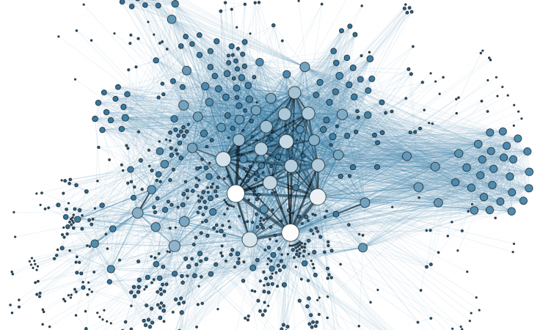

1. I do like it!6. Beautiful colors and the cohesion between the dots is beautiful.
2. 2. I don’t know anything because there is no information about the visualisation
3. Exploratory, visual,linear.
4. Nominal and interval
5. I would give some more information to know what about this chart is. And I would program it. So I would have a 3d visualisation.

Goed: <https://www.ah-book.com/Blog/visualisation-interactive-donnes.php>

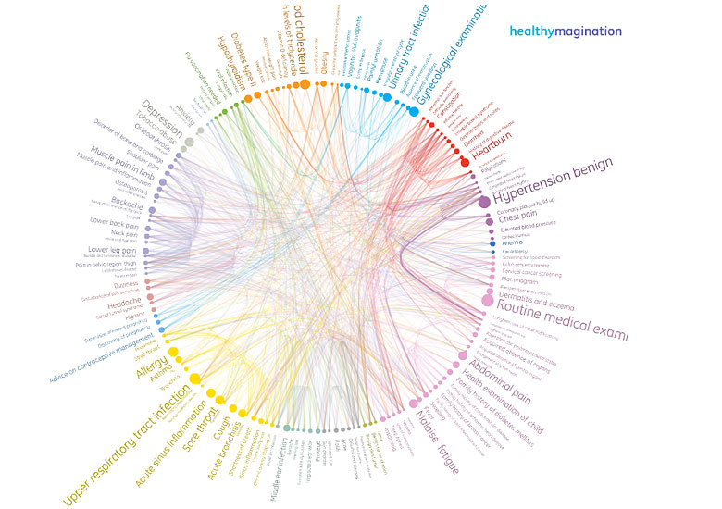

1) 8, the visualisation is very clear and beautiful in the same way

2) 9, even for someone like me who doesn’t know much about disease I can understand the link between diseases.

3)explanatory, visual, linear

4)nominal there is no order in the diseases, there are just put together with the same category

5) I would try to put a title to say that the chart is a link between different diseases and try to make the chart as big as possible.