**Project Report**: GOMOKU - A Gobang Game

**Developer name & NetID:** Yusen Li, ly2602

**Project Overview**:  
Gomoku, also known as Gobang or Five in a Row, is a classic abstract strategy board game that originated in ancient East Asia. The game is played on a grid board, typically 15x15, with the objective of aligning five consecutive stones horizontally, vertically, or diagonally before the opponent does. Although visually similar to Go, Gomoku stands out due to its unique mechanics, requiring players to think several moves ahead. The game's simplicity in rules yet depth in strategy has made it popular worldwide. Each move involves carefully positioning stones to either block the opponent or build towards victory. This project aims to recreate Gomoku as a digital game, preserving its essential gameplay elements while enhancing the user experience through an interactive interface and real-time game data management.

**Implementation Platform**:  
The project will be developed in Eclipse, using Java for the core programming and SQL for database management.

**Modular Structure:**

1. **User Login Interface Module**:  
   This module provides a GUI-based login and registration system for players. New users can register, while existing players can log in to participate in the game. Using Java's GUI features, players enter their credentials to access the game. The system verifies each login attempt by connecting to an SQL database, ensuring that only registered players can proceed. Both players must be logged in to initiate a game session, adding a level of structure and personalization.
2. **GOMOKU Game Module**:  
   The core gameplay takes place within this module, developed using Java’s JPanel to create the interactive game board. The interface includes a large GOMOKU title at the top of the board, enhancing visual appeal. Additionally, a competitive-themed image on the left of the board adds to the atmosphere. On the right, a dynamic prompt window displays critical information, including the current players' names, turn indicators, and the current game state. The game listens for mouse clicks on the board to register moves and checks after each turn for a winner. A game status prompt appears at the bottom to indicate win, loss, or continuation. After each match, the game logs the results to the database and prompts users with the option to play again.
3. **Data Storage Module**:  
   This module handles data storage using SQL. It records and manages players' game statistics, including total games played, wins, and losses. By storing this data, the module enables players to track their performance over time, fostering a competitive environment. Data is saved after each match, allowing players to continue to the next round without waiting for storage to complete.

**Technologies:**

1. **JPanel**:  
   JPanel is used to develop the graphical user interface (GUI) for both the user login and game interfaces. It allows for organized layouts and interactive elements, presenting a cohesive and visually appealing interface that is user-friendly.
2. **SQL Database**:  
   SQL is employed to store and manage user account information and game statistics. By connecting the application to a SQL database, it enables the persistent tracking of player records, enhancing the gaming experience by allowing users to review their cumulative performance.
3. **Multithreading**:  
   Multithreading is applied to handle data storage tasks asynchronously, particularly at the end of each game. This approach ensures continuity in gameplay, as players can proceed directly to the next game without delays due to storage operations. The background saving process optimizes the flow, maintaining an uninterrupted gaming experience.
4. **Algorithm for Win Detection**:  
   An efficient algorithm is used to dynamically detect when a player has achieved five consecutive stones, confirming a win. This algorithm runs after each move, verifying potential win conditions in real-time and ensuring smooth and responsive gameplay.

**Operation display：**

After click “run”, a login interface will display like below:

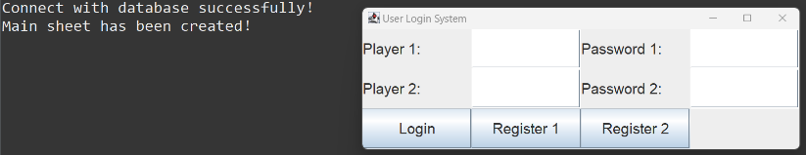

Now you can enter your name and your opponent’s name and create your password. If you are new here, you have to click Register1 and Register2 to register for player 1 and 2 separately. If you have already registered, you can directly click login button to start the game.

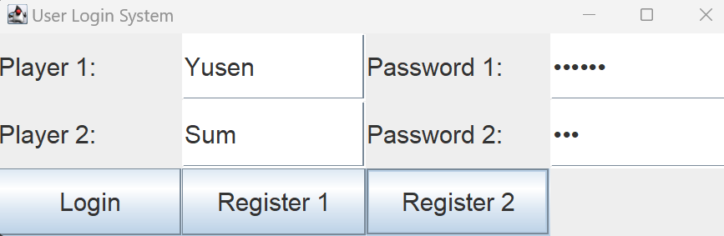

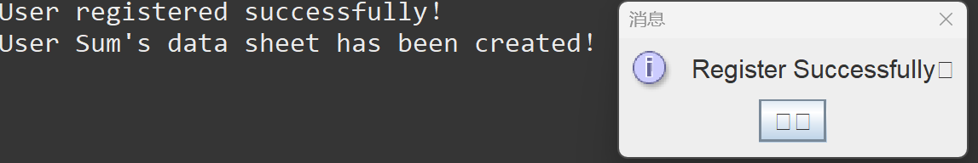

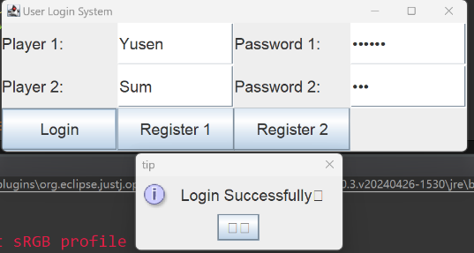

And now you enter the game interface below:

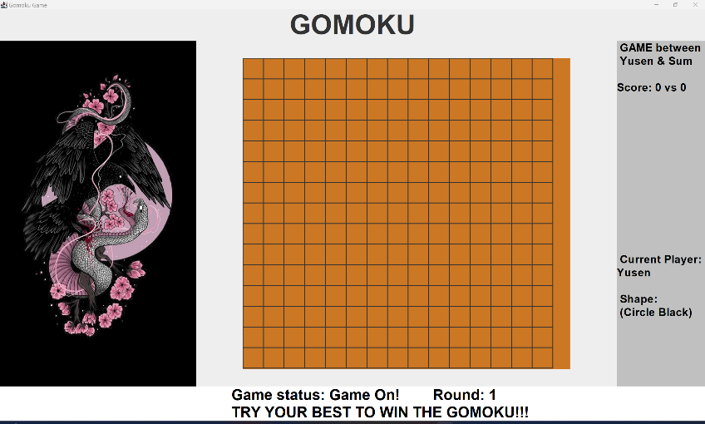

You just need to click on the place you want to drop your piece in it. After the end of the game, the winner will appear in the lower status bar to show who won the game and then a small window will pop up asking whether to continue the game.

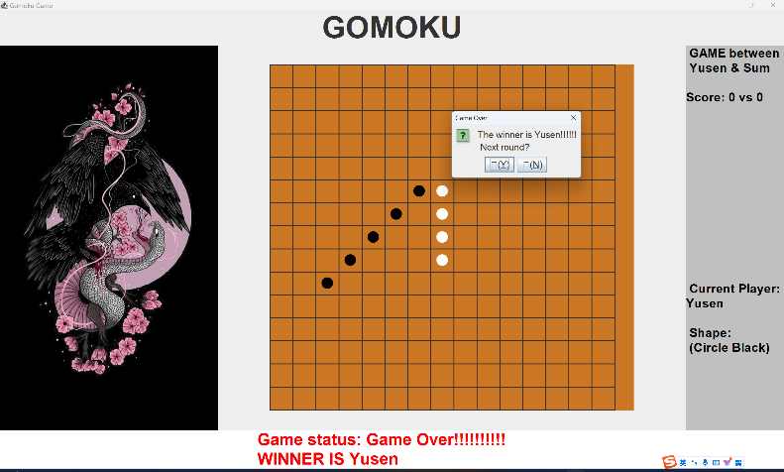

Click "Y" to continue, and "N" to quit the game directly. After "Y", you can see that the score on the right is updated to 1 point for Yusen because Yusen just won the game.

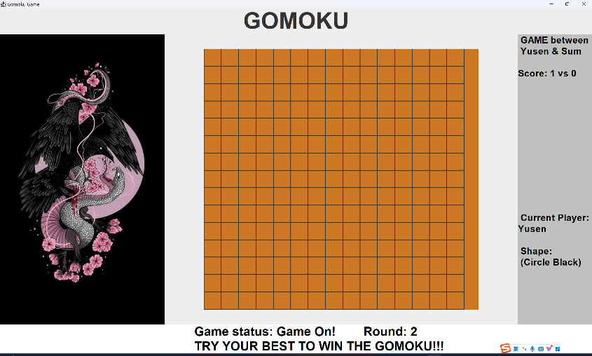

The details logged to database (.db) will be displayed in the console.

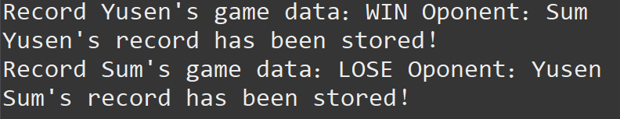

Here's what the database (.db file) looks like:

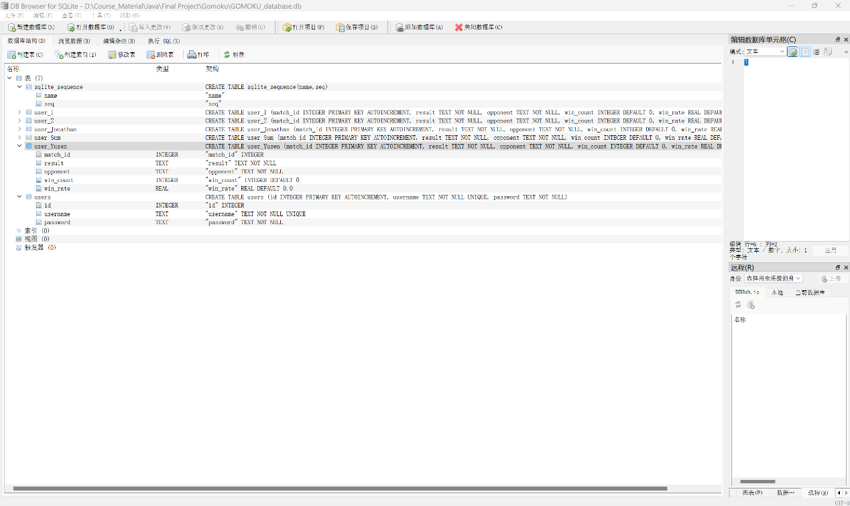

The table “users” contains the ID, username, and password of all registered players.

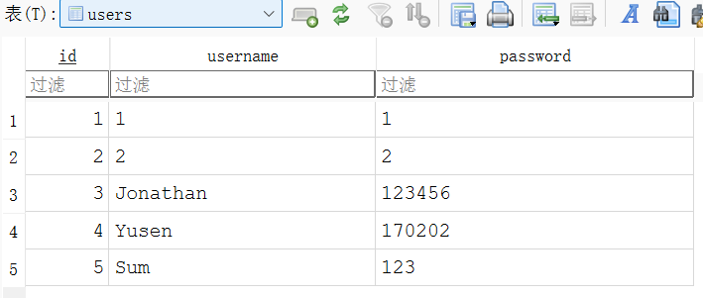

Each registered player has a separate data table that records the match_id, result, opponent of each match, as well as the updated number of wins and win percentage after each match.

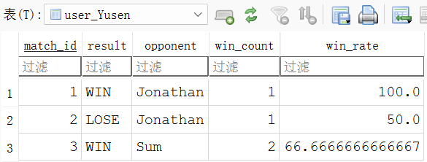

**Conclusion:**  
GOMOKU is a Java-based digital implementation of the classic Gobang game. By integrating GUI design, SQL data management, multithreading, and algorithmic win detection, the project delivers a robust and engaging experience for users. The modular structure not only provides organization but also facilitates future enhancements, such as adding AI opponents or expanding multiplayer capabilities. This project serves as a comprehensive exercise in software development, blending game logic, user experience, and data management to create an enjoyable and competitive environment for players.