Classifying Scientific Abstracts

Bingqing Yu 260477698 Bingqing.yu@mail.mcgill.ca
Liqiang Ding 260457392 Liqiang.ding@mail.mcgill.ca
Caitrin Armstrong 260501112 caitrin.armstrong@mail.mcgill.ca

Abstract- We explore several methods for automatically classifying scientific abstracts downloaded from the arXiv website.

I. INTRODUCTION
This report details our approach to classifying scientific abstracts. We were given a set of training data consisting of 88639 examples, each belonging to one of four classes. We chose to implement naïve bayes as a baseline linear classifier, k-nearest neighbours as a non-linear classifier and additionally used a library implementation of a passive aggressive classifier. After data processing, regularization and cross-validation, all models were able to give good results. Ultimately, the passive aggressive classifier returned the smallest error rate on the test set which was used as our submission to the Kaggle competition.

II. RELATED WORK

Text classification is a well-studied problem in the field of machine learning, with many documented approaches.

Linear models such as naïve bayes often provide sufficient results with relatively low use of computational resources. They are also easy to implement, train and understand. The simplicity comes at a cost, as the assumptions made by naive bayes are often violated. These can often be corrected or controlled by transforming the data. Rennie et al. use the tfidf score to properly model the word distribution as multinomial.[1].

Non-linear models can also be applied to text classification problems. K-Nearest neighbours is one of the simplest non-linear lazy machine learning algorithms, providing value in its ease of implementation and lack of computational investment in training. k-NN often provides results competitive with regularized linear approaches. As our problem does not have a particularly sparse dataset, this method is appropriate [2].

Finally, the most competitive approaches in text classification make use of techniques such as bagging or bootstrapping; they iteratively correct their own mistakes to build better models. The passive aggressive classifier is one such approach that deals well with large-scale learning and is therefore applicable to the problem at hand [3]. It is quite similar to perceptron approaches but does not require a learning rate; a regularization parameter is required instead [3].

III. PROBLEM REPRESENTATION

For each classification approach, the abstracts were processed into feature vectors by stemming using the Porter Stemmer available in the NLTK package [4]. For naive bayes and k-nearest neighbours English stopping words were removed using a standard NLTK function [4]. This has been shown to reliably reduce performance error and can be considered standard practice for text classification problems [5]. Additional processing required for each method is described below.

3.1 Naive Bayes

Both the bag-of-words and the tf-idf approach were trialed while choosing the most appropriate naive bayes classifier. To construct the tf-idf representation the frequency of each term in a document was divided by the inverse of the number of documents in which it occurred.

3.2 k-Nearest Neighbours

The feature representation for k-NN was as a ‘bag of words’ as recommended by [6]. To create this representation, all possible words were used to form the vocabulary. Each document was expressed as a feature vector comprised of integer values, which can indicate whether or not a particular word is in the document. If it is present, the value can be the occurrence frequency of that word or simply 1. We finally went with the occurrence frequency via k-fold cross validation, which will be explained later in the Testing and Validation section.

3.3
To run the passive aggressive classifier as implemented in Scikit-learn, it was necessary to construct a sparse-matrix from our features. The TfidfVectorizer from Scikit-learn was used to tokenize each abstract into individual words, with each given a numeric ID. The frequency of each token was used to compute the tfidf score. This score was then used by the vectorizer to eliminate stopping words. Finally, after this normalization, the vectorizer selected the tokens that occurred most frequently in each category [7], generating an n*m matrix where n is equal to the total number of samples, and m is equal to number of features selected based on the occurrence frequency. This matrix was then passed to the passive-aggressive classifier as one of the input parameters.

IV. ALGORITHM SELECTION AND REPRESENTATION

4.1 Among the naive bayes classifiers, the multinomial event model is best suited for text classification [1] as it can easily capture tokenized text data. The feature vector in this model is a histogram, with each element counting the number of times a particular event was observed in one instance.

Each abstract in our problem becomes a single feature and the distribution of words in each abstract is modelled as a multinomial (a histogram of word occurrences). As with most implementations we ignore the theoretical requirement that all documents should be of the same length [8].

While this model is both easily implementable and understandable it suffers from a number of flaws that have severe implications for a useable solution to the problem at hand, including the class imbalance problem and a poor modelling of real text distributions. In an attempt to ameliorate the second problem, and drawing from Rennie et al, we replaced word counts in our feature events with term-frequency/inverse-document-frequency (tfidf) scores, which transforms the word distribution by more heavily weighting the most frequently occurring words within a class while punishing the least frequent. This more closely mirrors real world term frequency, which is close to a power-law distribution [1].

Finally, for all naive bayes classifiers it was necessary to perform regularization while training the model. If a given class and feature event (word) never occur in the training data (despite that word having occurred in other classes) the probability estimate will be zero; which will create problems when multiplying with other estimates. Therefore, we incorporated an additive smoothing hyperparameter in that was selected using cross validation.

Due to time constraints we performed cross validation on a sample of 25% of the data, which still captures the distribution. All training data was then used for the construction of the class priors and probability estimates used in our two naive bayes models. For each implementation, 10-fold cross validation was run (leaving the testing set untouched) to determine the optimal value for \alpha, the smoothing parameter. Alpha was determined to be 0.1 for multinomial naive bayes and 0.001 for naive bayes run with tfidf feature encoding.

4.2

We used k-fold cross validation to split the data in train_in.csv into our training and testing data set. The cross validation was done in order to make an intelligent decision about the suitable number of k neighbors and number of keywords contained in the bag of words for our KNN classifier. The cross validation also permitted a better estimation of prediction error. 137 folds were created to perform cross validation. This was chosen in an attempt to make the data manipulation easier: we have 88639 examples and this number can only be entirely divided by 137 in order to include all the samples in the training and testing sets for each round of cross validation to choose the number of neighbours and the number of keywords. This is an important choice for our KNN model; it will be explained later in the testing and validation section. Euclidian distance was chosen for the distance metric; this is a common approach for many text classification problems. We will use the majority class from all k-neighbours returned as our final predicted class for each test instance.

4.3 We experimented with a number of methods provided by the Scikit-learn library, including random forest, Ridge Classifier, Perceptron, and Pipeline methods. Our final selection was based on the classifier that returned the best results. Although it was unknown to us at the time, the passive aggressive algorithm returned the best results.

The passive aggressive algorithm is available in the python Scikit-Learn package. Therefore, there we did not provide a manual implementation for this method. We chose this approach because this method is able to handle different sizes of datasets well and has a relatively stable performance in term of accuracy. Similar to the perceptron algorithm, it classifies different categories by calculating the signed distance of samples to the hyperplane [9]. Besides, its computation time (for training and validating) is relatively reasonable which only takes 5.99 seconds and 1.2 seconds for training 64000 and validating 16000 samples.
In terms of splitting training/validation/testing sets, we selected 80000 out of 88639 samples as a combination of training and validation sets by using the k-fold method (k=5). After five rounds of training and validating, we used the remaining 8639 samples as the testing set to test the method to provide a better idea of how well the algorithm would perform during the Kaggle competition. Our public result on the Kaggle leaderboard was quite similar to the testing results. The testing and validation section provides detailed results; splitting our raw data was valuable for testing purposes.

V. TESTING AND VALIDATION

5.1

Naïve bayes was the simplest model to train, with only one hyperparameter to tune (the smoothing parameter). The classifier was tested on a held-out 20% of the dataset. The results are presented in table 5.1a. Precision and recall are averaged across all classes. For both feature representations, the classifier was heavily biased towards predicting abstracts to be in the CS class.

Evaluation Measures | Bag of Words Naïve Bayes | TFIDF Naïve Bayes
Precision | 0.38 | 0.25
Recall | 0.32 | 0.25
Error | 0.41 | 0.49
Table 5.1a Results of the Naïve Bayes Classifier

5.2
Cross validation was first performed to find out the optimal feature encoding method. We first fixed K = 50 neighbors and took 60 words from the total “bag of words” vocabulary to consider two ways to encode our feature matrix. The final value of K is later determined via another set of cross validation tests. There are 2 possible methods for feature encoding. The first option represents the features as binary variables that can only indicate whether a specific word is present in the document or not. The second option sets the features as integer variables that encode not only the presence, but also the number of occurrences of the word in the document. Table 5.2a shows the results of the cross-validation performed

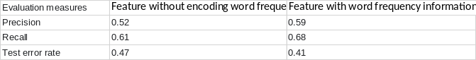
Table 5.2a Feature with encoding frequency VS without encoding frequency

To determine the number of keywords contained in the “bag of words”, we also performed cross validation with K =50 neighbors and used the encoding method with word frequency information. Table 5.2b shows the results from this cross validation. Therefore, we chose the optimal size of our “bag of words” as 200 words.

Accordingly, we decided to implement the feature vector with word frequency information for our KNN classifier since it has the lowest test error rate. The recall and precision values are averaged from the values given by the 4 output classes.

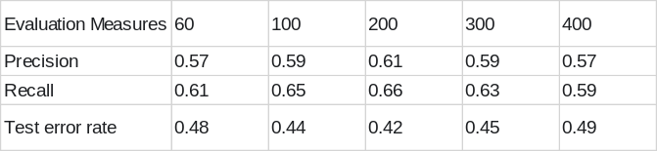
Table 5.2b Results of Different Bag of Words

According to Hassanat et al., the often-applied rule of thumb which dictates that the optimal k value for KNN should be the square root of the number of samples does not hold, and large values of k does not improve the accuracy of classification [10]. So, by referring to the K values that they have tested for their work, starting from 10-NN to 100-NN, we use cross validation to produce the Table 5.2c and chose the optimal K, which is 55-NN.

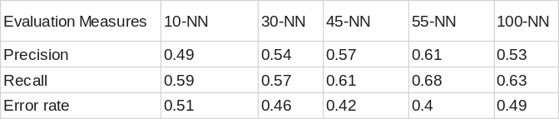
Table 5.2c Results of Different Number of K

The recall and precision values are average values obtained from 4 output classes. The error rate is the result obtained by dividing the number of good matches by the total number of testing data for each round of cross-validation. 55-NN has the lowest error and is therefore our best choice.

5.3

The default regularization parameter of Passive Aggressive Classifier method as provided Scikit-learn was used, while the iteration number was the primary parameter tuned in order to deliver the best score. To do so, the K-fold (k=5) validation method was run on the training set for each time we changed the iteration number parameter; this is the key parameter to optimize in order to achieve the testing score. Iteration number ranged from 1 to 80. As shown on the Table 5.3c, the method achieves its best performance when the iteration number is set to be 1. This likely prevents overfitting. The training accuracy rate is 0.9662 and validation accuracy rate is 0.923. As iteration number increases, the validation rate starts going down. With this optimal parameter, the public prediction rate on Kaggle is 0.81936.

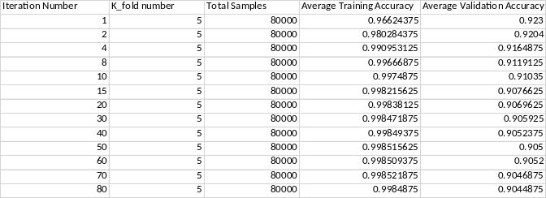
Table 5.3a Results of Different Iteration Number

To supplement statistical results, the keywords for each category are provided below in order to visualize its general performance during the k-fold validation method.

{[‘math’: ‘fixate, fix fithian fivp fivefold fitzpatrick fitzi fitzhugh fitts fitti’]
[‘cs’: input security language semantic audio np systems semantics computing neuron]
[‘stat’: eigenvalue conjectures mathematical infinity math category prime symple]
[‘physics’: optical entropy electric discussed seismic phys turbulence students]}
The selection of keywords for most of the categories was reasonable and promising. Even though the keyword section is hard to quantify, it still gave us a qualitative view of the selection results. The math category keywords surprisingly all start with the letter “F”. This strange result was consistent over 12 tests, we therefore concluded that this behavior was due to the limitations of the passive aggressive method. This certainly exerted a negative impact on our final classification results.

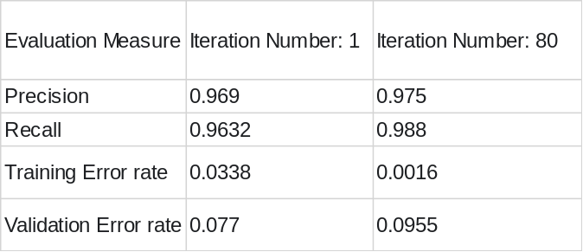
Table 5.3b Precision and Recall for Different Iteration Number

As the data is shown in Table 5.3c, the Precision and recall is inversely proportional to the error rate. These two terms are the average value from four categories. This makes sense because a perfect classifier algorithm is supposed to have a precision and recall of 1, respectively. Since we had a pretty high accuracy rate, this result is valid.

VI. DISCUSSION

The naive bayes classifier, while being the easiest to implement also provides the worst results, despite an attempt at improvement away from the most naïve model. It was also the slowest classifier. Disappointingly, the model using tfidf feature representation performed worse than the bag of words representation; we suspect this was due to a lack of data.

This classifier suffers greatly from the class imbalance problem; in which the most commonly occurring class will tend to unfairly dominate during classification. The skewed data causes the decision boundary weights to be biased towards this class even (and most importantly) in the case that a particular feature should not be representative of any class. To solve this in the future we could implement a non baseline model: ‘complement naive bayes’ as discussed in Rennie et al. [1]. This model aims to correct the class imbalance problem by learning weights for a class using all of the training data that is not in that class.

The naïve bayes, classifier, however, leave the biggest potential for improvement with use of ensemble methods such as bagging.

The KNN method that we used to implement a non-linear classifier for the problem presents some advantages. First, following careful pre-processing of the data using online packages, many noisy data points can be efficiently removed. This allows us to avoid a common drawback of KNN, which is that it is vulnerable to noise. Second, KNN benefits from having a large amount of training data and is able to make non-linear predictions. Third, by determining the most suitable number of k for KNN and the feature encoding method, its prediction error can be improved. However, KNN has high query time and memory requirements. Also, the choice of features, including distance metrics and the k hyper-parameter requires careful analysis and tests, so the results of prediction can be negatively affected if mistakes are made while choosing those hyper-parameters.

The passive aggressive algorithm ultimately returned the best classification results. During the feature extraction step, the “Bag of words” approach is used to vectorize the raw data. One of the drawbacks of this approach is that it ignores the relative positions of tokens, which could result in decreased accuracy. If this position information could be kept, the local combination of tokens relative to their positions would also be used to serve as another parameter in order to deliver a classifying result. Multiple-word tokens are also not counted due to this reason.
On the other hand, our passive aggressive algorithm has several advantages that are worth talking about. Comparative to lazy learner approaches, it is very memory efficient to use this eager learner method, especially when dealing with large amounts of data. Apart from that, the computation time of this algorithm is relatively reasonable, which makes it possible to choose a higher value of K for k-fold validation, so that the accuracy can be improved.

VII. STATEMENT of CONTRIBUTIONS

Caitrin worked on Part 1, the multinomial naive bayes classifier. This involved writing the implementation with two different feature representations in python, running training with cross validation and generating evaluation reports. She also formatted this paper and made significant revisions to all text.

Bingqing worked on Part 2, which implemented the K-NN method. Besides, she was also responsible for testing and validating the method so that the most optimal parameter values could be set. In the validation process, she made good suggestions to the team to calculate accuracy, precision and recall terms so that prediction results could be analyzed in detail.

Liqiang worked on Part 3, which was to explore and study multiple built-in package methods such as Passive-Aggressive Classifier, Random Forest and Ridge classifier to achieve the highest testing scores to submit on Kaggle. Also, he was responsible for configuring various parameters in each individual approach to find the most optimal values. Considering each method in terms of memory cost, computation time and accuracy, the passive aggressive classifier was chosen to be the method used in the project.

Finally, we all checked and collaborated on the results and methods presented.
We hereby state that all the work presented in this report is that of the authors.

REFERENCES

[1] Rennie, Jason D., et al. "Tackling the poor assumptions of naive bayes text classifiers." ICML. Vol. 3. 2003.

[2] Toker G, Kirmemis O. Text categorization using k nearest neighbor classification. Survey Paper, Middle East Technical University.

[3] J. Lu, P. Zhao and S. Hoi, "Online Passive-Aggressive Active learning", Mach Learn, vol. 103, no. 2, pp. 141-183, 2016.

[4] Bird, Steven, Ewan Klein, and Edward Loper (2009), Natural Language
Processing with Python, O'Reilly Media. http://www.nltk.org/

[5] Rajaraman, A.; Ullman, J. D. (2011). "Data Mining". Mining of Massive Datasets pp.1-17. doi:10.1017/CBO9781139058452.002. ISBN 9781139058452.

[6] Boulis C, Ostendorf M. Text classification by augmenting the bag-of-words representation with redundancy-compensated bigrams. InProc. of the International Workshop in Feature Selection in Data Mining 2005 Apr 23 (pp. 9-16).

[7] Scikit-learn.org. (2016). 4.2. Feature extraction — scikit-learn 0.18 documentation. [online] Available at: http://scikit-learn.org/stable/modules/feature_extraction.html#text-feature-extraction [Accessed 11 Oct. 2016].

[8] M. classification, "Multinomial Naive Bayes is not Multinomial in text classification", Stats.stackexchange.com, 2016. [Online]. Available: http://stats.stackexchange.com/questions/164351/multinomial-naive-bayes-is-not-multinomial-in-text-classification?rq=1 [Accessed: 14- Oct- 2016].

[9] "sklearn.linear_model.PassiveAggressiveClassifier — scikit-learn 0.18 documentation", Scikit-learn.org, 2016. [Online]. Available: http://scikit-learn.org/stable/modules/generated/sklearn.linear_model.PassiveAggressiveClassifier.html#sklearn.linear_model.PassiveAggressiveClassifier. [Accessed: 14- Oct- 2016].

[10] Hassanat AB, Abbadi MA, Altarawneh GA, Alhasanat AA. Solving the problem of the K parameter in the kNN classifier using an ensemble learning approach. arXiv preprint arXiv:1409.0919. 2014 Sep 2.

