**ECSE 683 Assignment 2 Liqiang Ding 260457392**

**Problem 1: Determining Image Correspondences**

**1. Implement the correlation-based method described in Section 7.2.2. of the Trucco and Verri text using the sum of squared differences, SSD, as the matching metric. How can you use this metric to infer a measure of reliability on your matches? Determine the set of the 20 most reliable matching pairs; we will use this later on to estimate F. Examine your results and comment on the quality of your correspondences.**

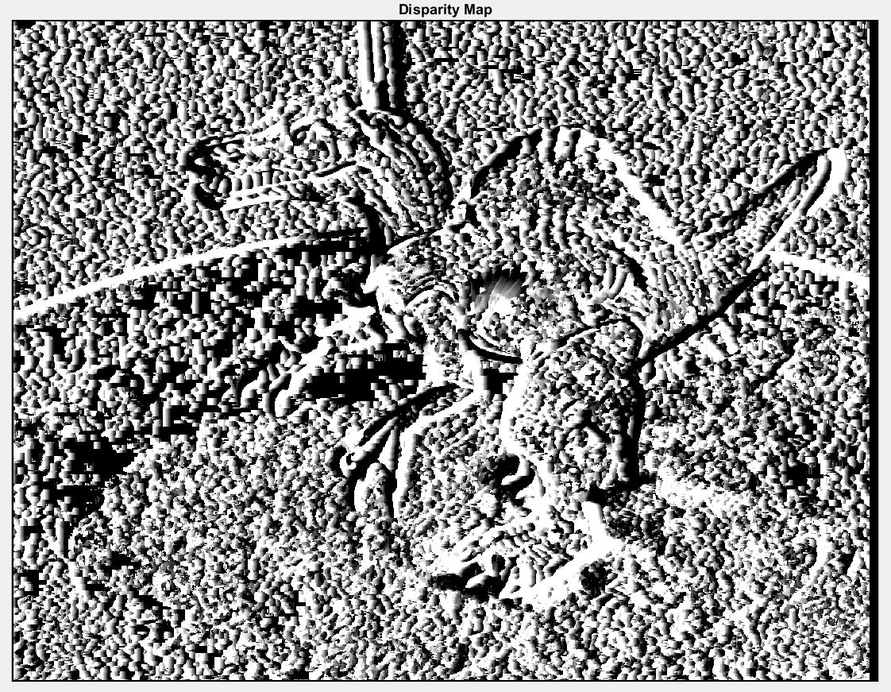

Figure 1 Disparity Map

The picture above is the disparity map which measures the corresponding elements between two pictures in terms of similarity. The corresponding element is given by the window that maximizes the similarity within a search region. The black pixel indicates 0 distance shifting between two pixels in two images. The further distance is, the brighter the pixel gets. In order to infer the measurability, we can find the certain pixel coordinates on the left image, and pixel coordinates on the left image. Then, we can compare shifting distance between these pixels with the results from the disparity map. If the pixel value of the disparity map is similar to the actual distance, it proves the reliability of the disparity map.

**2. Repeat Part 1, but this time using a feature-based approach based on the corner detector outlined in Section 4.3 of the text. You need to give some thought on what attributes of the corner feature can be used to match corresponding corners, as well as a reliability measure for your matches. Again, use this measure to determine your 20 most reliable matching pairs. Comment on the quality of your correspondences and note any similarities in the two results.**

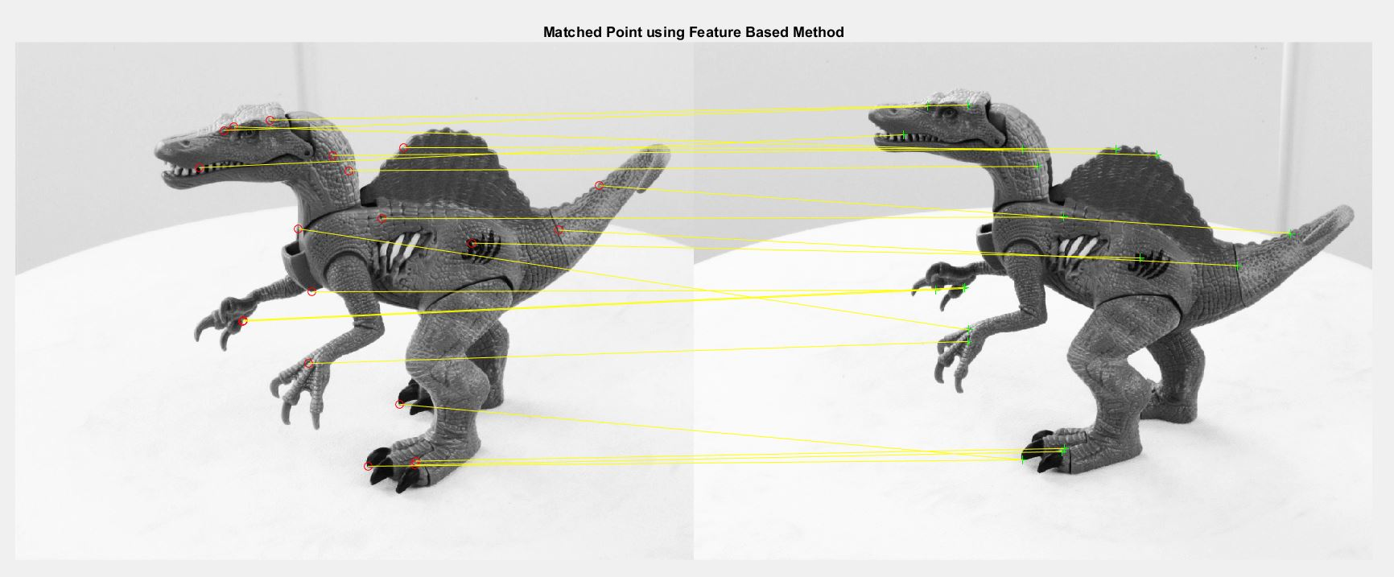

The picture above is the corresponding point matching result using feature based method. In detail, the Harris Corner Detector is used to calculate the corners from both images. Then, descriptors are extracted from these corners detected, and respective locations are returned as well. Next, descriptors get matched using the approach of nearest neighbor. An exhaustive search is performed in terms of similarly distance and indices of matching features and distance metrics are returned.

20 best points are detected and labeled on the image. Both manual implemented corner detection function and MATLAB built-in functions were tried. However, considering the very large time consumption and inaccurate results, the MATLAB function is used. As we can see from the image, most of points are correctly matched, however, there are three points get incorrectly matched. This can be fixed by setting adjusting similarity threshold. By increasing this threshold, fewer points would be matched but accuracy would be improved.

**Problem 2: Estimating Epipolar Geometry**

**1. Determine which of your two sets from Problem 1 is most “reliable” – explain why. These will serve as the basis for estimating the Fundamental Matrix, F, using the 8-point algorithm.**

Based on the results, and theories from sections 7.2.2 and 7.2.3 from Trucco and Verri text, the feature based method using the corner detector clearly provides a better corresponding matching results than the correlation based method using disparity map. The reason is that corners are relatively robust and unique features in the images, which have lower probability to be mismatched. Corners don’t change much with respective to point views and illumination. On the hand, due to foreshortening effects and changes in illumination direction, the correlation-based methods are inadequate for matching image pairs taken from very different viewpoints.

**2. Determine the position of the epipoles in pixel coordinates in the left and right images. For the best 5 matching pairs in your most reliable set, plot the epipolar lines in the corresponding image. That is, for the 5 points in the left image, plot the corresponding epipolar lines in the right image and vice-versa.**

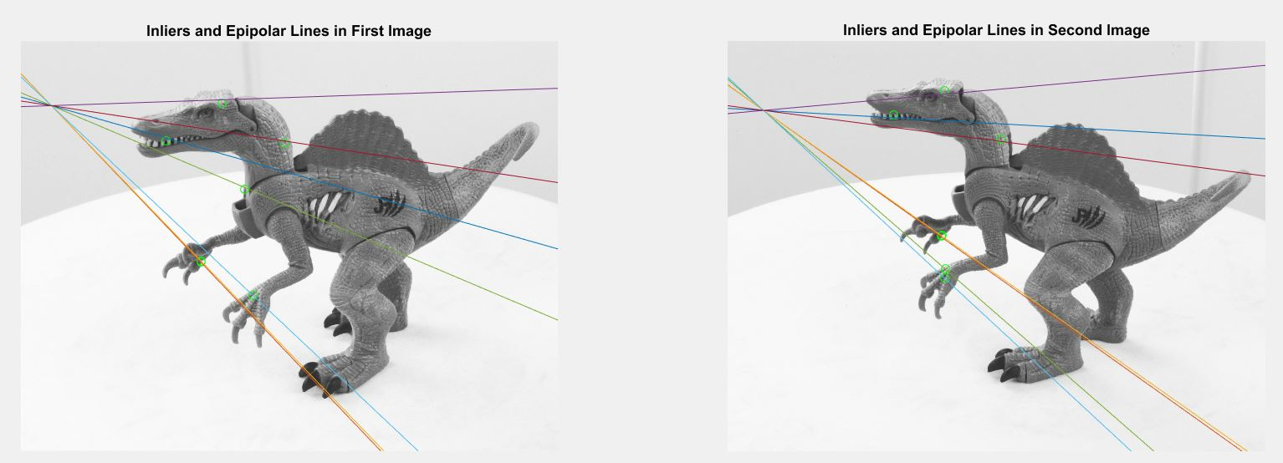

**3. Use F and the intrinsic parameters to estimate the Essential Matrix E, and use this estimate to estimate the unknown extrinsic parameters R, T using the procedure outlined in the text. Recall that both R and T have sign ambiguities, so you are going to have to check which one of the 4 possible configurations is the correct one.**

T = { -0.00649070521903764, -0.00613160989335390, 0.999960136258379}

R = { -0.999996664374004 -0.00257816785650452 -0.000155856890553729

0.00257818594267336 -0.999996669750399 -0.000115954111975839

0.000155557422347088 0.000116355553240528 -0.999999981131637}

**4. With R, T you have sufficient information to implement the Rectification Algorithm described in Section 7.3.7 of the text. Use this to warp the two stereo images into a fronto-parallel configuration where epipolar lines lie on adjacent scan lines. Show the corresponding images.**

This part was implemented and tried by the student. However, due to limited time constraint, this question is partially finished. Please check the Matlab code called Assignment2.m for detailed implementation.

**Problem 3: Reconstruction up to a Scale Factor**

**Putting everything together, we now attempt to reconstruct the 3D surface that is most consistent with the left and right image projections. Because we are now working with rectified images, finding correspondences is greatly simplified. Using either the correlation or corner-based method obtain a dense set of correspondences and use it to reconstruct the corresponding 3D surface. You can use the Matlab or Octave mesh plotting function to visualize the resulting surface.**

This part was implemented and tried by the student. However, due to limited time constraint. This question is partially finished. Please check the Matlab code called Assignment2.m for detailed implementation.