Hi

Will explain how to run this VBA project.

1. Open Excel document by clicking Book1.xlsx in project folder.
2. Open “View Macro” as bellow figure.

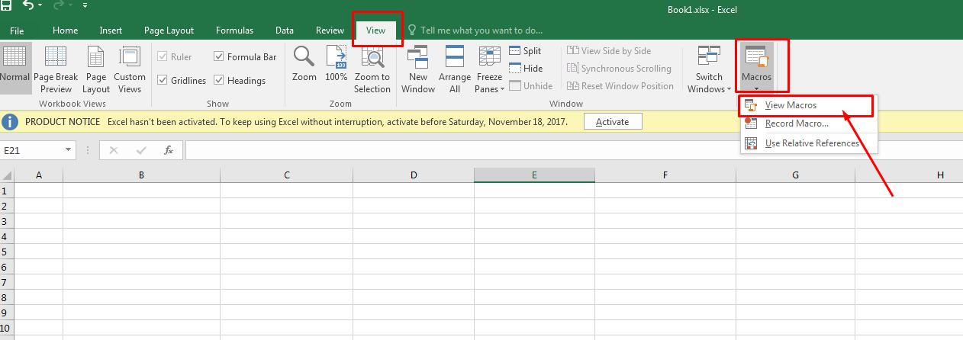

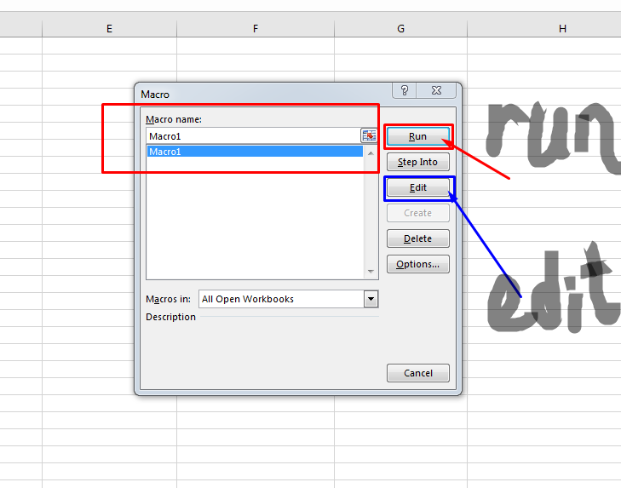

To run Macro, click Run Button and to edit macro, click Edit Button

If it’s happen bug, please do as follows…

Please open macro edit window by clicking “Edit” button.

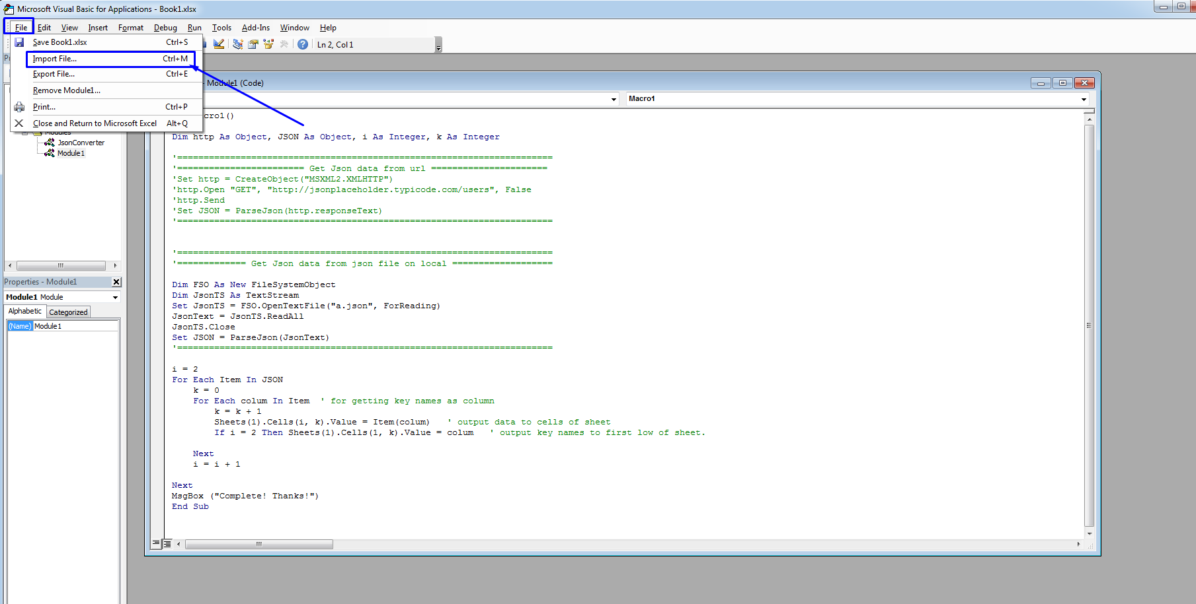

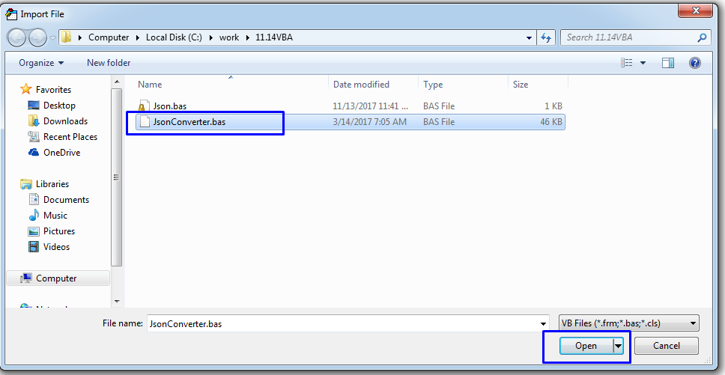

Please import JsonConverter.bas as above figures.

and…

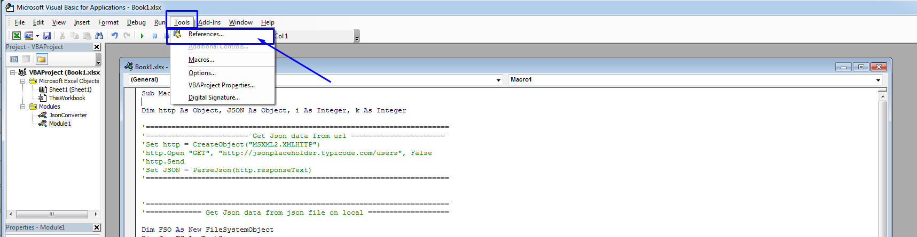

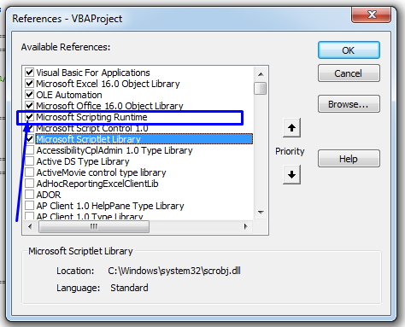

After that, please run again.

Then it will work well.

Thanks.