# CS5635.A4 – Vector Field Visualization

# I. Air Flow Above Heated Disk

I extracted the air stream with a stream trace filter and added a tube filter to make the nice strands seen in the image below. Opacity of the original volume was reduced to show the disc location while allowing the airstream to be seen.

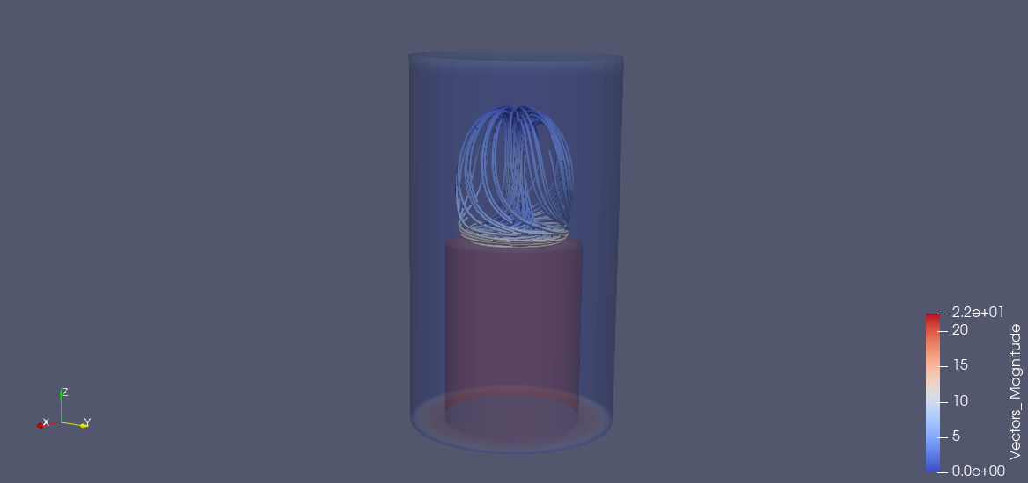

**Fig. 1** – Tube surface render of the air stream.

# II. Hurricane Visualization

To render the hurricane, a stream tracer filter was applied with a tube filter over the top. Low resolution cones were applied in the direction of the wind to communicate direction of wind travel. The number of randomly sampled points was reduced to 2000 and the seed set at 10339 using a uniform spatial distribution. Results can be seen in Figure 2.

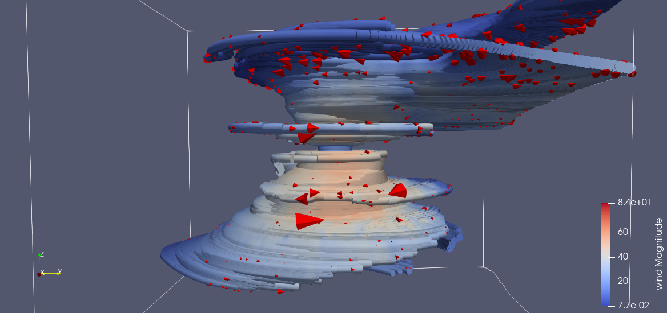

**Fig. 2** – Hurricane vortex with garishly red cones for wind direction.

When attempting to change over to arrow glyphs, I encountered a significant number of crash-to-desktop errors with no error message. I tried reducing the number of sampled points and rebuilding everything from scratch, but nothing seemed to be successful.

# III. Visualization of Air Flow Around Vehicle

I first created a transfer function with high levels of opacity from 0 to .63. This allowed for the volume render of flow velocity to be reasonably distinct. The ribbons were created with several seeds and visualizations are shown in Figure 3. The first is directly under the front of the vehicle, the second quite far from the front of the vehicle, and the third toward the rear or perhaps even past the vehicle. I prefer the ribbons generated from the seed being directly under or toward the rear of the vehicle.

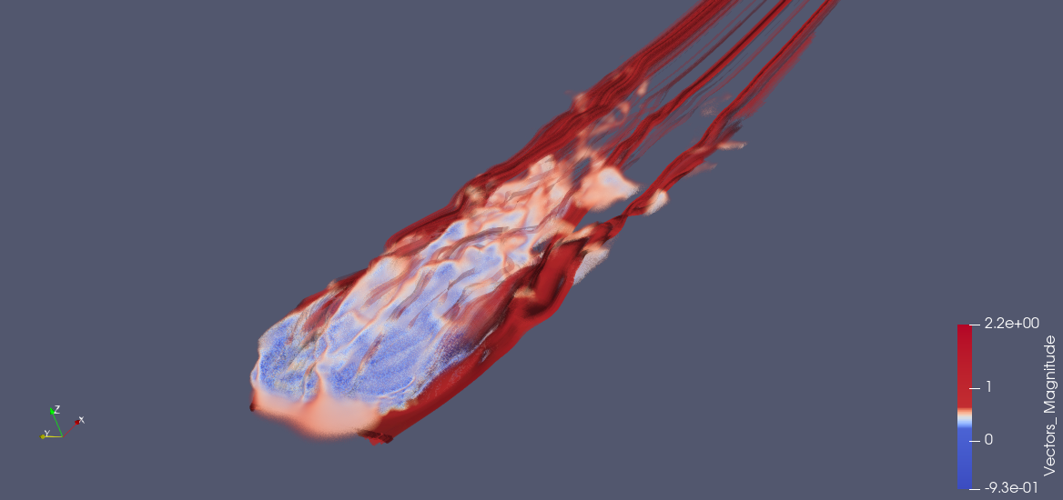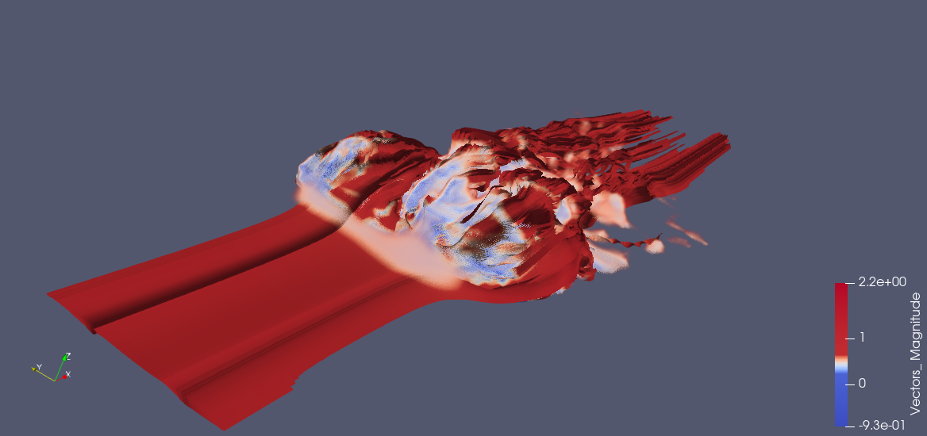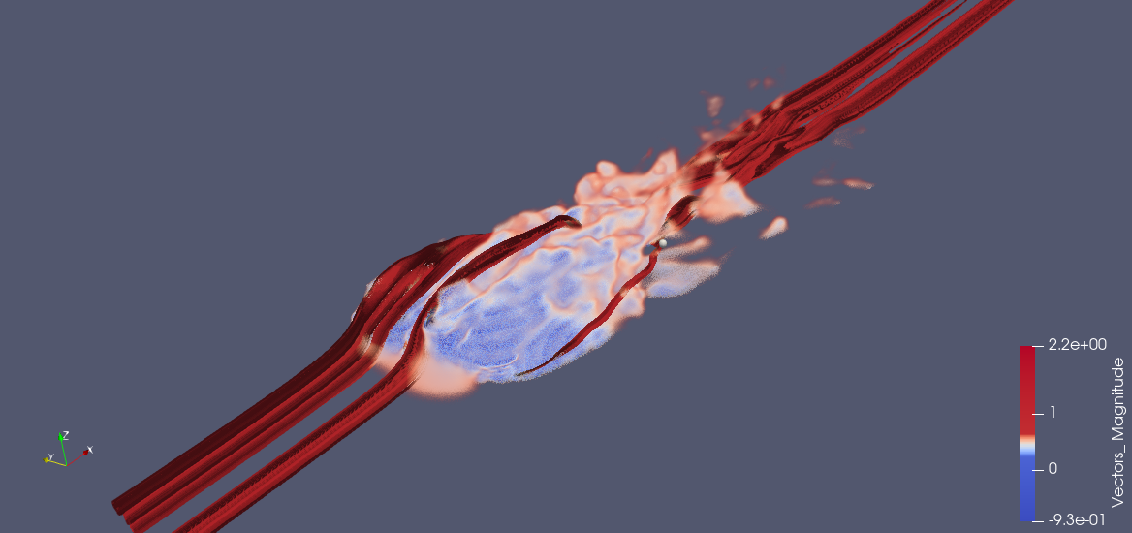

**Fig. 3** – Three visualizations of ribbon stream filter with varying seed configurations.

# IV. Conclusion

The need for vector visualizations is readily apparent for various applications. I suspect I may use it in my own project, so this was a much-needed tutorial on their use. I found the air flow around the moving vehicle to be incredibly striking. It may just be the bold red ribbons, but I quite like it. I imagine one could use the vehicle visualizations to understand what parts of a vehicle need to change for wind tunnel testing to enhance aerodynamics.